2023 Premier’s Anika Foundation Youth Depression Awareness Scholarship

Levers for School Leaders to Positively Impact Student Wellbeing
  - How do we create a human-centred learning environment to ensure every student is known and nurtured?
Peter Howes
Murwillumbah Learning Community High School
Sponsored by

Introduction
A sense of belonging and wellbeing is essential in reducing the impact of youth depression and suicide. This research predominantly explores the impact on student wellbeing that reimagined approaches to schooling are having on student wellbeing. The Scholarship enabled site visits and interviews in over 30 schools, universities and institutions across every state and territory of Australia, with the exception of the Northern Territory. Learning from previous visits and from virtual connections with international schools and practitioners of best practice also informed the report.

Focus of Study
How do we create a human-centred learning environment to ensure every student is known and nurtured?
Across the Western world, we are experiencing significant increases in student disengagement with school as reflected by a range of data, including growth in suspensions, poor attendance and students reporting a lack of belonging. Teacher wellbeing is declining, and the role of school leaders is becoming increasingly complex.
The research explores how we can re-imagine school to develop a learning culture, centred on high-expectation relationships, and how this can improve students' mental health, wellbeing and engagement with learning so that they develop sustained resilience and agency.
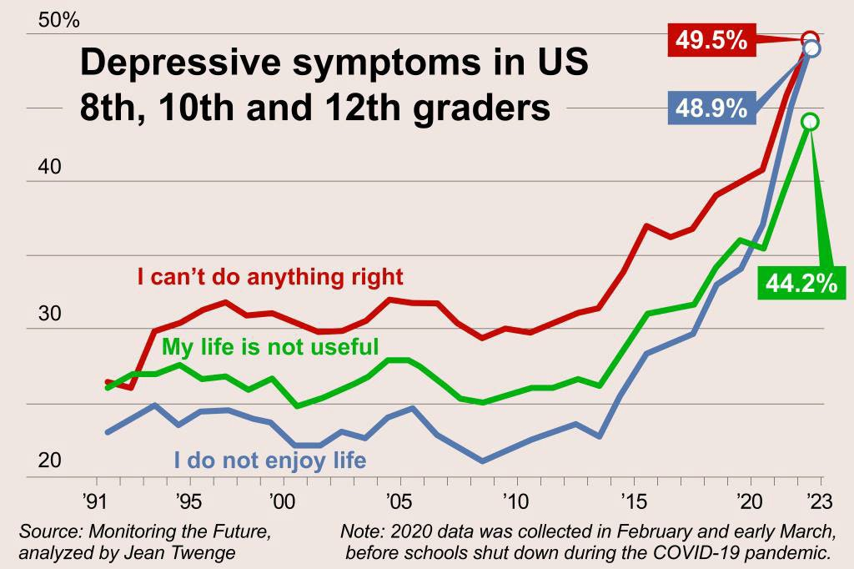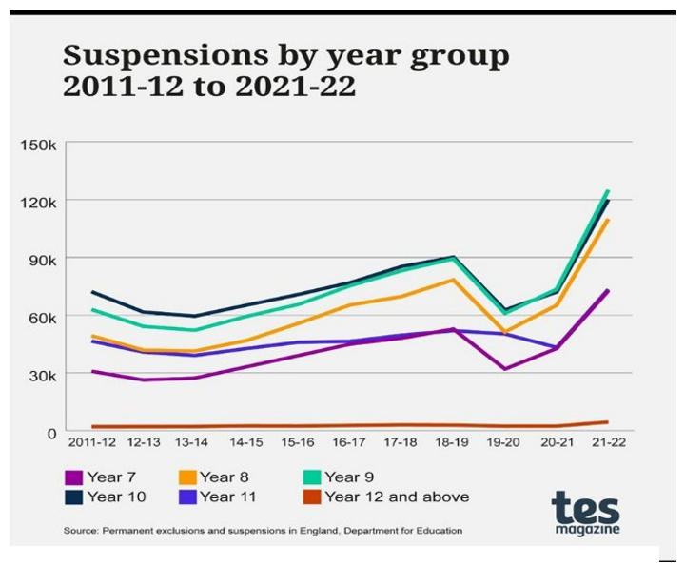
Figure 1: Number of teens who don’t enjoy life has doubled Figure 2: Suspensions and exclusions in England with social media, New York Post, Dec 5th 2023 TES Magazine (Photo by Melissa Grahovac)

Significant Learning

The Seven Levers for School Leaders to Positively Impact on Student Wellbeing

A Compelling Vision
A collaboratively developed school vision, that is informed by the community and holds the development of quality character at its core, is a common element for schools that are making positive impacts on student wellbeing. In the context of this paper, vision is considered to be an aspirational, yet attainable, statement. Values are those things that the community holds dear and near. Both intertwine to influence and shape the culture of the school. Often, school vision and values get drowned out by the relentless and complex daily demands that schools face.
The vision is informed by a desired graduate profile established by the community. The values of the schools that are making positive impact focus on the elements of quality of character. Underpinning this is an understanding of self-determination theory and a commitment to develop agency in both students and staff. In those schools, we consistently see the explicit teaching of character amplified to equal that of academic achievement. It is those values of human character that often feature as the values of the school, and manifest as learning dispositions or characteristics.
Schools that consistently impact student mental health and engagement see the leaders carving out time to religiously re-engage with the vision and values of the school community. They ensure that vision and values are regularly revisited with all staff, students and wider community. Too regularly, school leaders get tied up on the ‘dancefloor,’ focusing on the micro issues of running a school and meeting compliance. Leaders of schools that are making impact to positive wellbeing make regular time to move onto the ‘balcony’ to re-engage with the vision and values.
The principals lead a persistent, insistent, and relentless focus to shape as many elements as possible of the school day structure, curriculum and student learning pathways, assessment, decision making, staff roles and responsibilities, interactions, and the physical environment.
Leadership structures and roles are not only shaped by the vision and values but are crafted to become the enablers. Redesign of traditional role structures to create roles that explicitly help to drive the uplift of character was a common feature of the schools visited. Such roles include, but are not limited to, deputy principal responsible for culture, head teacher of learning design, leader of professional learning, and so on. Administration and support staff roles are redesigned and allocated traditional teacher and leader administration tasks, enabling key staff to focus on leading a string culture of learning, belonging and engagement.

Approach to Curriculum
“Great pedagogy leads to improved wellbeing,” Andy Hargreaves, 2023 ConnectEd Conference Hunter Valley.
A key tenet to improving student wellbeing is access to learning. It is worth taking the time to explore what curriculum could mean in an effective reimagination of school culture. Traditional notions of curriculum focus on the syllabus, the content and dot points of syllabus. This is most pronounced in high schools where the focus is heightened on the end game of external assessment. However, I argue that curriculum is much broader, and we see this in practice in the schools that are having positive impact on student wellbeing.
Such schools hold a common understanding that curriculum is everything we do related to school, from the moment students put on their school uniform to the signifiers when they arrive at school, such as the school fence, signage, the way in which we greet them on arrival and then to the learning itself.
Rob Houben from the Agora School in the Netherlands says, “Forget everything you know about teaching and focus on learning.” This is not about dis-engaging with the craft of teaching but rather focusing on learning so that teachers and leaders amplify the focus on learning in the school culture. Looking at the school experience through the lens of the learner we can reposition how we approach the curriculum we offer and how we support our students.
Approaching with a holistic understanding of curriculum with the lens through learning is powerful for student success. Dean Finlay, Principal of Ocean Road Primary School in Mandurah, Western Australia, states, “The school moves to meet the needs of each student.” Ocean Road Primary is a remarkable school where learning is at the heart of a complex ecosystem. The school amplifies learning about quality of character and is proving this to lead to improved engagement, student agency and academic success.
Multiple learning pathways that enable personalisation are an integral element of lifting student mental health. Those who are leading the way in this work focus their discussions and curriculum design to ensure that students have options and agency in their learning. They are aware that there is much unlearning of traditional notions of curriculum to be done. Alternative pathways to the final credential or ‘the end game’ are amplified. An example of this is seen in Hunter Sports High School, led by principal Rachel Byrne.
At Hunter Sports High School, students have multiple pathways for learning presented to them. Rachel Byrne describes the school as having multiple schools within a school. More specifically, students are provided with personalised options for the learning that best suits their need, including a traditional model focused towards the ATAR, a fully personalised Big Picture model where students learn through their passions and interests, leading to an alternative credential, a sporting excellence pathway, as well a school developed model that supports students to achieve a pathway to direct employment. Byrne reports that the impact on student learning and wellbeing has been profound, with increased attendance, reduced behaviour incidents and suspensions, and growth in NAPLAN.
Assumption College, a regional school an hour north of Melbourne, is led by principal Kate Foggarty and the deputy principal, Vaughan Cameron. Foggarty and Cameron have led the complete re-imagining of curriculum to create the MyMap (Mastery, Autonomy and Purpose) model that embraces student choice and agency. From Year 7 to 10, students select every subject at the level appropriate to their individual needs. Cleary explains, “the need for change was imperative.
There had been little change in performance data over a ten-year period despite hard working and dedicated teachers. Most students were not engaged or motivated, worse still they did not feel safe or lacked a sense of belonging.” The curriculum model was built on the basis of self-determination theory and an understanding that most learners, particularly adolescents, want autonomy. The impact on the way the school and its community engage with learning has been profound. The My Being program is embedded into the curriculum and focuses on the explicit teaching of values. Prior to implementing the structure Cameron states that surveys indicated most students reported that they did not feel safe, or they did not feel like they belonged.
The traditional curriculum structure, where education is done to students, is incongruent with adolescence, a critical point in a student’s life where they are seeking independence.
Fundamentally, school cultures that encompass and amplify holistic learning and provide multiple pathways for personalisation create and value opportunities for belonging, which has a positive impact on students' mental health and general wellbeing. Anecdotally, the teachers in the schools report positive impact on their own wellbeing as they spend time focused on the important work of learning and less on behaviour management. In all, students are engaged and improvements in academic results are a by-product.

A Foundation of Relationships
“High schools are places where students can practice and learn to be adults in a safe environment,’ Maurie Abrahams, Principal Hobsonville Point Secondary School, Auckland, NZ.
If indeed this is the case, then we need to have an absolute focus on learning to inform teaching. Schools that enable genuine partnership in learning between students and adults and focus on being a quality human.
How can schools ensure an environment where the development of quality character is amplified to the equal importance of academic development? In schools that succeed in this relational piece, there are emerging and common themes.
- A whole of school community commitment to the development of quality of character. Self- determination theory is understood, and the drive to develop staff and student agency is seen across all elements of the school in the form of values. Such values are also referred to as learning characteristics or disposition, including, but not limited to, empathy, focus, grit, creativity, communication, collaboration, and entrepreneurship. Fundamentally, it is the skills of learning that are explicitly taught, assessed, and most importantly, celebrated for both students and adults.
- Curriculum structures are critically reflected on and reimagined to develop the values of the school so that relational capacity building is enabled throughout the curriculum. Most of the successful models provide opportunity for student and staff agency. The ongoing exploration and evaluation of curriculum structure to ensure enablement of the vision and values is relentlessly driven by the schools' senior leadership that are making a significant impact.
- Restorative practice and/or a commitment to positive psychology is also evident in practice. Both are modelled and led by senior leadership who ensure professional learning and learning for parents and students is regular and continuous to meet the particular community's needs. Student behaviours are considered as breaches of a relationship and responded to accordingly.
- There is a clear understanding of brain science supported by ongoing learning for the school community. The underpinnings of self-regulation is evident through consistent and common language and approach to behaviour. Trauma informed practice is also a common theme that emerges in the schools.

A reimagined curriculum
If we as school leaders take the approach that everything is curriculum – from the moment students start the journey to school, walking in the gate, and then into the school day – then we have a better chance of creating an inclusive environment where the individuality of student learning is not only considered but met. It optimises the opportunity to create a better sense of belonging for every student. We know that it is a positive sense of belonging which positively impacts student wellbeing and mental health.
There are commonalities amongst the school communities reimagining curriculum:
- The structure of the curriculum, the school day, and timetable are reimagined to support multiple student pathways and maximise opportunities for individualised learning.
- There is an understanding that direct instruction and explicit teaching are enablers of project and inquiry-based learning. Learning characteristics or dispositions are embedded into the teaching of content, knowledge, and skills. Curriculum and assessment are structured to embrace project and/or inquiry-based learning.
- The school leadership structure is re-imagined, and role statements are enhanced to support the broader notion of curriculum, explicit teaching of values and a focus on engagement. The senior leaders purposefully develop and sustain cultures of support for intelligent risk taking and continually drive change in thinking away from traditional notions of school structure. This is supported by tailored and internally delivered professional learning.
- Collaboration is a core practice. Staff and students are supported to improve their capacity to collaborate. Team teaching is the norm and expected.
- Structures are embedded into the timetable for daily pastoral care, which ensures that every student has a deep connection with at least one adult in the school environment. The school values, characteristics or dispositions are discussed, and every student develops an individual learning plan.

Assessment and Reporting
We assess what we value, and we should value what we assess. On the study tour, many students reported that the relentless drive to assess in a more traditional manner was alienating and, in some cases, affecting their wellbeing. One student who is now participating in the Big Picture program at Canberra College, a pathway that is entirely based on individualised learning, explained that she was a high performing student at a traditionally structured high school, but the cumulative impact of years of ‘irrelevant assessment, including tests’ had impacted on her wellbeing to the point where she had become a school refuser. Since engaging in the Big Picture pathway, she is attending full time and is excelling. Her story is not uncommon.
Inclusive and individualised assessment practices are based on student agency. Schools that are excelling are designing assessment that is portfolio based. Students work towards individual learning goals which embrace literacy, numeracy and learning characteristics. The students provide and annotate work samples and present to staff as well as small groups of people who are important to them. Some schools are developing micro-credentialing, which is assessed by teams of teachers and students in collaboration.
Reporting is reimagined to reflect the values of the school and student progress as identified by the learning portfolios or credentialing. Student growth in learning quality of character is reported on equally to that of traditional academics.
The team behind the South Australia Certificate of Education are in the iterative process of trialing the inclusion of graduate capabilities alongside an ATAR result in the final certificate. The SACE website states: That's also why your personal capabilities are what employers want, and look for in you, when you apply for a job with them. Seven key personal capabilities are embedded into the SACE program. Literacy, Numeracy, Information and Communication Technology, Critical and Creative Thinking, Personal and Social, Ethical Understanding, and Intercultural Understanding, SACE.
A common experience for the schools leading such approaches to assessment is that the currently available software platforms, including learning management systems, are lagging and inadequate in enabling the work.
Professional learning plays an integral role supporting staff and building a culture which embraces whole of child approach with a commitment to quality of character. Celebration of and deep inquiry into the art and science of learning is common in successful schools. Senior leaders in such schools reimagine the more traditional approaches to professional learning.
Communities of practice is a common feature amongst schools that are making positive impact. What were traditional meetings, staff and executive meetings have a complete professional learning base and are themed on improving learning through engagement. Students play a role in leading the learning. Staff reflect on the same values and learning characteristics as do the students. In some cases, staff are presented with a provocation about improving practice. They then collaborate in an inquiry and showcase their learning for/ with each other.

Healthy Learning Environment
Steve Cook, Principal of Albert Park School in Melbourne, holds the belief that schools should create a sense of wonder and adventure. They should be filled with quality community artwork that evokes thinking.
Kevin Richardson, Principal of Immanuel College in Adelaide, asked his students what is the ideal place that you like to learn. The students came back with a range of ideas, from the city library, to cafes and parks. He then set about working with students to reimagine what classrooms look like, and, importantly what constitutes a learning environment. Consequently, Imanuel College sees a mix of indoor and outdoor learning spaces. Some appear as modern corporate office environments, and others more café like or park like. At Lindfield Learning Village in Sydney, Principal, Stephanie McConnell and her team have introduced homely furniture and plants.
At its most simple level, environments that are evocative of the adult world, evoke wonder, and adventure are proving to be a part of the ingredient to encourage belonging and comfort for every student.

Community Relationships
Another ingredient that enhances student belonging and wellbeing is relevance to the learning. Genuine relevance for learning is established through rich connections with community.
Successful schools firstly are able to communicate and consistently articulate a strong, synergised school identity that demonstrates what the school values. The school has a presence in the community.
Curriculum structures, including learning pathways that enable students to engage with community in the school and outside the school gates, is fundamental. One example is the Big Picture pathway, which sees students engage with employers, mentors or volunteer groups in the community for up to two days per week of their learning. The connections are aligned with the learning being undertaken at school. Other schools have developed their own approaches to ensure the students have the opportunity to become partners in learning with the community.
Leadership structures and positions are developed to support community engagement.

Conclusion
Schools play an integral role in enabling and promoting mental health for our students. Traditional curriculum structures and assessment is, in general, failing to provide relevance and engagement for our students, particularly in the era of artificial intelligence. It is imperative for school leaders to lead a process of reimaging schooling, which will take some significant unlearning for staff, students and parents.
Schools that are exploring the type of work outlined in this paper will benefit from networking and system support.
There is a strong need for developing, trialing and implementing technology that supports a reimagined approach to curriculum and assessment. Artificial intelligence could play a key role.
There is a need for the large, state education systems to support schools to engage with such systems.
Further study to qualitatively and quantitatively measure the impact of reimagined curriculum is needed. Further study into reimagining schools is required.

Acknowledgements
I would like to acknowledge the school leaders, their staff, students and the academics who gave willingly of their time to contribute to the learnings outlines in this paper.
Stephanie Mconnell, Principal of Lindfield Learning Village
Lachlan Glasby, Head Teacher of Murwillumbah Learning Community
Joanna Henderson, Primary Principal of Murwillumbah Learning Community
Prof Pasi Sahlberg, University of Melbourne
Myles Draper, Principal of Freemantle College, Perth
Harvey Wilson, Deputy Principal of Finnigan School of Distance Education
Simon Vaughan, Principal of Canberra College
Jackie Vaughan, Principal of Evlyn Scott School
Greg Terrel, Principal of Bonython Primary School Canberra
Dr Shayam Barr, University of Canberra
Aliza Werner-Seidler, Black Dog Institute
Viv White, CEO Big Picture Australia
Katherine Adnett and Cameron Bachelor, Pulteney Grammar School, Adelaide
Alison Colbeck, Principal of Aldinga Payinthi, Adelaide
Clare Nocka, Principal of St Mary’s Adelaide
Kevin Richardson, Principal of Immanuel College, Adelaide
Michael Bunce, Flinders University
Ray Boyd and Rachel Lehr, Dayton Primary School, Perth
John Burke, Principal of Bob Hawke College, Perth
Dean Finlay, Principal of Ocean Road Primar School, Perth
Jo Willesee, Principal of Hammond Park Secondary School, Perth
Nicole Adams, St Hilda’s Bayview Campus, Perth
Vaughan Cameron, Assumption College, Melbourne
David Runge, Future Schools
Hassan Mekawy, SACE
Rachel Byrne, Hunter Sports High School, Newcastle
Dr Paul Kidson, Australian Catholic University

