2023 Premier’s Anika Foundation Youth Depression Awareness Scholarship

It’s all about emotions
  - Emotion-based skills programs and approaches in schools
Margaret Tang
School Counsellor, Putney Public School
Sponsored by
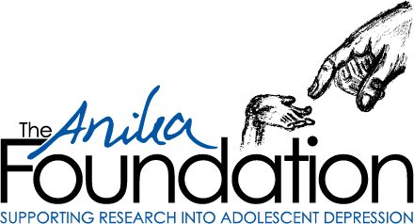

Introduction
Depression rates are rising and research suggests that signs of depression often begin in childhood. If childhood depression is not prevented or caught early and properly treated, the risk for relapse is very high (Hockey, 2003). One of the important ways that emotion-based skills programs and approaches in schools can help children with depression is by improving their overall emotional intelligence in the school environment. Emotional intelligence is a necessary set of skills for navigating learning/social challenges in the school environment. The power of emotional intelligence on student outcomes is not to be underestimated. People with high emotional intelligence understand how to manage their emotions, especially under pressure, and are better at expressing themselves, solving problems, managing stress, and relating to others (Goleman, 2005). Emotional intelligence is a well-established predictor of emotional wellbeing, academic success, quality of social relationships, and future workplace success (Goleman, 2005; Lopes, Salovey, & Straus, 2003).
However, many programs and approaches are primarily delivered to individuals who are already symptomatic. A more preventative focus in delivering emotion-based skills programs and approaches is thus required in school settings.
This study tour incorporated onsite visits to schools in Australia, interviews with leadership and teaching personnel in both Australia and the United Kingdom, and close collaboration with various program developers and researchers. Key programs and approaches that were explored included:
- Whole-school professional practice teaching and learning approaches for all students - Emotion Coaching for teachers and parents, Swinburne University’s Aristotle Emotional Intelligence Program and Yale University’s RULER Program.
- Targeted, therapeutic evidence-based interventions for “at risk” students – Emotion-Focused Therapy and Emotion-Focused Skills Training.

Focus of Study
The aim of this study tour is to help prevent the development of youth depression through building a shared body of knowledge and practices of whole school and targeted emotion-based programs and frameworks within schools.
I will primarily focus on emotion-based skills programs and approaches that have been used within Australian and UK schools in their use of Swinburne University’s Aristotle Emotional Intelligence Programs, Yale University’s RULER Program, and the emotion coaching approach.
Another goal was to undergo training in Emotion-Focused Therapy (EFT), learn about the Emotion-Focused Skills Training program (a parenting program that is based on EFT), and interview EFT practitioners and researchers in order to ascertain whether elements of EFT can be integrated seamlessly into the service model of school-based counselling for students with significant wellbeing needs.

Significant Learning

Whole-school professional practice teaching and learning approaches

Aristotle Emotional Intelligence Programs
The Aristotle Emotional Intelligence (EI) Programs are an evidence-based suite of skills-based EI programs that have been designed to cultivate emotional intelligence in students at a whole-school level (Downey, Johnston, Hansen, Birney, & Stough, 2010). Aristotle is a whole school comprehensive approach to developing competencies with emotions: assessments, programs for all year levels, teacher and parental development. Aristotle EI Programs follow the seminal four branch model of emotional intelligence by Salovey and Mayer (1990):
- Emotional Recognition and Expression
- Understanding Other’s Emotions
- Emotional Reasoning
- Emotional Management and Control
Aristotle EI Programs have been rolled out to various schools within Australia and internationally. They have a strong focus on testing base-line levels of Emotional Intelligence in students (across the 4 branches of Emotional Intelligence) and being data-driven in terms of tailoring their programs to schools with well-established lesson plans for any emotional intelligence content being taught in class (Luebbers, Downey, & Stough, 2007).
Interview with Professor Con Strough, Founder Aristotle EI Programs – Melbourne, Victoria.
I met Professor Con Stough, professor of Cognitive Neuroscience and Psychology at Swinburne University of Technology and developer of the Aristotle EI Programs. Professor Stough and I engaged in deep reflection on the importance of developing Emotional Intelligence in school communities. Professor Stough has employed a feedback-informed, data-driven approach to monitor and track progress in the development of emotional intelligence in children within school contexts. We acknowledged that children learn through social role-modeling and supportive relationships with adults. Professor Stough has a number of projects in the pipeline that support adults ‘at the coal face’, including courses for teachers and parents that focus on building their own emotional intelligence, wellbeing, and how they are responding to children.
Professor Stough also recognises the importance of supporting school leaders to learn about ‘Transformational Leadership,’ which is a leadership style that harnesses emotional intelligence skills to enact positive change in the workplace environment (Kumar, 2014). Transformational leaders develop followers by creating a direction for them to follow yet giving them the freedom to control their own behaviour. Professor Stough said he would be open to piloting the Aristotle EI Programs within NSW public schools.
As we know, schools are not the same; they all embody their own important values and goals with their own individual wellbeing maps.
School Visit - Dalyellup Public School (Preparatory to Year 6), Western Australia.
At Dalyellup Primary School, I met the principal, Alex Cameron, to discuss his experiences implementing the Aristotle EI Program as a whole school approach since 2021. The school has a small but sizeable population of Aboriginal and Torres Strait Islander students. The wellbeing culture has played an instrumental role in establishing one that is trauma-informed, prioritising inclusion, belonging and kindness to others. Cameron reported increased learning engagement and fewer behavioural incidents since establishing the program.
“Building Emotional Intelligence through the Aristotle EI program is a foundational step, as it positions students to be better able to access other social emotional learning programs and interventions that they may need within the school context.” – Alex Cameron, Principal at Dalyellup Primary School
I observed an Aristotle lesson that Alex ran with Year 5 students, centered on teaching students to build emotional literacy through looking at different ways of describing core emotions. For example, ‘surprise’ could also be described as ‘astounded’, ‘stunned’, ‘shocked’ ‘disbelief’. Students were then asked to order these words on a scale of emotional intensity (using a ruler). Student feedback about the lesson was also positive, with one student stating “being able to understand my emotions can help me get through tough times.”
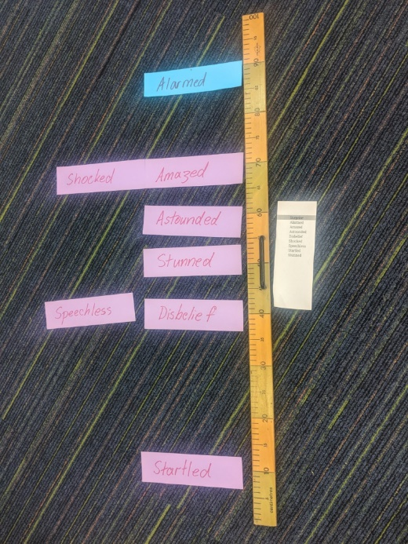
Image 1: Aristotle EI Program lesson materials, for teaching emotional literacy (photo: Margaret Tang)
School Visit - Tamborine Mountain State School (prep to Year 6), Tamborine Mountain, Queensland.
Tamborine Mountain State School (TMSS) is one of the first schools in Australia to incorporate the Aristotle EI Program in 2016 as a whole-school wellbeing approach. During the school visit, I had the opportunity to observe exemplary teaching practices and meet the executive/wellbeing/teaching staff. What was immediately apparent during my visit was a deep valuing of connections with students and the local parent community, a high level of collaboration amongst staff, and a strongly student-centered approach to introducing any wellbeing practices. The school prioritises the need for safe physical spaces for students to practice key emotional regulation strategies that may be taught in programs such as Aristotle EI. One of these designated safe spaces (Durungal room) is depicted in the photograph below. ‘Durungal’ means calm in Yugambeh language.
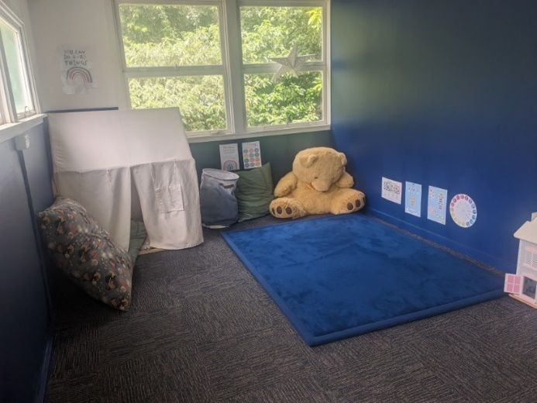
Image 2: The Durungal Room at Tamborine Mountain State School (photo: Margaret Tang)
Meeting with Dr Nathan Simmons, school psychologist in Brisbane, Queensland
I interviewed Dr Nathan Simmons about his extensive work within the private school system to support a whole school implementation of Aristotle EI Programs. Dr Simmons discussed the importance of teachers, students, and school leaders all being able to see the real-world benefits for the students (e.g. social, physical, emotional, academic) in order for a whole school program to be established successfully. We also discussed the power of using assessment feedback to help establish these benefits. The need for a program to be both student and teacher-friendly in lesson planning, to take the ‘guesswork’ out of teaching EI skills was also highlighted.
School Visit - Whitsunday Anglican School (Kindergarten to Year 12 private school) in Beaconsfield, Queensland
At Whitsunday Anglican School, I met with members of the school’s pastoral care and leadership team to discuss their experiences of implementing Aristotle EI Programs at their school. They discussed the strong alignment of this program with the values and goals of the school, as well as the academic, emotional, and social benefits of the program that they have seen for their students. The school leadership remains in close contact with the Aristotle team, who have also worked closely with them from the beginning (2019) in tailoring the program to the school community’s individual needs and goals. Aristotle is the ‘spine of the school’s pastoral care’, helping them establish a solid foundation for the implementation of other school wellbeing programs that are centered around building transformational leadership and other important life skills.

RULER Program
RULER is an evidence-based school-wide approach to Social-Emotional Learning developed at the Yale Center for Emotional Intelligence (Rivers et al, 2013). The RULER program has a strong focus on developing emotional intelligence and emotional literacy. RULER encourages perspective-taking and empathy so that students invest more fully in the health and well-being of their classmates and themselves. Students develop a deeper understanding of emotions by applying five key emotion skills (recognise, understand, label, express, and regulate emotions).
School Visit - Girton Grammar School (Junior Campus) in Bendigo, Victoria
Girton Grammar School was the first Australian school to adopt the RULER Program as a whole-of-school approach. In 2011, a team of Girton teachers were sent to Yale University to study under Dr Marc Brackett, PhD, Director, Yale Center for Emotional Intelligence. These teachers returned to Australia with a plan to implement the RULER program, firstly in the Girton Grammar Junior School and then, gradually, across the whole school population. Following a successful visit to Girton in 2013, Dr Brackett returned in 2014 to teach the RULER Program to more school community members.
RULER uses a skill-based approach to foster social, emotional, and academic competence. The RULER program includes four ‘Anchor’ tools to assist students in developing these skills – namely the Class Charter, Mood Meter, Meta Moments, and Blueprints which are reviewed and discussed in class daily. Students are also encouraged to wear badges that exemplify the school message that emotional regulation can help one’s reputation through being able to use skills to avoid further triggers and conflict and to make clearer decisions in stressful moments. – ‘My Regulation = My Reputation’.
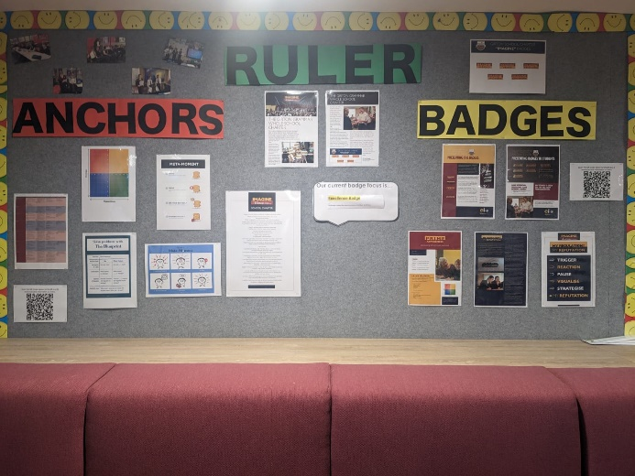
Image 3: Visual tools for the RULER Program in the staffroom at Girton Grammar School, Junior Campus (photo: Margaret Tang)
I met with the leadership and pastoral care team members of the Junior campus and observed an engaging RULER lesson delivered by an experienced RULER-trained teacher to a Year 2 class. The lesson’s theme was to encourage student reflection of ‘my best self’ at school and at home, and ways to apply emotional self-regulation skills (ie. thought strategies and action strategies) to put their best foot forward in both settings. The lesson served as a timely reminder on how we can choose our reactions to unexpected stressful situations in the presence of others when big emotions may arise within us. Girton Grammar School has offered training to other schools interested in using the RULER approach.

Emotion Coaching
Emotion Coaching is an attachment-based relational approach based on neuroscience that supports social and emotional development, promoting relationships and supporting behaviour in children. Originating as a parenting style that was identified by Dr John Gottman (1998), practitioners of emotion coaching tend to follow four key steps:
- Step 1: Recognise and empathise with the child’s feelings
- Step 2: Label and validate the feelings.
- Step 3: Set limits on the child’s behaviour if needed.
- Step 4: Exploring and agreeing upon solutions for the problem with the child.
Initial research into its use in educational settings in the United Kingdom has shown promising results (Gilbert, Gus, & Rose, 2015). In addition to a school ethos where wellbeing is central and an actively engaged senior leadership team, emotion coaching requires quality training to engage staff in the value of this approach. I participated in a comprehensive 2-day training course through Emotion Coaching UK to deepen my knowledge of whole-school applications for emotion coaching.
Interview with Licette Gus, Co-Founder of Emotion Coaching UK, in Adelaide, South Australa.
In Adelaide I met with Licette Gus (co-founder of Emotion Coaching UK), who worked for 20 years in the UK as an educational psychologist. During this time, she engaged numerous school personnel in Emotion Coaching training and qualitative research.
A possible key barrier to implementation of any whole school approach is the perceived pressure faced by school staff due to time constraints and curriculum demands. Ms Gus reflected on a common theme that has arisen amongst emotion coaching practitioners (ie. teachers) in school settings – the notion that emotion coaching can save teachers time through helping de-escalate behaviour incidents and increased classroom engagement.
“Emotion coaching requires practise in order to become a practice.” – Licette Gus, Emotion Coaching UK.
Rather than being a manualised program, the emotion coaching approach is considered by Emotion Coaching UK developers as a ‘way of being’ that needs to stem from ongoing and daily reflective application. Surface-level behaviour that we may see in students (e.g. defiance, avoidant behaviour, disengagement in the classroom) can stem from deeper feelings that need to be reflected upon. As facilitators of emotion coaching in children, it is up to the practitioner adult to help the child with identifying the underlying emotion in order to ‘tame’ the emotion. Conscious reflection and practice of emotion coaching can help with fine-tuning this process, to ensure that effective co-regulation can occur.
Virtual Meetings with Teaching and Leadership personnel from the United Kingdom
Within the United Kingdom, there exists a collegial and supportive community of established emotion coaching practitioners in schools. It is important to note that emotion coaching theory is grounded in neuroscience and that having a neuro-scientific understanding of the role that the brain plays in the expression of emotion and social learning is important to integrate into collegial discussions about effective emotion coaching (Rose, Gus, & Gilbert, 2021). I (virtually) interviewed several leadership and teaching staff who have utilised emotion coaching as a whole-school approach at places such as Leyburn Primary School, Birds Bush Primary School, Acle Academy, and Frenchwood Community Primary School.
These school staff discussed ways they integrated emotion coaching principles with restorative practices within their school contexts on a regular basis, as part of a whole school approach for supporting student wellbeing and behaviour. Some themes which resonated were:
- The importance of self-care and emotional self-awareness in one’s own practice of emotion coaching. Reflective practice regarding our own emotions (i.e. meta-emotion) is important. There is an important alignment of a practitioner’s values and own goals for their students with the emotion coaching approach.
- Children learn about their world through the process of neuroception (the brain’s ability to distinguish whether situations or people are safe, dangerous, or life-threatening). The power of emotion coaching lies in being able to scaffold real-world conversations with students, to help them feel safe and seen as individuals. At each school, there appears to be a conscious decision to move away from overly focusing on sanctions and rewards; instead focusing on role-modeling of real-world skills in dealing with conflict in ways that are trauma-informed and highly relational for students. Emotion coaching can be successfully integrated into restorative practices in schools to assist teachers, students, and parents to build, maintain and restore relationships.
- Importance of finding opportunities to connect with students through understanding their hobbies and interests.
- Benefits they have seen since adopting this approach, including improved attendance, classroom engagement, and relationships between teaching staff and students.
- Ongoing collaboration between schools and the Emotion Coaching UK developers to facilitate training to new staff and continually explore ways to engage parents in this approach.
- The importance of designated safe spaces in schools to promote emotional regulation in children was highlighted in each school. The ‘problem solving’ step in emotion coaching can potentially encompass a safe space with visual cues where the child is encouraged to choose a strategy to self-regulate. Mirror neurons (a type of brain cell) respond equally when we perform an action and when we witness someone else perform the same action. When the role-modeling of strategies occurs with an adult in a safe space, children can potentially learn how to self-regulate through using their mirror neurons (Rose, Gus, & Gilbert, 2021).

Targeted, therapeutic evidence-based interventions

Emotion-Focused Therapy
Emotion-Focused Therapy (EFT) is a therapy modality that places strong emphasis on emotions being an integral part of an individual’s identity – paying attention to our emotions (rather than trying to avoid feeling the emotion) can help us understand the needs that these emotions are associated with (Greenberg, 2002).
EFT acknowledges that there are different types of emotions (Greenberg, 2002):
- Primary emotions are our core responses that are either adaptive — fight, flight, or freeze responses that are helpful for survival — or maladaptive — fight, flight, or freeze responses that interfere with survival.
- Secondary emotions are a habitual or learned reaction to covering up primary emotions. For example, anger (as a secondary emotion) can be defensive cover for feelings such as hurt, fear, embarrassment, worry, or sadness. People who choose to undergo EFT usually present with secondary emotions in their initial behavioural presentation because secondary emotions tend to interfere with effective functioning as they tend to become more painful over time and be unwanted.
- Instrumental emotions can be seen as attempts by an individual to manipulate their environment. E.g. Crying (as an instrumental emotion) in order avoid an expected punishment.
EFT asserts that primary, secondary, and instrumental emotions should be “processed” — identified, fully experienced, and allowed to evolve and develop (Greenberg, 2002). EFT is posited to help address the maladaptive emotional processes that cause mental health disorders such as anxiety and depression.
Emotion-Focused Therapy (Level 1) Training with Dr Lou Cooper in Melbourne, Victoria
This four day course is the first step towards certification as an EFT therapist. My participation in the course enhanced my skills in empathic attunement and practicing of EFT exercises such as focusing, empty chair work and two-chair work. The exercises were highly experiential and built my confidence in incorporating principles of EFT into my own school counselling practice. Dr Lou Cooper was an amazing and engaging facilitator.
Meeting with Vivienne Wisniewski, Educational and Developmental Psychologist, owner Creating Ripples Psychology Clinic, EFT Practitioner - Melbourne, Victoria
I met Vivienne Wisniewski, who has a strong knowledge base using EFT working with children and teenagers in private practice and school settings. We reflected on potential applications of EFT principles within the framework of the school counselling service model. We also discussed the need exercise caution and put in place appropriate therapeutic boundaries around the implementation of EFT exercises that could evoke deeper emotional processing in children and teenagers in the busy school context. This conversation highlighted the need to seek ongoing supervision regarding the use of EFT with children and teenagers.

Emotion-Focused Skills Training
Emotion-Focused Skills Training (EFST) is a short-term parenting program designed by Dr Joanne Dolhanty (founder of the Emotion Training Institute in Ontario, Canada) for children and adolescents with mental health concerns that is based on the EFT model. EFST is an easily administrated, cost-efficient treatment program specifically directed towards the parental role in promoting change in children (Dolhanty, Hjelmseth, Austbø, & Vassbø Hagen, 2022). It focuses on guiding adults to navigate their own and the child’s emotions, enhance their own and the child’s motivation for change, and transform problematic relationships.
EFST has a simple format, with applications to parents, teens, adults, schools, and a variety of health and mental health contexts. The program can be completed by a parent with the support of a mental health professional such as a school counsellor/school psychologist. The EFST online course has also been adapted by Dr Dolhanty for use by teaching staff in the classroom context.
Virtual Meeting with Nadia Ansar, Clinical Psychologist/Ph.D candidate, University of Oslo, Norway
I interviewed Nadia Ansar regarding her research in the efficacy of EFST for parents of children with mental health symptoms. In research involving Norwegian parents of children aged 6-13 with externalising and/or internalising mental health symptoms (Ansar, Nissen Lie, Zahl-Olsen, Bertelsen, Elliott, & Stiegler, 2022), EFST showed efficacy in symptom reduction for children and adolescents, as rated by parents and teachers. Therapeutic outcomes were maintained over 12 months. Increased confidence, a sense of calmness, and being able to apply their new tools and learning in challenging situations was also reported by parents who participated in this program (Ansar, Hjeltnes,Stige, Binder, & Stiegler, 2021). Based on these findings, EFST appears to be a promising approach to supporting families of children with more significant emotional needs in the school context.

Conclusion
In addition to assisting with the prevention of mental illness in children, emotion-based skills programs and approaches have clearly tangible links to the Australian Curriculum (ACARA, 2014). The study tour has deepened my knowledge of emotion-based skills programs and approaches that can potentially be used in school communities to help educators to fulfil the goal of fostering 'Personal Responsibility and Social Capability' skills in the Australia Curriculum (ACARA, 2014). Through building greater self-awareness, a capacity to regulate one's own emotions and engage in pro-social behaviour, and a greater connectedness with one's school environment, emotion-based skills programs and frameworks can have a powerful influence on a student's drive to succeed academically and develop important life skills.
In order to maximise their benefits of an emotion-based approach for improving mental health outcomes for all students, I would make the following recommendations:
- Leadership investment in whole-school programs or approaches such as Aristotle Emotional Intelligence Programs, RULER Program, and emotion coaching would be of benefit to the long-term wellbeing of all school students.
- School counselling and psychology staff would benefit from targeted training and professional development in emotion-focused therapy (EFT) and emotion-focused skills training to support at risk students and families who require more targeted intervention.

Acknowledgements
- Anika Foundation
- Emotion Coaching United Kingdom
- Australian Institute of Emotion-Focused Therapy
- Emotion Training Institute, Canada
- University of Oslo, Norway
- Creating Ripples, VIC
- Dalyellup Primary School, WA
- Tamborine Mountain State School, QLD
- Whitsunday Anglican School, QLD
- Girton Grammar School, VIC
- Acle Academy, United Kingdom
- Birds Bush Primary School, United Kingdom
- Leyburn Primary School, United Kingdom
- Frenchwood Community Primary School, United Kingdom
- Yale University, USA
- Swinburne University of Technology, VIC

References
Australian Curriculum, Assessment and Reporting Authority [ACARA]. (2014). Foundation to year 10 curriculum: Language for interaction. http://www.australiancurriculum.edu.au/english/curriculum/f-10?layout=1#cdcode=ACELA1428&level=F
Ansar, N., et al. (2022). "Efficacy of Emotion-Focused Parenting Programs for Children’s Internalizing and Externalizing Symptoms: A Randomized Clinical Study." Journal of Clinical Child & Adolescent Psychology 51(6): 923-939. https://doi.org/10.1080/15374416.2022.2079130
Ansar, N, Hjeltnes, A., Stige, S.H., Binder, P.E and Stiegler, J.R. (2021). Parenthood—Lost and ound: Exploring Parents’ Experiences of Receiving a Program in Emotion Focused Skills Training. Frontiers in Psychology, 12, 559188. https://doi.org/10.3389/fpsyg.2021.559188
Dolhanty, J., Hjelmseth,V., Austbø, B., Vassbø Hagen, A.H. (2022). Emotion Focused Skills Training for Parents A Guide for Clinicians. Bergen, Hordaland, Empty Chair Publishing.

Downey, L. A., Johnston, P. J., Hansen, K., Birney, J., & Stough, C. (2010). Investigating the mediating effects of emotional intelligence and coping on problem behaviours in adolescents. Australian Journal of Psychology, 62(1), 20-29.

Gilbert, L., L. Gus and J. Rose (2015). "Emotion Coaching: A universal strategy for supporting and promoting sustainable emotional and behavioural well-being." Educational and Child Psychology 32: 31-41.

Goleman, D. (2005). Emotional Intelligence: Why It Can Matter More Than IQ. New York, New York, Bantam Books.

Gottman, J. (1998). Raising an Emotionally Intelligent Child. New York, New York, Simon & Schuster.

Greenberg, L. S. (2002). Emotion-focused therapy: Coaching clients to work through their feelings. American Psychological Association. https://doi.org/10.1037/10447-000

Hockey, K. P. (2003). Raising Depression Free Children: A Parent's Guide to Prevention and Early Intervention. Center City, Minnesota, Hazelden.
Kumar S. Establishing linkages between emotional intelligence and transformational leadership. Ind Psychiatry J. 2014 Jan;23(1):1-3. doi: 10.4103/0972-6748.144934. PMID: 25535436; PMCID: PMC4261205.
Lopes, P. N., P. Salovey and R. Straus (2003). "Emotional intelligence, personality, and the perceived quality of social relationships." Personality and Individual Differences 35(3): 641-658.
Luebbers, S., Downey, L. A., & Stough, C. (2007). The development of an adolescent measure of EI. Personality and Individual Differences, 42(6), 999-1009. doi: 10.1016/j.paid.2006.09.009
Rivers, S.E., Brackett, M. A., Reyes, M. R., Elbertson, N.A., & Salovey, P. (2013). "Improving the Social and Emotional Climate of Classrooms: A Clustered Randomized Controlled Trial Testing the RULER Approach." Prevention Science 14(1): 77-87.

Rose, J., Gus, L., & Gilbert, L. (2021). Emotion Coaching with Children and Young People in Schools: Promoting Positive Behavior, Wellbeing and Resilience. London, England, Jessica Kingsley Pub.

Salovey, P., & Mayer, J. D. (1990). “Emotional Intelligence.” Imagination, Cognition, and Personality, 9, 185-211. https://doi.org/10.2190/DUGG-P24E-52WK-6USACDG

