2023 Premier’s University of Sydney Mathematics Scholarship

Banishing boredom from the primary maths classroom by giving students a voice

Julia Priest
Bilgola Plateau Public School
Sponsored by

Introduction
The catalyst for this project was the classroom observation that a significant number of primary school students, surprisingly even high potential and gifted (HPG) students, say they loathe or dislike mathematics. This observation led to questioning how prevalent this attitude is, what the reasons behind it are, and what effective practices are currently being used in schools to engage students in mathematics and promote learning.
It seems that maths needs an image overhaul. To gain an understanding of the image of mathematics, I asked my class to “draw maths as if it was a person”. All students drew a masculine figure, generally with glasses, often with a white coat - someone who is unfashionable and unappealing.
Figure 1: Mathematics as a person by C.P, S.W and P.S (Year 6)
This negative attitude is often mirrored in the school community with parents promulgating or reinforcing their children’s beliefs. When commenting on their child’s academic report, parents are often heard to express the opinion that they hated maths or were “bad” at maths and it is therefore unsurprising that their child is poor at it, dislikes it, or doesn’t put in the necessary effort.
"Many people think of mathematics as one of the most logical, most impersonal branches of knowledge, yet it inspires more emotion than any other school subject" (Zaslavsky, 1994, p.5). It inspires anxiety and fear like no other learning area.

Focus of Study
The aim of the study tour behind this report was two-fold. Firstly, to identify “good practice” in teaching mathematics. The use of the word “good” rather than “best” is intentional as it is essential to acknowledge that there is no one-size-fits-all approach that will work in all schools, with all students and all teachers.
Secondly, having identified a negative attitude towards mathematics in one group of students at one school, to see whether this was a widespread phenomenon, and if so, whether it differed depending on whether the student was a High Potential or Gifted (HPG) student or not.

Significant Learning
Strategies for teaching mathematics vary widely across schools. The approach or resources that are predominantly used seem to depend on teacher preference, the professional learning journey of the school, school context, experience level of staff and leadership focus amongst other things.

Good practice in mathematics at a school-wide level

Number Talks
Number Talks were developed by Kathy Richardson and Ruth Parker in the early 1990s to engage students in meaningful mathematical discourse. A major goal of a Number Talk is to get students sharing as many strategies as possible. The basic structure for a Number Talk lasts between 5-15 minutes. (Richardson, 2007):
- A problem is posed
- Students spend some time thinking and attempting to solve it individually
- Answers are shared with a neighbour
- Students are invited to share their thinking with the group
- The teacher records various strategies in a visual display where all can see
- Students reflect on the range of solutions and an agreed answer is determined
For Number Talks to be effective the teacher needs to let go of being the “primary explainer” and facilitate the students to do the thinking.
On my study tour, I saw Number Talks in the classroom. They were conducted at the start of the maths lesson, with children sitting on the floor facing the front where there was a whiteboard that all could see. Students used silent hand gestures to signal various things, for example, closed fist on the chest to indicate they are thinking, a thumbs up with the hand on the chest to signal “I have an answer”, or one finger stretched out for one strategy that has been worked out to solve the problem, then more fingers as more strategies are arrived at. Once all students had arrived at an answer, they shared their strategy and answer with their neighbour while the teacher roamed the room listening for strategies that could be considered in the whole class discussion that followed. During this discussion, the teacher called upon students to share their strategy. While the student explained their strategy, the teacher wrote on the whiteboard using numbers, diagrams and pictures to represent the student’s explanation. The teacher checked in with the student to make sure that their answer was being accurately represented.
As each strategy was recorded and discussed, students indicated if they had used a similar strategy by using a pre-agreed hand gesture. Using a different coloured pen to represent each student’s ideas helped to keep the strategies separate. Initially, the teacher did not comment on whether the strategy and answer offered by a student was correct or incorrect. It is important to record and discuss student mistakes and to display wrong answers as this is central to a class getting the most out of a Number Talk (Parker and Humphries 2018). Mistakes are an opportunity to look at an idea that otherwise might be discounted and uncover existing misconceptions.
All students appeared genuinely engaged in the Number Talk process and discussions amongst peers used impressive mathematical meta-language to put forward their ideas. The teacher’s ability to orchestrate the discussion was key to the success of the exercise.

Maths Investigations - Launch Explore Summarise
The Launch-Explore-Summarise (LES) model of a mathematics lesson is fundamentally different from the “I do, we do, you do” (modelled, guided, independent) model of instruction. At South Australia’s Numeracy Summit in March 2023, Peter Sullivan advocated replacing that approach with “You do, we do, you do” (Sullivan 2023). LES lessons focus on student-centered, structured inquiry. The three phases of the lesson are cyclical in nature and may happen more than once in any one lesson:
- Launch the task to students without giving instructions on how to solve the problem.
- Allow students time to explore and engage with the task by themselves.
- Teacher selects students to share their thinking and solutions to summarise the findings of the class.
Enabling or extending prompts can be used throughout the lesson to support students of all levels and provide “differentiation”: Enabling prompts help students having difficulty with the main task. Extending prompts are for those who finish the main task ,to extend student thinking by encouraging abstraction or generalisation (Sullivan 2021). This lesson structure provides opportunities for students to engage in a productive struggle (NC2ML (2017)).
During school visits, I participated in lessons that broadly followed the LES structure. Various strategies were used by teachers in the Launch phase to start the maths lesson, for example a Number Talk, a “which one doesn’t belong” (WODB), reading a picture book or playing a game. The maths investigation itself could be taken from a wide variety of sources, including NRICH (NRICH 2023) and reSolve (reSolve 2023), and modified to suit the needs of students. In the Summarise phase, teachers used gallery walks to share ideas, and communicated clearly that all students are working to make sense of the problem and that all ideas are valued.
Success appeared to be helped by allowing a reasonably long lesson time (up to 80 minutes), allowing the “lesson” to be completed over multiple time periods, and using “vertical learning” as small groups discussed their different approaches and collaborated to come to a conclusion.

Teaching maths using STEM projects
Teaching mathematics as part of a STEM program assists students to develop creative approaches to problem solving and helps them to develop their logic and reasoning skills as well as the ability to generate questions (Panizzon 2018). Mathematics teachers have a positive view of teaching using STEM however they can have difficulty linking tasks to the maths curriculum (Sevimli and Unal 2022).
I attended an introductory workshop of The University of Sydney’s STEM Teacher Enrichment Academy’s year-long professional learning program, where teachers engaged enthusiastically with the theory and practice of teaching STEM. The model to plan a STEM project comprises four phases: engage, investigate, communicate, reflect and act (University of Sydney STEM Academy 2017-2020). The Academy partners with schools to deliver professional learning sessions and provide mentors to support the development and implementation of STEM projects. Their approach recommends a phasing in of STEM as students need to learn new skills to successfully engage with a complex, fully integrated and potentially long-running STEM project.
In my experience, the question of how to teach maths effectively using an integrated STEM approach is something that teachers find challenging. Teachers are under pressure time-wise to address the plethora of topics in the mathematics curriculum as well as to achieve NAPLAN result targets. Seeing STEM in action in a classroom environment where maths was also being taught explicitly was a revelation. The lesson observed at Blue Mountains Grammar with teacher Luke Carr, was part of a long-term project which was expected to take a term or more to complete. The lesson duration was longer than a typical “maths” lesson and spanned a variety of activities including class discussions, explicit maths teaching, pair and small group work, use of concrete materials, a site visit to discuss what had been achieved so far and what the next steps were. Students were enthusiastic about the project in general, were motivated to work towards the project aim and had an existing understanding of the project process through exposure to the ideas behind Kath Murdoch’s Journey of Inquiry (see Figure 2)
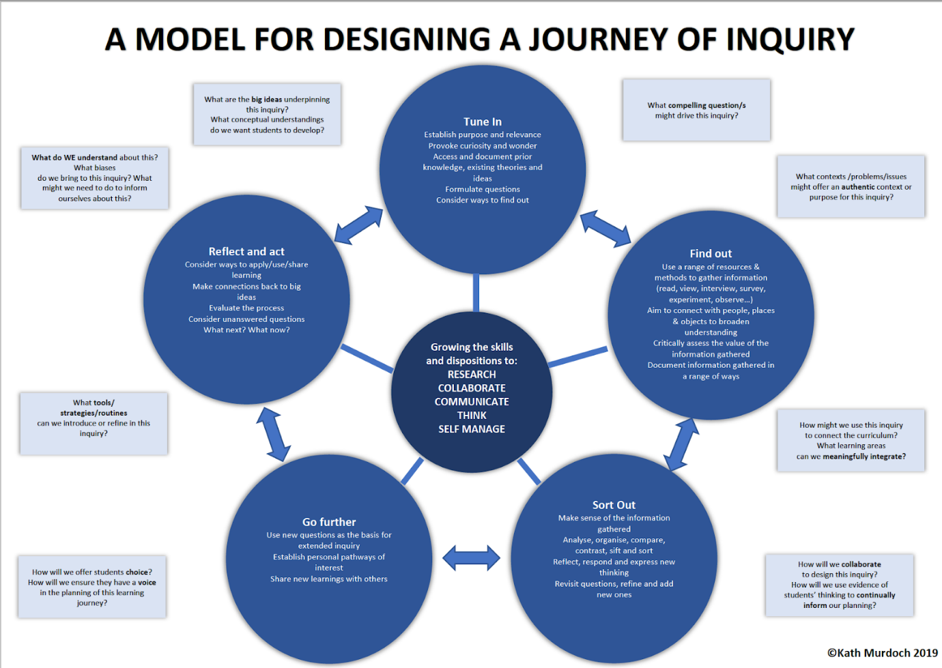
Figure 2: A model for designing a journey of inquiry (Murdoch 2019)
Several teachers who use integrated STEM projects identified the following advantages:
- the opportunity to get the parent community involved with their children’s learning in a positive way, for example, parents coming into the school to assist with construction, sourcing materials needed for the project, or viewing the final result;
- high levels of engagement and motivation by HPG students as well as reluctant mathematicians and low performing students;
- experienced STEM teachers can facilitate a project that is driven by student interest and adapt it depending on local context, students’ ideas and passions, thus driving student engagement as it becomes “their” project;
- forming relationships between the school and the wider community, for example, the local council, environmental groups, local businesses, local experts

Grouping according to ability and/or instructional need
Grouping students according to ability and/or instructional need can take many forms - within a class, across a grade, across a stage. Across the learning areas, mathematics appears to be the one in which there is the most support for grouping students according to demonstrated ability (Rozzo 2015).
There was a wide variety of approaches for grouping mathematics in the schools I visited. In some schools, maths is taught by the classroom teacher to their own class, and in others, students are grouped by ability across a year or stage. Some groups are organised based on formal assessment such as the online Australian Council for Educational Research tests (PAT, AGAT), or end of semester reports, others on teacher judgement. In small schools there is limited opportunity for grouping of any sort, and students are taught maths in their home classroom. The benefits of ability-grouping voiced by teachers who employed this practice were:
- extending HPG students by offering challenging tasks at a fast pace, and engaging them in specific maths challenges, for example, the annual Maths Challenge run by the Australian Mathematics Trust
- for low achieving students requiring more support, pitching the lesson content at an appropriate level, and enabling them to confidently participate and voice opinions without being overshadowed by HPG students.

Positive Maths Norms
Establishing positive norms in the maths classroom is seen as crucial to establishing a successful learning environment and banishing maths anxiety (Boaler 2016). Proposed norms (Boaler 2015):
- Everyone can learn maths to the highest levels
- Mistakes are valuable
- Questions are really important
- Maths is about creativity and making sense
- Depth is more important than speed
- Maths class is about learning not performing
- Maths is about connections and communicating
Schools that have embraced Jo Boaler’s positive maths norms have implemented it in various ways, from displaying posters in the classroom to a whole school focus – which may include communication to parents about the project, introducing one norm at a time to the community via the school newsletter, focussing on the norms at assemblies and discussing them in parent-teacher interactions. Teachers believe that it is having a positive effect on students' attitudes towards mathematics. Given the influence of parental attitude to maths and the impact it has on students' attitudes, this strategy may go some way to addressing the issue.
Positive maths norms support the development of classroom culture necessary for students to engage with inquiries by using reasoning and not expecting to be given the answer. It also encourages teachers to step back and guide.

Problem Solving - Newman’s error analysis
Newman’s error analysis is a valuable tool to analyse at which stage students are making mistakes when solving word problems. Sackville Street Public School has implemented it as a whole school initiative (Wescott 2023). From Year 1 to 6, the approach of students to problem solving was analysed using Newman's analysis. An example of this approach is shown in Figure 3 below.
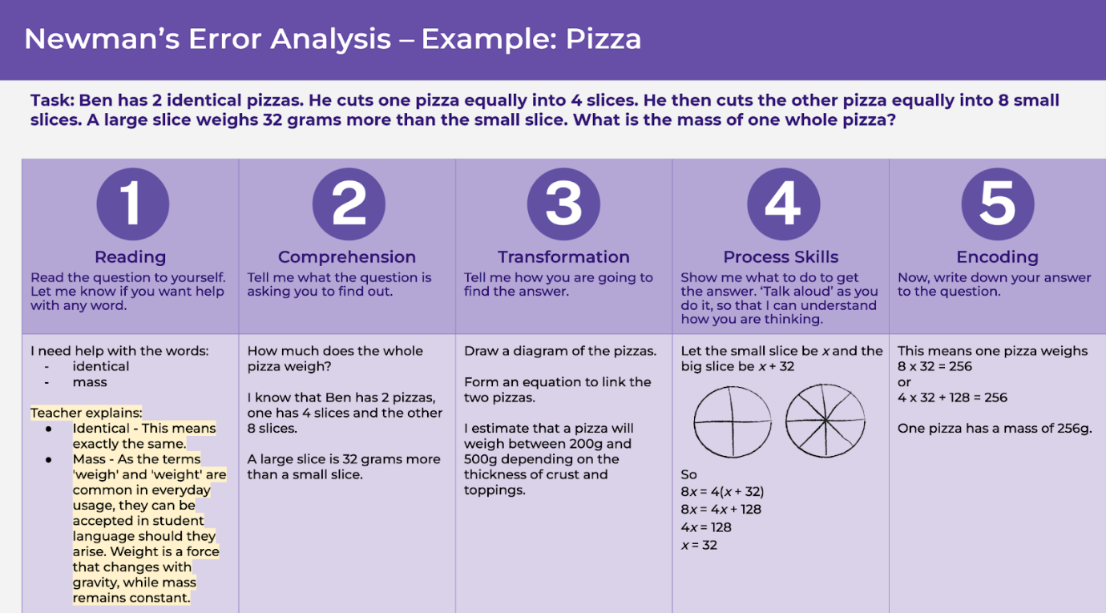
Figure 3: Newman’s Error Analysis (NSW Department Education n.d.)
The school then incorporated the 5 steps into their programming and explicitly taught students how to approach a word problem using Newman’s prompts. Once Newman’s approach was firmly embedded in programming and teaching, the school used strategies like reciprocal numeracy to provide social support for each of the steps and then introduced numberless word problems. Numberless word problems stop students from simply extracting the numbers, applying a (sometimes random) operation and ignoring the words (Bushart (n.d.).
This project has significantly improved student’s problem-solving skills and the accuracy of their solutions to word problems.

Bite-size strategies
While visiting schools and engaging with other professional learning opportunities, I encountered a range of tools and resources that teachers use in daily maths teaching which are not necessarily whole school approaches or major maths projects but are definitely worth mentioning.

Maths games/play
Devoting one lesson a week to “play” can help counteract potential negative attitudes about maths, and provides an anxiety-free environment where children can interact with maths concepts almost without realising they are in a “maths lesson”. Activities are set up by the teacher, and students move from one to the next. Students engaged with the “games” with enthusiasm. The activities were visually appealing and inviting, using materials like shells, paints, modelling clay, sand and leaves – not often seen in regular maths lessons.

Maths Think Map
A graphic organiser (see Figure 4) can help students organise their thinking when solving a maths problem.
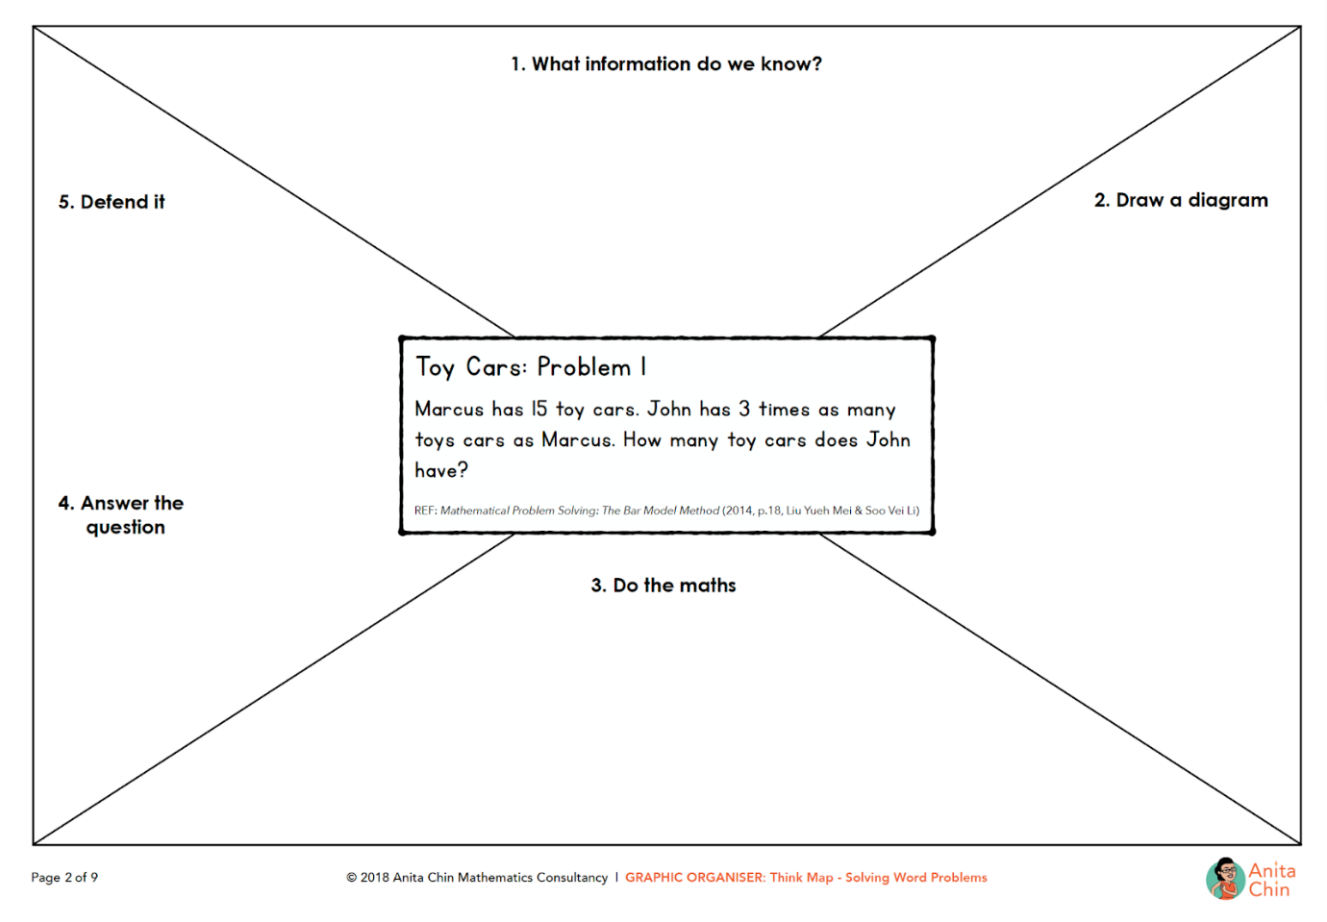
Figure 4: Think Map (Chin 2018)

Gallery walk/museum walk
Towards the end of a lesson/investigation, students walk around and view each others’ work to see strategies that others used to approach the problem. This is a way to encourage reflection. At one school I visited, different coloured sticky notes were placed on work depending on the reaction of the student: “You used a similar strategy to me” (yellow); “This strategy is unfamiliar to me” (pink); and “I wonder about this strategy or would like to challenge it” (blue).

Involving the school community in maths
The way that families view mathematics influences student attitude, engagement and therefore their success. Several teachers stated that the negative attitude of parents towards maths seems to rub off on their children. Schools that I visited used strategies to address this issue:
- using STEM projects to involve parents
- inviting parents to participate in and be part of a maths project. One school’s students investigated producing more interesting/tasty food at the canteen. This involved developing a range of financial literacy skills and working with a parent who is a chef. At the project’s conclusion, students cooked their dishes and parents invited to attend a special lunch.
- introducing positive maths norms to parents
- focussing a traditional event like Mothers’ Day on maths, where parents visit the classroom to play maths games with their children.

Student attitudes towards mathematics
Most classes I visited were keen to participate in a survey of their student's attitudes towards mathematics. Students' overall attitude to maths was gauged using a simple questionnaire. The results in Table 1 below show that of 413 students surveyed, approximately 70% either like or love maths, leaving approximately 30% of students having a negative attitude. It is important to note that the schools visited were recommended as schools that have above-average mathematics teaching practice so this is not a representative sample of all students’ attitudes. The number of students who expressed a negative view of mathematics may in fact be under-representative of the population because presumably in schools recognised for excellent maths teaching, students are likely to be more positive about mathematics than in a randomly selected school.
Table 1: The attitude of all students toward maths (n=413)
Love | Like | Dislike | Hate
25.18% | 44.07% | 23.97% | 6.78%
When asked why they feel the way they feel about maths, some students initially found it challenging to answer the question, possibly because they had never been asked before and required time to reflect. Some common themes emerged within the categories:
- Love: Excels; Finds it easy/enjoyable/interesting/challenging; Likes the teacher; Recognises that it is useful
- Like: Likes parts of maths but not the whole subject; Recognises that it is useful; Feels positive but not strongly; Ambivalence
- Dislike: Finds maths difficult/stressful/boring; Feels not good at maths; Feels it’s not useful; Unsure of why
- Hate: Finds maths too difficult/stressful/boring; Unsure of why

HPG student attitudes
Teachers were asked to identify their HPG mathematicians who were given a questionnaire on coloured paper or marked in some way so that it was identifiable. Different teachers likely used slightly different criteria to identify HPG students so this categorisation is quite loose.
The attitude of HPG students towards maths is significantly different from that of non-HPG students (see Table 2). Around 50% of HPG students love maths whereas only around 20% of regular students love maths. This is not surprising given that many students said they loved maths because they were good at it, and gifted students are the high-performing ones. At the other end of the attitude scale, around half as many HPG students hate maths.
Overall, a positive attitude to maths (love or like) is held by 84.61% of HPG students and 66.38% of non-HPG students. This leaves a concerning one-third of all non-HPG students holding a negative (dislike or hate) attitude towards maths. In addition, 15.39% of HPG students feel negatively about the subject.
Table 2: The attitude of HPG and non-HPG students toward maths
 | Love | Like | Dislike | Hate
HPG Students (n=65) | 49.23% | 35.38% | 12.31% | 3.08%
Non-HPG students (n=348) | 20.69% | 45.69% | 26.15% | 7.47%

Attitude changes with time
When asked if the way they feel about maths is the way they have always felt, 55% of children said no. Of that 55%, over half had become more negative in their attitude towards maths. One common reason given to explain that change is that maths got harder: “In kindergarten I was amazing at it and understood everything. but now its (sic) really hard for me.” (Year 3 student) The other main reason given was that it is not as much fun as it used to be: “In past grades it was fun but since we are getting older it is not as fun.” (Year 5 student)

Parent attitude
Parental attitude to maths influences student attitude as well as achievement: “Messages students pick up from their parents about math and their parents’ relationships with math can also change students’ math learning and achievement.” (youcubed 2023). Boaler (2016) emphasises that messages like “I was never any good at maths” from parents are harmful and need to be replaced with positive messages like “Maths is exciting and it’s everywhere”.
In the survey, one Year 4 student who loves maths obviously has an enthusiastic dad who communicates positive messages. When asked why they love maths they said “I like the hard questions and when my dad says “Let’s have a maths competition” and I can answer questions that he has to answer with a calculator, I find it really fun.” A Year 6 HPG student who also loves maths commented “My mother always helps me in maths & makes it easy for me”.

Conclusion
I started this project thinking that the main outcome would be learning new and better ways of teaching maths in an engaging way in the classroom. Whilst this did occur, one of the most important conclusions I arrived at is that acquiring maths skills is only one dimension of numeracy, and that children’s attitudes towards maths is a crucial part of the equation that influences their success. The student survey revealed that around one-third of all students have a negative attitude towards mathematics and more than one-tenth of HPG students feel this way. As there is an established link between attitude and performance, this does not bode well for these students’ achievements in the area. In addition, when they reach the point in their school career that maths becomes optional, it would seem logical to conclude that if they don’t like it, they are unlikely to pursue it, even if they are gifted mathematicians.
The survey also revealed that a concerning number of students become more negative about maths as they progress through primary school. Maths becoming less fun, more boring and too hard, are all aspects that schools can make a positive impact on. If schools consistently employ the full suite of engaging strategies that are available to them including Number Talks, maths investigations, STEM projects, positive maths norms and having specific programs to address the needs of HPG mathematicians, it will have a positive effect on student attitudes and therefore their achievements in maths.
Maths is generally perceived negatively and produces anxiety in adults and children alike. Schools cannot change the way that the learning area is thought about in a wide context, but they can have an influence on the way their students feel about maths and promote maths to the parent community. A positive change in the parent community will effect a positive change in their children.
Maths needs an image overhaul and primary schools are in the right place in our society to undertake the process.

Acknowledgments
I would like to sincerely thank all the people who gave up their valuable time to talk to me about maths in the Primary classroom. In particular I acknowledge the amazing classroom teachers who were happy to host me in their classrooms and share their expertise.
- University of Sydney – Professor Manjula Sharma, Dr. Heather McMaster, STEM Teacher Enrichment Academy, Dr. Katherin Cartwright
- Schools – Glebe Public School; Carlingford West Public School; St Peter’s Anglican Grammar School, Campbelltown; Sutherland Public School; Kurmond Public School; Blue Mountains Grammar School; St Joseph’s School, Crib Point; St Mary’s Primary School, Malvern East; Ainslie School, Braddon; Woongarrah Public School
- Arden Anglican School – Dr. Gabrielle Oslington
- MANSW – Fiona Foley
- Monash University – Dr. Ann Downton
- ACT Government – Sam Hardwicke, Director - Curriculum, Mathematics and Numeracy
- reSolve: Maths by Inquiry – Dr. Kirsten Tripet

References
Boaler, J. (2015) Setting up positive norms in maths class. Youcubed, Stanford Graduate School of Education. https://www.youcubed.org/resource/growth-mindset/
Boaler, J. (2016). Mathematical mindsets: Unleashing students' potential through creative math, inspiring messages and innovative teaching. Jossey-Bass.
Bushart, B. (n.d.). Numberless word problems. https://numberlesswp.com/
Chin, A. (2018). Graphic Organiser, Think Map. https://anitachinmaths.com.au/wp-content/uploads/2018/11/GraphicOrganiser-ThinkMap-WordProblems2-ToyCars-AnitaChinMaths-v1.0.pdf
NC2ML (2017). Launch-Explore-Discuss Lesson Framework. Research and Practice Briefs. North Carolina Collaborative for Mathematics Learning. Greensboro, NC. http://nc2ml.org/
NRICH (2023). Millennium Mathematics Project, University of Cambridge, Faculty of Mathematics. https://nrich.maths.org/
NSW Department Education(n.d.). Newman’s Error Analysis, Digital Learning Selector. https://app.education.nsw.gov.au/digital-learning-selector/LearningActivity/Card/650
Murdoch, K. (2019). Updated diagram - Designing a journey of inquiry. https://www.kathmurdoch.com.au/new-page-2-1
Panizzon, D. (2018). Putting STEM education into perspective. Best Advice, Leading Learning improvement. Department of Education, South Australia.
Parker, R. and Humphreys, C. Digging Deeper : Making Number Talks Matter Even More, Grades 3-10, Stenhouse Publishers, 2018. ProQuest Ebook Central.
reSolve(2023). The reSolve: Mathematics by Inquiry project. https://www.resolve.edu.au/resolve-mathematics-inquiry-project
Richardson, K. (2007). Number Talks. What is a Number Talk? Maths Perspectives www.mathperspectives.com/num_talks.html
Rozzo, J. T., Jr. (2015). Grouping practices in award-winning middle schools: A study of Pennsylvania Don Eichhorn schools to watch middle schools. Available from Education Database. (1717315515).
Sevimli, E. and Ünal, E. (2022). Is the STEM Approach Useful in Teaching Mathematics? Evaluating the Views of Mathematics Teachers. European Journal of STEM Education, 7(1), 01.
Sullivan, P. (2023) Keynote speaker at the Inaugural Department of Education Numeracy Summit, South Australia. March 2023
Sullivan, P. (2021). Building Engagement in Middle Years Mathematics. Oxford University Press Australia & New Zealand.
University of Sydney STEM Academy (2017-2020) A model for the planning and teaching of STEM projects for Primary. Course materials from 2023 workshop.
Wescott, Kris. (2023). Changing practice through Newman's Error Analysis. Conference Workshop. MANSW Pre-K to 8 Conference, 24 March, 2023.
youcubed (2023). Parents’ Beliefs about Math Change Their Children’s Achievement. Stanford Graduate School of Education. Accessed 13 May 2023 at https://www.youcubed.org/resources/parents-beliefs-math-change-childrens-achievement/
Zaslavsky, C. (1994). Fear of math: How to get over it and get on with your life. New York: Rutgers. University Press.

