2023 Premier’s Reserve Bank of Australia Economics Scholarship

Raising the Interest Rate
  - Analysing Best Practice Teaching in NSW to Increase Achievement and Enrolments in HSC Economics
Gavin Brennan
Alpha Omega Senior College
Sponsored by

Introduction
Economics enrolments in NSW have fallen notably in recent decades. Since 1991, economics enrolments in comprehensive schools have declined 3.5 times as fast as in selective schools, and government schools are around half as likely to offer Higher School Certificate (HSC) economics as non-government schools (Dwyer, 2017). Enrolments are falling most in regional and lower socio-economic status (SES) areas. The share of economics students from regional areas has more than halved since 1990. And for every economics student from the lowest income quartile in NSW, there are now more than four from the highest quartile (Dwyer, 2022).
An extensive survey conducted by the RBA concluded that the decline in enrolments is due to a number of reasons, including lack of subject knowledge and feeling that it is a risk to study. One prominent reason is that students from these schools and backgrounds have a ‘confidence gap’ and are less likely to believe they “could do well in Economics” (Tan, 2022).
This concern is not purely psychological – students from these schools and backgrounds actually do perform less well. In the 2021 HSC, only 9% of students that achieved 90 or above came from comprehensive government schools (NESA, 2022) – far less than the proportion of students from comprehensive government schools studying the course.
In summary, many students avoid economics because they doubt they can do well at it. A key reason for these doubts is that they have very few examples of peers succeeding in the course.
This report summarises elements that were consistent across ten top-performing schools in HSC Economics, and draws on them to recommend ways in which it might be possible to increase achievement, student confidence and enrolments in HSC Economics. These recommendations include improving the professional development opportunities available to HSC Economics teachers and the teaching resources available for the HSC Economics course.

Focus of Study
If part of the reason for the decline in economics enrolments is due to low student confidence in less advantaged schools, part of the solution could be to improve teaching practice to boost student confidence and achievement. To help improve economics teaching practices, this study identified the economics teachers in NSW who are having the biggest impact on their students’ achievement and researched what it is they are doing that is working so well.
The research had two components:
- Using data to identify schools that have the most significant impact on students’ achievement in HSC Economics; and
- Conducting a site visit to investigate how those schools are having such an impact on student achievement in HSC Economics.
The research project analysed more than 75,000 HSC results over a four-year period (2019-2022) to identify schools that were high-performing in HSC Economics. The dataset provided by the NSW Education Standards Authority (NESA) included information on around 20,000 students, anonymised so that individual students and schools could not be identified. In total, the study involved visits to 10 of the top-performing schools in HSC Economics, and discussions with 20 economics teachers along with observations in their classrooms.
This report sets out the common strategies that high-impact economics teachers use, and the views of those teachers on how best to enable more teachers to have a similar impact on their students, to raise student achievement and attract more enrolments.

Significant Learning
There are many ways to teach effectively, and all teachers involved in this study had their own teaching style and had adapted to their own school context. Nevertheless, there were eight teaching strategies that were consistently used across many of the high-performing schools involved in this study, as shown below. Crucially, most of these elements are skills that can be learnt or traits that can be developed.
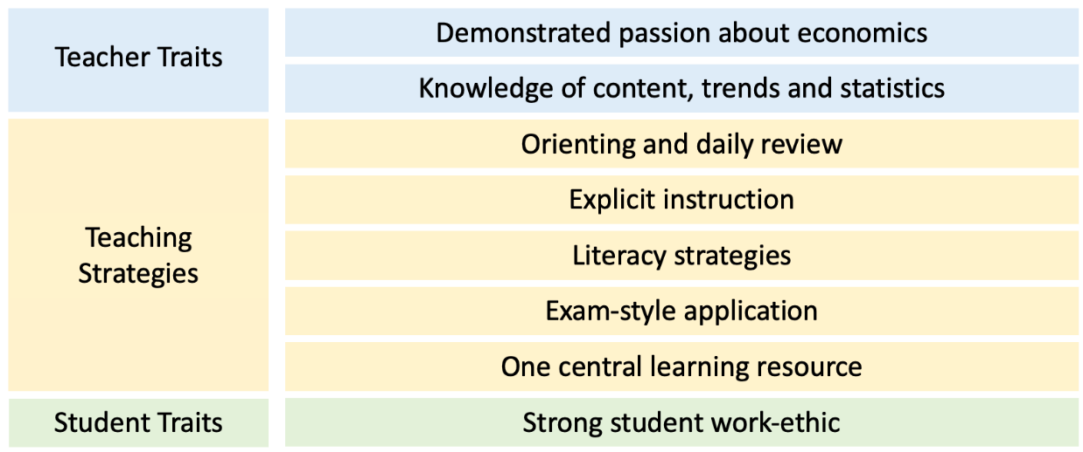
Figure 1: Eight common elements of high-impact economics teaching and learning

Teacher Traits
- Demonstrated passion about economics
Many teachers in the study emphasised that no matter how good the teaching strategies are, they will not work if the teacher is not enthusiastic. While all teachers in the study personally enjoyed studying and teaching economics, the economics course itself will not engage most students. It was clear that the high-performing teachers in the study are passionate about the relevance of what they are teaching, and that they communicate this passion and relevance to their students. As one teacher in the study described it, “I give a NIDA performance every class.” As a student at another school reported, “I like economics because it explains what is happening in the real world - and I only became interested in that because my teacher was so excited about it.”
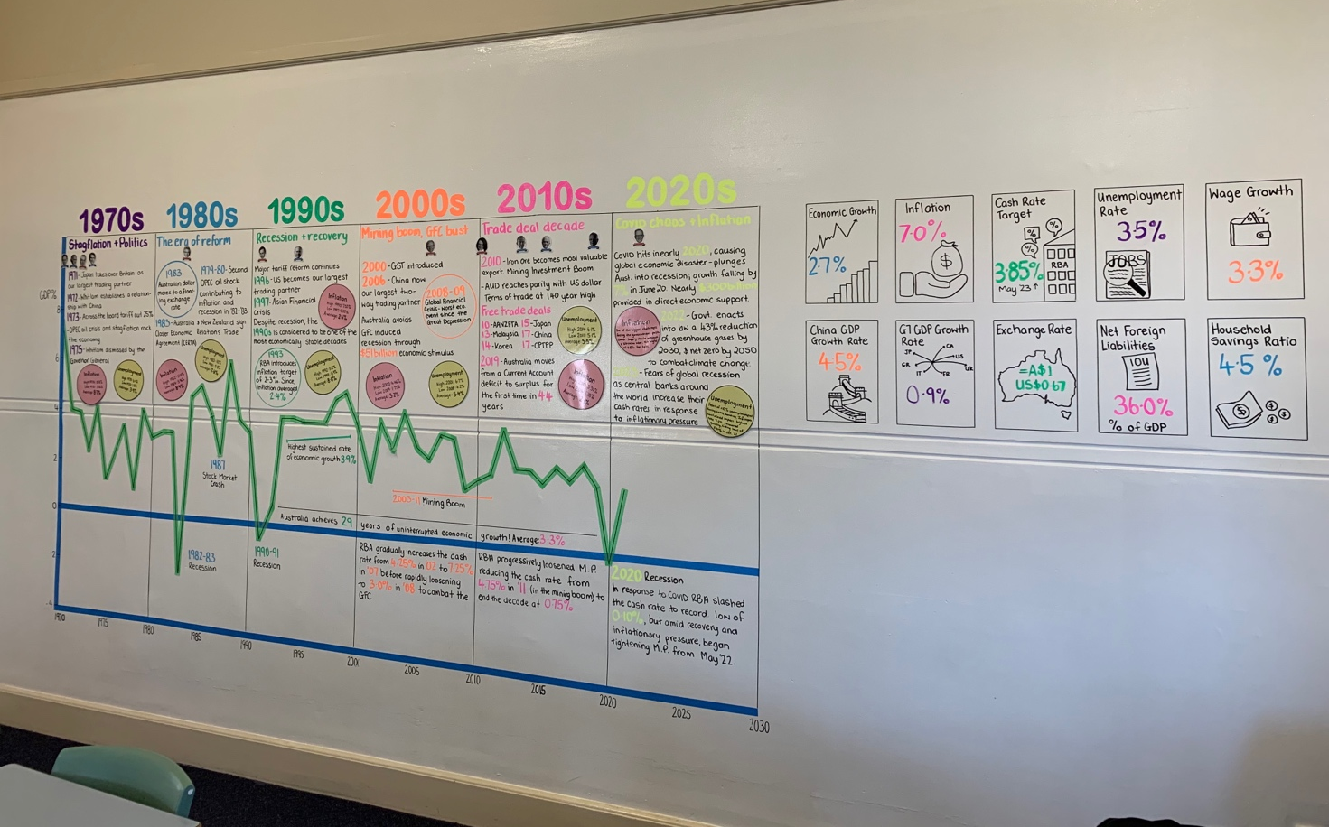
Figure 2: One passionate teacher’s classroom mural, which they regularly update with the latest trends and statistics (Photo by Gavin Brennan)
- Knowledge of content, real-world trends and statistics
The expert teachers in the study consistently had excellent knowledge of economic concepts and current trends and statistics relating to the Australian economy. This deep knowledge of the content reduced cognitive load when teaching. Rather than concentrating on recalling content and trends, teachers could focus on fluent explicit instruction, demonstrating their passion about current trends, and adapting to their students’ needs.
While up-to-date content knowledge is important for all subjects, participants regularly emphasised that staying on top of content was a bigger challenge for economics than the other subjects they teach, such as geography, legal studies or business studies. Despite that, this difficulty is not taken into account when allocating teacher loads or when allocating a teacher to teach economics for the first time. Unsurprisingly then, 80% of the high-performing schools had teachers who had been teaching the course for more than ten years.

Teaching Strategies
- Orienting and daily review
All teachers in the study consistently showed students where they were in the course at the start of every lesson. For a couple of participants, this involved creating learning intentions and success criteria for students to gauge their progress. For most though, it was done more simply by displaying the syllabus at the start of the lesson, recapping what they had already covered, and identifying what they would be learning next. In either case, all students were given a clear idea of where they were in the course, what they were expected to know already, and what they were trying to achieve in the upcoming lesson.
Teachers also used this process to ask students questions about previous learning, providing multiple exposures to content and reactivating schema to facilitate new learning.
- Explicit instruction
Every teacher in the study believed that the most effective strategy for teaching economic concepts was for the teacher to directly explain the concepts to students and to engage students with questioning and discussion to check and consolidate that knowledge. No participating teachers used inquiry-based learning as a strategy except for rare occasions where they believed the content was relatively simple. Multiple participants noted that if they used more inquiry-based or project-based learning, they ‘would have to re-teach the content anyway’.
With regards to how these teachers became so good at explicit instruction, many teachers reported that the most effective strategy they had used to upskill themselves was to observe other expert economics teachers modelling how they teach particular concepts. These examples showed teachers how to explain that specific concept clearly, and also gave them a style that they could apply to other content too.
- Literacy strategies
Despite the reputation of economics as a maths-heavy subject, most teachers agreed that the maths component of the HSC Economics course is accessible for most students. By contrast, a consistent belief across all participating teachers was that high-achieving students in economics need a strong literacy base and that teachers should focus heavily on improving students’ writing.
Teachers believed that the level of detail in the HSC Economics course required students to read about lesson topics in more depth after class, by reading summaries provided by the teacher and/or chapters from a textbook. Likewise, teachers recognised that students need to be able to structure and explain these concepts and trends with precision, detail, and clarity. Therefore, teachers appreciated that prior literacy skills were a strong determinant of performance in HSC Economics.
Teachers then deliberately built on these foundations with regular writing practice. At two very high-performing schools that participated in the study, economics students write an essay almost every week of the course throughout Year 11 and Year 12, with regular feedback. In almost every school in the study, a ‘standard lesson’ for the teacher would involve explicit instruction and discussion of concepts followed by application to HSC-style short response and/or essay questions. Teachers provided guidance and scaffolds for these responses that were appropriate for the literacy levels of their students.
- Exam-style application
Most participating schools had a focus on regularly applying course concepts to HSC-style questions as practice and revision. Many schools had printed booklets of questions for students to complete, both in class and at home. One school had designated one lesson per week to be used entirely for practice multiple choice and short response questions on content covered in the past month. Students often analysed marking criteria and model responses, and peer-marked the work of their classmates.
In addition, many teachers had intimate knowledge of the Economics HSC marking process. Of the ten schools in the study, six had teachers with HSC marking experience, two had teachers who were HSC senior markers, one had a teacher who had previously written the HSC exam, and one school contracted HSC senior markers to train their teachers and occasionally double-mark their assessments.
While regular exam-style application with HSC-aligned marking had the benefit of reducing anxiety about assessments and improving exam performance, teachers did not view this strategy as merely ‘teaching to the test’. Rather, they viewed these questions as an effective way of consolidating student knowledge, isolating misunderstandings, and making visible to students what they are expected to be able to do. They also believed that the HSC is largely a fair way to assess students’ understanding of economic concepts, and therefore did not see ‘teaching to the test’ as much of a problem.
Yet despite the wide support for this strategy, teachers struggled to include it in lessons as often as they would like to. In fact, most teachers relied on teaching content with extra depth in Year 11 in order to make more time for regular exam-style practice in lessons in Year 12. Some teachers even organised additional classes before school in order to make time for these practice questions.
- One central learning resource
The HSC Economics course is dense with concepts and real-world trends, and students can get easily lost or disorganised in the overlapping topics. To prevent this, many high-performing teachers provided their students with one organised resource for each section of the course (e.g. ‘globalisation’, ‘inflation’). For some teachers, this resource was a printed booklet, for others it was a set of slides that students have access to on their device.
This resource commonly included written summaries of course concepts and trends that reduced the need for excessive copying and note-taking in class. It also usually integrated graphic organisers, learning activities and short response questions throughout. The resource helped to give students structure and reference material to maximise the efficiency of class-time and facilitate at-home revision.

Student Traits
- Strong student work-ethic
While not a strategy, there was a clear correlation in the study between the quantity of work students are willing to do outside of the classroom and the results they achieve, as reported by their teachers. While all schools were achieving better results than schools similar to them, in absolute terms among the schools in the study, the schools that performed best had students with far higher levels of student effort, especially outside of the classroom.
One implication of this finding is that creating a class and school culture of independent practice and student responsibility will increase the effect of all other teaching strategies. How to do this will vary from school to school and student to student, but should be a priority.
Another implication is that teachers in contexts where students do less independent work could benefit from guidance on how to build more revision into class time instead. The high-performing teachers in those types of schools had adapted by making conscious decisions about what content to skip or only cover superficially in order to make time for frequent reinforcement of core concepts. However, they believed this was only possible because they knew from experience what is and isn’t a core concept and how content is most commonly assessed in the HSC. One teacher reported that because economics is largely taught at advantaged schools with higher levels of student engagement, professional development courses are also run by, and targeted at, teachers with those kinds of students as well. They believed that most professional development for economics teachers “isn’t suitable for schools like us.”

Possible reasons for the achievement gap
Based on the HSC data provided for this study, there is a correlation between the economic advantage of a school and the average performance of students in HSC Economics. By visiting schools from across the spectrum of economic advantage, I observed three clear factors that also seem to correlate with economic advantage and are likely to contribute to this disparity:
Literacy levels of the students. Teachers in the study strongly believed that reading and writing skills are a fundamental skill needed to perform well in HSC Economics – much more than mathematical ability. However, not all teachers believed their students had strong literacy skills. There was a clear correlation among the schools in the study between the literacy levels as reported by the teachers and the socio-educational advantage of the school. By contrast, there was less of a relationship with mathematical ability or prior economic knowledge. This finding suggests that a significant reason that students from more advantaged schools usually perform better in HSC Economics is that they have more sophisticated literacy skills that enable them to interpret and explain economic concepts at a deeper level.
Work-ethic of the students. As mentioned above, there was a significant disparity in the work-ethic of students at different schools in the study. The level of work that students undertook outside of the classroom correlated closely with the socio-educational advantage of the school (as measured by the school’s ICSEA rating). For example, at the most advantaged schools in the study, teachers noted that students completed around four hours of homework per week for Economics, frequently undertook additional revision, and even attended occasional revision classes before school and in the school holidays. By contrast, in the participating regional and low-SES schools, teachers reported that an average student might do up to one hour of homework per week with no additional revision. This means that the average student at the most advantaged schools in the study spent two to three times as much time learning and revising the course (both in and out of class) throughout the year than students at the least advantaged schools. The sheer amount of time students in different schools spend learning and practicing the content could go a long way to explaining the achievement gap between advantaged and disadvantaged schools.
Specialisation of the teacher in economics. Students in less advantaged schools are less likely to choose to study economics. For schools in the study, this trend meant that teachers in less advantaged schools only ever teach a maximum of one HSC Economics class per year, and some years there may not be a class at all. If there were two economics teachers at the school, they sometimes rotated who taught Year 12, meaning they gained even less experience teaching the course and spent less time developing their own teaching resources. It was difficult for them to stay up to date with current economic trends because they were teaching other subjects as well. By contrast, at the most advantaged schools in the study, teachers had multiple HSC Economics classes every year. At one school, there were five teachers who taught no subject other than Economics. This narrow specialisation enabled them to have an intimate knowledge of economics concepts and current trends, and to continually refine how they structure and deliver the course.

Conclusion
There are three main implications from these findings for how organisations such as the RBA, education authorities and professional teachers’ associations can improve economic achievement and enrolments.

1. Improve professional development / support for economics teachers
Recommendation: Consideration should be given to the most consistent and practical solutions proposed by participants, organised into “three layers” according to the types of teachers they apply to:
Improving Support for New Economics Teachers  Teachers new to economics need training in core content and demonstrations of how to do explicit instruction of that content.  Time-poor and inexperienced teachers should have access to centralised resources and lesson activities that are pre-made for them to ensure a minimum level of teaching quality.  Teachers new to economics would benefit significantly from a master class / mentoring program for teachers throughout their first year of teaching economics. This could involve fortnightly meetings to teach them the content, demonstrate how to teach it, provide relevant real-world examples to use in class, and explain current trends relating to it. | Ongoing Support for Experienced Teachers
 | Teachers in Less Advantaged Schools  New training opportunities are needed that focus on what works best in this context:  - Explain challenging concepts in simple ways  - Make time in the course for in-class application and revision  - Design effective in-class revision / application activities  - Scaffold summary notes  - Improve short response writing  - Essay writing strategies for weak writers  - Train in HSC marking (include mid-range responses)  These teachers often lacked access to HSC markers at their school or in their network, and were less likely to have HSC marking experience. Widening the pool of markers would equip more teachers to know what standard they are aiming for their students to achieve. | Teachers in Advantaged Schools  These teachers need guidance on how to extend their students and to help them achieve excellent marks in the HSC. This can be done through professional development on:  - Current trends in the Australian economy  - Recent developments in economic theory (but capped at a level that is appropriate for HSC students and relevant to the HSC course)  - HSC marking (with a focus on band 6 responses)

2. Improve resources available for economics teachers to use
Recommendation: NESA and other education authorities should be encouraged to produce centralised curriculum resources, such as programs, lesson sequences, lesson plans, slides/handouts and learning activities to establish a minimum level of teaching quality. These resources should be: produced by expert high-school economics teachers; customisable by teachers; and regularly updated for current events, trends, policies and statistics
Recommendation: The RBA should continue to improve the education resources on its website by:
- mapping existing resources to the syllabus in each jurisdiction (e.g. with drop down menus for jurisdiction, year level and topic).
- producing engaging and accessible videos aimed at students, potentially with the aid of teachers and animations.
- considering ways to provide content on current macroeconomic conditions for teachers, such as through the release of a supplementary video that focuses specifically on trends that relate directly to Australian economics syllabuses.

3. Address other factors affecting enrolments
Improve students’ experience of economics in the Commerce course – Recommendation: Increase the availability of professional development sessions for Commerce teachers who are not trained in economics. This training should:
- directly teach teachers the economic content in the Commerce course
- demonstrate how to explicitly teach those concepts effectively
- provide engaging real-world examples of the concepts
- suggest games and simulations that can used in class to illustrate economic concepts in an engaging way (such as a trading game to illustrate the price mechanism, or a role-play of the circular flow model)
Address the perception of Economics relative to Business Studies – Recommendation: Encourage NESA to have a similar level of rigour in the new Economics and Business Studies syllabuses, and that any differences in difficulty should be more accurately reflected in the scaling of subjects.
Improve the HSC Economics syllabus to attract more students – Recommendation: To improve the accessibility and appeal of HSC Economics, NESA’s syllabus reforms could:
- integrate real-world issues, trends and examples when introducing students to economics and teaching foundational concepts.
- remove content from the Preliminary Economics syllabus that is not built on in the HSC course.
- introduce foundational concepts for more parts of the HSC course in the Preliminary syllabus, to free up time in Year 12 to focus on deepening understanding and enabling mastery of course content.
- re-frame parts of the HSC Economics course in some areas to reduce the focus on memorising facts and to allow more flexibility in how questions can be asked in the HSC exam, in order to discourage memorising essays and instead incentivise deep understanding.

Acknowledgements
Many thanks for the support and assistance of the following people:
- My wise and empathetic mentors, Jacqui Dwyer and Madeleine McCowage at the Reserve Bank of Australia, for their advice, encouragement and mini-tutorials in regression analysis.
- Former scholarship recipient Anthony Jones, for his insights on how to manage the research project and proactively plan for potential risks.
- Management at my school, Alpha Omega Senior College, for supporting me in my study and allowing me to take time out of a busy term to visit schools across the state.
- All of the passionate, knowledgeable and inspiring teachers involved in the study, who welcomed me into their classrooms and volunteered their time to contribute to this report.

References
Department of Education (2021), Observation: a guide for use in evaluation, https://education.nsw.gov.au/teaching-and-learning/professional-learning/pl-resources/evaluation-resource-hub/collecting-data/observation/step-2-prepare-the-tools-and-the-people.
Dwyer, Jacqui (2017), Studying Economics: The Decline in Enrolments and Why it Matters, Reserve Bank of Australia.
Dwyer, Jacqui (2022), A Matter of Diversity, Reserve Bank of Australia.
Hattie, John (2011), Visible Learning for Teachers: Maximising Impact on Learning, Taylor & Francis.
Lemov, Doug (2010), Teach Like a Champion: 49 Techniques That Put Students on the Path to College, John Wiley & Sons.
Livermore, Tanya & Major, Mike (2020), Why Study (or Not Study) Economics? A Survey of High School Students, Reserve Bank of Australia.
NESA (2022), 2021 HSC Distinguished Achievers List, https://educationstandards.nsw.edu.au/wps/portal/nesa/about/events/merit-lists/distinguished-achievers.
Rosenshine, Barak (2012), Principles of Instruction: Research-Based Strategies That All Teachers Should Know, American Educator: Spring 2012.
Tan, Joyce (2022), Exploring the ‘Confidence Gap’, Reserve Bank of Australia.
Wiliam, Dylan (2011), Embedded Formative Assessment – Practical Strategies and Tools for K-12, Solution Tree.

