2023 Premier’s Anika Foundation Youth Depression Awareness Scholarship

Authentic school transition for students requiring acute mental health inpatient unit care
Brianne Balfoort
Kotara School for Specific Purpose / Nexus Education
Sponsored by

Introduction
The transition process from an acute mental health inpatient unit to a census school is of utmost importance in supporting the mental health recovery of young individuals (Weist et al., 2018). It presents an opportunity for the system to comprehensively assess and gather evidence to support the child, while also providing crucial assistance for their reintegration into the school environment. In order to ensure a consistent approach throughout New South Wales (NSW), it is essential that young people have a smooth and well-supported transition from the mental health unit back to their home school. This research paper aims to explore the efforts being made across Australia in acute mental health inpatient units to establish effective transition. This report strives to provide valuable insights and guidance for both young individuals and educators seeking clarity in facilitating an Authentic School Transition for Young People Accessing Acute Mental Health Care.

Focus of Study
The strategies employed for supporting students who have undergone an inpatient unit admission to a mental health setting can vary across services, schools, states/ territories, and individual cases. To gain a comprehensive understanding of these strategies, this study tour encompassed visits to Hospital Schools, Alternative and Flexible Schools, Mainstream Schools, Selective High Schools, Schools for Specific Purpose, and Universities. Additionally, I had the opportunity to engage in targeted professional learning from the Black Dog Institute.
The primary objective of this paper is to shed light on the concept of Authentic School Transition for Students Requiring Acute Mental Health Inpatient Unit Care, ensuring that our efforts remain centred on the child. It is important to note that this study is qualitative and specific to the sites visited. To protect the privacy of the young people involved, most census school settings remain anonymous. Data was collected through comprehensive visits, observations, interviews with students and staff, as well as surveys.
Throughout this research paper, systematic differences across Australia will be discussed, including topics such as liaison teachers, school-wide transition frameworks, relationships between schools and inpatient unit settings, mainstream schools' reception of returning students, information sharing and confidentiality, alternative settings, attendance and selective high schools, support plans, peer support, executive support, available professional learning, existing research, and data captured through the project survey.

Significant Learning

Systematic Differences
One significant observation during the study tour was the systematic differences across Australia in terms of schools employing inpatient unit teachers. In some states, there is a centralised approach, with a single school managing all inpatient units throughout the state/ territory. However, in other states, inpatient unit staff are employed by different schools. For instance, in NSW, inpatient unit staff are employed by various types of schools, including large mainstream high schools, hospital schools or schools for specific purpose. These schools operate with different models of funding, curriculum, and wellbeing resources, which ultimately affect the delivery of services. In certain states, there are multiple day programs and sub-acute mental health settings that provide support for the gradual transition back to school as opposed to my current setting, which is an acute unit, where students return directly to school.
A visit to the Jacaranda unit, staffed by the Queensland Children's Hospital School, showcased a subacute residential and inpatient unit that demonstrated effective learning. The unit incorporated developmentally appropriate and adolescent-friendly elements such as music rooms. The staffing model ensured that student needs were met, and transition support was provided through guidance counsellors and executive staff. The benefits of a unified system approach were observed at the Perth School of Special Education Needs - Medical and Mental Health, where a Memorandum of Understanding allowed the school to access student information to effectively support their academic and wellbeing needs. Reporting measures were also in place to facilitate seamless transitions between acute and sub-acute community services, ensuring continuity in a young person's recovery.
There were variations, across inpatient units, in restrictions on who could enter the classroom area, and this impacted the planning approach for returning students to school. An inpatient unit staff member expressed concern “I worry about – because of the setting – young people are discharged when they are still unwell. There isn't really a step down from hospital. Assumed risk isn't so high but it could be. Adults have a step down but we don't. Hospital is a pretty different environment to home. [There are] limited options of self-harm on the ward and then they transition back. When transition doesn't happen effectively, they will return.”.

Liaison Teachers
At my current workplace, the responsibility of facilitating the back-to-school transition for students is a collaborative effort involving the school team on the ward, the clinical team, the census school, counselling teams, school link, and departmental staff. After discharge, this transition work continues with the involvement of census school staff and community clinicians, if available. During my observations, I witnessed the valuable work of liaison teachers in three different states. The Austin School liaison teachers are woven throughout the programs and provide support at all points of admission and discharge, and the Perth School of Special Education Needs: Medical and Mental Health community liaison teachers played a crucial role in effectively supporting young people and maintaining a safe environment. They worked closely with community clinical teams and accompanied the young people to school, providing additional support and guidance during the transition process. This role also involved delivering professional learning to staff at schools where trauma-informed education might not have been previously accessed. Through these interventions, teachers were able to witness the effective implementation of trauma-informed education, including the skilful balance between regulation and transition support, while also demonstrating unwavering positive regard for students (Rogers, C. 1951).

School Wide Transition Models
Mainstream schools proved to be more effective in receiving young people back after a mental health inpatient unit admission when they implemented specific transition models that spanned across the entire school. Schools that lacked clarity regarding who was responsible for the transition process experienced inconsistency, which resulted in setbacks in staff relationships and for the young people themselves. In one instance, where there was no consistency, young people expressed their frustration, stating, "Teachers don't understand what I've been through; I don't want to relive my story" (Inpatient Student).
Monash Children's Hospital developed a transition model that focused on three phases: treatment, recovery, and reintegration. This model emphasised the collaborative efforts between all stakeholders and the young people to successfully reintegrate them into school. The highly effective school-wide transition model at the Queensland Childrens Hospital demonstrated a tremendous amount of effort invested in their transition process. Firstly, the model prioritised the developmental aspects of learning and wellbeing. It also included a focus on First Nations transition, acknowledging the importance of continuity throughout the process. Additionally, the model emphasised the inclusion of families, students, health professionals, and education providers. They have also been working with a virtual system of transition support for short bursts to targeted students. Adopting a trauma-informed perspective, incorporating elements of neuroscience, and recognising the importance of personal and social capabilities in personalised learning were other noteworthy aspects of their model.

Inpatient Unit and the Census School Relationship
A significant challenge is the communication between school teams and inpatient units. The passionate well-being team from one school expressed their frustration regarding not being informed about admissions, which resulted in them receiving young people back without any prior knowledge or support. “Collaboration with services providers is really poor. We are the ones reaching out for support. We have to chase them for information after a crisis admission” - School Psychologist. Some schools expressed a lack of trust in the information provided by the inpatient units, it became evident that specialist counselling staff is essential.
The lack of notification and communication between emergency departments, inpatient units and census schools is indeed a common challenge observed across Australia. When a young person presents to the emergency department but is not admitted to the hospital, there is often a gap in providing necessary support and information to schools. This can lead to misunderstandings and strain in the relationship between educational partners. To address this issue, it is crucial to improve communication channels and ensure that relevant information reaches the appropriate parties involved in the student's education. The "Planning Together for Safety and Support" document released by School-Link South Eastern Sydney serves as a valuable tool in upskilling parents/carers and young people to communicate with schools effectively.
After discussing this project with Professor Steve Houghton's "Right Time to Talk" project team, I felt hopeful and inspired by their innovative approach. During our meeting, they shared details about the wearable technology aimed at predicting an incident of self-harm that was being developed by Pro Vice-Chancellor Research & Professor of Psychological Science Andrew Page. Learning about this innovative system of symptom monitoring and alerting was truly fascinating, and I immediately recognised its potential benefit, as an innovative system, to reduce one gap for the school and inpatient unit communication.

Alternative Schools
Alternative school settings in my local area have demonstrated effective reintegration of young people following an inpatient unit admission, and I wanted to explore if this was consistent across other states. It was truly inspiring to observe a group of teenagers actively engaged in learning at the state library in Western Australia, as well as to have the opportunity to speak with the co-founder of IDEA academy. When asked about any concerns or necessary steps prior to reintegrating a young person who has experienced an acute mental health crisis, the co-founder, explained that their educational model allows them the time to care by removing the burdens of lesson planning and marking. Youth Futures School in WA places a strong emphasis on prioritising wellbeing before education. This school's model includes on-site psychologists, social workers, and youth workers. It was remarkable to witness the incredible work being done to support homeless youth, young parents, and individuals experiencing acute mental health crises.

Selective Schools
I had the privilege of visiting several selective high schools. When young people faced challenges to their identity, such as transitioning to a new school, they often felt that their sense of self was being challenged. Interestingly, I found that mental health literacy gaps exist across all levels of socioeconomic status. At one high school that I visited, a student wellbeing team took ownership of the meeting and fearlessly shared their perspectives on what works. When asked about whom they would turn to for help with mental health, some students expressed concerns about their parents' potential anger. Many students also shared that the pressure of assessments and the fear of failure negatively impacting them. In terms of coping strategies, some students found it difficult to answer, but typically leaned on their friends and some were trained in Youth Mental Health First Aid. In these school settings, students were more likely to seek support from staff members within the wellbeing team such as a chaplain, mental health nurse or education assistant.

Support Plans
A variety of support plans were observed among different schools, emphasizing the importance of open and honest communication, comprehensive clinical team involvement, risk assessments, and giving the young person a voice in the process. During my observations, I witnessed counsellors and inpatient unit teachers creating personalised support plans from scratch. I had the opportunity to see the implementation of Head Space Support Plans and versions highlighted in the project air training. When interviewing Dr. Steven Spencer, a passionate mental health nurse turned clinical director of Equi Energy Youth, he reminded me of the necessary system-wide efforts to support a young person's recovery. As the system is falling around the young person, the inpatient admission gives time and space for it to repair. Dr. Spencer's interview highlighted the need for alignment and collaboration among schools, inpatient unit staff, and other stakeholders, ensuring everyone is on the same supportive page. His work in the space of calming and support plans has been instrumental for local schools as noted in the survey responses.

Survey results
The survey generated a comprehensive list of 185 notable strategies based on the input of diverse stakeholders. In the subsequent section, there is a summary of factors that hindered transitions and the positive strategies that emerged from the survey. There is also a link to a document containing further survey strategies.
Factors hindering an effective return to school, as identified in the survey results, can be summarized as follows:
- Young person not yet ready: This includes instances of major self-harm incidents, acute illness, or schools requiring guarantees of safety before the return.
- Brief admissions with no transition support: Short or no transition support provided during brief admissions can make the return more challenging.
- Lack of access to support in the school setting: Insufficient resources or support available in the school setting can impede a smooth transition.
- Unrealistic expectations: Unrealistic expectations placed on the student or school can create difficulties during the return process.
- Medication changes: Switching to sedating medications may impact the student's ability to transition back to school effectively.
- Schools unable to manage medical risks: Some schools may struggle to handle the medical risks associated with mental health.
- Length of absence: The longer a student is absent, the more challenging it can be for them to reintegrate into school due to feelings of missing out.
- Lack of understanding of supervision: A lack of understanding regarding the required level of supervision in a mainstream school setting may hinder the return.
- Discharge process and lack of outpatient support: Issues related to the discharge process or a lack of support in the outpatient setting can impact the transition.
- Communication issues and fatigue: Lack of communication, last-minute communication, and fatigue/ burn out among teachers and carers.
- Overwhelming planning and expectations: Excessive planning requirements and overwhelming expectations can hinder transition.
- Difficulty sharing information: Challenges in sharing information due to lack of consent.
- Lack of feedback mechanisms: The absence of easy ways to provide feedback about the transition processes can hinder improvements.
- Insufficient time and support: Limited time to manage the transition and insufficient support from executive, census school and families.
- Lack of understanding and connection: Lack of understanding from the family or home school and a lack of connection with the census school.
- Rigidity of the system: The rigid education system may not adequately accommodate unexpected life events, and social issues can impact transitions.
- Limited window of opportunity: Often, the window of opportunity for effective support during the transition is small, resulting in non-attendance.
- Lack of communication: Lack of communication and uncertainties about the mental health unit, admission processes, and potential ward trauma can impact the return.
Considering these factors, it is essential to address communication gaps, enhance staff competency, provide step-down options, and ensure support for students transitioning from mental health units back to school.
Positive transition strategies from the survey. 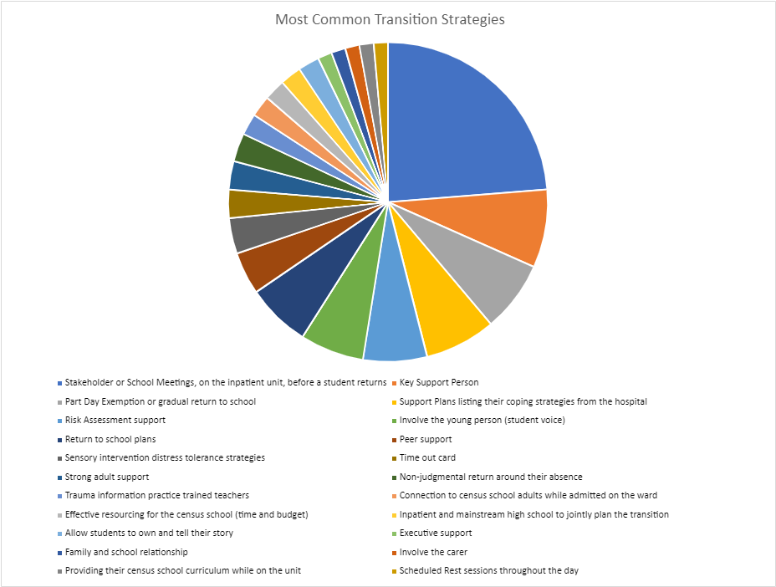
Figure 1: Positive transition strategies from the survey
The most common survey responses regarding effective transition strategies include:
- Stakeholder or School Meetings held on the inpatient unit before a student returns (33 mentions).
- Key support person assigned to the student (11 mentions).
- Part day exemption or gradual return to school (10 mentions).
- Support Plans that list the student's coping strategies from the hospital (10 mentions).
- Risk assessment support (9 mentions).
- Involvement of the young person through student voice (9 mentions).
- Return to school plans (9 mentions).
- Peer support (6 mentions).
- Sensory intervention and distress tolerance strategies (5 mentions).
- Time out card (4 mentions).
- Strong adult support (4 mentions).
- Non-judgmental return regarding the student's absence (4 mentions).
- Trauma-informed trained teachers (3 mentions).
- Connection to census school adults while admitted on the ward (3 mentions).
- Effective resourcing for the census school in terms of time and budget (3 mentions).
- Joint planning of the transition between the inpatient unit and mainstream high school (3 mentions).
- Allowing students to own and tell their story (3 mentions).
- Executive support (2 mentions).
- Family and school relationship (2 mentions).
- Involvement of the carer (2 mentions).
- Providing the census school curriculum while the student is on the unit (2 mentions).
- Scheduled rest sessions throughout the day (2 mentions).
There are additional strategies from the survey in the following linked document: Transition Strategies

Research and professional learning
Throughout this study I was able to find out about a range of research and services available and some resources that would be helpful for an inpatient unit teacher and these can be found in the following linked document Research and Professional Learning

Conclusion
Upon concluding my study tour it is evident that we need a better and more consistent approach across NSW to prevent further disconnection of our acutely unwell young people. There is a need for refinement and stakeholder meetings in each setting. Implementing a statewide approach, backed by executive support and funding for professional learning and relationship building specific to inpatient unit teachers, would reduce the likelihood of young people getting "lost" in a fast-paced system.
This report has been invaluable to my role and has allowed me to reflect upon and refine our own transition model. I will continue to disseminate this information through platforms such as the Co-Located Inpatient Unit network and special education settings, present to local schools and hospitals. The project will be transformed into a resource that can be shared with inpatient settings and used as a reflection tool for those seeking to improve and define best practices in inpatient unit transition.
After seeing a statewide approach to inpatient unit care, it would be highly beneficial, in my opinion, to expand sub-acute settings and outpatient services for young individuals who are not yet ready to return to school. Having a liaison teacher who guides their journey from acute to sub-acute and back to a mainstream setting would be a fantastic addition to the inpatient unit transition service.

Acknowledgements
I would like to express my sincere thanks to the Anika Foundation for providing the funding that supported this research project. I also extend my heartfelt appreciation to the staff, students, families, and communities who generously offered their time and welcomed me into their settings.

References
Rogers, C. (1951). Client-centered therapy: Its current practice, implications and theory. London, UK: Constable.
Weist, M.D., Evans, S.W., Lever, N., & Bradshaw, C.P. (2018). Schools as the Backbone of Mental Health Recovery: A Systematic Review. School Mental Health, 10(1), 1-23. doi:10.1007/s12310-017-9248-3.

