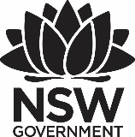
2020 Premier’s Teachers Mutual Bank Aboriginal Education Scholarship

Improving the attendance, engagement, retention and successful achievement of education outcomes of Aboriginal and Torres Strait Islander students in NSW schools
  - A true chance to close the gap and meet targets
Sabina Armstrong
Walcha Central School
Sponsored by
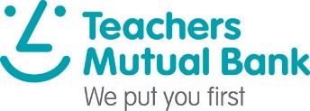

Introduction
I used my study tour to spend time with Aboriginal and Torres Strait Islander students and their teachers at seven schools in the Northern Territory.
All schools delivered the syllabus in an integrated approach, using a mixture of pedagogies. Central to classrooms, but not explicitly acknowledged, is the 8 Ways of Aboriginal pedagogy, a framework that supports teachers to include Aboriginal ways of knowing, being, doing, thinking and learning as they teach core curriculum content.
My aim was to learn more about Aboriginal and Torres Strait Islander ways of teaching children and to look at how these insights could improve the way we educate children in communities across Australia.

Focus of Study
The focus of engaging with the Northern Territory Department of Education and Principal, staff and students in remote area schools was to research how Aboriginal and Torres Strait Islander young people learn best and are best supported to remain engaged in their schooling and further education. Key emphases of the investigation included the range of pedagogies that are utilised by educators in schools, how communities ensure the learning continues within and on country, how their communities contribute to the learning of Aboriginal history and cultures, how best the teaching and learning leads to development of student cognitive complexity, how best to apply and transfer Aboriginal ways of knowing, being, thinking, doing and learning, across curriculum content.
From analysis of investigation and research, it is expected that the collective findings will be utilised to develop professional learning, knowledge and practice of all staff in the local school and region, with the aim that Aboriginal and Torres Strait Islander student engagement and retention will improve as they experience increased depth, breadth and integrity of learning experiences through the application of learning in a newly created integrated curriculum model that reflects the 8 Ways of Aboriginal pedagogy. Indeed, the learning of all students will be greatly enhanced.
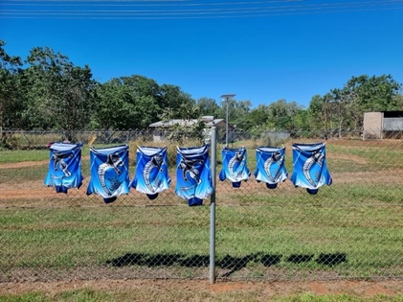
Figure 1: Belyuen Community School (Photo by Sabina Armstrong)

Significant Learning

The importance of research.
I sought research that challenged my beliefs about the need to change the way we provide education. From as far back as 37 AD (Plutarch) and possibly before, theorists have spoken about learning and children’s developing brains. Many dare educationalists to create learning environments for our young people in a different way to the traditional, industrial-age methods. The most significant research and readings I utilised were from the 1980’s through to the current day. Lilliedahl, in his research into ‘Thinking Classrooms’ (2020), believes that it is not just the teacher, or the classroom or even the school. It is the system. In different ways, this research permeated across my reading.
It is also very clear that traditional learning marginalises our Aboriginal and Torres Strait Islander young people from low socio-economic backgrounds. Governments have set targets for our Aboriginal and Torres Strait Islander students. We, as a system, focus on the ‘fruits’ rather than the ‘roots’. (‘The Power of Positive Leadership’ Jon Gordon 2017)
The other area of research I undertook was based on the Aboriginal ways of knowing, being, doing, thinking, and learning. This led to a greater understanding of learning ‘Both Ways’ or ‘Two Ways’. It is a recognition that Aboriginal and non-Aboriginal teaching and learning has an equal place. There is a visual representation that is reflective of a lagoon. Freshwater, or land water flows from one direction and is the non-Aboriginal knowledge. It meets the sea water of Aboriginal knowledge at a whirlpool. They say that the surface of the whirlpool looks smooth and calm but underneath there is swirling environment of nutrient-rich matter that is available to support the growth of plants and animals that lie within. It is an extraordinary concept and one that locally we have not truly considered. Could this be the key to meeting the much-desired targets? The 8 ways of Aboriginal learning is a part of the Both-Way, Two-way Learning. (An example of the belief can be found at Culture College).
This led me to leadership. Todd Whitaker’s research and findings support the need for our leadership to be shaken. There are many amazing schools doing just that.
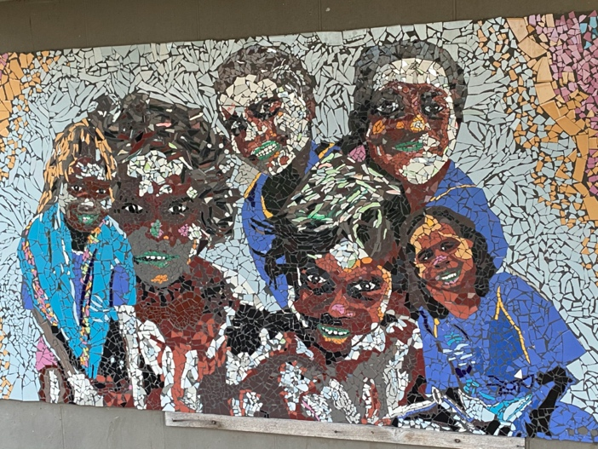
Figure 2: Tiled Mural designed and created by students at Gunbalanya Community School. (Photo by Sabina Armstrong)

The importance of people and context in the learning.
Prior to leaving for the schools, I met with professionals including the CEO of NT Education, Karen Western; Wellbeing and Engagement NT Education, May Martin; Senior Manager Bilingual education and Indigenous Languages and Cultures, Dr Ailsa Purdon; ‘Own Our Own’ Educational Engagement Strategy, Aderyn Chatterton; and Community Engagement Officer, Joe Brown. I also met with Sally Hodgson, Quality Teacher Advisor for the Northern Territory. Each meeting allowed for greater insight into the complexities of remote communities. It also allowed for me to consider the similarities and differences between my own community and the seven that I would be visiting: a mix of public and private schools in the areas of Belyuen, Jabiru, Gunbulanya, Elcho Island and Groote Eylandt: Belyuen Community School, Jabiru Area School, Gunbalanya, Angnurugu School, Andilinkwa Umbakumba School, Alyanguala Area School, and Shepherdson College.

Using the ‘8 Ways of Aboriginal Learning’ pedagogy.
8 ways is a process that captures the pedagogies used in the integrated model of learning. By understanding and believing the power of using the ‘how’ rather than the ‘what’, the ‘purpose’ rather than the ‘reason’, educators can use the curriculum content to shape and develop the skills, motivation and self-direction desired in many of the ‘happy to be spoon fed and not to have to think’ students, but it allows teachers to study mainstream content from an Indigenous perspective.
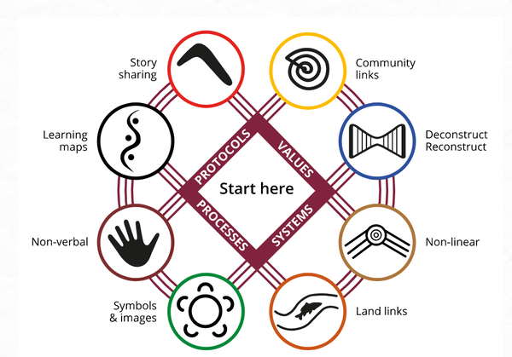
Figure 3: 8 Ways of Aboriginal Learning 2012. Diagram demonstrating the complexities of the relationships acknowledged in the connections: ‘The 8 ways framework is expressed as eight interconnected pedagogies involving narrative driven learning, visualised learning processes, hands on reflective techniques, use of symbols/metaphors, land-based learning, indirect/synergist logic, modelled/scaffolded genre mastery and connectedness to the community’, from https://www.8ways.online/
Looking at processes, how they teach and how best to engage students, regardless of the environment or physical resources that they work with, is what schools in the north are trying to do. Although they do not specifically refer to the 8 Ways, when reflecting on their programs and observing their teaching practices, it is embedded naturally.
From the research and through observation, the true pedagogies of an integrated curriculum has the potential to change the face of the education we deliver to enable access to curriculum at all levels of development, to stimulate learning and enhance the full potential of the complex, interconnected webs of every child’s brain.
Traditional pedagogy, often referred to as linear learning, has been identified as a key factor in marginalising Aboriginal and Torres Strait Islander learners and is not evident in the schools I visited. Linear learning protects those teachers who prefer to be safe in their own room and on their own, to use the same program and delivery they have always done.
Many teachers do apply pedagogical practices that stimulate and excite even the most resistant learner. These teachers are proactive in their own learning, finding new and creative ways to inspire and build deep knowledge in every student. In the integrated model of learning based around the 4 C’s (collaboration, communication, creativity and critical reflection), there is opportunity for teachers to utilise their expertise both individually and collaboratively. Others, who are more set in their ways, have the opportunity to see great teaching in action, and students are offered a variety of experiences that connects and deepens their learning.

School observations.
The communities are very different but the concerns in relation to education are similar to those in the NSW central school in which I work. My observations from the visited schools and education authorities in the NT include the following:
- Every Principal I engaged with is a leader of learning. They have a clear vision built on their understanding of research. They have a clear purpose, know the plan, and understand the process. Every member of the organisation has the plan, understands the plan and acts on the plan. There is no ambiguity, hesitancy or clutter slowing people down. Instead, there is organisational unity, operational discipline and focused action day after day.
- Their belief was in distributed leadership and a trust in their staff. They did not need to micromanage because they believed in the team. Their jobs were extremely complex. In many places they were the cooks, the cleaners and the handy people because positions couldn’t always be filled. They were the mediators between families and the navigators of the two-way/both-way learning streets.
- Attendance, engagement, and retention are issues for their students, as for our Aboriginal students. From observation, students that were taught using solely traditional methods displayed greater misbehaviours, poorer engagement, and lower levels of autonomy. These classrooms lacked the collaborative learning opportunities that increase engagement and promote higher order thinking, deeper knowledge, understanding and development of the general capabilities.
- The Prime Ministers Cabinet supports ‘The Attendance Strategy’ in each school. This provides a bus and a team of people to travel to homes to collect students. There is follow up after 9-9.30am, with members of the team visiting homes to meet with parents and carers.
- The curriculum being built in the schools paralleled the integrated learning that was a large part of the research. At the basis of the teaching and learning was relationships. The 8 Ways of Learning, although not explicitly referred to, was the main pedagogy.
- The cultural competence of the staff was evident and deep.
- The schools developed their curriculum through the eyes of the ‘Two Ways’. They built it with the community including key focuses based on knowledge of the community, stories, symbols, images, learning maps and on country, hands on experiences.
- The communities are embraced as a valuable resource. Their children come with funds of knowledge, not deficits in learning. Language is critical and acceptance that if you are not a part of the local peoples, you are still respected and included. The students from Families as First Teachers (FaFT) to Year 12 were keen to engage and do well. In FaFT, an initiative for families of children between 0-3 years of age, the environment is set up much like Montessori schools. Families come with their babies and infants into an environment that is safe and encouraging. It teaches families how to teach their children in those early years. Activities are organised. Meals are provided. Group activities are facilitated. This breaks down the barriers created when people have either had poor experiences with their schooling, or no experience, and allows them to meet staff and to gain confidence. Resources are provided for them to take home and continue the fun with their children. The preschools are attached to the school and parents can continue that connection.
- Creating thinking classrooms is important to the schools I visited. The belief is, that the students need to be able to think and to manage in both worlds, if they are to maintain their culture.
- The wellbeing in each of the schools I visited was paramount. They believed that before a child can learn, they need to feel safe, and that they belong. Their method was based on, or schools were about to undertake ‘Berry Street’ training, with a view to build consistency in language and student management. The ‘Zones of Regulation’ were at the core.
- In every school, any initiative was whole school. Every teacher was a part of the learning. Whether it was planning, literacy/numeracy development, or curriculum development, the staff was one.
- The teaching staff are capable and motivated and share a collective vision. They are working to change up their teaching and learning in an effort to engage the students, to teach both ways, to develop students’ creativity, skills, problem solving and initiative, to increase attendance, engagement and retention and meet expected targets. They have a clear understanding of the vision, purpose, plan and process. In many ways the complexity of their issues means that these staff perhaps don’t always feel that they win, however they work with a view that if they can change just one life, one family, then they have made a huge difference.

The influence of culture on learning.
Culture permeates in every classroom. This is reflected in the social nature and success of the learning. Aboriginal and Torres Strait Islander links to the land are strong as are their beliefs in family, community, and ways of knowing, being, doing, thinking, and learning. Without using the 8 Ways formally, the teaching and learning very much reflects it. The NT uses the Australian curriculum, which is laid over the seasonal calendar that each community has developed. Language is acknowledged and the Remote Area Teachers are the conduit to teacher/student understanding. Students are encouraged to continue to speak their languages, as well as learning in English. Almost all teachers know some language and the students love it when they can see the learning goes both ways. The best learning, as I believe occurs for all students, is a social learning platform. Independent, in pairs, in groups and as a whole class, the movement through activities reflects non-linear learning. Inquiry based, integrated learning is used, and the focus questions reflect culture. These are decided upon in collaboration with the staff and community and the related areas of curriculum are understood. Learning on country is integral to the success of the curriculum and the community engagement. Both Ways/Two Ways acknowledges the great depth of experience of Bininj and Balanda people and richness of the curriculum it can provide.
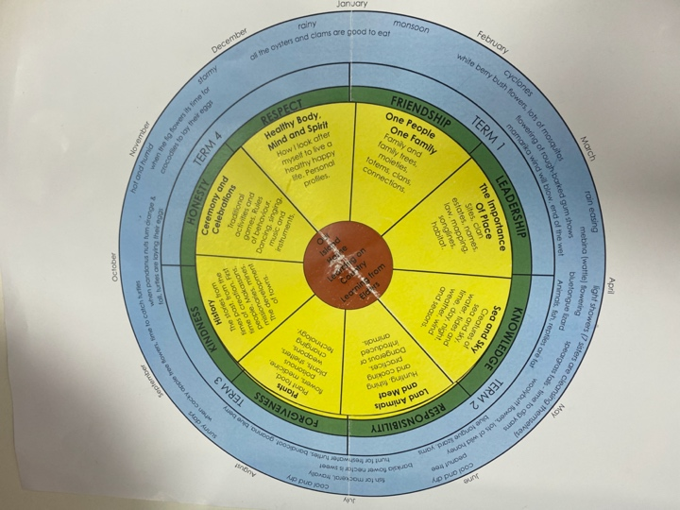
Figure 4: The curriculum wheel developed by schools and the community on Groote Eylandt. Photograph taken by Sabina Armstrong.

The importance of learning on ‘Country’.
The importance of country to Aboriginal people is evident. The impact of European influence is visible physically but emotionally, Country a part of their being. In learning, the students go onto Country, often weekly. They are exposed to Aboriginal culture and learn from teachers, Elders and Rangers. Their units of work embed culture in how they are delivered, and all include being on Country. The learning is based on what is important in the community. An example from Jabiru was the Kakadu food bowl. The whole school engaged in learning about available traditional foods, nutrition and medicine and worked towards contributing to a stall at the annual festival. Learning on Country engages the families and community. To access Aboriginal land, permission needs to be granted. To discuss sites and to engage in certain learning, advice is sought. This is a shared learning, a both ways/two ways that empowers communities and works to bridge the divide.
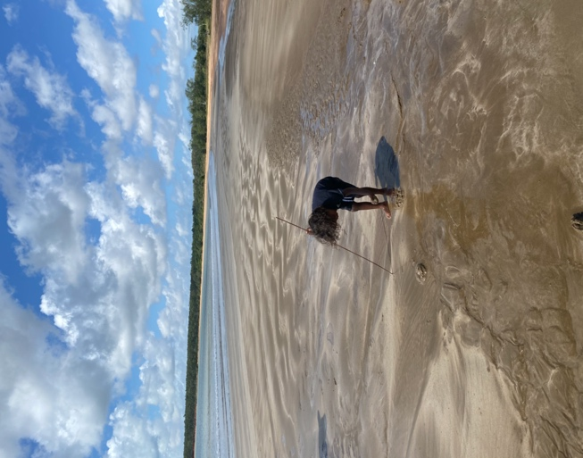
Figure 5: Learning on ’Country’, Thompsons Beach Groote Eylandt. Photo taken by Sabina Armstrong

What part does technology play?
Technology in the schools visited was limited, apart from Alyangula. The greatest issue is the access to good internet coverage. Whilst on Elcho, there were a group preparing to take on Telstra over the number of outages affecting the community. The affect goes beyond schools, with community members unable to purchase food, fuel or to contact family who may be away on ’Country.’ In the classes I worked in, technology was not used extensively, and the skill level was reflective of this. Integrated curriculum including the 8 Ways as a pedagogy, by design, builds oral language, and where devices are purely tools, teams must work together to achieve tasks.

Why a ‘thinking’ classroom?
To think that changing Aboriginal young people’s lives is purely about culture, would be naïve. Whilst culture is critical, the style of learning that we provide, determines how our young people engage and see their learning as relevant. In discussing these ideas with Tyson Yunkaporta, Senior Lecturer, Indigenous Studies, Deakin University, he is clear that learning is in the ‘ways’ of knowing, being, doing, thinking and learning, not in the ‘what’. From listening, observing and sharing in the learning in a range of classrooms, and having trialled the integrated curriculum utilising the ‘8 Ways of Aboriginal Learning’ it is my belief that cultural learning is most successful when embedded in the curriculum as the ‘how’ of learning.
“Thinking is a necessary precursor to learning, and if students aren’t thinking, then they are not learning.” (Lilliedahl 2020). The thinking classroom concept, one that is the focus of the integrated curriculum, leads to changes in room layout, instructions, types of tasks, student groupings and the high expectations of students. Jo Hewett, Principal of Shepardson College, Elcho Island, is an incredible leader of learning. He is an avid reader of research and has a clear vision for the students and staff in his care. The thinking classroom builds oral language which drives students’ ability to write, create, problem solve and to be excited about learning. Once students start thinking, it becomes an end unto itself. Students are willing to think and want to think because it feels good. Jo also bases his beliefs around the research of Russell Bishop and his book ‘Teaching to the North East’, and is working to create an environment where relationship-based learning, high expectations and quality teaching collide to provide a rich and rewarding learning environment for all.

Conclusion
Whilst the research focused on the attendance, engagement and retention of our Aboriginal and Torres Strait Islander students, the importance of language and how to connect community with the school, the findings consistently lead to and confirm my belief that to improve the learning culture in many of our schools for ALL students, we need to challenge the system. This is about raising the bar whilst allowing learning to be accessible and relevant for all students. For our Aboriginal and Torres Strait Islander students, meeting targets set by governments, improving outcomes and closing gaps will not occur unless we reflect on how we are currently delivering the learning in our schools.
- Leaders must allow for the creation of ‘thinking’ learning environments where teachers plan, assess and team-deliver the learning. To do this we need to integrate syllabuses and throw the opportunity to the students to become autonomous and excited about learning. The learning must have a clear purpose for their learning, have an end goal and a standard to work towards. The curriculum must allow for learners and teachers alike to work towards managing real world issues. It needs to be culturally sensitive and involve a range of pedagogies and based on passions, problems, people, place, and purpose, and be the move to take our young people to the next level. (Integrated Curriculum, 8 Ways of Aboriginal Learning, Both-ways). Targets for NAPLAN will improve, students will attend more readily despite what is occurring for them in their own world because it is a safe and motivating place to be. Aboriginal and Torres Strait Islander students who are marginalised by traditional, siloed learning will be less sidelined. In this environment, students will have their strengths or ‘funds of knowledge’ recognised. They can build on this whilst developing in areas that may require extra focus. They can learn themselves, from the teacher and more importantly from each other. Students will not be withdrawn from the environment to be taught basic skills; they learn through being in the environment. Learning Support becomes learning success, within the classroom. By focusing on the roots, we will grow more ‘fruit’.
- When parents become actively involved, at any stage, the students see that the school and their schooling is valued and important. Developing the relationships with the Aboriginal and Torres Strait Islander communities to develop aspects of the curriculum, is something that is possible in all school communities. Working through a two-way, both-ways lens supports the use of 8 Ways of Learning in teaching and learning. This idea is applicable regardless of the community. In the north, Aboriginal and Torres Strait Islander people know and are living their language and culture. In other communities, they are trying to re-connect. Community engagement draws on expertise or provides opportunity to learn language and culture together. Community engagement supports the improvement in practice that is necessary to improve attendance, engagement, and retention. The fruit.
I also believe that setting up a ‘Families as First Teachers’ opportunity for parents and their infants, in the 0–3-year age group, would increase confidence, break down barriers and acknowledge families as valued resources in school. This is important for Aboriginal and Torres Strait Islander families as well as those from low socio-economic families that may not have had the greatest or consistent experiences at school as others.
- Cultural competence is necessary for every person who engages with our Aboriginal and Torres Strait Islander young people. Schools need to invest deeply in their staff’s access to professional learning that brings about a greater understanding of core beliefs, values and attitudes that affect ‘how’ they engage with all students in the learning space. We should not be the reason our young people trip, as they come into the school or any learning space. Results from the NSW DoE Reconciliation Action Plan Survey support this.
- Wellbeing is a critical factor in all children’s learning. The opportunity to work with the community to build collective understanding of the expectations within the school environment can lead to a greater sense of power to support their children in building the skills of autonomy and self and social management for learning. Even for those students who may be lucky enough not to have experienced extreme traumas, the modelling, conversations and opportunity to have discussions will support them into the future when, in their lives, they do have difficult experiences.
As a part of the application for the scholarship, I planned to present at school, and at conferences in the area, region, and state. I also am writing a book and plan to draw as much as I can together in a short film documentary.

Acknowledgements
I would like to acknowledge and thank the schools and individuals I visited, and the NSW Premier’s Teacher Scholarship organisation and the Teachers Mutual Bank for their generous scholarship to enable me to undertake the study tour. Their interest and engagement in the journey has inspired my belief that through developing our experience and challenging the norm, we can make a difference to our young people’s education.

References
- 8 Ways (https://www.8ways.online/) is the result of a research project involving the NSW Department of Education, James Cook University’s School of Indigenous Studies and the Western New South Wales Regional Aboriginal Education Team between 2007 and 2009. Also: (8 Ways Pedagogical Framework: Yunkaporta 2009) and Uncle Ernie Grant’s Indigenous Framework (Grant 1998); (Indigenous tertiary education-we are all learning: both ways pedagogy in the northern Territory of Australia; Bat, Kilgariff and Doe, 2014), developed through a newly forward-thinking integrated curriculum model (Models of Integrated Curriculum: FL Loepp - ‎1999; CURRICULUM INTEGRATION – Magnifying teacher experience with curriculum integration: Sally Munro 2017).
- Australian Government Department of the Prime Minister and Cabinet (2019). Closing the Gap 2018 report.
- ‘Sandtalk: How Indigenous Thinking Can Change the World’ Tyson Yunkaporta 2019
- ‘Building Thinking Classrooms’ Peter Lilliedahl October 2020
- ‘Teaching to the North-East: Relationship Based Learning in Practice’ Russell Bishop 2019
- ‘NT Government: Education Engagement Strategy’ June 2021
- ‘Connected Beginnings: Giving children a strong start in life and school’ NT Government 2021
- ‘Skills National Cabinet Reform Committee Paper’ August 2021
- ‘The Power of Positive Leadership’ Jon Gordon 2017
- Todd Whitaker, http://toddwhitaker.com/

