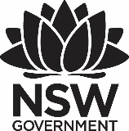
2020 Premier’s Mathematical Association of NSW Mathematics Scholarship

Connectedness in mathematics
  - Teaching in a way that shows the maths in culture, rather than putting culture into maths.
Laura Barry
Middle Harbour Public School
Sponsored by
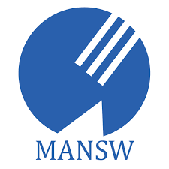

Introduction
What is mathematics and how do we learn it? As a primary school teacher, this question is rarely asked before launching into units of work focussed on teaching students how to count, quantify, and solve equations. We move quickly into the abstract, focusing on ‘how many? how much?’, counting, ordering and classifying through the knowledge of mathematics we know and for the purpose of assessing this knowledge. Too often, mathematics becomes a notion of ‘school’, compartmentalised and seen as something relevant only for an assessment or grade. In doing so, the connectedness in mathematics – the beauty and creativity in mathematics – seeing mathematics as a tool for analysing the world in which we live, and the importance of relating what students already know and value to deepen their understanding of key mathematical concepts can be forgotten.
Through the development of our school Reconciliation Action Plan (RAP) and an unpacking of the NSW Partnership Agreement Walking Together, Working Together, my knowledge of the multiple ways of understanding the world we live in was broadened to include the many Indigenous knowledges and processes that exist, and the importance of placing these knowledges at the fore for our Aboriginal and Torres Strait Islander students.
Focusing on connectedness in mathematics, and the importance of recognising that there are multiple ways of knowing, learning and doing, leads to an acknowledgement that culture affects the ways mathematics is learned. Understanding this, how do we ensure that our teaching of mathematics is culturally responsive to our Aboriginal and Torres Strait Islander students, and goes beyond simply inserting cultural referents into word problems? How can we value their cultural identity and draw on Indigenous knowledges to make them an authority in mathematics teaching and learning? How do we ensure success for all students through connected mathematical understandings? These are just some of the questions that have led to a further investigation into the connectedness and culture of mathematics as part of this study tour.
Valuing knowledge, how it is constructed and where it comes from are important elements in culturally responsive teaching. ‘Mingurrmirr’, a word from an Aboriginal language in Arnhem Land, explains the notion that we understand something when we can relate it to something we know and value.
Understanding how a child achieves as a learner [of mathematics] is less about intrinsic abilities and more about how one is constructed as a learner by the teacher. That construction also affects how power and ownership of knowledge are negotiated in the classroom and whose knowledge is valued. (Hogan, 2008, p. 95)

Focus of Study
The focus of this study tour was to identify the differences between Indigenous and western numeracy constructs, and how these may attribute to a cultural bias in the way we teach mathematics. The aim – through attending the Aboriginal and Torres Strait Islander Mathematics Alliance (ATSIMA) Conference, meeting leading researchers and educators, and visiting schools that use mathematics frameworks designed to enhanced the authority of Indigenous knowledges – was to learn more about how Australian educators might change how we teach maths to all students in a way that puts Indigenous numeracy constructs at the forefront, with a focus on the connectedness in mathematics, rather than the process of sequential learning.

Significant Learning

Misconceptions and cultural bias in the teaching of mathematics
Recognising and understanding student misconceptions in mathematics is fundamental in knowing next steps for student learning. Throughout this study tour it became clear that recognising our own misconceptions as educators about the knowledge systems that inform our practice is equally, if not more, important. It was not until I began research into various frameworks and pedagogies for teaching Indigenous perspectives in mathematics that I became aware of the existence and importance of different knowledge systems, and the impact of one dominating over another can have on student understanding and achievement.
One of the key drivers for my study in this area were articles written and public lectures held by Prof. Chris Matthews, Chair of ATSIMA, about Indigenous perspectives in mathematics education. Prof. Matthews asserts that to truly understand Indigenous perspectives of mathematics, one must accept the intrinsic connection between maths and culture and embrace the subjectivity that cultural knowledge systems bring. In doing so, richer student engagement, deeper understanding and more authentic personal connections to mathematics are achieved.
At the ATSIMA Conference, Yingiya Mark Guyula MLA talked about his personal experiences of education as a child on Country and in the classroom and the importance of being taught through two-way bilingual programs to achieve success. Mr Guyula also expressed frustrations at how despite the successes of two-way programs, Western world views on education remain dominant, to the detriment of Indigenous students. An example of such is evident in system pressures around achievement in high-stakes, standardised testing regimes such as NAPLAN. As asserted by co-presenter Kathy McMahon, lecturer at Charles Darwin University and former teacher in bilingual education at Yirrkala school, tests such as these highlight the cultural bias towards Western ways of knowing and learning in mathematics. NAPLAN, for example, administered first at the age of eight and now online, fails to recognise Aboriginal children come to school with a first language, making them emergent bi-lingual students who first need to learn the language before they can learn through it.

Two-ways learning
In the schools I visited where two-way learning was taking place, this was achieved in different ways, through a range of frameworks and school policy, but was noticeably making impact in schools where curriculum was co-designed with Indigenous and non-Indigenous knowledges sharing space in this design. In addition to this co-design, greatest success was evident when the presence of both Indigenous and non-Indigenous educators was given equal standing in the classroom.
While visiting Yirrkala in North East Arhnem Land, Yolŋu principal Merrkiyawuy Ganambarr-Stubbs talked through the process of curriculum design the school goes through each term to ensure Yolŋu knowledge, Western knowledge and student voice are included in the delivery of teaching and learning. Themes are first conceptualised from student curiosity and interest, which have a tendency to be about the country and systems that surround them and naturally lead to STEM learning and experiences. Merrkiyawuy gave the example of student’s interest in catching yumurrku wäyin (small lizards/bugs) being a provocation that led to an integrated unit in science and maths, drawing on Yolŋu cultural knowledge of these insects, the seasons and environment in which they are found. Programs are then planned using Garma Curriculum design – concepts are first taught in the Yolŋu way of knowing, then in the Western way of knowing. In doing this, the knowledges are balanced and connections are made to enhance student learning and understanding. At the start of each term, teachers, Yolŋu and non-Indigenous, plan together then present what each will teach and how they will be connected. Experiences on Country are also an essential element of the curriculum design as they connect classroom learning to culture, deepening students’ understanding of the concepts taught.
At Gunbalanya School in West Arhnem Land, two-way learning is a practice embedded in karriyikarmerren rowk – ‘everyone working together’. The school’s model of two-way teaching and learning is driven by a vision of ‘strong in both ways, Bininj and Balanda’, and is underpinned by a strategic co-principal leadership model, local community school board and seasonal calendar. The flexible calendar based on seasonal conditions of West Arhnem Land provides an important framework and foundation for cultural learning while also supporting student attendance at school. Co-principals Sue Trimble and Esther Djayhgurrnga, work together in a trust-based relationship to ensure that the learning, health, wellbeing and cultural needs of not just the students, but also the community are met. Sue outlined that the success of the two-way model at Gunbalanya lies in the journey of deep listening and thorough consultation with Indigenous Elders and knowledge holders of the area, their participation on the school board and recognition of the strengths, knowledge and skills that each member brings to the board. Hagar Nadjamerrek, member of the school board, teacher and Northern Territory Aboriginal Educator of the Year (2019), spoke of the importance of having both Balanda teachers and Bininj teaching assistances working together in every classroom.

Bringing out the maths in culture
From the vision of Dr Mandawuy Yinupŋu, Yirrkala School in North East Arnhem Land has developed a mathematics curriculum that is called Garma Living Maths which balances both Western and Yolŋu knowledge, i.e one is not more important than the other. From this balance, connections are made that inform the teaching and learning at the school. In Garma Living Maths there are two main strands – one connected with the teaching of the number system (drawing on the recursive pattern in both systems), and in the other strand, students learn how they are connected to Country and how they are situated in landscape, which connects them with the mathematical ideas of space, direction, coordinate systems, mapping and so on. In this curriculum, the maths is evident in the culture, culture is not being ‘inserted’ into the maths.
At the ATSIMA Conference, Yolŋu elder and bilingual educator, explained that at Yirrkala, mathematics is taught through ‘Gurrutu’ (roughly translated as ‘kinship’), a sophisticated system that defines interconnected relationships between all elements of the world – people, animals, plants, insects, wind, fire, water, land, etc. It forms a complex system of interconnected cycles. Yolŋu children are immersed in this system from birth, therefore grow up being system-thinkers. However, with such rich, authentic connections to complex mathematical theory, why are between 17-19 per cent of Indigenous students still achieving below the national minimum standards in numeracy? (Australian Curriculum, Assessment and Reporting Authority, 2019, unpublished)
“Aboriginal perspectives are about understanding how all things in the world are interconnected through patterning but we’re not teaching kids how to recognise the connection between these patterns and mathematics.” - Prof Chris Matthews, Keynote ATSIMA 2023
Research indicates that student success with mathematics is primarily due to opportunities to learn meaningful mathematics. Effective mathematics teaching cultivates the mathematics abilities of all students and provides equitable access and support in learning mathematics, including attention to students’ reasoning and cultural identities (NCTM, 2014; National Research Council, 2009).

The importance of first language in developing mathematical understanding
One of the successes of two-way learning that I observed throughout my study tour was linked to the important recognition and use of first language in the teaching of mathematics. Indeed, in the teaching of conceptual and content knowledge in any subject area.
All students have some difficulty moving from counting to more efficient means of calculating. For Indigenous students, especially those for whom mathematics is not taught in their first language or as a culturally embedded practice, this shift can be even harder. This is because it involves a sneaky switch between mathematical metaphors. Students who do not make this switch are not only stuck with inefficient ways of adding and subtracting but will find it very difficult to understand multiplication and, by extension, place value.
Yolŋu Matha is the first language of many Indigenous students in North East Arnhem Land. Since Dr Yunipungu’s efforts to assert the importance of two-way learning, the importance of teaching maths through Yolŋu Matha in North East Arnhem Land has been an area of constant study.
Researchers and educators including Emeritus Professor Dianne Siemon of RMIT and John Bradbury, teacher and educational researcher at Shepherdson College (Galiwin’ku) on Elcho Island go as far as to assert that in the research conducted as part of the Talking Namba project, evidence suggests that non-Indigenous teachers in a classroom without a Yolŋu team teacher, don’t have the educational competency required to teach Yolŋu students mathematics successfully simply because they don’t have the first language.

Culturally inclusive frameworks that support learning
Throughout my study tour I was exposed to several teaching frameworks designed to support students’ learning in mathematics. While some of the frameworks are derived specifically from Indigenous knowledge systems, and ideally implemented to support the success of Aboriginal students, all the frameworks have one thing in common – their success is based on the quality pedagogy they evoke.
The Goompi Model
The Goompi Model or Maths as Storytelling (MAST) framework, created by Prof. Matthews, begins with the world students know, and takes them through a process of abstraction and critical reflection to understand mathematics in its abstract form. While conventional wisdom with regard to Indigenous mathematics education is to utilise practical and visual teaching methods, this model harnesses the power of mathematics through symbolic understanding.
At Moree East Public School (MEPS) and Coonamble High School (CHS), the Goompi Model has been used to teach mathematics creatively through connectivity to culture with promising results, for both Indigenous and non-Indigenous students. At MEPS, students in Kindergarten used storytelling to explain their mathematical reasoning in combining and separating quantities, e.g. “I am at a picnic. The tree has 10 oranges on it. 5 oranges fell down. 5 oranges are left on the tree”. At CHS, the use of storytelling continued into Stage 4 using the Goompi model to teach algebra through ‘equation stories’.
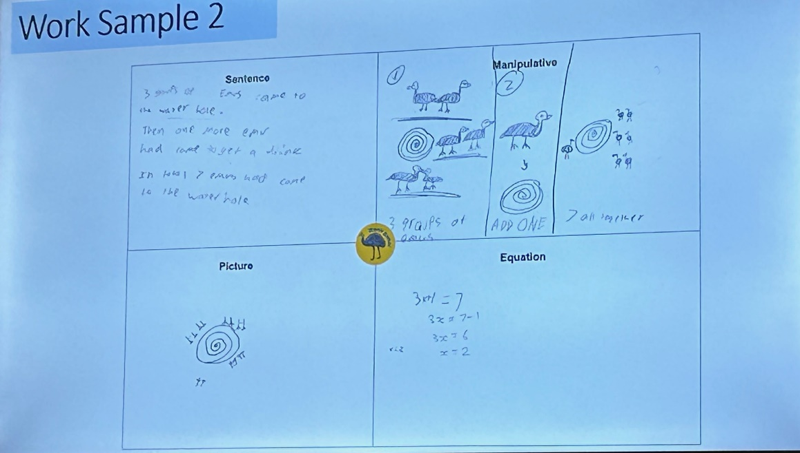
Figure 1: Student work sample from Coonamble High School demonstrating Goompi Model (Photo: Laura Barry)
The power of this model in teaching mathematics to Aboriginal and Torres Strait Islander students is that it contextualises mathematics pedagogy with Indigenous culture and perspectives and provides students with an opportunity to bring their own culture and knowledge into their mathematics learning. The approach focuses on stories and explains how symbols and their meanings can communicate these mathematical stories.
8 Ways
8 Ways is a pedagogy framework that allows teachers to include Aboriginal perspectives by using Aboriginal learning techniques. In this way, focus can remain on core curriculum content while potentially embedding Aboriginal perspectives in every lesson through processes rather than content.
Understanding these processes, and the ways of learning in Aboriginal culture to which they are connected, is essential for any teacher wanting to teach through this framework. One of the key messages I gained from seeing this framework in practice was that in order to teach through Aboriginal processes, one must first have a deep understanding of culture (one’s own and the culture in which one engages). In doing so, one is more likely to bring out the maths in the culture, rather than bringing the culture into the maths.
Like the Goompi Model, storytelling, symbols, learning maps and modelling are key elements (or learning processes) of 8 Ways. This is because the culture of the learners and how they learn is put at the heart of the pedagogy.

Mathematical metaphors and the power of Indigenous knowledge
While it might seem odd to elaborate on the use of metaphors in a study of mathematics, throughout my tour, it was through metaphors, particularly expressed by Yolŋu educators and leaders, that the pathway to seeing the culture, connectedness and creativity in mathematics was made clear. When discussing the development of Garma Living Maths, Helen Watson-Verran (1992, p.2) states that “metaphors give us strategies, tactics and categories for our actions.” It was through a strong, ancient metaphor that the success of two-way learning in mathematics in North Eeast Arhnem Land (Garma Maths) was built. Ganma is the name of a lagoon where salt and freshwater meet. Water is a symbol of knowledge in Yolŋu philosophy, and the metaphor of the meeting of two bodies of water is a way of talking about the knowledge systems of two cultures working together.
Yolngu people see a powerful metaphor in the meeting and mixing of two streams which flow-one from the land, the other from the sea-into a mangrove lagoon on Caledon Bay in NE Arnhemland. The theory of this confluence, called gaṉma, holds (in part) that the forces of the streams combine and lead to deeper understanding and truth. It is an ancient metaphor, one which has served Yolngu people well in the past. In recent discussions among the Yolngu and those non-Aboriginal Australians they have chosen to work with them, gaṉma theory has been applied to the meeting of two cultures–Aboriginal and Western. Thus, we may use the term 'ganma' in English to refer to the situation where a river of water from the sea (Western knowledge) and a river of water from the land (Yolngu knowledge) engulf each other on flowing into a common lagoon and becoming one. (Singing the Land,Ssigning the Land)
In using metaphors, it is essential that we make them visible. The same can be said for our teaching of mathematics – the purpose and relevance in learning must be made clear to students, and for Indigenous students this must be done through their culture. While it may be argued that mathematics is an objective subject, culture and value free, the extensive learning I experienced at the ATSIMA Conference and subsequent schools I visited proved this to be untrue. The keynote presentations of Dr Chris Matthews, Yalmay Yunupiŋu, Merrkiyawuy Ganambarr-Stubbs, Di Siemon and John Bradbury, as well as numerous workshops, made it clear that to see and understand an Indigenous perspective of mathematics, and to use that perspective to make mathematics accessible to Indigenous students, one must accept the premise that mathematics is intrinsically connected to culture, and has many different cultural expressions. In this sense, cultural bias is not perceived as negative, but as a powerful tool of knowledge keepers within a culture to provide much richer, diverse learning to engage with and allow students to personally connect with the subject area of mathematics and form deeper, more meaningful understanding.
One of the unique, and significantly impactful elements of attending the ATSIMA Conference was the focus of coming together to find the different messages and understandings delegates had taken from the keynotes and workshops. Some of the key take aways were the importance of valuing and communicating Indigenous knowledges, the need for quality resources to support teaching of maths in culture and the culture in maths, the failings of systems to listen to Indigenous knowledge holders for the ‘why’ and ‘how’ in improving mathematics outcomes for Indigenous students and the importance of allowing the teaching, learning and assessment of mathematics in first languages.
One of the most powerful take-aways from this final session for me was a metaphor created by one of the groups. The metaphor talks of a plant found on the coast of North East Arhnem Land that grows and renews itself year after year, with the only thing that makes it grow being fire. It is nourished by the rain of the wet season, then renewed, not destroyed, by the fire that comes in the dry season. The metaphor portrayed the idea of a maths revolution that sees the maths outcomes of Indigenous students being met through and within their culture – that spirals up and down through inspiration, reconciliation, unity, pedagogy, generations, the known and unknown, the seen and unseen, storytelling, student voice, curiosity and the wholeness of the child. Many of these concepts are not normally associated with the teaching of mathematics, but through this metaphor it provided clarity for me as to why they should be.
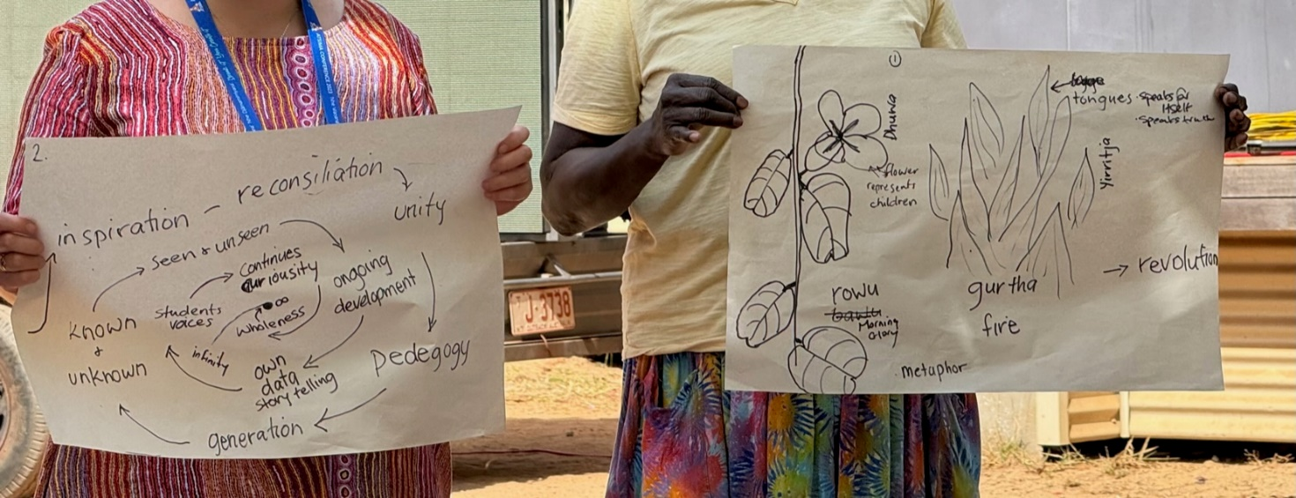
Figure 2: Metaphor of a maths revolution from closing day of ATSIMA Conference (Photo: Laura Barry)

Conclusion
One of the unexpected outcomes of my study tour has been my deeper appreciation for the beauty and creativity of mathematics, and the importance of making this beauty clearer and more accessible for all students. I’ve also learned that culture is one of the key mechanisms that enables this, not just for Indigenous students, but for ‘balanda’ like myself who are learning to listen and understand different knowledge systems to inform my practice and make a difference for students. The mathematical learning I experienced during my study tour that occurred through Aboriginal and Torres Strait Islander culture made connections in mathematics clearer – culture and connection to Country showed maths in the land, in the sky, in the ways of living, in kinship and family – and connected this back to understanding number systems, patterns, quantifying and space.
So much time learning mathematics in schools is spent on teaching through knowledges (largely Western) that start and remain in the abstract. This cuts out the creativity and opportunity for connections and deep understanding to be made in mathematics for all learners, but most notably Indigenous learners. if we want to engage and truly meet the needs of Indigenous students in mathematics, we must move away from placing higher value on non-Indigenous knowledge systems and ways of teaching and move closer to Indigenous knowledges to teach them mathematics. The examples I saw in practice in schools who were making this shift were promising and rewarding.
While questions remain on the ‘how’ of fully overcoming cultural bias in the teaching of mathematics in Australia with its complex history, my study tour did provide immense clarity around the importance that must be placed on the valuing of Indigenous knowledge, frameworks and pedagogies in mathematics and integrating these into teaching to help bridge the gap between Indigenous and non-Indigenous knowledge systems. Using, naming, and valuing the Indigenous cultural connection inherent in many mathematical concepts will allow Indigenous students to express and connect personally with mathematical ideas and understandings, and demonstrate to non-Indigenous learners the depth of understanding that can be obtained when mathematics is learned through multiple cultural perspectives. The expression of this in everyday teaching, in every classroom would benefit Indigenous students by placing their cultural context at the heart of mathematical understanding and achievement.

Acknowledgments
I would like to acknowledge and thank the schools and individuals I visited, and the NSW Premier’s Teacher Scholarship organisation and the Mathematics Association of NSW for their generous scholarship to enable me to undertake the study tour. I would like to particularly acknowledge Prof. Chris Matthews, the team at ATSIMA and the wonderful community at Yirrkala for their incredible organisation and support in ensuring authentic learning for all delegates to the conference, and for their advice and support on where else to seek knowledge and see quality teaching in practice.

References
Hogan, M. (2008). The tale of two Noras: How a Yup’ik middle schooler was differently constructed as a math learner. Diaspora, Indigenous, and Minority Education 2(2), 90–114.
National Council of Teachers of Mathematics. (2014). Principles to Actions: Ensuring Mathematical Success for All. Reston, VA: Author.
National Research Council. (2009). Mathematics Learning in Early Childhood: Paths Toward Excellence and Equity. Washington, DC: The National Academies Press.
Watson-Verran, H (1992) Singing the Land, Signing the Land: A Portfolio of Exhibits: Yolngu Community at Yirrkala. Note: online edition; originally published 1989
8 Ways - This pedagogical framework came from a research project involving NSW Department of Education staff, James Cook University’s School of Indigenous Studies and the Western New South Wales Regional Aboriginal Education Team between 2007 and 2009.

