2020 Premier’s Copyright Agency Creativity across the Curriculum Scholarship

Future Thinking – Creative, Connected & Engaged
  - Creative and innovative learning pedagogies implementing the Big Picture Learning Design
Jane Wilson
Liverpool Boys High School
Sponsored by

Introduction
Creativity, connection, and engagement drive my interest in pursuing future thinking about what creativity across the curriculum could look like. This report looks at the Big Picture Learning Design, a holistic cross-curriculum learning framework, focusing on students finishing secondary school with a Graduation Portfolio that gains them university entrance, employment, or further education and training. Its innovative and rigorous learning design is renowned for a personalised and collaborative approach to education that supports students to set a career vision, and work towards it, during their school years. This is achieved through Interest Exploration Projects (some schools call them Personalised Interest Projects), and then in Year 12 a year-long Senior Project, or, for those wanting to gain entrance to university, a Senior Thesis Project. Student growth and achievement is demonstrated by incorporating project proposals, learning plans, learning goals, collected evidence of learning and knowledge, learning through internships, and in assessment through exhibition.
Big Picture Learning (BPL) was established 1995, in North America by Elliot Washor & Dennis Littky. Big Picture Learning Australia (BPLA) was started by Viv White and John Hogan in 2006. BPL has over one hundred schools in its global network, including 44 schools in Australia. This study tour gave me the opportunity to learn more about the Big Picture Learning Design, a remarkable pedagogy that allows students and teachers to engage with learning, and to explore my belief that it is the creative curriculum. The BPLA schools and academies I visited included: two schools in Northern NSW that both started their Big Picture Academies in 2023; a 2022 purpose-built Victorian Big Picture school; and in Perth the first Australian school to implement the Big Picture Learning Design, starting there in 2007. All schools, with the exception of one, were government schools. The schools were in regional, remote, and urban environments.

Focus of Study
Looking towards North America and Tasmania, my pre-Covid, Creativity across the Curriculum scholarship application sought to learn more about the Big Picture Learning Design, and focused on how students could graduate High School with a portfolio, as opposed to a rank and score. Circa 2023, the focus of my interests developed, as had my own experiences as a Big Picture advisor. To give a framework to my study tour, I wrote my scholarship application in early 2019, having started my second year as a Big Picture advisor at Liverpool Boys High School (LBHS) Big Picture Academy. I had been a Visual Arts teacher for thirteen years. The LBHS Big Picture Academy was in its third year, and our inaugural Big Picture Year 9 students were now in Year 11. We were the only school in Sydney with a Big Picture Academy and had not yet had students graduate high school. In 2020 Big Picture Learning Australia introduced the International Big Picture Learning Credential (IBPLC) which was co-created with Melbourne University, BPLA, advisors and leaders from Big Picture schools around Australia. The IBPLC is a new way to graduate from secondary school, and be able to apply to university, gain employment or other educational pathways. LBHS is now in our fourth year of Year 12s in Big Picture graduating high school with the IBPLC. Every student who applied to university was accepted, and all our non-tertiary Big Picture graduating students have successfully gone on to further study and employment.
Developing a core belief that Big Picture is the creative curriculum, I looked at how the Big Picture Learning Design and Big Picture Distinguishers (see below) are being implemented around the country. My study tour focused on listening to and learning from leaders in BPLA & BPL, academics, students, and advisors at the 2023 National Big Picture conference and engaging with students, staff, and their learning environments around Australia.
The Big Picture Learning Design and the twelve Big Picture Distinguishers below (modified from BPLA) are a creative pedagogy that engage and empower students in their learning.
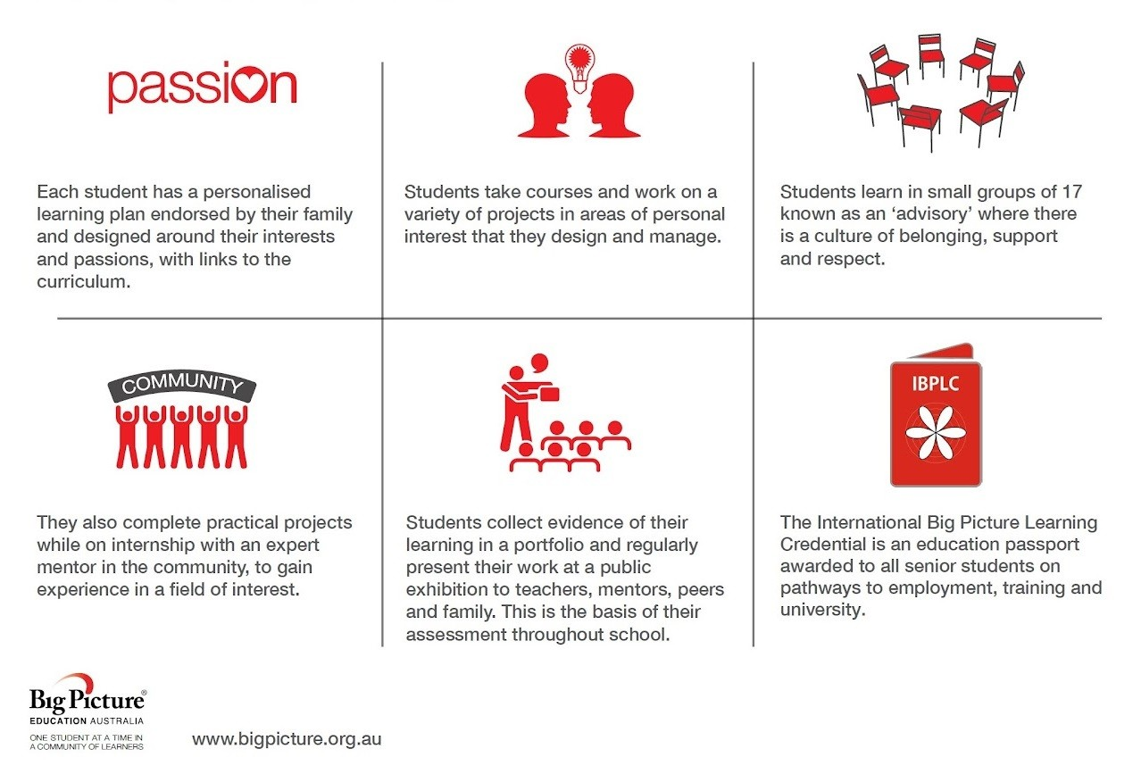
Figure 1: The Big Picture Learning Design
Big Picture Distinguishers
1. Academic rigour: head, heart and hand. Big Picture schools have a strong intellectual purpose for each student. Students are continually challenged to deepen their learning and improve their performance across six learning goals: Knowing How to Learn, Quantitative Reasoning, Empirical Reasoning, Communication Skills, Personal Qualities and Social Reasoning.
2. Leaving to learn: learning through internships. Students work two days a week in an interest-based internship with a mentor from the community on an intellectually rigorous real-world project that is connected to their learning goals.
3. Personalisation: one student at a time. With the help of the advisory teacher and parents, each student develops a learning plan that explores their interests and passions, and identifies personal learning goals, authentic project work and wider curriculum requirements. This plan is reviewed and updated regularly.
4. Authentic assessment. Each term the students exhibit their portfolios of work to a panel made up of the advisory teacher, family, peers, the mentor, and others from the community. They provide evidence of progress against their learning goals and they reflect on the process of their learning.
5. Collaboration for learning. Students work in one-on-one or small group learning environments around their interests both inside and outside the school. Through internships, the community plays an integral role in the education of the students.
6. Learning in advisory. Students are in an advisory group of no more than 17 students and an advisory teacher. They stay in the same advisory for much of their secondary education. The advisory teacher manages each student’s learning plan.
7. Trust, respect and care. One of the striking things about Big Picture schools is the ease with which students interact with adults in both the school and the wider community. A culture of trust, respect and care is shared between students and adults, as well as among students themselves.
8. Everyone’s a leader. in Big Picture schools, leadership is shared among the principal, staff, students, family, and community partners. Opportunities for leadership are created for everyone.
9. Families are enrolled too. Big Picture schools aim for real family engagement. Parents or carers are regarded as essential members of the learning team, beginning with the application process and progressing through to learning plan development, exhibitions and graduation.
10. Creating futures. All students are expected to graduate from school to further learning. They are prepared for, and connected to, opportunities for learning at university and/or other further education.
11. Teachers and leaders are learners too. New ideas constantly emerge as part of the learning cycle process. Teachers and leaders in Big Picture schools and programs regularly attend to new ideas and learn new ways of working. They develop reflective practice and find ways of sharing this learning with others.
12. Diverse and enduring partnerships. A Big Picture school has a strong focus on building and creating external partnerships. These include partnerships with: the family, mentors, local councils, businesses, universities, TAFE colleges and other training providers. These partnerships give students the opportunities to pursue their learning and achieve their goals.
I was excited to immerse myself in a tour of Big Picture schools, offering me a valuable opportunity to delve into its unique educational design. Stepping into these innovative learning environments would offer a firsthand experience of how theory translates into practice and witness the dynamic interactions between students, teachers, and the broader community, which exemplify the Big Picture Learning Design’s commitment to real-world, experiential learning. I could explore the intentional cultivation of trust, respect, and care that underpins the school culture, where every member of the school community is encouraged to contribute and collaborate. Observing how Big Picture schools prepare students for future learning opportunities and empower them to craft their own educational pathways. Overall, a tour of Big Picture schools would enable me to look into its educational design and further understand the transformative power of student-centered, holistic education.
Spending the first five weeks of Term two visiting ten Australian schools that have Big Picture, I wanted to talk with and observe students in Year 9 – Year 12, educators and school leaders. I visited Silkwood Senior School Gold Coast (Queensland), Kingscliff High School and Murwillumbah Learning Community High School Big Picture Academies (northern New South Wales), Hobart City High School Big Picture Academy (Tasmania), Croydon Community School Melbourne (Victoria). I then attended the 2023 National Big Picture Conference in Gosford and visited Morisset High School Big Picture Academy (central coast New South Wales). Traveling across to Western Australia to visit Karratha Senior High School Big Picture Academy, Roebourne District High School, Yule Brook College and Halls Head College Big Picture Academy, I then ended my study tour meeting with Big Picture Learning Australia co-founder and Honorary Research Fellow at Murdoch University John Hogan.

Significant Learning

Future
At the beginning of my scholarship application, I focused primarily on understanding the experiences of students within the Big Picture Learning Design. However, as I continued my research, it became clear that we must also take into account the perspective of educators. Many educators anticipate that their roles will come with significant challenges, and indeed, research shows that these challenges often pave the way for valuable pedagogical insights and innovations. Nonetheless, if educators are not stimulated and inspired in their work and school environments, it can hinder the development of innovative teaching practices. Current education models not aligned with modern times have this effect. The connection between educators' well-being and their ability to foster innovative teaching methods requires careful consideration.
My experience as a Big Picture advisor has been intellectually stimulating and everyday, creative learning is apparent; I was curious to know if other Big Picture educators felt the same. At each school visited, educators were focused on the learning of the student. One principal spoke of how in Big Picture you “start where the student is at and you move at their pace”. Speaking to teachers and school leaders, I heard how this element of personalisation gave them a sense they were doing more for the students. “Big Picture is flexible, there is always another plan.” said one advisor. Another commented, “It’s creative because students share their learning”. These pedagogical practices of personalisation nourished the students and teachers experience of being at school.
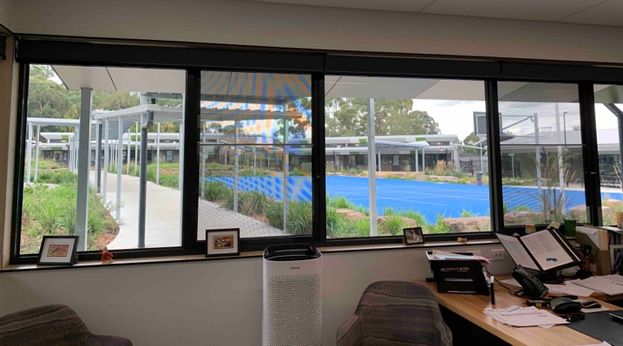
Figure 2: Principal’s office in a purpose built Big Picture School, Croydon Community School, 2023 (Photo by Jane Wilson)

Thinking
In all the schools I saw student agency, as I was welcomed into each ‘advisory’. In Big Picture a class is called an advisory, and each advisory has an advisory teacher, known to students as their advisor. An advisor has seventeen students who stay with them across their schooling, often from Year 9 to Year 12. Variations can occur depending on student numbers or the number of advisories at a school. Some advisories had mixed year groups and some schools had advisories from Year 7 through to Year 12. A creative practice I saw was the advisory check-in; most advisories started the day with an advisory check-in where the teacher and students came together. This collaborative practice connected students and developed their personal qualities, building confidence and support.
Another innovative pedagogical practice in the Big Picture Learning Design is the one-on-one advisor check-in with each student. These were done on a regular basis and allowed for depth, breadth and accountability in each student’s learning. I was privileged to sit in on advisor check-ins, as students talked about what they were working on and learning about, their challenges and highlights. From these advisor check-ins, students develop skills in their communication. Many were highly articulate in their ability to express and discuss their acquired knowledge, both practical and theoretical. I noticed that students were comfortable talking with adults, and this was reflected in all my observations and discussions with students. Year 9 students in their second term in a Big Picture advisory were already commenting, “I like having one teacher, I feel known”. This was echoed in all my discussions with students, I heard how many of them hadn’t felt seen or heard in mainstream education. “I like having one teacher and one room,” said another student. Students were able to identify the one teacher (advisor) and one room (advisory) as an element that bridged their connection in learning and attending school.
In talking with the students on my study tour, I often included the question, ‘What allows you to learn in Big Picture?’ Responses from students in Year 9 to 12 were very consistent from school to school, with comments such as:
- Flexibility. I can learn at my own pace, change and discover as I go. I like independence.
- Without opportunities, like Internships, I wouldn’t have discovered what my passion is.
- Big Picture lets me be myself, coming up with my own ideas.
- I like not moving classrooms all the time. My advisor notices things I don’t.
- Allows me to learn by doing projects. I can figure out my own style, it’s a cycle.
- I can spend more time on things I like rather than the things that don’t mean anything to me.
These responses highlighted students’ awareness that their ‘teachers gaze’ in the Big Picture Learning Design is directed at them and their learning (Sandra Millican spoke of this at the conference). On my study tour I heard students in Big Picture schools in the city express, “The advisor relationship helps grow your confidence”. They had the same positive experience and student agency in their teacher relationship as students in remote communities: “Smaller classes, teachers talk to you (like people), helps you gain confidence”. “I like having our own room (advisory)”. Around the country students identified this crossover between smaller classes and one main teacher who you stay with, and learning towards a more modern education system. This is foundational if we want to achieve successful creative change in educating young people.
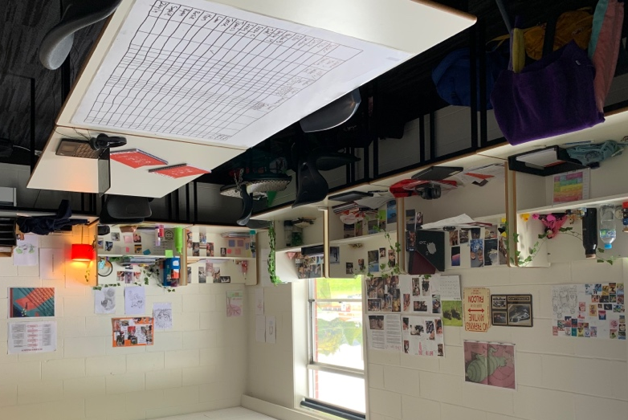
Figure 3: Big Picture Advisory at Hobart High School Big Picture Academy 2023 (Photo by Jane Wilson)

Creative
On my study tour, I saw how the Big Picture Learning Design allows for a personalised curriculum and this is where the heart of its creativity lies. The Big Picture Learning Design in all its essence is a creative curriculum, as one school leader stated, “Curriculum is every learning experience”. The Big Picture Learning Design allows for all learning experiences to be a component of a student's assessment, not just limited to school hours. I saw students who played soccer, or did a shift at McDonalds on the weekend, bring these aspects of their lives to their advisor. Together at their advisor check-in they explored which Learning Goals these qualities fall under and how the student can collect evidence of their learning in the real world. Within Big Picture schools, a pervasive culture of trust forms the cornerstone of the learning experience, wherein students are entrusted with greater autonomy and responsibility. Mutual respect is deeply ingrained, allowing for constructive engagement between students and educators, as well as among peers.
Advisors spoke to me about how they use the six Learning Goals that have links across the curriculum but are not specific to any one Key Learning Area. These Learning Goals are a cross-curricular learning framework balancing practical experience and educational learning. The Big Picture Learning Goals are: Knowing How to Learn, Empirical Reasoning, Quantitative Reasoning, Communication, Personal Qualities and Social Action. They are not in a specific order nor do the outcomes require grades, percentages or rankings.
The Big Picture Learning Design cycle is a dynamic process where new ideas continually emerge and evolve. Teachers and leaders actively engage in ongoing professional development, immersing themselves in the ever-expanding landscape of innovative pedagogies and methodologies. This commitment to growth fosters reflective practices that deepen their understanding of effective teaching and leadership.
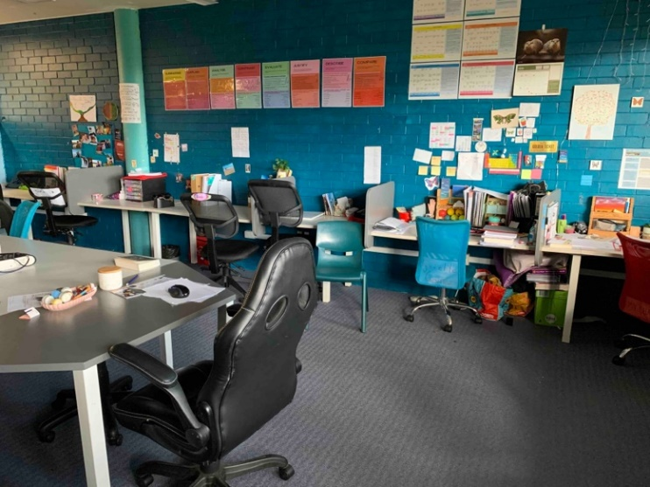
Figure 4: Big Picture Advisory, Morriset High School 2023 (Photo by Jane Wilson)

Connected
Curious about the student learning environment and its effect on a creative curriculum, it was of great interest to see how classroom design and the learning environment impact students' creativity and engagement with their learning. Creativity involves both internal and external dimensions. Within the Big Picture framework, students have a designated physical space they visit daily, known as the advisory rather than traditional classrooms. In this arrangement, Big Picture students have individual desks that they can personalise, and a larger table or space where the whole advisory can come together. The advisory's physical layout is intentionally designed to facilitate both independent and collaborative interactions among students and adults. Each advisory I walked into felt inviting, and I saw a physicality and a connectivity between learners, their advisor, and other adults. Students had greater agency than in a regular classroom, and appeared more connected to the space.
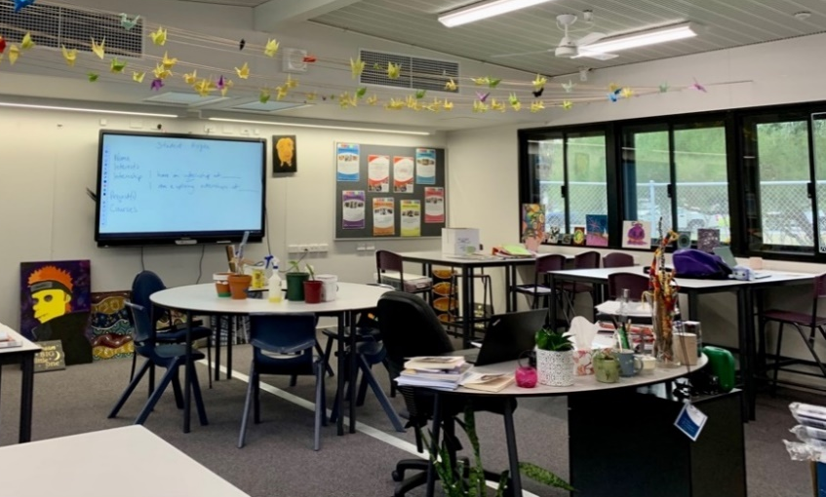
Figure 5: Big Picture Advisory, Yule Brook College 2023 (Photo by Jane Wilson)

Engaged
Attending the 2023 National Big Picture conference I learnt from innovators in Big Picture, including American co-founder Elliot Washor, and academic Sandra Milgen, Executive Director and Enterprise Professor and Assessment, University of Melbourne. In Washor’s keynote address, he spoke of Big Picture being a school (system) where each student is the curriculum. North American Big Picture Learning schools are beginning to implement the IBPLC. He explained how the uniqueness of the IBPLC approach assesses "how you are smart" rather than simply "how smart you are." This innovative pedagogical approach broadens the scope of student learning by emphasizing that a student's unique strengths and talents are integral to their educational journey. This perspective actively promotes the integration of creativity throughout the curriculum. On my study tour, I heard how numerous students felt overlooked or invisible in mainstream courses, whereas in the Big Picture educational model, they experienced a sense of recognition and visibility.
Students also expressed to me how the syllabus limited their ability to show what they can do. Interestingly, it was not a specific type of learner or student who communicated this to me. Those who were highly academic expressed the same conclusion as students struggling with the work at school. I understood it was less about the student and more indicative of a system that limits students' learning. The flexibility of the Big Picture Learning Design was discussed at the conference, how the school day looks, discussions of where the advisor or students place different parts of learning in different parts of the day. This is what I saw at each school, and is a unique component of the Big Picture Learning Design.
Sandra Milligan’s address discussed how previous educational assessments don’t tell if students can engage with content – that the teacher’s gaze is directed to the syllabus not the student, and the assessments are about ‘knowing’ (not) ‘knowing how’. Traditional educational assessments often fall short in determining a student's ability to truly engage with the development of practical skills and critical thinking abilities. To effectively involve young people in co-creating their own career pathways for successful futures, a shift is needed from a "knowing" approach to a "knowing how" approach. Milligan’s research and observations aligned closely with the experiences I encountered in all the schools I visited during my study tour
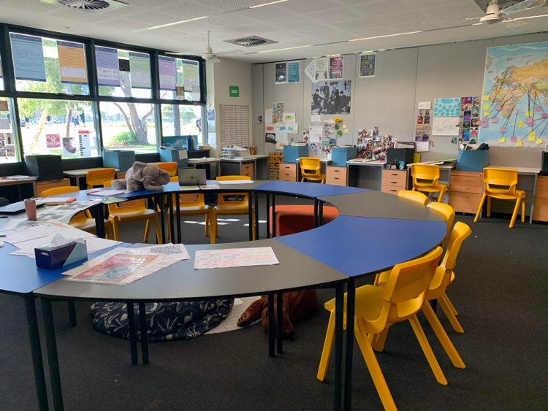
Figure 6: Big Picture Advisory, Halls Head College Big Picture Academy 2023 (Photo by Jane Wilson)

Conclusion
This study tour gave me the opportunity to see firsthand how we achieve excellence in the Australian education system, by creating a shift from “the current, industrial model of schooling to a model focused on individual student growth and achievement”. (The 2018 Through Growth to Achievement: Report of the Review to Achieve Educational Excellence in Australian Schools) Pivotal to this reform, is the recognition that empowering students to develop their own path of learning leads them to greater success. There are now eighteen schools in NSW with Big Picture – four schools and fourteen academies – and it is growing. Concluding my study tour meeting with John Hogan, I reflected on my visits to all the schools. Hogan noted that implementation of more Big Picture schools across the country will attend to the agenda of each student learning. Positioning the Big Picture Learning Design and the implementation of ‘All the design all of the time’, concurring with his belief that the Big Picture Learning Design is for all students – for those that are academic, and for those who want a trade or another pathway to a prosperous future.
A student I spoke to expressed that they “feel excited being in Big Picture”. Having looked at creative and innovative pedagogical practices used in Big Picture schools and academies around Australia, I also feel excited being an educator implementing the Big Picture Learning Design, working with others at Liverpool Boys High School and in the Big Picture Learning Australia and Global Big Picture Learning networks. This study tour has confirmed my belief that as a result of personalised learning in the Big Picture Learning Design, it is the creative curriculum creating success for students. In Big Picture schools, the expectation is not just for students to graduate, but to embark on a lifelong journey of continuous learning and personal growth. This holistic approach ensures that every graduate is not only academically equipped but also connected to a vast array of opportunities for further learning. Students are able to complete their secondary studies ready for their next learning stage of life in tertiary education, employment or further education. Within the Big Picture Learning Design, it is possible to equip students to be creative, connected and engaged learners.

Acknowledgements
I’d like to acknowledge:
- the Copyright Agency Cultural Fund and Nicola Evans for their sponsorship and belief in creativity and learning
- the NSW Premier Teacher Scholarship team for their support and assistance
- Lana Lewis for her mentoring support
- Big Picture Learning America and Big Picture Learning Australia, for all their generosity, knowledge and support in the organisation of my study tour, and their continual innovation of the Big Picture Learning Design around the world
- the Big Picture Academy staff and students at Liverpool Boys High School, and Mike Saxon, my principal to whom I will be forever grateful to for introducing me to such an outstanding, creative and stimulating design to educate young people
- a heartfelt thankyou to all the inspirational and generous staff and students at the schools I visited.

