Premier’s History Teachers Association History Scholarship

Plumbing the depths
  - Maritime archaeology in education
Sasha Joura
Vincentia High School
Aboriginal and Torres Strait Islander readers are advised that the following document contains an image of a deceased person.
Sponsored by
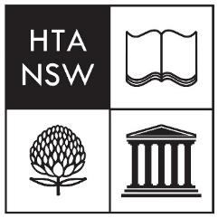

Introduction
An understanding of history requires an understanding of humanity’s relationship with the sea. Maritime archaeology is a growing field that demonstrates just how crucial this relationship has been in the past and how important it continues to be. By examining case studies of shipwrecks and using maritime archaeology as a focal lens to explore historical events and periods, students are pushed into exploring the complexities and connectivity of history, developing tangible real-world skills. The appeal of using shipwreck case studies and activities that mimic the real work of a maritime archaeologist is the high levels of engagement. A shipwreck is a single moment in time captured and preserved. It is not just any moment in time; it is a disastrous, life-threatening, catastrophic moment, that will capture the attention of any student. By providing inquiry-based learning sequences and hands-on activities, history can come alive.
There are several areas where maritime archaeology already fits well within the NSW history syllabus. Clear links exist to Stages 4, 5 and 6 history topics, such as Vikings, Movement of People, Australians at War, and the new topics on the Nature of Modern/Ancient History. Some maritime archaeology sites could even link to historiographical issues in Extension History. This will be a fresh approach to the junior history topics where students become the archaeologists investigating the shipwreck and accompanying artefacts. In the senior course, students will build on these skills and include higher order source analysis and evaluation of historical significance. The intended outcome is for students to learn the essential skills of history while being stimulated, challenged and invested in their own learning.

Focus of Study
The focus of my study tour was to explore and develop a deep understanding of how maritime archaeology can be included into the curriculum. This involved meeting with education staff, maritime archaeologists and other specialists to discuss successful strategies and where possible, observe their practices with school groups. It also included visiting and documenting significant maritime archaeological sites with the objective of creating new teaching and learning resources.
The areas I focused on were:
- Stage 4 Vikings
- Stage 5 Australians at War
  - Sydney II and Kormoran battle
- Stage 6 Nature of Modern History
  - 1629 wreck of Batavia
- General maritime archaeology and engagement practices
Though there are other opportunities within the syllabus to include maritime archaeology, I focused on these because they convey the range of possibility, from the pre-medieval era to far more recent times, and from the other side of the world to our own backyard. There are several more opportunities to integrate this approach in many ancient history topics which would cover an even broader timeline, but that was beyond the scope of this project.

Significant Learning
The burgeoning field of maritime archaeology is a clear example of how teachers can broaden current topics and increase student engagement with fresh, fun and challenging activities in the classroom. Creative and critical thinking is integral to the processes involved in being the archaeologist; making a hypothesis, posing relevant questions, finding evidence in a variety of sources, and arriving at a conclusion. Not only do students learn the processes used in archaeology, but also the meaning, purpose and context of historical sources. As their skills develop in Stages 5 and 6, they will learn to analyse and synthesise evidence from different types of sources to develop reasoned claims, identify weaknesses in their own and others’ positions, and form their own opinions about historical significance.
Maritime archaeology also fits clearly into the current Science, Technology, Engineering, Arts, Mathematics (STEAM) trend in education. It is an unusual blend of science, technology and historical inquiry, and as such it would benefit from being integrated into a cross-curricular framework. It can link to almost every other subject in the curriculum, including English, maths, many of the sciences, art, design and technology, and more. Students will come to understand the value of archaeology in developing new perspectives and interpretations of past events.

Vikings
During my study tour I visited several Viking era landmarks in Denmark, Sweden, and in the United Kingdom. The purpose of these visits was to record artefacts and sites, meet with learning organisations, and increase my understanding of this period.
One of the highlights of my tour was spending the whole day at the Viking Ship Museum in Roskilde, Denmark. The most remarkable aspect of the museum is the remains of the five Viking ships that were pulled out of the harbour and painstakingly reconstructed for display. It is also a working museum, with staff using the information gained from archaeology and the insights from modern shipwrights, foresters and other professionals, to build replica ships and artefacts. I had the opportunity to sail on a Viking replica ship and steer her back into harbour. The museum is a world leader in the field of experimental archaeology and in their boatyard they had their current project, the half-finished second replica of Skuldelev 3 (the first being no longer seaworthy). Their current work is being informed by the understanding gained during the first reconstruction.
I observed a Danish school group taking part in hands-on activities, such as using axes to split timber, working with ropes, and building model boats to then test in the pool. These types of activities are invaluable for students in not just enjoying their learning but building their knowledge with practical activities. It helped me to develop an artefact-centred program and a research-based assessment task for Year 8. Students begin with basic inquiry questions about the artefact which lead to further questions about how that object links to daily life or other key sections from the syllabus. This then scaffolds the research assessment, culminating in the students’ creation of a replica or model.

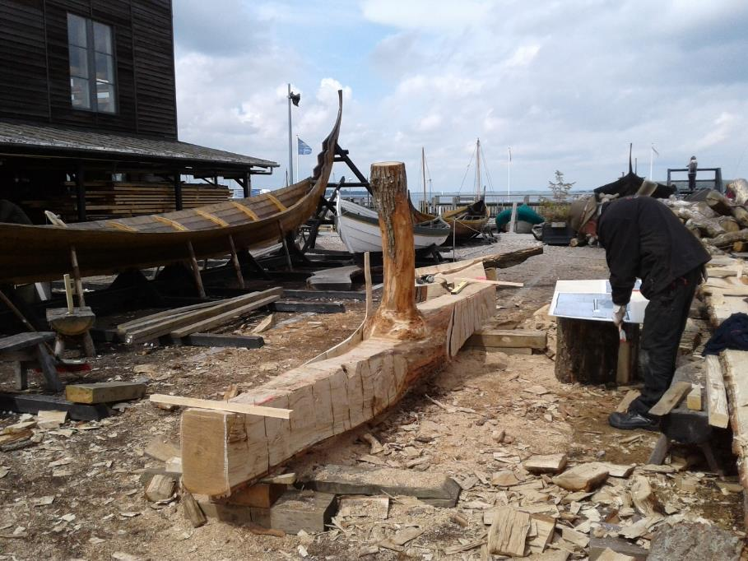
Figure 1: Timber for the keelson being shaped with half-finished replica of Skuldelev 3 in the background (Photo by Sasha Joura)

Australians at War
My focus for this Stage 5 topic was to learn more about the battle between HMAS Sydney (II) and HSK Kormoran in 1941. The battle culminated in the destruction of both ships and total loss of life on board Sydney. When teaching Australians at War, teachers often fall into the pattern of focusing on the well-known Australian engagements – Gallipoli in WW1 and Kokoda in WW2. Undoubtedly some teachers go beyond this, but I feel that by teaching some of our naval engagements and using the evidence of world war-era shipwrecks, we can hope to increase the depth of students’ understanding and present them in a new light.
This case study also shows the value of archaeology in bringing new, irrefutable evidence to a controversial topic. Since the government’s initial silence on the sinking of Sydney in November 1941, there have been multiple theories about how a seemingly inferior converted freighter could defeat and sink the Sydney, that was faster, had more guns and more men. With barely a trace of the Sydney recovered and only German accounts to tell the story, when the ships were discovered in 2008, the deep-water imagery both confirmed and denied various theories and gave far more information about its last moments than would have otherwise been possible. A later expedition in 2015 to collect further images showed the deterioration over just a short period of time, and how important it is to find and record these archaeological sites for future generations.
I visited the Sydney Memorial in Geraldton, as well as the excellent display at the Geraldton Museum, and a kind volunteer also drove me out to visit the grave of Australia’s lesser known unknown soldier, a Sydney sailor whose body washed ashore in a Carley float on Christmas Island.
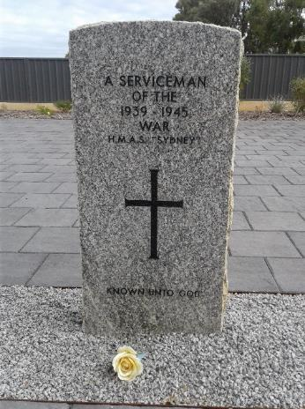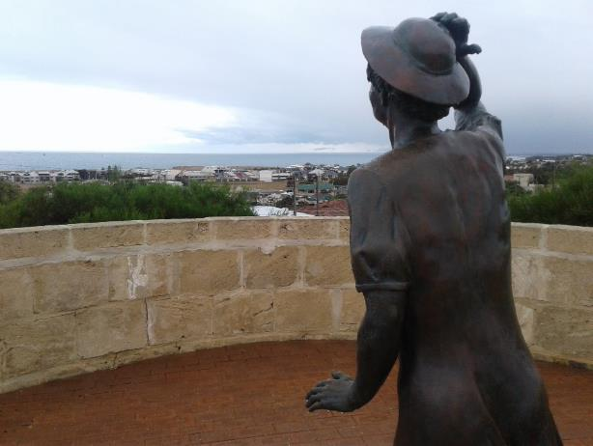
Figure 2: Grave stone at Geraldton Figure 3: The Waiting Woman sculpture at the Sydney
Cemetery of the unknown Sydney memorial, Geraldton (Photo by Sasha Joura)
sailor (Photo by Sasha Joura)
The Sydney Memorial in Geraldton could also link very well to the concept of Representation and Commemoration of the Past as an option in the Nature of Modern History topic, but further work will need to be done to outline this fully.
The idea of preserving our wartime heritage and using the archaeology to help inform our understanding of events was also evident when I visited the scuttled WW1 battleships of the German fleet in Scapa Flow, in the Orkney Islands. Although they are not part of our Australian heritage, extensive work has been done to survey the ships and their artefacts and keep them protected as war relics. You can imagine my surprise when, on my return to Australia, I discovered that the wrecks, included the two I had dived on, were up for auction on eBay! These kinds of discussions, such as who owns history, are vital in our classrooms in order to develop critical and ethical thinkers.

Nature of Modern History
Having read extensively about this topic, finding out more about Batavia was one of the areas I was most excited by during my scholarship tour. I was able to meet Hugh Edwards, who is an invaluable primary source as one of the discoverers of the wreck and a member of the excavation team. His first-hand memories were fascinating to provide additional detail about the early archaeology that was undertaken.
Also invaluable was being able to visit the Houtman Abrolhos islands, off Geraldton, where Batavia was wrecked. I was able to document several parts of the site from the low-altitude flight and from on the ground at East Wallabi Island. Being able to see the sites which Commander Pelsaert wrote about in his journal almost 400 years ago gave me a far greater insight than the text alone. It allowed me to see the story of shipwreck and the following massacre through the eyes of those present. For instance, the low scrub growing across the island group indicates how hard it would have been to hide from the tyrant Cornelisz and his band of murderous followers. Seeing a shark swimming through shallow water from the plane also goes to show how many of the survivors, even though they may have escaped, could not have made it to the safety of one of the surrounding islands. All these factors helped me to more completely understand the challenges faced by those who survived the wrecking event.
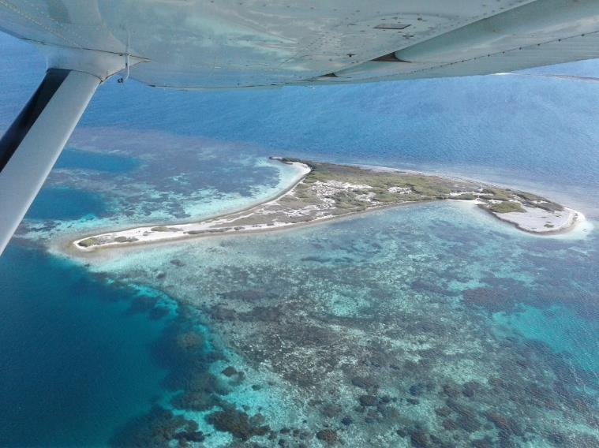
Figure 4: Batavia’s Graveyard, now known as Beacon Island was where the shipwreck survivors landed and the location of the massacres (Photo by Sasha Joura)
I also spent time at the Shipwrecks Museum in Fremantle and the Geraldton Museum, both of which have extensive galleries on the Batavia shipwreck and the items recovered from the reef and the survivors’ camp. These have given me a multitude of ideas about how shipwrecks and their artefacts can be used in the classroom. It also emphasised the oversight in the Modern History syllabus regarding the study of human remains, even though this is included in the Ancient History syllabus. Modern history students have just as much need to be able to cope with the symbolism of death and consider the ethical concerns regarding the display of human remains. Archaeologists have learnt much from the skeletal remains found on Beacon Island and have in some cases been able to reunite skeletons with missing pieces (see image below). Providing it is approached sensitively and appropriately, the study of human remains provides a venue for creating a history mystery lesson sequence with students to assess the identity of a skeleton and cause of death. This allows students to develop teamwork skills, observation and skills in deductive reasoning. With new technologies, the Western Australian Museum has also created 3D images of some of the artefacts associated with Batavia and its victims, including another skull. These types of artefacts and their replicas have a great potential for developing rich understanding of the topic and fostering student empathy.
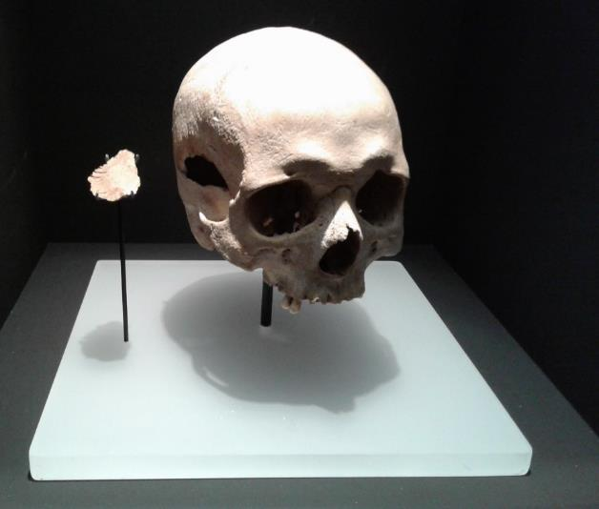
Figure 5: Skull from a male age 21-29. It was excavated on Beacon Island in 1964 but there was a large slice of skull missing. A more recent excavation in 2015 recovered the missing piece and they were reunited in public display. (Photo by Sasha Joura)
Beacon Island, and more recently Long Island, where the mutineers were hung on Australia’s first gallows, continue to be researched and excavated by Australian and international archaeologists. For a site first found almost 60 years ago, it is vital in showing students the ongoing importance of maritime archaeology and how it continues to teach us about past events. Our understanding of history is constantly evolving, due to new findings, research, and evidence, and we must never commit ourselves to thinking that we know the whole truth about a moment in time.

General Maritime Archaeology
While on my study tour, I also visited places and met with organisations that may not have a direct link to our syllabus, but which showcased the best ways to engage public audiences with maritime archaeology. This included the Cornish coastline and its museums and shipwreck trails, Maritime Greenwich and the Cutty Sark, the Vasa museum and the Mary Rose museum. I also had meetings with Rockingham High School (WA), members of the Batavia Coast Maritime Heritage Association (WA) and educators from the Maritime Archaeology Trust (UK).
The opportunities to meet and discuss with experts in the field of maritime archaeology, and especially those with a background in education and outreach, was very helpful in demonstrating how they approach the learning activities. One of the main patterns I noticed was that most maritime archaeology programs focus on primary school groups. Most museums indicated their topics fit better within a primary curriculum (especially in the UK), and that lack of manpower to develop secondary programs was a factor.
Most places had excellent ideas for engaging students with history through the stories of shipwrecks and several mentioned specifically that their aim is to allow students draw connections between themselves and the past. Several emphasised hands-on activities with the use of artefacts, either from a sacrificial collection or replica objects (which has since inspired me to take up leatherworking and create replica Viking objects for my students). I saw some of these sessions in action, and it allowed the students to share their observations and make links to current events and issues (e.g. linking maritime archaeology with rubbish found on underwater sites). Students had to deduce the use of an object and infer information about who may have used or owned it. Some sessions used the combination of artefacts and written sources to help students create a timeline of an event such as the wrecking of the Mary Rose, and to evaluate the most likely cause of sinking by looking at sources from a variety of perspectives. Students also evaluated these sources for their perspective and reliability. Information and resources to present these sessions is easily accessible and could be delivered in a classroom by any teacher of history.
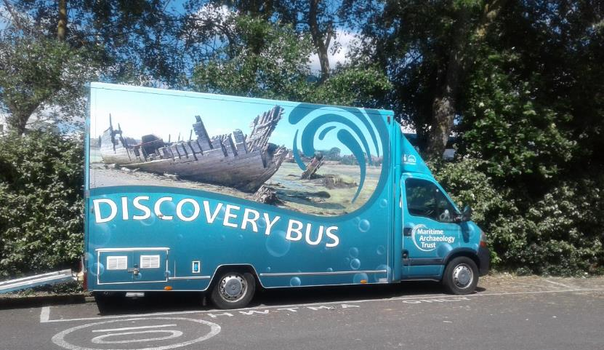
Figure 6: Discovery Bus used by the Maritime Archaeology Trust (UK) to visit schools (Photo by Sasha Joura)
Another motif I witnessed across all my visits was the excitement from students who were taking part in a maritime archaeology program, whether it was beginning their diver training on the wreck of the Omeo in WA, participating in a history mystery session at the Mary Rose museum or using axes in the boatyard at the Viking Ship museum. This enthusiasm validated my reasons for choosing this focus area, because at the end of the day we want our students to love history. Exploring history through maritime archaeology seems like a sure-fire way to do this. “I don’t know what it is, but I’m fascinated to find out!” (Year 4 student examining a ship’s log during an artefact session at the Mary Rose museum).

Conclusion
The study tour provided me great insight into how museums and other institutions present maritime archaeology to public groups, including students. The study tour allowed me to immerse myself in several topics across Stages 4, 5 and 6. It deepened my understanding of the practices used by maritime archaeologists in the field, whether it is underwater or ashore, and some of the challenges faced by maritime archaeologists today.
These visits provided many different ways to increase interest in our maritime heritage. Some of these are hands-on activities to mimic the skills used by maritime archaeologists when surveying or excavating a site. Others are activities designed to test students’ skills in deductive reasoning, making evaluations on evidence and working with artefacts. All of them are valuable, and I have begun writing new lessons and learning sequences, the first of which have already been used with great success in my own classes.
The main means of dissemination to other history teachers will largely be through the avenues of the NSW History Teachers Association. I shared my initial findings at the state conference in July and may also present at the History Teachers Association of Australia national conference. I intend to submit my learning resources and/or programs for publication in the HTA’s Teaching History journal. I will also share my research with other groups. In October I will be presenting a paper at the annual conference of the Australasian Institute for Maritime Archaeology (AIMA). This provides an exciting opportunity to share not with colleagues, but with professionals and students in maritime archaeology and encourage them to be open to and get involved with their local schools.
During my study tour, I plumbed the depths, and my experiences suggest that maritime archaeology, although not mentioned specifically, already exists in the syllabus in the guise of topics across Stages 4, 5 and 6. It can be used to explore familiar topics with a fresh approach and engage students with their learning. It provides a way for students to grow their knowledge about historical periods and events, and develop critical thinking, investigation and research skills that will be applicable in real-world scenarios. Through some of the ideas outlined in this report, and with the materials I will develop, it is now up to teachers to bring it to the surface.

Acknowledgements
My sincere thanks go to the History Teacher’s Association of NSW for their sponsorship through the Premier’s Scholarship program.
For the unpayable debt of first introducing me to history, my deepest thanks also go to:
Bruce Dennett
Maxine Ward

