Premier’s Kingold Chinese Language Teacher Scholarship

Engaging teens learning Mandarin
  - Strategies to boost engagement
Rebeca Tamas
Warners Bay High School
Sponsored by

Introduction
“What do you call someone who speaks three languages? Trilingual. What do you call someone who speaks two languages? Bilingual. What do you call someone who speaks only one language? Australian.” - Burridge & Stebbins, 2016 in Vlahakis, 2012
It is important find strategies that best engage high schools students in learning Mandarin because Australia’s language deficit is a threat to our role in the global economy. The rest of the world is increasingly becoming bilingual, often trilingual or polyglots. Nonetheless, in Australia, we are not devoting sufficient time, resources and effort to learning additional languages. Australians are unequipped for future economic growth with China as the leading power where English is not an official language. Donald Horne coined the term “lucky country” to ironically highlight that our natural resources have rendered us complacent in our prosperity (Piller, 2010). Michael Clyne (2005) recognises our greatest skills shortage is a national language deficit that will harm our security, prosperity and role in a competitive global economy. Our largest linguistic deficits are with the fastest growing developing markets.
The nature of foreign languages as mandatory for only one year of schooling in NSW further exacerbates the “monolingual mindset” (Clyne, 2005). It is essential for Australian language education to prepare students for the future in which Mandarin will provide them with leverage in their careers and business goals.
In addition, the level of difficulty involved in learning Mandarin to general proficiency takes approximately four times longer than languages closely related to English (Effective Language Learning, 2019). The two major factors of this difficulty for English speakers are tones (yīn) and written characters (Hanzi). For teachers to maintain the motivation levels of students in an elective context, we must proactively and creatively craft lessons that make use of memory techniques, actions, tunes to remember vocabulary and games. That is to say that language teachers need a pedagogical toolkit that goes beyond best practice.
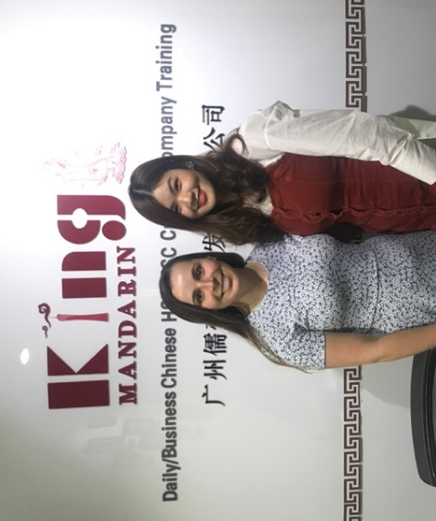
Figure 1: King’s Mandarin Language Teacher trained in engaging teaching methods (Photo by Rebeca Tamas with permission of King’s Language School)

Focus of Study
The aim was to find engaging teaching practices that are based on real-world language use, teaching Mandarin in a way that it is learnt when growing up. I then aspired to report strategies back to teachers in Australia to improve their teacher toolkit. I travelled through China visiting private language schools, international schools and universities that teach Mandarin to foreigners. I conducted teacher discussion panels, student interviews, observed language lessons and drew upon my teaching experiences in Australia. Between the 24th March and the 26th April I visited a variety of institutions for multiple days to gain a deeper understanding of their practices.
- King’s Mandarin, Guangzhou
- Yale International School Fuzhou
- LTL Mandarin, Shanghai
- Yew Chung International School, Qingdao
- Lanzhou University
- Xi’an Hanova International School
- Yew Chung International School, Beijing
The strategies I found that worked best had authentic language use at their core. This means that teachers chose topics that were relevant, students were given opportunities to listen, imitate and take risks reproducing.
These schools also taught foreign languages using a balance of Engage, Study, Activate (ESA) and Total Physical Response (TPR). Jeremy Harmer’s ESA approach tried to collate all the good things about existing theories into one teaching approach. Firstly, engaging students in the lesson through games to get students talking and thinking in the target language. Secondly, studying board work and activities based on the lesson focus. Finally, activating this knowledge using a realistic scenario for communication. The games part of the lessons often used TPR for songs, games and flashcards in the target language. In this way, students were associating target language vocabulary with actions that helped them consolidate the meaning.
ESA and TPR approaches combined were prominent in the best practice lessons. These methods involved songs, actions, flashcards, stories and games; methods which language teachers have been using for a long time. This provides students with a chance to use the language in context. There has been extensive research supporting these methods common to successful language teaching. Paired with authentic assessments, students have an environment in which they are likely to become passionate learners.
Every language lesson has multiple considerations for deciding which pedagogical tools to use. TPR method is most suitable with learner groups from infants to eighteen years old. Some students may come to high school with prior knowledge in the target language or even background speakers. The classroom is a complex space and the methods presented here are just some of the endless opportunities teachers have to make lessons engaging.
Use of positive reinforcement by way of praise, stickers or prizes may improve achievement and/or behaviour but could also devalue the intrinsic motivation of students curious to learn a new language. Each teacher makes this choice according to their context. Nonetheless, it was observed that common practice was for the teacher to tally five positive moments that students can trade in at the end of the lesson for a reward prize or award.
As a guiding text, teacher-made booklets or textbooks were considered valuable by most language teachers. These texts keep students and teachers on track, allow students to move at their pace and ensure productive work is completed in the case of unexpected teacher absence. Different texts and PowerPoints were used by all schools, only the highest quality language classrooms used flashcards. In addition, the use of names and thinking music in the classroom were also used as appropriate in high quality learning environments.

Significant Learning

Flashcards
Standard practice in the language classrooms visited was the use of whiteboards / smartboards supplemented by the use of flashcards. Flashcards are one of the most effective strategies for several reasons. The expectation is clear to students that these are the key words to learn, they can study them independently at a time that suits them and games using flashcards make the learning social. Most importantly, students learn the language through repetition (Bygate, 2018). Flashcards form the basis of many classroom songs, stories and games. This formative testing increases student achievement and allows teachers to measure individual’s progress.
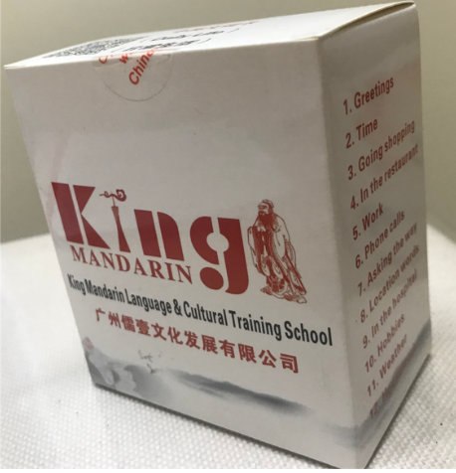
Figure 2: King’s Mandarin recommended resources for students studying Mandarin (Photo by Rebeca Tamas with permission of King’s Language School)
Flashcard activities invariably appeal to students with differing learning preferences. Flashcards with a colourful cartoon on one side and vocabulary item on the other side make a real impact on visual learners who form a large proportion of learners. These cards may also be separated. Many of the associated games, such as miming, appeal to kinaesthetic learners. As extension activities, fast finishers may work alone to review, together or take home their own set to play with family members as a take-home task.
Flashcards are best online (quizlet), as a supplementary pack with a textbook or self-made. Buying them online often doesn’t cater to specifically what you are teaching. To make sure they are the same size, try searching Free flashcards maker on the internet. It will provide you with choices but remember to look for a site where you can upload clipart. Choose cardboard every time instead of paper and do get them laminated to make best use of your time. For the time poor teacher, getting students to create the flashcards can lead to student ownership and some funny results from the less creative souls!
I observed a lesson using realistic combinations of two topics and I believe there is more opportunity for teachers to draw on prior learning. In the lesson learning animals, the teacher made a flipbook that had a picture of an animal with a paper on top, the paper had a small cut-out over the body part that would prompt students to say for example, “the dog’s leg”. Using both animals and body parts to problem solve was a successful strategy. I also saw a lesson teaching surrounding suburbs and the associated grammar concepts for this sentence pattern. In the second part of this lesson, the teacher brought in adjectives to describe each place. This was a very real-world and engaging class for students to make connections. The following are a list of observed activities to maximise student engagement with Mandarin study (Budden, 2009).

Memory Tester
Place a selection of flash cards on the floor in a circle. Students have one minute to memorise the cards. In groups, they have two minutes to write as many of the names as they can remember.
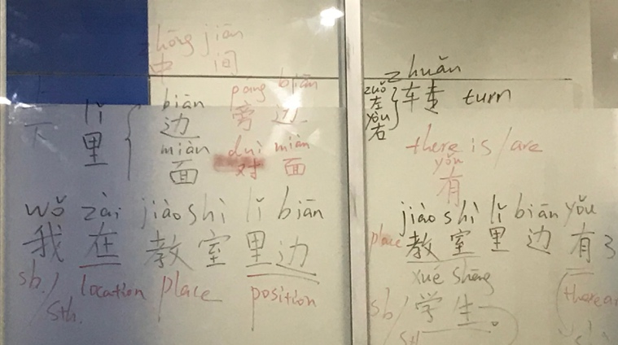
Figure 3: Teachers providing visual cues to learners prior to using flashcards and activities to reinforce vocabulary (Photo by Rebeca Tamas with permission of LTL Language School)

Invisible Flashcards
Stick nine flash cards on the board and draw a grid around them. Use a pen or a pointer to drill the nine words. Always point to the flash card you are drilling. Gradually remove the flash cards but continue to drill and point to the grid where the flash card was. When the first card is removed and you point to the blank space, nod your head to encourage children to say the word of the removed flash card. Students should remember and continue as if the flash cards were still there. They seem to be amazed that they can remember the pictures. Depending on the age group I then put the flash cards back in the right place on the grid, asking the children where they go, or I ask students to come up and write the word in the correct place on the grid. This activity proves that the images stick in students' minds.

Reveal the Word
Cover the flashcard with a piece of card and slowly reveal it. Students guess which one it is. Once the card is shown, chorally drill the word with the group using different intonation and silly voices to keep it fun. Vary the volume too, whisper and shout the words. Children will automatically copy your voice. Alternatively, flip the card over very quickly so the children just get a quick glimpse. Repeat until they have guessed the word.

Race to the Flash cards
Stick flash cards around the class. Say one of them and students point or race to it. Students can then give the instructions to classmates. You can extend this by saying 'hop to the cat' or even 'if you have blonde hair, swim to the fish' etc. You can also incorporate flash cards into a game of Simon Says. 'Simon says, jump to the T-shirt'.

A What?
Students sit in a circle. You show a flash card to student one and in target language say, 'This is a hamster.' student one looks at the flash card and asks you, 'A what?' The teacher replies 'A hamster' and passes the flash card on. Student one passes the flash card on to student two and says, 'This is a hamster'. student two asks student one 'A what?’, student one asks the teacher 'A what?', and the teacher replies to student one 'A hamster', student one replies to student two 'A hamster,' and so it goes on until the flash card travels full circle. When the group has mastered it, two flash cards can go around the circle in opposite directions. They will cross over mid circle. When students know the game, choose one of them to play the teacher's role.

Fast Finger
Stick flash cards on the board or on the wall (for very little people who won't reach the board!) in a line. Give a clue to indicate which flash card you are thinking of. When presenting a new lexical set for the first time, give the whole word, e.g. 'Say stop when the fast finger is above the vocabulary item’. When revising, or with higher levels, you can just give a clue, e.g. 'It's an animal that can't fly, but it can climb trees.' Ask students to shout 'stop' when your finger is above the required flash card. Then bounce your finger along in a random fashion to a silly tune until they shout 'stop' at the right time. When they get the idea, ask a student to be the fast finger. You can also use word cards instead of a finger. When the word is above the corresponding picture flash card students shout 'stop'.

Ladders
Students sit in two lines facing each other with legs out and feet touching. Each facing pair is shown a flash card that they must remember. When you call out their card they stand up and run over the legs of the others, the ladder, around the back and back to their places. The first one back wins a point for their line. If the students are very lively you can do it standing up to avoid trampled legs!

Songs and Stories
Inspiration for creative song to aid vocabulary retention are difficult to invent but a very effective memory technique in language learning. YouTube channels such as Chinese Buddy are very useful in this regard.
Greetings:
- Tune of Frere Jacques: Salut, Bonjour, Salut Bonjour, Comment ca va?, Comment ca va?, tres, tres, bien, tres, tres, bien, merci beaucoup, merci beaucoup.
Animals:
- where are you?
- 2 tigers (counters, tigers, run fast)
Prepositions of place:
- Tune of London Bridge is Falling Down: Shangmian, Xiamian, limian, shanmian, houmian (repeat) zuo bian, youbian
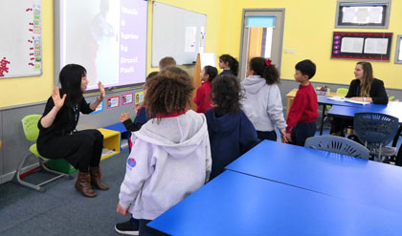
Figure 4: Teachers at Yew Chung International School Qingdao use songs to educate bi-lingual students (Photo by Rebeca Tamas with permission of Yew Chung International School)

Games
The co-operative learning environment increases student achievement due to its social nature and real world exercises. Just as each teacher has their own personality, they will create their own rules. Variations to these activities can make them more structured for classes with challenging behaviour. Alternatively, they can be made more difficult for classes that need extending. Explanations in this report are simply a guide.
Question Ball: teacher passes the ball to students asking a question. Students respond with one word or a phrase, depending on their level. If a student can’t respond, sit down.
Simpler: teacher says zero, student one pronounces one in target language and passes ball to student two who says three and passes the ball on.
Extended: after the teacher asks a question, passes ball to student one who answers, student one could have to think of a question and ask student two, once they answer and pass the ball on, they sit down so that every classmate gets a turn.
Suggested rules: underarm throw only, only the person with the ball can talk, when teacher affirms that a student is out, they sit down.
What’s on your mind? like celebrity heads but without celebrity names. Scramble all flashcards in the centre of the group, each student places one above their head and can look at what others have in order to guess their own.
Board Jump: Students all line up at the back of the room. First, the teacher says the target language and the first student that calls out the correct answer in target language gets to take one jump forward. To make this activity more difficult, teacher speaks in English and students call out target language.
Suggested rules: to avoid all students calling out at once, ask them to raise their hands when they are ready to respond and wait for the teacher to point to them first. To avoid injuries, put in place a consequence for students who are irresponsible.
Pay it Forward: The teacher projects each vocabulary item on the board one at a time, students each have one card with the vocabulary written on it. The teacher asks the class to repeat a question “Where is vocabulary?” The teacher displays one vocabulary picture on the board at the front. Individually, the student with that word needs to say, “The vocabulary is here.” Teacher displays the second image, the class asks “Where is vocabulary?”
Vocabulary Slow Reveal: three shapes blocking whole word on a PowerPoint. This slow reveal works especially well with scripted languages. For example, one character ‘shi’ has three rectangles covering it, the top dissolves showing just a small section, the bottom disappears and students may attempt to guess the character first. Finally, the middle and final rectangle disappears, leaving the character visible. If students are not able to guess this vocabulary item then the teacher has found a gap in their knowledge that will need addressing.
Class Survey: After teaching a concept, distribute a scaffold to students and model how you would like the recording of answers presented. Grammar and vocabulary will thus be used as a tool for a communication, not an end in itself.
Jigsaw
- Student asks Student B classwork questions
- Student B asks Student A classwork questions
- Students report to the groups around them/whole class
TPR Circles: (The Teacher Toolkit, 2019) Organise the students into a circle around the teacher. The teacher says the word and the last person to do the action is out. This person then stands behind the teacher and watches for the student who does the action last. Eventually there is only one student, he or she is the winner.
TPR Simon Says: (The Teacher Toolkit, 2019) Play Simon Says. The teacher gives a command and students should only do it if the teacher "Simon says..." at the start. The teacher might say, "Simon says, 'slice some bread'" or "Simon says, 'chop an onion'" and the students must do the action. However if the teacher says, "Whisk an egg" the students shouldn't do this. If anyone does the action that Simon doesn't say then they are out and have to watch for the mistakes of the other students.
TPR Sounds: (The Teacher Toolkit, 2019) The teacher will first get the students to do the actions connected with each vocabulary word. Then, the teacher adds a sound related to the word and the students practise hearing the word and doing the action along with making the sound. The students are then ready to give commands to each other.
Figure 4: Yew Chung International Teacher Discussion Group (Photo by Rebeca Tamas with permission of Yew Chung International School)

Conclusion
The common themes that emerged from several site visits are the use of flashcards, songs and stories and games correlate with high quality learning environments. Students of the Yew Chung International School Qingdao saw the value of learning languages based on play and communication in an authentic context, “I look forward to going to Chinese class. It’s really fun and my teacher helps us learn hard things really quickly. I love coming to school” (Year 1 student, Yew Chung International School). To disseminate the valuable teacher resource ideas I found, I plan to debrief with my Kingold sponsors and meet with pre-service language teachers at the University of Newcastle present at the Chinese Language Teacher Association meeting, the Hunter Head Teacher Network Meeting for Languages and the Hunter Language Teacher Network. In addition, this report will be disseminated through online Language Teacher forums

References
Budden, Jo (2009) Using Flashcards with Young Learners. Available from: https://www.teachingenglish.org.uk/article/using-flash-cards-young-learners
Bygate, Martin (2018) Learning Language Through Task Repetition. University of Lancaster: John Benjamin Publishing Company.
Effective Language Learning (2019) Language Difficulty Ranking. Available from: https://www.effectivelanguagelearning.com/language-guide/language-difficulty
Piller, Ingrid (2010) Monolingual Mindset in the Lucky Country. Available from: http://www.languageonthemove.com/monolingual-mindset-in-the-lucky-country/
Rowland, M. (2019) Total Physical Response (TPR). Available from: http://www.theteachertoolkit.com/index.php/tool/total-physical-response-tpr
Vlahakis 2012 Vlahakis, Mark (2012) The Study of English Literary Texts in a Monocultural Secondary School Context and Students’ Attitudes to the ‘Cultural Other’. Available from: https://digital.library.adelaide.edu.au/dspace/bitstream/2440/86233/8/02whole.pdf

