Premier’s Early Childhood Education Scholarship

Embedding creativity across the Early Years (P – 2)
  - Exploring contemporary and effective approaches to foster student engagement based on learning spaces and experiences that nurture creativity and imagination.
Ljiljana Kocic
Lansvale Public School
Sponsored by

Introduction
Creativity is a complex and very broad concept to examine. Teachers don’t usually identify themselves as creative professionals (King, 2018). I personally never viewed myself as a creative individual, however, as I engaged in the Creative Leadership in Learning project (CLIL) with the Sydney Opera House, my view around creativity has shifted. It has inspired me to further investigate and unpack the term creativity and how it can be embedded in everyday learning experiences without it being an additional task to the educational program.
Children need to be immersed in opportunities that foster creativity and engagement to support future focused learning. Sir Ken Robinson illustrates how creativity and innovation are fast becoming requirements for personal and professional success (Gandini, 2015). The NSW English Syllabus illustrates the importance of making meaning in ways that are “imaginative, creative, interpretive, critical and powerful". By enhancing learning opportunities and environments that foster creativity, students will be encouraged to take more risks, problem solve, think critically and be open to new possibilities.
This study explores and investigates contemporary and effective approaches including learning environments that foster innovative and creative learning spaces. It details creative application and practices which have been inspired by a rigorous early childhood pedagogy.

Focus of Study
As I embarked on my study tour, I had three guiding questions I explored at each site visit:
- How does the learning environment nurture self expression and creativity?
- How is student learning assessed and how is future planning and programming determined?
- How can this learning framework/principles be modified and integrated in Australian classrooms?
Site visits
- Centres visited include: Cow Hollow School, San Francisco; Children’s Day School, San Francisco; La Scuola International School, San Francisco; Opal School, Portland, Oregon; Wooranna Park Primary School, Melbourne; Sandringham East Primary School, Melbourne; Brunswick East Primary School, Melbourne.
- Randall Museum; San Francisco; Children’s Creativity Museum, San Francisco; Portland Children’s Museum, Portland, Oregon; Lincoln Center for Education, New York; The Museum of Modern Art (MoMA), New York.
Conferences/Study tours
- La Scuola Workshop: Reggio Inspiration within the PYP Framework (2 Day Workshop: 9th-10th May, 2019)
- Opal School Study tour for International educators: Empathy, agency and changemaking through playful inquiry (Four Day Study tour: 12th - 15th May 2019).

Significant Learning
This experience has deepened my working knowledge of creativity and enabled me to explore effective practices and inspiring learning environments in various settings in USA and Melbourne, Australia.

Materials and preparation matter
It is important to empower children to have ownership of their own learning and make decisions that shape their lives and experiences. Concrete materials can be a natural and man made substance. Materials can be powerful tools used for communication, creative expression and storytelling in a variety of learning experiences. There are extensive possibilities when engaging with materials as children have the opportunity to use their imagination, explore and make meaning in a variety of ways. Children are able to make their own mark in the world with the material of their choice. This notion is supported by Penfold’s (2019), belief that creativity emerges from various and multiple sources and across different timeframes, developing vital relationships between people and materials over time. Children are therefore not separate from the material world but in a constant mode of becoming with it. King (2018), further emphasises how people tend to think creativity is about making things, but creativity is often more about doing things. It is the spirit of exploration, pick it up, touch it, smell it, examine it; that leads to an investigative and playful approach to learning with materials.
At the Opal School in Portland, Oregon, I observed how materials are used in an effective and innovative way and embedded with a variety of discipline areas. Preparation was key and the children were invited to engage with open ended materials of various textures, colours, sizes and shapes. They were immersed in playful inquiry around an idea or question and explored their material of choice, before writing their reflections in a notebook, which was later shared with their class.
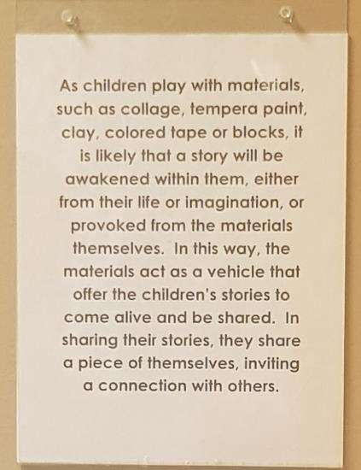
Image 1: Poster displayed in the classroom about the significance of materials at Opal School Portland, Oregon USA (Photo: Ljiljana Kocic)
When children are provided with these open ended options, some form of constraint is vital for the experience to flourish and foster their creativity and imagination. At the Children’s Creativity Museum in San Francisco, I was interested to learn more about the concept of the mystery box challenge. This idea is based on various materials (7-10) placed in a box. The educators explained that in order for the mystery box to be successful and inviting, children must work with some constraints. They state “constraints force us to forget about what we don’t have and to think critically about what we do have” (Children’s Creativity Museum, 2019, p.1). This in turn, encourages children to think outside the box and work with what they have to solve the mystery box challenge in an innovative, creative and engaging way. Furthermore, “constraints can reveal unexpected insights and invite our minds to play in ways we never previously considered” (Alton and Alton, 2019). This encourages children to find different ways to solve problems, think critically and be open to new possibilities, which are all significant for future focused learning. Loris Malaguzzi defines ‘the 100 languages’ as children being able to express themselves, explore and connect their thoughts, imaginings and feelings in multiple ways. This signifies the importance of being open to exploring and learning in different ways and educators having a strong image of the child as creative.
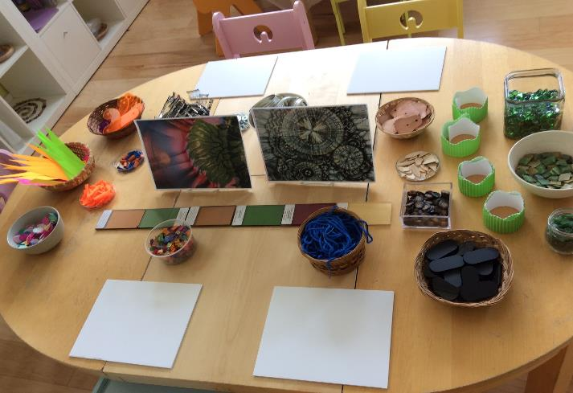
Image 2: Learning experience set up with open ended materials and provocations for learning at La Scuola International School, San Francisco, USA (Photo: Ljiljana Kocic)

Environment as the third teacher
The definition of environment as outlined in the Cambridge dictionary (2019) is; “the conditions that you live or work in and the way that they influence how you feel or how effectively you can work”. The educational learning environments I visited on my study tour were welcoming, inviting and aesthetically pleasing. The resources, learning experiences and spaces were deeply intentional and purposeful. It was evident there was a sense of identity and a place for the imagination in each defined learning area with guiding questions and statements displayed. All learning spaces had an abundance of richly documented learning experiences that have been explored within the classroom community. The key to preparation was evident as visitors who entered the spaces were able to see the powerful tools of communication, messages and connectedness of pedagogy through both a child and educator lens. Loris Malaguzzi believed there are three teachers of children: adults, other children and their physical environment. “Educational environments must be designed to maximise the possibilities for exchange which invites the discovery of connections and patterns of relationships as the child encounters them in the world” (Mackay, 2010, p. 31). It is evident at the Opal school, that every question mattered; every space offered complex and real questions promoting rigorous thinking and learning.
Gandini (1993), describes that in Reggio Emilia, practice drives theory, rather than the opposite. This was evident as I examined and explored the rich and meaningful experiences that occurred at Opal school. There was a continuity of exemplary practice and teaching and learning environments that offered choice, promoted playful inquiry, creativity, agency and a sense of wonder. Engagement occurs when educators establish an environment that is relevant to the children, “reflects their interests and yours, promotes learning, and is both visually and emotionally appealing” (King, 2018, p. 95).
In addition to the environment as a third teacher, many schools and services I visited had a specialist teacher, known as an atelierista. An atelierista uses creative arts as a medium for building knowledge, embodies endless amazement, a path to communication and freedom of expression in multiple ways. Learning experiences with an atelierista, ensure students have the opportunity to engage in social imagination through the exploration and application of the creative arts. They develop various future focussed skills through preparation, questioning and making new meaning and understanding. Furthermore, exploring a form through arts practice fosters creativity and new processes of reflection and remembering in an innovative and engaging way.

Importance of play
Early childhood settings that encourage play in their program illustrated that children “excelled in creativity and intelligence and oral expression” (Miller & Almon, 2009, p. 2). During my visit to all of the services, I observed various types of intentional play in the classroom. At Sandringham East Public School, there were opportunities for investigations which were supported as part of the Walker Learning approach (play-based teaching and learning). Stage one students were engaged in playful investigations in a large flexible open learning space, in which the children had the opportunity for reflection and sharing at the end of the session. I noticed the children were quite engaged in their play and investigation experiences and recorded their learning and observations which they shared with their peers and educators. Playfulness is strongly related to cognitive development and emotional well-being (Anon, 2019).
At Wooranna Park, I noticed the students engaged in flexible learning spaces and agency was promoted by allowing children to engage in experiences of their choice. The students had ownership of their learning and a sense of wonder and curiosity. The students also came back together to share and reflect on their learning at the conclusion of the session. Positioning play as the engine of learning, early years educators embrace play as a key catalyst to plan and create a stimulating and flexible space where inquiry learning and playful investigations can unfold (Miller & Almon, 2009). The other preschools and schools I visited also offered play experiences throughout the day. They were intentional experiences set up and the children revisited some experiences over time to foster growth, relationships, inquiry, problem solving and skill building. Experiences that encourage risky and creative exploration, stretch an individual’s capacity and involve them in an element of discovery. Csikszentmihalyi (1996), calls this optimal experience as ‘flow’, as many experience things that are going well as an effortless, yet highly focused state of consciousness.

The art in questioning
There is an art in asking the right type of questions. There are various questions that can be used as a powerful tool to guide, inquire, connect, scaffold, provoke and extend learning opportunities and thinking. Questions can be used to empower students and to promote their sense of themselves as confident, skilful, knowledgeable and creative. Skilful questioning can be the driver of learning, the connective thread to experience and the organisers of the curriculum. At the Opal School, all classrooms had many questions displayed around the room and in the hallways. There was also evidence of children's statements and thinking displayed in large font which illustrated a strong sense of belonging and agency within the classroom community. The questions were used to provoke playful inquiry, critical thinking, and problem solving. They provoke fresh ideas, foster collaboration, working courageously and most importantly thinking creatively. Questions should be open ended so children are encouraged to think deeply (Wolf, 1987). This was evident in the classrooms at the Opal school, as documentation was displayed that illustrated students engagement and thought provoking answers and commentary from the projects they explored. The learning experiences offered open ended questions which enabled the students and educators to build new and complex ideas. It’s interesting to see how classroom dialogue and language can establish a lasting climate of inquiry, not just a momentary discussion. It is so much more valuable and complex with pushing forward many complex ideas, problems to solve, playful inquiry, investigations, self-discovery and agency within the learning community.
The way in which teachers question creates the classroom culture and social values. This can illustrate how students and teachers can learn together and from each other from questions that lead into a collaborative inquiry process. The Lincoln Center for Education offered suggestions for asking authentic and open ended questions. There are three categories of questioning that can be used as a scaffold which involve to describe (open-ended questions that elicit noticings), analyse (open-ended questions that ask students to analyse parts of their work and lastly to interpret (open-ended questions that encourage to find meaning and make connections to self). Some questions may include “What do you notice?”, “What questions do you have?”, “What connections do you make?”. These questions can be extended and used for a variety of learning experiences. What I took away from the Opal school study tour was the reflection upon ‘questions for thinking versus questions for skill building’. Both are significant, however, the importance is in the authenticity of the questions. It is vital to invite children to consider those real, authentic questions that may lead to many possibilities. These questions engage and foster students’ imagination, creativity and curiosity which enable diverse ideas to come alive and be developed into new learning.
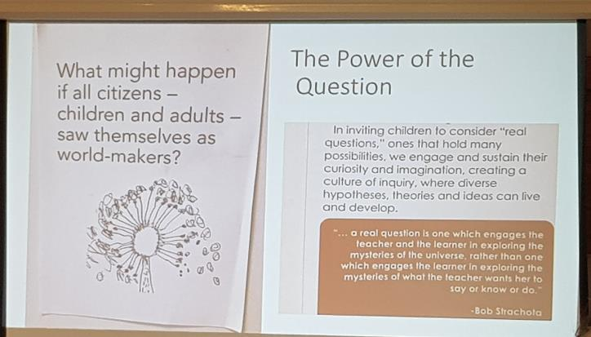
Image 3: Anne Van Dam presenting “Who is a changemaker?” at Opal School Portland, study tour. (Photo: Ljiljana Kocic)
Educators need to respond to questions with answers that extend students thinking and pursue in investigations where simple factual inquiries enable new insights to occur. Students should be encouraged to think deeply and critically. They should also be encouraged to ask questions as there are many positive outcomes to questioning. If students ask questions, it will support their social development as they need the skill of raising questions with others in order to clarify their understanding and the willingness and bravery to ask and learn new information. Another positive outcome is the creative and inventive side. It will further foster students’ ability to ask strong and authentic questions and support inquiry and creative processes. "One could rephrase the Chinese proverb: ask a man a question and he inquires for a day; teach a man to question and he inquires for life" (Wolf, 1987). This in turn, further emphasises the importance and art in questioning as a significant lifelong skill that will assist students for the future.

Supportive leadership
Many educators I interviewed in this research expressed how their leaders inspired, supported and were committed to fostering their knowledge and experience around creativity in the classroom and learning environment. The educators felt empowered and highly supported by members of the leadership team, which enabled the educators to feel more confident and curious with embedding creativity and playful inquiry in their classrooms. Many educators embarked on research projects and study around creativity and documentation to cultivate an understanding of teacher as researcher. In turn, this process enabled educators to become even more involved and engaged in students learning. Wheatley, (2002) states “Great ideas and inventions miraculously appear in the space of not knowing. If we can move through the fear and enter the abyss, we are rewarded greatly. We rediscover we’re creative”. This further highlights the feeling the educators experienced as at first they didn’t feel confident with embedding creativity in their classroom, however with a supportive leadership team, they progressed beyond these feelings and developed a strong sense of engagement and collaboration in the classroom as the teacher worked alongside the children, all as researchers. This confidence also initiated teachers to become co-researchers with their students and often led to authentic questioning. Mackay, (2010, p. 11) explains “genuine inquiry leads to genuine understanding because it is fuelled by a powerful engagement, without which, learning cannot occur”. This is essential for supporting creativity and teacher research.

Conclusion
Embedding creativity in the early years will better support all students and educators for future focused learning and prepare their minds to think critically and creatively for jobs that have not yet been created. Children should be fearless learners and should develop a range of skills to prepare them for a world where change is accelerating. Rich learning can unfold when educators and students are open to new ideas. Reflecting on my study tour visits and three guiding questions, it is imperative to cultivate a learning environment that fosters open ended learning experiences to explore, investigate, problem solve, engage in critical thinking and be open to new possibilities. Below is a summary of the significant learning intertwined within the three guiding questions;

How does the learning environment nurture self expression and creativity?
Each learning environment offered students the capacity to express themselves and use their imagination in a creative way through the use of thoughtful and intentional open ended and concrete materials and resources. The provocation of authentic questioning with play based learning was also nurtured to further explore creativity and critical thinking, wonder and curiosity.

How is student learning assessed and how is future planning and programming determined?
Educators would use observations as a tool for future planning and programming as students were engaged and immersed in learning experiences independently or in small groups. The experiences were deliberately unhurried and the learning encouraged students to use their imagination, listen to others, share their views and ideas and express their opinions in multiple ways. Their ideas and voices were central to further planning and programming of learning.

How can this learning framework/principles be modified and integrated in Australian classrooms?
As an educator, it is vital to ask a variety of real and authentic questions for thinking and fostering students to use their imagination and be curious about the world. Penfold, (2019) illustrates “materials have the ability to support children in making new connections with themselves, others, and the ever-changing world around them. This framework is important for educators, creative practitioners, and policymakers in shaping education practices, as it raises significant issues around the importance of the creative arts and materials in children’s lives”. In turn, the use of creative arts and mediums can be embedded and integrated in a variety of discipline areas to foster children's imagination, engagement, creativity and problem solving skills. Furthermore, Mackay (2010. p.12) highlights “when classrooms are playful places, learning is deep and lasting. Play reduces risk and makes the brain more open to novel connections”. A play based learning approach can encourage student engagement, foster creativity and imagination.
These findings have been disseminated to all staff, students and the local community at Lansvale Public School, through whole school teacher professional learning, newsletters and P&C meetings. It has also been shared with NSW DoE preschool educators and online via Yammer. The online blog has been shared with DoE preschools, the Early Learning team, as well as Modern Teaching Aids and Early Childhood Australia.
In conclusion, Loris Malaguzzi believed that “creativity should not be considered a separate mental faculty but a characteristic of our way of thinking, knowing, and making choices” (Gandini et al., 2015. p.138). As educators, we need to listen to, notice, question, provoke student’s thinking and support their intrinsic curiosity, creativity and inventions of the fertile unknown.

Acknowledgements
I would like to thank all of the educators who accommodated my visit and shared their skills, knowledge and expertise with me;
- Darcy Campbell, Cow Hollow School, San Francisco
- Antonette Greene, Children’s Day School, San Francisco
- Anne Van Dam & Valentina Imbeni, La Scuola International School, San Francisco
- Matt Karlsen, Opal School, Portland. Oregon
- Ray Trotter, Wooranna Park Primary School, Melbourne
- Laureen Walton, Sandringham East Primary School, Melbourne
- Dr Janet Di Pilla, Brunswick East Primary School, Melbourne.
- John Holyoke and Jean Taylor, Lincoln Center for Education, New York.

References
- Alton, L. and Alton, L. (2019). What Is Creativity? Embracing Different Kinds of Creativity from a Global Perspective. [online] The Content Standard by Skyword. Available at: https://www.skyword.com/contentstandard/creativity/what-is-creativity-embracing-different-kinds-of-creativity-from-a-global-perspective/ [Accessed 1 Aug. 2019]
- Anon, (2019). [ebook] Available at: http://www.importanceofplay.eu/IMG/pdf/dr_david_whitebread_-_the_importance_of_play.pdf [Accessed 1 Aug. 2019].
- CSIKSZENTMIHALYI, MIHALY (1996). Creativity: Flow and the psychology of discovery and invention. New York: Harper Collins. Gifted Child Quarterly, 41(3), pp.114-116.
- Children's Creativity Museum. (2019). Mystery Box Challenge – Teacher’s Guide. [online] Available at: https://creativity.org/mysterybox/ [Accessed 18 Jul. 2019].
- Gandini, L., (1993) For an Education based on relationships. by the National Association for the Education of Young Children. (Volume 49, Number 1].
- Gandini, L., Hill, L., Cadwell, L. and Schwall, C. (2015). In the spirit of the studio. 2nd ed. New York: Teachers College Press.
- King, H. and King, W. (2018). The Wild Card. San Diego, CA: Dave Burgess Consulting, Inc.
- MacKay, S., Graves, J. and Papandrew, T. (2010). Creativity at the heart of learning. Portland, Or.: Portland Children's Museum.
- Miller,E. & Almon,J. (2009) Crisis in the Kindergarten. Why Children Need to Play in School
- by the Alliance for Childhood. All rights reserved.
- Penfold, L. (2019). Material Matters in Children’s Creative Learning. [online] Journal of Design and Science. Available at: https://jods.mitpress.mit.edu/pub/bwp6cysy [Accessed 18 Jul. 2019].
- Wheatley, Margaret J. (2002) Turning to One Another: Simple Conversations to Restore Hope to the Future. Journal of Catholic Education, 6(1).
- Wolf, D,P. (1987). The art of questioning. Academic Connections, 1-7.

