Premier’s Copyright Agency Creativity across the Curriculum Scholarship

Weaving the weft of tradition with the warp of innovation
  - A study into traditional textile making and techniques, as well as modern innovative design practices to improve the student range of options when undertaking practical projects in classroom practice
Mrs Kelly Evans
Wollondilly Anglican College
Sponsored by

Introduction
My study will focus on honouring the traditions of textile making while acknowledging and incorporating future focused elements into the teaching and learning of design. The Technological and Applied Science key learning area combines traditional skill and knowledge with modern technology. Being practically based, it is an area that strongly encourages and promotes the exploration of individual based learning through developing a solution to a design problem. Projects must be a creative solution to a design brief with a focus on the use of innovative technology to enhance the project being produced.
Environmental sustainability and the impact of human choice needs to be a priority in education. Waste minimisation, upcycling and the use of resources needs to be considered when designing. We also live in an era where textile heritage is at a crossroads and centuries of tradition and knowledge are being compromised. The need arises to protect tradition in terms of skill but also embrace the future of textiles.

Focus of Study
Textiles as a curriculum learning area, in the not too distant future could be discarded from the mainstream curriculum. It is undervalued by some schools, parents and students and some schools fail to recognise the importance of this subject. In a society where it is easy to throw away and replace, there is little value and there is no emphasis put on learning skills to repair and fix. Textiles is a material focused subject that is relied upon in everyday life. If it continues to be undervalued, traditional skills will be lost, and future generations of the world will suffer.
The need exists to revitalise and revamp the way that mandatory technology and textiles is taught. For this key learning area to be more highly valued teachers must teach traditional skills with modern innovative design projects that are relevant to 21st century learning
Students need to develop an appreciation of textiles culture and tradition and appreciate the practicals skills that are passed down through communities, without this the future of textiles as a subject area and as an industry is cannot be sustained.

Significant Learning

Cambodia
A visit to the Artisans Angkor silk farm and weaving centre, allowed me to see firsthand the skills and lack of technology used in the production of this traditional fibre. Resources and equipment were basic with the all the spinning and weaving of silk produced being completed by hand. Work is completed in a community centre and children right through to the elderly work together to produce fabric and fibre that is sold in the tourist market but is also sent to larger shops and marketplaces. None of the skills used in fibre and fabric production is written down but rather is taught by mothers to their children at an early age.
A similar story of production existed at the Khmer Traditional Textiles centre where cotton is spun and woven into cloth. Being a more versatile fibre, the range of textiles woven and produced at this centre was more diverse.
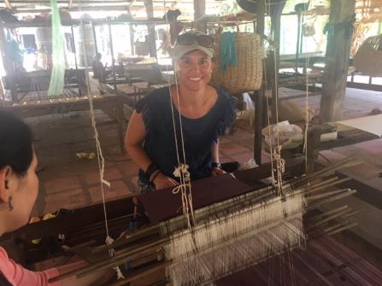
Figure 1: Learning to weave at the Khmer Traditional Textiles centre

Laos
Laos is considered as one of the most ethnically diverse countries of South East Asia, with over 54 minority groups. Diversity of culture groups is shown by costumes worn and often an individual can be identified by simply what they are wearing. I undertook a private tour of the Traditional Arts and Ethnology centre which houses an amazing collection of traditional ethnic textiles. Through this visit, I had a better understanding of variations in ethnic minority groups via the clothing that is worn. The diversity and the large range of garments on display was impressive,
I also participated in several workshops at the Ock Pop Toc Living craft centre whose focus is on teaching traditional textiles skills via women in local communities. Workshops completed included a course on traditional dyeing techniques, by collecting and gathering plants from the local garden to create a range of natural dyes. I also attended a workshop on mastering the techniques of Lao silk weaving which included spooling silk threads to weaving a pattern silk piece on a traditional silk floor loom. The final workshop on the third day was a Hmong Batik class where traditional Hmong Batik was learnt and a piece of textile with traditional motifs was created.
A visit to a traditional local community saw another textile class completed, this time the focus was on the process of spinning and weaving using cotton as a fibre and this material is much harder to work with, unforgiving and the end product was not as luxurious. The final learning experience in Laos was an afternoon spent at the Mae Te Sai gallery learning the traditional Lao skill of Hmong Reverse applique using the Pa Nadau design.
Many of these skills can be easily applied to any design project in Stage 4, Stage 5 or Stage 6 to increase and improve the aesthetic appeal of the item being produced by the student in the classroom.

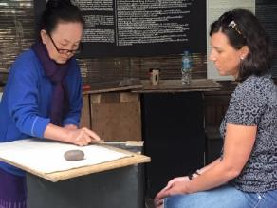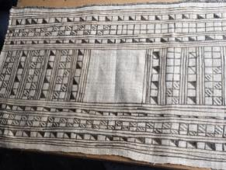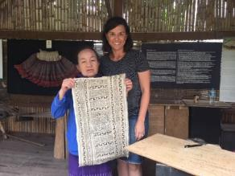
Figure 2: Undertaking a lesson in traditional Hmong Batik. (Photo taken by tour guide at Ock Pop Tuk)

Vietnam
A day was spent at the Ethnology Museum in Hanoi to investigate some more minority costumes specifically looking at the embellishment skills used to add aesthetic appeal to these garments. This was followed by a day long drive into the hills of Sapa to visit traditional ethnic communities of the Flower Hmong, Phu La, Tay and the Giay ethnic minority groups. Several embroidery workshops were undertaken with the local Taphin village women focusing on a similar style of embroidery that is used to heavily embellish their collar, sleeve and jackets of their handmade and handwoven garments. The traditional colour of yellow is used to represent the fields surrounding the village. Again, many of these skills learnt can be applied to several areas and stages of the TAS mandatory and Stage 5 / Stage 6 elective curriculum.
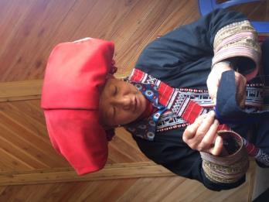
Figure 3: A traditional embroidery lesson by the Taphin Village women. (Photo taken by – Kelly Evans)

London
Modern innovation in the area of textiles was hard to define and pinpoint as the topic is very broad. However, the focus of this half of the study was to investigate and provide elements of research that would be helpful to colleagues and students in relation to the teaching the curriculum. A visit to the Victorian and Albert Museum was necessary to view and see the vast collection of textiles and fashion from early days to present. Over 100,000 objects from buttons and ball gowns, to silk and lace were on display and the emphasis was on progressive and influential designs. It is important to revisit the past to understand the future of textiles and where the textiles industry is currently heading. Traditionally London was the largest manufacturing centre of its time with more shops than any other European city. The wealthy shopped for fashionable and luxurious goods to furnish their homes, and many skilled textile immigrants from Scotland, Wales, France were employed to bring their textiles skills to the British fashion industry.
I also visited the Fashion and Textile Museum of London to explore the amazing work of British designer Mary Quant, and the impact she had on the Pop revolution. Inspired by the aftermath of destruction and devastation caused by the Second World War, and determined to bring a new, fairer and certainly a more fun approach to life, she and others the social landscape of Britain forever
I also had a personal tour of CuteCircuit who is considered a pioneer in the field of fashion and wearable technology. CuteCircuit was developed in 2004 and their aim and purpose to merge futuristic fashion design with advanced technologies and smart fabric to create beautiful fashion with magical interactive capabilities. Cutecircuit has created a new fashion paradigm through technological innovation. They believe that in the future our bodies will become an interface to data, and clothing will become an intelligent second skin enabling the wearers to connect with each other in a more intuitive and intimate manner. Perhaps their most significant creations are their HugShirt – the world’s first wearable haptic telecommunication garment, designed to answer the human needs for connectedness and intimacy. The shirt allows wearers to physically touch and connect while being in two different places.
Other notable pieces include Cutecircuit X SAAB – the world’s first solar powered garment. The tShirtOS - the first app controlled t shirt that can change pattern and display in real time, an illuminated handbag, the SoundShirt - the first haptic garment that allows a deaf person to feel music during a concert and finally the world’s first wearable mobile phone garment that allows you to answer mobile phone calls from your little black dress. Many of these amazing designs and innovations have had a significant impact on the textiles industry but will also have strong links to various areas of the syllabus and curriculum.
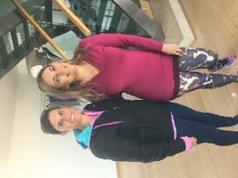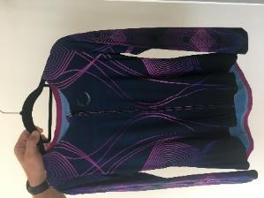
Figure 4: Francesca from Cute circuit and the SoundShirt. (Photos taken by Kelly Evans)
I also visited a bespoke tailor Dashing Tweed which started by weaving their own specific range of cloth and offering a tailoring service to men who specifically wanted colour and texture in their tailored sportswear. Dashing Tweed has modernised this traditional fabric by working with technical yarns but by also working with a bright and modern colour pallet. Perhaps their best known innovation is when they created their Lumatwill range where they used a reflective thread in the cloth production result in a high vis tailored tweed jacket that was perfect for the working and modern British man.

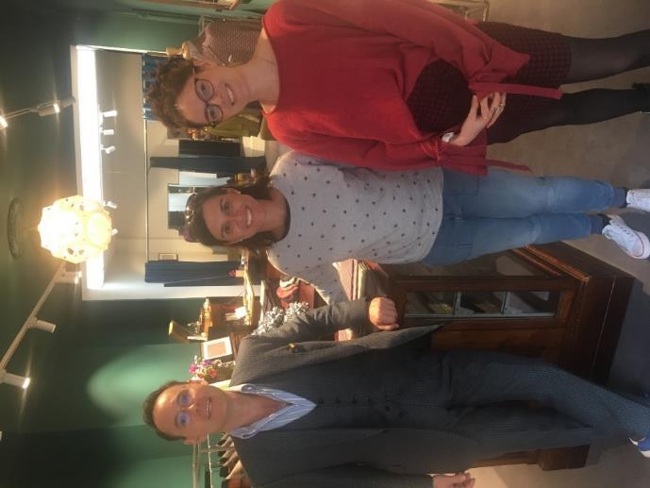
Figure 5: Owner and creative directors of Dashing Tweed, original inventors of Lumatwill. (Photo taken by Kelly Evans)
A workshop/class at the premises of the London Loom saw another class in weaving completed however this time with a modern and innovative twist of using an individual’s DNA to create the weave pattern. Simply answering a few specific questions resulted in a loom card allowing a weave to reflect my responses. A simple but perfect design brief that would be easy to apply and implement in any classroom environment.
The final company visit in the United Kingdom included a visit to Elvis and Kresse a company who have developed a successful and thriving business by using London’s decommissioned fire hoses that were destined for land fill and using them to create a stunning range of accessories from seemingly useless waste. Products included wallets, bags, belts, door mats, computer cases, washbags and even dog collars and leads. A perfect company to highlight to students that sustainable and ethical fashion pieces can be created from reclaimed materials and that environmental sustainability in the textiles industry should be at the heart of design decisions.

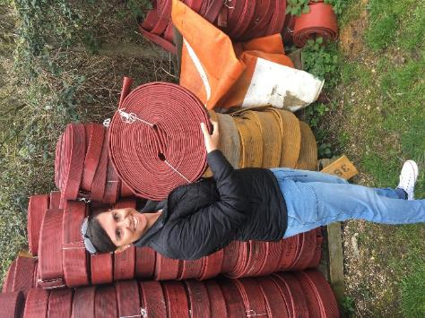
Figure 6: Elvis and Kresse make a fashion statement with accessories made from reclaimed fire hoses. (Photos taken by Kelly Evans)
I had a meeting and discussion with Julie Boyd a leading United Kingdom educator and now private consultant in the Design and Technology curriculum area. She reinforced the fact that the Australian curriculum is very similar to the British curriculum and that the United Kingdom are also facing similar issues that we face in Australia in terms of textiles. Her core business now as a private consultant involves upskilling the teaching profession so that students in the British education system are learning basic skills that are transferable. She stated traditional skills are important and should not be lost, but it is also important to consider the modern high-tech element of the textile industry. Teaching and Learning must therefore reflect this in terms of discussion, experiences and opportunities so that students understand the breadth of the industry beyond traditional craft heritage
I also met and interviewed Heidi Ambrose Brown Director of Curriculum and Professional Learning for the Design and Technology Association in the United Kingdom She stated that design and technology is about providing opportunities for student to develop their capabilities, combining their designing and making skills with knowledge and understanding in order to create quality products She is a textile expert and agreed with Julie Boyd that the biggest problem facing textiles as a curriculum area in the United Kingdom is the fact that students have lost basic skills and don’t have an understanding of properties and performance of basic textile materials. She believes lack of teacher knowledge and skill is the main priority to address over the next few years and the professional learning and reteaching basics will address some of these obvious issues. Incorporating modern technology such as 3D printers and the use of laser cutting into textiles, as well as introducing basic e textiles projects will help to revamp and reenergise a tired curriculum. Design and technology teachers need to focus on incorporating multiple materials into their design projects and design briefs, so students are not limited in their responses.

Netherlands
Visiting the Fashion for Good museum was the highlight in Amsterdam, it is the first interactive museum in the world dedicated to exploring stories behind how clothes are made and incorporating ethics and sustainability into educating consumers on their impact of their decisions when buying clothes. The museum also highlighted exciting innovations shaping the future of fashion and the textiles industry as a whole. Some of the notable exhibits were Tamicare (based in the UK) which has created the world’s first fully automated 3D printing technology for apparel and footwear, Agraloop (based in the USA) is a closed loop bio-refinery that transfers food crop waste into natural fibres – a creative way to make use of agricultural waste that would otherwise would have been left to rot. Mango Materials (based in the USA) has created a sustainable polyester alternative created from methane – a waste gas from landfills and water waste treatment plants. Frumat (based in Italy) has created a leather like material from apple skins and finally Mycotex made from mushroom roots and is completely biodegradable.
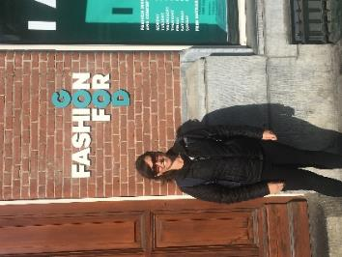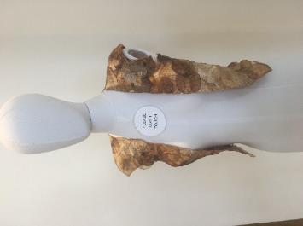
Figure 7 : A visit to Amsterdam’s ‘Fashion for Good’ Museum
A workshop with the Waag society while in Amsterdam saw a hands on practical based opportunity in the makerspace lab to view some of the work local textile educators are investigating and exploring. They are dyeing with bacteria, creating fabrics from biomaterials such as kombucha and 3D printing of materials. Again, there were many areas of learning and exploring that can be applied to all stages of the TAS curriculum.

France
A brief visit to France saw the exploration of several historical textiles in notable museums but perhaps the most intriguing was a pop up museum showcasing the history of the 150 year old Moulin Rouge cabaret theatre performances in Montmartre. The Moulin Rouge museum showcased the many designs and elaborate details that go into making the costumes for the performances, with many hours and in some cases, days put into each and every garment. Hundreds of sketches are carried out as each show compromises of various outfits, and the glittering and luxuriant costumes are said to be some of the most expensive garments in the world. The costumes must be comfortable to wear and easy to control so that the dancers can dance in them. Fabrics and materials are chosen with serious attention to sublimate choreographies, and each costume requires approximately eight craftsmen including embroiders, jewellers, feather masters and shoemakers. Everything has to be hand-made and flawless to achieve the perfection that only French savoir-faire is able to reach.
Costuming forms a large part of the Stage 5 Textile Technology curriculum and it is also a focus area option that is studies in the Stage 6 Textiles and Design course.

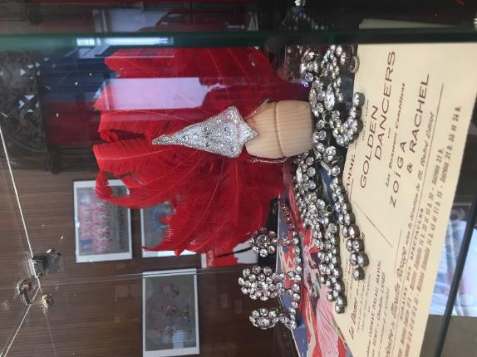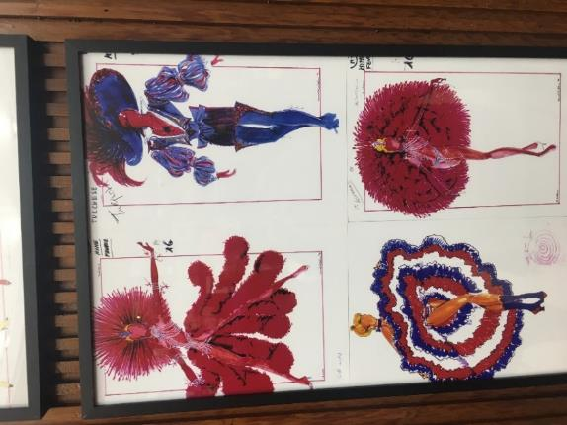
Figure 8: Costuming from the infamous Moulin Rouge. (Photo taken by Kelly Evans)

Switzerland
Visiting Switzerland involved attending several workshops in which further research and development into textiles from an innovation perspective was explored. Switzerland have moved the production of classic fabrics offshore to Asia and have preferred to focus on specialisation and development of high tech and smart fabrics. With this as their focus, a lot of their production and development is aimed at commercial manufacturers and they specialise in outdoor textiles that is used in the Swiss Alps. Having a wealth of industry experts available and accessible and with a strong focus on textiles for medicinal purposes has resulted in garments such as the nano sensor T-shirt that monitor physiological signs such as heart rate, blood pressure and body temperature. This has had a significant impact on the medical field of innovation as well as innovation (fibre, yarn and fabric) in the textile industry

Milan
The final visit to Milan during design week saw a strong emphasis being placed on social responsibility, ethics and sustainability from a textiles perspective. With the need to consider our ecological footprint, Italian designers are not only making their textiles and textile products and garments visually appealing but also ethical in terms of social responsibility and sustainability. Focus was put on using e textiles in recyclable materials to create new products of interest, and a visit to the We Make designer lab saw the fabrication of materials to make a kombucha vest and make use of the 3D laser printer to add visual interest to textiles.
Again, many aspects of this learning can be used in design briefs and applied to the TAS key learning areas. In particular, some strong links to the Stage 6 Textiles and Design syllabus and the Stage 6 Design and Technology
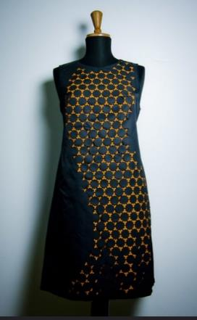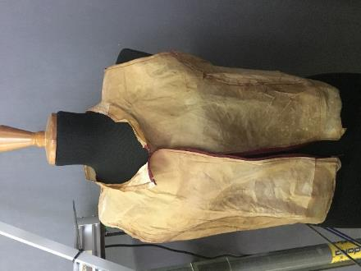
Figure 9: Laser cut dress and Kombucha jacket. (Photo taken by Kelly Evans)

Conclusion
The relevance of technology and textiles in a modern education system should not be undervalued. It has a significant place in the heart of mainstream curriculum and has links to many other subject areas. The challenge is for educators and the school community to bring this key learning area in line with 21st century learning by using modern and inspiring design brief and projects.
As educators it is our responsibility to engage in regular professional learning and to upskill our colleagues with basic skills that if not shared will become obsolete. The importance of a professional association such as the Technology Educators Association that actively promotes networking and the upskilling and engagement of teachers skills and ideas is needed to keep the interest and engagement of this subject area alive. A presentation at the annual conference in May 2019 allowed me to share my study tour with colleagues. As educators we must focus on teaching skills in problem solving, critical and creative thinking so that students emerge prepare to succeed in life beyond school. We also need to be on a continuous cycle of self and subject improvement.

Acknowledgements
- Artisan d’Angkor silk farm – Cambodia
- Khmer Traditional Textile centre – Cambodia
- Ock Pop Toc Living craft centre – Laos
- Ethnology Museum – Hanoi
- Taphin Village women – Sapa
- Victorian and Albert Museum – London
- Fashion and Textile Museum – London
- Cutecircuit – London
- Dashing Tweed – London
- London Loom – London
- Elvis and Kresse – Tonge, United Kingdom
- Julie Boyd – Boyd Education, United Kingdom
- Heidi Ambrose Brown – Director of Curriculum and Professional Learning for the Design and Technology Association in the United Kingdom
- Fashion for Good Museum – Amsterdam
- Waag Society – Amsterdam
- ‘We make ‘ – Milan

