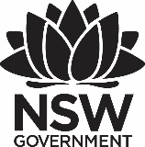
Premier’s First State Super Financial Literacy Scholarship

How entrepreneurship and project based lessons can lift the financial literacy of our students.
Keith Barnett
Epping North Public School
Sponsored by

Introduction
My research tour investigated how the most successful schools in the world incorporate project design and entrepreneurship in their teaching and how we could use the format to transform how financial literacy is presented in Australia.
In particular, my aim was to:
1. Explore and document examples of organisations successfully using project based lessons that could be adapted to better teach financial literacy in Australian schools. With teachers so busy, time at a premium and a crowded curriculum – a new delivery vehicle is required. Cross curriculum project- based lessons allow teachers and students to embrace new concepts in a manner they are comfortable and open to. Long term retention of content is increased, while problem solving, collaborative skills and attitudes towards learning are improved. Finding out how we could effectively merge financial literacy lessons with the teaching of other subjects was a paramount focus.
2. Investigate opportunities for students of financial literacy to authentically engage with the community and business world - to access mentors and expertise. I wanted to explore fresh insights and stimulating examples in high quality learning environments that encouraged the successful building of entrepreneurship and enterprise in students.
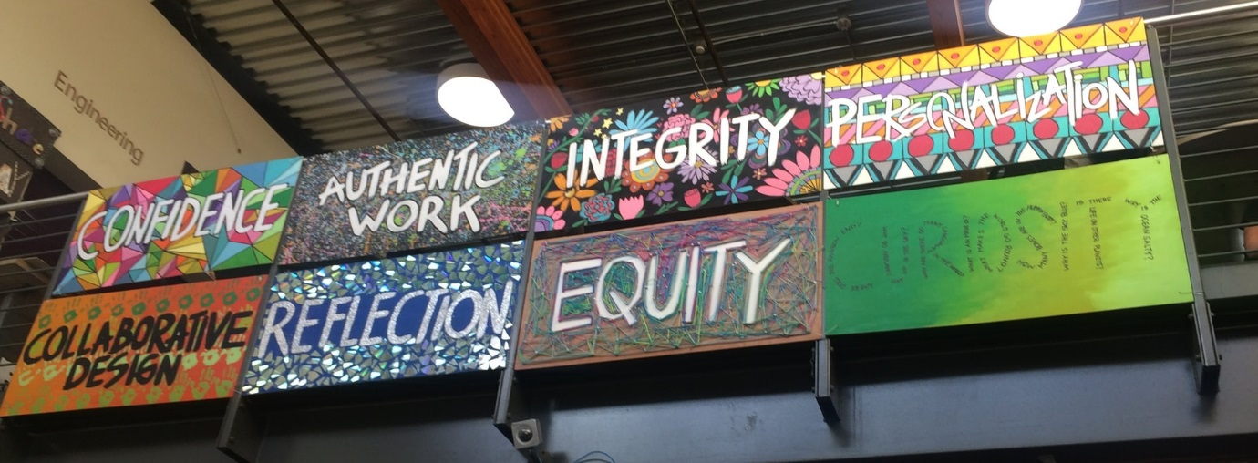
Figure 1: Mural at High Tech High, San Diego highlighting PBL focus areas. (Photo Keith Barnett)

Focus of Study
In order to win the battle for relevance in our students’ lives and to challenge them to reach their potential, we must create engaging learning activities. We must build informed decision makers, who readily and confidently participate in future society.
The PISA 2015 financial literacy assessment highlighted general policy suggestions - including:
- helping students make the most of available learning opportunities at school
In Australia, financial literacy is strongly correlated with mathematics and reading performance. 71% of the Australian financial literacy PISA score reflects skills measured in mathematics or reading assessments, with local students performing 10% worse than students around the world who perform similarly in mathematics and reading. This suggests students could be helped using skills widely taught in school to attain higher levels of financial literacy, particularly if students are actively engaged in cross curricula units.
- providing equal opportunities for learning to boys and girls
In Australia, girls perform better than boys in financial literacy, on average and there are more boys than girls among low performers. Research clearly indicates that project-based learning is beneficial, with increased student engagement, more robust development of problem-solving strategies and greater depth of learning. Early positive experiences for boys in financial literacy should heighten their interest in content and ability to transfer skills to new situations.
- providing young people with opportunities to learn by engaging with mentors and the business world
Deeper learning gives students real world knowledge, by creating direct connections between the classroom and workplace, with businesses and community partners offering direct support and mentorship.
The 21st century economy increasingly relies on a project-centric approach, which is why a curriculum that embraces project concepts better prepares students for the workplace. Embracing a model along these lines will help ensure that we close our skills gap and preserve our economic success.
From the curriculum “Financial Literacy provides a real-world context for students to learn mathematics in the curriculum. Using authentic learning experiences engages students in mathematics, enables them to gain an understanding of a whole range of mathematical concepts and the use of real-world contexts as a platform also develops students’ ability to make informed judgements and effective consumer and financial decisions. The content descriptions relevant to Financial Literacy give students opportunities to ‘think and do’ mathematics in contexts that are real and engaging. This learning helps students make informed decisions in real-world contexts with confidence and to assess risk based on sound reasoning”.( Australian Curriculum: Consumer and financial literacy: Mathematics )
In economics and business, students develop enterprising skills through investigations and creative activities such as business ventures. Making decisions based on an assessment of the costs and benefits of alternative choices prepares students to apply informed and assertive decision-making in a range of real-world contexts. By exploring the intended and unintended consequences of their decisions, students are also equipped with the skills to reflect on the appropriateness of their initiatives.
Project Based Learning (PBL) builds financial literacy and is essential to develop the business owners and financially literate citizens Australia needs in the future.

Significant Learning
As a participant in the ELEVATE program, (an AISNSW initiative working with the Innovation Unit, and AITSL) my school sought to design a model that would lift student learning outcomes. Research involved 45 minute ethnographic interviews on 24 students, analysing what they required to be more invested in their learning. A breakdown of student responses - indicated they would be more motivated if they had strong mentors, collaborative tasks, learning was more authentic, and they were challenged by their work. PBL and a hands on approach were also mentioned.
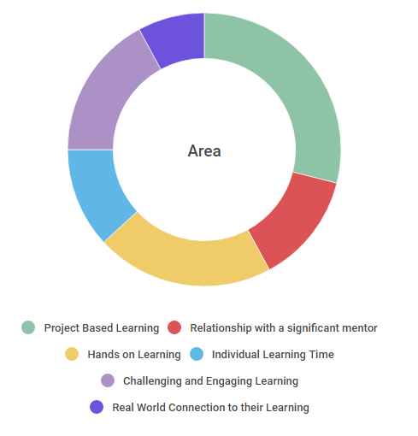
Figure 2: Summarised results of interviews of 24 school students from K-6 on what they required to be more involved in their learning
The ELEVATE project examined 30 of the most promising educational practices around the world, the majority of which were at PBL institutions. A focus of my visits was to see what aspects of these practices we could adapt to make financial literacy more engaging, together with some exemplar schools and organisations already making outstanding progress in financial literacy.
Research Study Findings

High Tech High schools San Diego
Collaborative design equity, personalisation and authentic work, are the design principles that influence the educational approach of the High Tech High schools in San Diego. Examining their teaching practice and learning about the public exhibitions of finished projects, over two whole day school visits and four days of workshops, helped me understand how they support teachers to design memorable lessons that engaged students and challenged them to apply what they had learned, to other situations in their lives. Collaboration and exhibitions to parents and community ensure teachers are highly accountable. Students are incredibly engaged and energised and can confidently articulate their learning.
Example of an interdisciplinary class - 7th Grade Chula Vista Math Teacher Adam Ko was running a year long simulation that mimicked real life financial situations for students, e.g. students borrowed money to attend an in class university to obtain a degree focusing on a skill that would enable them to get a particular job in the class. The loan would have to be repaid at current interest rates, alternatively they might take on credit card debt to purchase items such as a nicer chair within the class. This was being run co-currently with a Model United Nations (MUN) international academic simulation where students represented countries to debate issues and form resolutions. Just like in the real world, students could use diplomacy or economic and military pressures as viable negotiating tools, and wield their power according to what they knew, believe, and learn. The MUN Trade War simulated these economic and military engagements in a game based in statistics and social studies.
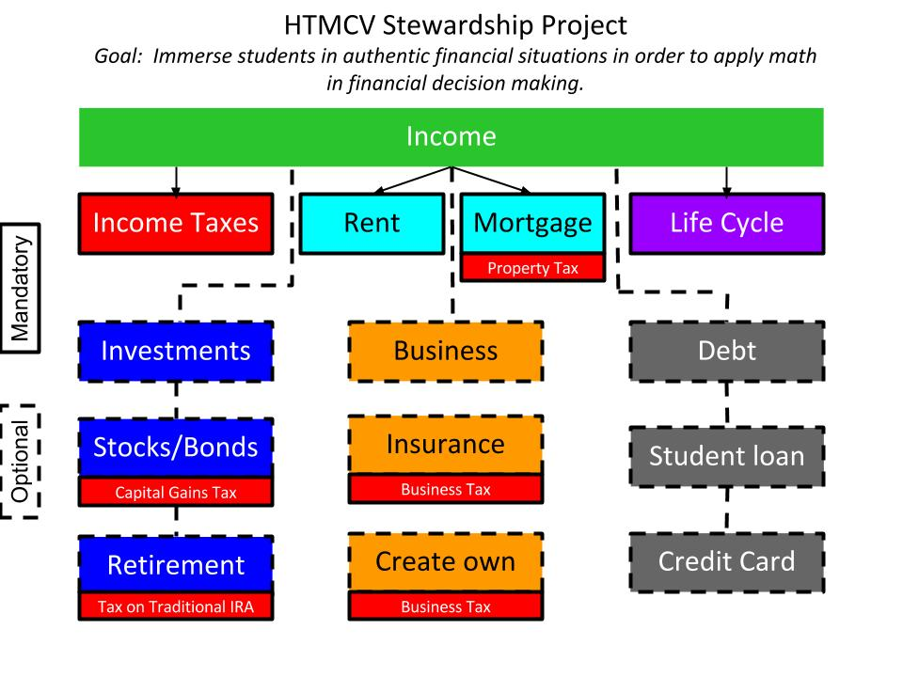
Figure 3: Adam Ko’s overview of incorporating Financial Literacy across everyday class lessons in an interdisciplinary format.
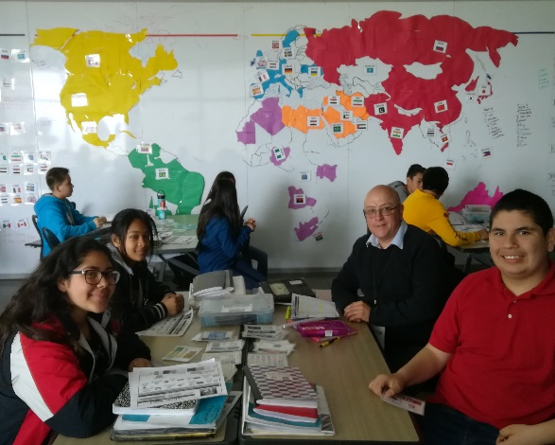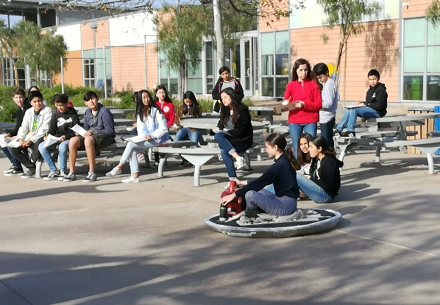
Figure 4: Author joining a group in a trade simulation lesson; Students riding home made hovercraft around the same school. (Photo Keith Barnett)
All students I observed were very motivated and engaged with all discussion revolving around creativity or problem solving. Students ran student led conferences with their parents for 30 minutes where they could share their work and twice yearly public exhibitions allowed them to share their work with an audience outside the class.
Other PBL schools visited included – Katherine Smith Elementary School, San Jose A 21st Century Exemplar School, a National School of Excellence, and Californian Distinguished School; Bulldog Tech, San Jose – An Apple Distinguished school; Lobo School of Innovation, San Jose - a Californian Distinguished School; and Ross Schools, Marin County - a California Distinguished School and an International Education School of Distinction Award winner
Each of these schools promoted learning by doing, student personal responsibility and a hands on approach. Learning at school was connected with the wider community and community mentors were utilised to provide advice and guidance. Students were engaged in deeper learning through PBL. Work was personalised through open ended driving questions that could be answered in a variety of ways. Group projects encouraged collaboration, creativity and critical thinking.
Students worked on authentic projects that were meaningful to their lives. Students were extremely confident, able to fully articulate and explain the challenge they were engaged in. e.g. kindy students learning their letters so they could teach pre-schoolers, made it real for them and gave them a purpose for doing it. All lessons were planned around real problems. Innovative and passionate teachers were employed who were focused on preparing students for a successful future. Students collaborated with each other to demonstrate deeper learning around open ended inquiries.
Bow School, Hamlet Towers London
This school had an extensive Enterprise/ Financial Literacy setup. Students in all year groups were encouraged to think about their future and were given opportunities to meet a wide range of employers and universities. Key employer partnerships have been recognised as exceptional and contribute to students’ experiences, broadening their horizons and providing them with important skills, knowledge and understanding beyond the classroom. Projects have been developed to enhance the range of enterprise and entrepreneurship opportunities on offer to Bow School students. Students in Years 8 and 9 participated in a range of activities, including lessons on starting your own business, managing finances and developing a company ethos.
Hamlet Towers borough itself is a real contrast as it encompasses one of the most deprived areas in the UK – with 80% of families reliant on out of work benefits and Canary Wharf, which is the headquarters and home to some of the world’s largest financial organisations and the UK’s highest paid workers. The financial institutions promote a social responsibility quota for all staff and many elect to help out local schools. These partnerships (including one with Macquarie Bank) take the form of staff volunteering their time to mentor and support students. Very generous scholarships are provided to students (standard offer is £5000 per university year) who elect to study at a higher level outside of London, to get them out of cycle of crime and poverty. Students are very inspired by financial literacy lessons (including classes for parents) with the school having received a School Excellence certification for striving to educate the community to the highest level. Students are encouraged to develop and run their businesses and to understand concepts such as debt and interest rates.
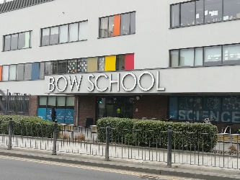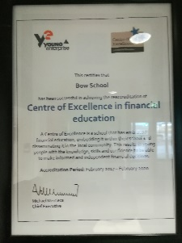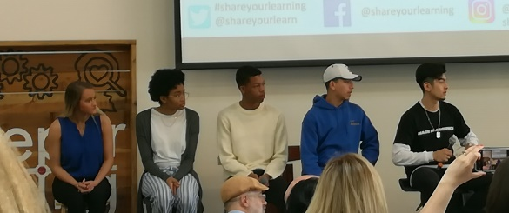
Figure 5: School entrance; Financial Education Centre of Excellence certification; Student discussion. (Photo Keith Barnett)

Young Enterprise and Young Money Foundation, London
To introduce collaboration and entrepreneurship, activities were divided into Enterprise and Financial Literacy sections. Through generous sponsors and a professional management team, this not for profit organisation, had developed and provided every school in the UK with 60 copies of a comprehensive Financial Literacy textbook and supports teachers in its delivery. The foundation has a three pronged approach
a) delivering teacher training to primary and secondary school educators teaching financial and enterprise education – showing teachers how to build students’ ability to analyse financial information, manage money well, and make informed decisions to plan for successful financial futures
b) a whole school approach that recognises and rewards schools who commit to develop and continue excellence in financial education in their own school and beyond
c) promoting a My Money Week - a high profile themed activity week for 4-19 year-olds, with the fundamental aim of improving financial capability in young people.
The London Young Enterprise Awards and presentation ceremony is a culmination of enterprise, challenge and company programs and an example of an engaging and innovative applied curriculum.
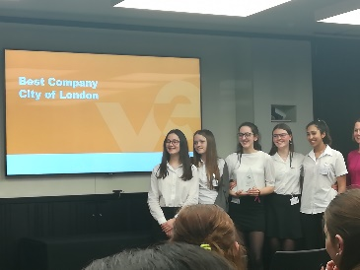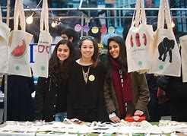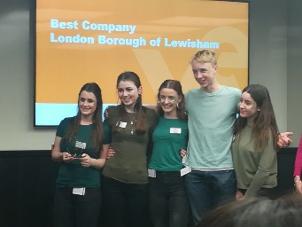
Figure 6: Young Enterprise 2019 Company of the Year Awards, London. (Photo Keith Barnett)
If we want financial literacy teaching to be integral learning, alternative approaches to teaching project design and entrepreneurship may be key to integrate successful methodology in teaching.

Conclusion
Many young people themselves have become more realistic about their job prospects in an uncertain economy and are starting their own enterprises. (Department of Economic and Social Affairs of the United Nations Secretariat 2016, p. 34)
Daniel Kahneman stated anything you experience is so much more vivid than if you’re just told about it. We need to utilise aspects of project based and enterprise learning to help students make the most of Financial Literacy learning opportunities at school:
We have to stimulate students to embrace and learn financial literacy. The challenge is to now create experiences that actively engage the student and support their making sense of these experiences. We have to give students time to experience financial literacy instead of just showing them scenarios and telling them why it is relevant to their lives. Possible inroads include the entrepreneurship and enterprise curriculum capabilities and project based cross curricula learning opportunities. Students find the idea of creating a company and delivering a product to market stimulating, giving teachers an opportunity to present the underlying concepts of the subject. Students are constructing their own learning as they purchase virtual products, construct budgets and make financial decisions. Other engaging projects incorporating fundamental concepts are easily developed and introduced.
Resources and funding haven't been put in place to support teachers through the addition to the curriculum and teachers of specialist subjects are more likely to embrace financial literacy if it is not seen as an additional new stand-alone subject. At the primary level, teaching is done at connected units level and it makes sense to present the learning in an engaging form to both teachers and -students Communication and problem-solving skills, and capabilities like critical and creative thinking and collaboration have always been important, and evidence suggests they are even more important now.
Financial literacy teaching must incorporate underlying premise of PBL (that students learn deeply, think critically, and strive for excellence) and the underlying accompanying pillars of:
- authenticity – students working on projects that are meaningful and relevant to their culture, their lives, and their future
- production of a public product – student work is publicly displayed, discussed, and critiqued
- collaboration – students collaborate with other students in person or online and/or receive guidance from adult mentors and experts
- project management - students use a project management process that enables them to proceed effectively from project initiation to completion
- reflection – students reflect on their work and their learning throughout the project.
If we promote student agency and ownership with regard to learning, within a collaborative educational environment of real world authenticity - students are engaged in learning that is deep and long-lasting. Such projects also build success skills that prepare students for the adult world and the workplace and create confident young people who are willing and ready to take on challenges.

Harnessing connections:
- Involving the community:
Students welcome meaningful opportunities to present to a wider audience and to authentically pursue individual interest areas. Community mentors are willing and available to provide knowledge and insight but are either currently overlooked or unsure how to make a connection with a school. Encouraging collaborative conversations through financial literacy projects offers an ideal context for students to learn from others and share responsibility for finding solutions. Having students work with adult mentors and experts that they can receive guidance from brings a sense of realism and importance to a project. Currently NSW Working with Children checks can be prohibitively expensive and time consuming for retired businesspeople wishing to work as mentors in schools. Local community groups such as RSLs, bowling clubs, retirement homes, etc have members who would love to contribute their knowledge and expertise. Facilitating technology options to connect with industry experts unable to make it to the classroom would make it real for students.
- Authentic, real world enterprise based learning:
PBL is a most effective and engaging way to deliver information for students to understand concepts. Organisations such as the UK’s Young Enterprise have designed highly interactive, four -week long challenge initiatives (Fiver for primary school children aged 5-11 and Tenner for young people aged 11-18), that provide safe environments to experience the complete process of setting up and running their own mini-business. Their arm in Australia (JA) has been as yet, relatively ignored by the education sector. The involvement of private enterprise to support the delivery of comprehensive enterprise programs in schools in Australia, should replicate the proven success of these programs in the UK. Private enterprise recognises the need and value of investing in young people and must fill the gap the government is as yet unwilling to take.
- Business world involvement
Australian companies need to be encouraged to offer internships and scholarship funding to students at a high school level, and especially at institutions servicing disadvantaged or lower socio economic communities. NSW schools need assistance to deliver independent financial literacy programs, but these must be genuinely brand-free education initiatives. The UK Young Money school textbooks and teacher training provided to every school in the UK are the result of combined ongoing donations from private organisations. Funding staff or alumni to visit schools through social responsibility programs, can have powerful effects on student attitudes to money management.
- Increase the profile of financial literacy in teacher education courses.
Making financial literacy and project authenticity an essential component of university teacher education is paramount. Teacher training for both enterprise and financial education and supporting teachers to value and further develop these key areas within their schools needs to be developed. A broad and flexible university teaching course – that emphasises and encourages student financial know how and collaborative learning is required. Giving students more autonomy to struggle over real world problems and to present their ideas and solutions to a real audience is essential. If students are more engaged in their learning, they are more likely to retain knowledge and motivation. Financial literacy has an advantage over other subjects in that it is authentic learning. Creating connections and sharing case studies of successful blending, will inspire educators to present financial and enterprise education in the engaging manner required.

References
- OECD PISA financial literacy assessment of students PISA 2015 Results: Students' Financial Literacy (Volume IV) 24/05/2017 http://www.oecd.org/finance/financial- education/oecdpisafinancialliteracyassessment.htm
- Unleashing Brilliance: How high potential learners are challenged and supported around the world. 30 Case Studies from Educational and non educational settings. Aisnsw.edu.au https://www.aisnsw.edu.au/Resources/WAL%204%20[Open%20Access]/Unleashing%20Brilliance%20Sparking%20Possibilities%20Cards%20-%20ELEVATE.pdf
- World Economic Forum, Closing the Skills Gap https://www.weforum.org/projects/closing-the-skills-gap-regional-skills-projects
- World Youth Report Civic Engagement https://issuu.com/undesa-dspd/docs/world_youth_report_civic_engagement/36
- Young-enterprise.org.uk https://www.young-enterprise.org.uk/wp-content/uploads/2019/05/Impact-Report-17-18.pdf
- Zhao, Y (2016), ‘Product-oriented learning: What is it?’, in Y. Zhao, H. Tavangar, E. McCarren, G. Rshaid & K. Tucker (eds.), The take-action guide to world class learners: How to “make” product-oriented learning happen, Corwin/Sage, London.
- https://en.wikipedia.org/wiki/Thinking,_Fast_and_Slow Kahneman D (2012), Wikipedia Contributors (2019). Thinking, Fast and Slow. [online] Wikipedia.
- High Tech High webpage, https://www.hightechhigh.org/

