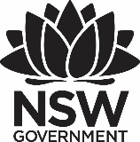

Premier’s TAFE NSW Scholarship

Breaking the cycle

The role of TAFE NSW in lowering youth unemployment and re-engaging youth not in employment, education or training (NEET)

Jennifer Polk

TAFE NSW, West Region

Sponsored by

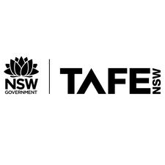

# Introduction

The TAFE NSW Premier’s Scholarship provided the opportunity to learn how Iceland, Denmark and Finland were addressing youth unemployment and how the implementation of programs and supports were positively affecting change within those countries. More specifically, I aimed to gain a greater understanding of programs designed to meet the needs of disengaged youth classified as NEET (not in employment, education or training).

According to Trending Economics as of June 2019, Australia’s youth (ages 15-24) unemployment rate is 12%. This is an increase of .9% from February 2019. In addition, underemployment/underutilisation is a growing concern. According to the Brotherhood of St Laurence *Part-Time Purgatory: young and underemployed in Australia* report, young Australians in 2018 were more likely to work part time and this is not due to full-time study (Brotherhood of St Laurence 2018). Data shows that nearly “half of all 20-24 year-olds working part time are underemployed compared to only around 30% for those part-time workers aged 35-54.” (Jericho 2018). A casualisation of the labour market along with decreased low-skilled manufacturing may be a cause for this shift. In addition, transitioning to a service industry aligns itself to shift work.

Alongside youth seeking employment or additional working hours, are those youth classified as NEET. The Organisation for Economic Co-operation and Development (OECD) 2016 report states that youth who have not completed an upper-secondary education account for more than one out of three NEETs (OECD 2016). In addition, the OECD calculated that in 2015, Australia’s 580,000 NEET youth caused an estimated earnings loss of around 1% of Australian gross domestic product (GDP) (OECD 2016). Those youth classified as NEET may lack the necessary foundation skills required for employment. Unfortunately, this will most likely exacerbate their inability to enter the changing labour market.

However, the concern goes beyond economics. The scarring effects of long-term unemployment have long-term consequences. These scarring effects may include (but are not limited to): welfare dependence, mental health concerns, drug/alcohol abuse, deterioration of skills and alienation (Carvalho 2015). The compounding negative effects of youth unemployment may be present for generations.

# Focus of Study

This study focused on how vulnerable youths were provided supports to encourage not only improved engagement within community and education but also increased self-worth with the eventual goal of employment.

It is suggested that improved basic skills will result not only in a possible return to the Vocational Education and Training (VET) sector for additional qualifications but may reduce dropout rates in programs and improve opportunities for highly skilled jobs (OECD 2017). As low-skilled jobs are slowly becoming more automated, students with low basic skills will continue to struggle to find a foothold in the labour market.

Youth classified as NEET prove to be an additional challenge. With rising numbers, there is a population of youth who would greatly benefit within the VET system. Closer examination of the NEET data indicates that lack of sustained employment or education and training is of concern. According to the OECD’s Study Skills report “*Building Skills for All Australia*”, one-third of all vulnerable NEETs lack basic skills (OECD 2017). This may be due to the fact the earlier youth leave school increases the likelihood of becoming NEET. Those who have prolonged gaps in education and employment struggle to re-enter the VET system and labour market. Due to the scarring issues stated above, NEETs may require additional support while in or prior to commencing any form of training or employment (OECD 2017). This support may come from several internal and external stakeholders including but not limited to social and health services.

# Significant Learning

## Government-funded programs

Vulnerable youth classified as NEET are not a homogenous group. However, many of those youth who are referred to programs present with similarities. These barriers may include: homelessness, mental illness, substance abuse, early school leaving and coming from a lower socio-economic background.

Denmark, Iceland, and Finland, through European Union and local municipality funding, designed and implemented programs to support disengaged youth classified as NEET. These programs were designed in collaboration with the local Public Employment Service (PES), vocational providers and the Ministry of Government.

### Building Bridge to Education – Denmark

Denmark’s Building Bridge to Education, commencing in 2013, aimed to ease the process for young people to enrol in mainstream education. The program, targeting young people between the ages of 18 to 29 who were receiving education but not enrolled in mainstream education, worked with those most at-risk of not obtaining a qualification. Young people participated in maths and Danish studies along with immersion into student life. The goal was to increase confidence in their abilities. A mentor was provided to support the young person not only during the program but until enrolment into mainstream education. In addition to focusing on improving foundation skills, young people participate in numerous traineeships within the community. On average, a NEET young person was in the program for three months. However, there was flexibility if less or additional time was required (European Commission 2018).

By the end of 2017, nearly 3,000 unemployed young people participated in the program with over 40 vocational schools as the base. Over 50% of the participants of the pilot program enrolled in further education or found employment (European Commission 2018).

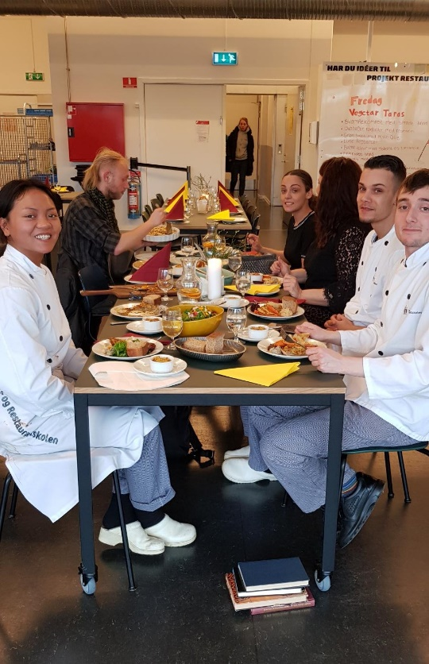

Figure 1: Copenhagen Building Bridge Program (photo by Jennifer Polk)

### Vítamín- Iceland

The global financial crisis proved to have disastrous consequences for Icelandic youth. In response, the Icelandic government in collaboration with Hitt Húsið, a youth centre in Reykjavík, designed a program for those vulnerable youth with few employment prospects in 2009. Vítamín is a program designed for youth facing short-term unemployment. However, like Australia, it became clear that youth facing long-term unemployment was a more serious concern. Thus, a second program, Vinnustaðanám, was created in 2012 to assist those most vulnerable to disengagement from not only employment but also community.

Vinnustaðanám, for youth aged 18-29, is an eight-week program. The first four weeks, held at the youth centre, is non-formal training, focusing on improving confidence and improving connections with society. The program runs for five hours per day with a light lunch provided. NEET youth learn the importance of work ethic, employability skills and improving self-determination. The second half of the program culminates with a four-week internship with no financial benefit to the participating employer unlike the Australian federally-funded Prepare, Hire, Trial (PaTH) program. A trainer visits the youth weekly from the youth centre to assess progress.

### Vamos- Finland

Funded by municipality and European Union institutions and run in conjunction with Helsinki Deaconess Institute, Vamos was founded in 2008. The free support with no financial sanctions aims to provide a unique individual coaching experience to vulnerable youth (ages 12-29). Thus, municipality and federal financial assistance payments for the individual are not withheld if participation does not take place. The goal is for the young person to attend school or employment. However, immediate goals are to meet the day-to-day demands they are facing. Many of the youth have mental health concerns, suffered bullying, drug abuse, come from broken homes and may have little to no financial literacy. The youth have a desire to change themselves but lack the personal resources to do so. The belief is a young person cannot undertake the demands of education or employment if they lack the ability to manage everyday problems. Once progress in life management is documented, they can transfer to Vamos group activities (Kujanpää 2018).

“A young person will use Vamos services on average for eight months. Some are only involved for three months, but others will need support for a number of years. Over 50 per cent of Vamos participants go on to school or working life. Many leavers also attach themselves to other care providers.” (Kujanpää 2018) The coach works closely with the young person directly, parents, social services, employment agencies and Ohjaamos (Finnish youth guidance centre).

Vamos results:

Proven support of the young people who completed the Vamos service in 2017

81 % felt their lives had changed for the better.

76 % believe their affairs will be better in the future.

74 % felt that their mental wellbeing had improved.

97 % would recommend Vamos to others.

(Helsinki Deaconess Institute N/A)

## Validation of non-formal and informal learning

In 2004, the Icelandic Ministry of Education contracted the Education and Training Service Centre (ETSC/ Fræðslumiðstöð atvinnulífsins) to develop methodologies to validate non-formal and informal learning (Fræðslumiðstöð atvinnulífsins N/A). It was believed that recognising and validating real life skills and knowledge would motivate individuals to complete a formal education. The initial target group when designing the program was adults who have little formal education (education obtained in a formal school system). The validated skills would highlight the strengths of each individual and how those skills match those required in the labour market. “The goal is that the individual achieves recognition on the competence he/she possesses at any given time, for the purpose of not having to acquire education in what he/she already knows or in order to gain recognition that leads to job development at the work place.” (Fræðslumiðstöð atvinnulífsins N/A)

The pilot project, in collaboration with the Public Employment Service, was offered to 23 year olds with little formal education with some work experience. The participants were interviewed by a counsellor at the beginning of the process. After an introduction to employability skills and team building, the individual worked on a self-assessment portfolio over several weeks. Througout this time the particpant worked closely with careers counsellors, project managers and assessors. At the conclusion of the program, the individual is interviewed to decide how the “individual’s competence measures up to a certain qualification requirements (Fræðslumiðstöð atvinnulífsins N/A).” A confirmation of competence process is required to ensure accuracy and validity. Upon conclusion, the individual is provided a formal, valid document providing details of the levels of employability skills.

An example of employability skills validated through the process are:

* adaptability
* critical judgement
* information gathering and processing
* work ethics and values;
* valuing cultural diversity
* teamwork
* communication
* planning and organising.

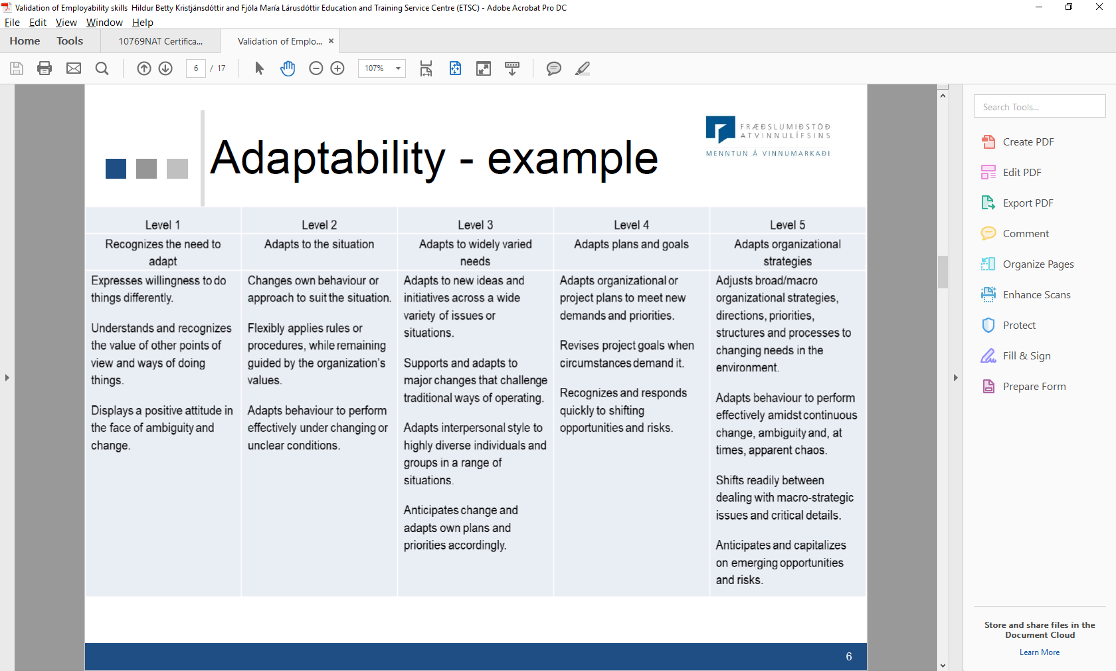

Figure 2 Example Validation Employability Skill- Iceland

## Youth support

### Ohjaamo

Between 2001 and 2015, Finish youth unemployment rates rose each year (Adams 2018). In 2017, the Finnish We Foundation opened a registry to calculate the number of marginalised youth in Finland. The data showed that 69,000 Finnish youth were classified as marginalised. These youth include: migrants, teenage-single parents, young people from workless families, young people from remote/disadvantaged areas and young people with a disability (Kililakoski 2018).

In 2014, the Finnish government recognised that although numerous supports were available to youth in communities, they were working in silos. A decision was made that a holistic approach was required to meet the needs of Finnish youth. Thus, Ohjaamos were created. Ohjaamo, one-stop guidance centres, were developed following studies, which showed that in some cases young people valued face-to-face contact over other forms of contact (e.g. online contact). A second reason for the implementation was to ease the challenge of a fragmented service sector. This included combining employment, social and health services, as well as to accommodate changes in working life.

One-stop-shop guidance centres for young people (under 30) provide a holistic approach where different service providers across private, public and other sectors operate in one place, providing a better and simpler way to serve young people who are not in employment or education. The centres were rolled out nationwide under the Youth Guarantee scheme and have proven to meet youth’s needs. The one-stop-shop guidance centres are now one of the Finnish Government’s spearhead projects.

Examples of some activities/services that are available:

* initial meeting with qualified youth worker to assess young person’s needs
* psychologist
* education counsellor (knowledgeable of vocational and university options)
* employment office representative (equivalent to Centrelink/Job Active staff)
* work coach
* social worker
* nurse
* entrepreneurship counselling
* youth housing counselling
* programs run with Ohjaamo support
* job recruitment events.

(European Commission 2018)

### Turku Vocational Institute

Turku Vocational Institute (Turun Ammatti-Instituutti/TAI), one of Finland’s largest upper secondary school, provides qualifications in basic foundation skills as well as vocational further education and training. Some examples of vocational qualifications available are: Business, Technology, Health, Beauty, Construction and Hospitality. The Institute, operating at eight locations and funded through the local municipality, recognises that extensive supports are required to ensure the needs of the students are met. Student wellbeing plays an important role in the development of students and ensuring their successful completion of qualifications and continuing on into employment. The Student Welfare Steering Group of the city of Turku created a strategic plan to develop, steer and evaluate student welfare at TAI. The plan focused on community-centred and preventative student welfare services. A multidisciplinary student welfare group provides individualised services that comply with Finland’s Pupil and Student Welfare Act. A pedagogical group complies with the Vocational Education and Training Act. Students can receive support regarding life challenges (housing, etc.), health concerns, academics, financial matters and work experience.



Figure 3 Turku Vocational Institute Student Support

# Conclusion

Future employment for young Australians looks different from a generation ago. Changes in the labour market indicate that it will be more challenging for youth to get their ‘foot in the door.’ Young people must have an understanding of specific skills required for the changes. The Foundation for Young Australians *The New Work Mindset* report states that young people today will have 17 employers over five industries in their working career (Foundation for Young Australians & AlphaBeta 2017). These changes in the labour market require those who work closely with youth to prepare them for future work. Young people’s understanding of the importance of employability skills and how these skills can be transferred from job to job plays a significant role in employment readiness. Iceland’s validation of employability skills allows job seekers to assess their life skills and how those skills align with job advertisements. Opportunities for youth to gain confidence and strengthen their self-determination may improve their job prospects, as they may feel more comfortable to seek employment where they may have felt underqualified in the past.

For those classified as NEET in Australia, the challenges regarding employment may seem insurmountable. Many youth classified as NEET have significant barriers. Currently, there are numerous programs in Australia to support those classified as NEET. Programs in Iceland, Denmark and Finland acknowledge that due their significant barriers, forward progress will take time. In fact, setbacks may occur throughout the journey to employment. On average, it will take months, not weeks, for those classified as NEET to gain the confidence and skills to commence seeking employment.

Icelandic, Danish and Finnish programs also recognise that numerous supports from internal and external stakeholders are needed to provide a holistic approach. Vocational education plays a significant role in skilling youth for future employment. However, this educational journey cannot be completed without collaborating with community services and working closely together to meet the needs of young people. In fact, young people must have their day-to-day problems addressed before commencing vocational education. If prospective students are homeless, hungry and/or mentally unwell, these conditions must be addressed prior to or in conjunction with any vocational training, as learning is diminished and not a priority until basic needs are met.

Australia and more specifically, New South Wales, must ensure programs designed to improve youth unemployment are tailored to those NEET individuals with complex needs. These programs must recognise that development of skills essential for sustained employment may require numerous attempts until deemed competent. Those tasked to deliver the programs must have knowledge and training in working with NEET youth to prevent program failings and poor statistical outcomes. A substantive program appropriately financed without bureaucratic barriers has the ability to reverse cyclical journeys some youth currently endure.

Lowering youth underemployment and unemployment and re-engaging those classified as NEET is of great importance. It requires all federal, state and local stakeholders to understand changes in the labour market, educate and prepare young people for these changes and work collaboratively to provide supports to ensure they are best prepared for the future. As it is in everyone’s best interest for Australian youth to be working at his or her full potential.

# Acknowledgements

1. Inga Jóna Þórisdóttir, Manager of Education and Development- Mímir
2. Sveinn Aðalsteinsson, Managing Director- Fræðslumiðstöð atvinnulífsins
3. Fjóla María Lárusdóttir, Methodology of VPL and study and career counseling- Fræðslumiðstöð atvinnulífsins
4. Arnheiður Gígja Guðmundsd, Methodology of study and career counseling and validation- Fræðslumiðstöð atvinnulífsins
5. Elísabet Pétursdóttir, Department manager/Youth employment- Hitt Húsið/Youth center
6. Jørgen Christensen, Development Consultant-Youth Guidance Centre
7. Ann-Sofie Munk Hansen, Mentor for brobygningselever- Hotel-og Restaurantskolen
8. Maria Hokkanen, Coordinator of International Affairs- Turku Vocational Institute
9. Hanna Salminen, Project Manager- Salpaus Further Education
10. Dr. Anu Gretschel, Senior Researcher, Finnish Youth Research Society
11. Reetta Alakallaanvaara, Youth Worker, Ohjaamo Lahti

# References

Adams, E 2018, 'Addressing youth unemployment through outreach, activation and service integration', Directorate General for Employment, Social Affairs and Inclusion, European Commission, European Commission, Belgium.

Brotherhood of St Laurence 2018, 'Part-Time Purguatory: Young and Underemployed in Australia', Brotherhood of St Laurence, N/A, Brotherhood of St Laurence, Fitzroy.

Carvalho, P 2015, 'Youth Unemployment in Australia', The Centre for Independent Study, 7, The Centre for Independent Study, St Leonards.

European Commission 2018, 'Building Bridge to Education: Developing young people's skills and confidence to enter vocational and further education-Denmark', European Union, European Union, N/A.

European Commission 2018, 'One-stop-shop guidance centres for young people (Ohjaamo)', European Commission, European Commission.

Foudation for Young Australians & AlphaBeta 2017, 'The New Work Mindset: 7 new job clusters to help young people', Foundation for Young Australians, Melbourne.

Fræðslumiðstöð atvinnulífsins N/A, 'Validation of non-formal and informal learning in Iceland', Fræðslumiðstöð atvinnulífsins, Fræðslumiðstöð atvinnulífsins, Reykjavík.

Helsinki Deaconess Institute N/A, *Support to youth: Effective support to youth throughout Finland*, < HYPERLINK "https://www.hdl.fi/en/support-and-action/young-people/" https://www.hdl.fi/en/support-and-action/young-people/ >.

Jericho, G 2018, *Underemployment has risen and its young people paying the price*, viewed 24 July 2019, < HYPERLINK "https://www.theguardian.com/business/grogonomics/2018/aug/09/underemployment-has-risen-and-its-young-people-paying-the-price" https://www.theguardian.com/business/grogonomics/2018/aug/09/underemployment-has-risen-and-its-young-people-paying-the-price >.

Kililakoski, T 2018, 'Youth employment policies in Finland', EXCEPT Working Papers, EXCEPT Working Papers, 35, Tallinn University, Tallinn.

Kujanpää, A 2018, *Our target is to prevent a single youth from being excluded*, < HYPERLINK "https://dtg.tesi.fi/cases/vamos-our-target-is-to-prevent-a-single-youth-from-being-excluded/" https://dtg.tesi.fi/cases/vamos-our-target-is-to-prevent-a-single-youth-from-being-excluded/ >.

OECD 2016, 'Investing in Youth: Australia', OECD, OECD Publishing, Paris.

OECD 2016, *Society at a Glance 2016: A Spotlight on Youth*, < HYPERLINK "https://www.oecd.org/australia/sag2016-australia.pdf" https://www.oecd.org/australia/sag2016-australia.pdf >.

OECD 2016, *Society at a Glance 2016: A spotlight on youth*, < HYPERLINK "https://www.oecd.org/australia/sag2016-australia.pdf" https://www.oecd.org/australia/sag2016-australia.pdf >.

OECD 2017, 'Building skills for all in Australia: Policy insights from the Survey of Adult Skills', OECD Skills Studies, OECD Publishing, Paris.