Premier’s English Teachers Association English Scholarship

Extending the learning through Extended Reality

Imelda Judge
Macquarie Fields High School
Sponsored by
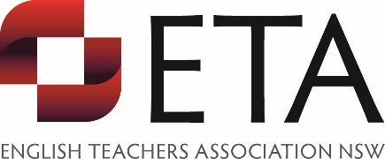

Introduction
With each new technology we see the ancient art of oral storytelling moving into new fields. The most recent development has been in the field of digital storytelling with virtual reality (VR) and augmented reality (AR) texts or experiences becoming increasingly available, offering new ways of telling stories and yet, as English teachers, we continue to teach the filmic form ignoring its maturing cousins. AR, VR with its 360 view and mixed reality (MR), now more commonly grouped together as extended reality (XR), change the point of view of the reader by adding immersivity. The content or story world that the responder or, who Jessica Brilhart labels, the experiencer or visitor accesses in VR is very different from more traditional texts, even film. The dynamic nature of the technology means the availability of a very different experience, even since 2014. This was when my students were using a desktop to access 360 cities (before it was available as an app) and viewing the 360 panoramas in headsets, constructed from cereal boxes.
Information and communication technology and its skills play an important role in 21st century education, regarded as a General Capability in the Australian Curriculum and Learning Across the Curriculum in the NSW syllabus. By Stage 5 in NSW, students should be able to ‘effectively use and critically assess a wide range of processes, skills, strategies and knowledge for responding to and composing a wide range of texts in different media and technologies’ ("Course content | NSW Education Standards", 2019). The reference to technology here is necessarily broad and ambiguous, acknowledging the pace of technological change and the need for teachers to incorporate relevant technologies. The questions are how can teachers keep up with the rate of change; how do they know what technologies are relevant when digital texts now are so varied and the skillsets used to create them seem far beyond the capacity of any English teacher?
An exploration of these questions was central to my tour visiting schools and practitioners across the USA. Many of the most innovative creators of VR works, particularly in journalism, have come from the USA; home of XR experimentation, the Tribeca Film Festival, the Tribeca Immersive Arcade and Cinema 360.
The intent of this report was to achieve two aims:
- investigate how American educators use the dynamic innovations accessible to them to develop the skills of their English teachers to discuss these emerging texts with confidence
- how American educators harnessed the power of these textual media to build the capacity of their students to create new narratives.

Focus of Study
This study was focused on the following:
- The future of storytelling: how immersive and emerging technologies are being used to create unique digital narratives.
- How USA tertiary institutions are preparing their English teachers to facilitate student learning with emerging technologies in the subject area of English.
- How schools in the USA provide opportunities for students to appreciate the conceptual power and aesthetic qualities of these texts as well as develop student capacity to create new narratives with these mediums.

Significant Learning

The experts
Multi-modal forms are communicating narratives in ways that are more sensorial and interactive, in ways that written narratives have not been designed or able to do, resulting in an immersivity of a new kind. This is not to say that narratives in the form we are more accustomed to (novels, short stories, picture books and film) are not immersive, because this is not the case. As Marie-Laure Ryan (2019), author of Narrative as Virtual Reality 2, reminds us ‘immersion is a state, but it takes mental effort to reach it.’ Discussions with Marie-Laure in Fort Collins, revealed she was committed to the notion that written language is far more immersive because it ‘depends on the artful management of the contrast between representation and simulation’ (Ryan, 2019) and insisted that this is still evident as all reading requires ‘readers to suspend disbelief’ (in conversation with Marie-Laure Ryan 08/05/2019). For her, the language of literature and the structural features of literary works were not overturned and she questioned the legitimacy of VR or XR texts as ‘new immersive narratives’ (Ryan, 2019). Given the research emphasis of this report is specifically associated with English as a key learning area, Ryan’s claims about the essential nature of traditional narrative in new texts is an important element to consider. A take away question from this discussion has to be, to what extent do immersive texts fulfil the role of storytelling in a meaningful way? A conclusion to this is that an exploration of XR experiences can provide the opportunity for critical discussion as to what defines narrative and this is well placed in our Stage 6 common courses: Reading to Write and Texts and Human Experiences.
Technology offers a new way of sharing common narratives of human experience as seen through the work of Milica Zec. Zec’s childhood home was in Belgrade, Serbia. She was eight when war came to Yugoslavia and 16 when she fled to the US. In discussion with her about her VR and XR projects, namely Giant and Tree, one is positioned to reflect upon the importance of passion and persistence in the shaping of a sense of identity that contributes to a young person’s preferred path to their future world of work. These are also a thorough reminder of the power of personal context that contributes to the creation of a text. Through her father’s support, she experienced an early exposure to street theatre, and realised the value of film, theatre and literature. These early cultural experiences shaped her desire to go into the field of film and VR became part of her creative journey as a film director. Her own personal experience informed by research of the collective experiences of children in war torn countries across the globe became the seed for her first VR success, Giant. Incredible nous, determination and networking skills ensured the project was completed and showcased to a broad audience.
Zec’s work may be regarded as a potential ‘empathy machine’ – a term used by Gabo Arora (who echoes Chris Milk in the use of this phrase) and marking this evolution ‘as the birth of a new artistic expression’ with greater capacity to tell stories for ‘good’. Arora also acknowledged that, as composers and creators push the boundaries of textual form, we also recognise the importance of understanding the timeless phenomenon of the relationships between ‘tools, technology and creative expression’ (in conversation, Arora 24/04/2019).
From film director and experience creator, Gabo Arora, to others right across to the West Coast, one thing remained constant: all the creators were surging forward, looking at breaking the boundaries of text construction and utilising emerging technologies. Many of the texts remain accessible to a broad audience and are recognised as significant pieces of work. However some experiences exist as room installations, limiting their audience. They all tell stories in new ways and respond in significant ways to the ontological questions that make them relevant to a broad audience if they all could be accessed. They open up discourses with younger audiences who appreciate the technology and, through the clever manipulation of the textual medium, can more easily access the conceptual opportunities that lie within the text. The differences offered by the textual media not only make them interesting and engaging but draw renewed attention to the ideas within these texts or prompt conversations where new ideas are raised. To achieve this, innovators made clear the pace of change: what may be termed emerging for teachers and responders, in many ways, is no longer cutting edge in the hands of these creators.
Inspired by a need to respond to real world problems and remain cutting edge, Arora has explored the boundaries of narrative construction through VR whilst growing an ever-impressive biography. As a former Senior Policy Advisor for Secretary-General Ban Ki-moon, the United Nations’ first-ever Creative Director, the founder of UNVR.org, the United Nations’ VR lab and an award-winning filmmaker represented by Within, he directed and produced a series of widely acclaimed VR documentaries. These focus on individual and collective human experiences and are often political representations of vulnerable populations in crisis. These experiences have premiered at major film festivals around the world, including Cannes, Sundance and Tribeca. They have also screened at the World Economic Forum in Davos and at the White House. Some have been exhibited at the Museum of Modern Art’s inaugural program on immersive storytelling. Many of these texts are readily available through the Within app on a mobile phone, broadening the potential access to these narrative experiences.
Two of his most recent and significant experiences are The Day the World Changed and The Last Goodbye, both room scale installations. The Day the World Changed is one of the first multi-participant VR documentaries and can also be regarded as a social VR memorial. Here, Arora seeks to commemorate all those who died as a result of the bombing of Hiroshima and immerses the experiencer within the Ruin of Hiroshima Prefectural Industrial Promotion Hall, now the Hiroshima Peace Memorial. The experiencer is immersed alongside partially visible souls listening to the voices of mothers talking to their children who were killed that day. Artefacts from the rubble, picked up by the participants, activate the voices of mother after mother unveiling the identity of the children who once owned the artefacts, underscoring the human tragedy of this act.
Made in partnership with Nobel Media & ICAN (International Campaign Against Nuclear Weapons), Arora and his team sought to bring about empathy and change through the immersivity of this piece. This immersivity is carefully created through the combination of 360 degree filmmaking, data visualisations, innovative 3D scanning, photogrammetry, first hand testimonies from survivors and strategically placed authentic voices. Participants are positioned to adopt the mind of an activist when, in the final scenes, they collaborate physically in this room-scale medium to obliterate the literal and metaphorical darkness that pervades the environment with the use of their haptic gloves. It is a whole body activity. The experiencer responds to aural and visual stimulus emotionally, intellectually and kinaesthetically. The evocative experience moves them to reconsider their silence on the topic of weapons of such mass destruction.
Arora’s other transformative educational experience is the room scale installation, The Last Goodbye. As a 20 minute immersive, single participant VR documentary produced in collaboration with the USC Shoah Foundation, this experimental space of textual composition could also be labelled an immersive VR testimony. Pinchas Gutter, an aging Holocaust survivor, is the host who makes his final return to Majdanek, where his parents and twin sister were murdered by the Nazis during WWII. This VR journey enables the experiencer to walk alongside Gutter as he recounts his own personal account of this tragedy and transports the visitor back in time and place in this unprecedented advance in storytelling.
Through exposing our students to texts such as these, understanding the complexity of their composition, as well as their narrative purpose and act, we are enabling them to connect curiosity intrinsically with the creative act. Integrated into Stage 5 and 6 English courses, as related material, students can appreciate the diversity of creative potential needed to compose such persuasive texts and the importance of being able to work collaboratively with creators and partners to give voice to those whose voices have been sidelined, forgotten or have remained absent.
Opportunity should not be missed to study these digital narratives alongside more traditional narrative forms to illuminate the impact of textual form on meaning and immersivity and, at the same time, exposing the limitations of our attempts to define narrative. Integrated within a scope and sequence, exploring the textual concepts of point of view and perspective in Stages 4, 5 and 6, students will be able to better access the English HSC courses, with more rigorous understanding.
In conversation, Arora was able to share some interesting insights as both a creator and tertiary educator. He values the importance of curiosity and is constantly seeking to innovate. The future of film was a thematic highlight of the Tribeca Film Festival talks this year where XR featured heavily. Audience interest indicated VR and other immersive forms of storytelling were more than a gimmick. Experimentation by creators saw the determination to achieve the allusive mix of interactivity and sensorial immersivity through the seamless fusion of technology and narrative. With the Storyscapes Award going to The Key, made in partnership with the non-profit Friends of Refugees, it is evident that as technology becomes more adaptive, the experiences are becoming more technically and aesthetically impressive, engaging and should be considered for critical study in Stages 4 and 5, on the path to the Preliminary Standard course, Contemporary Possibilities or the HSC common course, Texts and Human Experiences.
While Arora’s work and many of the others have a predominantly political emphasis, VR and XR are also becoming more attractive for storytellers and film makers who wish to adapt a text for a new audience. Pete Billington and Jessica Shamash’s adaptation of Neil Gaiman and Dave McKean’s work into the immersive story, Wolves in the Walls: It’s All Over was a significant feature at the Tribeca Immersive Arcade this year. It incorporates artificial intelligence, natural language processing (NLP), motion capture and the powerful illustration and animation software tool by Facebook, Quill, to develop a narrative where the participant becomes the critical companion to the protagonist, eight year old Lucy. It becomes quickly apparent, she is a virtual being. She responds emotionally and verbally to the participant’s eye contact, actions and choices emulating the capacity to remember and incorporate this insight into discussions that occur between Lucy and the participant. As a result, each conversation between the two is unique and interactive, creating a perception of a natural two way conversation. This adaptation and its characterisation are so skilful that Lucy is the first virtual being to receive an Emmy Award.
According to Billington, ‘the future of character is grounded in memory’ (Carlton, 2019) as participants seek a greater sense of reality and connection for a more enhanced immersive experience. Hence, we can expect that there will be more integration of artificial intelligence into digital narratives. The exploration of experiences like this one in our secondary English classes has the potential to broaden student capacity to understand the way in which character is manipulated by all composers of stories for an increased immersive impact. With the multi-modal focus in the Stage 6 syllabus, the integration of texts like this one that utilise AI, provide a significant learning opportunity to appreciate the technology works in these engaging and persuasive texts.

The universities
As yet, there is no specific way that this aspect of early career English teacher education is being addressed consistently across universities. Instead access is determined by the university attended and the course taken. Courses are either related to Media Arts, Communications or Psychology, not education. Therefore building teacher capacity is strictly limited to personal interest. This is an area where NSW pre-service education could benefit. Equity of access to the technology to both compose and create XR experiences needs to be made available to all pre-service teachers, including those concentrating on the key learning area of English so that experiences can be appreciated as valid immersive texts that have a place in enriching how our students appreciate the power of the narrative form. Working beyond the silos defined by the curriculum needs to be made more possible through a reduction in curriculum content and a serious revaluing of cross- curricular or inter-curricular approaches that are encouraged and adequately practiced at the pre-service teacher level.
Arora believes that students need to have access to specialised spaces that encourage the innovation and collaboration essential for the development of this textual medium. At John Hopkins University, he and his students have access to the JHU MICA Film Center, a restored space that was the result of a clever partnership between Jubilee Baltimore, Johns Hopkins University, Maryland Institute College of Art, TRF, and the American Communities Trust to restore the theatre to its former splendour. Here, students can book themselves into this space after hours to develop and create film projects with other community members. Some of the resources include:
- a 49-seat screening room, capable of presenting both digital video and 16mm films
- a 600 square foot sound recording studio that includes a smaller booth for vocal dubbing and foley mixing
- a 2,000 square foot cyclorama green room soundstage large enough to accommodate set building
- individual high definition editing suites, a computer room with 20 Mac computers, classrooms, lounge and meeting areas.(‘JHU-MICA Film Centre’, 2019)
- a VR experimental space with Oculus Rift.
Similarly, at Stanford University, Professor Jeremy Bailenson also values the importance of a specialised space. As the founder of the Stanford University Virtual Human Interaction Lab (VHIL), he has had a lab space that is specifically designed to conduct research for the Communications Department set up on the Californian campus since 2015. . He has also developed the space in the NY campus for a similar purpose but for a smaller audience.
Students and organisations that need to access the Stanford University VHIL can get access to:
- Oculus Rift set up and equipment
- large screens that capture the participants’ perspective for delivery to an audience watching simulations
Current projects researched and developed in this space include how virtual experiences lead to changes in perceptions of self and others, how VR can teach empathy, how VR can prepare people for the workplace or improve social capacity.

The schools
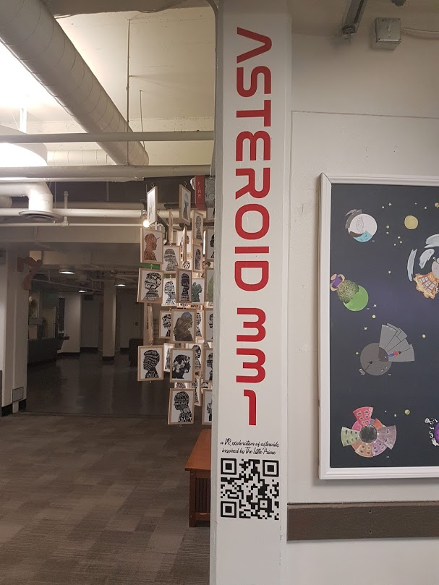
Figure 1: High Tech High Middle School Narrative VR Project (photo: Imelda Judge)
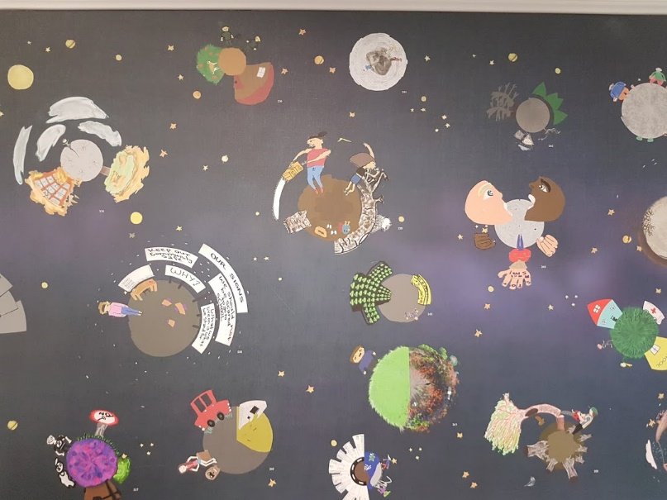
Figure 2: 2D Planets on wallpaper-then viewable in their 3D format via QR code (photo: Imelda Judge)
Both schools I visited – Boulder High School in Colorado and High Tech High in Point Loma – had very different approaches to VR. The IT teacher in Boulder High School created opportunities for the students to access the VR technology by working closely with the community and engaging the local VR team from Reality Garage but working within the confines of one subject area. Students’ responses varied on this task, dependent on their level of engagement with the technology, ability to work across the KLAs and their understanding of what was achievable with the technology. Whilst this was a wonderful collaborative initiative, the students did not necessarily draw on their narrative composition skillsets. The notion that their subjects and skills learnt in these subjects were siloed was strong.
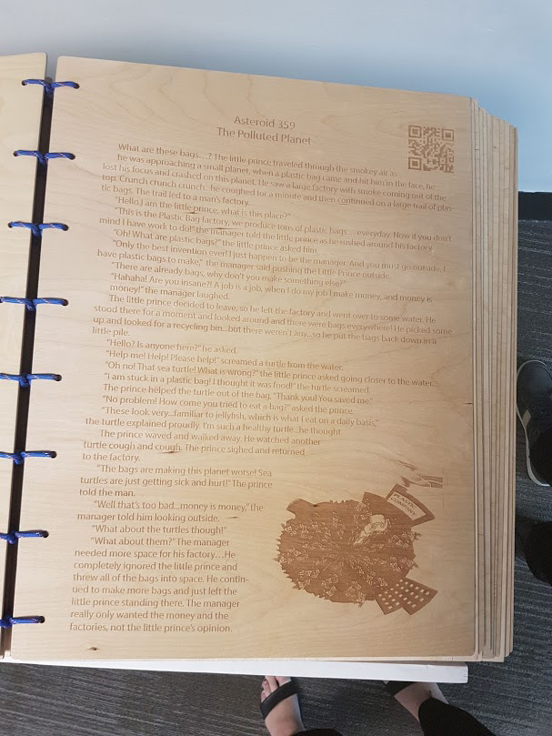
Figure 3: High Tech High student's story laser cut in balsa wood (photo: Imelda Judge)
High Tech High, on the other hand, seemed well resourced and the task that students were given was quite complex. Students in 6th grade created their own personalised VR worlds inspired by the fable, ‘The Little Prince’ by Antoine de Saint-Exupéry. The middle school students designed their own story based on the 2D planet they created. They then converted the 2D version of their invented world into a 3D version which could be activated to be viewed through the VR headsets via a QR code prompt. The QR code and the story were laser cut into balsa wood pages of a gigantic class anthology left on display in the middle school’s foyer. Here, the project based learning opportunities helped facilitate the students’ progress through the task. Many of these students entered the school by lottery and had an appreciation of their place there, so they were committed to performing well. Their teachers were skilled at working collaboratively and were encouraged to develop their own areas of passion every year to gain the desired outcome for students, supported by a budget to help students bring such big projects to completion.
There are innovative teachers who are integrating the exploration of extended reality into their units of work but the approach is predominantly sporadic and, in cases I did get to see, it was integrated as a creation tool only. Exploring XR narratives as texts was overlooked. The New York Times school of journalism was the only school that seemed to integrate a study of VR journalism as texts. Evaluating what has already been created and how the composer has achieved his or her purpose is an important part of every journalists learning and development. As educators of the English language and how it used persuasively, it makes sense for our English teachers to include XR as part of our secondary English study to keep our students learning contemporary and real, connected with the real world of work where some of our students may take this language and literature focus.

Conclusion
There is no doubt that with innovation, textual media continue to morph and dissolve into new pieces that privilege different technologies. What is important is that we recognise the potential richness of the narratives that are being developed and the space these textual media provide for exploration in the English language, literacy and literature classroom.
For this to be successful, there needs to be time for students to work collaboratively across the curriculum but only after the deep learning in English that clearly assists students’ capacity to engage with these texts critically. While these new textual media disrupt the way we read or access narrative, they provide our teachers and our students with greater insight into what makes narrative effective. It positions our students to question our fixed definition of narrative and the notion of canonical texts or what makes a text worthy of study.
Most importantly, there needs to be greater availability of professional learning that shows the richness of these digital narratives and supports teachers to talk with greater confidence about these texts in the classroom.
Access to the technology and professional learning to support the exposure, understanding and the capacity to create and experience these immersive, multimodal narratives is essential so that we can help our students broaden their capacity to view these texts critically. The way we access stories is becoming as varied as the ways we tell them. With the developments in technology, the way these stories will look and even feel will only continue to change.

Acknowledgements
- Bailenson, J. Experience on demand (1st ed., p. Chapter 10). New York: W.W.Norton & Company.
- Carlton, B. (2019). TRIBECA: Interact With A Virtual Being In Fable's 'Wolves In The Walls: It's All Over' - VRScout. Retrieved 28 April 2019, from https://vrscout.com/news/tribeca-wolves-in-the-wall-vr/
- English. (2015). Retrieved 10 July 2019, from https://www.australiancurriculum.edu.au/f-10-curriculum/english/
- English | NSW Education Standards. (2019). Retrieved 22 September 2019, from https://educationstandards.nsw.edu.au/wps/portal/nesa/11-12/stage-6-learning-areas/stage-6-english
- English | NSW Education Standards. (2019). Retrieved 22 September 2019, from https://educationstandards.nsw.edu.au/wps/portal/nesa/k-10/learning-areas/english-year-10/english-k-10/content
- History — JHU-MICA Film Centre. (2019). Retrieved 22 September 2019, from https://jhumicafilm.com/about
- Ryan, M. (2015). Narrative as Virtual Reality 2. Johns Hopkins University.
- Rienzi, G. (2018). The immersive world of Gabo. Retrieved 22 September 2019, from https://hub.jhu.edu/magazine/2018/summer/gabo-virtual-reality-filmmaking/

