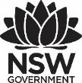
Premier’s Teachers Mutual Bank Indigenous Education Scholarship

Consistent Aboriginal student engagement in an urban high school environment
  - Indigenous engagement programs in use around Australia and New Zealand.
Bec Gray
Canterbury Boys High School
Sponsored by
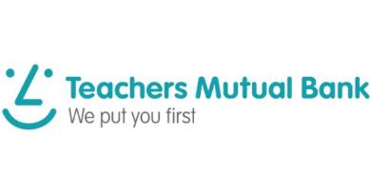

Introduction
Aboriginal Education has been a focus area of the NSW Government for some time. As a teacher in an urban high school education setting, I have been interested in different programs and engagement strategies that have been used to support student attendance and retention rates. The Prime Minister’s Report: Closing the Gap 2018 states that Indigenous students in urban education settings disengage as they progress through the school years (attendance rates drop significantly), highlighting a need for research into consistent student engagement.
This is accompanied by a participation rate drop in NAPLAN from Years 7 to 9. The Prime Minister’s Report indicates that only 55% of Indigenous students in major cities attend school 90% or more of the time. This is compared to 80% of non-Indigenous students who attend school 90% or more of the time. The number of students in major cities who complete Year 12 or equivalent is only 63.1% compared with non-Indigenous students at 89.1%.

Focus of Study
The aim of my study tour was to investigate various programs and methods used to increase student engagement in urban high schools throughout Australia and New Zealand. I visited schools and organisations in Sydney, Perth, Brisbane, Auckland and Hamilton. I attended the Native American and Indigenous Studies Association conference in Hamilton, which provided me with the opportunity to engage with the top Indigenous researchers from around the world. This research focused on identifying the significance of the combined effort of the school and wider community and aims to examine methods of engaging everyone towards a singular goal – consistent Aboriginal and Torres Strait Islander engagement in an urban educational environment. The study tour explored how schools are using, manipulating and innovating their syllabus to engage Aboriginal and Torres Strait Islander students and ensure increasing levels of engagement as they mature and begin to be moved in the directions of independence and increased responsibilities. From this study tour I aim to create a simple, yet effective program for Aboriginal and Torres Strait Islander students that can be easily implemented and used in urban high schools to improve outcomes.

Significant Learning

Self-Determination

AVID Australia
One of the schools that I visited have started using a program called AVID (Advancement Via Individual Determination) Australia to boost individual student self-determination. AVID started in the United States (1 million students have participated in this program). The main aim of the program is to improve academic results regardless of the student’s background or disadvantage. The school and program focus on teaching students how to learn because if they do not know how to learn, the content they are given is irrelevant as they won’t be able to access it. The focus is on the whole student (confidence, self-esteem, work readiness and academics), preparing them for post school options. The program also aims to upskill teachers in the use of consistent language and explicitly teaches the desired skills. The school I visited has been participating in this program for four years, which indicates it is still in the implementation phase. However, they have reported they have seen visible change over the four years and have significant data to support the success of the program.

Inclusive and welcoming environments
Australian schools that I visited that reported positive attendance and retention rates had an Acknowledgement to Country front and centre as you walked into the school as well as student artwork displayed throughout the whole school. Students spoke about how they felt their culture was valued and respected within the school and they felt proud of having their work displayed.
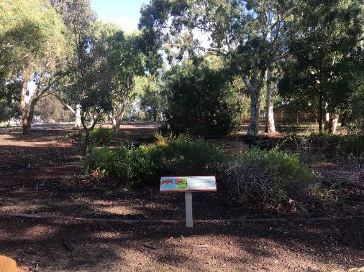
Figure 1: Bush tucker garden located at the front of Yule Brook College. (Photo: Bec Gray)
Students had a safe space to go to in most schools I visited. The spaces had all been created by the students and had artwork, quotes, workstations and chill out areas. Often these areas were in the library or another central area of the school. Some of the schools also had areas at the front of the school where community members and students could gather and have a yarn or a bush tucker garden that they could use.
In New Zealand, a significant number of high schools have their own school Maori Marae (meeting house) on site. This is a place where cultural activities and programs can be run for both the school and the community as well as for official ceremonies. In the schools in New Zealand it was also noted that all schools had visible cultural artwork on display in the form of traditional paintings, weavings, carvings, dance props and weapons. When being welcomed into the schools in New Zealand I was welcomed in te reo (Maori language) before they switched into English.
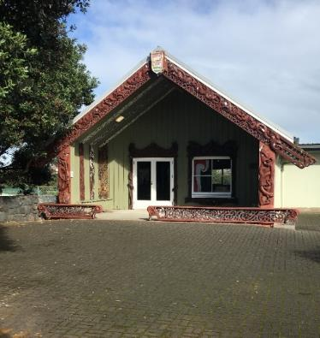
Figure 2: Onehunga High School’s Marae where cultural activities and official ceremonies take place. (Photo: Bec Gray)

Cultural Programs

Sista Speak and Bro Speak
Sista Speak and Bro Speak are Aboriginal wellbeing programs run for girls and boys. The programs are designed to run in collaboration with the local community. The programs inspire and motivate young Aboriginal and Torres Strait Islander students to develop positive relationships, learn about respecting themselves, others and the community and be proud of their culture and identity. One of the most valuable aspects of the programs is that the students have a say in what they would like to learn about, visit or connect with. Some of the programs that have been running at Matraville High School and Sydney Secondary College Balmain Campus include:
- Aboriginal Sexual Health lessons – run by Elders from the local community to discuss safe sexual health
- the rights of young people – run by the Aboriginal Community liaison officer to discuss the rights of young people
- cyber-bullying lessons
- post school options – TAFE and University days
- cultural art lessons – run by community artists
- Bush Tucker workshops – run by local Elders.
Workshops change depending on student needs and different student interests. Students spoke about how they valued having a safe space to talk about specific issues that have come up and being able to get to know different members of the community. It is hoped that the programs will help to raise awareness of different career options, the importance of identity, culture and to develop leaderships skills.
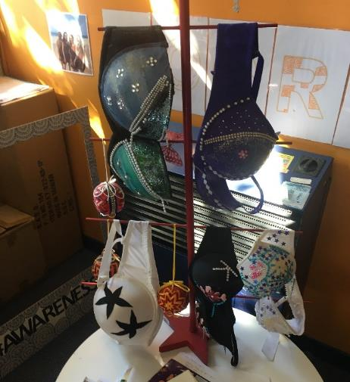
Figure 3: "Bling a Bra" artwork created by students who participated in a Sista Speak workshop about breast health at Matraville High School. (Photo: Bec Gray)

Clontarf Foundation
“The Clontarf Foundation exists to improve the education, discipline, life skills, self-esteem and employment prospects of young Aboriginal and Torres Strait Islander men and by doing so equips them to participate more meaningfully in society.” Clontarf motto
There are 116 Clontarf Foundations in schools around Australia. I was lucky enough to see it in action in three different schools. The set up varied in each school, however, the focus was always on self-esteem and life skills. Each setting had their own space that the students could access before school, at recess, lunch and after school and giving students the opportunity to have breakfast if necessary. One of the mentors whom I met spoke strongly about building positive relationships and being open about students understanding their cultural identity.

Curriculum Frameworks and different ways of delivering education

Big Picture Education
Big Picture Education Australia was established in 2006 by Viv White and John Hogan. It draws upon the philosophy and success of Big Picture Learning in the U.S., co-founded by Elliot Washor and Dennis Littky who established the first Big Picture school in Rhode Island in 1996. I spent a day at Yule Brook College in Perth where I participated in a part day training course on Big Picture Education, delivered by Eric Radice and met with Viv White. She spoke about some of the reasons why she values the Big Picture Education Model, such as:
- too many young people disengaged
- disconnect from learning represents a significant problem for individuals, families, schools, communities and government
- surprising decline in active participation in education, employment and training for 15-24-year olds
- increase in non-ATAR entry to universities
The Big Picture Model aims to use the student’s interest/passion as the centre of their learning. They can work with expert mentors within their local community while doing work that interests them. It is important that families are involved in these passion projects and at Yule Brooke College, families are encouraged to come into the school frequently and are encouraged to be involved in their child’s learning. The passion projects require a significant amount of reflection by each student on the quality of their work as well as how the project has changed them.
The passion projects focus on the 5 A’s:
- Authentic
- Adults from outside the school
- Active Learning
- Academic – five learning goals
  - personal qualities
  - better at communication
  - developing an awareness of how maths impacts on the world
  - element of actively exploring
  - social reasoning
- Assessment – how will the work be assessed?
Another key aspect of the Big Picture Model is the internship process. Eric Radice spoke about the importance of using the expertise of the local community to support the internship process. One student I spoke to was doing an internship at a nursing home as that related to her passion project on disabilities. This student was also completing her Certificate 3 in disability services through TAFE. She spoke about being able to pursue her interest and how it made school interesting and relevant to her life.
Each student belonged to an advisory group made up of 17-20 students. These advisory groups have the same teacher for as long as possible. The role of the advisory teacher is to develop a sense of belonging for their students. The students are in their advisory groups for most of the day, which is where they work on their passion projects and the advisory teacher can support them. Students and staff participate in mindfulness sessions each day and specific literacy and numeracy lessons. Yule Brook College has just been announced as a finalist for 2019 Western Australian Education Awards for Aboriginal Education for their work with local community members and students to renew their Aboriginal community agreement which celebrates the spirit, strength, resilience and intellect of Noongar peoples.
The Big Picture Model makes me think about how the education system could support individual student needs with different models. The idea of ‘one student at a time’ in a community of learners is a compelling motto and a powerful reminder that the student should always be at the centre of education. With this in mind, schools may benefit from adjusting the way they deliver the curriculum to include cross curricular and individual projects that focus on authentic learning experiences that prepare students for life post school.
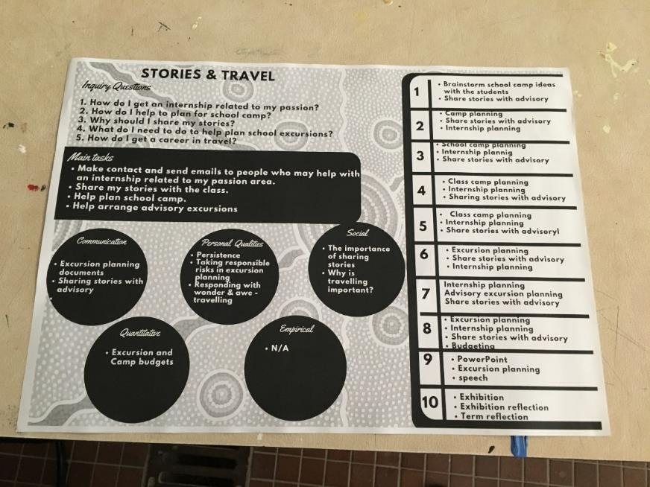
Figure 4: An example of a Big Picture Education mind map creating by at year 9 student at Yule Brook College. (Photo: Bec Gray)

Solid Pathways – creative and critical thinkers
This program has been designed for high achieving Aboriginal and Torres Strait Islander students in Queensland. The focus of this online program is to develop students’ ability to be critical and creative thinkers and empower students with lifelong ability to be successful. This program provides students with the opportunity to collaborate with other students from around Queensland and help develop skills such as; teamwork, leadership and goal setting. The program is delivered online at set times each week where all participants log in from their home schools and work together to complete the lessons. The creative and critical thinkers program uses the following frameworks:
- ACAR – critical and creative thinking learning continuum
- Intellectual Values
- Community of enquiry – 4C’s
- My Land My Tracks: A framework for the holistic approach to Indigenous studies was developed by Ernie Grant, Dijirabal/Djirrabal Elder and published by the Innisfail and District Education Centre. The holistic approach to learning promotes cross-cultural understanding
- 8 Aboriginal Ways of Learning - this is a pedagogy framework that allows teachers to include Aboriginal perspectives by using Aboriginal learning techniques.
It was interesting to sit and watch the lessons in progress and to see how all the different frameworks are embedded throughout them. Questioning and reflection were big aspects of the lesson and it was interesting to see how the students were able to reflect upon the lesson and themselves.

Aboriginal Cultural Standards Framework
Paulina Motlop is the Director of the Aboriginal Education Teaching and Learning Directorate at the Western Australian Department of Education, among other roles. She took time out of her busy schedule to meet with me and discuss the Aboriginal Cultural Standards Framework that has been implemented into Western Australian Department of Education schools. . Motlop leads the team and works with principals to upskill them and help schools implement the framework. The framework points out the value of working with staff, Aboriginal and Torres Strait Islander students, their parents and families as well as the community to support student learning. She spoke about the importance of recognising that students have knowledge, skills and experiences that are valuable to the classroom and that other students and staff can learn from them. It is also necessary to understand that Aboriginal and Torres Strait Islander students speak Aboriginal English and that English is often their second language. We discussed how the framework is just as vital for schools who do not have any Aboriginal and Torres Strait Islander students as it is for those who have a high percentage.
The framework is a continuum designed to be an ongoing reflection tool for schools. It is broken into five different standards that all have indicators to guide staff through the continuum:
- Relationships: Culturally responsive schools foster positive participation, communication and interaction between staff, Aboriginal and Torres Strait Islander students, their parents and families and the local Aboriginal and Torres Strait Islander community.
- Leadership: Culturally responsive schools have leaders who develop and sustain an individual and school-wide focus on improving education outcomes for Aboriginal students.
- Teacher: Culturally responsive schools have high expectations for Aboriginal students and teach in ways that enable them to better reach their full education potential.
- Learning environment: Culturally responsive schools build an environment that is welcoming for Aboriginal students and reflects community aspirations for their children.
- Resources: Culturally responsive schools target resourcing to optimise the education outcomes for Aboriginal students.
The continuum uses the following terminology:
- Cultural Awareness (Emerging)
- Cultural Understanding (Developing)
- Cultural Competence (Capable)
- Cultural Responsiveness (Proficient)
Paulina Motlop described the continuum as a continuous cyclic process that enables schools to honestly assess themselves against set standards and identify areas to work on. It is too early to assess the effectiveness of the framework; however, it aligns with the Council of Australian Governments’ Closing the Gap targets. We spoke about the different programs available to students as well as the Personalised Learning Pathway and after external evaluation, the Western Australian Department of Education decided they weren’t value adding and have moved towards the framework instead.
She asked me the question “what do you think needs to happen” and this allowed an open and honest discussion about different educational models including: Big Picture Education; inclusivity and how welcoming the school environment was for students, staff, parents and the community; and the importance of engaging with the local community as they provide a wealth of knowledge and experience that cannot be found inside the classroom. It was a privilege to spend time talking with her as she has a deep understanding of Aboriginal and Torres Strait Islander education and is so passionate about improving outcomes for all students.

Maori Education
The New Zealand schooling system has three different types of schools:
- English Medium schools – all subjects taught in English
- Maori language in English Medium schools – Maori language offered as a subject
- Maori Medium Education schools –schools where teaching is in te reo Maori and is based on Maori culture and values. These schools follow the curriculum for Maori-medium teaching, learning and assessment.
I was fortunate enough to visit a Maori language in English Medium school and a Maori Medium school. I was amazed by the amount of Maori language throughout both schools. The staff at the front office welcomed me in Maori before switching to English, the newsletter was written in Maori first and then translated to English and everywhere I looked I could see cultural artwork. Murray Saunders the Deputy Principal spoke about how they offer weaving, weaponry and wood carving as electives; however, they are classified as the equivalent of a non-ATAR course. We spoke about the challenges of finding Maori staff who were qualified to teach those electives and how lucky they are at the school as they have their own Marae on site as well as several Maori teachers. Maori is taught to all students at this school until they reach senior school where it becomes an elective.
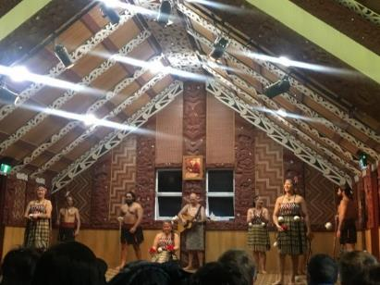
Figure 5: An image of a Maori cultural performance including: Poi dancers and the Haka. (Photo: Bec Gray)
Nga Taiatea Wharekura is a Maori community school in Hamilton. The local community petitioned the government continuously for six years to establish a school to meet the needs of the local community. The school teaches 80% of lessons in Maori and follows the Te Marautanga o Aotearoa Maori Curriculum which is based on Maori philosophies. Each student at the school has their own education plan and follows an individual timetable depending on subjects and areas of interest. The school places a high value on hands on learning and encourages students to do traditional Maori subjects such as wood carving and weaving. Some students have received scholarships to study wood carving and weaving post school because of the knowledge and skill development they have gained at school. This has given students purpose and has shown them that their culture is valued and respected throughout the education system.

Conclusion
There is no one simple solution to improve the engagement of Aboriginal and Torres Strait Islander students in urban high schools. A continuous theme throughout the tour was about creating an environment that students, families and the local community felt connected to. Schools achieved this by developing and displaying an Acknowledgement to Country at the front of the school as well as displaying student and local community members’ artwork and images. It has also been noted throughout how valuable and important it is to have Indigenous perspectives throughout the curriculum and, where possible, hands on experiences being delivered by local community members. New Zealand went one step further than Australian schools, using Maori language throughout schools and cultural venues. I was welcomed into schools in Maori and school publications were written in Maori and then translated into English. This was also the case for museums, historical sites and environmental sites.
Interest based learning is gaining momentum in schools around NSW and I can certainly see the benefit in implementing a variation of this to support students who are becoming disengaged from school. Allowing students to more deeply explore their interests within a guided framework creates opportunities for them to succeed in their chosen career. What really caught my attention is that several universities around Australia are now accepting interest-based portfolios as entry into university instead of an ATAR mark.
Self-determination was mentioned at a couple of different schools. From this study tour I have a greater understanding of how self-determination programs can be implemented into a classroom environment and the value these specific programs can have on the lives of young Aboriginal and Torres Strait Islander students. Through the study tour I have developed an interest in exploring self-determination in more detail and working with Aboriginal and Torres Strait Islander students, staff and community members to create a simplified self-determination program that draws from different aspects of programs that I experiences whilst on my study tour. The program needs to be easy to implement, collect and analyse data so that it is accessible to all schools and benefits students. This would provide staff with a simple template to use to help students develop the necessary skills to create opportunities for success post school and provide families with positive and achievable goals.
I would like to sincerely thank Teachers Mutual Bank for generously providing me with the funds to embark on my study tour and the NSW Premier’s Teacher Scholarship program for giving me this opportunity.

Acknowledgements
- Campbelltown Performing Arts High School
- Sydney Secondary College Balmain Campus
- Sydney Secondary College Glebe Pathways
- Endeavour Sports High School
- Matraville Sports High School
- AVID Australia
- Le Salle College
- Paulina Motlop – Director Aboriginal Teaching and Learning, Western Australia Department of Education
- Yule Brook College
- Solid Pathways
- Queensland Aboriginal and Torres Strait Islander Foundation
- Onehunga High School
- Taiatea High School
- NAISA conference
- Viv White – Big Picture Education Co-Founder

Reference
- Australian Government Department of the Prime Minister and Cabinet (2019). Closing the Gap 2018 report.

