Premier’s Vocational Education Scholarship

Advancing skills for the future
  - The use of immersive technology in VET
Allyson Fisher
Albion Park High School
Sponsored by

Introduction
The 21st century workplace is characterised by dynamism and innovation, and places high value on a key skill set that is often referred to as enterprise skills. The nature of work is undergoing a significant and rapid transformation and to cope with this, employers are prioritising creativity, critical thinking, collaboration and problem solving. Teaching practices with the aim of developing workers in the context of the Industrial Revolution are rapidly becoming redundant in preparing students for the modern world. Providing ongoing opportunities to develop and refine key enterprise skills should be a focus of modern education.
Technology is synonymous with modern life, with an exponential rate of change. A range of such technologies are being used by industry and business to keep up with the rapidly shifting workplace, including e-learning, virtual reality (VR), and augmented reality (AR). These methods are enabling feedback-driven experiential learning and are overcoming some of the barriers evident in traditional education teaching strategies. Immersive technologies, such as VR and AR, have the potential to be deployed in a range of learning situations and are an effective method of facilitating the personalised learning and development of 21st century skills recommended by the Gonski 2.0 Report.
Some areas of education and training have mirrored industry and business and recognised the benefits of experiential learning through simulation of real-world environments and have adapted and updated their teaching and training methods to incorporate relevant technologies. Vocational Education and Training (VET) in secondary schools is a preparation phase for young people moving into the world of work and as such it needs to extend learning, wherever possible, beyond the classroom. Thus, it is a perfect setting to implement Immersive Technologies. However, the adaptation of these technologies into VET is in its infancy and requires much further planning and research.

Focus of Study
Current Usage Patterns | - how, where and when is it being used?
Associated Outcomes | - benefits of use
Equipment | - hardware (e.g. Headsets and associated technology – cost, function, accessibility, comparisons, quality, positives, negatives)  - software (development: Off-the-shelf or bespoke learning materials)
Implementation | - costs  - practical considerations / strategies  - barriers  - industry partnerships
My research aims to provide the foundation for an informed and sustainable application of immersive technologies in secondary education, to bring the delivery of VET qualifications firmly into the 21st century.
Table 1 - Outline of major areas considered in report

By investigating the use of immersive technologies in industry, education, and vocational training I hope to enable their generalisation to the secondary school context. Immersive technologies provide resources and tools that have the capacity to complement existing learning strategies and assist in key skill development and workplace learning in VET, Work Education and Careers Education. In theory, learning takes place in a safe and monitored environment and thus enables students to develop work readiness and make more informed and appropriate career choices. It has strong potential to increase the quality and efficiency of training and encourage the development of key enterprise skills.
The primary focus of my study was to research whether there is a place for the use of immersive technologies in delivering vocational qualifications to the average student in a secondary high school setting.

Significant Learning
In the UK, immersive technologies are being used effectively in some areas of training and industry. However, the uptake of this technology could best be described as steady and is not currently widespread, especially in education settings.
The technology, including headsets and gaming computers, continues to develop. Quality is improving, cost is decreasing, increasing accessibility and is linked to the continued growth of the video-gaming industry. The slow uptake can therefore not be blamed on the technology but is probably due to an initial reluctance by educators, trainers and teachers to try something new.
The gamification of learning or serious game uses game mechanics in non-game situations to enhance learning, influence behaviour and make learning more realistic. The learner audience in secondary education is open to and familiar with gaming and therefore ready to embrace this new way of learning.

Current Usage Patterns

How, where and when is it being used?
I visited a range of organisations during the study tour. These included:
- universities (University of the West of Scotland, University of Manchester)
- schools and colleges (Fife College, North East Futures UTC, National College for High Speed Rail, Ark Helenswood Academy)
- instructional design companies (Hammerhead, Walkgrove, Gooii, eLearning Studios, AiSolve, Warp Industries)
- government organisations (Skills Development Scotland, Learn Appeal)
- a conference (EdTechXEurope, TechXLR8)
Professional teams involved in VR development and application included academics, teachers, technicians, administrators and developers.
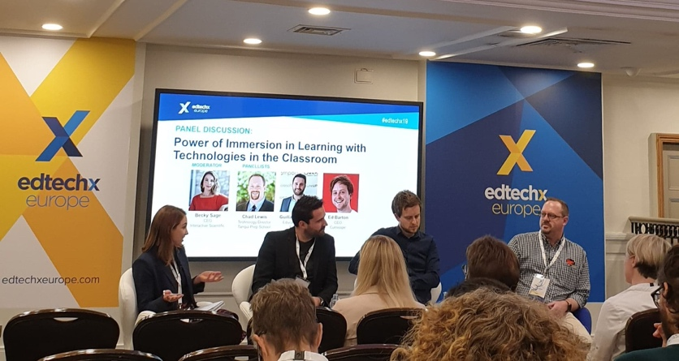
Figure 1: Panel members at EdTechX London 2019 (photo taken by Allyson Fisher)
Common themes that emerged were that immersive technologies had their greatest application when training or learning in the following areas:
- procedural tasks that have an ordered sequence of steps e.g. assembling or disassembling a car engine
- emergency situations or high-risk activities – training at heights or medical emergencies
- activities that require the use of expensive resources – flight simulations
- safe exploration of real-life situations such as driver safety
- design simulation and exploration – architecture and engineering
- high empathy tasks – dealing with customers/clients/patients.
Several organisations also indicated that there were benefits of using VR for social learning. Collaborating and working as a team to solve a problem allowed users to share ideas and also experience how others respond to or approach a particular situation. Technical colleges and universities in the UK are beginning to use immersive technologies for training purposes. I saw examples of VR and AR being used to train individuals in customer service, maintenance and safety, engineering, public speaking, leadership and medical procedures. Examples of how the technology was being used in a secondary school setting were less apparent. Schools that I met with indicated that they could see the benefits of using this technology, but there was no current widespread implementation.
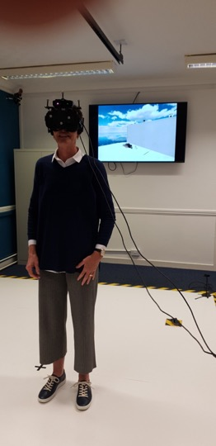
Figure 2: Testing the technology at Fife College, Rosyth (Photo taken by Jim Brown)

Associated Outcomes

Benefits of use
Observations in a variety of settings suggest a range of benefits. Immersive technologies are:
- immersive and deliver a realistic, distraction-free experience that helps learners prepare for real world scenarios
- interactive, directly engaging learners and can be repeated as required
- highly structured initially and as the learner develops proficiency additional features can be included e.g. time and emotional pressure
- able to improve knowledge, skill, and muscle memory retention
- scalable and can deliver consistent training to a large number of learners
- cost and time effective – as the need to build simulators or physical replicas is reduced and travel costs for training are minimised
- effective in developing soft skills – communication, problem solving, empathy
- useful in providing ‘controlled failing’ situations – users are forced to make decisions and be faced with the consequences, without being in any real danger
- suited to a range of procedural work tasks common in the work environment.
Immersive technologies could be applied in the following situations in secondary education in NSW:
- safety training in VET courses such as Construction and Engineering
- soft skill training in all VET courses but specifically Retail, Business Services and Hospitality
- public speaking skills for job interviews, presentations and debates
- coaching skills for students in Sport Coaching
- emergency and first aid training for both staff and students
- procedural training in Hospitality, Construction and Engineering e.g. barista training
- career planning for students – virtual work experience.

Equipment

Hardware (e.g. Headsets and associated technology – cost, function, accessibility, comparisons, quality, positives, negatives)
An array of headsets and supporting devices, ranging from those constructed from cardboard right through to high end models with movement sensors and attached to powerful gaming computers, are available to those wanting to experience a virtual environment. I tested a range of devices - all provided the user with a virtual experience.
Identifying the range of products on the market is important if immersive technology is going to become common place in education. Good quality stand-alone headsets (such as the Oculus Go and Quest) are becoming more accessible due to a decrease in prices and can provide the user with a high-quality experience.
High end products, such as the HTC Vive Pro, have high quality visual and audio capabilities including features such as body movement sensors, facial movement sensors, eye tracking and dual hand-held controllers. They can detect fixed objects in a room and can define a workspace via a virtual grid.
Headsets can include:
- cardboard headsets that utilise mobile phones and downloaded apps. These headsets use a point and click function to move between activities in the virtual environment. These are a cost-effective option and could be used effectively in a classroom. Connectivity and credit may create some issues
- more substantial plastic headsets also utilise mobile phones. These models can also have headphones attached, and have a similar costs and challenges to the cardboard option
- mobile headsets with an in-built processor. Internet connectivity allows VR applications to be streamed or downloaded directly to the unit. Hand-held controllers allow for greater interaction with the virtual environment. The mobile units provide flexibility as they do not need to be connected to a PC and can be packed up and relocated with ease. The units need to be re-charged regularly
- tethered headsets linked to a gaming computer have high quality graphics and audio. These units come with dual hand-held controllers and multiple built-in sensors that impact on the virtual experience
- hand controllers translate real world gestures into the virtual environment. Some headsets come with a single hand controller. The more expensive versions come with dual-hand controllers.

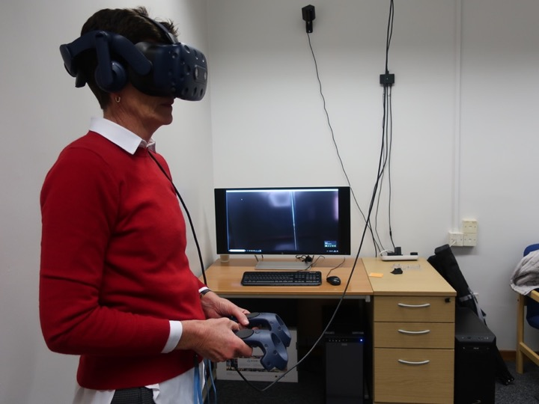
Figure 3: Getting ready to walk Richie’s Plank Experience - University of Manchester (Photo taken by Antony Paton)
Regardless of the level of sophistication, each headset can provide a quality virtual experience. Thus, a full scoping review of the feasibility of a variety of hardware should be conducted prior to implementation in Australian schools. I would recommend headsets similar to the Oculus Go or Rift due to the combination of price, portability and quality of the immersive experience.

Software (development: Off-the-shelf or bespoke learning materials)
Currently, there are two main ways of obtaining educational or training VR applications.
- Download or use off-the-shelf products available in app stores (App Store, Play Store, STEAM). Some applications are free with others being available at a cost, similar to apps downloaded to a mobile phone. These products generally lack measurement or assessment elements and do not have the capacity to provide detailed feedback relating to performance.
- Work with an instructional design company to create a bespoke product that is developed for a specific purpose.
A third option does exist if you have the time and skill to create your own virtual simulations. There are a range of readily available authoring platforms or game engines to assist with this and 360-degree cameras are becoming more accessible.
During my study tour I had the opportunity to visit a number of companies who work with industry and education to develop bespoke learning materials. A Design Sprint method is utilised which allows collaboration between project managers, developers and subject matter experts. The training simulation is storyboarded and a prototype developed. Based on feedback the prototype has many iterations before it becomes the final VR simulation. The graphics in a VR simulation can be either 360-degree video that has been captured or computer-generated graphics.
The production and development budget will determine the style of the VR simulation. There are a range of platforms used by developers to create VR content. Some design companies have developed their own platform, such as Warp Studio. This could be a limiting factor as some VR experiences can only be viewed on a specific type of headset.
Developing VR content for training in vocational education courses would require the use of a platform that would allow the simulation to be viewed on a range of different headsets, including the cardboard models that utilise a mobile phone. Access to appropriate technology for all students in NSW schools would be an important consideration if the use of VR and AR were to become more widespread. This would include access to quality headsets and appropriate content. Part of this issue could be managed by engaging with local instructional designers with an understanding of the NSW education system and its needs. This could lead to the development of a VR platform that could be utilised across devices and operating systems.
A key feature of VR simulations for educational purposes is functionality that provides performance data and feedback which links directly to an existing Learning Management System (LMS). This allows the trainer to track progress and provide feedback to the trainee. The trainer can also identify areas of learning that may need to be re-visited if performance data is low. The learner gains immediate feedback regarding their performance via simple scoring systems. For example, in a VR simulation called Virtual Speech, designed to develop public speaking skills the user gets feedback on the number of hesitation words used, eye contact score (/10) and speaking pace (words/min).
Advice from all design companies was to keep the scenarios short, simple and engaging. VR simulations need to complement and support other forms of learning.
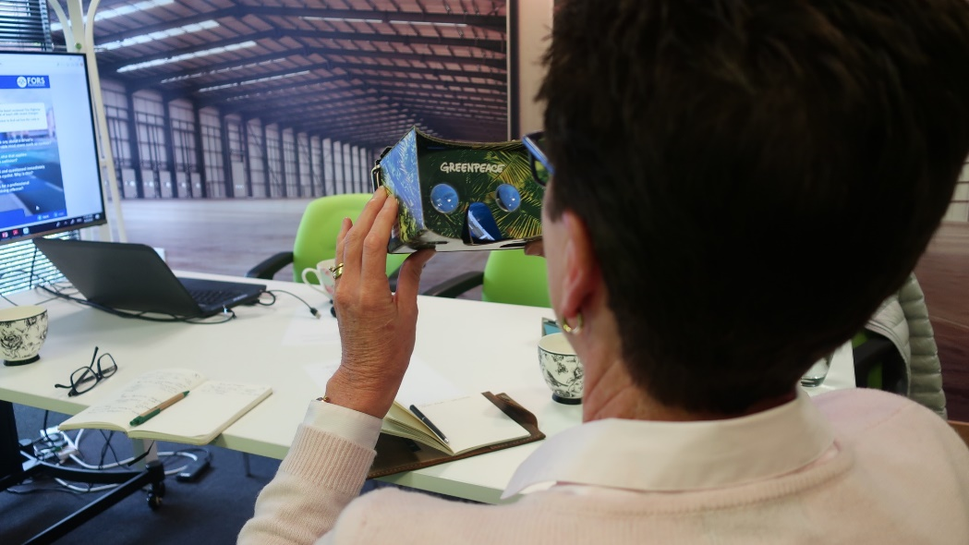
Figure 4: Cardboard VR headset with customisation (Photo taken by Sarah Smith)

Implementation

Costs
- Headsets do not need to be expensive. Apps are available and can be developed to use on low-cost cardboard headsets ($2-$5). They can be blank or customised with logos etc.
- Mobile headsets remove the need for dedicated labs and classrooms. They are portable, can be re-charged like a laptop and can be plugged into any computer to obtain analytics or upgrade software.
- Access to appropriate educational and training content without significant expense is still a limiting factor.

Practical Considerations / Strategies
Recommendations
- Utilising immersive technologies in a training program should only occur if by doing so the learning outcome for students or trainees is enhanced.
- Developing VR learning modules is an expensive exercise and it should only be used where current methods are not working or where the use of technology significantly improves learning outcomes.
- Technology should not be used as a gimmick although the gimmick factor could be explored when trying to re-engage learners.
- Serious games can support and enhance learning when used in an appropriate way and should be embedded in training programs.

Barriers
Commonly reported barriers to implementation are:
- resistance to change – teachers and trainers
- technical expertise of trainers
- lack of appropriate content – quality, relevance
- costs involved in developing bespoke solutions and purchasing headsets
- storage and maintenance responsibilities – who looks after the technology
- technical failures – lack of credit/charge on mobile phones, poor wireless connections
- meeting the needs of all learners and adapting to a range of learning styles
- possible reduced social interaction and verbal communication
- possible health and safety risks
- measuring value-added.
Barriers identified from the UK example would be similar for educators in NSW. Teachers and education systems in NSW are faced with similar constraints around funding, infrastructure and technical skill and this impacts on the ability to bring about significant and rapid change.
However, these barriers can be overcome if the education system, and as a flow on teachers, perceive that the technologies will provide value to teaching programs and improved outcomes for learners. As with all new technology, continued exposure, targeted professional learning and time generally results in a change of perception and behaviour. The necessity to learn and work remotely in the future may also have an impact.

Industry Partnerships
Providers of vocational education and training need to work with industry and business to improve the quality of training. Learning should be designed in collaboration with industry experts to ensure there is a full understanding of future skill needs and that skill shortage areas are being adequately addressed. This was a common message throughout the tour. Creating strong partnerships will help ensure the relevance of training both in the development of industry specific skills and also more generic enterprise skills.
A range of industry sectors are already embracing the use of immersive technologies for training. These include medical and health, construction, emergency and safety, automotive, manufacturing, engineering and management. The industry sectors identified see value in supplementing their existing training programs with VR and AR because it is:
- real world problem solving
- provides immediate and accurate performance feedback, both to the trainer and trainee
- cost effective
- safe– dangerous work environments can be explored in a virtual environment
- repeatable
- able to replicate a place and situation that would be difficult or near impossible to do in real life.
In the UK, skill shortage areas have been identified in geographical areas e.g. North East of England have identified Health and IT. University Technical Colleges (UTC) are the equivalent of secondary high schools in Australia that provide a vocational curriculum that is developed to address the identified skill shortage areas. Industry partners play a significant role in project-based learning with students, offer work-based learning opportunities, mentoring and support students with work-readiness activities. The UTCs have direct links with local universities which provides a direct pathway for students wanting to gain higher level qualifications.
Recently in NSW there has been a greater focus placed on the need for developing strong partnerships between schools and industry. The Regional Industry Education Partnerships (RIEP) is an NSW Government initiative that is looking to strengthen connections between local industry and secondary school communities and support students in planning their future career pathways. The UTC model that has been adopted in the UK could provide the basis for further strengthening connections between schools and industry in NSW and deserves serious consideration.
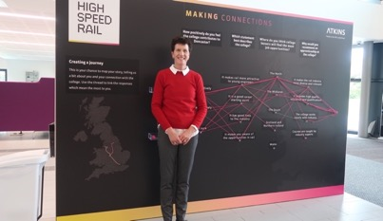
Figure 5: National College of High Speed Rail - Doncaster. Significant industry partnerships exist between the NCHSR and the rail industry.

Digital Literacy
Whilst not directly related to my research topic something that became obvious during my study tour is the need for Australian students to have high levels of digital literacy. This means being able to identify and use technology confidently, creatively and critically to meet the demands of life, learning and work in a digital society.
Digital technologies are causing significant disruption in society. Young people need to have the skills to manage their digital footprint and use technology in an ethical and responsible manner. As the world changes, especially the world of work, digital skills will need to be developed alongside other enterprise skills to ensure young people thrive.

Conclusion
- VR and AR may be part of the learning solution, but it is expensive to create. It can be useful in providing experiences that a learner can't normally have e.g. dangerous situations or business critical activities.
- VR and AR also create memories (neural pathways) that can be recalled next time a learner finds themselves in the same situation. This could be particularly useful in a VET environment, especially in a secondary school.
- VR and AR can make the learner more interested or engaged, but it still needs to be backed up with effective learning that is linked to identified learning outcomes.
- Good storytelling is a key to effective VR and AR development. If the story is strong and real, then the chances of effective learning are increased.
- Significant professional learning would need to occur for trainers/teachers – the use of a local tech evangelist to promote and support the use of new technology could help overcome this.
- VR simulations need to be embedded in teaching or training programs – it is just one of the tools trainers/teachers have at their disposal and they need to determine when best to use it.
- There needs to be significant buy-in from the various industry sectors if the use of immersive technologies is going to become a viable learning tool. Industry, education and training need to work together to design relevant digital content.
- Presentations to the local Careers Advisers network, Senior Executive at Albion Park High School and VET Coordinators from the Wagga Wagga RTO (Illawarra North and South) have led to significant, but measured interest regarding the application of immersive technologies in both VET and workplace learning. Educators at all levels can see how VR and AR could be utilised to improve learning outcomes and engage learners in a range of situations but getting their heads around how to use the hardware and then sourcing appropriate software is not on most people’s radar. Busy schedules, compliance, programming and a plethora of administration tasks leaves very little time for innovation.

References
Deloitte Insights. (2019). Digital reality: The focus shifts from technology to opportunity. [online] Available at: https://www2.deloitte.com/us/en/insights/focus/tech-trends/2018/immersive-technologies-digital-reality.html [Accessed 30 Sep. 2019].

Acknowledgements
- NSW Department of Education – Vocational Education & Training
- David Squire – Founder and Creative Director, DESQ
- Sarah Smith – Managing Director, Walkgrove Limited
- David Patterson – Director & Consultant, Learning Light Limited

