Premier’s HTA History Scholarship

Resourcing and Teaching Irish History in Australian Schools

The potential of Irish History to enrich the Australian curriculum
Rebekah Poole
Knox Grammar School, Wahroonga
Sponsored by

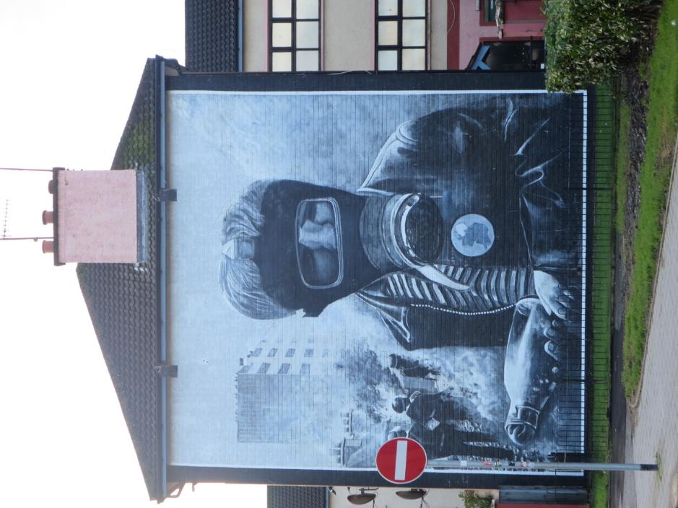
‘The Petrol Bomber’ – Bogside mural depicting scenes from the 1969 Battle of the Bogside. The image can be used as a source relating to the use of CS gas and the Bogside rioting during the Civil Rights Campaigns, as well as evidence of change in Northern Ireland. The original mural had the boy’s ‘Ireland’ badge painted as a united nation, now it illustrates the North as a separate entity.
My study aimed to collect and develop resources focused on the history of Ireland for the benefit of multiple educational stages. Preliminary topics, including the Easter Rising and a Michael Collins personality unit, were to be resourced in the Republic of Ireland, while time spent in Northern Ireland would focus on building upon the scarce resources available in Australia to teachers who were interested in the topic. Links were also to be made to the Stage Five Civil Rights/Movement of Peoples studies for the new Australian Curriculum. Given the complexity and multiple issues linked to key concepts such as imperialism, nationalism, terrorism and socialism within the Modern History syllabus, I selected Ireland as a source that could provide multiple resources across various stages of education, and one that was widely acknowledged as being difficult to resource.

Planning and Study Focus
In 2014, I presented at the History Teachers Association Stage Six Day on ‘Utilising the murals of Northern Ireland as sources for visual learners’. There I was able to interact and engage with other educators who believed in the potential of Irish history as a study in Australian schools. Following discussion, it became clear that every member of the group felt that Irish history was being under-utilised as a study of both conflict and civil rights movements due to the difficulty in resourcing it within Australia. With this in mind, I developed a concept map illustrating how learning Irish history could benefit Australian students.
In November, I noticed an article in the Irish Times about the incarceration of former PIRA operative Ivor Bell. This sparked my interest, as for some time I had been considering how Irish history could be of benefit to students of History Extension. It is one of the few modern and easily linguistically accessible examples of recorded conflict in recent history and the debate over how it is presented is only currently developing. I decided to investigate issues pertaining to how the conflict was recorded and authored while I was in Ireland.
I had travelled to Northern Ireland previously and had an existing network of contacts that I was able to consult while I planned a study tour that would best support the links I had created within the concept map. A contact at the Museum of Free Derry suggested talking with a representative of Sinn Fein and also gave me the name of Paul Doherty, who was conducting tours of the Bogside. I also spoke with Will Kelly, one of the acclaimed Bogside Artists of Derry. Will was unable to meet me due to being in Australia while I would be away; however, he put me in touch with his brother, Tom, who still lives in Derry and was open to meeting and discussing the murals.
Following my examination of Northern Ireland, I plotted a course that would allow me to examine the causation that created a path to the Troubles by resourcing the 1916 Easter Rising. This involved contacting military historian Donal Buckley, who was excited by the project and kind enough to take on my trip himself, promising to personally take me to the often inaccessible Cork Barracks Michael Collins section using his military credentials. Through Donal I also spoke with Tim Crowley, curator of the Michael Collins Centre in Clonakilty, who was just as open to meeting and going through historical evidence about the life and death of Collins.
Once the contacts and itinerary had been confirmed, I began to research other sites I could view that would provide Australian teachers with additional information when teaching different units, including looking at resources not available in Australia.

Three Stages of History: Newgrange, Battle of the Boyne and Portadown
I arrived in Ireland on 27 December 27 2015, and immediately drove to Newgrange. Newgrange is the best known of the passage tombs located within Ireland’s Bru Na Boinne complex and I hoped to examine it for possible use as a preliminary Ancient History study. The site is considered Neolithic, much in the same manner as Orkney’s Skrara Brae, making it older than Egypt’s pyramids.
The artwork surrounding the tomb itself has been examined and is noted as having petroglyphs similar to those found in Indigenous Australian artwork, as well as Indigenous US and Canadian art. I photographed the site and was able to document aspects of the chamber and petroglyphs. These, along with further information on the carvings and purpose of the Newgrange site, have been published on my website for the use of other teachers.
In the same area I visited and documented artefacts from the Battle of the Boyne Heritage Centre. Although the battle itself is much discussed as background to the Anglo-Irish Conflict (Stage Six Modern History), very few resources exist within Australia to illustrate it.

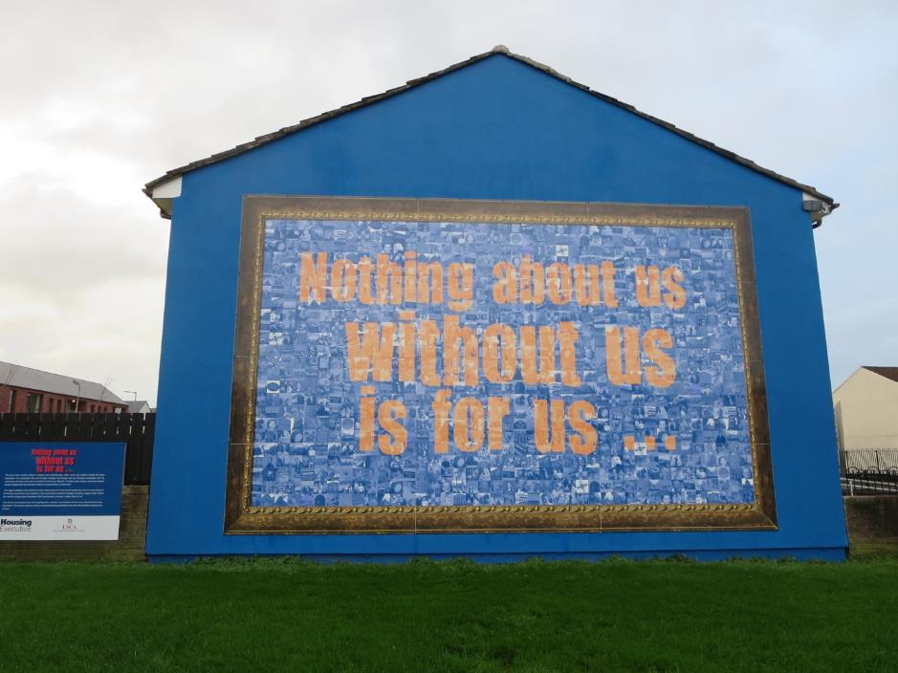
‘Nothing about us without us is for us’ is a newer loyalist mural that replaced a former artwork dedicated to the 2nd Battalion of the Ulster Freedom Fighters, the loyalist paramilitary responsible for over 400 deaths during the Troubles. The mural is now a community-based comment about changes to Belfast and the Lower Shankill area and how these can only occur with meaningful community engagement. Note the plaque to the left depicting the murals previously on the wall and explaining the need for transition.
As I travelled towards Belfast along the east coast’s main arterial road, I stopped at Portadown. That small village is still very much segregated along loyalist and nationalist lines. I wanted to visit Drumcree Church there (See Appendix II), as it remains a conflict hotspot due to its significance to Orange Order marches. By photographing and writing about this on my website, I hope to provide students with more detail about the events that aggravated social tension within the Northern Irish conflict.

Belfast: Still Divided and Divisive
I visited and documented several items in Belfast, including a recreation of a nationalist cell at Crumlin Road Jail, the Stormont Parliament Buildings and the location of key sites relevant to the Troubles, such as the Divis Street Flats. However, the key focus remained the use of murals as historical sources.
I was able to spend time with former paramilitary members from both the Loyalist and Nationalist factions, who took me through their sections of the city and discussed the murals with me. It was important to document these because, although students enjoy using them as visual sources to provide a relief from text-heavy items in essays, they were often failing to correctly describe the events and symbolism within them.
As I documented the murals, one key fact occurred to me in terms of the possibility of this topic for the teaching of History Extension: Ireland’s murals remain constantly transforming, the way history is recorded within them ever-changing. The best example was within the loyalist areas, beyond the Shankill Road, where previously confronting murals (such as that of a skeleton running and armed) were now replaced with community-based murals. Beside these new
murals, however, the memory of the old is documented on small info plaques, a suggestion that Belfast remains committed to the memory of how it documents conflict, in addition to moving beyond it.
I toured the Nationalist sites with a member of the Republican community, who was able to give me a first-hand account of his experience of being present at the Milltown Cemetery shootings in 1988. This is crucial, as it links directly to the cycle of violence syllabus section within the HSC Anglo-Irish study. His narrative, in addition to his explanations about the ever-changing murals of the International Wall, were crucial in allowing me to better document the symbolism of murals for students studying the conflict.
I also spent two days examining Belfast’s amazing Titanic complex. The ship itself serves a dual purpose in the Australian study of history; it can stand alone as a historical film study in addition to providing detailed comparisons of the class divide for the Preliminary Modern History ‘World at the Beginning of the 20th Century’ study. I was able to photograph and later write an article for Teaching History on the museum itself, which also holds interesting information about how Belfast has chosen a multifaceted selection of media to display the links between industrialisation in the North and the voyage of the liner itself.

Derry/Londonderry: The Bogside
In Derry I was able to interview several key figures whose first-hand accounts of Irish history were not readily available in Australia. These interviews have been transcribed and are available on my website.
Tom Kelly is one of the three Bogside Artists, who created a ‘people’s gallery’ of murals in the Catholic stronghold of the Derry Bogside neighbourhood, the location made infamous by the events of Bloody Sunday in 1972. Tom was an amazing interview subject and was able to explain the motivation behind the murals, which have been visited by figures such as the Dali Lama. These murals are frequently cited as sources in HSC Anglo-Irish essays and to receive primary information on their message and meaning, in particular the goal of keeping them politically neutral, was incredibly important.
I met with Raymond McCartney at the Sinn Fein offices in Derry on January 6. He was amicable and very welcoming, providing me with a narrative of his life, including his reasons for joining the Provisional Irish Republican Army and his time on Hunger Strike in the Maze Prison, where he had been the Officer Commanding of IRA prisoners in the notorious H Blocks of Long Kesh. Raymond’s interview statements are invaluable to anyone teaching the Anglo-Irish conflict as they provided insight into the rationalisation behind joining militant Republican groups and the experience of Catholics as a marginalised people in Northern Ireland. As he suggests, Catholics were driven to paramilitary groups, frequently as a last resort to protect their communities.
On 7 January I met with Paul Doherty at the Derry Guildhall. It was a significant meeting place, as it was out the guildhall’s windows that Paul thrust his ‘thumbs up’ sign on 15 June, 2010, as the Saville Report erased the dark findings of the Widgery Report, which had concluded that those murdered on Bloody Sunday had been guilty of wrongdoing. Paul’s father, Patrick, had been killed on the day and exonerated by Saville.
Paul was able to walk me through the events of the day in addition to providing a first-hand account of the findings of Saville, information not previously readily available to Australian teachers from a primary source. Our walk through the Bogside, with Paul’s explanations about locale and events, provided me with new insight into the moments of that day and allowed me to gain a better understanding of events and causation when teaching the topic.
All three interviews were of incredible value in adding to the resources available for teaching the Troubles. They allowed me to deepen my own understanding by providing personal insight. Interestingly, although all interview subjects displayed a very different opinion on how the Nationalist experience in Northern Ireland should be portrayed, all agreed on one central point: education is the key to a peaceful future. This was interesting to consider, given the HSC Anglo-Irish syllabus point of ‘A Lasting Peace?’
I also was fortunate enough to spend time in the Free Derry Museum, currently located near the city walls while the main site is undergoing an extensive restoration and upgrade. There, the curator was able to show, and allow me to photograph and document, primary sources that will assist students in building a clear understanding of the events of Bloody Sunday and to draw conclusions from the evidence. These resources have been developed into a lesson plan currently available on my website.

Enniskillen, Omagh and the ‘Famine Trail’
My aim in these regions was to document evidence of paramilitary methods by photographing memorials in Enniskillen and Omagh (both sites of PIRA bombings, in 1987 and 1998 respectively). I was able to do this and then focus on sites relevant to the Irish Famine, which I felt held strong connections to the conceptual ‘Movement of Peoples’ topic in the Australian Curriculum. I visited the Famine Museum and Strokestown and was able to document the impact of the famine and draw connections between it and migration for a lesson plan.
Additionally, a visit to Westport, on the Atlantic Way, allowed me to compare memorials at Strokestown and Westport to examine how the famine is portrayed. The Westport effort was far more dramatic: a migration ship threaded with the skeletons of famine victims, which I have displayed as part of the lesson plan on my website for student analysis. This section of the tour allowed me to develop a four-lesson sequence based on Irish migration and its links to the famine that I believe will broaden the scope of the Movement of People’s topic, especially given the large numbers of Irish migrants who fled to Australia. I further developed my resourcing of the migration topic by visiting the Ulster American Folk Park, which was modelled to depict the lives and living conditions of migrants from Ulster to the US.

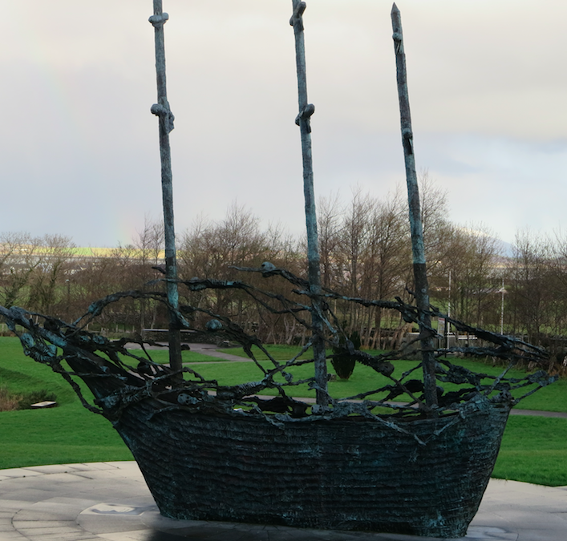
Famine Memorial, Westport. The ‘Famine Ship’ was a typical migration boat upon which over a million people fled Ireland for the USA alone to escape the famine. The combined impact of the famine and migration lowered Ireland’s population by over 20 per cent, a blow from which it hasn’t yet recovered.

Cork and “Collins Country”
I had previously developed a study of Michael Collins as a controversial historical personality for Knox Grammar’s Year 11 course. I wished to further resource the study, which I felt could also be used in History Elective. I was able to meet with historian Donald Buckley and gain access to Cork Barracks’ Michael Collins section, documenting multiple sources that would be beneficial to studying and broadening student understanding of Collins’ life.
Buckley also introduced me to the curator of the Michael Collins Centre in Clonakilty, Tim Crowley, who guided me through local sites in West Cork relevant to the life and death of ‘The Big Fellow’. Notable was Collins’ childhood home, sections of it still showing the marks of where the British had burnt it down, and the site of Collins’ assassination at Béal na Bláth. Tat allowed Crowley and me to discuss, from multiple vantage points, the possibility of whether Collins’ assassin could have known who he was aiming at. The experience gave me further insight into the life of Collins, and deepened my ability to teach the topic from multiple perspectives.

Dublin: 100 Year Anniversary of the Easter Rising
The Easter Rising took place 100 years ago. That failed attempt to overthrow British rule in Ireland set in motion a chain of events, from the War of Independence to the Partition, that would eventually divide Ireland. The Rising itself still links to Republicanism and symbolises, for Northern Republicans, the continuity and legitimacy of armed struggle against the British. In Dublin I was able to examine media for the debate over commemorations and contribute to the research for my History Extension unit. I also had the opportunity to add to the meagre resources available within textbooks and visited Kilmainham Jail, where the Rising leaders were executed, as well as toured Dublin with a company that specialises in the weaponry of the Rising.
I also documented sites relevant to the study of the Rising, such as the Four Courts, the General Post Office and Dublin Castle, taking note of the debate about the flying of the tri-colour at the site. A visit to Trinity College allowed me to undertake research into documents relevant to providing source studies on both the Rising and the famine’s links to migration, now to be used in lesson plans and programs on my website.
Being present in Dublin at that time allowed me to purchase multiple resources, such as the Independent’s ‘Revolution Papers’, that provided primary sources Australian teachers had no way of gaining access to.

Significant Learning
Not only was I able to gain previously unattainable resources during this tour, I was also able to deepen my aim to include an examination of how Irish history (and centrally, that of the Troubles) is recorded. This was an element I hadn’t fully considered until the tour and the opportunity to resource it, thus providing an entirely new idea and example for History Extension teachers, was invaluable.

Conclusion
When I returned from my study tour, a former scholarship winner told me of her experience, ‘It changed my life.’ How correct she was. The study tour feels like it was the first step of a journey down a metaphorical road from which I continue to find small paths that branch off into deeper areas of interest. As a result of my tour, I have:
- developed and strengthened important networks of contacts in Northern Ireland, the Republic and the Australian history community
- formed a relationship with Tinteán, the journal of the Australian Irish Heritage Network. At their invitation, my article ‘History is in the Graveyards’, was published in their March 2016 issue. I have since spoken at the Irish Consulate of Australia on my experiences
- created the website Irish History Australia, which continues to extend my network of contacts and receive mail from teachers wanting to use its resources in new and innovative ways
- published multiple articles with Teaching History, the journal of the History Teachers’ Association New South Wales, on Titanic and the 100 Year Anniversary of Easter 1916
- been selected to speak at the Australasian Perspectives of Easter 1916 conference, held at Melbourne University and sponsored by the Irish Embassy, on the topic of Representations of 1916 in Conflict Murals
- submitted a proposal to speak at the History Teachers’ Association of Australia National Conference 2016 on Resourcing and Uses of Irish History
- developed a PhD proposal for submission on the study of conflict murals
- developed strong contacts with other teachers passionate about the benefits of teaching Irish history, working with some to examine how it can be developed for the study of History Extension
- reaffirmed my passion for Irish history and the belief in studying and teaching things that you love.
None of these could have been possible without the amazing opportunity afforded to me by the NSW Premier’s Scholarship Office and the History Teacher’s Association of NSW. It is with the greatest appreciation that I thank them for allowing me to extend my teaching and passion for history in this manner.

Ivor Bell to be prosecuted over Jean McConville murder (June 4, 2015), Irish Times, p. 3.
Raymond McCartney Interview, January 6th, 2016, Retrieved from http://www.irishhistoryaustralia.com/interviews-derry.html, January 18, 2016.
Crowley, T, In Search of Michael Collins, Clonakilty, Michael Collins Centre.
Bateson, R. 2013: Memorials of the Easter Rising. Dublin: Irish Graves Publications, p. 11. Bibliography Bateson, R. (2013) Memorials of the Easter Rising, Dublin, Irish Graves Publications. Crowley, T. (2015), In Search of Michael Collins, Clonakilty, Michael Collins Centre. Dwyer, R. (1998), Big Fellow, Long Fellow: A Joint Biography of Collins and De Valera, Dublin, Gill & Macmillan. Keefe, P. (2015, March 16) ‘Where the Bodies are Buried’, The New Yorker, Retrieved July 2015, http://www.newyorker.com/magazine/2015/03/16/where-the-bodies-are-buried. Poole. R. (2015), Irish History Australia, http://www.IrishHistoryAustralia.com. Rolston, B. (2010 edition), Drawing Support, Belfast, Beyond the Pale. The Irish Times (2015, June 4), Retrieved June 6, 2015, http://www.irishtimes.com/news/crime-and-law/ivor-bell-to-be-prosecuted-over-jean-mcconville-murder-1.2237386.

