Premier’s Kingold Chinese Language Teacher Scholarship

Collaborative practice, technology and redesign in Chinese language courses
Katie Grubb
Southern Cross School of Distance Education, East Ballina
Sponsored by

Young Australian learners in distance education are unique in that they are often from diverse backgrounds, studying in isolation. Regional learners that are studying Chinese language in distance education are even more unique because they don’t have many opportunities to engage with Chinese culture or use the language to develop intercultural communication skills. Students’ needs are constantly changing with the demands of society and tertiary education; however, current content heavy, lock step coursework that is not embedded strongly enough in the real world is difficult to change at the same pace. The World Economic Forum (2015) emphasises that never before has this gap between what we currently have in our learning environment and the skills we actually need in the workforce been so obvious. The implementation of 21st Century Learning aims to address the gap and help students develop global perspectives and intercultural competence; however, even though current content focussed coursework in distance education Chinese language courses try to include 21st Century learning elements, it has often been treated as an ‘add on’ to existing coursework rather than part of re-design.
In the transition to 21st Century learning, the role of ICT is now seen as more important than before. It’s not just about delivering content in fancy packages, but also about enabling co-creative activities and task-based learning to take place. Applying ICT and collaborative practices in course design has potential to create a living bridge between the personal world of the student, culture and global perspectives. It is from this place that students can develop real intercultural competence and 21st century skills. Intercultural learning comes from students being supported and encouraged to investigate and understand both the visible and invisible aspects of their own culture in relation to an additional language culture (Lo Bianco, 2003; Liddicoat et al, 2003). It involves linking students with ideas and topics that they can relate to which will enable students to ‘experience and analyse’ in order to move to a higher level of thinking and self-awareness.
Using ICT and collaborative practices in Chinese language coursework also allows for including authentic texts and would provide a more accurate and interesting medium for cultural context and cross-curricular themes to be presented through interacting, producing and understanding texts. Carr and Paulwels (2006) support this throughout their article by emphasising that including authentic materials in coursework can be chosen to suit a greater amount of learner’s needs and backgrounds. Crawford (2000) also states that tasks that have a relationship to real-world activities, ‘ensures that learners come to the language task with a personal position and so have something real to communicate’ (p.10). Tasks that primarily involve learners in comprehending, manipulating, producing and interacting in the target language while their attention is principally focused on meaning rather than form is where intercultural competence can finally occur (Nunan, 2004). In this way authenticity becomes part of the strategy and structures that allow students to contribute and collaborate, and in turn, facilitate deep understanding.
Learner motivation increases when coursework provides a range of pathways for students to demonstrate their learning outcomes that link beyond the classroom, cross cultures and engage with parents and the broader community whilst providing a supportive environment for exploration of the implications of these connections to occur, (State of NSW, Department of Education and Training, Professional Learning and Leadership Development Directorate, 2008 and Crawford, 2000). In response, part of my research was to:
  - explore how to develop possibilities for connection and collaborative partnerships for developing curricula in Chinese language teaching that reflects 21st Century Learning, and the role of ICT in this process
  - investigate what collaborative ICT is available between Australian and Chinese cultures as well as the NSW Department of Education
  - develop design thinking processes to find strategies for task-based learning and collaborative practices to become more central in Chinese distance education courses.
This report sets out the range of activities that were undertaken for this research from January to June 2015 with details of further exchanges that followed and ideas for possible innovative and collaborative developments that could be explored and enabled should sufficient funding be found.

Framing the opportunity
The research was carried out using action cycle learning with iterative reviews and adjustments (McNiff, 2002). The action cycles in the activities were then conducted using reflective practice (Schön, 1991). As a result, realisations occurred that reflections could take place in action (whilst on the study tour and running collaborative projects) and on action (after the study tour and collaborative projects). Throughout my research tour, and in pre and post tour sessions with educators, it became evident that this self-reflective process could also be similarly used as self-reflection for learning for students and teachers from engaging in any immersion and/or co-creative activity. See Fig 1.
Fig 1. Action Learning Cycle
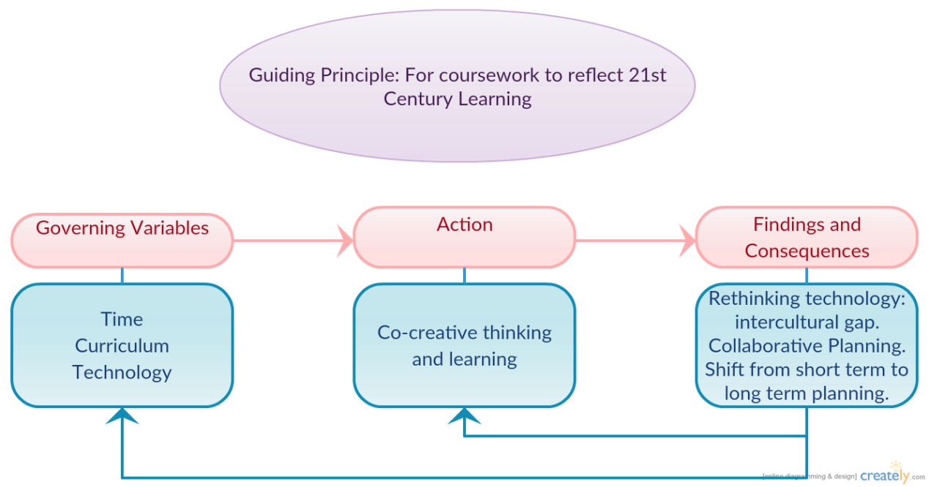

Through the action process, I found that for current coursework to properly reflect 21st century learning, redesign is necessary using co-creative design thinking processes. See Fig 2. Tim Brown from IDEO (World Economic Forum, 2014) states, ‘We need to give our kids cognitive models of how to live in a networked world where they are learning constantly, incorporating systems thinking and design thinking.’ (p.68). Design Thinking is the confidence that everyone can be part of creating a more desirable future, and a process to take action when faced with a difficult challenge. Through this process, students can see their learning gaps and play a role in choosing how they are going to fill the gap whilst creating digital learning legacies that then become part of the course content for future student learning. Students become active contributors rather than consumers and play an important role in giving the coursework authenticity and life.
Fig 2. Design Thinking Process.
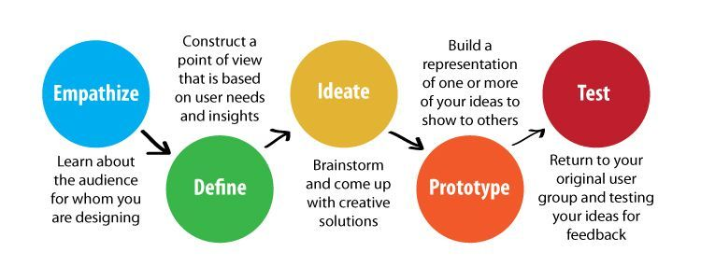

Actions and learning
Explore how to develop possibilities for connection and collaborative partnerships for developing curricula in Chinese language teaching that reflects 21st Century Learning and the role of ICT in this process
Synchronous and asynchronous collaboration
Synchronous collaboration is one of the first steps in connected learning and creating authentic intercultural awareness. In response to my distance education students wanting to know who else was studying Chinese, I organised a four-way video conference with three schools and a Beijing tutor, the first of its kind in Australia. This immediately personalised student learning and increased learner motivation. However, we found it unsustainable without some sort of asynchronous continued collaboration to support it. Participating in the Flat Connections Global Educator course enabled me to explore asynchronous digital tools and build a strong global professional learning network (PLN), which became an incremental part of organising connection between China, Australia, community groups and parent groups.
Blogging and professional learning networks
I started to blog and co-create blogs with colleagues from around the world as an informing, connecting and reflective process. Immediately, I found that blogging created a bridge between my teaching practice, the outside community and parents. In turn, the content I was creating started to contribute back to my professional learning network and enable me to become aware of my own gaps in knowledge. Blogging also enabled me to present my learning of the NSW Teaching standards by using categories, becoming a living digital portfolio. It gave my role as teacher legitimacy beyond the education institution and helped build relationships with the community sector. I created a partners page on the blog that showcased supporting institutions and community groups and to reciprocate the support. The relationships that I built with the community in Australia became an incremental part of forming successful connections in the community sector in China and gave strength to the research project. The partners beyond the NSW Education Department and Kingold Group that supported (and continue to support) the research project both in Australia and China are: Asia Education Foundation, Australia China Business Council, Australia China Friendship Society, Australia China Friendship and Exchange Association, Australian Marine Debris Initiative, Flat Connections, My Chinese Tutor, Green Initiatives Shanghai, East China Normal University, and RiYue Bay Surf Club.

Authentic materials and community groups
A major part of the study tour was to develop authentic materials to enable cross curricular priorities: Sustainability and Australia’s engagement with Asia to be delivered in a way that actually relates to the personal worlds of learners. I started with the interest areas of the seemingly least interested demographic in studying Chinese Mandarin. That is of teenage boys in regional Australia who relate well whilst surfing and at the skate ramp, but who are perhaps not yet able to make the connection that products from brands like Volcom and Billabong are (proudly) brought to them from China, even if their imagery is from somewhere else. I visited the world’s largest skate ramp in Guangzhou and the second largest in Shanghai and also visited the RiYue Bay Surf Club in Hainandao to engage with emerging subcultures of Chinese youth.
I also visited Green initiatives in Shanghai, Biofarm, and East China Normal University and attended Shanghai Smart City Conference to learn about sustainability initiatives in China. From those meetings I was able to obtain authentic education materials and use them in developing how cross curricular priorities could be linked to the Personal Worlds (NSW Chinese Syllabus) of learners. Although the authentic materials I gained from those visits were useful to include in coursework, it was the relationships built that really enabled integration of authentic materials. By using current technology to maintain these relationships, we’ve developed collaborative partnerships that are able to generate up-to-date authentic materials with scope for future growth.
Intercultural social media and school visits
I visited both local and international schools in China to investigate what sorts of task-based learning and collaborative technology was in action. These visits included Ganquan Middle School and Little Beautiful Language School in Shanghai, and the Favor View Palace Experimental Primary School and Kindergarten in Guangzhou. I found that these local schools were not employing pedagogy that involved task-based learning or collaborative practice, but were very interested in organising exchange programs to stimulate future collaborations. The international schools were the opposite. They were not interested in developing exchange opportunities, but very interested in using technology for collaborative practice. The international schools that I visited were Concordia, Shanghai and Qingdao. These schools have more access to collaborative technology because they were using a VPN (Virtual Private Network).
I found WeChat to be the best digital tool to use to connect with China and organise learning actions. It was at this point that I realised that the current PLN I was part of using media such as Twitter, Facebook, and email groups excluded Chinese language teachers except those living outside China unless they were using a VPN. Engaging in the research project made me aware that I was actually participating in perpetuating the subconscious cultural superiority that the West holds, which acts as a mental block in finding new ways of connecting. Rather than waiting for the Great China Firewall to disappear, or to embody the attitude that China is excluding itself, I launched the Connect with China Collaborative WeChat group and invited Chinese language teachers from around the world to participate. That meant learning new technology for a lot of Western teachers, but the group has more than 50 teacher members from China, Taiwan, Australia, New Zealand and the USA now participating.
Initially there was a lot of communication within the WeChat group, but after the initial buzz, communication started to diminish. The main reason for this was that beyond sharing pedagogical philosophy, the group did not have a clear goal shared by all parties. This possibly shows that even though there is great interest from educators to design collaborative learning tasks, there still needs to be more professional development focused on collaborative planning and leadership at the teacher level.
Develop design thinking processes to find strategies for task-based learning and collaborative practices to become more central in Chinese education courses
Connect with China Collaborative Pilot Program
The visits to both local and international schools in China helped create a network of schools that could engage beyond exchange programs. Using digital 2.0 technologies, the Connect with China Collaborative pilot program was launched in partnership with Flat Connections. The Connect with China Collaborative provides a flattened learning environment for interactive sharing of concepts, ideas and solutions to real world issues within a Chinese cultural context.
The goal of the Connect with China Collaborative was to develop design-thinking strategies to enable sharing of Chinese language and culture to develop perspectives that facilitate better understanding of world and place. Through connected and collaborative learning using digital and online technologies, it has enabled education to grow beyond the walls of the classroom to a world where solutions for positive change become real. More specific goals of the collaboration aimed to:
- build empathy through virtual connections
- identify environmental and other issues
- define what problems need to be solved
- ideate solutions
- share solutions via multimedia and invite feedback
- encourage reflection.
The Connect with China Learning Collaborative theme for 2015 was ‘My Community.’ Participants explored the concept ‘think global and act local’ and came up with initiatives that make positive contribution to their community. The guiding questions were:
- How am I connected to my community?
- What is my relationship with my environment?
- How does my daily life and consumption patterns affect my environment and how does this affect me?
The first online Connect with China Collaborative involved educators, learners (from schools, home school, distance education and community groups) of all different ages and levels. Groups were geographically from Colorado, Nevada, Oregon, Canberra, Adelaide, Geelong, Aukland, Yantai, Wuxi, Shanghai and Beijing. The subject areas of the learners included geography, Chinese language, English language and Ancient Chinese culture and history. A key goal of all involved was to have synchronous question and discussion times between schools and community groups. This provided stimulus for asynchronous communication, authentic resource sharing and collaborative tasks. The first task for the collaborative was to design a digital handshake (digital way of saying hello). Educators filled out a survey that indicated cross-cultural peer-to-peer communication was a key interest area from educators.
The biggest issue beyond organising synchronous workshops with different time zones was finding technology that everyone involved in the collaborative could use. Even without a VPN in China, we found scope for collaborative practice using programs such as Edmodo, VoiceThread and WeChat. See Fig 4. However, this is changeable in China and the endorsed collaborative technology currently available in the NSW Department of Education, such as Google Apps, do not allow for easy collaboration with China or with community groups or schools outside of NSW. Most schools in Australia involved with the Connect with China Collaborative were independent schools. Only two State schools in Australia were involved. This reflects the development still needed around digital technology and policy. According to global educators Davis and Lindsay (2012), more steps remain beyond inter-connection to move to true global collaboration.

Exchange Outcome
Building trust and support
Actively expanding my ways of connecting through visits and becoming part of the WeChat system enabled me to build trust with my China relationships and develop action plans much faster than would have been possible before. For example, it has been central to organising exchange groups from China visiting Australia and vice versa. In less than two months after returning from the study tour, our local region had its first exchange group from China. The visit was such a success that Australian students have now been invited to visit local schools in China and the second exchange group from China is due to visit in the next five months. By writing a simple news story about the exchange and publishing it in a local paper, community support, both local and international, was strengthened. The exchange has since been earmarked by North Coast Destination Network as the type of authentic experience that the region wants to provide to Chinese travellers. They were able to identify that education travel for Chinese families needs to be a key part of their marketing strategy. The result of this is stronger bridges between education and community creating potential interest and growth in Chinese language learning.
The learning that has occurred from the exchange program development is that there is a need to better understand policy and different ways exchanges can occur. More planning between the teacher and middle management before the study tour would have enabled purposive synergy to develop strategies to foster longer-term exchange programs. This is reflects the development still needed in collaborative planning across different hierarchy levels within schools.

Conclusion
As a summary of the lessons learnt from my research I have several conclusions for consideration:
- Using digital technology and task-based learning in Chinese language programs enables authenticity, cross curricular priorities and increased learner motivation.
- Collaborative technology plays a key role in developing 21st Century learning skills and intercultural awareness through task-based learning in Chinese language programs.
- Using digital technologies helps build communication and support between schools community, professional learning networks and are key to growth in regional Chinese language programs.
As recommendations I offer the following:
- Development of sustainable processes for identity management with web 2.0 tools is needed. This could involve developing a digital literacy checklist for web 2.0 tools that will support teachers wanting to design task-based collaborative learning experiences. A lot of useful technology is available to use within NSW Department of Education, yet teachers often lack understanding around student safety, digital literacy and informed consent. This results in many teachers not having the confidence to take up new technologies.
- Along with Local Schools Local Decisions, there could be a shift for local decisions to flow into technology and tools with global perspectives. You can see this happening already with bring your own device policies. It would give a greater sense of agency to teachers, enabling them to better design learning experiences that meet student needs.
- Leadership and support to help teachers unpack and re-imagine learning that reflects 21st Century Learning, developing a broad guided vision and long-term strategic planning that then shapes short-term plans for achievable implementation.

References
Carr, J., & Paulwels, A. (2006). ‘Boys talking’. In Boys and foreign language learning: Real boys don’t do languages. Basingstoke, Hants., New York: Palgrave Macmillan.
Crawford, Jane. (2000). ‘Implications of the shift to task-based learning’. MLTA Quarterly 119, pp.9-13.
Lo Bianco, J. (2003). ‘Culture: visible, invisible and multiple’. In Teaching invisible culture. Melbourne: Language Australia.
Nunan, D. (2004). ‘What is task based language teaching?’ In Task based language teaching. Cambridge: Cambridge University Press.
McNiff, Jean. (2002) Action Research for Professional Development. Concise advice for new action researchers. http://www.jeanmcniff.com/ar-booklet.asp
Scarino, A., Papademetre, L., Liddicoat, A. J., & Kohler, M. (2003). Report on intercultural language learning. Melbourne: Department of Education, Science and Training.
Schön, Donald. (1991). The reflective practitioner: how professionals think in action. Aldershot, UK: Arena.
State of NSW, Department of Education and Training, Professional Learning and Leadership Development Directorate (2008). Quality Teaching to support the NSW Professional Teaching Standards. NSW Department of Education and Training.
World Economic Forum (2014). Outlook on the global agenda, Mapping the future. Cologny/Geneva Switzerland: World Economic Forum
World Economic Forum (2015). New Vision for Education, Unlocking the Potential of Technology. Cologny/Geneva Switzerland: World Economic Forum.

