Premier’s IOOF Centre for Educational and Medical Research for Itinerant Support Teacher (Hearing) Scholarship

Building teacher capacity in the use of captioned multimedia for curriculum access
Anne McGrath
Catholic Education Office, Sydney
Sponsored by
Using multimedia in schools to support the curriculum is commonplace and expected. All learners require schools to cater for their needs whilst responding to ever increasing curriculum demands, technology use and online media. To fully access the curriculum, students who are deaf or hard of hearing (DHH) and those with diverse learning needs require media access barriers to be addressed.
The Convention on the Rights of Persons with Disabilities asserts the right of people with a disability to participate fully and independently in all aspects of society, including the Internet and access to information. As such, access to educational multimedia for DHH students and others requires the use of an accessible format, namely captions. Without captions, students suffer undue disadvantage and barriers to information and education.
Using captions in schools incorporates a Universal Design for Learning approach for whole class benefit by providing context, information, engagement and focus. These benefits are particularly keen for students with English as an additional language and/or dialect (EAL/D), Indigenous students, DHH students and those with language delay. For Indigenous students the high incidence of otitis media and fluctuating conductive hearing loss directly affects their language development, learning and literacy.
The advantages of captioned video for improved student reading comprehension and incidental vocabulary acquisition are well documented, with Jelinek Lewis et al (2001) suggesting including captions with video provides an information advantage to DHH students (p.50). They also observed that, although DHH students’ reading comprehension scores may be lower on average than their hearing peers, their script comprehension scores for captioned videos is greater than those in different text formats (p.52) . Furthermore, Linebarger, (2001) reported that using captions has been found to serve as a focussing agent assisting readers to identify central story elements (p.297).
There is a general lack of teacher awareness of the need for and benefit of captioned multimedia/video for improved literacy opportunities for diverse student populations. This issue is compounded by a lack of confidence in the appropriate use of technology by teachers. Wachira and Keengwe (2011) asserted that ‘… teachers may lack knowledge in two ways: lack of skills and expertise in using technology and the lack of pedagogical knowledge in using technology appropriately’ (p.21). Considering the need for a specific level of knowledge required for teachers to integrate the use of captions into their pedagogy, recommendations for the building of teacher capacity would be a useful starting point. A further exacerbation is the variable availability of captioned multimedia content online, and 55 per cent of new release DVDs being captioned, whilst TV series on DVD are captioned at a higher rate.
My study tour focussed to some extent on researching exemplars that build mainstream teacher capacity in using captioned multimedia for curriculum access to benefit DHH students and those with diverse learning needs, in part utilising the Concerns-Based Adoption Model. However, my research was essentially around the idea of change and the need to build teacher capacity to motivate towards the effect of that change, whilst acknowledging the concerns that come with such a process.

The notion of change
Change is a part of life, but at times it’s not always readily apparent that change is required. This may well be the case in regard to teachers’ awareness of the need for captioned access in schools. Hall et al (2006) considered change to be a ‘… process through which people and organizations move as they gradually come to understand and become skilled and competent in the use of new ways’ (p.4). That process is a necessary one for schools regarding access to media.
For change to be successful requires momentum, and I hope that one of the outcomes of my study tour will be the uptake of ideas and the possible ongoing commitment to change being exercised in regard to access. A combination of approaches is required; however, in regard to bottom-up approaches to change that may be successful over an extended period of time, Hall et al (2006) have found that ‘… if administrators do not engage in on-going active support it is more likely that the change effort will die.’ (p.11) .

The study tour
My study tour encompassed a five week comprehensive program visiting Sydney and Orange in NSW; Adelaide in South Australia; Darwin, Katherine and surrounds in the Northern Territory; Perth in Western Australia; Melbourne and Bendigo in Victoria; Hobart in Tasmania, and Auckland, Wellington and Christchurch in New Zealand.
During that time I visited 43 educational establishments and met with a system leader, university staff, sensory leaders and teams, school leadership, learning support teachers and class/subject teachers.
The breadth of the study tour and the rich diversity, number of people and places visited, conversations and experiences shared gave me a unique and valuable perspective on the issues at hand. I was impressed with so many people openly sharing their concerns and also by those who are actively working to make a difference in access to captioned multimedia for DHH students and those with diverse learning needs.

Methodology
The following method was employed at each educational visit:
- Building capacity
My previous experience as education manager at Media Access Australia and adviser to the national captions awareness raising campaign for schools CAP THAT! made me aware that teachers have varying levels and at times poor knowledge of captions as a vehicle for access to curriculum and improved literacy opportunities for diverse student populations.
I took the approach that it was important to build the capacity of those with whom I met (as required) to be better placed to engage in dialogue and gather qualitative data about the best ways to build mainstream teacher capacity. This process involved discussions and a purpose designed presentation about the value and use of captions in schools.
- Presenting to staff
A key part of the process was presenting to staff about captions research, the link between literacy and learning, using captions to explicitly teach skills and concepts for curriculum access, and the discussions that followed.
- Discussions around the need for change
Before any significant change can take place it is important to understand what concerns may exist in relation to turning on captions in schools.
- Researching concerns
My research mixed a study tour visiting jurisdictions, education centres and key personnel with gathering qualitative and quantitative data and recommendations to assist in building teacher capacity.
- Brainstorming, sharing and exchanging of ideas
In each visit we shared ideas about how to build mainstream teacher capacity for specific situations and how to consider a national perspective.
- Providing a copy of my detailed presentation
The comprehensive presentation that I developed was given as a resource. It is adaptable to differing situations and was designed with the needs of mainstream teachers in mind and as a response to concerns.

Quantitative data

Stages of Concern Questionnaire
The Stages of Concern Questionnaire (SoCq) is one of three components of the Concerns-Based Adoption Model. Through the SoCq process, leaders can identify concerns and provide targeted support to help individuals cope and focus on the task at hand. The SoCq is a de-identified 35-item online questionnaire that asks staff members to rate the extent to which they agree with various statements related to an innovation.
The innovation to be considered by the SoCq was turning captions on for all videos and multimedia to support literacy and learning across all curriculum areas.
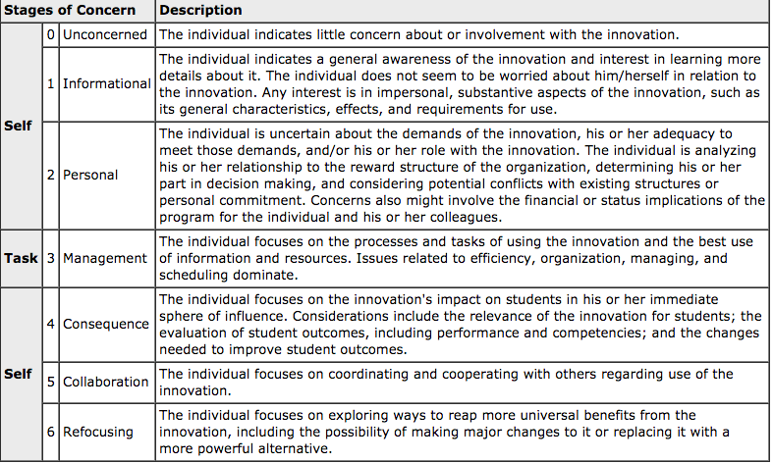
Figure 1: The Stages of Concern About an Innovation,
page 8 of Measuring Implementation in Schools: The Stages of Concern Questionnaire.
The return of sufficient questionnaires at the time of writing was inhibited by several factors: the nature of the study tour, with many short visits and limited time to follow up whilst travelling; and the SoCq needing to be sent to mainstream teachers by educators with varying access to that cohort. I have been reassured that more data will follow from several quarters. This additional data will be very useful when presenting these findings at conferences and workshops.
A small sample of 13 questionnaires has so far been returned. This may not be statistically significant; however, there is much to learn from these responses as they highlight areas of concern. Figure 1 describes the seven Stages of Concern, with the concerns broken down into those that affect self, task and self again, and indicated the types of concerns considered in the SoCq.
Figure 2 represents the Stages of Concern for the innovation of turning captions on for all videos and multimedia to support literacy and learning across all curriculum areas.
The areas of highest concern for the respondents and the ones for immediate interest and consideration when designing an intervention were:
- informational
- collaboration
- personal.
Referring to Figure 1 will assist in highlighting what the concerns indicate. A cursory analysis would indicate that respondents wish to learn more about the innovation, how they can effectively collaborate, and what the effects on time and extra workload might be. This is a great starting point to consider interventions.

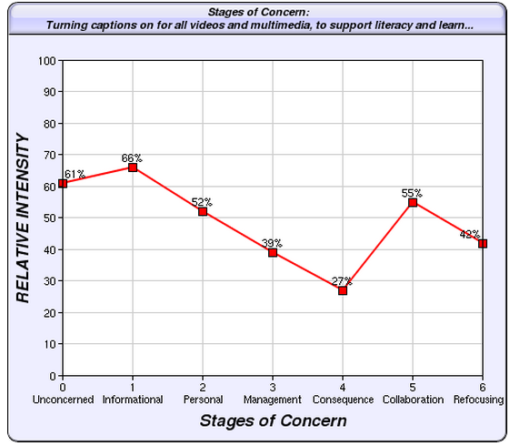
Figure 2: The Innovation and Stages of Concern: Turning captions on for all videos
and multimedia, to support literacy and learning across all curriculum areas
As a response to these concerns, a targeted strategy could be devised that accommodates the concerns and other aspects of the Concerns-Based Adoption Model that could be integrated to further support change towards implementing the innovation. As Hall et al (2006) asserts that ‘understanding the Stages of Concern and using the assessment techniques can result in significantly more effective one-on-one coaching sessions, more relevant workshops, and strategic plans that take into account the personal side of the change process.’ (p.134)
School systems need to exercise caution in interpreting Stage 0 as it depends on whether the respondent is a user or non-user of the innovation. School systems would be well advised to include some subset questions for mainstream teachers to indicate whether a de-identified individual participant was a user of captions or not when designing appropriate interventions. For the purpose of this study, the relevance of Stage 0 was not an issue as the study was looking for overall concerns for the mainstream teacher demographic.

Qualitative data
Information was gathered through general discussion and was also stimulated by the following questions:
- What do you believe are mainstream teachers’ concerns about using captions in school?
- What do you think would be the best ways to build mainstream teacher capacity in using captioned multimedia for curriculum access?
For the purposes of reporting on the data, the use of the term ‘many’ refers to a common and often repeated concern put forward by respondents.
Teachers of the Deaf in Australia and Resource Teachers of the Deaf (NZ) were part of the cohort involved in the study and their key concerns are represented below:

Key concerns of teachers of the deaf
- the need for pre-service teacher training in accessible media for curriculum access
- eBooks video content not being captioned, which breaches the Disability Discrimination Act (DDA) when using this content with DHH students (if not providing a suitable alternative)
- flipped classrooms – videos need to be captioned to ensure equitable access
- variable availability of captioned content across subject areas
- lack of teacher awareness of their obligations under the DDA
- a need to raise awareness of these obligations under law
- lack of teacher awareness of language deficits in DHH students
- the desire of some teachers of the deaf to organise a campaign to raise awareness of benefits of captions
  - a need for both school and system policies around access implementation
  - a need to mandate use of captions.
Categorising the qualitative data in this study under headings that may correlate to the Stages of Concern questionnaire headings allowed me to make a clearer distinction as to where those concerns lie.

Informational Concerns – Referencing the (SoCq) Category
- Many teachers don’t know anything about captions, where to find them or where to search for captioned content and how to use them.
- Many teachers are unaware of the positive link between using captions and access to the curriculum and literacy benefits and supportive research.
- Many teachers are unaware of their obligations under the DDA.
- Some teachers don’t understand the language deficits of DHH students.
- There is a need for pre-service teacher training in accessible media for curriculum access.
These points represented discussions with mainstream teachers and point out that the informational concerns of mainstream teachers were in many ways similar to those of teachers of the deaf in Australia and Resource Teachers of the Deaf (NZ).

Personal Concerns – Referencing the (SoCq) Category
- Many teachers are not confident with technology.
- Many teachers perceive that using captions requires new technology.
- Many teachers lack the time to source and prepare lessons with captions.
- Some teachers don’t want to feel embarrassed if captions don’t work.
- Some teachers think that it’s not worth the effort because of previous bad experience.
- Some teachers forget to turn on captions.

Management Concerns – Referencing the (SoCq) Category
- Many teachers think there are too many things to do in class without having to provide captions.
- Many teachers lack the time to source and prepare lessons with captions.
- Some teachers think that if captions are not used at home then poor attitude towards captions at school may ensue.

Consequence Concerns – Referencing the (SoCq) Category
- Some teachers believe that captions distract students.
- Some teachers think that if students haven’t requested use, then it’s not necessary.
- Some teachers think that pre-primary children aren’t proficient readers yet, so it’s not relevant.
These groups of concerns of teachers of the deaf and mainstream teachers are not insignificant, and without effective interventions they pose a real barrier to equitable access to the curriculum for DHH students and those with diverse learning needs.
Interventions are necessary from a national perspective because systems have obligations under the requirements of the DDA to provide education opportunities for DHH students ‘on the same basis’ as their hearing peers. This obligation does not preclude captioned access to curriculum content and captions can be considered a ‘reasonable adjustment’.

Consistent responses to building teacher capacity
The following were consistent responses to the question: What do you think would be the best ways to build mainstream teacher capacity in the use of captioned multimedia for curriculum access?
- Using captions and accessibility should be included in teacher training courses.
- Systems need to develop interventions to support implementation.
- Using captions in schools needs to be mandated.
- Collaboration with interested parties was mooted for different states and possibly NZ to develop training videos.
- At school level, schools need action plans for implementation.
- Purpose designed workshops about captions are needed, with sample units, including reference to DDA Canberra modules.
- Teachers need to support each other by visiting each other’s classes when captions are being used.
- Top down and bottom up approaches in combination are necessary to fully address the issues across systems.
- Large publishers need to be approached about making eBook videos accessible.
- A hugely positive and consistent response and a vehicle for teacher engagement has been the concept of using captions to directly teach skills and concepts.
- Captions need to be seen as more than an access format and a teaching strategy.
- Great interest has been generated which needs support and momentum to keep it going.
- Issues need development into an awareness raising campaign for the need for change across education sectors.
- Teaching and learning teams or curriculum coordinators need to support those who champion captions in schools (CAP THAT! ).
- Strategies about need for captions use need to be added to the Individual Education Plan (IEP) for student support and as a key tool (also a legal document).
- Tracking SMART goals through the IEP process to ensure access.
- Parental support must be engaged.

Some practical ideas to begin to build capacity in using captions
- Media Access Australia has resources and extensive information about where to find sources of captioned content.
- CAP THAT! has resources, lesson plans with captions and professional development videos for schools etc.
- Soundfield amplification systems and captions create an inclusive environment. The Classroom Access Project 2 is a pilot project that examined the use captions in schools.
- CAP THAT! has resources for developing in-school lesson plans and units.
- Screen shots of captioned videos can be used for social skills to assist students with autism.
- The importance of pre-teaching vocabulary before viewing captioned video needs to be stressed.
- Using screenshots of captioned content can be used as teaching points.

Key recommendations as a result of my study tour
- Increased collaboration is needed between government, industry and educational suppliers to work towards making captioned educational video/multimedia more available.
- Pre-service teacher training in accessible media and the link between captions and improved literacy benefits is needed.
- System level responses incorporating obligations under the DDA, referencing the importance of SOCq:
  - provides data for addressing initial and school-based concerns
  - interventions, professional development and implementation plans more targeted.
- School level responses:
  - development of a school action plan
  - professional development, support, encouragement and accountability
  - school culture that supports inclusion and access
  - close alignment with student IEP
  - use of Universal Design for Learning principles which assist DDA compliance.

Conclusion
The issue of building capacity in captioned access to media in schools is a multi-layered one, compounded by varying levels of available captioned content. My study tour has facilitated the discovery of general concerns of teachers across diverse school communities and great distance, as well as ways to build their capacity. Each state, territory and also NZ have their own systems in place. The recommendations of the study tour are relevant to all and any interventions need to reflect concerns specific to those communities.
Additional information about the study tour can be found on the Empower with Captions blog.

References
Archie A. George, Gene E. Hall, Suzanne M. Stiegelbauer, Shaila Abdullah. (2006). Measuring implementation in schools: The Stages of Concern Questionnaire. Austin, TX: SEDL.
Australian Human Rights Commission (2010) World Wide Web Access: Disability Discrimination Act Advisory Notes ver 4.0 (2010). Retrieved from https://www.humanrights.gov.au/world-wide-web-access-disability-discrimination-act-advisory-notes-ver-40-2010
CAP THAT! Captioned for learning (2015). Retrieved from www.capthat.com.au
CAP THAT! Captioned for learning (2015). Retrieved from http://www.capthat.com.au/resources
CAP THAT!: captioned for learning (2014). Using captions to teach skills and concepts. Retrieved from http://www.capthat.com.au/news/using-captions-teach-skills-and-concepts
Catholic Schools NSW/ACT (2008). Pilot project gives students with hearing impairment better access to education. Retrieved from http://www.catholicschools.nsw.edu.au/news-details/latest-news/pilot-project-gives-students-with-hearing-impairment-better-access-to-education
Hall, E., & Hord, S. (2006). Implementing change: Patterns, principles and potholes. Boston: Pearson
Jelinek Lewis, M.S & Jackson, D.W. (2001) ‘Television literacy: comprehension of program content using closed captions for the deaf’, Journal of Deaf Studies and Deaf Education, (6), 43-53
Linebarger, D. L. (2001) ‘Learning to read from television: the effects of using captions and narration’, Journal of Educational Psychology, 93(2), 288-298
Media Access Australia (2015). Retrieved from www.mediaaccess.org.au
Media Access Australia (2015). Retrieved from http://www.mediaaccess.org.au/education/hearing-impairment-deafness/teacher-information-hearing
Wachira, P., & Keengwe, J. (2010). ‘Technology integration barriers: urban school mathematics teachers’ perspectives’, Journal of Science Education and Technology, 20(1), 17-25.

Australian Human Rights Commission (2010) World Wide Web Access: Disability Discrimination Act Advisory Notes ver 4.0 (2010).
Jelinek Lewis, M.S & Jackson, D.W. (2001) Television literacy: comprehension of program content using closed captions for the deaf, Journal of Deaf Studies and Deaf Education, (6), 43-53
Jelinek Lewis, M.S & Jackson, D.W. (2001) Television literacy: comprehension of program content using closed captions for the deaf, Journal of Deaf Studies and Deaf Education, (6), 43-53
Linebarger, D. L. (2001) Learning to read from television: the effects of using captions and narration, Journal of Educational Psychology, 93(2), 288-298
Wachira, P., & Keengwe, J. (2010). Technology integration barriers: urban school mathematics teachers’ perspectives. Journal of Science Education and Technology, 20(1), 17-25.
Hall, E., & Hord, S.(2006). Implementing change: Patterns, principles and potholes. Boston: Pearson
Hall, E., & Hord, S. (2006). Implementing change: Patterns, principles and potholes. Boston: Pearson
Media Access Australia (2015).
CAP THAT! Captioned for learning (2015).
Archie A. George, Gene E. Hall, Suzanne M. Stiegelbauer, Shaila Abdullah. (2006). Measuring implementation in schools: The Stages of Concern Questionnaire. Austin, TX: SEDL.
Hall, E., & Hord, S. (2006). Implementing change: Patterns, principles and potholes. Boston: Pearson
A flipped class is one that inverts the typical cycle of content acquisition and application so that students gain necessary knowledge before class, and instructors guide students to actively and interactively clarify and apply that knowledge during class. https://learningsciences.utexas.edu/teaching/flipping-a-class, accessed 3 December 2015.
CAP THAT!: captioned for learning (2014). Using captions to teach skills and concepts.
CAP THAT! Captioned for learning (2015).
Media Access Australia (2015).
CAP THAT! Captioned for learning (2015).
Catholic Schools NSW/ACT (2008). Pilot project gives students with hearing impairment better access to education.
CAP THAT! Captioned for learning (2015). Resources.

