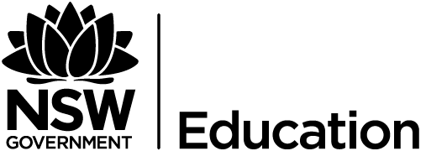

2021 Short-Term E-Exchange Program – Research Submission

Years 7- 9 Physical Literacy: A spotlight on wellness
  - Curriculum- student support focus
Sheridan Worthington
Macquarie Fields High School
PDHPE Secondary Teacher

E-Exchange participant during 2021 with:
Lila Berg, Edmonton Public Schools, Alberta, Canada

Introduction
As part of the International E-Exchange Program, a virtual exchange was completed between New South Wales and overseas counterparts. This exchange provided an opportunity for short-term one-on-one partnerships between educators with similar interests or fields. This action research report on the shared focus area was completed following the 6-week program.
The focus of this exchange was to use the strengths of both counterparts to review and research how physical literacy is being applied in classrooms and how implementation can assist in combating wellbeing issues. This exchange also explored the importance of viewing physical literacy from a holistic perspective and that educators are provided with the necessary support and resources to use the physical literacy continuum for its intended purpose.

Focus area / Research question
When comparing the wellbeing challenges of students in Alberta and students in New South Wales it was clear that the complexities were very similar. The value of exercise has lowered due to the increased use of technology, and body image issues are on the rise due to high exposure to social media. There is also a more significant requirement for students to develop mind and body connections further to learn how to promote a holistic lifestyle.
It became increasingly evident that there is a need for further prevention and intervention of wellbeing issues occurring and to ensure that students are provided with the appropriate support. Figure 1 confirms the demand for help; it indicates that in 2021, 41.9% of Australian young people are extremely concerned or very concerned about their mental health and that 33.6% are extremely concerned or very concerned about their body image.

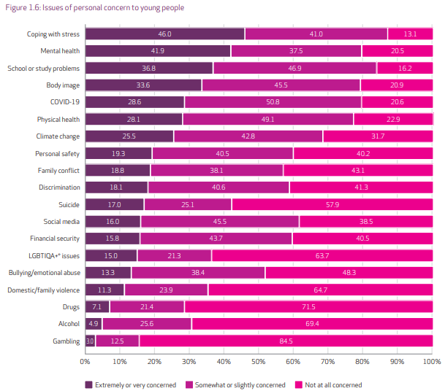
Figure 1- Issues of personal concern to young people (Mission Australia Youth Survey report 2021)

The NSW Department of Education utilises the Physical Literacy Continuum, as Edwards et al (2018) suggests that physical literacy influences many health outcomes, including strength, cardiovascular fitness, motor skills, and other health variables such as social, behavioural, and social outcomes.
The discussion leads to the fact there is a growing interest to learn more about the Physical Literacy Continuum in a greater capacity in Alberta. Collaboration would allow conversation around connecting physical literacy and wellbeing in both New South Wales and Alberta.
Though the partnership of both exchange counterparts resulted in the development of activity ideas that connect wellbeing and physical literacy. The activity ideas developed, target the following four key questions:
- How can building connections contribute to the development of physical literacy?
- How can a positive body image impact participation in lifelong physical activity?
- What effect can media literacy have on establishing healthy habits?
- What is the relationship between a healthy mind and a healthy body?

Signficant learnings / Findings
New South Wales has a large focus on the Physical Literacy Continuum. It was found that resources from NSW were utilised and incorporated into the NSW PDHPE curriculum, and the Alberta counterpart appreciated thorough nature of the material.
The New South Wales Government (2015) completed research that indicates that an individual’s attitude and behaviour towards physical activity is dependent on their ability to feel confident in physical activity settings. It was also reported that the development of physical literacy is attained more successfully through a holistic and inclusive approach with a balanced emphasis on the motivation to move, movement proficiency and appreciating the value of movement. Therefore, a discussion of how physical literacy goes beyond traditional practical lessons and a more holistic approach towards the delivery of physical literacy is required. Whitehead (1993) supports that physical literacy is required to comprise more than structured physical activities and should incorporate a more comprehensive view unassociated with physical ability.
Edwards et al. (2018) argue that assessment of physical literacy traditionally focuses on solely the physical components. However, the holistic view underpinning physical literacy should also aim to assess the psychological components. Collaboration between educators will allow for the further development of ideas and activities that will allow them to appropriately assess physical literacy to the extent required.

Conclusion / Recommendations & sharing
As a result of this exchange, it has become evident that educators will require further support and ideas that will allow the successful implementation of physical literacy. With the growing demand for wellbeing support, it is necessary that educators are provided with the appropriate guidance required to facilitate this.
Both exchange counterparts will continue to develop a range of activity ideas that connect physical literacy and wellness. Both counterparts will endeavour to continue working on these ideas and share with their networks.

Acknowledgements
Edwards, L.C., Bryant, A.S., Keegan, R.J. et al. ‘Measuring’ Physical Literacy and Related Constructs: A Systematic Review of Empirical Findings. Sports Med 48, 659–682 (2018). https://doi.org/10.1007/s40279-017-0817-9
New South Wales Government. (2015). An overview of the Physical Literacy Continuum K-10. https://schoolsequella.det.nsw.edu.au/file/20471941-8d31-4405-ba5f-5046fa9080f0/1/Overview%20-%20Physical%20Literacy%20continuum%20.pdf
Tiller, E., Greenland, N., Christie, R., Kos, A., Brennan, N., & Di Nicola, K. (2021). Youth Survey Report 2021. Sydney, NSW: Mission Australia.
Whitehead, M. (1993, July). Physical literacy. In International Association of Physical Education and Sport for Girls and Women Congress. Melbourne.

