2021 Short-Term E-Exchange Program – Research Submission

Performing Arts in Rural Schools
  - Performing Arts in Regional/Remote Areas – Alberta, Canada and New South Wales, Australia.
Sally Atkinson
Lake Cargelligo Central School
Classroom Teacher

E-Exchange participant during 2021 with:
Catherine Farley, New Sarepta Community High School, Alberta, Canada

As part of the International E-Exchange Program, a virtual exchange was completed between New South Wales and overseas counterparts. This exchange provided an opportunity for short-term one-on-one partnerships between educators with similar interests or fields.
This action research report on the shared focus area was completed following the 6-week program.

Introduction
Catherine Farley and Sally Atkinson explored the performing arts in rural/remote areas of each other’s towns in their exchange countries. My Research report focuses on music and drama at both Lake Cargelligo Central School and New Sarepta Community High School. I researched school’s involvement with the creative arts, how the community is involved in the creative arts in New Sarepta and the fundraisers and excursions Catherine Farley organises in her teaching context.

Focus of the Study: Performing Arts in Rural/Remote Areas
New Sarepta Community High School (NSCHS) is a smaller rural school in Alberta, Canada. It has approximately 230 students, grades 7-12. Lake Cargelligo Central School (LCCS) is a Central School in New South Wales, Australia, with approximately 200 students from grades K-12. Both schools engage in the performing arts, but the findings from my study show that NSCHS has a stronger fine arts program that LCCS can learn and use ideas from.
NSCHS has a strong fine arts program. Drama, band and art classes are offered to junior and senior high school students. The band program is an important part of the school. Last year there were 64 students in the program. Students participate in One Act Drama Festivals and Music Festivals. The Senior Band performs for Awards Evening, Remembrance Day, Christmas, Spaghetti Supper, Spring Seniors Tea and Year End. The band program has been negatively impacted by the pandemic.
LCCS has junior music classes and does not have a drama class this year. Music is a part of the junior curriculum. There is not a school band at LCCS. Music classes are offered at lunch time and students participate in music for enjoyment. There are currently no annual music performance opportunities due to staff turnover and the pandemic. Some musical performance opportunities exist at school assemblies, but there has not been any organised in 2021.

Significant Learning: Findings
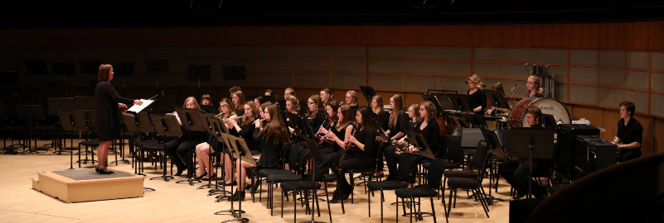
Figure 1: New Sarepta Community High School Band

NSCHS and LCCS
Community involvement in New Sarepta is high. “Our community is very supportive of our band program,” Catherine Farley band teacher says, “I, as the teacher, believe it is important for the students to give back to their community also. The band performs at the Remembrance Day Ceremony, our local Senior Tea and does two performances for Christmas.” At Lake Cargelligo, there is a community Drama Group who perform a play for the community each year. Students from LCCS are involved. This is a highlight on the community calendar, even if not directly linked to the school, many teachers are also involved. Community members direct, cast and produce plays for the community in community venues and raise money for local charities.
NSCHS students pay a fee for their band class, which covers maintenance, cleaning and repair of their instruments, which the school owns. To go on Band Camp, the junior and senior bands participate in fundraising, which includes: bake sale at the Fall, Christmas and Spring Concerts, a Spaghetti Supper with a silent auction and flower basket fundraiser. For the bake sale, band parents donate baking and run the sale. LCCS students utilise instruments provided by the school for free, however, these are not formal orchestra instruments, more guitars, drums and ukuleles. LCCS does not currently do any fundraising for the performing arts. This is developing and growing with a new music teacher at the school. LCCS has a new dedicated performing arts room, which the students learn and rehearse in.
NSCHS has an ongoing fundraising and community involvement program; they also have excursions that run yearly. These events are run by Catherine Farley who has overseen the band for over 6 years. LCCS has a high turnover of staff due to its remoteness. It has been challenging to have a program that is ongoing over a number of years because of this. LCCS can use ideas and learn from NSCHS to build its performing arts program, while building on the already established Drama Group in the town of Lake Cargelligo.

Conclusion: Recommendations
NSCHS has a number of excellent fundraising ideas for LCCS to gain ideas and inspiration from. Silent auction, bake sale, performances at community events, Spaghetti Supper, Fashion Show, Flower Basket Sale and other ongoing fundraising ideas are ideas for LCCS to consider. With a new music teacher who has committed to a number of years at the school, LCCS should be able to implement a band program like NSCHS that carries over and gains community support. The Lake Cargelligo Drama Group can promote a drama class (there is a drama teacher at the school) to begin again at the school and encourage the study and participation in the performing arts.
Excursions such as band camp, seen at NSCHS, can also be implemented by LCCS with the development of a school band and greater participation in the performing arts.

Acknowledgements
- Figure 1 Facebook – New Serapta Community High School Band
- Catherine Farley for her help with this report.

