2021 Short-Term E-Exchange Program – Research Report

Getting more from Markerspaces
  - Integrated STEAM and transdisciplinary approacheds to Project Based Learning
Russell Carins
Jasper Road Public School, NSW
Classroom Teacher Digital Technologies and Robotics

E-Exchange participant during 2021 with:
Terri Lee Grattan, Grade 4 Educator and Discovery Lead Educator, St. Paul Elementary School, Alberta, Canada

As part of the International E-Exchange Program, a virtual exchange was completed between New South Wales and overseas counterparts. This exchange provided an opportunity for short-term one-on-one partnerships between educators with similar interests or fields.
This action research report on the shared focus area was completed following the 6-week program.

Introduction
This E-Exchange highlighted for the two participants, that despite them working in two different countries with differing education systems, they shared similar experiences in implementation and community building due their specialist roles they undertake. It highlighted the effectiveness of collaborative practice when like-minded educators combine pedagogy with innovative stakeholders.

- The effectiveness of action-research such as Jane Hunter’s (University Technology Sydney) and Matt Bower’s (Macquarie) for informing models or approaches to transform classroom content delivery into well integrated transdisciplinary (not siloed) learning challenges.
- They compared models and the application of STEAM delivery, resourcing and professional development, examining programs such as CSER and the STEM Enrichment Academy.
- Discussed whole school implementation programs in their schools and challenges in effective STEAM implementation and more effective delivery of curriculum supply chain.

Russell Cairns teaches 900 K-6 students per week in an RFF (Relief from face to face) position in a constantly evolving 55 seat Makerspace. The current student focus is explicit teaching of creation skills using digital literacy and digital technologies at Jasper Road Public School, Baulkham Hills NSW.

Terra Lee Grattan teaches in a dual tract English and French Immersion school teaching 4th Grade Language Arts, Math, Science, Art, and Religion in a publicly funded catholic school of 450. She also supports school EdTech integration in a Leader Discovery educator role to build competencies students outlining what they need to know, how they think and what they can do.

Both educators represent culturally and linguistically diverse student communities with strong STEAM initiatives, however Canadian students currently outrank their Australian counterparts in STEAM educational outcomes. An Alberta STEAM Education policy was to directly fund STEAM to all schools via grants to teachers. In NSW, funding was mainly via the stem.t4l project which uses lending kits and 8 week challenges to schools as a trial program.

Additional local programs are offered from various curriculum teams, the Big Schools program and short term outreach or action research projects such as CSIRO STEM professionals, CSER (Computer Science Education Research – University of Adelaide), Aust Computer and the STEM Enrichment Academies (University of Sydney) and the SISP Program (STEM Industry School Partnerships).

Focus of the Study: Description of Current Practice
The purpose of this virtual E-Exchange was to pair with a Canadian teacher to collaborate, compare and contrast various aspects of STEAM education between the Canada and NSW and to share the learning in this report. The topic chosen was the comparisons between approaches to makerspace use. A Makerspace is an area in the school where students ‘make’ an item using Project Based Learning (PBL) through collaboration on design, review, consideration of outcomes, students reconsider and explore solutions to create a product to meet a brief.

During several online meetings both educators shared resources of curated links and websites they had created, relevant research and lesson ideas. There was much discussion comparing experiences of how each school system and district allocated funding and resources. They also spoke about active involvement in communities of practice, curriculum reform in the areas of General Capabilities or Core Competencies using Project-based Learning (PBL) using Makerspaces to teach STEAM outcomes to students and teachers.

Exchange ideas and implement stakeholder initiatives
These online meetings resulted in ‘refresh’ of ideas and a commitment to a more PBL approach of practice in Term 2. Terra updated her resource websites for teachers she had created, and Russell delivered weekly webinars, presentations, and panels using new audio-conferencing apps of Clubhouse and Twitter Spaces for education conferences.

Educational stakeholders Makers Empire and Osmo Learning Systems were approached as both educators had worked with these platforms previously and local hardware was not being utilised, so pilots occurred with students in both school settings. These pilots helped support classroom teachers in both schools through combining innovative content delivery and teaching new student skill acquisition of literacy, numeracy, and spatial intelligences.

Existing school resources of 3D printers combined with a content learning delivery system where service and extra Osmo bases which use physical game pieces in conjunction with an iPad screen, making scripting and coding accessible for pre-readers were purchased from Gumtree or loans were arranged.

Building community and driving whole-school change
Both educators enjoy lead roles in their schools to support a range of innovative low and high STEAM practices using a TPACK (Technological, Pedagogical and Content Knowledge for teachers). Both have similar pedagogical beliefs and make curriculum relevant to life outside school by including design thinking and topical science into so a typical STEAM lesson involves:
- Identifying a real-world problem;
- Asking questions to explore the problem (and potentially solve the problem);
- Developing solutions using a design or engineering process; and
- Explore a hands-on activity.

Both are advocates for creating, integrating, and funding shared Makerspaces in schools and providing active (hands-on learning) to erase cultural bias and flip the classroom providing opportunities to be content creators and not just content consumers.

Terra Lee supports teachers in her Canadian district and beyond as a Lead Discovery Educator and within her school through co-teaching during Tech Time to support teachers.

Russell has taken leads in his school’s Critical and Creative Thinking, Science, committees and piloted a Makers Empire Pedology Project after applying for and being granted STEM Funding from Inspiring Australia.

In these dual roles, both teachers sharpen their classroom teaching practice, unpacking new curriculum concepts to students (design, computational and systems thinking) and strengthening professional learning committees by working with these educational stakeholders and providers.

Outside Russell’s teaching duties he builds his practice with Jumpstarting Computational Thinking workshops to school and mentoring student teachers in the Junior Science Academy at Macquarie University.

The teaching experiences gain through longer or full day workshops with students help to strike balance between explicit instruction and open-ended inquiry. The aim is to:

- set authentic tasks that are appropriately problematized;
- to sequence tasks constructively;
- to consider the design of their teaching spaces; and
- to attend to students’ prerequisite knowledge, and actively guide group work processes.

Significant Learning: Findings
Engaging Stakeholders
The learning designers at Makers Empire, were approached for a 10 week trial license to test and deliver learning of new science units using gamification within the app. The platform’s student-directed approach of challenges explicitly teaches students how to think and create using 3D design and 3D printing technology.

During RFF Technology lessons, Stage 3 students were introduced to design thinking using Makers Empire they also learnt essential science content knowledge which was delivered in a newly developed gamified format. As part of their Living World STEAM Stage 3 science project students (in pairs) were given a scenario, pairing a random animal with a random habitat. They consider adaptations that the animal will need to make to survive in the given habitat and create a 3D printed model of their adapted animals and created a diorama.

Using a range of devices students added to their research with a learning journal and a digital portfolio, delivery required a clear goal for student using a template (Figure 1) below as a worked example.

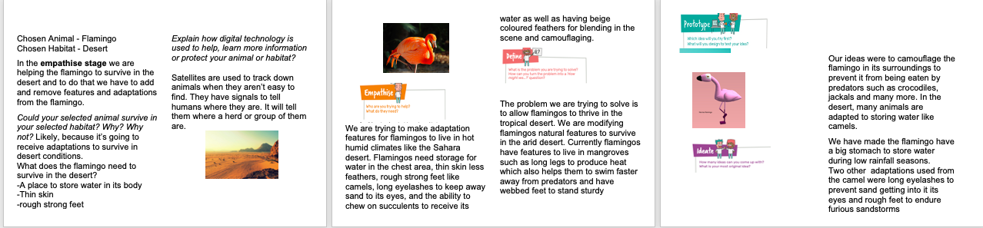
Figure 1: Template of example given to students using a Makers Empire Design Thinking Template. Groupwork over 8 weeks with skills and
This pilot enhanced student learning and teaching outcomes including:
- Creativity, problem solving, critical thinking - girls chose to engage in building type challenges, and boys were often drawn to creative, free make tasks;
- Inquiry, scientific understanding, and design thinking- students were excited to have something that is a physical prototype to their designs;
- Collaboration - students just working in groups, making, and designing dioramas and talking about what features they wanted in their 3D designs;
- Autonomy, literacy, and numeracy - some students who struggled with reading and self-regulation were supported with opportunities for easy entry and extension;
- Communication, digital literacy, and reflective learning capabilities - students had a look at the flaws in their design and then they went back and changed it, right at the end was really where a lot of the learning took place; and
- Resilience. They found problems with their designs, and they were not really intimidated by that anymore.
The makerspace which previously had a lab set up of rows for explicit instruction was reformatted each day to allow for instruction and group work (Figure 2 below). During the diorama construction a pop-up outdoor learning and making spaces was created. Extra opportunities were made available at lunchtimes for student drop-in. The app stores student work in the cloud programs downable at home on library and classroom devices. A clear proforma and examples were given with student choice and a range of methods or form of capturing their learning and submitting work digitally.

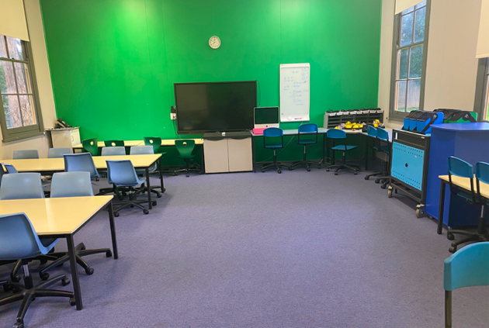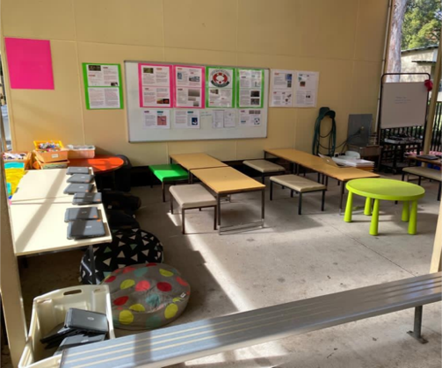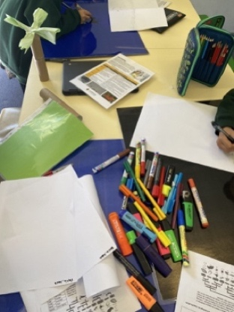
Figure 2: Indoor (Lab) and outdoor spaces (Making) to cater for the 7 classes per day and facilitate better transitions
Osmo and stem.t4l extra loan kits and iPads in a co-teaching, two-class environment.
Below is an example of the implementation of extra Osmo learning kits, (which were loaned for one term) to introduce to younger students using peer-mentor learning.

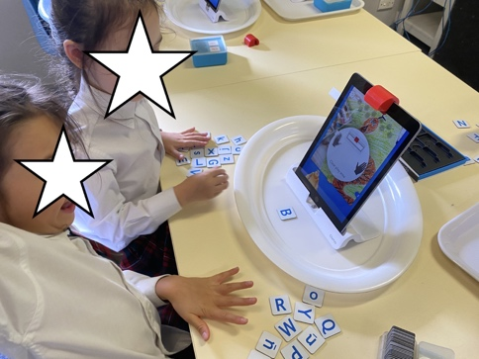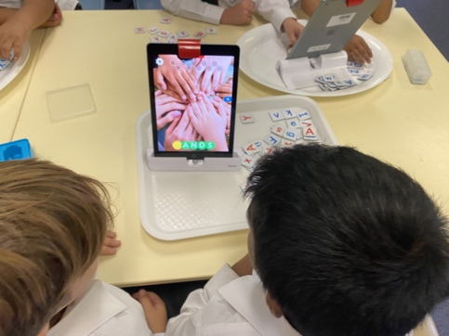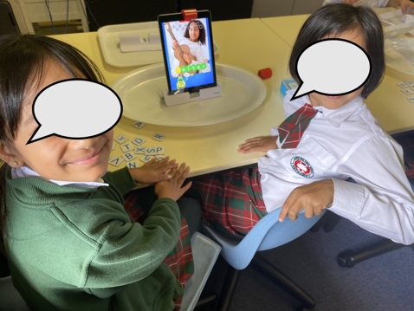
Figure 3: additional kits and peer mentoring with a co-teacher allowed for up to 444 students using the space at one time.

Acknowledgements
- Albert Educators 2018, Launch into EdTech, sites.google.com, viewed 10 May 2021, https://sites.google.com/erlc.ca/launchintoedtech/home?authuser=0>
- Anon 2016, Alberta Education Student Competencies, Alberta Educators Competencies, viewed 10 May 2021 Education | Alberta.ca
- Bower, M, Wood, L, Lai, J, Howe, C, Lister, R, Mason, R, Highfield, K & Veal, J 2017, ‘Improving the Computational Thinking Pedagogical Capabilities of School Teachers’, Australian Journal of Teacher Education, vol. 42, no. 3, pp. 53–72.
- Gonzalez, J 2018, What Is the Point of a Makerspace?, Cult of Pedagogy, Podcast and Blog, viewed 13 May 2021, What Is the Point of a Makerspace
- Grattan, TL 2018, Welcome to the SPECS Makerspace! Created intentionally for our students to have opportunities to be content creators and not just content consumers!, viewed 10 May 2021, What Is the Point of a Makerspace? | Cult of Pedagogy.
- Greenwell, T 2020, Why do Canada’s schools outperform Australia’s?, Inside Story, Inside Story Publishing, viewed 5 July 2021, Why do Canada’s schools outperform Australia’s? | Inside Story
- Hunter, J 2021, High possibility STEM classrooms: integrated STEM learning in research and practice, Routledge, New York, Ny.
- International Society for Technology in Education 2021, ISTE Standards for Students, We are ISTE | ISTE
- Izadinia, DrR (Mahsa) 2021, Does stem.T4L improve student learning outcomes? Evidence from Teacher Survey and school case studies, Home - Technology 4 Learning (nsw.gov.au) viewed 18 July 2021, stem.T4L Research - Technology 4 Learning (nsw.gov.au)
- Marginson, S, Tytler, R, Freeman, B and Roberts, K (2013).STEM: Country comparisons. Report for the Australian Council of Learned Academies
- Resnick, M 2018, ‘How Kindergarten Got It Right’, MIT Press Podcast, 31 January, viewed 5 July 2021, How Kindergarten Got It Right (podbean.com) Chris Gondek interviews Mitchel Resnick about his work at the MIT Media Lab, the foundation for his new book, Lifelong Kindergarten.
- Resnick, M & Robinson, K 2018, Lifelong kindergarten : cultivating creativity through projects, passion, peers, and play, The Mit Press, Cambridge, Massachusetts.
- Spencer, J & Juliani , AJ 2016, LAUNCH : using design thinking to boost creativity and bring out the maker in every student, Dave Burgess Consulting, Inc, San Diego, Ca.
- Stager, G 2014, Seymour Papert -- inventor of everything:, TEDxASB , viewed 5 July 2021, https://youtu.be/6-dFTmdX1kU
- Stevens, R. 2013, ‘Issues in assessment of general capabilities’, Scan 32(4) Vol 32 2013 (nsw.gov.au) issues-in-assessment-of-general-capabilities 21 January 2021

