2021 Short-Term E-Exchange Program – Research Submission

Leading the adoption and implementation of Response to Intervention in primary schools
Rob Griffith
Moss Vale Public School
Assistant Principal Instuctional Leader

E-Exchange participant during 2021 with:
Jonathon Klinger, RancheView School, Alberta, Canada

As part of the International E-Exchange Program, a virtual exchange was completed between New South Wales and overseas counterparts. This exchange provided an opportunity for short-term one-on-one partnerships between educators with similar interests or fields.
This action research report on the shared focus area was completed following the 6-week program.

Introduction
The focus study for the exchange was centred in the Response to Intervention (RTI) framework and how to effectively lead its adoption and implementation in a primary school. This submission explores the focus of the study and the concusions drawn from it.

Focus of the Study: Description of Current Practice
It was established early in the exchange that both contexts shared many similarities in learning structures related to an RTI framework.
Rancheview School – Description of Current Practice
- RTI mostly class based – a whole school framework still developing.
- Intervention practices in reading include small group interventions through guided reading. Levelled Literacy Intervention (Fountas and Pinnell) used for Tier 2 and 1 intervention.
- Assessment – a school wide approach using a reading and writing continuum. Teachers assess and pass on assessment data. Data collection becoming more prominent at the school.
- Two learning support teachers currently working with complex students (ASD, one on one).
- In 2022, Rancheview is moving towards having 2 learning support teachers, focusing on increased learning intervention with Tier 2 students.

Moss Vale Public School – Description of Current Practice
- RTI implemented across the school from 2020-2021.
- RTI used to identify students for the COVID Intensive Learning Support Program in 2021.
- School wide screening in literacy and numeracy developing.
- One SLSO, 1 learning support teacher and 1 paraprofessional teacher currently implementing intervention programs in reading.
- RTI currently being used as part of the school’s PBL behaviour program.
- RTI being led by Instructional leader and learning and support teacher.

Signficant Learning: Findings
Systematic Assessment Practices: Both contexts are working towards developing and implementing assessments to screen for Tier 2 and 3 students. Moss Vale is further along in this process, using whole school PAT testing, NAPLAN, Best Start, Check In and literacy screeners as part of an RTI framework. Rancheview is using a learning continuum approach, including data sharing, to identify Tier 2 and 3 students.
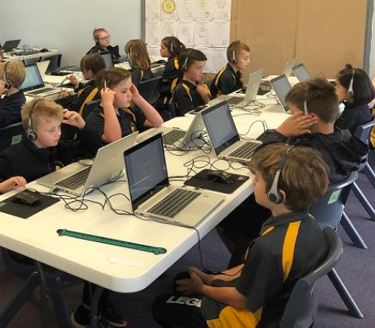
Figure 1: MVPS students completing online Check In assessments. Photo by Meredith Hines.

Intervention Programs: Both contexts are utilising small group or one on one interventions for literacy and numeracy intervention. Both contexts are focused on finding evidence based approaches to support interventions. Many ideas and resources have been shared across the schools.
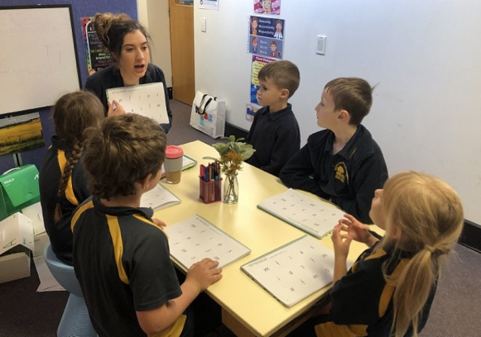
Figure 2: MVPS students participating in small group reading intervention using the MiniLit program. Photo by Meredith Hines.

Common Challenges: We found that we faced common challenges with leading RTI. These included:
- Teacher reticence, particularly in the area of assessment and data analysis.
- Adequate time to deliver professional learning in RTI to staff.
- Access to evidence based resources for intervention programs
- Financial issues concerning staffing. RTI may require the employment of more learning support teachers or officers to deliver programs and this is not always possible with school budgeting constraints.
We were able to discuss and share solutions to such challenges as part of the exchange.
Leading Change: The implementation of an RTI model is a novel concept in both contexts and requires pedagogical shift from many teachers. Our challenge is to use the evidence base of RTI as a means of promoting its use in our schools. We have discussed a range of change management models, including Teaching Sprints, as part of the e exchange. We are now applying these in our schools to help in implementing RTI.

Conclusion: Recommendations
The following conclusions have been made as a result of this study:
- Both the Australian and Canadian school contexts are very similar with regards to learning support, inclusive education and resourcing.
- A stong change management model is required to ensure RTI is embedded successfully in both school contexts.
- Sharing ideas, resources, successes and challenges across the two contexts is extremely valuable.
- RTI can only be successfully implemented when strong assessment practices are consistently utilised and appropriate interventions are available.

Acknowledgements
- Teaching Sprints change management model: https://teachingsprints.com/
- MultiLit: https://multilit.com/
- Response to Intervention Network: http://www.rtinetwork.org/learn/what/whatisrti
- Learning Difficulties Australia: https://www.ldaustralia.org/
- Rancheview School, Cochrane, Alberta, Canada: https://rancheview.rockyview.ab.ca/
- Moss Vale Public School, Moss Vale, NSW, Australia: https://mossvale-p.schools.nsw.gov.au/
- Jonathon Klinger, RancheView School, Alberta, Canada

