2021 Short-Term E-Exchange Program – Research Submission

Women in Leadership
  - Leading during Covid 19
  - Leadership Development
Patricia Lindsay, Holsworthy Public School, NSW, Australia
Relieving Deputy Principal

E-Exchange participant during 2021 with: Alberta Teacher Association
Susan Anderson (Principal), Ronald Harvey Elementary School, St. Albert, Alberta, Canada
School Website -- https://ronaldharvey.spschools.org
Division Website -- https://spschools.org

As part of the International E-Exchange Program, a virtual exchange was completed between New South Wales and overseas counterparts. This exchange provided an opportunity for short-term one-on-one partnerships between educators with similar interests or fields.
This action research report on the shared focus area was completed following the 6-week program.

Introduction
This report outlines the key ideas discussed throughout the six week exchange between Susan Anderson, Principal of Ronald Harvey Elementary School in Alberta Canada, and myself. Ronald Harvey Elementary School is a school of three hundred and fifty students and has forty-two members of staff.
Susan and I met once a week to get to know each other and discuss a range of leadership processes and procedures. One of the key comparisons that was discussed was the process of Merit Selection. What I found interesting was that schools in Alberta have a very different approach to Merit selection.

Focus of the Study: Description of Current Practice
- Leading during Covid-19
- Hiring Practices for Administration

Significant Learning: Findings
The COVID 19 pandemic has filtrated into all aspects of our lives. It has significantly impacted the education of thousands of young Australians. As educational leaders, we know the tremendous amount of disruption it has caused not only to our students and their families but also the stress, due to the ever changing educational climate, it has caused our teachers.
One of the notable differences from my exchange school in Canada was the response to a student COVID outbreak in the school.
Leading during Covid-19 Ronald Harvey School Context:
Elementary Schools have been engaging in in-person learning all year (September till June) with the exception of one week after Winter Break (January 4 – 8) and two weeks after Spring Break (April 5 – 16). Covid-19 cases in Alberta during the peak have been reported as high as 2000 positive cases per day. When schools have had a positive case in the building, the close contacts to that person have been sent home for at home learning.
At Ronald Harvey, we had one positive case that sent home over one hundred students and five staff members. The remaining students and staff continued to learn and teach in the building. From this one case, four others were identified placing the school on the “outbreak” list.
Cleaning protocols were put into place and the school was given a “full clean” the night the reported cases were stated.
The administration of the school was responsible for contacting all the families of those students who were deemed close contacts.
All students and staff are required to wear masks at all times. Each student and staff member, at the beginning of the year, were given two masks each. Disposable masks were also available for all students and staff.
Students enter and exit the building from their assigned door and must follow physical distancing requirements.
Signage is on every door and throughout the school, reminding everyone of the protocols.
Parents/Visitors are NOT allowed in the building.
Leading during Covid-19 Holsworthy Public School Context:
New South Wales went into lock down on the 26 June when we had twenty-two new cases. In comparison schools in Alberta continued to operate when there were hundreds of COVID cases in the community.
The department has established key actions with NSW Health to manage and respond accordingly to keep our staff and students safe.
Key actions include:
- Contact tracing to identify all close contacts to a confirmed case. In some instances, this may require closing the school while the contact tracing process is completed
- Communication with parents advising them whether their child has been in close contact with a confirmed case
- Thorough cleaning of the school site to ensure the environment is clean and safe prior to the school resuming onsite learning.
The first two key actions are similar to those of Alberta. The third action is where the differences begin. In Alberta schools, after there has been an identification of a positive case, the school is cleansed overnight. Here in NSW, when there is a positive case in a school, schools are deemed
non-operational for onsite attendance to enable the contact tracing process to take place and/or to have the school site thoroughly cleaned. This process could take one to two days.
In Alberta, students from Grade four and up must wear masks. Teachers also must wear masks. Currently students from age twelve are being vaccinated. In comparison to the slow process of the Australian vaccination program, the Canadian program has been quite vigorous and thorough. People were able to receive a vaccination from a vaccination centre, their local pharmacy or at their local doctors. 48.328% of the Alberta population has been fully vaccinated in comparison to only 10% of NSW citizens.

Process of Merit Selection and Promotions
When discussing the merit selection process with Susan, I discovered that there were some similarities and quite a few differences. The below information outlines the structure of the Albert school division where Susan Anderson works.
Hiring Practices for Administration St. Albert Public Schools Context:
St. Albert Public School is a school division with 16 schools:
2 -- High Schools (gr. 10 - 12)
1 -- Outreach program (gr. 9 - 12)
2 -- Junior Highs (gr. 7-9)
2 -- Elem/Junior High (gr. KG to 9)
1 -- Elem/Junior High (gr. 4 - 9)
7 -- Elem (gr. KG - 6)
1 -- Elem (gr. KG -3)

Our System Leadership hierarchy is as follows:

- Superintendent
- Deputy Superintendent
- Assistant Superintendent and Associate Superintendent
- Principals
- Assistant Principals and Divison Office Staff
- Department Heads (High Schools only)
- Teaching Staff

The division follows a Site Based Decision Making model. Principals make the majority of the decision with Division Office having some input. So all hiring is done at the school level for positions needed within their walls. Hiring of a Principal is completed at the division level. In our hiring practices we tend to hire from within the district. The process to hire involves: job posting within the district, candidates applying (resume and 2 work related references), short listing, interviewing and then selection. We always interview using a panel method (4 or 5 division staff on each interview panel). If a suitable candidate is not found within the division, job posting is posted to external divisions.
System Set up Alberta Context:
The hierarchy of our system in Alberta is:

- Government of Alberta
- Alberta Education
- Local School Boards (mine is St. Albert Public School)
- Superintendent
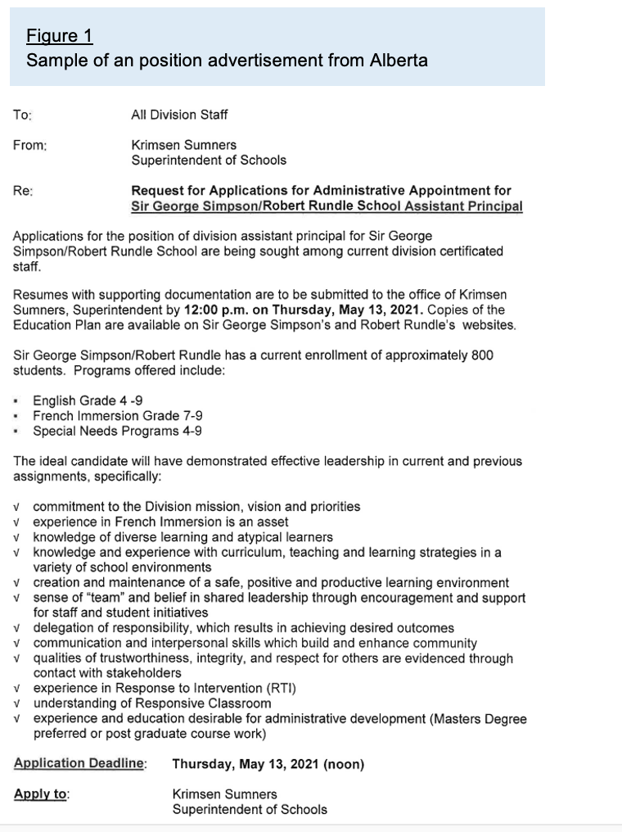

To apply for a position in Alberta, the advertisement (see Figure 1) is sent out to all district schools first. Leadership positions are discussed with the District Superintendent. When someone is appointed they are appointed on a contract for a year. At the end of the year the school principal can offer the successful candidate a permanent contract.

When applying for a promotional position in a NSW public school, applicants need to produce a lengthy curriculum vitae. This application is usually a minimum of six pages. The applicant then maybe offered an interview, and if successful the position.

An application in Alberta consist of a one-to two page cover page and a one to three page resume. The resume basically consists of information outlining tertiary education and qualifications, previous experiences and interests. Unlike Alberta schools where you have a trial for one year, a successful applicant in NSW achieves permanent status as soon as they accept the position.

Conclusion: Recommendations
I feel very fortunate to have had the opportunity to be part of this experience. It has been wonderful to connect with someone on the other side of the world who is also working through such difficult times. Susan Anderson has been an exemplary mentor, great listener and wonderful new friend. Her leadership is authentic and transformational.

My only criticism is that the program was not long enough. Through these challenging times, teachers and school leaders are very time poor. I wish I could have had more time to discuss things like 21st century learning, innovative school environments and dealing with the rise of student anxiety.

