2021 Short-Term E-Exchange Program – Research Submission

Wellbeing through Meditation and Mindfulness: An Inclusive, Positive Approach for Staff and Students
Megan Loiterton
NSW School Name: Lightning Ridge Central School
NSW Position: 2395 Learning and Support Teacher

E-Exchange participant during 2021 with:
Karla Marsh
JC Charyk School Hanna, Alberta, Canada

As part of the International E-Exchange Program, a virtual exchange was completed between New South Wales and overseas counterparts. This exchange provided an opportunity for short-term one-on-one partnerships between educators with similar interests or fields.
This action research report on the shared focus area was completed following the 6-week program.

Introduction
The demographics between Karla Marsh’s JC Charyk School, Hanna Alberta, Canada and Lightning Ridge Central School, appear quite similar. Both are set in small mining communities with K-12 Central Schools. Inside our schools we found very similar characteristics between our problems of practice and issues affecting staff and students surrounding:
- Wellbeing - considered in relation to how we feel and function across several areas, including cognitive, social, emotional, physical and spiritual wellbeing (NSW DoE, 2021). The Wellbeing Framework for Schools, supports schools to create teaching and learning environments that enable students to be healthy, happy, engaged and successful, to ‘connect, succeed and thrive’ (NSW DoE 2020).
- Inclusion – for all students and staff including those with a disability, behaviour or mental health challenges.
- Behaviour - evidence-based practice to influence positive behaviour for learning.

Focus of the Study: Description of Current Practice
Inter-school discussions revealed that the recent global pandemic COVID-19 has heavily impacted upon the teaching and learning program in both schools as well as a shortage of school counsellor resources, and a spike in school counsellor referrals. Discussion surrounding these issues, led us to investigate the benefits of implementing student/staff wellbeing programs with a capacity to positively build upon behaviour and inclusion. Therefore, the focus of this study is to research evidence-based tools for staff and students to improve/maintain their wellbeing and mental health, whilst positively influencing inclusion and positive behaviour for learning.

Signficant Learning: Findings
According to Cambridge University in 2020, mindfulness and meditation practices translate well across different populations and the introduction of these practices during the pandemic, has been a low-cost, beneficial method of providing support for mental health and wellbeing.
Australian research suggests that the Smiling Mind, mindfulness program is an evidenced-based program/tool with links to the curriculum, and activity likened to ‘gym for the brain’ (Smiling Mind 2020). Investing 6% of the school day in the mindfulness/meditation program led to a positive increase in achievement and mental health by 16%. In addition to being a free resource, the program has been credited with improving emotional regulation, attention, memory, learning, positive social behaviour and has the capacity to alter neuroplasticity and executive functions of the brain, and can be applied across settings for access at home, school and work (see Figure 1).
According to Smiling Mind researchers, triple the number of young people have been experiencing psychological distress since 2007 (see Figure 2).
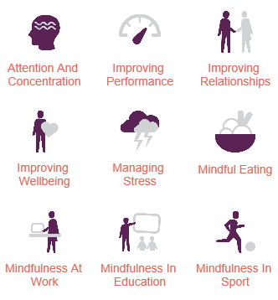
Figure 1 - Implementation across areas (From Smiling Mind, Evidence Based Guidelines for Mindfulness in Schools 2018, A guide for teachers and school leaders)

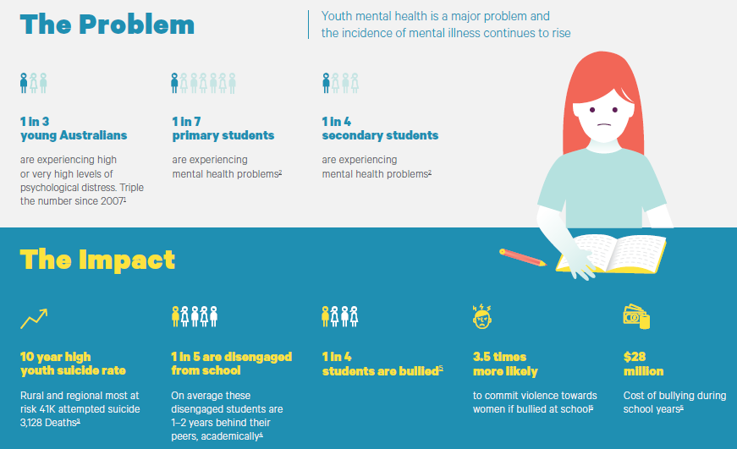
Figure 2 - The problem and impact (From Smiling Mind, Evidence Based Guidelines for Mindfulness in Schools 2018, A guide for teachers and school leaders)

Anecdotal Evidence – Lightning Ridge Central School
The Special Education class had been trialling the Smiling Mind program, where students participated in meditation after recess and lunch. A shift in positive behaviour for learning was recorded and shared with colleagues at a staff meeting. Staff members expressed an interest in boosting wellbeing, engagement and positive behaviour and began to practice the meditation (see Figure 3, Figure 4).
Figure 3 - Lesson Sample (From Smiling Mind, Evidence Based Guidelines for Mindfulness in Schools 2018. A guide for teachers and school leaders)

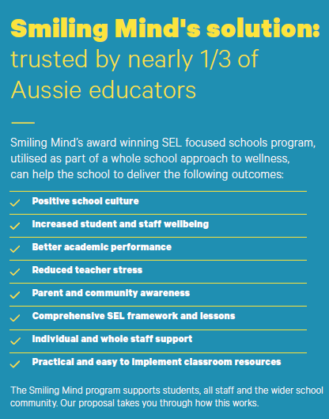
Figure 4 - A whole school approach -benefits (From Smiling Mind, Evidence Based Guidelines for Mindfulness in Schools 2018, A guide for teachers and school leaders)
After 3 weeks, data was collected and 6/10 classes had responded, with 60% of the cohort engaging in Smiling Mind after recess and lunch (see Figure 5).
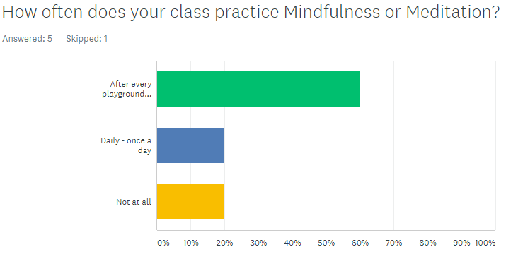
Figure 5 - Results of beginning implementation phase in primary school at Lightning Ridge Central School (Survey Monkey, Smiling Mind 2021)

Conclusion: Recommendations
Based on the demographics between schools, current research and anecdotal evidence, mindfulness and meditation is a low-cost tool that translates well across schools, providing positive support for wellbeing, behaviour and inclusion for all (Cambridge University 2020). The Smiling Mind program is an effective evidenced-based tool with curriculum links and proven results and is an inclusive, positive approach for staff and students and can be accessed by both schools (Smiling Mind 2018).

References
- New South Wales Department of Education and Training 2020, Wellbeing Framework. https://education.nsw.gov.au/student-wellbeing/whole-school-approach/wellbeing-framework-for-schools#:~:text=pdf%20557.71%20KB)-What%20is%20wellbeing%3F,schools%20is%20for%20all%20students

- Smiling Mind, Evidence Based Guidelines for Mindfulness in Schools 2018: A guide for teachers. https://www.smilingmind.com.au/nsw-schools-program

- Smiling Mind, Mindful Champion 2020, Training Workbook.

- Cambridge University,The Benefits of Meditation and Mindfulness Practices During Times of Crisis Such as COVID-19 2020. https://www.cambridge.org/core/journals/irish-journal-of-psychological-medicine/article/benefits-of-meditation-and-mindfulness-practices-during-times-of-crisis-such-as-covid19/076BCD69B41BC5A0A1F47E9E78C17F2A

- Smiling Mind 2021 Survey Monkey of beginning implementation phase in primary school at Lightning Ridge Central School. https://www.surveymonkey.com/r/PPRDF88

