2021 Short-Term E-Exchange Program – Research Submission

Challenges Teachers Face with Student Mental Health
  - Student Mental Health and Teacher Training
Annie Bestwick
Lithgow Public School NSW
Classroom Teacher

E-Exchange participant during 2021 with:
Heather Vowles, Sibylla Kiddle School, Alberta, Canada

As part of the International E-Exchange Program, a virtual exchange was completed between New South Wales and overseas counterparts. This exchange provided an opportunity for short-term one-on-one partnerships between educators with similar interests or fields.
This action research report on the shared focus area was completed following the 6-week program.

Introduction
Discussions during this E-Exchange revealed the struggles teachers face in relation to student mental health and illness. Mental illness is defined as ‘a health problem that significantly affects how a person feels, thinks, behaves, and interacts with other people’ (Department of Health, 2007).
This report will highlight the challenges the teachers in a NSW primary school face with student mental health.

Focus of the Study: Description of Current Practice
Students come to school with a range of backgrounds and mental health, including anxiety, depression and impact of trauma. A 2013-2014 survey reported that almost 1 in 7 children and adolescents aged 4-17 years experienced a mental health disorder (Austalian Institute of Health and Welfare (AIHW), 2021).
There are also a range of unprecedented factors that can further impact a child’s mental health. Across NSW, these include:
- 2019/2020 bush fires
- 2017–2020 drought
- 2021 floods
- generational trauma
- child abuse, placement in Out of Home Care
- ongoing 2020 global pandemic, including the impact of lockdowns, and change of school to remote learning.
These factors are not isolated to a specific student group. Rather, they can impact students in a range of settings and locations across NSW.

Significant Learning: Findings

Teacher Importance and Impact
Bronfenbrenner’s Ecological Systems is a levelled developmental theory that places students at the centre. The Microsystem is the first level and includes the relations and impact of family, health services and school (Guy-Evans, 2020). The microsystem is ‘the most influential level of the ecological systems’ as it is the daily interactions that a child has (Guy-Evans, 2020).
Across one school year, NSW teachers generally spend 200 out of 365 days with their students. Spending more than half of the year with their students, teachers are ‘uniquely placed to address student mental health’ (Froese-Germain & Riel, 2012). This is because such a presence in a child’s life positions schools as a universal provider to meet needs and ultimately minimise negative impacts (Signorini & Bryer, 2011).

Professional Learning
Fortunately, there are a range of professional learning courses that teachers can participate in to improve their understanding of student mental health. These include privately organised courses that are offered, as well as NSW Education Department programs that are endorsed and provided on their website (NSW Government Education, 2021).

Challenges Faced
Twenty-five teachers from a NSW school and one teacher from a Canadian school completed an anonymous survey to gain data around teacher’s understanding and confidence in teaching students with mental health.
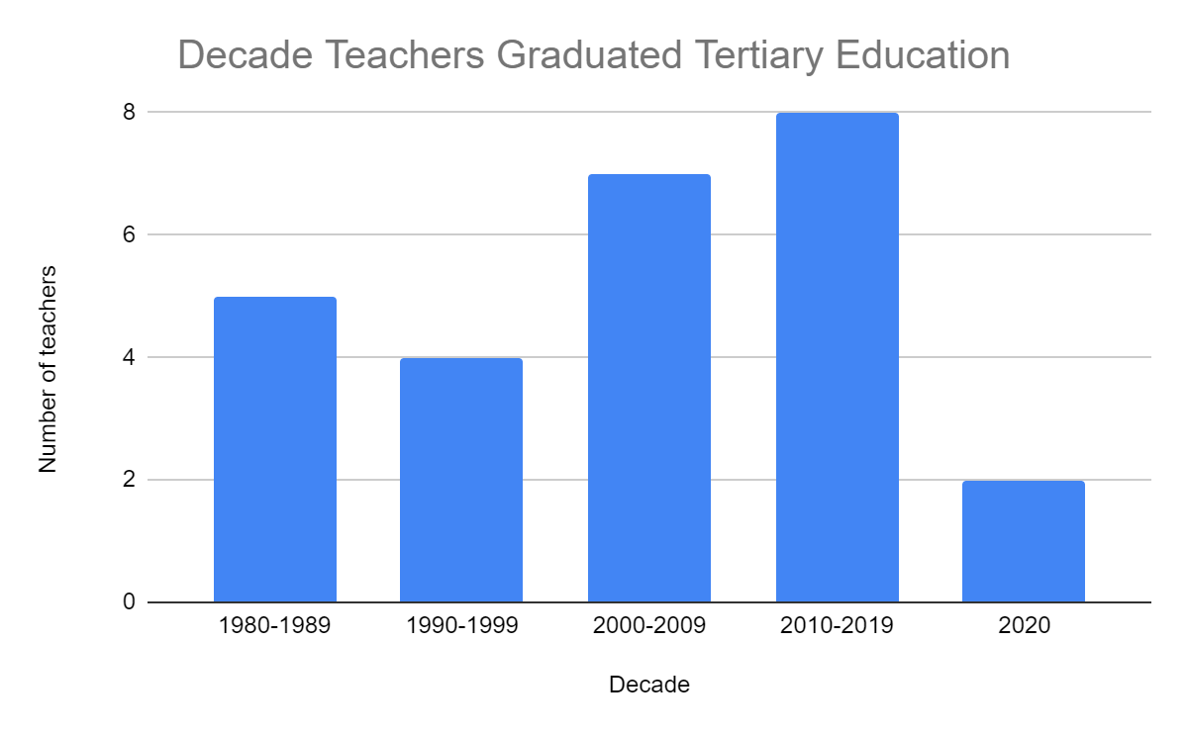
1980-1989 | 1990-1999 | 2000-2009 | 2010-2019 | 2020
5 | 4 | 7 | 8 | 2
The responses come from 26 teachers who have completed their tertiary education ranging from 1980 – 2020.

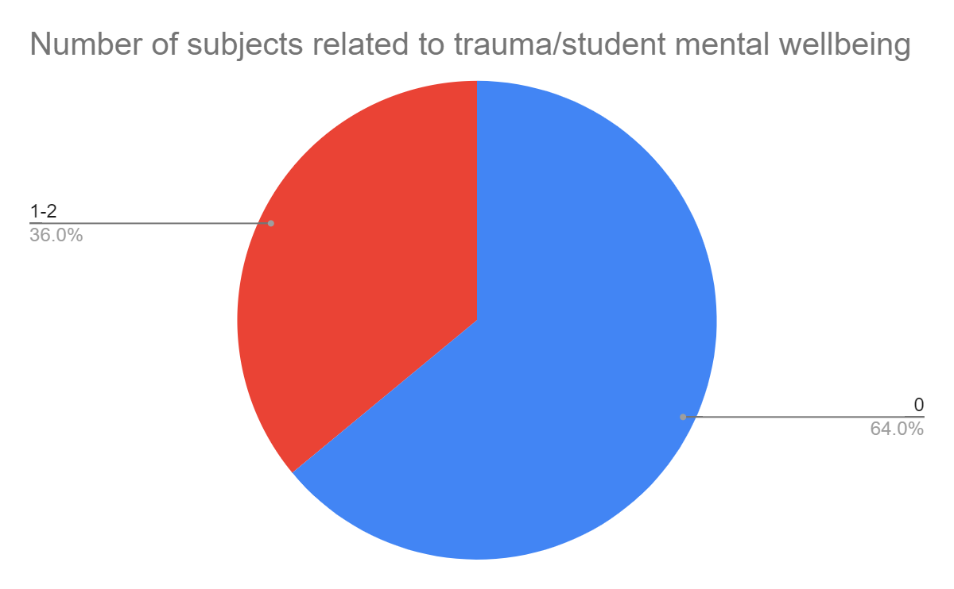
0 | 1-2 | Not included due to ambiguity
16 | 9 | 1
64% of teachers indicated that they could not recall undertaking any pre-service subjects relating to mental health or trauma. 36% indicated they had undertaken 1-2 subjects. One response was not included due to ambiguity of answer ‘0-1’.
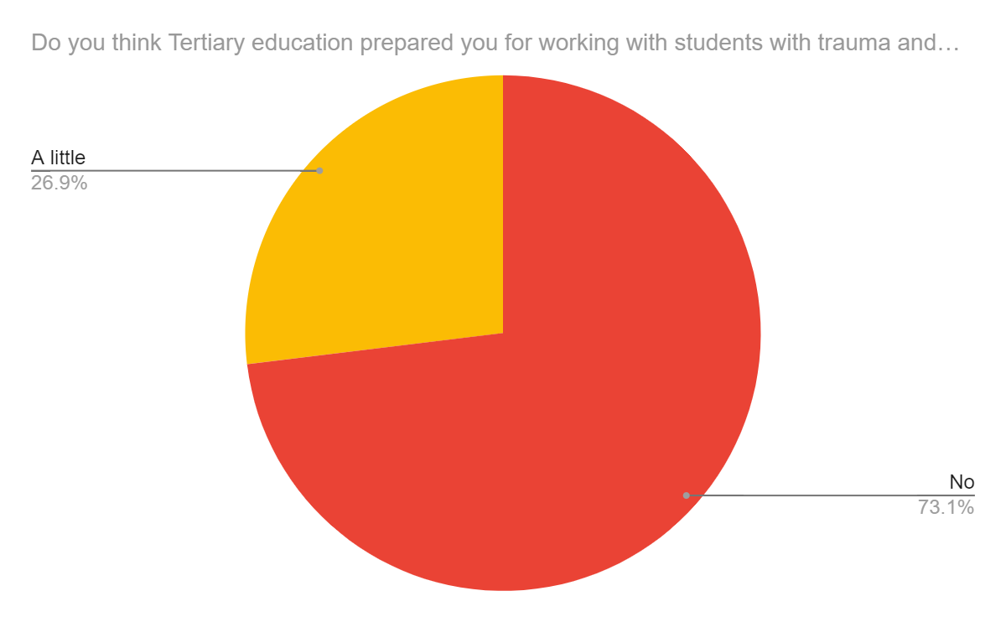
Yes | No | A little
0 | 19 | 7
No teacher indicated that tertiary education had prepared them for working with students with mental health struggles.

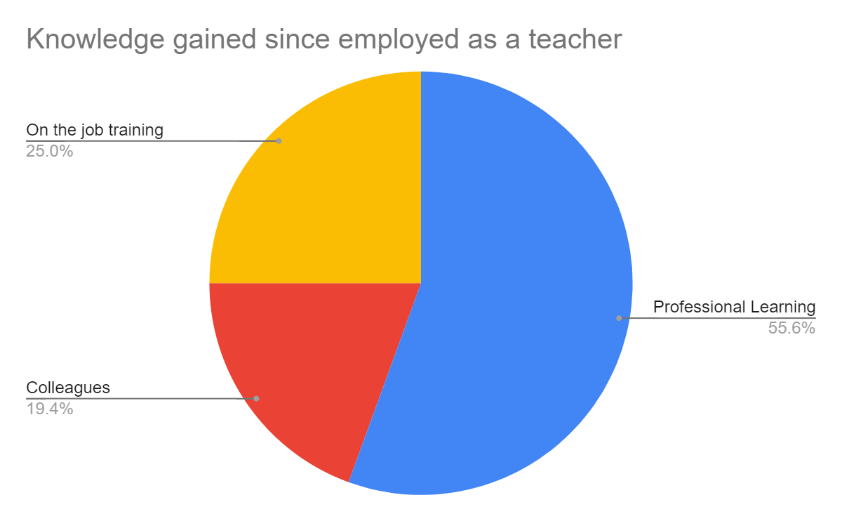
Professional Learning | Colleagues | On the job training
20 | 7 | 9
Teachers have gained understanding and knowledge from professional learning, colleagues and on the job training.

Conclusion: Recommendations
Teachers have an integral role in supporting a student’s mental health. While there is a plethora of professional learning available, a survey of current teachers indicated that since the 1980s, there is a deficiency in the tertiary education programs in preparing teachers to support student’s with mental health.
It would be beneficial for the NSW Department of Education to further investigate and research these inadequacies. The Department then needs to work with Universities that provide teaching degrees to mandate compulsory pre-service subjects that:
- provide explicit understanding and pedagogy of children with trauma and mental health
- focus for practicums to prove a pre-service teacher’s efficacy in teaching students with mental health
Doing so will improve a teacher’s impact on student development and therefore education.

References

- Austalian Institute of Health and Welfare (AIHW), 2021. Mental health services in Australia.
Available at: https://www.aihw.gov.au/reports/mental-health-services/mental-health-services-in-australia/report-contents/summary-of-mental-health-services-in-australia/prevalence-impact-and-burden
[Accessed 10 7 2021].
- Department of Health, 2007. What is mental illness?
Available at: https://www1.health.gov.au/internet/publications/publishing.nsf/Content/mental-pubs-w-whatmen-toc~mental-pubs-w-whatmen-what
[Accessed 10 7 2021].
- Froese-Germain, B. & Riel, R., 2012. Understanding Teachers' Perspective on Student Mental Health.
Available at: https://files.eric.ed.gov/fulltext/ED544259.pdf
[Accessed 4 5 2021].
- Guy-Evans, O., 2020. Bronfenbrenner's Ecological Systems Theory.
Available at: https://www.simplypsychology.org/Bronfenbrenner.html
[Accessed 10 7 2021].
- NSW Government Education, 2021. Mental health programs and partnerships. [Online]
Available at: https://education.nsw.gov.au/student-wellbeing/counselling-and-psychology-services/mental-health-programs-and-partnerships
[Accessed 10 7 2021].
- Signorini , J. & Bryer, F., 2011. Primary pre-service teachers’ understanding of students’ internalising problems of mental health and wellbeing.. Issues in Educational Research, 5(21), pp. 233-258.

