2021 Short-Term E-Exchange Program – Research Report

Creating a Positive School Culture

Amanda White
Camden High School
Classroom Teacher: PDHPE Teacher and Aboriginal Education Coordinator

E-Exchange participant during 2021 with:
Jackie Fuga, Hillcrest Junior High School, Alberta, Canada

As part of the International E-Exchange Program, a virtual exchange was completed between New South Wales and overseas counterparts. This exchange provided an opportunity for short-term one-on-one partnerships between educators with similar interests or fields.
This action research report on the shared focus area was completed following the 6-week program.

Introduction
The ability of a school to create a safe, inclusive and supportive environment for all students is paramount to the success of students both in the classroom and out. Having regular whole school events and celebrations help students engage positively with peers and staff and have the capacity to foster school spirit and connectedness which are key to developing a positive school culture. Many studies have explored the impact of school climate on students' attendance, achievement and autonomy within the classroom, citing that feeling psychologically connected to school is of the utmost importance for a student’s academic success (Reynolds et. al 2017). With the goal of education systems around the world being to create both lifelong learners, as well as contributing citizens within the community, ensuring the learning environment focuses on the whole child is crucial to ensuring these goals are met.

Focus of the Study: Description of Current Practice
Camden High School is a large co-educational High School in the South West of Sydney, Australia. It caters for 1100 students from Year 7 to 12 offering a range of curricular and co curricular pursuits. Over the past 5 years, a significant drop has been observed in participation at school events such as sporting carnivals and excursions with a potential correlation to a slide in attitudes to learning also observed during this time. Similar observations have been made in partner school Hillcrest Junior High, which caters for 400 students from Year 7-9 in Edmonton, Alberta, Canada. School leadership at both schools strongly support the running of co curricular events and acknowledge the benefits to both students and staff that such events have on learning, the development of positive relationships and school culture. However, with continued pressure to meet attendance and educational targets, the high student absentee rate during these events is a cause for concern. A summary of whole school events and celebrations running at each school can be found in Table 1.
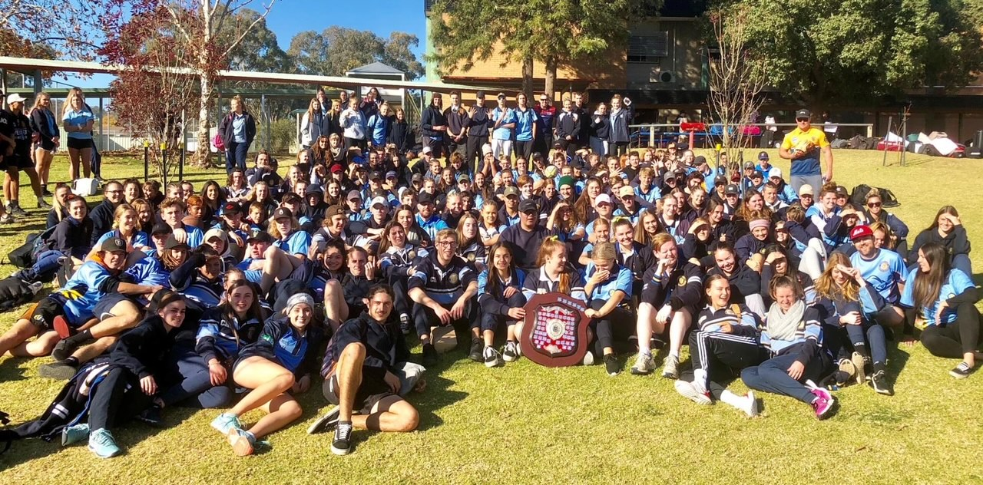
Figure 1: Camden Vs Cowra Cultural Exchange Team, 2019 (Photo by Camden High School)
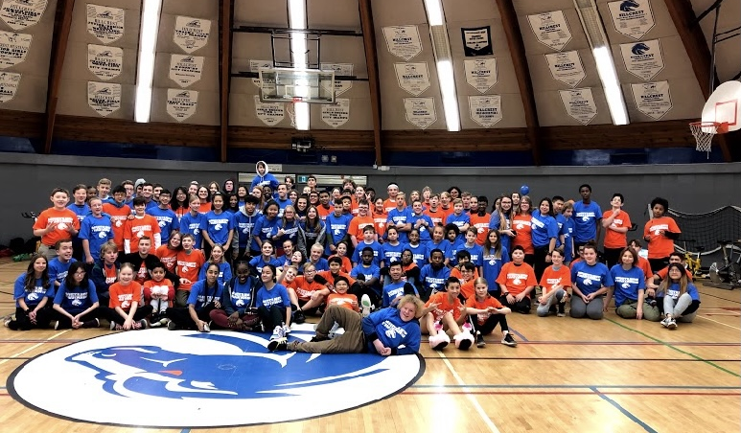
Figure 2: Hillcrest Junior High Bike-a-Thon participants, 2019 (Photo by Jackie Fuga)
Table. 1 A snapshot of whole school events and celebrations in E-Exchange schools
Camden High School |  | Hillcrest Junior High School
Event | Description | Event | Description
School Swimming Carnival  School Cross Country Carnival  School Athletics Carnival | Whole schools sports carnivals where students participate in a range of events for house points. Successful individuals are selected to represent the school at Zone carnivals. | Hillfest, Bike-A-Thon, Valentines Week, Black history month, Hallowe’en, breakfast program, Holiday Week, mental health day, Survivor Week, Welcome Week, yearlong Charity Challenge | Events run by the student leadership team to raise awareness of topical issues, cultural celebrations or fundraising
Camden Vs Cowra exchange | A cultural exchange with Cowra High School (4hours away) in which students from both school compete in a range of sporting and academic challenges for a perpetual shield. | Track and Field Day | A day dedicated to athletics. Students have an opportunity to participate and compete amongst their peers. Top competitors get to further compete at zones or city championships. Every student gets a taste of competition while greatly addressing their affective and social domains of physical literacy.
NAIDOC Week Celebrations | Whole school event in line with a national week of recognition of the achievements of Aboriginal peoples and celebration of Indigenous culture | Talent show | Students audition and showcase their talents to the whole school. While a winner is declared, there is a ton of celebrating and acknowledging the amazing students within school walls.
Celebration of Learning Day | Whole school reward day to the positive efforts of students throughout the year | Fine arts day | A day dedicated to the arts. It is very easy to have sport or physical activity embedded around the school - this one speaks to the artist inside all of us.
Welfare assemblies | Year group based assemblies to celebrate student achievement and share welfare initiatives/support for students | Pride Week | A week full of acknowledgement, resources, education and supporting (promoting allyship) for our LGBTQ2S+ community.

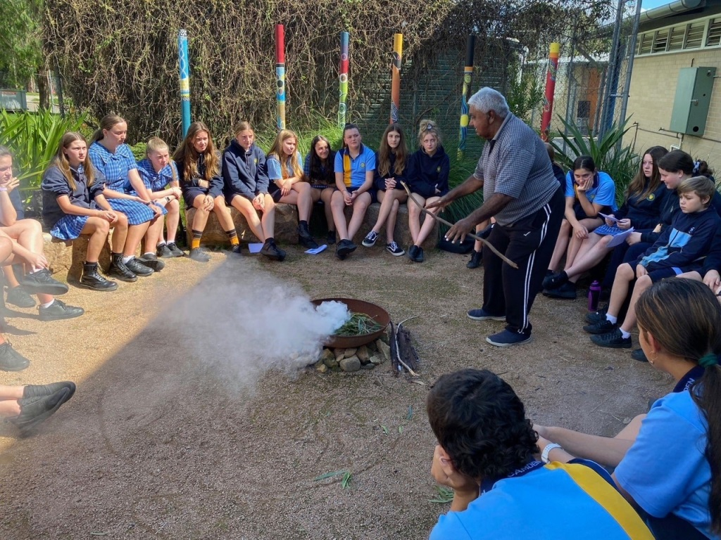
Figure 3: NAIDOC Week Celebrations at Camden High School, 2020 (Photo by Amanda White)
Figure 4: Camden High School Swimming Carnival, 2021 (Photo by Camden High School)

Signficant Learning: Findings
Developing positive relationships and a strong sense of belonging are at the heart of creating and maintaining a positive school culture. We know that students who experience a positive sense of belonging at school also have improved overall wellbeing, mental health and long-term academic success. They are more likely to experience positive friendships, tend to value learning, and show high levels of effort, interest and motivation (Centre for Education, Statistics and Evaluation, 2020). A key way to foster the building of these relationships and sense of belonging is through co-curricular activities, with research indicating that whole school events and activities also contribute to improvements in student attendance and engagement in the classroom (Queensland Department of Education, 2021). Furthermore, we know from student and staff feedback at both E-Exchange schools that the experience of participating in such events is overwhelmingly positive. This is not reflected however by observations and attendance data which indicate a significant drop in student’s participation at whole school events and activities over the past 5 years. Which leaves the questions, if research and student experience support positive outcomes, what are the barriers for students who are opting out of these experiences and what is being done, and can be done to get more students involved?

Barriers to participation on whole school events
As noted through collaboration in the E-Exchange, possible barriers to student participation in whole school events include;
Pressures of social media - social media places a substantial pressure on tweens and teens to act older than they are. In a lot of cases, gone are the days of ‘kids being kids’ without considerable encouragements and support structures in place
Lack of confidence/self-consciousness - when requiring athletic capacities, those who struggle with their perceived competence are less interested to participate. Students seem less inclined to participate for the joy of joining in and ‘having a go’, rather opt to participate only in activities they excel in
Support of colleagues - convincing staff to take time away from academics for community/culture building or raising social awareness can be difficult, when there is not 100% buy in from staff it can be quite obvious to students
Apathy – an observed increase in unmotivated students with a lack of interest, goals and determination to succeed at school. This can stem from peer influence and other socio-cultural factors, with family playing a major role. When family aren’t supportive of co-curricular activities offered at school it can be difficult to motivate students to participate.

Strategies to improve participation in whole school events
A range of strategies have been implemented at Camden High School and Hillcrest Junior High School in an effort to draw students back to these once popular, school culture building activities. These include, but are not limited to;
- Aligning teaching and learning programs in PDHPE so skills for the upcoming events are taught in the lead up to carnival to boost students’ confidence and competence in the activities
- Tying carnival participation to assessment tasks
- Offering venues that appeal to students i.e. changing the Athletics Carnival to an Olympic standard track
- Running novelty events alongside competitive events i.e. colour run, pool noodle races, senior student fancy dress parade, staff v student races
- Offering a range of extra- curricular activities to cater to a wide range of student interests (sporting arts and cultural events)
- Actively generating hype for events through Facebook posts, and promo videos
- Making events free and/or offering free food
- Taking time away from scheduled academics to make events happen during class time
- Having prize incentives for participation (i.e. a pencil or small sweet)
- Having student autonomy and involvement in planning and organisation i.e. Polling the whole school and tailoring activities and challenges based on student voice
- Having staff participate

Conclusion: Recommendations & Dissemination
Having a positive school culture has an impact, not just on the attitudes of students and teachers, but on the entire learning experience. Success at school is about more than the rigours of content and curriculum and where a school can actively engage students and staff through a range of whole school events and celebrations, benefits such as positive relationships and behaviours, increased engagement and attendance, and the development of confident, well rounded students can be seen. This is not without challenges, but a commitment to the planning and delivery of whole school activities, to adapting and modifying activities to meet the needs of students is highly recommended as an outcome of this research project.
The findings of this International E-Exchange report will be shared with the PDHPE faculty at Camden High School and Hillcrest Junior High School, with a view to inform further planning of whole school events and activities.

Acknowledgements
- Reynolds, KJ. Lee, E. Turner, I. Bromhead, D. Subasic, E. 2017. How does school climate impact academic achievement? An examination of social identity processes. Sage Journals (Online). Available at: https://journals.sagepub.com/doi/abs/10.1177/0143034316682295 (accessed 15/5/2021).
- Centre for Education, Statistics and Evaluation. 2020. Supporting students’ sense of belonging synthesis paper. (Online) available at: https://www.cese.nsw.gov.au/publications-filter/sense-of-belonging-synthesis-paper (Accessed 11/6/2021)
- Queensland Department of Education. 2021. Developing a positive school culture. (Online) available at: https://education.qld.gov.au/initiatives-and-strategies/initiatives/every-day-counts/addressing-school-absenteeism/developing-positive-culture (accessed 4/5/2021).

