2021 Short-Term E-Exchange Program – Research Submission

Your Research Title here
  - Your research area here (ie, Leadership Development, Explicit Literacy and Numeracy Teaching Strategies)
Author Name
NSW School Name
NSW Position

E-Exchange participant during 2021 with:
Host teacher name, host school name, Alberta, Canada

As part of the International E-Exchange Program, a virtual exchange was completed between New South Wales and overseas counterparts. This exchange provided an opportunity for short-term one-on-one partnerships between educators with similar interests or fields. This action research report on the shared focus area was completed following the 6-week program.

Introduction
Use this section if you wish to introduce your report. You might introduce yourself and your E-Exchange counterpart, eg, background, educational role, reasons for undertaking the E-Exchange.

Focus area / Research question
Use this section to describe the professional learning priority or key area that you focused on during the E-Exchange. Outline specific question/s that you researched and what you hoped to learn or achieve through your E-Exchange discussions and research.
You might describe how you and your counterpart worked together to determine this project focus based on your learning priorities, career or personal goals, or arising from your school or educational setting. It might also be helpful to describe the current practices or understandings in your roles or educational settings around this focus area.

Signficant learnings / Findings
Use this section to describe the activities and discussions that occurred as part of your E-Exchange experience which were aligned to your focus priority. Indicate how you worked independently and collaboratively to research, analyse and document your learning.
Compare and contrast aspects of education between your own and your counterpart’s systems. Consider sharing your reflections about your own practice as relates to the focus area.

Conclusion / Recommendations & sharing
Use this section to share recommendations arising from your report, both in terms of your own learning and enhancing your own practice, and in terms of any possible wider systemic or network future directions. This section may also include your plans for disseminating and sharing your learning with colleagues and wider networks.

Acknowledgements
Cite any sources / links to available resources / details of contact personnel here:
- Source 1
- Source 2
- Source 3

Guide to preparing your E-Exchange research report
Your report is a valuable tool for disseminating your learnings and is a Departmental document. Report writing tips from our editor include:
- You are writing a report, not an essay or a narrative. Your report should be a short, concise document and relatively formal in tone, not the informal language of a narrative.
- Use concise, active and engaging language. Drawing comparisons with the current NSW education setting is critical to engaging your audience with the findings of your report.
- The conclusion should provide your thought-provoking insights gained as a result of your study.
Accessibility
Research reports may be published on the NSW Department of Education website and so must meet standards of accessibility. Accessible documents are consistent in text and format styles to allow readability including through use of a screen reader. Exchange teachers are required to use the accessible template provided.
Length
The report length is 500 words (excluding reference and acknowledgments).
Photographs
A maximum of five photos may be included in the report. Assistance is available for managing inclusion of your photos. As these photos may be published on a public web page there must be approval from all subjects in the photos for this use. An email agreement is the minimum requirement. Photos should:
- be 100KB in size;
- include alt (alternate) text for screen readers;
- include a caption;
- be placed on a separate line to the text as shown in the template; and
- acknowledge the photographer.
Figures and Graphs
If you need to use figures and graphs, they must be captioned to provide the information in an alternate non-visual format. For example, if you use a graph then also, and underneath, use a table with the same information.
References
A reference list is to be included only where cited references are linked to the body of your report. While you may have read extensively on your subject, a reading list is different to a reference list and is not required. The Harvard AGPS is recommended. A guide to this system is online: http://www.citethisforme.com/guides/harvard-agps
Sending your report
Reports are to be sent as a Word file to exchangeprograms@det.nsw.edu.au.

Other formatting suggestions
In completing your report, you may insert sub-headings and extra features included below, but they are not required.

Sub-Heading
If you wish to include a list, please use the following format.
- Unordered List item 1
- Unordered List item 2
Here is an example of a quotation.
“I hate quotations. Tell me what you know.” – Ralph Waldo Emerson (Quote style)
You may wish to include captioned photographs.
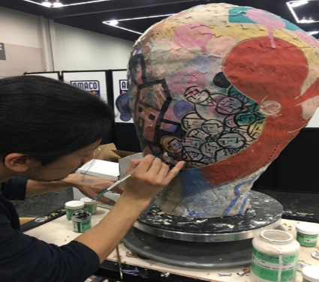
Figure 1: Live demonstration by En Iwamura at NCECA 2017 (Photo by Melissa Grahovac)
If you include a graph or chart as part of your discussion, please also include a corresponding table to present the information in an accessible manner.
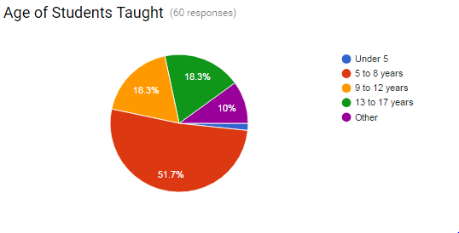
Here is an example of presenting the above charted information in an accessible readable table.
Under 5 | 1.7%
5 to 8 years | 51.7%
9 to 12 years | 18.3%
13 to 17 years | 18.3%
Other | 10%

