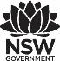
Premier’s First State Super Financial Literacy Scholarship

Global Money Week:
  - How do other countries celebrate Global Money Week, and what can Australia learn from this?
Cassandra Portelli
Hunter School of Performing Arts
Sponsored by

Introduction
The conclusion of MoneySmart week in Australia reduced the opportunity for students to engage in financial and consumer literacy. Australia participated in Global Money Week for the first time in 2016, arguably with limited school impact. Global Money Week provides countries across the globe with the opportunity to reinforce consumer and financial literacy in schools and in the community. The key focus of my study was to learn from other countries and thereby improve the impact in Australia.
A secondary part of my research regarded how financial and consumer literacy education was delivered in the countries that I visited. I was looking for formal syllabuses, elective courses, online courses, guest visits and other opportunities. It became apparent early in my tour that Global Money Week is designed to celebrate what is already happening through these other vehicles for financial and consumer literacy education.
During my research I visited more than thirty providers and events, including central banks, government ministries, schools and the opening of Global Money Week which involved the Dutch Queen, Maxima. From this I was able to see international trends in Global Money Week activity selection.

Focus of Study
As part of the Premier’s First State Super Financial Literacy Scholarship I visited the Netherlands, Spain, Italy, Canada and the United States. I was able to review their Global Money Week involvement and extend that learning to consumer and financial literacy education generally.

Significant Learning

The Netherlands
This portion of the journey really focused on Global Money Week. The Netherlands first celebrated the Week van het Geld, and Child and Youth Finance International took the idea across the globe in 2012. From the opening ceremony and into classrooms around the country there was a tangible hype about consumer and financial education.
The Week van het Geld targets students between 10 and 12, and directly impacts one third of the student population with activities, guest speakers, competitions and more. All students from a particular year group were issued with a special newspaper including an article from the Minister of Finance, games, quizzes and information. Events are coordinated through a branch of the Ministry of Finance, and highly publicised through radio, television and social media. In the Netherlands there is a nightly children’s news feature which highlighted Week van het Geld activities every evening of Global Money Week.
The opening ceremony combined the opening of the Dutch Week van het Geld and the official opening of Global Money Week. The opening was attended by approximately 400 students from a nearby school, executives from business and banking, and the press. The ambassador of both the Week van het Geld and Global Money Week is the Dutch Queen, Maxima.
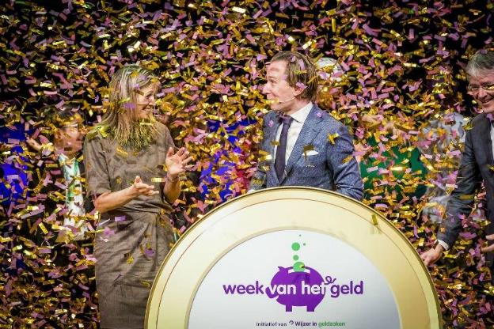
Figure 1: Dutch Queen Maxima opens Global Money Week and the Week van Het Geld in the Netherlands (Photo by Wijzer in Geldzeken)
The variety of initiatives taking place across the country over the course of the week was very impressive. It was impossible to attend all the events, but highlights included the filming of the ‘Big Money Show’, a children’s press conference with the Minister of Finance, performers and respected community members in schools, a national money exam, a community money market and guest lessons by experts. These guest lessons often mentioned scams, ‘shouldering’ (protecting your pin) and other technological impacts on financial literacy.
Like Australia in the last decade, the Dutch hope to implement new syllabuses by 2020 and it is expected that financial capability will be embedded in these new documents. A framework has already been developed by the National Institute for Budgeting, and it is likely that this will be integrated into the new curriculum in some way. Research suggests that while the Week van het Geld and other initiatives have an impact on student understanding, there are significant improvements that could be made through curriculum renovation.
Key take-aways from the Netherlands:
- a central organisation point for events across the country was crucial to the huge success of the week.
- a highly respected ambassador (Queen Maxima) was a distinct advantage to promotion.
- there was exceptional public relations across the nation.
- the interaction between banking, business and education was remarkably collaborative.
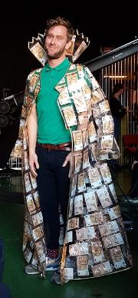
Figure 2a and 2b: The Big Money Show grand prize was awarded by Tim den Besten wearing a cloak borrowed from the Dutch Central Bank containing ten thousand Euros and ‘Mr Cash’ at the Money Market in Alkmaar (Photos by Cassandra Portelli)

Spain
In Spain I visited with teachers of mathematics and economics, the Bank of Spain, and a business called Fun Finance. Many exciting events are taking place during Global Money Week in Spain, but they are not centrally organised and do not involve many students, as opposed to the Netherlands.
There are aspects of financial literacy built into the Mathematics courses in Spain, but the applications are narrow. There is much more taught through Economics; however, this is an elective subject in Years 9 and 10, much like Commerce in Australia.
The education provided by the Bank of Spain has two components; education about the role of the bank in the economy, and education about participating in the economy as a consumer. The Bank had developed several high-quality games, online courses, radio spots and an impressive website of resources for consumers.
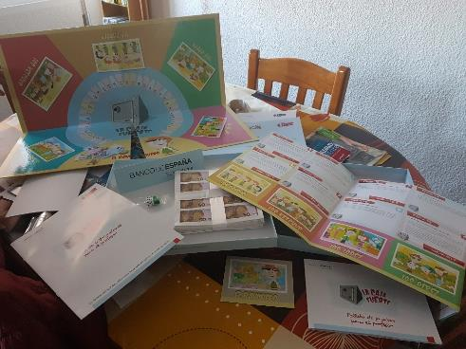
Figure 3: An example of one of the Bank of Spain games provided to schools. (Photo by Cassandra Portelli, games published by the Bank of Spain)
Fun Finance provides education to children from and beyond Spain in entrepreneurship. The lessons conducted for Global Money Week were particularly engaging. This business was looking to expand its delivery to education about sustainable economic practice through a grant from the European Union.
Key take-aways from Spain:
- When the finance sector works with the education sector much can be accomplished.
- Tangibles are still important and were perceived by students as memorable.
- Environmental and social costs are still costs that need to be considered in financial decision making.

Italy
I visited Professor Piccirilli because of his role as one of the researchers who published On the Anatomy of Financial Literacy in Italy. This research was conducted over more than a thousand random participants of all ages, over five areas of financial literacy capability and concluded with results that are very similar to other countries’ findings, including Australia. These included that females scored lower than males, less educated people scored lower than more educated, less wealthy people scored lower than wealthy people, and people from regional towns scored lower than those from cities. All of these findings are very similar to Australia, and addressing these inequities is important.
The Foundation for Financial Education (Feduf) are a foundation funded by the banking association and responsible for many of the financial education resources available in Italy. Feduf showcased a book of Italian fables and applications for kindergarten teachers of financial literacy, and a book of stories made by middle school students on various financial themes. They also described a comedy roadshow run by a mathematician and a physicist that addressed economic issues. I felt that this kind of creativity and narrative in learning materials is an area with potential to be echoed in Australian resources.
My trip to the Bank of Italy was made up of three parts. I learned about the National Strategy proposed by the Committee for Financial Literacy which was accepted into law recently. This outlined the four steps to the plan already well on its way to achieving its goals.
The Bank’s activities for Global Money Week were produced in kits for the students involved. Local offices of the Bank of Italy then chose either an activity about wants and needs, or an activity about an imaginary friend, both adapted from lesson resources suggested on the Global Money Week website.
I was shown the Italian adaptation of the Organisation for Economic Cooperation and Development financial education framework, learning materials, and past evaluation documentation. Finally I viewed a planned data collection tool that will feed information to a central referral point for schools and consumers.
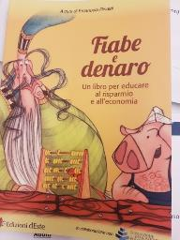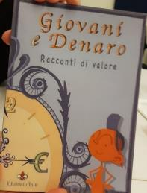
Figure 4a and 4b: Kindergarten traditional fables with a financial message and a middle school authored story collection available to all schools in Italy. (Photos by Cassandra Portelli, books published by the Bank of Italy)
Key take-aways from Italy:
- Government policy is powerful. Things will change rapidly in Italy because financial literacy education has been legislated into law.
- All countries are all facing the similar challenges to financial literacy equity.
- There are many ways to be creative in the provision of financial education.
- Students can contribute to the resource pool.
- There are benefits of working from an educational framework.
- Program evaluation is important.

Canada
Global Money Week is presented as Financial Literacy Month during November in Canada, and comprises a variety of programs that support schools in implementing the financial literacy curriculum. While this is different in each of the provinces, it is mandatory for schools provide financial literacy education.

In Financial Literacy Month in 2017, 808 events and resources from 43 organisations were entered into the financial literacy database. There were more than half a million impressions to the Financial Consumer Agency of Canada (FCAC) Facebook and Twitter accounts, and 5.4 million exposures to print, radio and television mentions. Parliament, including the Prime Minister, actively supported Financial Literacy Month. Some of the activities included a focus on budgeting, money fairs, speeches, essay competitions (including one about ”The Dumbest Thing I Did with My Money”), scholarship awards, and a presentation by comedian James Cunningham called “Funny Money”

Jane Rooney, who is the Financial Literacy Leader of the FCAC, described some of the school curriculum support available. Nova Scotia has introduced a Citizenship subject in Grade 9 to cover financial literacy, just in time for Programme of International Student Assessment (PISA). Canada has world leading results in PISA testing in this area, and Jane expressed her belief that there are three important factors at play; students have bank accounts, they earn money from an early age, and financial literacy topics are discussed in the home.

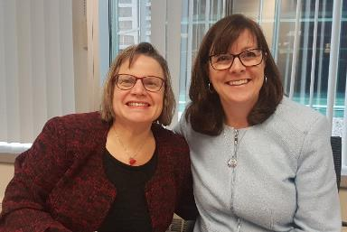

Figure 5: Julie Hausen and Jane Rooney from FCAC. (Photo by Cassandra Portelli)

The Bank of Canada Museum was an absolute highlight for me. I was able to explore the economic lives of Canadians, travel through the history of money and discover the role of the Bank of Canada in helping the Canadian economy run smoothly.

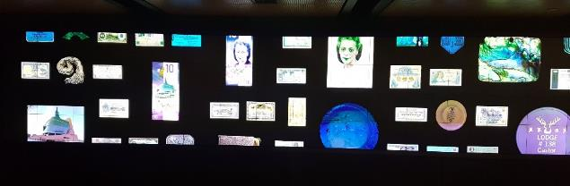
Figure 6: The Bank of Canada Museum’s interactive wall. (Photo by Cassandra Portelli)

Another organisation I visited in Canada was Penny Drops, a university student run not for profit, who held a trivia night by means of a Kahoot. These students deliver outreach presentations in schools following a well-developed curriculum including technology and financial literacy.

Chartered Professional Accountants Canada ran some workshops on budgeting and saving at Canterbury Arts High School. The students were really involved and had lots of ideas to contribute to the lesson. I loved the idea of the rider and the elephant - the rider being the rational mind working toward your goals, and the elephant being your emotional mind tempted by other wants.

AFOA have produced financial literacy education programs that are specifically written for Canadian Aboriginal students. The school programs come with student booklets that are highly engaging, colourful and relevant for students. A stand out feature for me was the encouragement of entrepreneurial behaviour, with case studies including blueberry jam making and the sale of handmade crafts.

Causeway is a unique not for profit, as financial literacy was interwoven with other community work, including employment preparation for youth and adults with barriers to employment, and four businesses employing over 80 people operating under its auspices. Causeway works with lending institutions and a finance fund to provide low interest loans to start small businesses or to end the payday loan cycle. Participants are helped through a budgeting process to ensure they can afford to pay these loans back, and then the plans are taken to the lending institution. Again, I saw the benefits of community working together in a coordinated way to support financial literacy.

Entraide Budgetaire (EBO) educators shared an impressive digital and paper collection of resources covering sixteen topics of finance for 16-25-year olds called “Personal Finance: I'm in Charge”. The resources were produced with assistance from Desjardins, but EBO is not affiliated with any bank, meaning they can provide unbiased advice. EBO give interest free loans to individuals and families experiencing financial difficulty, with budgeting counselling, given the capacity to repay. Their third role is to help low income earners to file their income tax returns.

Key take-aways from Canada:

- Effective use of technology can engage students in learning and understanding.
- A central database of educators is very powerful.
- Financial literacy education delivered through social welfare agencies has a great impact.
- There are strong similarities between Canada and Australia.
- There is a possible relationship between the timing of intensive education delivery and international testing results.
- Community support and volunteering for financial literacy education in this country is very strong.
- The importance of Indigenous people developing material to use within their community.

The United States
In the United States I attended the Annual Conference of Financial Educators which brought some of the best programs from the United States and other countries to the one place. Presenters and collaborators included Financial Fitness, Reserve Banks from several states, Next Gen Personal Finance, Jump$tart, Smart Money Smart Kids, Life Happens, assorted Universities and Colleges, and Banks.
One of my favourite sessions was from “Ms Money and the Coins”. This was a about a 35-minute musical theatre performance for primary students sponsored by the Blue Hills Bank in Massachusetts and written by the presenter. Many of the presentations focused on edutainment or the process of making financial education so entertaining that students are completely engaged in the learning.

Key take-aways from the United States:

- There is a wealth of digital resources available.
- Student debt and a lack of superannuation is a huge problem in the States.
- Again, the potential to educate using creative measures such as musical theatre is exciting.
- In Australia we are lucky to have a national curriculum with financial literacy embedded.

Conclusion
Australia is uniquely placed among the countries I visited in that it has a strong framework of consumer and financial literacy education which is embedded in National Curriculum from K-12. Australia currently has an excellent collection of educational resources housed within the MoneySmart website.
All of the countries that I visited celebrated Global Money Week in some way. The Netherlands had the most effective program, and devoted considerable resources to the event. Some countries felt a week was not enough and had identified a Financial Literacy month. This did not necessarily coincide with Global Money Week.
Reserve Banks in all of the countries visited had a vast collection of very useful resources, and all contributed in a significant way to the celebration of Global Money Week or Financial Literacy Month. Similarly, banking foundations, money museums and certain not for profit and for profit organisations are a valuable resource across these countries for financial education.
Countries with better Global Money Week programs made exceptional use of publicity, including social media. They may have used a mascot, ambassador or recognisable logo to represent the initiative. They may have created a buzz with competition, excursions and other variations of routine, and the focus was on the celebration of learning. In most countries there was a central launch point for Global Money Week initiatives, and there was an element of reporting back to that central launch point to improve publicity during the week and streamline reporting back to Child and Youth Finance International.
Recommendations:
At a local level: plays, musical theatre, music and other performances were being used around the world to reinforce the messages of consumer and financial literacy, including an understanding of modern money management and safe practices. Since I work at a Performing Arts school, it would be ideal to harness this creativity in some way to celebrate Global Money Week locally.
At a state level: the contribution of students to financial education resources increases the authenticity of those resources. It would be wonderful to see a collection of student stories (with a financial literacy message) to be collected during Global Money Week 2019 and launched as a published collection in school libraries across the state during the following Global Money Week 2020.
At a national level: a central database of alternative providers and more tangible resources, such as guest speakers, touring performances, and organisations with shows or games available specifically for Global Money Week would be beneficial. Schools and organisations should be able to access this collection to plan Global Money Week events and register their event. A promotions team to coordinate this, promote events on social media and through more conventional forms of publicity, and collect information on the impact of these events would be ideal. Also, due to the rapid evolution of financial practices and risks since 2010 when the Framework for Consumer and Financial Literacy was published, there is a need to review the framework and ensure that elements of digital risk management are incorporated into national curriculum.
The Global Money Week Report 2018 page dedicated to events in Australia is virtually blank. It features one picture and three short paragraphs. As a result of this research and my recommendations I hope Australia can promote Global Money Week 2019 as an event of national significance, improve the opportunity for financial literacy education in our schools, and celebrate a national framework that is the envy of many countries.
Acknowledgements
- On the Anatomy of Financial Literacy - https://onlinelibrary.wiley.com/doi/abs/10.1111/ecno.12111
- Global Money Week Report 2018 –
https://issuu.com/childfinanceinternational/docs/gmw_report_2018

