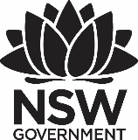
Premier’s Commonwealth Bank STEM Scholarship

Reimagining Learning
  - Observations and recommendations for innovative practice in STEM education
Sophie Poisel
Emanuel School
Sponsored by

1. Introduction
To prepare our students for the future, schools need to foster the development of transferable enterprise skills, and foundational dispositions (Foundation for Young Australians, 2016; Institute for the Future, 2011; 2016). Embedding these skills and dispositions in curriculum has been evidenced internationally (Foundation for Young Australians, 2016, p.19) and has more recently, been highlighted as a key recommendation in the Review to Achieve Educational Excellence in Australian Schools (Australian Government, 2018).
Transdisciplinary curriculum design and associated pedagogies have gained momentum as they seek to empower the learner and foster the development of these key skills and dispositions (Clapp, Ross, Ryan, & Tishman, S., 2017; Foundation for Young Australians, 2016). Clapp et al. (2017) highlight that “it is essential to develop assessment and documentation strategies that illustrate and support the educational outcomes of this work” (p.163). Observing the craft and practice of lead educators, how they have reimagined learning experiences, embedded thinking processes, developed innovative assessment and used new spaces, offers a window to their practice and insight into how we can reimagine educational experiences for students in NSW and Australia.

2. Focus of Study
The focus of this study is to investigate how innovative learning institutions in North America are reimagining learning through transdisciplinary opportunities, such as Science Technology Engineering and Mathematics (STEM). In this study, I aimed to explore how these opportunities foster the development of enterprise skills and foundational dispositions through processes such as Design Thinking and alternative assessment and reporting regimes. I was also seeking to investigate which conditions foster innovation in educational settings. This study relates to and builds on the research recognising the need for innovation in education (Australian Government, 2018; Clapp et al., 2017; Institute for the Future, 2011; 2016; Foundation for Young Australians, 2011; 2016) and the rise of interdisciplinary curriculum models and new pedagogies which aim to offer authentic contexts for learning.
The scope of the study ranged from California to New York and Toronto. The itinerary was shaped around visits to well known schools, museums and universities that had a reputation for innovative practice. I conducted interviews with teachers, educational leaders, tinkerers in residence, museum curators, curriculum experts, students and attended a conference.
I visited the following key locations:
- California
- Nueva School, Hillsborough
- Exploratorium Tinkering Studio
- Castilleja School, Palo Alto
- Stanford d.school, Palo Alto
- York School, Monterey
- Viewpoint School, Calabasas
- Windward School, Los Angeles
- Arete Prep, Los Angeles
- The Moxi, Santa Barbara
- High Tech High, Elementary, Middle and High Schools, San Diego
- Montgomery High School, San Diego
- The Children’s School, San Diego
- New York
- Marymount School of New York, New York City
- The MET, New York City
- New York University, New York City
- Columbia University, New York City
- Hudson Lab School, Hastings-on Hudson
- Heathcote Elementary School, Scarsdale
- Scarsdale High School, Scarsdale
- Portfolio School, New York City
- Toronto & Ottawa
- The Children’s Garden, Brickworks
- York School, Toronto
- Holy Trinity School, Richmond Hill
- Diefenbunker, Ottawa

3. Significant Learning
My significant learning falls into four categories: catalysts for innovation, the design thinking process, innovative reporting and assessment practices and grassroots revolution.

3.1 Catalysts for Innovation: Space, Culture, Community and Leadership
Space, culture, community and leadership were key elements that fostered innovation in the sites that I visited. While each site used a different name for these leaders and spaces, the intentions behind the existence of their roles and the experiences occurring in the spaces included fostering curiosity, encouraging idea exploration and innovative thinking through hands-on transdisciplinary experiences. For some of the schools, this space was used to introduce new processes, such as design thinking and new forms of assessment.

Developing a maker culture was supported by opportunities for students, staff and community members to make and to celebrate making. For students this meant time and space to develop class projects, personal interest projects and learn new skills. For staff, this meant building knowledge of each other’s strengths, opportunities to learn new skills and embed them into teaching practice and connect with maker communities in schools across the country. Community connections were also fostered through parent learning events, student exhibitions, mentorships and projects with local not-for-profits and businesses and tinkerer or artist in residence programs.

3.1.1 Marymount School of New York
Eric Walters, Director of STEM Education, shared the projects and programs offered at Marymount School which included those involved in using the IdeaLab and FabLab. He noted that the school had a culture of collaboration which had been essential to the development of interdisciplinary learning opportunities within the school. Breaking down disciplinary silos, offered opportunities for students to solve real world problems. This is more challenging in an Australian context with curriculum built into discipline specific modules. Beyond Marymount School, Walters connected educators across the country through the Maker Learning Institute, with stories of best practice in a bi-annual publication and an online lecture series. This is also an area for further development in NSW, particularly across systems.

Partnerships and connections beyond the school meant that students could experience applied STEM through a variety of internships and courses (pilot training, Museum of Natural History, International Centre for Photography, Bloomberg Terminals, MET Museum). Students participated in several programs to foster a love of STEM including involvement in Girls Advancing in STEM Network (GAINS). Emphasising real life STEM applications in teaching is a key step towards gender equality in STEM fields.

3.1.2 Castilleja School
Castilleja School had several Makerspaces across the campus: The Bourn Lab, the Nook and pop-up spaces which were used for design thinking and engineering classes, co-curricular clubs and spaces to create during break times. To foster continuous innovation and interdisciplinary learning opportunities, staff could apply to be involved in a formal fellowship program. In the first year, teachers selected a tool to investigate and use to create something that did not have to be school related. In the second year, teachers needed to develop an interdisciplinary program using this tool. In the third year, the teacher would need to write a new program and learn a new tool. This was important in building teacher confidence with new tools, spaces and pedagogies. Allowing for teachers to experiment with new tools they are interested in, built capacity and benefitted program development and student skill development.

3.1.3 Windward School
Windward School had several of spaces to foster innovation: Create Studio, Design Lab and the Robotics Room. The Create Studio Director, Dorothy Lee, worked with teachers to co-design learning experiences across disciplines. Open shop times were clearly posted on the door which meant students could drop in at any point in the day. Establishing this type of culture in the school required the room to not be timetabled and at least one staff member to be present at all open shop times. Lee highlighted the importance of the space in developing a community through voluntary participation.

This community was further extended and embedded into classroom practice through periodic events for staff. Lee reflected that allowing staff to opt in and learn a new skill in the space, makes it feel less daunting. Similarly, new processes were piloted in the space. While I was visiting, Max Nishimura, Resident Tinkerer, was experimenting with embedding Maker Mindset attributes into assessment rubrics. The goal of this was to highlight the importance of the design process, in particular re-iteration of prototypes and capturing documentation of their process. As educators value process, but rarely is this reflected in individual assignments, particularly at the primary school level. Writing dispositions and process criteria into a rubric demonstrates its value.

3.1.4 New York University
The New York University MakerSpace was part of the Tandon School of Engineering and run by Victoria Bill. The space was used for coursework, student clubs, skills workshops and grant and personal interest projects. The space had been through a series of iterations and a study was being conducted to understand practices in the space. Several grants were available to students. One student shared the aquaponic system they had developed as part of a grant. Staff and student mentors were available to assist with tools. A skills connection board was visible for students to post their projects and ask for help with particular skills.

3.1.5 Viewpoint School
At Viewpoint School, there had been a lot of time spent in developing the space and organically growing programs that were sequenced and connected to classroom learning. The space was also used by students to explore Design Thinking and build collaborative and discipline specific skills. The school was interested in developing a maker culture and held several community events and celebrations. These involved the students teaching their parents how to code, workshops for school administration and teachers, K-5 collaborative building projects and artists in residence programs.

3.1.6 York School
The York School had a multipurpose design shop which I observed a Year 8 history and design class in action. Students were designing and creating monuments using laser cutters, hand tools and resin. Another way transdisciplinary learning is offered at York is through the lens of 20% time (Brookhouser & Megnin, 2015). Students who work on their 20% time projects in the earlier years may use this to inform their capstone project, leading to a seal of Distinguished Global Scholar on their diploma. An example of a recent 20% project a team of students was working on included developing a museum exhibit for two- eight year olds at the local My Museum. Students used design thinking to learn about their audience and learn the messages they could teach them. One student I spoke to remarked, “It would be so much fun if all school was like 20% time.” The school continues to foster this partnership and is working towards a new project involving a performance space at the museum. A struggle for NSW educators is how to offer opportunities like this with such an overcrowded curriculum, and these opportunities become extra-curricular opportunities rather than part of the core learning. If we were to reimagine how we organise syllabus documents and develop learning experiences with a conceptual lens, we may be able to create time for experiences like this.

3.1.7 The Children’s School, San Diego, CA
The Great Artists Grande Finale exhibition demonstrated a whole school approach to interdisciplinary learning. Students presented their learning following an in-depth, study of a specific artist over a six week period, which involved learning in language arts, maths, science, and social studies in addition to learning to emulate each artist’s particular style. Process diaries and artist’s sketchbooks showed the development of student work across subjects. Toddlers to Year 8 students explained their work to their parents and friends. A large collaborative artwork stood at the front of the room. Each room had its own magical feel using lights, film, sound and food to immerse the guests in the world of the artist. This type of exhibition or celebration of learning was common across schools in North America and in International Bacculauret (IB) schools in Australia. This might be a great way to reimagine Presentation or Awards Assemblies at the end of the school year, where community comes together to celebrate the learning and progress of all students.

3.2 Design Thinking
Design Thinking has applications across all year levels, fosters interdisciplinary learning and the development of key skills and dispositions as students engage in authentic problem solving opportunities. As of 2019, Design Thinking will feature in new NSW K-6 Science and Technology syllabus.

3.2.1 Stanford d.school, Palo Alto, CA, Design Thinking Burst
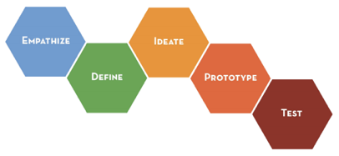
My key take-aways from the two hour workshop included:
- the adaptability of the d.school model (see Fig. 1). Schools are encouraged to adapt the model for their context.
- clarity on the connection between Design Thinking, the Arts and Ethnography. This was made clear through the structure of the evening: the focus on observation, noticing and seeking stories and emotion in the empathy stage using semi-structured interviews, drawing and note-taking
Figure 1. Stanford d.School Design Thinking Model (Design Thinking Burst, April 2018)

- clarity that a prototype can look like, work like, interact like or experience like the intended design.
Beyond this workshop, the d.school offers invaluable professional networking and coaching opportunities through their K-12 Network.

3.2.2 Nueva School
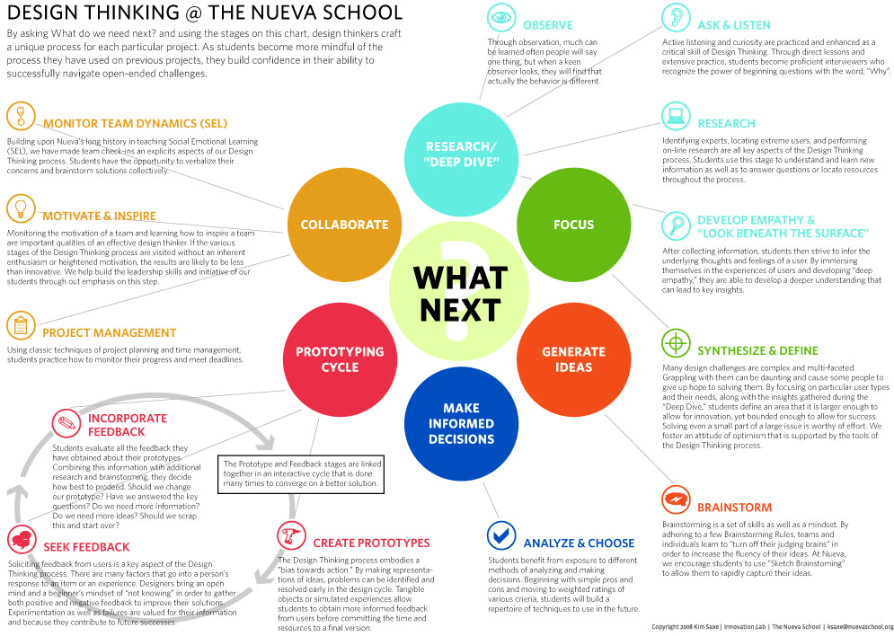Design Thinking is embedded in K-8 programs through developmentally appropriate projects. This involves the earlier years being given a problem or having a need identified and posed as a question or challenge, for example, how can we be more environmentally sustainable at Nueva? or design a treehouse for a first grader. Scott Swaaley, Assistant Director of the Innovation Lab, noted that having someone to design for meant the students were held to account for their designs. He said that Year 1 students can give very direct feedback to Year 5 students during the treehouse project. Swaaley noted that even an industrial designer has to build in process, so they don’t fall back into the trap of designing for themselves. A project that is more complex would involve students identifying their own problems in the school or local community. The school’s Recital and Quest projects further develop the student’s application of Design Thinking in middle and high school. The new NSW Science and Technology Syllabus (NESA, 2019) embeds this process in these areas, but it should be applied across disciplines.
Figure 2. Nueva School Design Thinking Model (accessed from https://www.nuevaschool.org/academics/design-thinking)

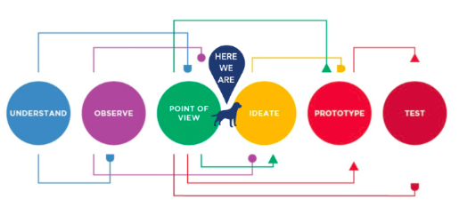
3.2.3 Hudson Lab School
Hudson Lab School demonstrated how Design Thinking could be applied in cross-age transdisciplinary learning opportunities. Centred on the question “what simple solutions can we create to improve the lives of those in our community?”, students in Kindergarten – Year 4 empathised with the residents of the nursing home in their building. They interviewed the ‘grands’, their families and carers and made observations to understand their needs. The staff reflected that development of relationships and internalising the Design Thinking process were key outcomes in this project. The documentation of this project offers insight into how effective the process can be in developing success skills.
Figure 3. Design Thinking Process
(Hudson Lab School Newsletter, January 2018)

3.3 Assessment
Several schools were trialling innovative assessment and reporting strategies that focused on transdisciplinary learning, development of skills and character traits. This included the Mastery Transcript Consortium (MTC), researcher in residence programs, pilot groups and alternative assessment. While a number of the schools I visited were working on project based learning and assessing process, these were three key examples that stood out.

3.3.1 Mastery Transcript Consortium, various schools
Several schools discussed the MTC (Nueva, Windward, Castilleja, York) a non-for-profit that seeks to “reinvent how students prepare for college, career, and life” (MTC, 2018). The transcript aims to remove standardised credits and grades from a traditional report card and to highlight the importance of skills, content knowledge and character traits, as defined by the crediting school. A student at Nueva School commented "one of the best parts about this school is that there are no grades. I don't feel judged. There is evaluation, but that is very different." This is an area of development for NSW Education as grades are currently mandatory component of school reporting under NSW Education Standards Authority (NESA). Research into benefits of grading students needs to be assessed and its continuation questioned.

3.3.2 Castilleja School, Palo Alto, CA
Castilleja had recently received a grant for a research project into measuring and reporting on 21C skills, accompanied by a Stanford Educational Researcher, Karen Stobel, on campus. This study seeks highlight the importance of key dispositions and skills in our planning, assessment and reporting. At this phase in the project, co-curricular clubs were being used to pilot the study through experiential learning and a student directed assessment model and rubrics. Discussions with staff highlighted the complexities of developing rich learning opportunities with dispositions based outcomes, including systems of planning, assessing and reporting and aspects of change management.

3.3.2 Alternative assessment, d.school puzzle bus & Diefenbunker
Originally designed for adults, escape rooms have made their way into education (BreakoutEdu, Puzzle Bus, individually created escape experiences). Stanford d.school has further developed this concept by designing an observational matrix to allow teachers and students to observe and assess skills (collaboration, communication, critical thinking). The matrix can be designed by the teacher or co-designed with the students. Experiencing the world’s largest escape room inside a Cold War bunker in Ottawa demonstrated how this type of assessment could be scaled for a class, a grade or a mixed age group within a school setting. This involved splitting the group into teams with differentiated missions that led to a collaborative puzzle at the end.

3.4 The rise of new schools
A phenomenon we are starting to see more of in Australia, the rise of new boutique schools, was common in North America. The charter school model in the USA is on the rise, which I learnt about at the Deeper Learning Conference at High Tech High. These are schools founded by teachers, parents, activists, universities and non-profit groups. Similarly, two of the newest independent schools I visited were Portfolio School and Hudson Lab School, both opened by entrepreneurs. In Australia, we have seen schools like Luminaria in Victoria and the Central West Leadership Academy in New South Wales follow this model. Some of the leaders in the more established schools I visited spoke about the dichotomy between tradition and innovation and the challenges that this posed in new age of education.

Conclusion
All of the sites I visited demonstrated how we might reimagine school in NSW and Australia, and how space, culture, community and leadership catalyse innovation. It was clear that each school engaging in innovative practice had a highly supportive leadership team, a space for piloting new pedagogy and processes, a culture of maker-centred learning, a team of exceptional educators and an engaged and supportive community. These key elements meant that transdisciplinary learning opportunities, thinking processes and alternative assessment could be piloted, and staff felt safe taking on new challenges.

Professional collaboration and strengthening community engagement enriched learning opportunities through sharing experiences, developing industry specific knowledge and by providing authentic contexts for learning. Innovative schools had strong partnerships with different schools across the country, universities, museums, student and teacher networks and industry. We need to build more connections between the stages of education, and with industry, in NSW and Australia.

Flexibility in curriculum delivery, reporting and assessment meant that connections across disciplines can occur more organically. Teachers could break down subject silos more easily into concept driven transdisciplinary courses that gave prominence to future skills. Teachers focused their time on the documentation of learning rather than the administration of the written program. Innovative assessment and reporting processes that focused on character and future skills were being piloted.

It is without surprise that the findings of this study echo some of the key recommendations in the Review to Achieve Educational Excellence in Australian Schools (Australian Government, 2018), such as the need for professional collaboration (p.57) and strengthening community engagement to enrich learning (p.41), flexibility in curriculum delivery, reporting and assessment regimes (p.ix) and more prominence of general capabilities and future skills (p.38). Australia Schools require space, culture, community and leadership to catalyse innovation, flexibility from mandated curriculum and increased collaboration between schools, universities and industry.

These finding have been disseminated to staff, students and parents at Emanuel School (April 30, May 2, May 9) and with colleagues at the AIS DigiSTEM Conference (October 25). I have also been accepted as a speaker at 2019 National Future Schools in March and have applied to speak at EduTech in Sydney in June. I will continue to share the findings of this study by submitting articles to Education Week and AHISA Independence Journal and by keeping my website updated. I am also forming a K12STEMx Network in NSW, which seeks to bring some of these findings into action through collaboration of schools across independent, public and Catholic systems.

References
Australian Government. (2018). Review to Achieve Educational Excellence in Australian Schools. Retrieved from https://docs.education.gov.au/system/files/doc/other/662684_tgta_accessible_final_0.pdf on 2 July, 2018.
Clapp, E., Ross, J., Ryan, J.O. & Tishman, S. (2017). Maker-Centered Learning: Empowering young people to shape their worlds. Jossey-Bass: U.S.A.

Foundation for Young Australians. (2016). The new basics. Retrieved from https://www.fya.org.au/wp-content/uploads/2016/04/The-New-Basics_Update_Web.pdf on 27 October, 2017.
Institute for the Future. (2011). Future Work Skills. Retrieved from http://www.iftf.org/futureworkskills/ on 27 October, 2017.
Institute for the Future. (2016). Future Skills Report. Retrieved from http://www.iftf.org/fileadmin/user_upload/downloads/wfi/ACTF_IFTF_FutureSkills-report.pdf on 27 October, 2017.

Acknowledgements
I’d like to thank all of the educators who generously offered their time to share their practice and their journeys with me. In particular, I’d like to thank Eric Walters (Marymount) connecting me with educators across North America and Cate Han (Hudson Lab School) for connecting me with educators in the Scarsdale region in New York. Thank you to the following educators who organised my visits: Scott Swaley (Nueva), Gabriel Mellan (Exploratorium), Angie Chau (Castilleja), Devon Young (Stanford), Sean Raymond (York School), Alison Corneau (Viewpoint), Lisa Kessler (Viewpoint), Dorothy Lee (Windward), Batsheva Frankel (Arete), James Dec (Marymount), Victoria Bill (NYU), Mo Haroun (Columbia), Christine Boyer (Heathcote), Lisa Yokana (Scarsdale), Tim Cooper (York) and Stephanie Stephens (Holy Trinity). Thank you the other amazing educators and leaders who offered their time and expertise and made this the most enriching professional learning experience of my career.

Transferable enterprise skills include creativity, interdisciplinarity, design thinking, computational thinking, systems thinking and technical (Foundation for Young Australians, 2016; Institute for the Future, 2011; 2016).
Key dispositions of future workers include resilience, novel and adaptive thinking, collaboration, design mindset, transdisciplinarity (Institute for the Future, 2016).

