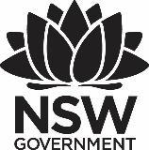
Premier’s History Teachers Association History Scholarship

Vietnam and Cambodia
A historical inquiry
Dianne McGowan
St John Paul College, Coffs Harbour NSW
Sponsored by
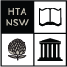

Introduction
This report will depict the findings of the historical inquiry into Vietnam and Cambodia. A historical inquiry is the process of developing knowledge and understanding by asking questions about the past, interpreting and evaluating sources of evidence to develop informed answers.
This study tour has aimed to further my understanding of the causes and consequences of conflict, dispossession and interdependence along with the effects of events and people on the development of both Cambodia and Vietnam.
I was able to visit a number of temples in Cambodia. Some had been restored and many were in their original state. The temple sites themselves were all good examples of the effect nature, time and man has had on historical sites. Disappointingly Banteay Chhmar has been affected by theft, with traffic in antiquities fetching high prices - free standing figures, lintels and pediments hacked away and removed for sale to Western collectors. As recently as 1998 temple blocks forming a 20m section of the gallery were seized at the Thai-Cambodian border, it is still unclear how much of the temple has been lost.
In Vietnam I was able to visit national sites of memory – memorial temples, martyr cemeteries, monuments, museums, all of which contribute to the country’s national memory. By visiting these sites and standing amongst locals and other tourists, I was able to gain a greater understanding of Ho Chi Minh, his presidency, and his lasting effect on the people of Vietnam.
The opportunity to be guided by local people who had lived through different regimes and/or experienced the conflicts that I teach has added another dimension to the study tour that I was not expecting.

Focus of Study
The Vietnamese and Cambodian study was devised to promote intercultural understanding by examining some of the events, people and developments that have shaped the history of these two countries. As one of the general capabilities found in the Australian Curriculum, Intercultural understanding which “involves students learning about and engaging with diverse cultures in ways that recognise commonalities and differences, create connections with others and cultivate mutual respect”.
The tour itself was been specifically created to focus on supporting learning and teaching in history. Partaking in this historical inquiry has given me the opportunity to visit, observe, explore, examine and discuss – immersing myself in the events, people and developments that have shaped the history of both Vietnam and Cambodia. This personal encounter has allowed me to discover more and to better comprehend the perspective of the local people. More importantly it has allowed me to prepare more insightful shared units of work that will allow history students in NSW to also gain a better understanding of the two countries. By visiting museums and artefacts and other culturally significant heritage sites I have gained a better insight into the events of their past and thereby furthering my understanding of the causes and effects of events on the development of these societies.

Significant Learning
The study tour has further developed my knowledge and understanding of the significant people and events that form such a major part of the Stage 4 Australian History Syllabus and Stage 6 NSW Modern History Syllabus.
The tour has developed my knowledge of continuity and change by visiting sites of significance, discussion with local people and through observation and examination of the different museums and archaeological sites. The way cultures represent and commemorate their past was also highlighted by the tour.
The tour highlighted the importance of religion for the Cambodian people - both in the past when many of the monuments were being built but also more recently. Under the Khmer Rouge, all religious practices were forbidden. The pro-Vietnamese communist regime that ruled Cambodia in the 1980s only encouraged Buddhism in a limited way. Thus, between April 1975 and the late early 1990s religious practice was significantly affected. Monks were killed or deported, shrines violated, sculptures mutilated and many religious artefacts destroyed. However this systematic destruction did not eliminate faith, and the study tour highlighted the deep religious observance of the Cambodians.

Northern Vietnam
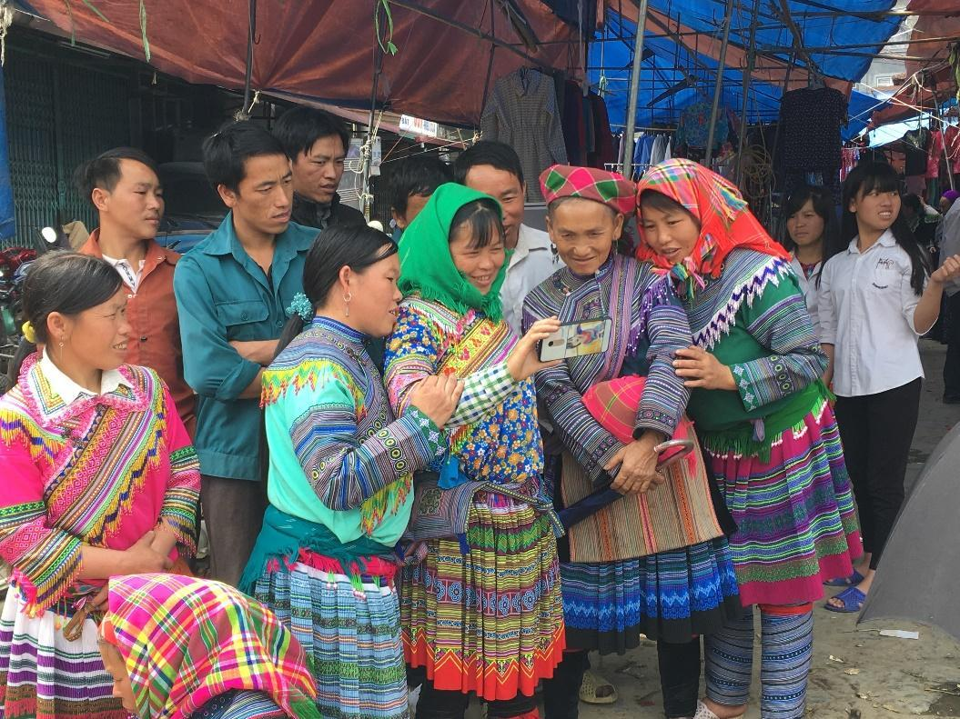
Figure 1: Flower H’mong people at the Bac Ha Market looking at their image on a smart phone (Photo by Dianne McGowan)
The Northern Vietnam section of the tour provided an opportunity to experience firsthand the way of life of the ethnic hill tribes also some of the historical sites of Hanoi (Ho Chi Minh’s Mausoleum / Cottage and Presidential Palace). The hill tribes in Northern Vietnam have a rich cultural diversity and complex cultural characteristics. The historic sites were useful in gaining a greater insight into the forces that have shaped Vietnam and how the country represents and commemorates the past.
On the study tour I was fortunate enough to briefly experience the culture of the people in and around Sapa. The Bac Ha market two and a half hours from Sapa presents the market trade of a variety of ethnic minorities. The Flower H’mong, Phu La, Black Dao, Tay and Nung people were there selling their wares and it is a vital part of existence in an area that still reveals the rustic charm of a relatively traditional way of life. However, the continuity of this aspect of the hill tribe culture is contrasted by impacts of the various external influences which are effecting the sustainability of this traditional way of life. Tourism is one of those external influences. The very presence of outsiders erodes their isolation and perhaps some of the aspects of their culture that tourists visit the region to observe.

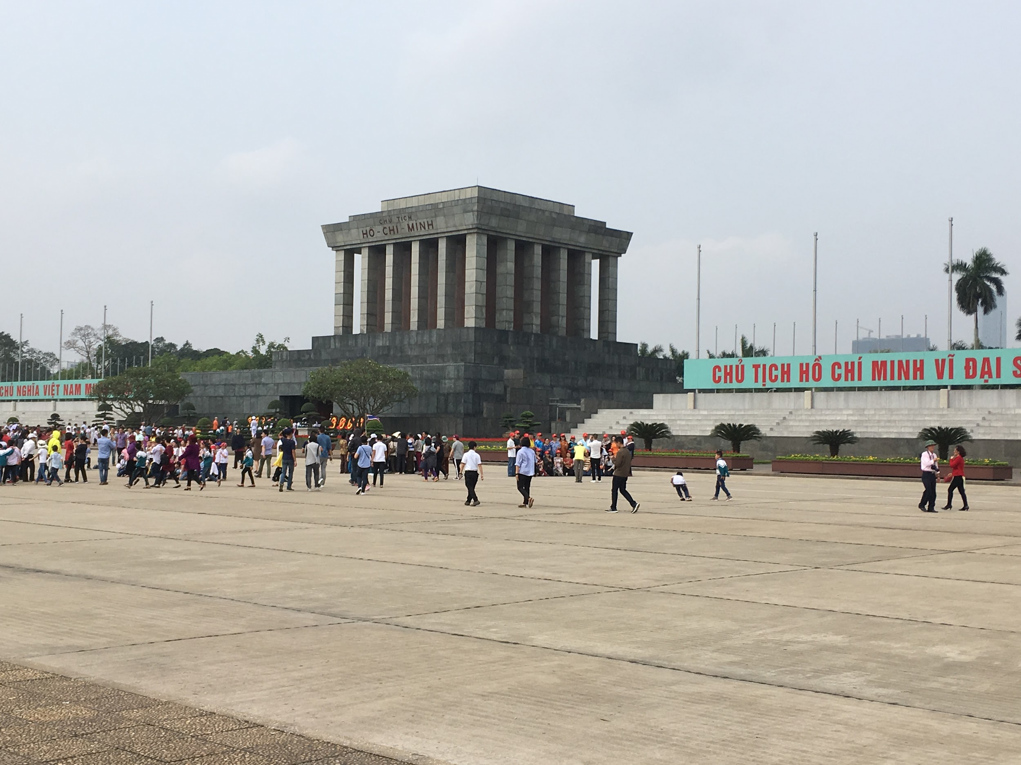
Figure 2: Ho Chi Minh’s Mausoleum (Photo by Dianne McGowan)
The historic sites in Hanoi represent a variety of national sites of memory – memorial temples, martyr cemeteries, monuments, museums, all of which contribute to their national memory. Three of the public representations of history found in Hanoi that have supported the immortalisation of Ho Chi Minh’s role in Vietnam’s development are Ho Chi Minh’s Cottage, The Presidential Palace, and his Mausoleum.
The cottage, that Ho chose to call home, situated on the grounds of the Presidential Palace (an opulent French colonial building) is in sharp contrast to the way that colonial leaders lived. One can understand why Ho Chi Minh has achieved such immortality. The mood at his mausoleum was solemn, and queues to visit the mausoleum were extremely long. Even in death he is sending a message-teaching those who wait in line patience and respect. The willingness of the Vietnamese people to line up and queue for hours is indicative of the reverence that they hold for their leader. The buses of school children, locals and foreigners who have travelled long distances and queued for hours for the one minute, silent, glimpse of Ho in his final resting place is a testament to his resounding impact. There is no sense of duty or obligation for the local visitors, but a desire to pay their respects to a man whom they love. The impression that one man has made (and is still making) on a country is palpable. The villagers, factory workers and business owners, young and old, are happy to wait hours to pay their respects to a man, who by dedicating his life to fighting for and gaining independence from foreign powers, changed their world.
There is no doubt that this public act of commemoration is still very important to the Vietnamese people. By visiting these sites and standing amongst locals and other tourists I was able to gain a greater understanding of Ho Chi Minh, his presidency, and his lasting effect on the people of Vietnam.

Southern Vietnam
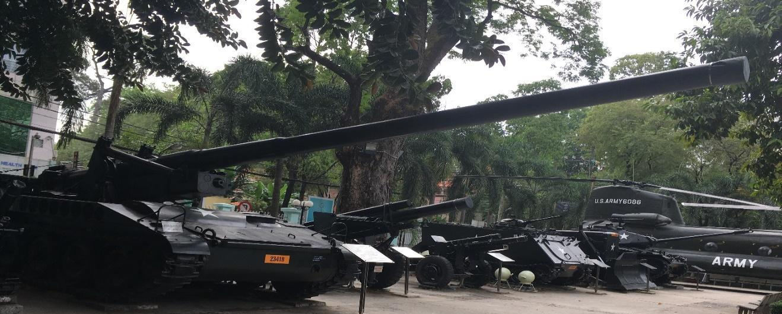
Figure 3: Weapons of the Vietnam War: Open Air Exhibition War Remnants Museum (Photo by Dianne McGowan)

This section of the study tour posed questions about culture and cultural meaning; the role of historic sites; and ways that memorials transmit knowledge of the past to post war generations.
Museums are not merely storage areas but rather a dynamic space. The modern museum needs to change exhibits and the stories they tell by reframing, removing or repositioning artefacts sometimes based on geopolitical relations and changing influence of global power. Due to the massive economic reforms in the country over the past 40 years and the fact that Vietnam is now seeking trade and tourism from democratic nations the way that the country represents and commemorates the past has changed.
The Vietnamese state has invoked many memorials of war to commemorate and keep the spirit of the revolution alive, as well as to transmit knowledge of the past to post war generations. The War Remnants Museum – previously known as the Museum of American War Crimes is one such memorial.
Over the last 50 years this museum has changed in not only its name but also the way it represents the past. Political, economic and social context has played a significant role in refashioning history. When I visited 20 years ago - although the museum was just as confronting as it is today – it tended to only focus on the ideological struggle and the crimes of America as an invading nation. Now the site is more organised, and has curated areas such as agent orange consequences through children’s paintings and a section promoting peace called white doves. Interesting too was the addition of the imprisonment system during the Vietnam war highlighting some of the horrific treatment of Vietnamese prisoners of war at Phu Quoc and Con Son islands.
The War Remnants Museum is a good example of directing an audience to have a certain view, positioning an audience via the exhibits on display. Similarly, the Cu Chi Tunnel complex left the visitor in no doubt as to the nation’s ingenuity, resourcefulness and perseverance. The tunnels, infamous to many US war veterans and a national symbol of courage, cleverness and heroism for the Vietnamese are a major tourist attraction- the relics preserved to promote the war efforts of the local people. The network of tunnels represent the determination of Viet Cong (VC) who used these underground routes to lay booby traps and mount surprise attacks, after which they could disappear underground to safety.
Interestingly there are two main Củ Chi memorial/ representative sites both situated approximately 70 kilometres north west of Ho Chi Minh City centre. One is Ben Duoc – a site mainly for Vietnamese tourists to learn about their history, the other, Ben Dinh has been reconstructed to meet the physical size of western tourists and is where most tour companies go. Whilst both sites had documentaries, weapons, shooting ranges and examples of the tunnels and the spike traps, Ben Duoc was by far more interesting – perhaps due to the lack of people (it was a work day and this site is usually busy on weekends). Ben Duoc tended to also have a more realistic feel, trees may have regrown but the bomb craters were still evident, trenches were easy to see and the tunnels were smaller. A part of the Ben Duoc complex was also a simulation of a liberated area that represented what the village life would have been like before and during 1960-1975.
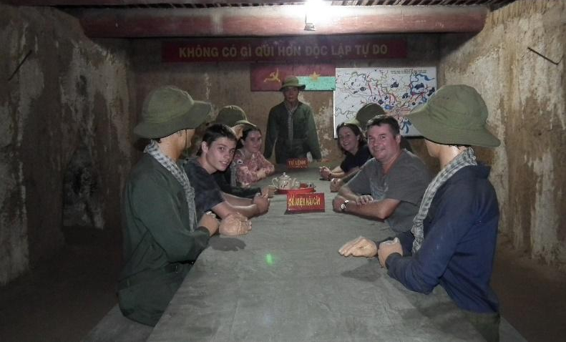
Figure 4: Within the tunnel system of Ben Duoc: Wax models and tourists sit at the Viet Cong HQ table (Photo by tour guide)
The cultural meaning of historic sites was also a focus when visiting Nui Dat and Long Tan Battlefield in the company of author and historian Gary McKay and his tour group of RSL Directors and friends from throughout Australia, some of whom served in Vietnam.
It may be difficult for those of us who did not serve, fight and suffer in the Vietnam War, to understand the significance of the area and the importance of these sites for veterans and their families. As a remembrance service and prayers were offered we remembered a generation of Australians and Vietnamese who fought, who served their nations and who suffered due to the Vietnam War.
Part of the area is still a military reserve and some sections can be restricted to visitors. Now the area is back to the original rubber plantations and the only traces that a base was even here are the air strip that has been turned into a road and a cement plinth that used to house the flag. Gary and the Vets were the only way one could get a glimpse of what life was like from their perspectives, during the Vietnam War.
Attending the small memorial gave thought to the effect that this battle had on the Australians who fought in it and many of the conflicts that we as a country have been involved in. I also imagined what the Vietnamese think about the clash and the impact of the death, devastation, and disrupted lives of a people who may have viewed the Vietnam War as a civil war, in which nationalistic Vietnamese were fighting to reunite their country.
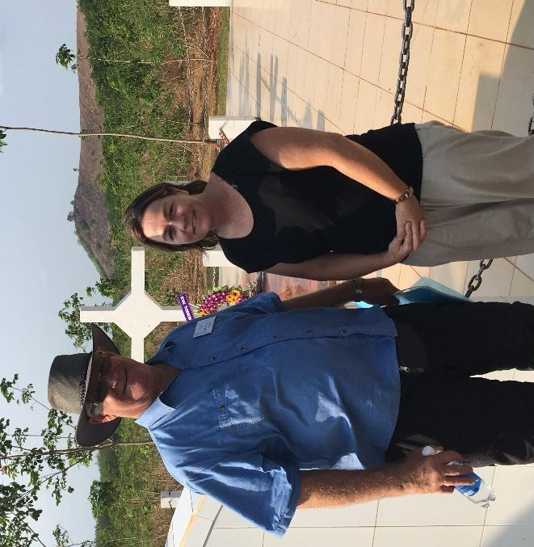
Figure 5: Historian Gary McKay and Dianne McGowan in front of the replica of Long Tan Cross: near Long Tan Battle field (Photo by Michael McGowan)

Cambodia
The Cambodian section of the study tour traced the development of early Khmer society.
Examination of the archaeological evidence is a way of highlighting the cultural achievements of the Khmer civilisation. A civilisation that was one of south east Asia’s most powerful empires by the 8th century. Trade with India and China in the 6th century influenced the development of the civilisation and we can see the direct result of cultural contacts through the introduction of Hinduism and Buddhism and the way these religions are represented in the archaeological structures.
Religion is not only represented via the physical structures created by the ancient Khmer. It is also found in the way that the citizens interact with these sites today. When visiting the temple complexes of Cambodia, visitors experience the presence of worship. Local people are seeking blessings from Buddhist monks, incense sticks are alight and flowers and goods are offered at small and large shrines.
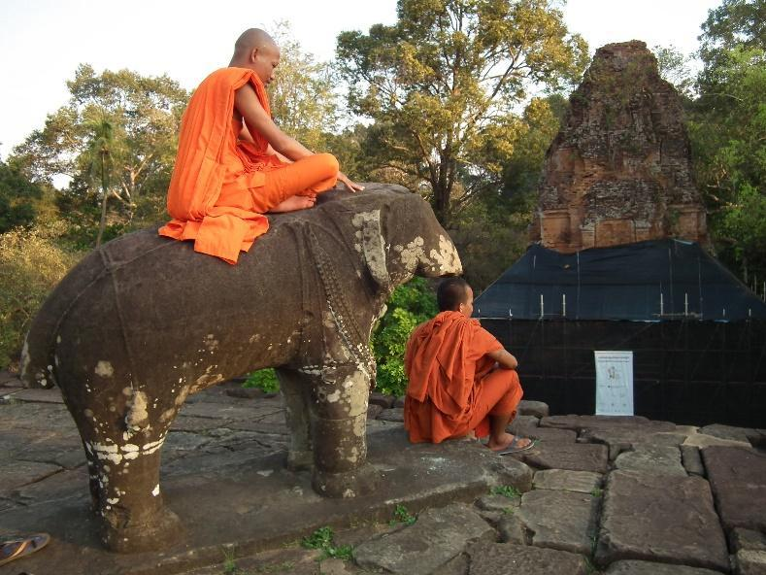
Figure 6: Buddhist Monks reflecting at Bakong temple (Photo Dianne McGowan)
Some of the monuments visited on the study tour included: Phnom Kulen (Kulen Mountain); The ruins of the Rolous Group of monuments; Koh Ker; Preah Vihear temple; Angkor Wat; Beng Mealea; Ta Prohm; and Angkor Thom.
Angkor Thom is a three kilometre walled and moated royal city, was the last capital of the Angkorian empire. This temple was constructed late 12th early 13th century by Jayavarman VII and has similarities to that of Angkor Wat. However, it is distinguished by the Bayon Temple at the city’s heart, which hosts a collection of 54 towers encompassing a total of 216 striking, smiling, enormous faces as seen below.
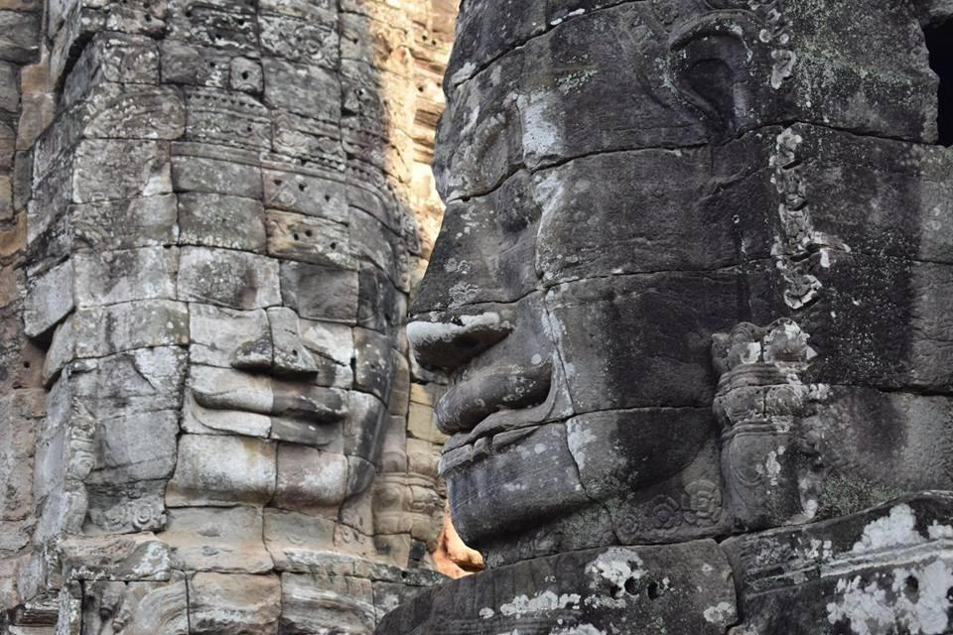
Figure 6: The Bayon Temple Angkor Thom (Photo by Dianne McGowan)
All of the above temples either have been or are currently undergoing restoration. In order to garner a true depiction of the influence of time on the temples, they can be compared to the Banteay Chhmar Temple. The Banteay Chhmar ruined Buddhist complex has had limited restoration work done and sits in ruin. This temple has also been affected by fighting between the Khmer Rouge and government forces. As an archaeological ruin it is a good example of the effect of nature and mankind on historical sites.
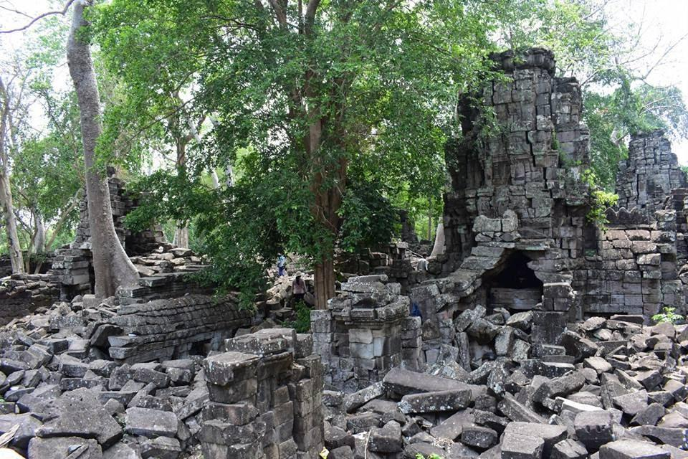
Figure 7: Banteay Chhmar (Photo by Dianne McGowan)
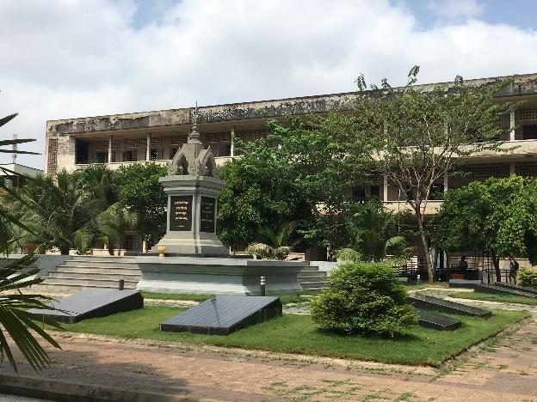
Figure 8: Tuol Sleng Museum of Genocide (Photo by Dianne McGowan)
The impact of the Khmer Rouge regime formed a part of the study tour and thus the tour included visits to the S-21 prison and Killing Fields along with Ta Mouk’s house (Khmer Rouge Military Commander) and the cremation and grave site of Pol Pot.
We were guided in Cambodia by 50-year-old Sopanha Yous, a survivor of the horrors of this strange regime. Under his guidance we were able to garner another dimension to this period of history. Sopanha has lived through five different regimes and his perspective was invaluable.
Sopanha was a nine year old child when the Khmer Rouge seized the nation's capital. As the child of two intellects – a government lawyer and a nurse, Sopanha’s future was forever altered by the Khmer Rouge’s ultra-dogmatic attempt to make all of society rural. The Khmer Rouge were in power for three years, eight months and 20 days forcing Sopanha’s family to be split for three years while he was 9-12 years of age. Like many Cambodians, he lost loved ones (including his father and grandmother) during this period. As we toured through Cambodia Sopanha told us his story of survival and brought to bear some of the horrors that the Cambodian people experienced.

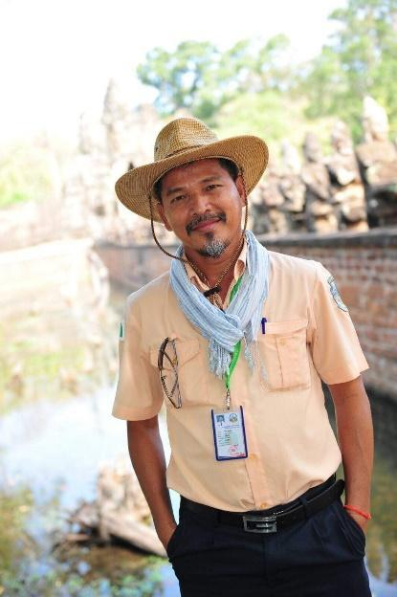
Figure 9: Sopanha Yous (Photo by Dianne McGowan)

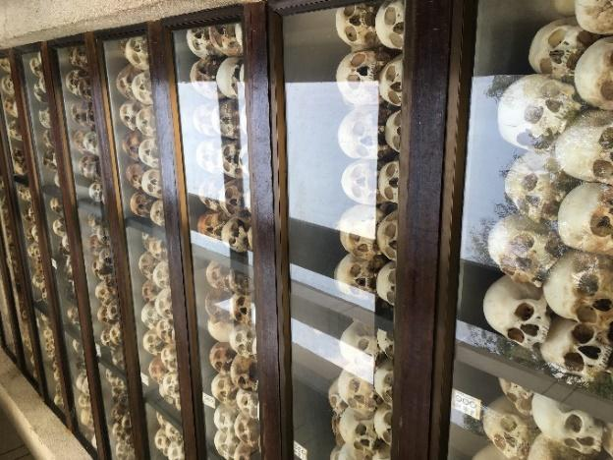
Figure 10: Interior of the Stupa :The Killing Fields (Photo by Dianne McGowan)

Conclusion
The sites I have examined throughout this study tour have complicated histories. They are located in countries that face a variety of challenges including reconciling a colonial past with a post-colonial present, struggles with political corruption and/or instability, and, in some cases, burgeoning populations and a high premium for real estate in historically significant areas.
The way that the Vietnam War is represented and commemorated in Vietnam reflects the communist perspective of national cultural pride. Prior to the era of economic reform many statues and monuments were state funded and needed to portray a particular image – promoting the uprising of the heroic soldier righting the wrongs of colonial imperialism.
“People tend to reconfigure their world as time passes.” Schwenkel (2009) p.107
The historic monuments in Cambodia represent the remains of a once thriving and powerful civilization, developed over a period of six hundred years. These temples built of either stone or brick were regarded as dwellings of the gods. These permanent masonry structures have survived remarkably well for almost one thousand years, and today constitute open books of the Khmer culture. Whilst the ancient structures tell a story of the power of the Ancient Khmer, what has happened in Cambodia’s most recent history was revealed in some of the more recent monuments and museums. The power of oral history as a historical source was exemplified though our time with Cambodian guide Sopanha Yous, a man with many stories to tell.
By visiting, exploring and examining these societies first hand I have gained new insights to share with teachers for their use across Australia. In the material I created I have focused on the historical concepts of significance, evidence, continuity and change, cause and consequence, and historical perspectives.
I hope that the resources found on the website that I have created and maintained throughout my journey will support teachers in the classroom and highlight the importance of teaching topics relating to Vietnam and Cambodia to future generations.
https://sites.google.com/lism.catholic.edu.au/2017-premiers-hta-history-scho/home
I would like to sincerely thank the HTANSW for their generous sponsorship, the NSW Government for coordinating the scholarships and the Lismore Diocese for their support. It has been both an honour and a privilege to have had the opportunity to immerse myself in the culture of Vietnam and Cambodia.

References
- https://www.phnompenhpost.com/national/analysis-surviving-khmer-rouge
- The American War in Contemporary Vietnam (2009) Transnational Remembrance and Representation, Christina Schwenkel

