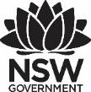
Premier’s Teachers Mutual Bank Indigenous Education Scholarship

Improving the engagement of Aboriginal and Torres Strait Islander students in TAFE NSW
  - Walking together to build cultural competence
Renee McBride
TAFE NSW
Sponsored by

Introduction
Aboriginal and Torres Strait Islander students studying in vocational education and training (VET) have the right to feel proud of their cultural identity. At TAFE NSW, we need to focus on developing learning experiences which celebrate and promote their culture. The role of teachers is to provide a culturally safe, inclusive and welcoming learning environment. Teachers are responsible for nurturing this environment through their attitudes, behaviours and cultural competence.
This study is the result of a personal passion to explore the diversity of culturally responsive strategies to engage Aboriginal and Torres Strait Islander students in the TAFE learning environment. I conducted interviews in numerous education and health settings in New South Wales, Queensland, Western Australia and the Northern Territory. Time restrictions limited this study from travelling further afield, however future plans to continue this research are being planned. Personal stories and experiences were summarised and collated into themes in this report.

Focus of Study
My research focused on the personal learning experiences of Aboriginal and Torres Strait Islander students who have previously studied, or are currently studying, in high school and TAFE. I also interviewed TAFE and University educators and mentors who work closely with Aboriginal and Torres Strait Islander students, and who develop resources for Aboriginal health and cultural qualifications. The study expanded into urban, rural and remote areas to envelop a wide collection of learning and teaching experiences, and highlights the ongoing barriers faced by different cohorts and regions.
During the course of the study, I participated in active learning through culture at the Garma festival in the Northern Territory, and attended several conferences related to Aboriginal culture, education and health. I developed collaborative relationships with local Aboriginal and Torres Strait community members, and shared the achievements and challenges facing our students. As a result, I gained insights into how the needs of Aboriginal and Torres Strait Islander students are currently being met through TAFE around Australia, and where improvements need to be addressed.

Significant Learning

Yothu Yindi Foundation Garma Festival (Northern Territory)
The 20th annual Garma was held in August 2018, where I proudly celebrated the Aboriginal culture in the theme of truth telling – Yuwalk Lakaranja. It was a privilege to engage with the local Yolngu and Arnhem Land families, and with everyone who had travelled from around Australia and overseas. I participated in cultural activities, such as a dawn crying ceremony for women only, a bush spa and massage from traditional women healers, traditional dancing (bunggul) and storytelling and explored the local country with Rangers from Yolungu and surrounding areas.
I attended the inspiring Education Forum and learned about the commitment and vision of the Elders to prioritise education and culture through the Yothu Yindi Foundation (YYF). Yolngu and non-Yolngu educators work proudly together in a two-way approach to meet the diverse needs of Aboriginal students. In partnership with the Northern Territory Department of Education, the YYF developed a program called ‘Foundational Learning’. This was created to engage secondary school-aged students and provide them opportunities to enter the workforce with appropriate skills. Their key focus areas are life skills, basic literacy and numeracy skills and job readiness skills.
Through the stories of guest speakers, I developed a deeper understanding of the importance of role modelling, kinaesthetic learning, and social and cultural connections in Aboriginal and Torres Strait Islander culture. Teachers from TAFE NSW develop strategies, which are aligned to traditional ways of Aboriginal learning, impacting on the ability of students to make connections to both learning content and their Aboriginal identities. Using these strategies meets the preferred learning preferences of this cohort, improving the ability of teachers to engage students in an authentic and genuine manner. Generations of Aboriginal families have transferred knowledge using these techniques, which is referred to as cultural intergenerational knowledge transfer. This concept was observed first hand as I watched generations of extended families share knowledge and skills to one another during cultural ceremonies, celebrations, painting and basket weaving workshops and women’s healing traditions.
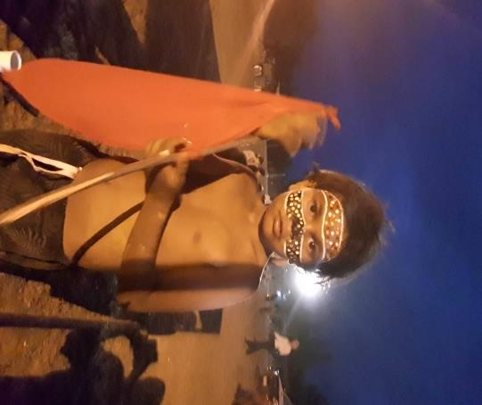
Figure 1: Bangamalanha Conference in Dubbo. Photo taken by Renee McBride

Cairns Indigenous Women’s Conference
This conference provided inspiration through the speakers who shared their experiences in education, business, politics and health care provision. Stories included the ways in which they overcame barriers to completing their education, and how they found alternative paths to the expected completion of Year 12 into university. Personal challenges to their success included racism, assumptions, lack of cultural safety, and irrelevance of Western education to their lived experience. As many speakers were actively involved in the health sector, they spoke of their cultural obligations to provide quality care, which is inclusive, safe and relevant to their community. Limited Government funding remains a common barrier to achieving this goal, however the resilience and determination of each speaker to continue to drive quality education and health care services among their communities was inspiring. Success stories revealed how they were helping to close the gap in health and education outcomes between Aboriginal and Torres Strait Islander people, and non-Indigenous people.
Implications for TAFE NSW mean that success will not be solely evidenced by increased numbers of Aboriginal and Torres Strait Islander students completing their qualifications. True success is observed in positive student feedback about the cultural competence of teachers, the culturally sensitive learning support received, and the culturally safe learning environment of TAFE NSW. These combinations build confidence among local communities to engage in future study with TAFE NSW. This positively impacts on the reputation of TAFE NSW as being a learning organisation which actively welcomes and engages Aboriginal and Torres Strait Islander students.

Women’s Teachers Federation Conference (Surry Hills)
This conference offered the opportunity to attend a workshop led by Charline Emzin-Boyd, who is the Aboriginal Education Coordinator for the NSW Teachers Federation. She spoke about how to authentically align organisational values with cultural values and embed cultural relevance into education. The importance of collaboration with community was also featured in discussions about resource development and learning activities. Participants shared their teaching stories in small groups, and developed ideas about how to improve their current practices and learning experiences with Aboriginal and Torres Strait Islander students in secondary schools and TAFE. This way of sharing enabled us to hear the diversity of demographics and cohorts, and how challenges such as minimal cultural engagement, restricted student support and insufficient engagement with local Aboriginal communities was being overcome.
The Department of Education Aboriginal Cultural Standards Framework was also reviewed to see how our organisations are meeting performance indicators such as culturally safe learning environments and teaching responsiveness. This brought to light the lack of a specific Aboriginal cultural framework that all employees could use to work with at TAFE NSW. Teachers would benefit from a clear framework to ensure an ongoing transition from cultural safety through to cultural responsiveness.

Bangamalahna Conference (Dubbo)
During this conference, we were welcomed into an environment full of the celebration of culture by local Aboriginal dancers of all ages. Dance and stories were shared during the opening of the conference at a special dinner, where local Aboriginal TAFE hospitality students cooked and served traditional foods. They were mentored by Mark Olive, a world renowned Aboriginal chef from Bundjalung, who is committed to working with TAFE students to help them achieve success in the hospitality industry.
The Maliyan Experiences is a cultural competence program being run through TAFE NSW. Tracy Goodwin, Head Teacher of Aboriginal Health Programs, and Maxine Greenfield, Senior Project Officer from TAFE NSW, spoke about how the Maliyan program aims to develop the cultural competence of whole organisations, not just individuals. The importance of community endorsement for learning resources and assessment was reinforced, to reflect the diversity of cultural needs. For learning to be contextualised, it needs to focus on the communities it is servicing, and how their educational and health needs impact on the programs being delivered.
The 8 ways of Aboriginal learning pedagogical framework was discussed at length by Allan Hall and Yvonne Hall from the Department of Education. They spoke about this way of learning was developed through stories among communities asking how the Elders used to learn. Key learning is achieved through conversation, partnerships with different people, and equal opportunities work together and focus on similarities rather than differences. The 8 ways is not officially or consistently used in TAFE teaching, as it is a relatively new pedagogy in the VET context. However, due to the inclusive nature of this approach, students from all cultures, level of study and qualifications would benefit from these teaching strategies. It can be applied in both practical and theoretical sessions, with examples including mind maps exploring new units of competence, deconstructing and reconstructing techniques exploring complex concepts, and community links offering opportunities to network with industry partners and services.
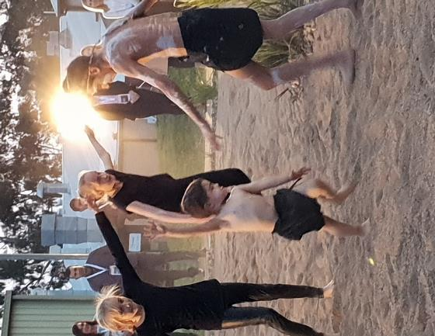
Figure 2: Local Aboriginal dancers at the opening ceremony. Photo taken by Renee McBride
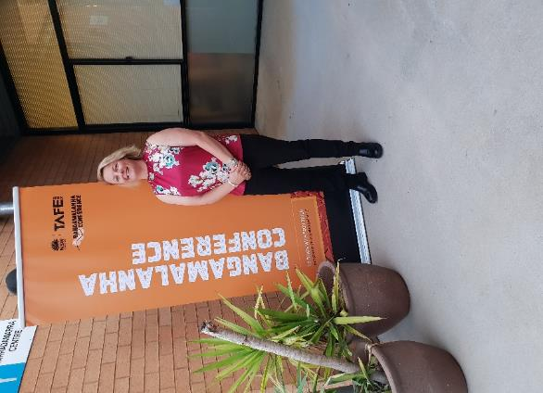
Figure 3: Bangamalanha Conference in Dubbo. Photo taken by Renee McBride

Interview findings with Aboriginal and Torres Strait Islander students
Students were interviewed from age 16 years and upwards, who had or were currently studying in health, leadership, management, and community services qualifications. The term engagement was discussed with students in relation to many concepts. These included their experiences with learning in a culturally safe environment, how effectively Aboriginal culture was embedded into their learning content and the level of cultural competence of their teachers.
There was a wide range of responses, with the majority describing positive learning experiences in all areas. Students were also asked to make suggestions for cultural activities they would like to engage in to improve their engagement with learning at secondary school and TAFE. A popular suggestion included inviting Aboriginal mentors into the classroom on a regular basis. Students stated that having someone they could relate to who was famous or successful would motivate them to learn better and stay in school and TAFE longer.
Aboriginal and Torres Strait Islander students who were interviewed described engaging and enjoyable learning with teachers who were friendly, positive, and were not afraid to speak about their culture. They explained their preference for learning activities which avoided lengthy reading and writing exercises. The majority of students shared their dislike for PowerPoint presentations and one-way lectures from the teacher. Students described small group activities, role plays, games, puzzles, and case studies as some of their preferences. Learning in an outdoor environment was also popular among students and they discussed connection to country as reasons for wanting field trips and excursions to be part of their learning in TAFE NSW. Students expressed the need to learn more about their local cultural land history and acknowledged the importance of guided learning from local Aboriginal traditional owners.

Interview findings with educators in NSW
The consensus among educators was the agreed importance of spending time getting to know students throughout the course, particularly during the first month or so. During this time, trust and rapport is developed, and students observe teachers role modelling culturally safe teaching practices, while showing genuine interest in connecting learning to their Aboriginal and Torres Strait Islander culture.
Prioritising connection to identity throughout learning experiences is a key factor in connecting with Aboriginal and Torres Strait Islander students and educators discussed numerous strategies they use to achieve this outcome. Examples include using the first lesson to build relationships among peers, using yarning circles both inside and outside the classroom environment. Many educators found that power sharing is also essential, giving students regular opportunities to share their life and cultural experiences throughout their classes.
Power balance can be reflected in the power of voice, and for students to be truly engaged with their learning, they need to be truly in control of their learning journey. Empowering students to make decisions about how they learn is evident in both the 8 ways of Aboriginal learning framework, where traditional ways of learning become a natural extension of their connection to Aboriginal culture. Additionally, students can use the power of their feedback to take control of their learning environment and learning preferences. Teachers can show timely responsiveness to student feedback and demonstrate flexibility in future teaching styles and choice of learning activities.
Educators expressed their concern about lower levels of Language, Literacy and Numeracy (LLN) skills impeding the motivation and confidence of this cohort to continue with their studies. Culturally appropriate student support was considered crucial for these students, as long as it was within a culturally safe environment and delivered by culturally competent teachers.

Interview findings with educators in North Region TAFE, WA (Broome)
Educators and student support employees discussed specific strategies currently in place to engage Aboriginal and Torres Strait Islander students in TAFE. Firstly, they generate holistic individualised learning plans for Aboriginal and Torres Strait Islander students, collaboratively identifying their holistic needs. Pastoral support provided to students considered cultural, family, community, housing, transport, psychological, and employment needs.
Once these needs were identified, a well-being plan is created, which links students directly to a wide range of culturally safe services to meet their individual needs. All teachers were educated about appropriate services, and a portfolio is available for TAFE staff to refer students to services. In addition, interagency staff are invited regularly into the classroom to interact with students, and provide education about topics such as sexual health, healthy eating, drug and alcohol harm minimisation, and activities for improving mental health and stress. This resulted in increased student retention and completion, and higher satisfaction levels among students.
Cultural awareness training is paramount in this region, as there are so many Aboriginal languages, customs and protocols to be aware of. Consultation with Aboriginal staff when travelling into communities is compulsory, as they mentor both Aboriginal and Torres Strait Islander and non-Indigenous staff to ensure cultural safety.

Interview findings with educators in Queensland
Qualifications in the Aboriginal and Torres Strait Islander Primary Health Care are among the most popular health-related courses provided by Queensland TAFE. Christine Cutts and Julia Meredith, Indigenous primary health teachers from TAFE North, generously shared successful strategies for improving the engagement of Aboriginal and Torres Strait Islander TAFE students. They concentrate on building the capacity of remote communities in Queensland, Thursday Island and surrounding areas by generating qualified primary health workers and practitioners, who are able to educate and treat their own people. This results in a collective community impact where the meaningful development of health-related knowledge and skills becomes shared among local communities, improving the health and education of their mobs. The engagement of students in these qualifications has led to an exponential increase in enrolments into health practitioner TAFE courses.
The needs of the community take precedence over the needs of TAFE, and teaching staff are highly supportive of cultural commitments which affect attendance. Examples include sorry business, caring responsibilities for family members, employment commitments and crisis management. Effective communication ensures students are genuinely supported through these times, with flexible arrangements made to ensure they achieve their educational expectations.
Culturally safe and respectful techniques, which are endorsed by local Indigenous community members are used for communicating with Aboriginal and Torres Strait Islander students. Their endorsement of culturally appropriate learning resources is also imperative, as breaching local cultural protocols and values creates barriers to student engagement and may result in students leaving their studies.

Interview findings with educators and health care providers in the Northern Territory
Implementation of the reversal of traditional teacher versus student power provides opportunities for students to be recognised as cultural experts. Group work is an example of a successful teaching strategy. Student-led projects develop initiative and innovation in a social enterprise model. While projects are aligned to mainstream curriculum and outcomes, students can also be guided to reflect, plan and direct their own learning. Students develop leadership capabilities, and by using a collaborative approach they create a collective impact.
There is a clear link between relationships and teaching skills. The way in which teachers react and respond in the classroom has a direct effect on the learning of Aboriginal and Torres Strait Islander students. High expectations must drive the quality of learning Aboriginal and Torres Strait Islander students’ experience. Teachers need to maintain the value of student voices and create opportunities for them to share their stories regularly.
Genuine community involvement enables culturally safe contextualisation, and the continuation of traditional culture within education. Key stakeholders and students are collaborating to co-construct lessons, using prior learning to make sense of content. Students authentically engage with local cultural protocols and values, build new relationships among community members and students, and are given opportunities to proudly share their own knowledge and experience.

Themes of successful strategies to engage Aboriginal and Torres Strait Islander students in TAFE

Create genuine partnerships with local Aboriginal community members and services specific to the industry being studied at TAFE.
Teach through Aboriginal culture, not about it. Aboriginal language and culture are not icons. Focus on lived experiences and the skills of students to guide learning resource development.
Develop a community profile for teaching teams which includes information about local demographics, populations, language groups and traditional owners.
Regularly self-reflect on teaching practice to continuously improve engagement. Examine personal assumptions, beliefs and world views.
Ask for regular feedback from students throughout the course and be culturally responsive to the diverse needs of Aboriginal and Torres Strait Islander students.
Locally contextualise teaching resources and assessments to improve relevance of learning to Aboriginal and Torres Strait Islander students.
Use a two-way teaching approach for cultural safety, and simultaneous sharing of experiences, world views and perspectives
Engage Aboriginal mentors to improve cultural support, reduce shame of learning levels, and for early identification of student support.
Use Aboriginal pedagogical frameworks, such as the 8 ways of learning, to meet culturally appropriate learning preferences
Consult with local Aboriginal people and services to ensure cultural protocols are met when teaching through culture and language.
Be open to teaching alternative cultural approaches, such as traditional Aboriginal pedagogy, two-way teaching and learning on country.
Create a yarning circle inside your classroom for a safe and supportive space to share and explore experiences and reflections and provide feedback. Ensure conversations between students and teachers are equal.
Employ an Aboriginal and Torres Strait Islander mentor to ensure culturally appropriate support students throughout their whole learning journey at TAFE.
Build capacity of Aboriginal and Torres Strait Islander students through ongoing tutorial and LLN support at all ages and levels of learning.
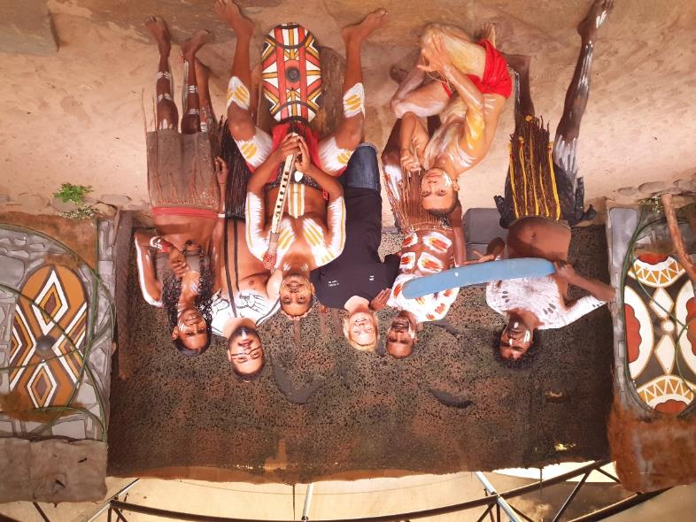
Figure 5: Cultural activities with the Cairns Tjapukai Cultural Park mob. Photo taken by Renee McBride

Conclusion
Aboriginal and Torres Strait Islander students deserve quality education which is culturally relevant and delivered by culturally competent teachers. They have an inherent right to sit in classrooms and be surrounded by their culture through education. These students need to feel safe to be allowed to celebrate their identities as Aboriginal and Torres Strait Islander people and learn both Western and cultural ways. Empowering Aboriginal and Torres Strait Islander students in TAFE to drive their educational agenda strengthens their identity and connection to learning content. Designing and implementing their learning pathway helps to close the ongoing educational gaps that continue to challenge their potential. Safe and culturally sensitive learning environments are key to maintaining engagement with Aboriginal students, while we continue to teach through Western educational models in TAFE NSW. Recommendations for future practice include:
- compulsory cultural competency training for all TAFE NSW teachers which is contextualised to meet local Aboriginal cultural protocols
- regular collaboration with local Aboriginal and Torres Strait Islander industry services
- development of culturally appropriate Individual Learning Plans, incorporating holistic interagency portfolios for teaching staff
- development of an Aboriginal Cultural Competency Framework for TAFE NSW which is endorsed by the TAFE NSW Aboriginal Community Engagement Coordinator team
- increased recruitment of Aboriginal teachers and mentors in TAFE NSW
- two-way teaching to provide an assimilated approach and new perspectives
- training TAFE NSW teachers to authentically embed the 8 ways pedagogy into their learning activities
- commitment from TAFE NSW to actively seek regular student feedback from Aboriginal and Torres Strait Islander students in all courses
- publish student feedback on TAFE NSW Intranet to maintain open and transparent communication and remain culturally responsive .
Implementation of these approaches may lead to a more consistent and strengthened approach to engage Aboriginal and Torres Strait Islander students in TAFE NSW and provide learning which is culturally relevant and meaningful.

