Premier’s Copyright Agency Creativity Across the Curriculum Scholarship

Transdisciplinary Practice
  - Polymathic studies through the visual arts and science
Alana Lewis
Asquith Girls High School
Sponsored by
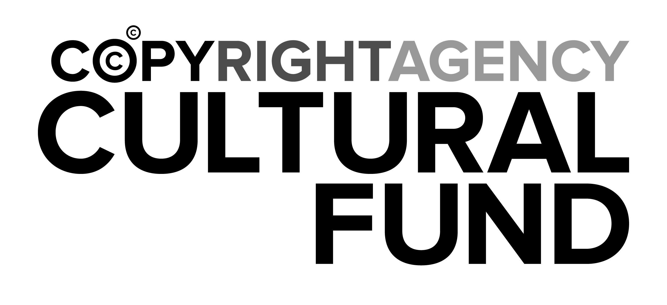

Introduction
Visual arts teachers across the country and indeed the world have been discussing the growing disconnect between the arts and their academic neighbours. I have often questioned the reasons behind it and how this disconnect detrimentally affects student learning and post school opportunities. My research focuses on creative collaborations between subjects such as the visual arts and sciences looking specifically at Transdisciplinary practices and Polymathicism as a means of developing a student’s own ability to amalgamate a variety of practical skills and subject specific knowledge to enhance their understanding of creativity and innovative practice.
Although the Science, Technology, Engineering and Mathematics (STEM) initiative has put a global spotlight on the need for multidisciplinary practice for 21st century learners, it is exclusive in its very nature. To exclude subjects, themes and topics can only hinder or limit the spectrum of what is possible in education.
As we educate students for jobs that may not even exist yet, and we see how quickly technology and information becomes obsolete, it would suggest that the content of our courses can only ever be of a foundational nature, so the focus must therefore be on teaching students HOW to think more than WHAT to think. We must assist them in developing a toolkit of transdisciplinary practices and skill sets, unhindered by divisive labels and acronyms. In short, we must create a generation of postmodern polymaths who embrace and value education in all fields.

Focus of Study
Stemming from the Renaissance principles of the polymath, transdisciplinary practice seeks to develop a curriculum convergence to better understand the world around us. By examining the amalgamation of practices, this study focuses on skill and knowledge cross-overs and future careers in creative industries> It also aims to broaden the understanding of best practice when educating students to develop autonomous creative thoughts through transdisciplinary approaches.
This research looks specifically at collaborations between artists and scientists and analyses the effectiveness and importance of imbedding transdisciplinary practice into school curriculums.
The study considered a range of questions such as:
- what is a postmodern polymath, and how do we use subjects such as the visual arts as a polymathic learning platform
- what is the purpose and benefits of collaboration between subjects like science and the visual arts
- what will employment look like for students in the future and what kind of adaptable skillsets will they need
- how do we develop creative thinking and innovative practice through transdisciplinary practices in the classroom
- how do we avoid learning in silos and develop value for transdisciplinary education?

Significant Learning
The scholarship tour was undertaken in Perth Western Australia, Singapore, London and Edinburgh with artists, industry experts and academics in the fields of scientific research and/or the arts. The research was conducted in colleges, institutions, universities, galleries, museums and laboratories.

Tertiary Transdisciplinary Training (the future of higher education)
The University of Western Australia is home to one of the most unique transdisciplinary learning facilities in the world, SymbioticA. SymbioticA is a Biological Arts research laboratory run by renowned, award winning artists and academics, Oron Catts and Ionat Zurr. The facility is situated in the anatomy, physiology and human biology building and runs undergraduate elective units such as the Aesthetic Crossovers of Art and Science and Art and Life Manipulation. It also runs Postgraduate Masters and PHD research programs. SymbioticA allows artists and researchers to develop skills in wet biological practices and encourages further research and questioning into cultural and ethical issues surrounding the manipulation of life and Neolifism. It is a place where so many subjects collide, philosophy, art, biology, psychology, technology, sociology and more. If Leonardo Da Vinci were alive today, he would want to be here. During my visit I held discussions with students, academics and lecturers and discovered a broad range of skill sets and knowledge bases that were being used in the fields of academia, research, personal artmaking practice and varying vocational applications. The visit inspired a deeper understanding of the possibilities and opportunities of transdisciplinary practices within both tertiary and secondary education than initially expected. http://www.symbiotica.uwa.edu.au/
Oron Catts and Ionat Zurr have become well known for their pioneering work in the biological arts. Their unorthodox material practice through the manipulation of cells and carbon-based life forms, kept alive by artificial support machines, are reminiscent of Mary Shelly’s Frankenstein. Catts and Zurr have sensationally captivated the minds of artists, academics and researchers alike with their work on Semi-living worry dolls, Disembodied cuisine – semi-living steak, and Victimless leather. Also working in collaboration with Australian artist Stellarc, Catts and Zurr helped create tissue for Stelarc’s replica ear using human and animal cells. These artists create works that test out ethical values and encourage us to debate our ability and sensibilities when manipulating living systems. http://lab.anhb.uwa.edu.au/tca/
Not only does the University of Western Australia house one of the world’s only academic biological arts research labs, it also incorporates broadening units for undergraduate courses. As a requirement, students must take at least two units of study which are offered in other degrees that are outside of their areas of expertise. The reasoning behind this new pedagogical practice is a result of a push from employer groups and professional associations who demand that graduates be prepared for the changing world and that students must learn to be adaptable in a new work environment. With vast combinations of courses and units, students develop their understanding in multiple fields. As a result, students find connections between the different academic fields and can integrate their skills and knowledge, finding deeper purpose and direction, expanding their networks and creating new pathways for post-school and vocational opportunities. http://handbooks.uwa.edu.au/undergraduate/broadening

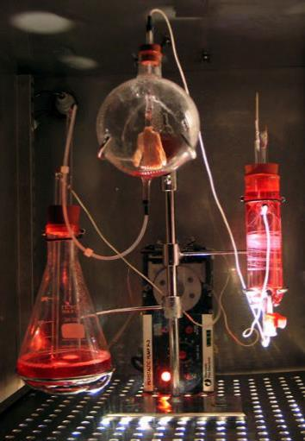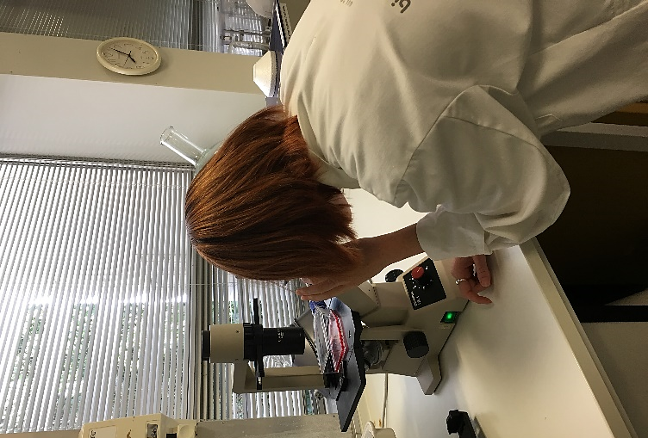
Figure 1: Tissue Culture and Art Project, Victimless Leather, 2004 Photo: Ionat Zurr and Oron Catts

Figure 2: SymbioticA student completing Microscopy research. 2018 Photo: Alana Lewis

Professional pathways (Changing nature of careers)
Academic, Lee Scott, (Leader in creative computing at Bath Spa University England) has discussed the importance of the 21st century polymath. He believes that academics will not become masters of subjects but an adaptable sage across various fields of learning. Scott states: for new economies to emerge, and breakthroughs to be made, we need multi-specialised lateral thinkers who can connect the dots in unexpected ways. We need contemporary Leonardos. We need 21st century polymaths (2018). His full article can be read on the link below.
https://theconversation.com/why-the-renaissance-man-and-woman-is-making-a-comeback-55603
The way we educate students in academic silos to a direct singular vocational path is not equipping them for the future. It is believed that millennials could have on average up to 11 different careers and that these roles will vary in the knowledge and skills required.
The true goal of education should be providing students with a toolbox of skill sets that they can manipulate and augment to have a fulfilling life in whatever careers they may choose to have. We are stuck in the past of discussing careers such as doctor, lawyer, banker, and while these jobs are important, we are limiting their potential by being narrow in our definition of vocation.
There are more and more transdisciplinary careers emerging such as photogrammetry, molecular animation and visual computing and subsequently it is becoming more important to teach students to develop their transdisciplinary practice and to value imagination, creativity, positive risk-taking, resilience and adaptability.

Edinburgh International Science Festival
Whilst the name suggests that this festival is all about science, it was actually one of the most significant festivals to showcase and promote transdisciplinary practice in action. The festival has an ingrained system of delivering educational programs to schools and communities, for people of all ages, interests, abilities and occupations. There were a multitude of activities, lectures, exhibitions and workshops from a variety of experts from around the world. Artists, engineers, chefs, musicians, geneticists, biologists, psychologists and mathematicians just to name a few, all under the one roof at Summerhall presenting their research on Life, the universe and everything, which was the 2018 festival theme.
During my visit I attended a talk by and was lucky enough to meet , Dr Allan McRobie, a structural engineer and lecturer at Cambridge University and author of The Seduction of Curves. In his talk McRobie discussed links between the human form and complex mathematical theories such as the stability and catastrophe theories. He demonstrated how undertaking life drawing classes with nude models improved the understanding of symmetry and forms such as cusps, folds and the swallowtail. By linking mathematical theories with art, engineering students had a much better understanding of the application of these theories in connection with the physical world around them. This can go on to influencing key concepts in structural and architectural design for bridges and buildings, and in the field of cosmology in gravitational lenses and the biological understanding of morphogenesis. In fact, multiple career opportunities can be influenced by the understanding and manipulation of this concept. McRobie does not claim these as his own original ideas but credits it as an extension of past research of topology expert Rene Thom and from the works of artists Salvador Dali and Naum Gabo.
It is the combination of skills sets, creativity and knowledge that spark ideas and concepts which help creative people develop new technologies and theoretical understandings that have far reaching effects in multiple fields of study and for applications in the real-world environment.
This is where I discovered the true connection between every subject taught in the education system. It is LIFE. No matter what we are teaching, we are educating students about our human experience of life and our interactions with the world. STEM/STEAM explores the ideas of marketable transdisciplinary practice within a professional setting with its focus very much on entrepreneurial principles and design thinking. However, it takes more than just the economic market to sustain and develop the future and culture of our communities.

Community Collaboration (Transdisciplinary practice in action)
Community links and cultural investment was high on the agenda for all the people and institutions I visited on tour.
During my visit to London I attended the Cambridge University Science festival where I participated in a workshop delivered by the Neural Knitworks team. Neural knitworks was co-founded by Australian artist Pat Pillai and is a community-based initiative that creates installation events based around the neuroscience of the brain and brain health. Participants knit, crochet or wrap woollen neurons to add to the art installation while listening to a series of talks by doctors, psychologists, researchers and mental health experts. The neural knitworks team travel both nationally and internationally delivering these workshops within the community. It is a fun and informative way of discussing the inner workings of the brain and the links to mental health. Participants are getting valuable information and participating in a hands-on communal group activity. It also provides much needed information and access for people who require assistance.
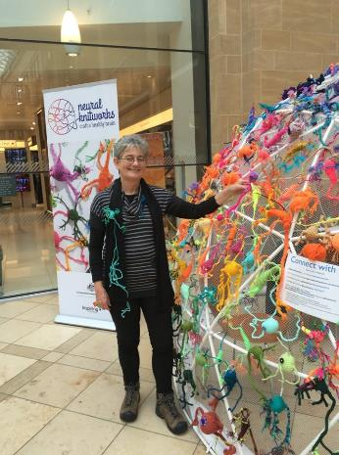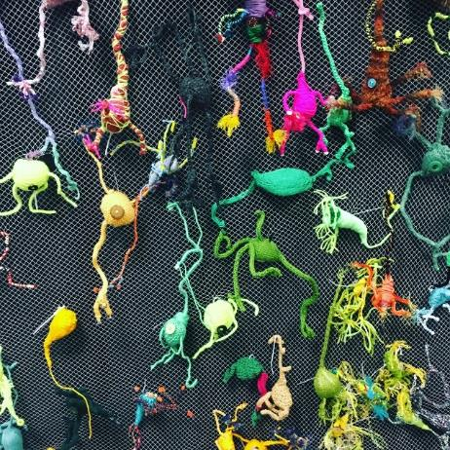
Figure 3: Pat Pillai, Artist and Co-founder of Neural Knitworks with Cambridge Science festival installation
Figure 4: Knitted neuron wall Cambridge Science festival. Photo Alana Lewis

A substantial period of the tour was spent completing an exploratory visit with Dr James Howie, director of ASCUS Labs, a transdisciplinary community initiative in Edinburgh. This is a non-profit organisation that dedicates time and resources to develop opportunities for all members of the community to have collaborative learning experiences through art and science. http://www.ascus.org.uk/
Throughout my visit to ASCUS Labs I had access to the Biosafety Level 1 Wet Lab and participated in a series of workshops, learning skills in microscopy, microbiology, DNA analysis and genetic modification. As an artist, I have never had access to the equipment and resources required for these types of activities. ASCUS Labs are the centre of a large network of artists, scientists and academics and provide the physical environment for unique transdisciplinary collaborations.
Many people question why artists would need to understand these processes for the sole purpose of making art, however, art is no longer bound by traditional mediums and/or subject matter. In fact, it is often the role of the artist to create works that question the world and spark cultural and ethical conversation and debate. ASCUS Labs gives artists and researchers the opportunity to look at the world from another perspective and gives skills that can be used in their practice. Artists like Oron Catts, Ionat Zurr, Stellarc, Suzanne Anker, Anna Dimitriu, Heather Barnett, Ting Tong Chang, Marta De Menezes and Maria Fernada Cardoso are incredible examples of this. I was fortunate enough during my travels to meet with four of these artists, Oron Catts, Ionat Zurr, Ting-Tong Chang and Marta de Menezes who had works exhibited in the Synthetica exhibition in collaboration with ASCUS Labs and the Edinburgh Science Festival in Summerhall.
At ASCUS, my workshop experiences included Capturing the Chromosome, Model Organisms and Making Mutants, Our Nano World, and The Heart Inside and Out.
What I noticed in these talks and workshops was the broad experience and motivations of the people attending. The ages varied from teens to the elderly and from school students to professional artists, microbiologists, chemists, teachers, physicists, engineers, mental health practitioners and the public who simply had an interest in science and/or art. Each person developed the same skills for different purposes, so they could merge them into their own transdisciplinary toolbox.

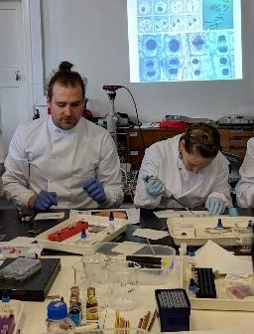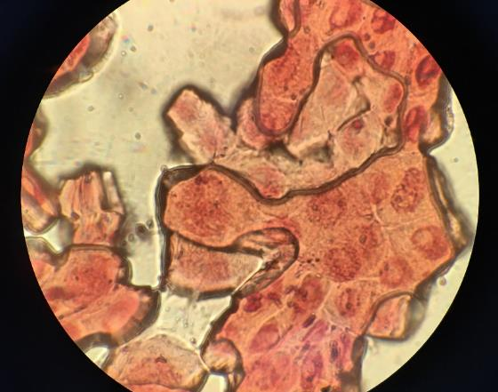
Figure 5: Dr James Howie, Director of ASCUS Labs and Alana Lewis during workshop Photo by ASCUS Labs
Figure 6: Cells under the microscope. Photo Alana Lewis

Cultural connections (Galleries and Museums)
It seems that there has also been a push for commercial galleries to join the STEM/STEAM trend. It does make you question the richness of the cultural experience that galleries are supposed to embody. For decades, galleries and museums have been the catalyst for bringing together exemplary artifacts and objects of cultural significance that both confirm and challenge our understanding of the world around us.
The ArtScience Museum, Singapore is an interesting look at an artificial world of interaction with technology through immersion in digital fantasy and augmented reality. While pitched to a younger audience, the exhibits within the ArtScience Museum are a delight on the senses. The exhibits include light, sound and imagery in 2D, 3D and 4D forms. It creates an imaginative environment for play and experimentation. However, the question remains if the experience is at all culturally valid or just commercial entertainment under the guise of the arts. As a part of the STEM/ STEAM involvement, the gift shop will also 3D print or laser cut your souvenirs while you wait.
It appears the arts needs to be wary of infiltration of design thinking for corporate enterprises and big business. This is where STEM and the arts truly separate and why it is important that we look at more than just a business model when educating students to become the future thinkers and leaders of our cultural communities.

Conclusion
The economic and vocational sectors of our global community are changing rapidly. Expectations on educational institutions are evolving from both the societal and commercial perspectives. Students need to be better equipped to face challenges in the future. Though, it is important to understand that we do not just educate students for tertiary studies or career opportunities, we educate them to become young leaders within our communities who will uphold our cultural and ethical beliefs for the betterment of our society. Teaching students to be adaptable, resilient, life-long learners who can use transdisciplinary skills sets to innovate and augment opportunities as they see fit is the key to success. What we want is a generation of postmodern polymaths who value education and have a positive attitude rather than a generation of failure fearers and fixed mindsets who place more worth on grades than knowledge.
Initiatives such as ASCUS Labs and Neural Knitworks are examples of not-for-profit organisations helping to educate our communities through transdisciplinary practice. Artists like Oron Catts and Ionat Zurr are creating new forms of art that challenge us and create discussions and ethical debates on our understanding of life manipulation and neolifism through transdisciplinary practices. SymbioticA and the University of Western Australia are leading the way in transdisciplinary education through broadening courses and unexpected combinations of skills and vocational opportunities thorough tertiary research and academia. All of these amazing people, initiatives and institutions have one thing in common. They are developing a strong cultural understanding of the human experience of life using transdisciplinary practices, placing value on knowledge and skills and on working collaboratively for the betterment of our world and the people within it.
This scholarship tour has already begun to impact student outcomes through the creation and implementation of new teaching and learning programs entitled “Authentic Learning” for Stage 5. The development of which has been based on the understanding of broadening courses whereby students learn key skills and knowledge from a range of subjects such as maths, science, ICT, geography and the visual arts. Students are required to use these skills to complete tasks that have real life benefits which demonstrates how skills from different key learning areas can be used for a common purpose and reinforces the value of each and every subject.
Dissemination of my research has already begun with two conferences in rural and metropolitan areas. I discussed my first paper on Polymathic Education at the annual Visual Arts & Design Education Association (VADEA) conference, held at the Bundanon Trust near Nowra in May 2018, and again at the VADEA Indulge & Inspire STEAM conference, hosted by Pymble Ladies College in June. With several journal articles and a website in the making, my research on Polymathic Education through transdisciplinary practice will hopefully continue to question the validity of STEM/STEAM on the cultural context of educating students though a business model of design thinking and urge educators to look at developing a transdisciplinary tool box that is effective and adaptable and will enhance student accomplishment.

References
- Catts, O. and Zurr, I. (2018). SymbioticA : The University of Western Australia. [online] Symbiotica.uwa.edu.au. Available at: http://www.symbiotica.uwa.edu.au/ [Accessed 17 Mar. 2018].

- Catts, O. and Zurr, I. (2018). The Tissue Culture and Art Projects. [online] Lab.anhb.edu.au. Available at: http://lab.anhb.uwa.edu.au/tca/ [Accessed 17 Mar. 2018].

- Handbooks.uwz.edu.au. (2018). Broadening requirements : UWA Handbook 2018 : The University of Western Australia. [online] Available at: http://handbooks.uwa.edu.au/undergraduate/broadening [Accessed 17 Mar. 2018].

- Scott, L. (2018). Why the Renaissance man-and woman- is making a comeback. [online] The Conversation. Available at https://theconversation.com/why-the-renaissance-man-and-woman-is-making-a-comeback-55603 [Accessed 12 Jul. 2018].
- Howie, J. (2018). ASCUS Lab – ASCUS. [online]ASCUS. Available at http://www.ascus.org.uk/ascus-lab/ [Accessed 2 Apr. 2018].

