Premier’s Anika Foundation Youth Depression Awareness Scholarship

Mediating the role of childhood traumatic stress in the development of youth depression by studying the implementation of whole-school reparative and resilience projects.
Author
Deborah A. Costa
Cessnock West Public School

Sponsored by
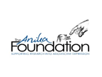

Introduction

This project’s purpose was to enhance understanding of the provision of evidence-based in-school programs and practices targeting traumatised students’ mental health needs, notably youth depression. Schools are recognised as ideal entry points to enhance student access to mental health services because they are places where students spend considerable time across their developmental spectrum, learning about themselves and their world; ideal places to promote, support, prevent and intervene with students’ mental health, emotional and wellbeing needs.

Two school-based models internationally recognised for their contribution towards helping attenuate the deleterious effects of early life traumatic stress and supporting students’ positive adaption to life stress were examined. Both programs, one a direct clinical intervention approach (CBITS), and the other a whole of school social-emotional teaching and learning practice approach (ECiES), are being successfully implemented, sustained and upscaled within school systems in the USA and the UK.
This study tour incorporated visits to universities, schools, school district offices, collaborative partnerships and community and government agencies. In meeting with a broad range and number of key people directly linked to the design, dissemination, consultation and implementation support of evidence-based practices for addressing the mental health needs of traumatised students in schools, key issues were explored:
- provision of targeted, therapeutic evidence-based interventions – Cognitive Behaviour Intervention for Trauma in Schools (CBITS)
- provision of whole-school professional practice teaching and learning approach - Emotion Coaching in Education Settings (ECiES)
- creating Safe and Supportive Learning Environments.

Focus of Study

The focus of this study tour was on researching international, within-school approaches and practices for addressing the mental health, emotional and wellbeing needs of students impacted by childhood traumatic stress. Two evidence-based practice approaches for traumatised students experiencing depression, or at risk of depression and other comorbid mental health conditions, were the focus of this study tour. One, a targeted therapeutic program aimed at improving students’ psychological distress symptoms relating to traumatic experiences, increasing school based functioning and enhancing skills to cope with future stresses. Two, a school-wide professional practice approach that supports educators to understand and regulate students’ emotional and physiological experiences by developing capacity to attune to these experiences, respond openly and empathically to deescalate difficult situations, and encourage reflection and problem solving capacity relationally.
The broad focus has been to study whole-school framework and targeted practice approaches, and understand the process of implementing and supporting these whole-school and targeted practices for use in NSW schools. These overseas school initiatives are designed to attenuate the deleterious effects of early life traumatic stress (depression), support students’ positive adaptation to life stress (resilience) and positively contribute to the learning and well-being of traumatised students and their educators.

Significant Learning

Provision of targeted, therapeutic evidence-based interventions
Across the United States, since 1999, a targeted, therapeutic program for supporting the mental health needs of traumatised students in schools and reducing the rates of depression and Post Traumatic Stress Disorder (PTSD) rates has been successfully disseminated, sustained and upscaled. CBITS is a school-based intervention to support students (5th to 12th grade) who have witnessed or experienced traumatic life events such as community and school violence, accidents and injuries, physical abuse and domestic violence and natural and man-made disasters.

CBITS is intended to be delivered as a tier two or tier three intervention specifically for students with identified symptoms of psychological distress. Through 10 group sessions, an individual session and parent and teacher psychoeducational sessions CBITS aims to:

- reduce symptoms of trauma induced depression, PTSD and anxiety
- develop coping skills and resilience
- increase peer, parent and teacher understanding and support.

CBITS’ theoretical underpinnings are based on cognitive-behavioural theory and the link between traumatic life events and impairment (psychological reactions, behavioural problems and functional impairment). This impairment leads to long-term problems including PTSD, depression, violent behaviour and substance abuse. CBITS addresses the risk factors for developing chronic disturbances following trauma including poor coping skills, cognitive factors and low levels of social support.

Symptom reduction is accomplished through cognitive behaviour therapy practices, reducing maladaptive thinking that can drive depressive and anxious moods, reducing anxiety through relaxation training and behaviour therapy, and processing traumatic experiences to reduce anxiety and traumatic grief. CBITS develops students’ present and future oriented skills for coping, problem solving and decision making (communication, social skills, self-care, self-regulation, cognitive flexibility) and student support networks (peer, parent and teacher). Thus, CBITS provides an answer to reducing clinical symptoms of depression, PTSD and anxiety for traumatised students within the natural, supportive setting of their school.

CBITS is now being recognised as a sustainable practice for systematic and systemic implementation across the US, with two different modes of implementation available and effective:

- as an individual, stand-alone intervention where there are not yet systematic trauma-informed supports in place – with this approach, CBITS becomes a way to inform the school system; support learning about trauma and trauma informed practice, and demonstrate the effectiveness of supporting traumatised students
- as part of a tiered system of trauma-informed supports and interventions – a continuum of trauma-informed care model.

Whilst the focus of this study was on researching one within-school evidence-based practice for targeted therapeutic group implementation, during my study I learned of the suite of evidence-based practices available within the CBITS ‘collection’ designed to be implemented in schools. This CBITS ‘collection’ offers schools a menu of evidence-based practices to provide traumatised students struggling with depression, or at risk of depression, to be able to reduce symptoms of depression, PTSD and behavioural problems, and improve general functioning, grades, attendance, peer and parent support and coping skills.

Having a menu of evidence-based practices gives schools flexibility to choose the interventions most appropriate for their students and their setting. This CBITS ‘collection’ is below (TSA, 2018).
- CBITS – Cognitive Behaviour Intervention for Trauma in Schools – a standardised series of 10 group therapeutic sessions for students from 5th through to 12th grade.
- CBITS – low literacy version - an adaptation for students with low levels of literacy.
- SSET – Support for Students Exposed to Trauma – a non-clinical adaptation of CBITS for use by non-clinical school staff.
- LIFT – Life Improvement for Teens – web-based stress and trauma curriculum for teens that can be a companion for CBITS and SSET. It is designed to extend and augment learning with a different modality that is fun and interactive.
- Bounce Back (baby CBITS) – an adaptation of CBITS for children in grades kindergarten through 5th Grade.

NSW schools have the ability and capacity to coordinate and implement small group based ‘treatments’ targeted to meet the learning and wellbeing needs of their students. The co-ordination of these supports is through the school’s learning and support structure and system of supports for students with identified need. Having specific programs ready to refer students to as part of the system of targeted supports enables schools to systematically address the identified needs of their students.

Currently, many students with wellbeing and mental health support needs stemming from challenging behaviours within the context of traumatic experiences are unsupported, managed reactively or supported utilising Student Learning and Support Officers on an individual basis in classrooms and playgrounds. This approach is not sustainable long term and is not evidence based. Whilst traditionally schools have known what programs or approaches to implement for identified students requiring targeted literacy and/or numeracy support, targeting the support needs of students with wellbeing and mental health needs is less known but equally necessary. The NSW Department of Education’s Wellbeing Framework and new strategic direction that ‘every student is known, valued and cared for’ recognises the inextricable link between wellbeing and learning in the context of schooling.

These CBITS school-based programs are tier2/tier 3 interventions for students with levels of psychological distress resulting from traumatic experiences and impacting on the students’ learning and wellbeing within the school setting. Given the worldwide statistic of one in four students being impacted by traumatic experiences enough to impact their learning and behaviour it is crucial for schools to be set up to support their needs with evidence-based approaches that offer targeted support and achieve improved outcomes. In my work as a District School Counsellor within a vulnerable community I witness a remarkable level of need for addressing essential wellbeing and mental health factors with the students, and a greater than one in four presence of students impacted by traumatic experiences. Supporting these students with their needs utilising evidence based programs requires a planned,coordinated, systematic approach.

Image1:
demonstration by En Iwamura at NCECA(from left) Diana Perry, Project Manager CBITS, Deborah Costa Bethany Zorba, Manager Department of Children and Family meeting at the Child and Health Development Institute, Connecticut, New York (Photo: Deb Costa)

Provision of whole-school professional practice teaching and learning approach - Emotion Coaching in Education Settings
Emotion Coaching is a way of helping children to understand and manage the different emotions they experience; initially observed as a parenting approach in the 1970s by US psychologist Dr John Gottman. Emotion coached children demonstrate better capacity to control their impulsesand delay gratification, self soothe when upset, greater attentional capacity and increased motivation, perform better academically and are better able to function in social relationships.

Within the UK researchers in childhood education (Emotion Coaching UK) have developed and rolled out a school specific program of Emotion Coaching (Emotion Coaching in Education Settings) using four core steps of Emotion Coaching, set out below. Broadly, Emotion Coaching as a developed practice in education settings guides educators’ functioning as safe, attuned adults to support students in developing emotional resilience, self-regulation, empathy and problem solving (Rose et al, 2015). Educators, through daily student-teacher interactions support their students to understand and regulate their physiological and emotional experiences and develop effective coping and behavioral responses. During heightened emotional experiences, students are first connected to and supported to calm and then coached to help cope, learn and problem solve.

Emotion Coaching in Education Settings (Emotion Coaching UK) is a prominent piece of the UK’s Melksham 0-19 Emotional Resiliency Project, and the Attachment Aware Schools Project focusing on improving the educational outcomes and wellbeing of students in care and other vulnerable students, as well as promoting positive mental health and well-being. Emotion Coaching in Education Settings’ usefulness with traumatised students is in facilitating emotional attunement within the teacher-student relationship, buffering of stressful experiences within a safe relationship and promoting long-term solutions to resilience through relationship and skill development.

Emotion Coaching in Education Settings (Emotion Coaching UK) encourages the process of emotional and behavioural regulation and builds attuned relational connections through:

- recognising the student’s feelings through attuning to and empathising with them
- validating and labelling the emotion the student is feeling in the moment to facilitate relational connection and a return to calm
- setting the limits on behaviour to teach and encourage reflection (if necessary)
- problem solving with the student to empower and teach.

As a professional teaching and learning practice approach (Gilbert, 2018) its value lies in the potential to:

Support students as individuals and learners

- help students develop increased awareness of their emotions and manage these feelings effectively through recognising and validating their emotional experiences, setting limits where appropriate and problem-solving with the student to develop effective behavioural strategies
- help students to feel calmer because they feel connected, heard and attuned to and supported with their difficulties
- help students regulate, improve and take ownership of their behaviour
- help students to think about issues affecting them and empowers them to problem solve rather than being told what to do.

Support teachers as professionals

- educators become better able to understand, connect with and develop within student’s self-awareness and self-regulation through regular interactions
- enhances educators’ understanding of students’ emotional and mental health needs through training that provides knowledge of physiology of emotions, emotional regulation, mental health, stress response system physiology, attachment awareness
- engages with the adult’s beliefs, attitudes, awareness, expression and regulation of emotion, as well as their reactions to pupils’ expressions of emotions; addressing unhelpful mindsets about emotions and behaviours
- improves staff empathy and patience in taking the perspective of the student, rather than dismissing of students’ behaviour.

Promote student-teacher relationships

- as a relational approach it is essentially an empathic and dialogic process which enables students to feel acknowledged, validated and safe to explore and regulate their emotions and reflect with others (safe adults)
- a co-regulatory soothing narrative and process to translate, understand, soothe, validate with the child’s emotional state – not condoning the behavior but empathising with the emotion to regulate and connect
- facilitate openness between teachers and students to talk about their emotional and mental health.

Benefit the whole school environment
- develop a culture of openness around students’ emotional and mental health needs and support healthy emotional expression and prosocial responses to reduce negative mental-health outcomes;
- create an ethos of positive learning behaviour and teacher confidence to deescalate situations when behaviour is challenging, creating opportunities for longer-term solutions to children’s mental health and well-being;
- provide a consistent approach and a clear structure for managing behaviours and situations that are emotionally intense, including de-escalation before a crisis occurs.

Training NSW school personnel (classroom practitioners and executive) in Emotion Coaching in Education Settings will give them the knowledge, insight and skills to recognise and understand the underlying emotional and physiological experiences of students displaying challenging behaviours and/or experiencing heightened levels of distress. It is this ability to recognise and understand the students’ experience that leads to an adult response in the moment that can safely address the issue for the student and for the school. Emotion Coaching in Education Settings supports the student to feel heard and calm down, and then supports the student and the school through addressing the limit setting where necessary and the reflective practice and problem solving, essential in supporting students in developing their capacity to self-regulate.
Predominantly, in schools the focus is on the students’ observable behaviours, which can tend to be addressed via a dismissive and/or disciplinary approach; ineffectively resolving it for the student, and ultimately the school. This focus on the observable behaviours of students displaying challenging behaviours and/or experiencing heightened levels of distress in the moment is at the expense of understanding where the student is at and what the students needs to calm down and for the issue to be addressed. Intervening based on observable behaviours can be dismissive of the students’ concerns, and is often confrontational in its approach, triggering either an escalated or a shutdown response from the student, both of which impact negatively on wellbeing and can lead to longer term negative outcomes for mental health, learning and wellbeing.
In contrast, Emotion Coaching in Education Settings builds capacity and practice for adults to attune to and understand the perspective of the students first in the moment, rather than from the adults’ perspective. This is valuable in addressing and attempting to resolve the issues for students and for the school. Emotion Coaching in Education Settings provides the foundation for this understanding and the professional practice to respond to these experiences in a way that encourages connection, de-escalation, reflection and problem solving, rather than in a way that is disconnecting, escalating and punitive.
Each and every NSW school is a unique community made up of individuals, both students and educators. The interpersonal interactions between students and staff are at the core of daily school life. All of these experiences impact on the wellbeing of staff and students, either positively or negatively because relating interpersonally with others influences our wellbeing either positively or negatively. Interpersonal experiences that are positive for us benefit our wellbeing; interpersonal experiences that are negative for us can have a ‘wear and tear’ effect on our wellbeing.

Image2:
Meadowview Farm School, Leicestershire, UK (Photo: Deb Costa)

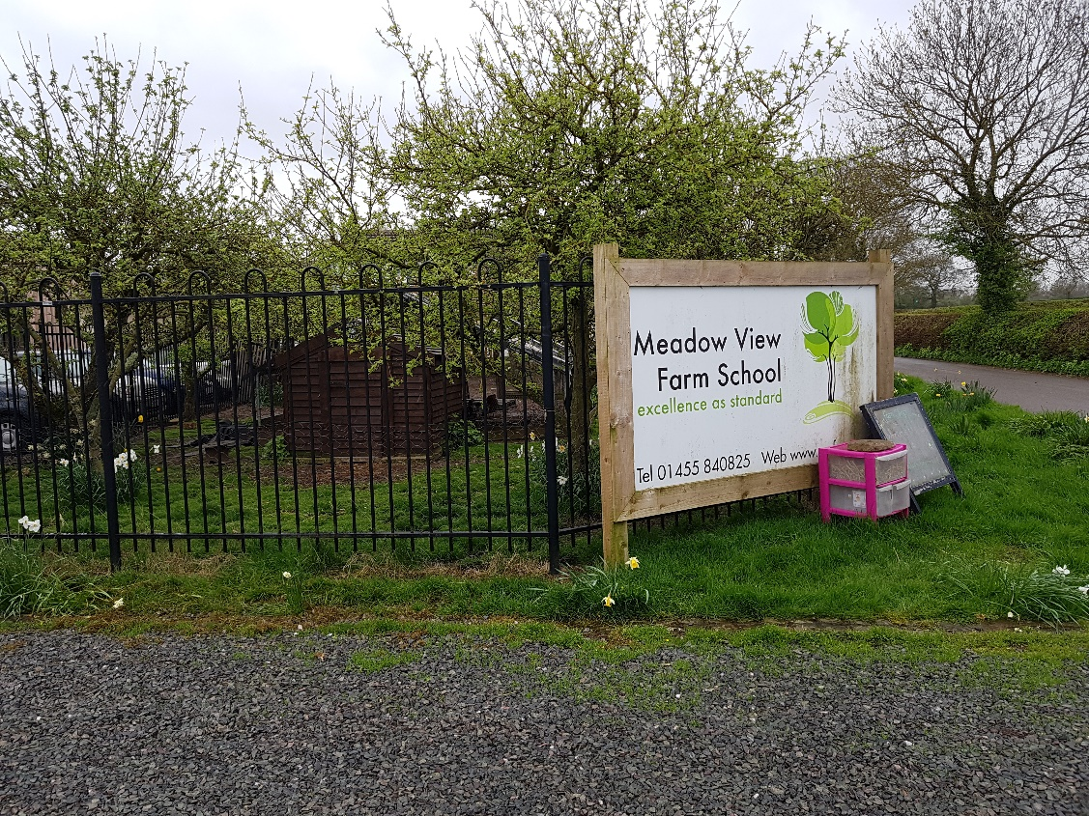

Safe Supportive Learning Environments
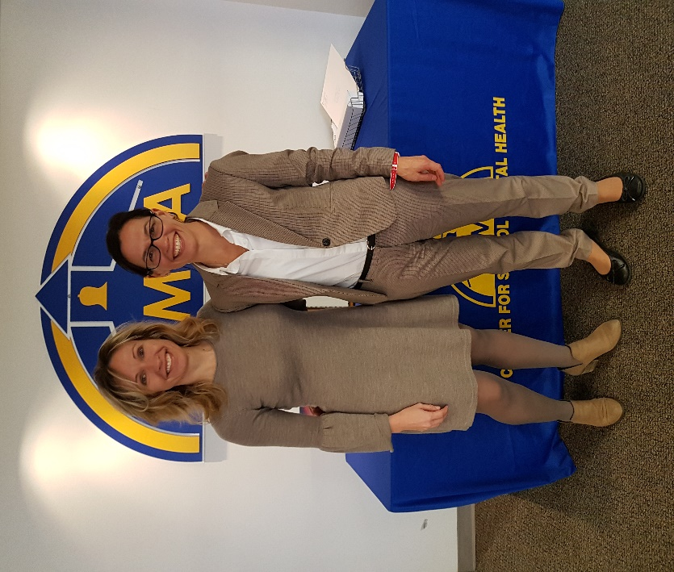
Visiting many key learning, research, policy and practice institutions and agencies I observed the unquestionable and broad universal shift towards creating safe and supportive learning environments for school students in schools. This shift encompasses the concept of actively nurturing positive school climates and conditions for learning through the creation of safe supportive learning environments.

Image3:
Professor Sharon Hoover, National Center for School Mental Health, University of Maryland, Baltimore, Washington DC and Deborah Costa meeting at the National Center for School Mental Health (Photo: Deb Costa)

School practices are reflecting scientific findings on the needs of the developing student as a learner, as an individual and as a learning community contributor. Via tiered early safety net systems for promoting, as well as preventing and intervening with, student’s mental health and wellbeing. Through shifting away from a behaviourist view towards looking at and understanding student behaviour differently and then responding in a different and a better way. By integrating restorative practices for community building, conflict management and cultural responsiveness. In considering and promoting students’ core strengths and values and fostering resilience in learners and staff. Through enhancing social emotional learning and targeting violence and bullying,

This shift resonates with the ‘advance’ Thomas Jefferson calls for in the quoted section of his speech below, inscribed at the Thomas Jefferson Memorial in Washington, DC;

Image 4: Thomas Jefferson Memorial, Washingto DC (Photo: Deb Costa)
“I am not an advocate for frequent changes in laws and constitutions but laws and institutions must go hand in hand with the progress of the human mind as that becomes more developed, more enlightened, as new discoveries are made, new truths discovered and manners and opinions change. With the change of circumstances, institutions must advance also to keep pace with the times. We might as well require a man to wear still the coat which fitted him when a boy as civilised society to remain ever under the regiment of their barbarous ancestors” - Thomas Jefferson.
Perhaps, it is also what the NSW Department of Education’s Wellbeing Framework for Schools is conveying, in making clear that; ‘our understanding of wellbeing needs to be contemporary and forward-focussed’ (p.2 2016 ).
This ‘advance’ is palpable within the US, where there is burgeoning interest in trauma-informed schooling and in the UK with attachment aware schooling. Developments in the field of neuroscience, trauma theory and child development are establishing clear links between trauma and psychopathology, poor academic outcomes, destabilised childhood developmental trajectories and the damaged cognitive, social and emotional capacities required by a student to function and achieve in school.

Trauma-informed and attachment aware schools integrate the scientific knowledge into practices and processes within a multi-tiered system of student supports. Traumatised students struggle with meeting the multiple demands of daily school life. Burdened with depression and other comorbid mental health difficulties and challenged by opposing needs to survive and meet basic needs and feel safe and focus on learning and getting along, schools, particularly those with high numbers of students exposed to chronic toxic stress and trauma, are learning and engaging with ways to best understand and support their students’ needs and help them thrive.

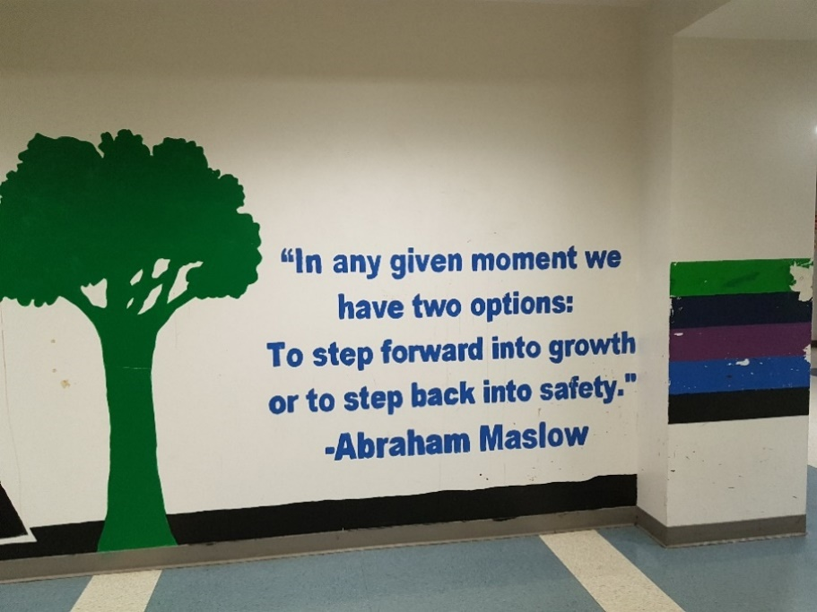

Image 5: Corridor in CHAS High School South Central, Los Angeles, California (Photo: Deb Costa)
Disregarding this will see traumatised students continue to very frequently encounter retraumatisation at school; exacerbation of their existing challenges, further decline in their mental health and wellbeing, and fail to be advantaged by school based educational opportunities. When managed through the repeated use of reactive and disconnecting discipline policies, done in the absence of active reparation and promotion of connections to the school and alternate positive and supportive measures, this is understandable. The NSW Ombudsman Inquiry into behaviour management in schools (2017) recognises the significant consequences for students from suspensions, that there is no research evidence that the general use of suspensions reduces disruptive classroom behaviour and that suspensions may exacerbate challenging behaviour for students with trauma. Alternatives to suspensions in the US are supporting their students to stay connected, restore and keep relationships, whilst learning to be safe and successful; reflecting recognition of the importance of students staying connected to their school for their safety, mental health and education.

The National Center for Safe and Supportive Learning Environments (NCSSLE) a collaborative with the American Institutes for Research promotes positive schools climates to create safe and supportive learning environments within schools. NCSSLE’s elements for co-create a positive school climate comprise:
- trauma informed to create shared understanding of what’s going on for the students, responding in a way that is not triggering, and not making things worse for the students
- intervention, prevention and promotion around mental health and wellbeing through a tiered, early safety net system
- social emotional learning curriculum embedded throughout schools for universal ‘prevent and promote’ approach to mental health and wellbeing
- grounding/mindfulness based practices for promoting calm
- evidence based practices to support students at tiers one, two and three (universal and targeted interventions) for mental health and wellbeing
- actively targeting violence and bullying
- restorative practices to engender restorative thinking, and healing processes for addressing conflict, building community and cultivating cultural responsiveness
- fostering resilience in staff and students, through the language of resilience, recognition of students’ core values and promoting a strengths-based approach to understanding and being inclusive of students.

Conclusion
Every day students are attending New South Wales schools, unseen and unknown in having experienced multiple forms of trauma inducing experiences, suffering silently from depression, anxiety and other mental health conditions related to trauma exposure, and challenged to competently cope with the daily demands of school life. Equally, every day New South Wales schools are attempting to manage the challenges these students experience day to day; increased absenteeism, decreased academic performance, increased negative incidents, decreased social competencies, complex learning, wellbeing and support needs, with significant drain on their resources without hoped for outcomes. Schools continue to allocate resources towards managing these students day to day. Over time, resources expended towards management of these students increases, without facilitating potential recovery and success.

There endures a compelling argument for accurately targeting and addressing the mental health needs of traumatised students in schools. When the deleterious effects of not addressing student trauma are acknowledged, the drain on school resources when attempting to manage these students is considered, the quantity of special education funds being spent on the needs of traumatised students without inducing recovery are calculated and the knowledge that most of these students never access mental health care services is realised. This underscores the need for increased attention to broad implementation of trauma-informed interventions and supports in our schools.

This study tour has shown that implementing trauma-informed interventions in schools can ensure that students receive needed support and care, not likely to be provided and accessed outside of school, to address the difficulties they face in the school setting. Through accessing support in schools, students are afforded the opportunities that minimise the impact trauma can have on their future learning, wellbeing and and mental health, supporting their development and promoting their recovery, growth and success.

With the understanding, knowledge, connections and resources garnered, I feel more equipped to advise schools, to plan supports, to develop systems and to promote the mental health and wellbeing needs of traumatised students in our schools.
Already, I have begun disseminating with:
- presentation to approximately 30 school counsellors and psychologists in the Newcastle region on the findings of my study tour and plans for dissemination
- presentation to approximately eight school counsellors and psychologists in the Cessnock district on the findings of my study tour and plans for dissemination
- presentation to a large audience at the 2018 International Childhood Trauma Conference in Melbourne on findings of my study tour and specific details of researched interventions
- planned presentation to Hunter Region Primary Executive Network Conference September 2018 on findings of my student tour and specific details of researched interventions
- planned training sessions September 2018 to staff in my base school to implement and cascade whole of school intervention
- planned presentation to school counsellors, school psychologists and senior psychologists, education across the Tamworth Group of Schools on findings of study tour and specific details regarding interventions
- preliminary discussions with local high schools briefly discussing study findings.

- References Cognitive Behaviour Intervention for Trauma in Schools (CBITS) https://cbitsprogram.org/
- Emotion Coaching in Education Settings (Emotion Coaching UK) https://www.emotioncoachinguk.com/
- Gilbert, L (2018) Summary Findings of Doctoral Research on Practitioner EC Experience louisegilbert.ec@outlook.com
- Gus, L., Rose, J. and Gilbert, L. (2015) ‘Emotion Coaching: A universal strategy for supporting and promoting sustainable emotional and behavioural well-being’, Educational and Child Psychology http://researchspace.bathspa.ac.uk/5836/

- National Center for Safe and Supportive Learning Environments (NCSSLE) https://www.air.org/center/national-center-safe-supportive-learning-environments-ncssle
- NSW Department of Education Wellbeing Framework for Schools (2016) https://www.det.nsw.edu.au/wellbeing/about/16531_Wellbeing-Framework-for-schools_Acessible.pdf
- NSW Ombudsman Inquiry into behaviour management in schools (2017) https://www.ombo.nsw.gov.au/news-and-publications/publications/reports/community-and-disability-services/nsw-ombudsman-inquiry-into-behaviour-management-in-schools-august-2017
- Rose, J., McGuire-Snieckus, R. and Gilbert, L. (2015) ‘Emotion Coaching - a strategy for promoting behavioural self-regulation in children and young people in schools: A pilot study’, European Journal of Social and Behavioural Sciences http://researchspace.bathspa.ac.uk/5851/
- Treatment Services Adaptation for Trauma in Schools (TSA) https://traumaawareschools.org/

