Premier’s Leadership Scholarship

Harnessing digital technologies for the classroom
  - A study tour to the United States and Singapore
Geoffrey Childs
Denison College of Secondary Education – Bathurst High Campus
Sponsored by

Introduction
This study tour allowed me to access centres of best practice in the USA and Singapore to benchmark schools known for their use of educational technology against schools here in Australia. It gave me the opportunity to identify successful components of professional learning design and to improve my skills in the leadership of the complex change process from traditional to blended digital learning. I see the importance of connecting this knowledge and insight to the teachers in my region and beyond, as it will aid in their delivery of innovative new future focused teaching practices.
I chose to visit multiple cities in the USA and Singapore, where I could see high performing schools in action. I selected schools that demonstrated an effective blend of classroom technology use and were then able to assess the needs for an effective implementation of digital learning technologies. I visited technology museums that virtually immersed participants in exhibitions, attended conferences that addressed the current dialogue of quality teaching and learning practices and participated in workshops that focused on new styles of pedagogy design. Whilst I visited many fantastic technology museums and some amazing schools, the following report covers specific areas of focus that will help inform future professional development programs and projects across the Central West region.

Focus of Study
The focus of this study was to look at:
- the models of professional learning used to prepare teachers for future focused teaching
- the choice of digital platforms that enabled innovative learning management systems for schools
- best practice in leading the change of a teacher’s delivery methods for a new curriculum that uses a blend of traditional and newer 21st Century technology focused teaching.
Most schools I visited had dedicated district or school resourced technology integration leaders to advance the skills of the teaching body. They drove the technology teams with clear and focused goals that had simple strategies to achieve the intended vision. These technology leaders work one-on-one or in small faculty groups and each school has the luxury of a full-time technology integrator. What is key to their programs is that the professional development is intentional, sustainable and long term focused. It is authentic with purpose and, built into most programs is the accountability of a partner or personal learning network or group to ensure personal development is tracked through shared responsibility.

Significant Learning

The models of professional learning used to prepare teachers for future focused teaching
Chris Dede - Professor in Learning Technologies, Harvard University, USA
Dede’s fundamental interest is developing new types of educational systems to meet the opportunities and challenges of the 21st century. His research spans emerging technologies for learning, infusing technology into large-scale educational improvement initiatives, developing policies that support educational transformation, and providing leadership in educational innovation. These were key in our discussions around how best to initiate and manage the change process to strengthen teacher pedagogy in preparation for the modern student in a heavily connected world.
He spoke about the modelling process of learning that teachers undertake in their classroom and the way this should match their experiences for their own learning to allow an effective transition to a greater eLearning presence. Teachers need to immerse themselves in professional learning that mirrors how they want their students to interact with technology.
Dede has spent a vast amount of time studying the use of online simulations that immerse students in a learning context that would never be possible with textbooks and talk. These virtual learning sequences can drive a deeper understanding as the student is wholly immersed in the context of the learning without distraction and it can be personalised to their learning context. Such simulations can be blended with the content on a regular basis and can be low cost to the school.
To gain teacher buy-in with technology, it needs to be simple, authentic and worthwhile in allowing a student to experience concepts and content beyond traditional instruction. He emphasised that this aspect of learning is critical today as students are more connected socially than before and for them, this virtual world is forming another dimension of engagement. He sees social media as a medium that students are heavily engaged with and an avenue that needs to be explored by teachers for its learning potential.
Meredith Thompson - Research Scientist, WW/Teaching Systems Lab - Massachusetts Institute of Technology (MIT)
Thompson’s role at the Open Learning Centre is in lecturing and teaching pre-service teachers at MIT and the continued development for immersive experiences in Science Technology Engineering and Mathematics (STEM) education. She conducts research into the impact of educational innovation and how it can best be measured.
Her key objective is to ensure students have a real experience when learning and this is to be done by doing, hands-on or online. The online presence she spoke of are immersive experiences that are web based and allow students to interact with content that build a learning progression by unlocking levels as they work their way through the experience. This hands-on approach is not too dissimilar to the Project Based Learning (PBL) focus seen today in many progressive schools. By having an immersive experience, a student retains many of the processes involved in the activities undertaken, like a science experiment, students will have a method to achieve an outcome.
Professional learning in this space should then be focused around how technology can be used but not at a cost to the teacher in time and relative learning effort. The teacher buy-in must come from the perceived benefits to aid their practice and the benefit to the learning of their students.
Craig Kemp - Head of Educational Technology, Stamford American International School, Singapore
Stamford American International School is a private school in the north east of Singapore and is predominantly focused on educating the expat community. It is only nine years old and in that time in has seen exponential growth, going from just 90 K-12 students to over 2800 with a teaching body of 480.
Craig Kemp has been Head of Educational Technology for the past two years and is responsible for the operations and educational integration across the school. He has a team of five technology integration specialists who work with teachers on programming, team teaching, professional learning. They enrich the curriculum throughout the school with the use of the easy to adopt, Google Classroom. His focus is to see the implementation of a more digitally rich environment and that all staff have a baseline level understanding with use of specific digital tools. His priorities include, being an Apple school, all staff achieving the Apple teacher certification and the Common Sense Educator certification in Digital Citizenship and Digital Teaching. Stamford use the International Society for Technology in Education (ISTE) Standards for teaching as their guiding principles of engagement to assist teachers to integrate the necessary ICT skills into their teaching programs to ensure students are proficient and well prepared digitally for post school options.
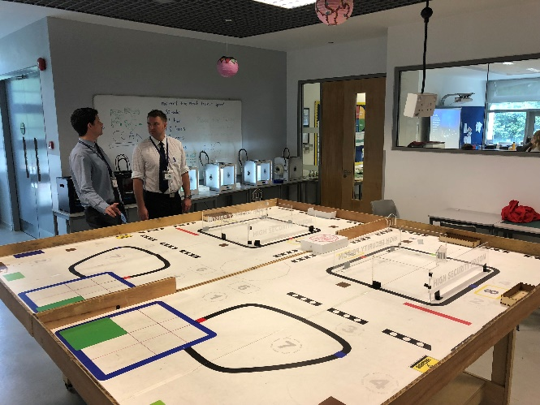
His team also work closely with the teaching staff on their development and understanding of the specific digital tools for the classroom but not for hardware help. This clear distinction ensures the continued quality of eLearning and not distracted by technical issues. He also has introduced a selection of interested and capable faculty members to form a team of Digital Champions to ensure the spread of ideas and having a technology representative as a first point of call before engaging with an Ed Tech coach.

Figure 1: Craig Kemp and co-worker at Stamford American School’s makerspace. (Photo: Geoff Childs)
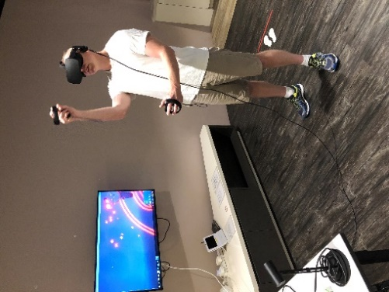
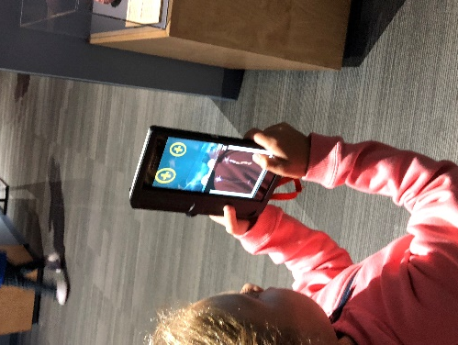

Figure 3: Geoff Childs immersed in Goole’s Virtual Reality (Photo: Geoff Childs)

Figure 2: Interactive Museum Tour (Photo: Geoff Childs)

From these discussions, we as school leaders need to ensure that the introduction of online tools for classroom content delivery is timely and the subsequent follow-up of teacher professional learning is well structured with continued support is paramount. Virtual environments are now proving to be significant in a student’s learning and ensuring the teaching body are introduced to this innovation will help generate change toward deeper and engaging classrooms.

The choice of digital platforms that enabled innovative learning management systems for schools
Liz Davis - Assistant Principal, Synapse School Menlo Park, CA, USA
Synapse is a small school making a big statement in styles of learning and leadership. They integrate the social emotional learning development of the student and build their intelligences with cross curricular PBL, different to traditional schooling methods.
Technology is well used where needed however they are more focused on the overall development of the whole student than individual separate units of skill learning. Students integrate technology throughout their classes and Synapse have a bring your own device laptop program for middle school where all students participate. Interesting to note that given the locality within Silicon Valley, families are more interested in computer science being integrated into the curriculum and see that the tools are not the focus. This was evident with many even reducing the amount of screen time at home preferring them to be outside. It is the computing languages that many parents hoped for these to become part of the language set for all the students. Davis explained the importance of the school's approach to learning and how it affects every aspect of their program for developing the future change makers of tomorrow.
Dunman High School, Singapore
Dunman High was another Government school with a significant Chinese history that is evident throughout the campus. Dunman is considered a high performing school and 99% of its graduates will continue to university. For Dunman High, Google Classroom was a simple answer as to which Learning Management System offered the biggest impact for teachers and students. It allowed them to provide information quickly to students with minimal effort and gave students easy access to content. A science lesson saw students engaged in a workstation-oriented learning activity using Metaverse, YouTube and QR codes covering the digestive system. Built into the activity was micro quizzing with instant feedback to gauge understanding and engagement. This simple mix of roving activities at workstations gave the students enough autonomy of the lesson but still had the drive from the teacher to maintain the pace.
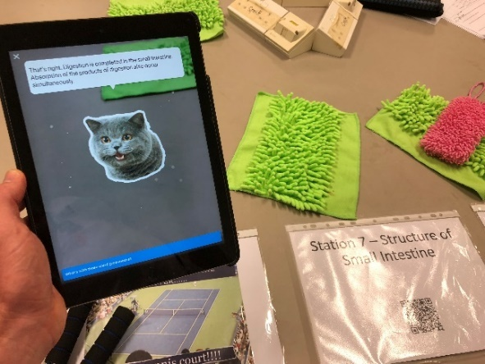
Interestingly, the Ministry of Education has been developing a nation-wide resource portal that will have quality resources and content that have been vetted for quality to then be placed on the Student Learning Space. The success of such projects often requires an investment of funds and time to ensure best practice can be achieved and that the resources raise the standards of even the weaker teachers.
All schools are part of a network of learning for teachers and many Dunman High teachers were leaders of faculty networks where they could build the capacity of other school’s teachers. The Ministry have been true to their vision and is now into their 4th revision of the Master Plan for ICT giving schools support and clear direction of how ICT will be implemented in the classroom.
Figure 4: A science workstation combining QR codes and Metaverse (Photo: Geoff Childs)

Tanglin Trust School, Singapore
My visit to Tanglin Trust School was a good chance to immerse myself in a school for two days with time to discuss many options for technology integration with faculty heads and interested staff. Technology wise, Tanglin was like most other schools with laptops for seniors and iPad for middle and junior school. However, their emphasis was on the studied patterns of cognition from handwritten notetaking and its infusion with today’s digital technology. The Microsoft OneNote platform was taken to the next level with the inclusion of a stylus that gave students the ability to continue to develop handwriting skills whilst interacting and utilising the online resources we heavily rely on for further knowledge development. Microsoft Surface Tablets were given to early adopting staff and were met with high appraisal early into the trial of the OneNote platform.
Tanglin’s roll-out of OneNote across the school has meant students, and staff, have access to subject and course material in a layout that is familiar to their books. This gives students the option to handwrite notes, annotate pictures, drawings and graphs in an effort to maintain the hand-eye practice. Tanglin saw that OneNote was a sufficient LMS as all notes, presentation, quiz and video content could be housed in the one location and was available online and offline. This software has proven itself in not just Singapore but Australian schools and looks to be improving with recent updates to its integration of additional online content.
It is the choice of online resourcing and options for digital course delivery that will bring efficiencies the craft of teaching. Resources used in classrooms play a big role in the formulation and retention of ideas for students therefore if the quality of these allow the full immersion of experiences to then we as teachers are creating the conditions to better enhance our student’s outcomes.

Best practice in leading the change of a teacher’s delivery methods for a new curriculum that uses a blend of traditional and newer 21st Century technology focused teaching
ASCD Empower conference, Boston MA, USA
ASCD Empower 18 attracted all types of educators across the globe to focus on improving outcomes for all students with improved pedagogy. Of the many workshops available, the “Using Digital Tools to Promote Authentic Student Learning” workshop was cleverly executed to ensure participants gained a strong understanding of the concepts being discussed with the presenters modeling the intended style of delivery. A quick example of this was the use of ‘FlipGrid’ to capture a review task.
Similar to Chris Dede’s focus on the importance of modelling expected practice, a common theme was that we as leaders need to be able to demonstrate the benefits of adopting efficient new techniques of instruction and ensure the teaching body build the skills to utilise the tools. This technique could be used after teachers attend PD to ensure the benefit is spread among the school’s teaching staff.
Bullis Charter School - Los Altos, CA, USA
Bullis Charter offers "a collaborative, community environment that augments academic excellence with social and emotional growth." Their primary focus is developing the student's potential through an integrated curriculum within a learning community that has their social emotional needs as a priority. Block scheduling classes provides opportunities for more in-depth cross-curricular learning. Intersessions, on the other hand, offer units of study that extend learning beyond the classroom into the real world with access to industry experts spread over a three week no class period. Resources available included dedicated low-cost Makerspaces and FabLabs where they could prototype their finding and ideas. Finally, advisory classes nurture leadership, a growth mindset, digital citizenship, and 21st-century success skills. Classes were predominantly PBL focused on integrated disciplines across all faculties.
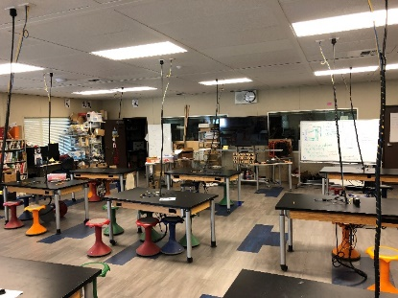
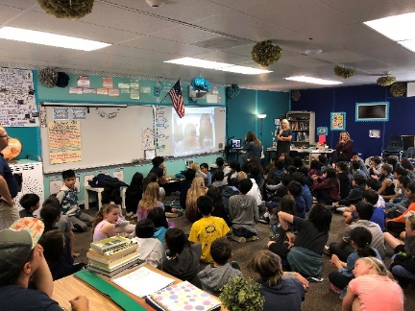
I managed to visit a class that was conducting a cross country interview with a school in Brazil. They were developing their cross-cultural questioning skills and learning how to be respectful in situations beyond their comfort level. Technology again, was used as a resource that could be called on but not all students had devices. They relied on laptop pods/trolleys in each classroom that were used to complement the learning when traditional methods could not achieve the desired result.
Figure 6: The FAB Lat at Bullis Charter school (Photo: Geoff Childs)

Figure 5: The class is utilising Microsoft’s Skype Translate in a video call to a school in Brazil (Photo: Geoff Childs)

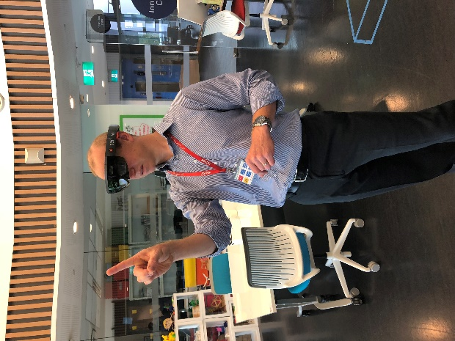
At Stamford American School, subject buy-in for Kemp’s team is a mix of faculties, but he emphasises the openness of the team and their clear aim is to ensure all students have access to sound experiential learning with some exceptional tools at their disposal. Stamford was approached to pilot Microsoft’s Halo Lens mixed reality headsets and currently holds five of the six units available to Singapore! This new frontier of simulations offers huge potential for rural students where excursion costs prevent such an experience and is instantly repeatable. Stamford also has the luxury of having a dedicated Innovations Centre that allows students the time and space to combine learning and technology in a supported environment outside of the classroom. The centre is equipped with a makerspace, green screens, 3D printers, Lego robotics, Google Expeditions and a suite of tools that ensures students can learn by playing and prototype with many of the vast tools that exist in the educational technology landscape of today. Being a resource available to all staff, the centre is used regularly throughout the day and Kemp’s team are rostered on duty at break times to assist students in their construction and discovery of ideas.
Figure 7: Microsoft’s Halo Lens mixed reality headset
(Photo: Geoff Childs)
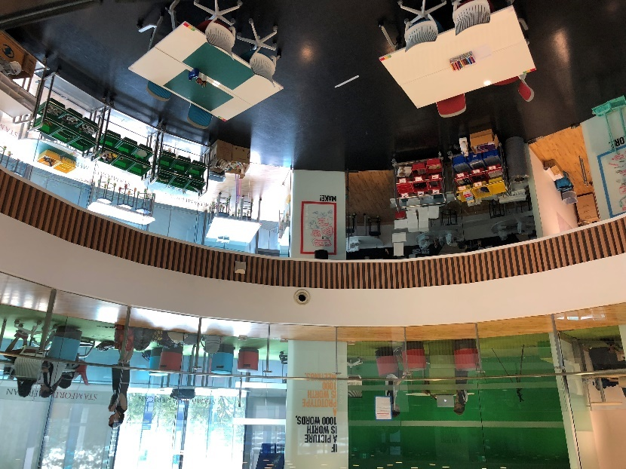

Figure 8: Stamford’s Innovation Centre (Photo: Geoff Childs)
Ngee Ann Secondary School, Singapore
Ngee Ann was very much a different visit to Stamford AIS as they are a Government school. I chose to visit Ngee Ann due to their excellent reputation within Singapore's local school system and for their status as once a Microsoft Innovative School and now an Apple Distinguished school. Alvin Chen and Geck Woon spent the morning with me showing how their school has been a pilot for many of the Ministry of Education driven innovations and the opportunities these present their students.
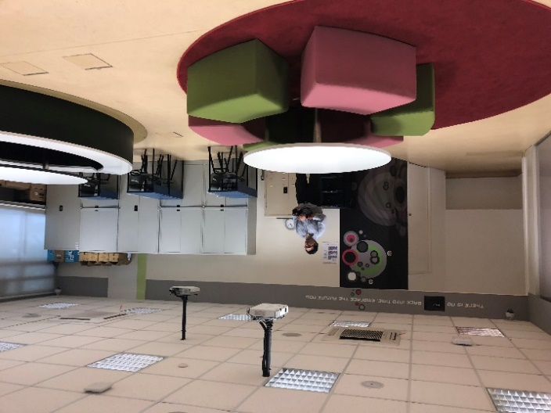
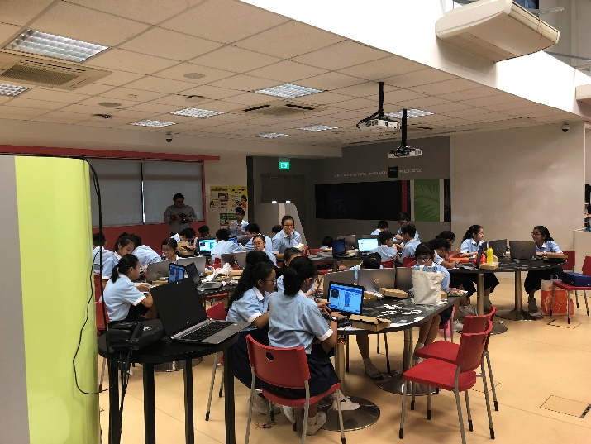
Figure 9: The teacher training classroom (Photo: Geoff Childs)

Figure 9: The busy classroom at Ngee Ann Secondary (Photo: Geoff Childs)

A dedicated training classroom is equipped with video cameras for staff development. This allows teachers to have observations by colleagues without the pressure of them in the room and students can be without distraction. A second room is for the observer. The relentless focus on teacher improvement meant that staff could access training in specific areas to better equip themselves for greater student achievement.
Having the expectation of introducing innovative technology focused activities into the classroom requires a clearly structured plan that factors in the incentives for teachers to change their practice. Technology can bring many opportunities to students, but this can be confusing and overwhelming for teachers who don’t have an affinity with selecting the best tool. Leadership in this area will ensure that teachers have the confidence and support during this change process.

Conclusion
Technology’s inclusion in the classrooms of today and tomorrow have become a necessity due to the breadth of the potential it can provide our students. The vast offerings of digital content and practices makes the argument clear that it will be the effective integration of technology into the classroom that will allow our students to experience the full benefit of this new and exciting learning environment. We as teachers need to be willing to explore digital teaching trends, such as simulation activities which are becoming more accessible for many subject areas and knowing that simple online learning platforms are best for on demand delivery of content e.g. Google/ OneNote.
What is clear is that technology integrators/coaches can be successful in changing practice by having an active role in faculty program development and implementation and through ongoing staff training. Investing in dedicated facilities will force the shift to innovative new practices to better prepare our students for future focused learning.
Being able to see a variety of technology practices in action means that I will be able to further mentor staff in the rural parts of the Central West with new ideas and techniques to ensure our students receive greater opportunities from their interaction with technology. It was pleasing to see many of the tools we currently use and seeing students interacting in a similar way with technology as our Australian students already do.
This research will be used in the development of quality professional learning structures and programs with the focus on using educational technology in classrooms and to then be informing regional schools to broaden engaging educational opportunities for Years 7-12. The key will be further up-skilling and support of the teaching body to ensure they are comfortable with the embedding of digital technology throughout their lessons and to build on the significant potential for student engagement.

