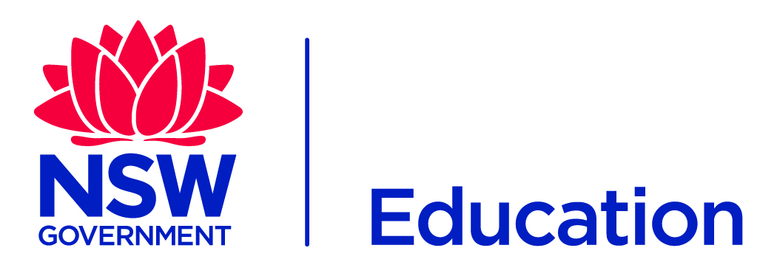
Click here to enter a date.

[Recipent’s name]
[Address 1]
[Address 2]
[Address 3]
Dear [Name]
Each year at [School] we encourage the staff and school community to let us know what projects they think will have the greatest educational impact for our school and our students, and reach out to the community to partner with us on our vision by providing financial or in-kind support.
Every public school works in line with the department’s values and strategic plan to ensure a quality education in a safe environment that guarantees student wellbeing. The projects we have in mind and that are eligible for sponsorship and collaboration are over and above the school’s day to day operations.
We want to make our school an example of excellence and best practice. We have asked for ideas that will help to set us apart and draw on the strength of our local community. We want to partner with people who are similarly invested in the future of our local community to pursue projects that have a lasting impact on the lives of the young people in our care.
This year we have identified:
- E.g. capital works program
- E.g. musical equipment
- E.g. robotics extension program
Any funds we raise from our community sponsors will go directly towards:
- [be as specific as possible about where funds raised will go]
- E.g. purchasing seven new keyboards, repairing and upgrading the school’s set of guitars, funding our year 6 class to attend a masterclass with a professional musician
- E.g. purchasing robotic equipment, software, funding the team’s trip to compete in a competition
I hope to hear from you and look forward to discussing how we can work together for the benefit of the young people in our community.
Kind regards
[Name]
[Title], [School]
NSW Department of Education
Click here to enter a date.

The NSW Department of Education manages sponsorship and collaboration in compliance with the Commercial Arrangements, Sponsorship and Donations policy and implementation procedures.

