Plant pests, diseases and disorders – mandatory focus area
This revision module will assist you to review and revise the content of the mandatory focus area: Plant pests, diseases and disorders. Each focus area prescribes the scope of learning for the HSC and is drawn from the associated unit of competency.
AHCPMG202 - Treat plant pests, diseases and disorders
This module is broken up into:
A. Important notes
B. Key terms and concepts
C. Activities
D. Putting the theory into practice
E. HSC Focus Areas
How to use the resource
Work through the notes and the suggested activities. Great revision techniques include working through how a problem is solved, explaining the concept, testing yourself and retrieving information from your memory. Spread your revision over a number of sessions rather than sitting at one subject for lengthy periods.
Discuss your responses with your teacher, fellow students or an interested family member.

A Important notes

You should use the information here as a prompt and guide when revising your study notes or resources provided by your teacher.
AHCPMG202 - Treat plant pests, diseases and disorders
This unit of competency describes the skills and knowledge required to recognise plant pests, diseases and disorders, determine the treatment options and apply treatments under supervision.
A student must be able to demonstrate the knowledge required to perform the tasks outlined in the elements and performance criteria of this unit. This includes knowledge of:
• common pests, diseases and disorders identification
• pests, diseases and disorders and dissemination method common to work area
• pests, diseases and disorders treatment options, including:
- cultural
- chemical
- mechanical
- biological
- Integrated Pest Management
• basic environmental considerations when using chemicals for treating pests, diseases and disorders, including:
- spray drift and off target damage
- inversion
- re-entry period
- residues
- chemical handling
• regulatory requirements and responsibilities when applying control measures
• pests, disease and disorders control equipment, capabilities and limitations
• health and safety in the workplace including personal protective equipment required for treating pests, disease and disorders
• principles and methods for securing treatment sites including, caution or hazard signs and signals
• purpose and use of chemical labels and safety data sheets (SDS)
• environmental considerations when treating pests, diseases and disorders, and disposing of waste materials
• record keeping methods and requirements.

B Key terms and concepts

You can use the following information to revise the key terms and concepts from this unit of competency. Perhaps you could:

1) Copy the table into your own file, remove all the key terms, then fill in the blanks (without peeking at the original file) with your own answers.

2) Copy the table into your own file and remove the definitions. Write a definition in your own words – it doesn’t have to word perfect but should show you understand the concept
Key term or concept | Definition
Aphid | A small sap-sucking insect that may carry plant viral diseases
Bacteria | Microscopically small forms of life that can live anywhere organic matter is found. Some bacteria cause diseases in plants and animals
Beneficial insects | Insects that feed on plant pests. Pest management systems should monitor and encourage these insects as they reduce the reliance on chemical use
Biological control | A method to control pest parasites and pathogens instead of chemicals
Blight | A symptom of plant disease. Can include spotting, sudden wilting and death of leaves, flowers, stems or entire plant.
Disease | A condition where any part of a living organism is abnormal
Flora | Plant life
Gall | A pronounced localised swelling on a plant
Insecticide | A substance used to prevent, destroy, repel or control insect pests
Integrated Pest Management (IPM) | Uses a variety of control measures to keep pests from reaching harmful levels. Options could include exclusion, managerial/cultural, physical, genetic, biological and/or chemical
Lesion | A localised spot of diseased tissue
Life cycle | Stages in the life development of an organism
Microorganism | Any organism that can be seen only with a microscope
Mildew | A plant disease where a fungus forms a coating over the surface of a plant
Pest | A living organism that causes loss, damage or injury to plants, animals or produce
Pathogen | A disease-producing organism. Includes fungi, bacteria and viruses
Plant disease | Harmful conditions that negatively affect plant life. May be caused by fungi, bacteria, nematodes or viruses
Resistance | The ability of a pest to tolerate the label rate of application of a chemical
Safety Data Sheets | Information produced by a manufacturer that provides the information needed to allow the safe handling of hazardous substance
Spray drift | The movement of airborne spray droplets from the spray nozzle beyond the intended target area by wind to an area not intended to be treated.
Virus | Disease-producing agent that is able to multiply outside the host tissue. Plant viruses are usually spread by insects
Wilting | When a plant loses excessive amounts of water by transpiration through the leaves. Plant droops

C Activities
- What is the meaning of the term integrated pest management (IPM)?

- Outline THREE valid strategies that could be used in an integrated pest management program in a primary industries enterprise.

- How would you dispose of used chemical containers to have the least impact on the environment?

- List 3 Common plant diseases you have studied. Describe their symptoms, how you could prevent them and how you could control the diseases.

- Use this link (https://www.agriculture.gov.au/pests-diseases-weeds/plant) to choose 3 plant pests. Describe the pest and explain the best control methods for each pest.

- Use this link https://sielearning.tafensw.edu.au/MPR/RTC2016A/html/pages/website/f_sheet/fs_53.htm to help you describe the difference between plant pests, diseases and disorders.
This link will also be helpful
https://ausveg.com.au/biosecurity-agrichemical/crop-protection/overview-pests-diseases-disorders/

- Use the information in this link to answer the following questions
https://www.slideshare.net/kathryngraham/plant-diseases-and-pests

- What information should be included when recording and reporting plant disease?

- Make a list of Agricultural and Horticultural methods of controlling pests.

- Explain how you would choose the correct application equipment for chemical control of a plant pest.

D Putting the theory into practice
The following questions are from past years’ Primary Industries HSC examination papers
HSC exams are intended to be rigorous and to challenge students of all abilities. If you have difficulty understanding a question you should look for key words and identify the aspect of the course to which these relate. You are then in a position to formulate your answer from relevant knowledge, understanding and skills.
- How would you dispose of used chemical containers to have the least impact on the
environment?
(A) Rinse the containers and stack them in a shed.
(B) Double rinse the containers and burn them at a secure site.
(C) Triple rinse the containers and bury them in a secure paddock.
(D) Pressure rinse the containers and take them to a drum muster site.

- Chemicals are absorbed through the skin at different rates for different parts of the body. In which of the following are the body parts listed from highest to lowest rates of absorption?
(A) Forehead, upper foot, abdomen, forearm
(B) Abdomen, forehead, forearm, upper foot
(C) Forehead, abdomen, upper foot, forearm
(D) Abdomen, forearm, forehead, upper foot

- In Australia, colours and shapes on safety signs have a particular meaning.
Which row in the table correctly matches the signs with their meanings?

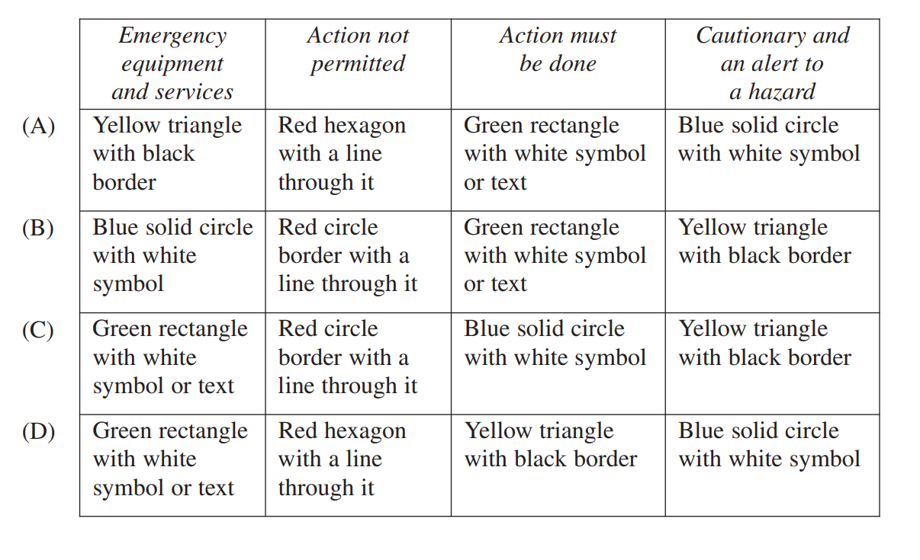
- A tractor applying chemicals is moving across a paddock at 5 km/h with a boom spray that covers 5 metres.
How long will it take to spray a 10­hectare paddock?
(A) 4 hours
(B) 5 hours
(C) 25 hours
(D) 40 hours

- A farmer is spraying a 300 hectare paddock. The spray unit holds 500 litres. The
application rate is 10 litres per hectare.
How many tankfuls will be used to completely spray the paddock?
(A) 3
(B) 5
(C) 6
(D) 10

6. An insecticide is only supplied in 1 litre bottles. The mixing rate is 12 litres per 100 litres.
The application rate of the mixture is 30 litres per hectare.
How many bottles of insecticide must be purchased to spray half a hectare?
(A) 1
(B) 2
(C) 3
(D) 4

7. The Bureau of Meteorology is predicting strong winds for the afternoon. A primary
Industries worker is planning to spray for an outbreak of insects that afternoon.
What should the worker do?
(A) Record the wind speed
(B) Wear more PPE when spraying
(C) Reschedule the spray program
(D) Spray in the direction of the gusts

8. A chemical is being used for the first time at your workplace. It has been spilt on your
work colleague. They do not appear to be in distress or badly injured.
What should your first action be?
(A) Call for an ambulance
(B) Check with your supervisor
(C) Use current first aid principles
(D) Review the MSDS for appropriate treatment

9. How would you determine the chemical output for a hand operated spray unit?
(A) Read the label for that chemical
(B) Carry out a pre-operation calibration check
(C) Read the operator’s instructions for the spray unit
(D) Mix the chemical and water in the correct proportions

10. Which of the following is an example of substitution as a procedure for minimising risk?
(A) Using only pre-mixed chemicals
(B) Separating chemicals from all food products
(C) Using a modified mechanical sprayer to spray crops
(D) Using a product in pellet form rather than as a dust or powder

11. The appropriate personal protective equipment (PPE) that must be worn when mixing a chemical is determined by
(A) using existing chemical records.
(B) using the same PPE that was used in the past.
(C) reading the chemical label after mixing the chemical.
(D) reading the material safety data sheet (MSDS) before mixing the chemical.

12. A primary industries worker is applying a chemical with a hand-operated pump. The
worker notices that the chemical is not coming out of the nozzle evenly.
What is the most likely cause of this?
(A) Poor calibration
(B) Incorrect mixing
(C) Incorrect chemical type
(D) Dirt particles in the nozzle

13. What is the colour of a mandatory safety sign on a primary industries worksite?
(A) Red
(B) Blue
(C) Green
(D) Yellow

14. What is the shape of a mandatory blue safety symbol in the workplace?
A. Circle
B. Rectangle
C. Square
D. Triangle

15. Which of the following best describes integrated pest management (IPM)?
A. Breeding plants or animals that are pest resistant
B. Alternating the chemicals used in a pest control program
C. Encouraging or introducing natural enemies to control a targeted pest
D. Using the most appropriate control strategies from a range of available options

Questions from Section II
- Explain the importance of keeping chemical application records in a primary industry enterprise. 6

- Outline the general features of TWO items of chemical application equipment used in a primary industries enterprise 3

- Develop a safe work practice procedure for using a piece of chemical application equipment. In your answer, include at least FIVE steps in a logical sequence. 5
Name the piece of equipment __________________________________

- (i) Identify ONE alternative to using chemicals for pest management. 1

- Outline ONE advantage and ONE disadvantage of this alternative. 2

- Distinguish between re-entry and withholding periods. 2

- Explain the importance of recording and reporting chemical use. 4

- A primary industries worker has been asked to apply two different sprays on the one day using an open cabin tractor.
In the morning, the worker will be spraying a crop with a chemical that has a signal heading POISON (S6 chemical).
Complete the following table listing TWO pieces of PPE appropriate for the task and give ONE reason for selecting each piece of equipment. 2
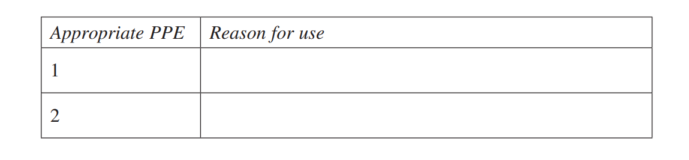

Questions from Section III
There will be one extended response question in Section III. This will provide you with the opportunity to
• demonstrate knowledge and understanding relevant to the question
• communicate ideas and information using relevant workplace examples and industry terminology
• present a logical and cohesive response
The expected length of response for questions in Section III and IV is around four pages of an examination writing booklet (approximately 600 words). You should allow about 25 minutes for a question in Section III and in Section lV in the exam.
In each of the following, map out your answer using post-it notes or a sheet of paper. Pay particular attention to incorporating a variety of aspects of your Primary Industries curriculum into the plan.
- Explain how chemical labels and material safety data sheets (MSDS) assist in identifying hazards and risks when developing safe work practices. 15

Questions from Section IV
This section is specifically for questions on the Plant Pests, Diseases and Disorders Stream
1. Plant Pests, Diseases and Disorders (15 marks)
(a) Name and describe a characteristic or feature of a plant. 2
(b) Explain the importance of keeping records in relation to the treatment of plant
pests, diseases and disorders. 5
(c) Explain the importance of correct disease identification for the control and
future management of a disease. 8

2. Plant Pests, Diseases and Disorders (15 marks)

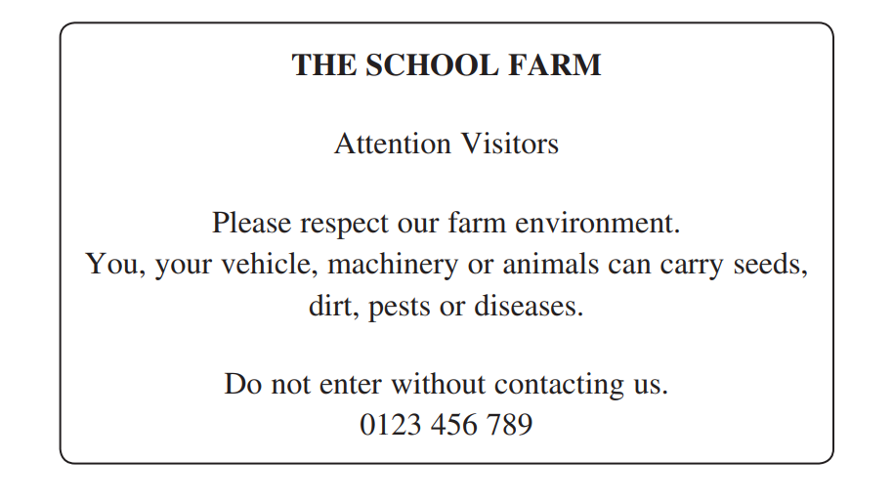

(a) Describe strategies for dealing with diseased plant material and waste in a
primary industries enterprise. 5
(b) Explain measures that could be implemented as part of a biosecurity plan to
minimise the spread of weeds. 10

3. Plant Pests, Diseases and Disorders (15 marks)
(a) Outline the purpose of legislation in relation to the treatment and control of plant
pests, diseases and disorders. 2
(b) Identify FIVE parts of a plant and describe their key functions. 5
(c) Explain why biosecurity, safe work practices and record keeping are important
in the treatment and control of plant pests, diseases and disorders. 8

4. Plant Pests, Diseases and Disorders (15 marks)
(a) Name and outline the purpose of ONE piece of equipment used in the treatment
and control of plant pests, diseases and disorders. 2
(b) Explain the importance of safe work practices in the treatment and control of
plant pests, diseases and disorders. 5
(c) Evaluate methods used for the treatment and control of plant pests, diseases and
disorders. 8

5. Plant Pests, Diseases and Disorders (15 marks)
For a plant you have studied:
(a) Name TWO common plant pests, diseases or disorders which may affect that
plant type. 2
(b) Describe the signs and symptoms of the TWO named plant pests, diseases or
disorders. 4
(c) Describe the steps a primary industries worker would follow to prepare for,
treat and record treatment details of ONE of the named plant pests, diseases or
disorders. 9

6. Plant Pests, Diseases and Disorders (15 marks)
(a) Outline a process that could be used to assess the health of a plant. 3
(b) Describe the signs and symptoms of TWO plant pest infestations. 4
(c) Analyse a range of prevention and treatment measures that could be used to
control a pest infestation in plants. 8

E Scope of learning for the HSC
The scope of learning for the HSC should be addressed in the context of significant plant pests, diseases and disorders for a particular workplace/situation in primary industries.

range of plants
- range of plants common to a sector of primary industries:
types:
- native
- introduced
- beneficial
- weeds
common name
characteristics and features:
- parts:
- stems
- roots
- leaves
- flowers
- fruit
growth characteristics

recognition of plant pests, diseases and disorders
- difference between a plant pest, disease and disorder
- for a range of significant plant pests, diseases and disorders:
common name
identification and assessment:
- signs and symptoms
- level of infestation
tolerable levels
- potential impact of plant pests, diseases and disorders within primary industries:
threat
damage

management
- difference between treatment and control measures
- importance of safe work practices in the treatment and control of plant pests, diseases and disorders
- methods for the treatment and control of plant pests, diseases and disorders:
biological
chemical
cultural
mechanical
physical

management cont/d
- treatment of plant pests, diseases and disorders:
types
preparation:
- including consequences of incorrect preparation
methods of application:
- including the importance of minimising off target damage
post-treatment operations:
- clean-up
waste disposal
- appropriate selection of treatment for significant plant pests, diseases and disorders for a particular workplace/situation
- principles and strategies for control of plant pests, diseases and disorders
- appropriate selection of control measures for significant plant pests, diseases and disorders for a particular workplace/situation
- range of equipment used in the treatment and control of plant pests, diseases and disorders:
name and general features
selection:
- correct for task
- manufacturers’ specification for use
use/application:
- calibration
- legislative requirements
cleaning, maintenance and storage
- assess the environmental impact of the treatment and control of plant pests, diseases and disorders and recommend measures to minimise the impact
- requirements applying to the treatment and control of plant pests, diseases and disorders:
legislation and regulations
industry codes of practice
workplace policy and procedures, including biosecurity

recording and reporting
- recording and reporting related to treatment and control of plant pests, diseases and disorders:
occurrence
treatment
monitoring
records

