Information and Digital Technology
Stream Focus Area: Web and software applications
Welcome. This module will assist you to review and revise the content of the stream focus area: Web and software applications. Each focus area prescribes the scope of learning for the HSC and is drawn from associated units of competency.
You will have studied the following units of competency, which together address the scope of learning:
ICTICT203 Operate application software packages
ICTICT308 Use advanced features of computer applications
ICTWEB302 Build simple websites using commercial programs

This module is broken up into:
- Important Notes
- Key terms and concepts
- Activities
- Putting the theory into practice
- HSC Focus areas
How to use the resource
Work through the notes and the suggested activities. Great revision techniques include working through how a problem is solved, explaining the concept, testing yourself and retrieving information from your memory. Spread your revision over a number of sessions rather than sitting at one subject for lengthy periods.
Discuss your responses with your teacher, fellow students or an interested family member.
All images, apart from those acknowledged, are © NSW Department of Education.

Important notes
You should use the information in this section as a prompt and guide when revising your study notes or text-book information or other resources provided by your teacher.

The following units of competency address the scope of learning:
The competency ICTICT203 Operate application software packages describes the skills and knowledge required to identify, select and operate three commercial software packages, including a word-processing and a spreadsheet application package
The competency ICTICT308 Use advanced features of computer applications describes the skills and knowledge required to use computer applications employing advanced features. It involves manipulating data and accessing support resources to solve routine problems
The competency ICTWEB302 Build simple websites using commercial programs describes the skills and knowledge required to use web authoring tools to create, modify and test, simple web pages and websites.

The outcomes of the HSC stream focus area ‘web and software applications’ requires that the student:
- demonstrates extensive knowledge of the features and functions of three commercial software applications
- explains the use of problem-solving and troubleshooting strategies for solving software-related problems.

Software
Two main types of software are used in modern computers:
- operating systems
- application software

Operating system
An operating system (OS) consists of one or more programs which manage the operations of the computer. These programs function as an interface between the user, the applications, programs and the computer equipment.
For a computer to operate, the essential and most frequently used instructions in the operating system are loaded into main memory (RAM). The remaining parts of the operating system are usually stored on the hard disk and are loaded into memory as required.
There is a number of different operating systems in use. Some of these are used for particular specialist applications and will only be found on certain types of computers:
Windows XP, Windows vista, Linex, Apple OS X
Most IBM compatible PCs will be using Windows 10 version of the Windows operating system.
Apple Macintosh users will be familiar with the Apple operating system called Mac OS X.

Application software
Application software is the program you use to perform a specific task, or to do a particular job.
A word processor program is used to create business letters, reports, or almost any kind of text document.
A spreadsheet program allows you to manipulate large amounts of numerical data.
A database management program is used to manage large amounts of data.
Communications software provides a method of connecting to other computers to exchange data.

Commercial software packages
Software has three basic categories:
- system software which is used to control the hardware components of a computer.
- utility software which helps protect and maintain a computer, and
- application software which allows a user to complete a specific task.
Commercial software is software that is mass-produced to sell or distribute and to meet a business need. It may be free or sold and it can be system, utility or application software. Commercial software is often referred to as ‘off-the-shelf’ software as it comes readily packaged and is available for sale or distribution to the general public.
Open-source software - Most commercial software is sold under licence, where the end-user licence restricts what the user can do with the software. Open-source software is distributed with the source code available to the user. This allows the user to modify the source code if they wish. Open-source software is not necessarily free software.
Software package is a term used to refer to most software programs today. A package will usually contain a single file (usually an executable file), the file containing the actual program (source code) plus the necessary files to install the program. In addition, a software package will provide advice on how to install the software, plus support information on how to use the program. This support information may be included as paper-based with the software or usually as advice on how to access a relevant website. Software packages are sold for system, utility and application software.
Software suites are a group of software that share a common user interface and integrated components. An example is the Microsoft ‘Office’ suite that provides a user with a series of applications; each for specific a purpose. The Office suite, as other suites, has a common look for navigation and functionality.
Enterprise or customised software - This is software developed or used for a specific purpose by an organisation. An enterprise created application is developed by programmers to meet a unique business need, eg a hospital patient’s records system.

Choosing the correct application
As a competent ICT user, you should be able to determine the most suitable software application to meet a specific need. This does not mean which is the best brand, but which software has the functionality to produce a required output.
As an example, if you want to create a document that will attract readers’ attention by using fancy headings and indenting, then a word-processed document would be better than a spreadsheet.

Target Audience
When creating a word document or a spreadsheet or webpage it is important to firstly identify the purpose and target audience. Steps to help you identify your audience include:
- What information are you readers looking for?
- What is the age range of your audience?
- What is their existing level of knowledge of the subject?
- What is their cultural background?
- Is there a key interest you can use to connect to your audience?

Spreadsheet or word document
Once you identified your subject matter and target audience, you need to decide the relevant application. In the case of spreadsheets and word-processing the following steps can help you decide.
When to use spreadsheets:
- Your data includes the use of rows and columns with numbers.
- Your data includes numbers, $ signs and decimals points.
- Your data includes calculations, especially complex ones.
- You are using rows of text that contain words or symbols that are repeated in other rows.
When to use word-processors:
- Your data contains a lot of paragraphs and space between lines or paragraphs.
- You want headers and footers that stand out.
- The layout of your document is complex, i.e. requires section breaks.
- Within your text there is a mixture of characters, numbers and symbols.
In addition to the above, it should be remembered that when using word-processing and spreadsheets it is possible to link or embed, parts or all of a spreadsheet into a word document. This can help when you need to make complex calculations (in a spreadsheet) and want to present the information in one document (a word document).

Spreadsheets
A spreadsheet is a computer based document that uses rows and columns to organise data. This allows for the data to be easily sorted and allow for calculations to be carried out.
Originally spreadsheets were developed as an electronic version of accounting paper-based worksheets. However, the use of spreadsheets has been further utilised to sort data for a wide range of functions where lists of data are used.

Document purpose and audience
It is essential that the target audience of a spreadsheet is identified. This allows the creator of the spreadsheet to use the program settings and formatting to ensure information is presented as needed.
Any document is a form of communication and for it to be effective it needs to address three basic criteria:
- Who is the audience?
- What information do they hope to obtain?
- What information do you wish to present?
When compiling an effective document consider the following:
- Content what is the information readers are seeking.
- Organisation and layout how the information is presented, is it relevant, helpful and easy to follow.
- Language is the language of the document relevant to and understood by the audience.

Simple formulas and functions
A formula is a mathematical relationship expressed by using symbols. As an example, to add the numbers three and four you could write 3 + 4.
A function is a pre-defined formula within a program. As an example, in a spreadsheet program there may be a function SUM used to add values together.

Spreadsheet settings
As with most software, the ability exists in spreadsheet software to make changes to basic settings to meet the users’ needs. Examples of settings that can be adjusted include menu ribbons, printing options, creating macros, format styles, creating templates and automating reports.
Customising spreadsheets to meet a user’s needs makes it easier to read and manipulate data.

Spreadsheet software
There are a number of spreadsheet software available, one of the most well-known is Microsoft’s ‘Excel’. Other spreadsheet software includes LibreOffice Calc’, OpenOffice’s ‘Calc’, Lotus’s ‘Lotus 1-2-3’, Google ‘Sheets’ and Corel’s ‘Quattro Pro’

Word processing
Word processing can be defined as using a computer device to input and manipulate text to create a printable output.

Word processing software
There is a variety of software programs for word processing. The most well-known would be Microsoft ‘Word’ which is part of their Office suite. Other software includes ‘Writer’ by OpenOffice, ‘Writer’ by LibreOffice, ‘WordPro’ by Lotus, ‘Quickword’ by QuickOffice and ‘Google Docs’.
The usual method for word processing is to input data via a keyboard, however, there exists voice activated software that can allow the user to create a word document via voice, eg ‘Dragon Home 12’.

Document structure and layout
Organisations may have their own guidelines (style guide) on how to design text-based business documents. A key requirement in designing documents is to be consistent.
Some examples are:
- headings are a larger font size then the body text
- generally, no more than 2 different coloured fonts should be on the same page
- generally, no more than 2 font styles on the same page.
Following such guides ensures that the reader is not distracted from the intended message of the document. Consistency in the use of fonts, margins, and other formats ensures a more readable document.

Naming and storing of documents
It is essential that any document (or file) can be easily retrieved when needed, so there needs to be consistency and relevancy of document names. For example, a document describing July’s sales figures could be called ‘July_Sales_2014’ as opposed to just ‘Sales’.
Most businesses have their own rules and guidelines when it comes to naming documents and this need to be followed so that not only yourself, but all staff can easily identify a document.
Similarly, the storing of documents needs to be consistent and relevant, eg the ‘July_Sales_2014’ document could be saved in a folder ‘Sales’ as opposed to a folder ’MyWork’. Most businesses have rules about folder names and structures.
It is good practice to have such document naming and filing conventions in your own work so you can practice industry standards in this area.

Organisational requirements for text-based business documents
Word-processing software comes with its own in-built format & style templates such as Microsoft Word’s ‘normal.dot’. However, businesses often have their own requirements as to how word-processed documents are to be formatted and styled and this can be saved as a template.
For example, a business may decide all documents are to use a 12pt Verdana font and text to be black; headings to be 16pt bold text. The business may also require that all documents have the company logo on the top left corner and need to include the business’s contact details.
A user needs to be aware of the business requirements and ensure they follow these guidelines when producing business documentation.

WHS - ergonomic, work organisation, energy and resource conservation requirements
As with any computer usage, the use of software such as word-processors requires adherence to basic WHS guidelines. Correct ergonomics, such as seating position is essential.
Organising work in a manner that means lowering or removing potential stress, due to factors such as work overload or poor time management is essential. As with any computer usage, it is necessary to consider energy and resources. For example, using screen savers or automatic stand-by functions can conserve energy. Additionally, emailing a document instead of printing can conserve energy and resources.

Printing specifications
These include page set-up, print area, page orientation, paper size and the number of pages to be printed. In addition, there may be more than one printer available, so the relevant printer needs to be selected.
It is essential that a user not only follows any business guidelines regarding printing, but also the actual printer specifications. As an example, a particular printer may not have the drivers to print ‘legal’ size and can only print ‘A4’ size paper.

Technical functions and formatting
Word-processing technical functions include templates, style sheets, callouts, columns, macros, section breaks, page numbering and footnotes.
Formatting is the process of changing how the text appears and how it is placed in a document. Functions such as text size, font style, font colour, line spacing, use of bold, underlining and italics all relate to formatting.

Web authoring software
Web authoring is the practice of creating web documents using modern web authoring software and tools. Web authoring software is a type of desktop publishing tool that allows users to navigate the tricky environment of HTML and web coding by offering a different kind of graphical user interface. You can make a web page in almost any software package these days, but a web site authoring tool gives you so many more features.
What is the difference between a web-authoring program and an HTML-editing tool? A web-authoring tool provides a visual interface for creating entire web pages, including the necessary HTML, CSS, and scripts. HTML editors provide only shortcuts to writing HTML documents manually.
Some web authoring tools include:
- Dreamweaver.
- Weebly
- Wix
- Corel Website Creator.
- NetObjects.
Dreamweaver allows you to do the following:
- WYSIWYG display – visualizing of web content while coding
- Browser link
- Supports lots of languages – such as
  - ActionScript
  - Active Server Pages (ASP).
  - C#
  - Cascading Style Sheets (CSS)
  - ColdFusion
  - EDML
  - Extensible HyperText Markup Language (XHTML)
  - Extensible Markup Language (XML)
  - Extensible Stylesheet Language Transformations (XSLT)
  - HyperText Markup Language (HTML)
  - Java
  - JavaScript
  - PHP
  - Visual Basic (VB)
  - Visual Basic Script Edition (VBScript)
  - Wireless Markup Language (WML)
- Available in different languages other than English
- FTP
- SFTP
- HTML coding editor
- CSS etc
- Site Management Tools
- Coding hints
- Spell Check
… and many more!

Codes of ethics
Most organisations have developed a code of ethics for their workers, to assist in setting a high professional standard for their business.
‘The Australian Computer Society (ACS) is the professional association for Australia’s Information and Communication Technology (ICT) sector’ (https://www.acs.org.au/). Their goal is to help their members achieve excellence in their professional pursuits in the ICT industry, nationally and internationally.
As an ICT worker it is important to be aware of codes of ethics such as those developed by the ACS as they can help you define both your professional work ethic and attributes.

Australian computer society code of ethics
As an ACS member you must uphold and advance the honour, dignity and effectiveness of being a professional. This entails, in addition to being a good citizen and acting within the law, your conformance to the following ACS values.
- The Primacy of the Public Interest
You will place the interests of the public above those of personal, business or sectional interests.
- The Enhancement of Quality of Life
You will strive to enhance the quality of life of those affected by your work.
- Honesty
You will be honest in your representation of skills, knowledge, services and products.
- Competence
You will work competently and diligently for your stakeholders.
- Professional Development
You will enhance your own professional development, and that of your staff.
- Professionalism
You will enhance the integrity of the ACS and the respect of its members for each other.

Troubleshooting and problem solving - software applications
The concept of troubleshooting and solving problems relating to computing usually refers to hardware issues. However, there are times when these concepts apply to the actual software being used.
An important part of being a competent user of the advanced features of any software application is to be able to troubleshoot any problems or errors which may arise. This includes the ability to research solutions, to help solve routine problems associated with using word processing, spreadsheet and web authoring software.
The following table provides examples of common software errors and problems a user may need to rectify.
Word-processing errors | Spreadsheet errors | Web authoring errors
Word cannot open <path\filename>. The file may be in use by another application, the file format may not be supported by any of the installed converters, or the file may be corrupt.’ | ‘#NAME?’ - error in a cell formula. | The following translators were not loaded due to errors …
Cannot display the template add in template is not valid template name. | There was a problem sending the command to the program. | While executing onBlur in Image Placeholder.htm, the following JavaScript error(s) occurred: In file ‘Image Placeholder’; updateUI is not defined.
Microsoft Word has encountered a problem and needs to close. We are sorry for the inconvenience. | ‘#REF!’ - Invalid Cell Reference Error Message. | The website cannot display the page (HTTP 500).
A variety of resources exist to help solve such problems and include pop-up alert messages built into software, user manuals (both manufacturers manuals and third-party manuals), online help, web-based help, training websites and manuals, and user groups.
Another key tool available to users to assist in solving and reducing software errors is the use of the software manufacturers updates. Regularly maintaining software by ensuring it is always up to date can prevent many problems occurring. Activating software pop-ups which advise of updates, for example Adobe’s Flash updates or Microsoft’s Office updates, should be part of regular maintenance.

Support to solve software-related problems
There are a number of sources available to help users troubleshoot and find solutions to software-related problems.

Documentation
The term documentation usually refers to hard-copy material such as user manuals and training materials. However, it is becoming more common for such documentation to be available in a softcopy (online) format.
Software developers usually provide some form of user documentation which explains the attributes of the software, i.e. what it is designed to do and how to use it. Such documentation often includes methods of how to troubleshoot any issues with the software. This documentation is usually provided in the form of online help.
In addition to developer’s documentation, there is documentation created by third-parties. A common example of this is the ‘Dummies’ books, eg ‘Excel for Dummies’.
Another common form of documentation is a training manual. These provide information on features and functions and exercises on how to perform a variety of tasks using the software. These often include help in how to troubleshoot problems.

Online help
User guides can provide information on the features and functions, procedures to perform a variety of tasks, and tips to solve common problems. These are commonly embedded in the software as online help files.
Additionally, software developers often provide web based help assistance, an example being MSDN (Microsoft Developer Network).

Technical support
This is support which can be provided to registered users of software. This type of support can range from dedicated helpdesks to websites, to inbuilt alert messages. Often developers will charge a fee for technical support. An example is the accounting software MYOB.
Alert messages can be built into software to assist users; for example, a ‘Low Disk Space’ error; advising a user when they attempt to save a word-processed document to their hard drive.

Web authoring tools

Choosing the correct application
Website applications – There are a number of website creation (web authoring) applications in the market. So, when to use which application, or which aspects of an application, are key ICT skills.
The creation of any website building requires identifying the target audience and their needs, including technical and information needs. To this end the following types of information is required to assist in identifying the target audience:
- What internet browser(s) do they use?
- Are they using a mobile computer device?
- Does the audience have any special physical needs such as vision issues?
- Are there any specific demographics of the targeted users to be considered?
Key considerations when choosing a web authoring software include:
- Will it enable the website author to develop a site that meets client and target audience needs?
- Does it suit your level of expertise, the more complex the software the greater your skill level needs to be.
- Does the software contain the features you will need, functions such as rollover creation, script support, automatic file backup and mobile optimised tools are just a few such features?
- The level of product support such as video tutorials, FAQs and live chat.
- The level of multimedia support such as animations, audio, quick time and video. Meaning what multimedia functions can be included in the website development.
- In regard to the hardware to be used in development, is the authoring software technically compatible.
Defining issues such as the following will influence the complexity of a website and help determine what authoring software will be needed.
- Will the website feature interaction such as, user engagement, information presented in a pre-set format, the ability to access a database or ability to allow user customisations?
- Will the website connect to other services, applications or systems?
- Will the website need to be maintained by a client?
The above is not an extensive list but indicative of the issues to be considered when considering a web authoring software.

Website navigation
A key attribute of websites is the concept of using active links to move around the site or connect to external sites. The process of a user moving around a website is known as navigation.
The HTML tag for navigation is <nav>.
Ease of navigation is one of the main design principles to enhance the usability of a website. If visitors can easily find what they are looking for they will be more likely to stay on the website rather than leaving and going to some other site.

Styles
There are a number of different navigational styles and these allow for the information on the website to be delivered easily and directly. Styles also help differentiate between categories and the sites themselves to indicate what key information is and enable the users to scroll down further to access more information and facts discussed within the website. Navigation styles include, but are not limited to, the following:
Breadcrumbs – this allows users to keep track of their location within the website, it shows exactly where a particular page is in relationship to the overall website.
Dropdown menus – these exist in other GUI applications such as database forms as well as in websites. They allow a website user to select a certain value and this can be thus linked to a certain category of information on the website.
Hotspots – these are usually invisible hyperlinks. Web designers may use an image or an area of a webpage to become a hotspot. The user finds these hotspots as the mouse pointer will change shape as it covers a hotspot. Behind the hotspot image or area is the same HTML code for other types of hyperlinks.
Hyperlinks – navigation on websites use a system of hyperlinks to move to another page, site or an element on the current page. Hyperlinks work by either clicking on them or placing the mouse cursor over them.
Navigation Bars – these are usually a bar of buttons or tabs, and often displayed in a horizontal or vertical column. They allow the user to move around the website.
Sitemap – this is a list of the pages on a website and usually laid out in a hierarchical fashion. Sitemaps are used both in the planning, creation stage of website development and often part of the final website design.
Text Links – these are a type of hyperlink where the user can click on defined text to navigate.

Current changes in web navigation
Web designers today are increasingly using adaptive web navigation, this term describes the process of real-time changes in a website's navigation system. Adaptive web navigation uses algorithms that capture a user’s browsing behaviour and uses this information to suggest useful short-cut links in real time. The rise of portable wireless devices such as smart phones and tablets is driving web designers to invent better navigation methods such as adaptive web navigation.

FTP (File Transfer Protocol)
FTP is a system of rules (protocols) used to transfer website files from one host to another host: usually transferring from a website author’s computer to a website server or downloading files from the website to the author’s computer.
One a website author has created a website, or if they wish to modify a website, they need to upload the files to a web server so it can be accessed over the internet. Some web authoring software, eg Adobe Dreamweaver have built in FTP functions. If a built-in FTP function does not exist, an author can use third part ftp software such as Filezilla.
FTP software allows for the configuring of the website author’s computer (client) as well as the website server (server).
The client computer configuration will include settings such as:
- the URL of the proposed site
- what server technology is being used
- where files are stored on the client computer.
The website server can be configured to set:
- the password to allow FTP access
- groups of users and their related access rights
- maximum number of visitors to a site at any one time
- the related TCP (Transmission Control Protocol) port
- if the site will be a secured site (SSL) that requires a username and password to access
- the related IP (Internet Protocol) address.
The file storage structure and mapping of the website is also created via the FTP software.
The image below is an example of a typical options screen in FTP software.

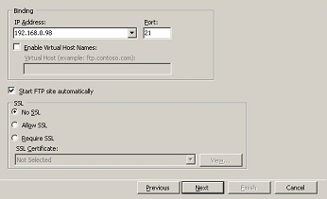

Key terms and concepts

Key Terms and concepts | and definitions
Accessibility | Websites are developed so that people with disabilities can understand, navigate and interact with the site
Alignment | How the text is placed – left, centre, right, justified
Bullets | Can be represented by a range of symbols, usually round dots, which are used to set apart points in paragraph style.
Cells | The rectangles created at the intersection of columns and rows.
Charts | Charts (sometimes called graphs) are a pictorial way of displaying data. There are a number of different chart formats designed for different purposes.
Clipboard | A facility in the program to store items of text or graphics when they have been cut or copied, so they can be pasted to a different location; up to 12 items at one time
Commercial software | Software that requires payment before it can be used
Conditional Formatting | A style function which allows certain cells to be highlighted when they meet a user set condition. As an example, a range of cells could contain $ values, a conditional format could be set to highlight with red shading any cells that contain a value greater than $20.
Conditional Logic | Use of logical comparisons between expressions using the AND, OR NOT, IF functions to create conditional formulas
CSS | Cascading Style Sheet. Describes how HTML elements are to be displayed on screen, paper or in other media
Cut & Paste | A feature that allows you to move information from one place to another.
Data Validation | This is used to restrict the type or value of data entered into a cell. This is useful when the user shares a workbook with others and wants to ensure they use the correct format when entering or changing data. As an example, a range could be set which only allows the input of numbers between 10 and 50; a data validation message could be created so if a user tries to enter a value outside the input range a pop-up message would appears saying to ‘enter a value between 10 & 50’.
Dialogue box | Dialog boxes prompt the user to enter information.
Directory Structure | Website linking and navigation relies on a consistent directory, i.e. a system of folders and sub-folders. For example, clicking a link on the ‘Home’ page to access the ‘About Us’ page must have a hyperlink that points to the directory location of the ‘About Us’ page or it will not be displayed. The location of images is defined in the related HTML <img> tag. As an example, an image  ‘image1’ could be located in the folder ‘Myweb\Images\image1.’ If the directory structure is not correct or consistent for all files, then the image would not be found and thus not displayed.
Edit | To make changes to existing text.
Export | The process of taking (exporting) data from an application, i.e. a spreadsheet, and placing it into another application, i.e. a database.
Font | All the characters in a particular typeface.
Format | The look of a document, text, graphics, characters (noun) or to change the way a document looks (verb).
Form | An element which allows a user to enter information. This information is then sent to a web server for processing and possible feedback. A form may be as simple as clicking a ‘Yes/No’ button or as complex as a set of text fields that require input, such as name and address etc.
Formula | An equation that performs operations on worksheet data.
Lists (formatted or unformatted) | Lines of text in a document can be displayed in a list format, using either bullets or numbers. A bulleted list is an unformatted list; a list using numbers is a formatted list.  Lists allow the grouping of related information in a manner that clearly shows they are related.  HTML lists can be ‘ordered’ <ol>, ‘unordered’ <ul> or ‘description’ <dl>.  Examples of these are:  Ordered – use of numbers, eg 1.2.3. etc.  Unordered - use of bullets, eg *  Description - use a list name and related list term, eg the word ‘Coffee’ as the list name and ‘black or white’ as the related terms.
Freeware | Software that is free to use and does not require payment
FTP | File Transfer Protocol a standard protocol for transfer of files usually between client and server on a network.
Function | A predefined formula that performs calculations by using specific values, called arguments.
HTML | Hypertext Markup Language, a standardized system for creating web pages. Elements tell the browser how to display the content
Hyperlinks | Hyperlinks link web pages or parts of a webpage by the clicking on a specific text. As an example, clicking on an ‘About Us’ link to launch that webpage. Hyperlinks are not restricted to text but can comprise of images, or video or sound or audio input. The use of video, sound, audio, images is often called hypermedia rather than hyper-text.  ‘Hyper’ in this sense refers to ‘over’ because hypertext or hypermedia works by placing a cursor over something to activate the link.
Import | The process of bringing (importing) data into an application, ie spreadsheet, which has been saved in another applications format, ie database.
Insertion point | The flashing vertical bar that indicates where the text will be entered at the current position.
Justification | Paragraph alignment left, centre, right or fully justified.
Landscape | The orientation of the document when printed is wider than it is long.
Macro | A series of commands and instructions that you group together as a single command to accomplish a task automatically.
Mail Merge | A feature within word processing applications that enable users to send the same letter or document to multiple recipients.
Menu | In Word pull-down menus give a choice of options to make it easier to use the program, eg File, Edit, View
Object | An item which can be individually selected and manipulated. As an example, a table in Word is an object.
Object Embedding | Allows you to embed applications and files within another file/application, eg an excel spreadsheet can be embedded into a Word document
Object Linking | Allows you to dynamically link files and applications together. When a user links an object, a copy of the original data appears in the second (destination) application.
OLE | Object Linking and Embedding refers to technology developed by Microsoft which allows the user to create work in one software application and share it with another software application.
Online help | Can be accessed to explain and help the user with any questions or problems relating to the application being used.
Pagination | The process of separating print or digital content into discrete page
Pivot Table | A statistics tool that summarizes and reorganizes selected columns and rows of data in a spreadsheet or database table to obtain a desired report. These are tables created to easily summarise data and highlight desired information. Pivot tables are especially helpful when looking at workbooks which contain a large amount of data.
Portrait | The orientation of the document when printed longer than it is wide.
Server | A computer device that has specific application software installed, that allows interaction over a network. The server is the key unit in a network and receives requests from client computer / devices and responds accordingly. There are different types of servers, such as a web server, file server, mail server or application server and others
Server Options | The settings required to specify communication method between a client and a server, HTTP, SSL, FTP
Shortcut | Keyboard shortcuts/ shortcut keys – a combination of keys when pressed will run a command, eg Ctrl+P for print
Spellcheck | Underlines spelling errors with a red wavy line; when used gives other spelling options, can add to the dictionary or ignore.
Spreadsheet | Computerised worksheet on which text, numbers and formulas can be entered for fast, accurate calculations.
Status bar | Located at the bottom of the screen and displays information for the user, eg Page no, Section, Total pages, line, column.
Table | A facility which allows the user to make columns with or without borders and can be used instead of tabulating.
Table of Authority | Lists the references in a legal document, along with the numbers of pages the references appear on
Table of contents | The use of headings in your document to build an automatic table of contents that updates when you change heading text, sequence, level or page number usually inserted near the beginning of the document.
Table of Figures | A table of figures is a list, sorted by page number, of the captions pulled from figures, images, or tables in your document. It's like a table of contents, but it's a table of anything to which you can add a caption.
Template | A file that contains pre-designed layout that can be used as a pattern for creating other similar files
Thesaurus | Provides synonyms and antonyms for words or phrases.
Toolbar | A toolbar can contain buttons with images (the same images you see next to corresponding menu commands). When used these give Microsoft Word instructions about what you want to do.
Track changes | The Track Changes function in Word allows you to keep a record of amendments made to a document. You can then choose to accept or reject the amendments. It is a useful tool for managing changes made by several reviewers to the same document.
Undo | Allows the user to reverse up to the last 16 actions performed.
Version Control | Also known as revision control is a way of keeping track of different versions of documents, software, content, websites or information
Web Authoring tool | The process of designing and creating a webpage / website is known as authoring. Although a website can be authored by creating the desired HTML code using a text editor, most websites are created using web authoring software such as Adobe’s Dreamweaver. Web authoring software enables the developer to tab between raw HTML and graphic interface design mode. The term web authoring tool is often used for any software that can be used to create or modify web content. This includes software such as Dreamweaver, but also includes web debugging tools.
Website Testing | The process of analysing website functionality before it is made available on the World Wide Web, i.e. to the general users. Testing looks at functionality, eg hyperlinks; checks the site can work on different browsers, especially mobile devices and against different operating systems. In addition, load testing of the site, i.e. its ability to handle the number of users who want to access the site; checks on the ability for users to interface with the site, eg possible language options or other access functionalities are tested. Security of the website is another testing area. Related to website testing is the function of website validation where the code of the website is tested against accepted WC3 standards.
Word Processor | A program that allows users to create, edit and print documents, store text electronically and display on a screen.
Workbook | A spreadsheet file containing one or more worksheets
Worksheet | A sheet within a spreadsheet workbook; used for displaying rows and columns of figures and labels
Worksheet tab | The tab at the base of a worksheet; default tab names in Excel are Sheet1, Sheet2 etc.
WYSIWYG | In web design, WYSIWYG refers to webpage development software that uses a graphic design process as opposed to a mark-up language coding system. WYSIWYG builders use a process of what the web designer sets out in the creation phase is basically how it will look as a finished product. WYSIWYG software does not require the web creator to have a detailed understanding of what and how to use tags as HTML editors do. Software such as Adobe Dreamweaver have tabs that allow web creators to jump between a WYSIWYG screen design and a HTML coding screen (code) for the same page being developed.
XHTML | XHTML is stricter, more XML-based version of HTML. Stands for Extensible Hypertext Markup Language

Activities

Activity 1: Questions
- What is ONE advantage and ONE disadvantage of using a text editor instead of a word processor to create a webpage?
- Outline TWO common issues that may occur when a website is tested across a variety of browsers.
- Explain the benefits of using an external CSS file compared to embedding CSS within HTML code.
- A game store wants to collect data from its customers using an electronic survey.
Two of the questions are shown.
Question 1:
What is the age of the game player?
Possible answers could include:
• 13 or under
• 14–25
• 26 or older.
Question 2:
Where did you see the game advertised?
Possible answers could include more than one of the following options:
• Television/radio
• Social media/online advertising
• Word of mouth.
  - For each of the survey questions, suggest a form component to collect the data. Justify each choice.
  - Identify a type of chart that could be used to display the results of the first survey question and justify your choice.
- Name 10 different types of documents that can be created using a word processing application.
- Name 3 different spreadsheet programs
- Research the current HTML standards and explain why standards exist.
- Research SEO and explain how it can be achieved.

Activity 2: Multiple choice questions
The following questions are from past years’ NSW HSC examination papers for this subject. HSC exams are intended to be rigorous and to challenge students of all abilities. To better understand a question, you should look for key words and identify the aspect of the course to which these relate. You are then in a position to formulate your answer from relevant knowledge, understanding and skills.
All questions in this activity are acknowledged © 2019 NSW Education Standards Authority (NESA) for and on behalf of the Crown in right of the State of New South Wales.
- Which action does the icon perform on a web browser?
  - Rates the webpage
  - Reloads the webpage
  - Downloads the webpage
  - Bookmarks the webpage
- The diagram shows an icon commonly used in commercial software packages.
What is its function?
  - It suggests words with similar meanings.
  - It checks for spelling and grammar issues.
  - It counts the words, characters or lines in a document.
  - It checks that a document follows best accessibility practices.
- Which of the following uses automatic referencing in a word-processed document?
  - Comment
  - Word count
  - Bibliography
  - Page header and footer
- What is the purpose of creating a pivot table?
  - To update the data in the source table
  - To transpose the data from columns to rows
  - To arrange and summarise the data into a table
  - To split a single column of text into multiple columns

- The diagram shows a chart.

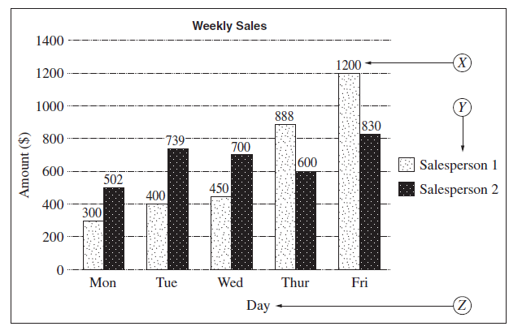
Which of the following correctly identifies the features labelled X, Y and Z in the chart?

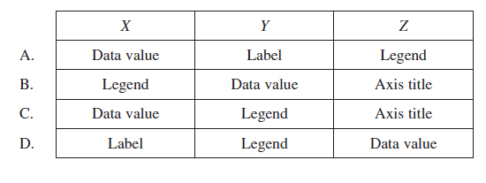
- Each time a date of birth is entered into a spreadsheet cell, hashtags are displayed instead of the date.
What does this indicate?
  - The column width is too narrow.
  - An incorrect formula has been entered.
  - The cell format has been set to display text.
  - The spreadsheet is using privacy protection.
- The following text appears in a document.
Which of the following could have been selected to produce the text?
  - Serif font, shadowed
  - Serif font, embossed
  - Sans serif font, shadowed
  - Sans serif font, embossed

- The spreadsheet shown contains details of learner drivers.
To be eligible for the driving test, the driver must meet the following requirements:
  - have held a learner licence for at least 12 months
  - have logged at least 120 hours driving time in their Learner Driver Log Book.
Which of the following can be used in D3?
  - =IF(B3>12,IF(C3>120,’YES’,’NO’),’NO’)
  - =IF(B3>12,IF(C3>=120,’YES’,’NO’),’NO’)
  - =IF(B3>=12,IF(C3>120,’YES’,’NO’),’NO’)
  - =IF(B3>=12,IF(C3>=120,’YES’,’NO’),’NO’)

- Which row of the table shows valid code for HTML and XHTML?
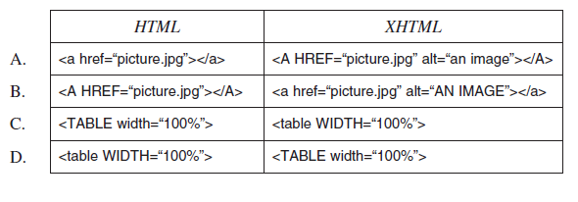
- The following macro is used to create a table.
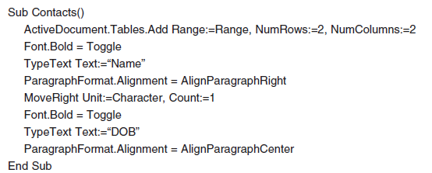
Which of the following correctly describes the table created by the macro?
  - The first row is right aligned.
  - The first row is centre aligned.
  - The first cell is right aligned.
  - The first cell is centre aligned.

- Consider the following HTML code and images.
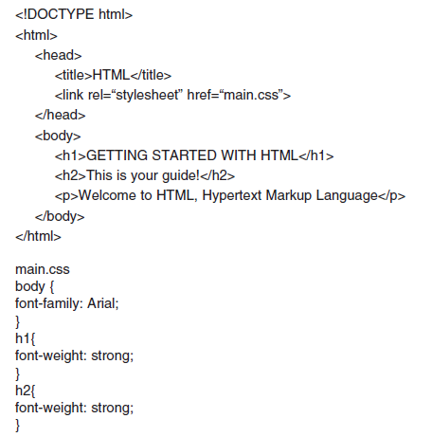
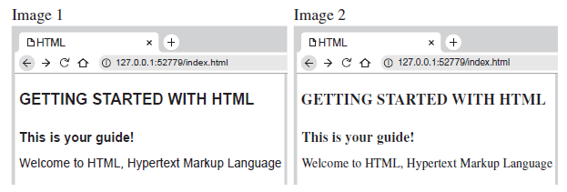

The coder had expected the HTML code to display Image 1, but Image 2 is being displayed.

What is the most likely cause of the problem?

  - Font family is missing.
  - <B> bold tag is missing.
  - Style sheet is incorrectly referenced.
  - Attribute of <p> has not been defined.

Putting the theory into practice
Some questions in ‘Putting the theory into practice’ are acknowledged © 2019 NSW Education Standards Authority (NESA) for and on behalf of the Crown in right of the State of New South Wales.

You are the owner of a Real Estate Agency.
- Create logo for the business
- Create a letterhead template in Word
- Create business cards
- Create a training presentation using PowerPoint to train staff on how to use the following spreadsheet functions and features
  - conditional logic
  - conditional formatting
  - data validation
  - formulae and functions
  - import and export data
  - mail merge
  - pivot tables
  - sort
- Create a spreadsheet customer list with 10 customers
- Import the spreadsheet into an Access Database
- Create a mail merge to customers database inviting them to an Open House
- Create an Operations Manual for staff that explains how they will implement the following functions:
  - Version control
  - Using Styles
  - Document Automation
  - The need for security and protection of documents
  - Table of contents
  - File Permissions
  - Grammar and Spell check
  - Automatic referencing
  - Track changes
  - Trouble shooting guides – links to online help for Word, Excel and Access

- Create a weekly timesheet for sales staff (example below). Use correct formulas and functions in your spreadsheet. Use the logo you created in activity 1. Conditionally format the total hours to display red if the staff member has worked more than 50 hours in the week.
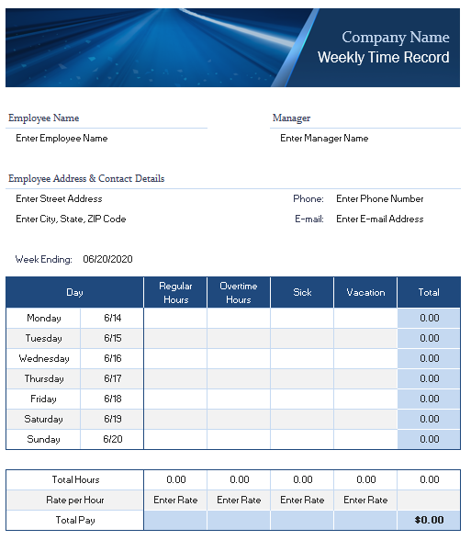

- Using an example, distinguish between a formula and a function in a spreadsheet.

- Describe file management functions that need to be implemented to ensure that a confidential document can only be accessed by authorised users and that the document is up to date.

- What is a benefit of using cascading style sheets (CSS) in website development?

- Why is it useful for a web author to understand coding as well as WYSIWYG authoring?

- A small software company has produced a new range of online games using XHTML.
  - Justify the use of online documentation over paper-based documentation for game support.

  - The company is considering purchasing images instead of creating its own images for its games. Discuss copyright issues associated with purchasing images for this purpose.

  - The games will be accessible through a new website. Recommend and justify strategies for testing the website.

- Explain the benefits of using an external CSS file compared to embedding CSS within HTML code.

- Use the following source code for a webpage to answer the question on the next page.
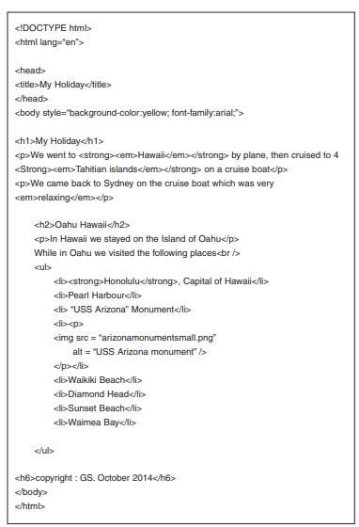

Draw the webpage as it would appear in a browser based on the given code.
You may use text to describe features you cannot draw.

- An online university, with staff and students physically located in different parts of Australia, requires communication resources for its staff and students to interact at any time.
Recommend and justify electronic communication methods and tools that could be used by the staff and students to communicate, collaborate within teams, access resources and submit work.

- A user wishes to include part of a copyright-free image from a website in a word-processed document. List the steps to achieve this.

- Outline ONE aspect of how a code of ethics relates to the use of commercial software packages.

- A school that allows its students to use their own computing devices such as laptops, tablets and mobile phones, has just developed a simple website to inform students about its events.
Outline suitable procedures for testing the website

- Using examples, explain how conditional formatting may be applied to improve the visual presentation of a spreadsheet.

- This diagram shows a website template designed for a school.
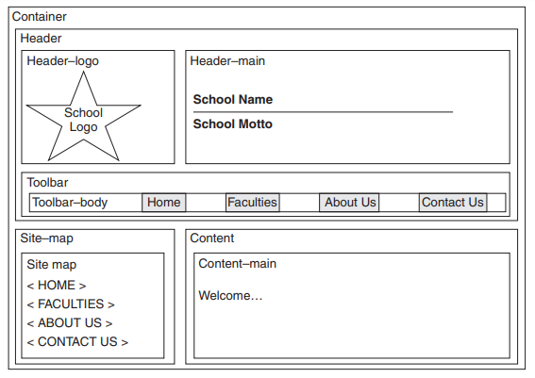
Construct a site map for the website template labelling all relevant features and justify the benefits of using cascading style sheets (CSS) in this website.
Draw an online form to allow users to submit questions or requests via the CONTACT US page on this website. Justify your choices of form elements used.

- This diagram shows a word-processed document before and after some changes have been made. Describe the changes that have been made to this document.
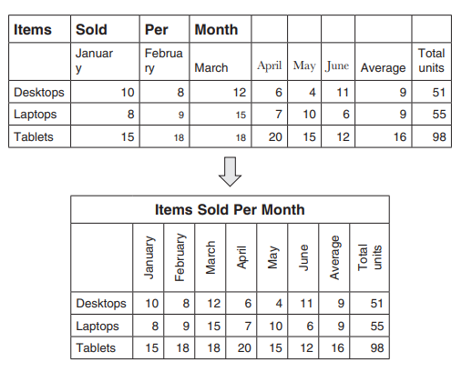

- The image shows part of the code of a website. Identify and correct the error
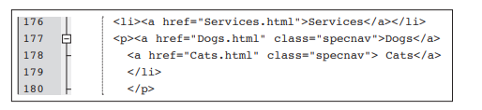

- Explain why it is important to test a newly built website on different types and versions of browsers.

- The diagram shows part of a spreadsheet. Create the spreadsheet in Excel and use the appropriate formulas and features as presented in the diagram.
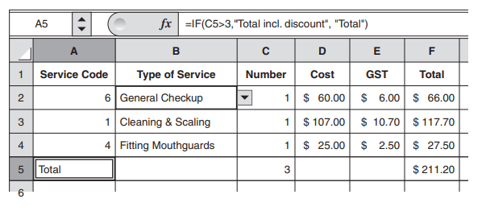
What feature has been used in Column B to validate input data?

Explain the purpose of the formula in A5.

- Write a procedure for creating an automatic table of contents in a word-processed document.

- Tony has just updated his word processing software. However, he is frustrated with the new features and has trouble locating the functions that he frequently uses. Suggest a range of sources where Tony may be able to obtain support for his problems and justify your answer.

- Explain how a pivot table can be used in business, use examples in your answer.

- A web designer has been asked by a small business to create a website to sell its products online.
  - Describe how a site map can be used in the construction of this website

  - Recommend a web authoring application suitable for the creation of this website and justify your choice.

  - Explain what information the web designer would need to consider for the creation and maintenance of this website.

- A large web design business wants to streamline its operations and improve the presentation of its documents.
  - Why are conventions for naming and saving files important for this company?

  - Explain how formatting features may be used to improve the structure and visual appeal of text in this company’s documents.

  - How can templates and document automation be used to improve both document presentation and efficiency of document production? Support your answer with examples.

- What is ONE advantage and ONE disadvantage of using a text editor instead of a word processor to create a webpage?

- A bakery business uses the following spreadsheet template to create invoices

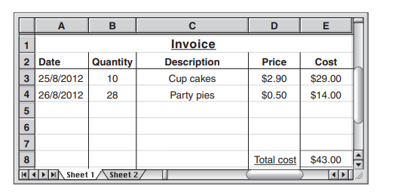

What formula should be used to calculate the total. Explain why =E3+E4 would not be the most efficient or correct formula to use in this instance.

- Outline TWO common issues that may occur when a website is tested across a variety of browsers.

- A business has offices in Sydney and San Francisco. Staff from both offices contribute to the production of monthly reports. The reports are stored on a server located in San Francisco.

  - Outline the benefits of using templates and version control in the production of the reports.

  - Discuss a method that staff in the Sydney office could use to upload a monthly report.

  - Justify strategies to ensure the security and protection of data for this business.

HSC Focus Areas
For the purposes of the HSC, all students undertaking the 240 HSC indicative hours course in Information and Digital Technology must address all of the mandatory focus area content plus one stream focus area.
IDT Mandatory focus areas
- Working in the industry
- Operating system software
- Diagnostic testing
- Safety
IDT Stream focus areas (know which one of the stream focus areas you are studying)
- Web and software applications
- Networking and hardware
- Digital animation

The scope of learning describes the breadth and depth of the HSC Content and has been grouped together into key ideas/areas. The scope of learning describes the minimum content that must be addressed, and the underpinning knowledge drawn from the associated units of competency
Creating a mind map is a great way to organise your knowledge and understanding of the content of a topic.
You could use software such as a hierarchy chart, download ‘MindNode’ or similar or use a large sheet of paper (or several A4 sheets taped together)! It is important to try to include all the detail you can, so add definitions, case studies or examples to prompt your memory.

The following scope of learning is taken directly from Information and Digital Technology Curriculum Framework Stage 6 Syllabus commencing at page 45.

commercial software packages
- general features and purpose of commercial software packages:
- word processing
- spreadsheet
- web authoring
- awareness of the range of commonly used applications for:
- word processing
- spreadsheets
- web authoring and browsers
- working knowledge of one word processing application, one spreadsheet application and one web authoring application
- purpose of input and output devices when using commercial software packages
- safe work practices when using commercial software packages
- basic understanding of how the Australian Computer Society Code of Ethics relates to the use of commercial software packages

document and website production requirements
- importance of using an application that suits the nature of the document and/or website, its purpose and intended audience
- how a range of requirements affects the design and structure of documents and simple websites:
- client requirements
- workplace requirements related to:
- structure and layout (to ensure consistent style and image)
- content restrictions
- copyright
- editing and amending
- conventions for saving, naming and storing document/files:
- file names, locations and pathnames
- folders
- directory structures
- drives
- backups
- distribution and storage requirements for:
- text-based documents:
- archive
- printing, including page set-up, print area, print quality, select printer, paper source and selection/range of pages

document and website production requirements cont/d
- websites:
- file transfer protocol (FTP) client for uploads to server
- server options

features and functions common across word processing, spreadsheet and web authoring software
- working knowledge of features and functions within applications to prepare and present documents and simple websites:
- for entering and editing content:
- alpha/numeric text
- images and graphics
- interactive components including forms, fields, buttons and drop-down lists
- links including hyperlinks and embedded links
- reviewing, including spell and grammar check
- for structuring content:
- columns
- indentations
- pagination, including page identification, page breaks, worksheets and web pages
- new lines and paragraphs
- sections
- tables and tabulating information
- for formatting content:
- alignment
- fills or shading
- lines and borders
- merge and split cells
- styles
- text direction
- typeface and font size
- for file management:
- document automation:
- macros
- scripts
- shortcuts
- permissions
- security and protection
- sharing
- templates
- version control

additional features and functions specific to word processing, spreadsheet and web authoring software
- features and functions within a word processing application to prepare and present documents:
- automatic referencing
- formatted lists
- mail merge
- track changes
- sort
- table of contents
- features and functions within a spreadsheet application to prepare and present documents:
- charts
- conditional logic
- conditional formatting
- data validation
- formulae and functions
- import and export data
- mail merge
- pivot tables
- sort
- features and functions within a web authoring tool to build simple web pages/websites:
- formatted lists
- HyperText Markup Language (HTML), Cascading Style Sheets (CSS) and eXtensible HyperText Markup Language (XHTML)
- what-you-see-is-what-you-get (WYSIWYG) versus coding (HTML and CSS)

problem-solving
- sources of support commonly used to solve software-related problems:
- documentation:
- manual
- training material
- vendor/supplier documentation
- online help
- technical support:
- troubleshooting results
- alert message
- solve routine problems associated with using word processing, spreadsheet and web authoring software

website authoring
- use of site maps in planning website navigation
- process for modifying existing markup
- website testing:
- outline reasons for testing newly built websites:
- consistent presentation
- consistent performance
- meet client needs, including accessibility
- procedures for testing elements of simple websites across a variety of browsers and across versions of a browser
Example of mind map being developed.
