Information and Digital Technology

**Mandatory Focus Area: Safety**

Welcome: this module will assist you to review and revise the content of the mandatory focus area ‘Safety’. Each focus area prescribes the scope of learning for the HSC and is drawn from associated units of competency.

You will have studied this competency, which addresses the scope of learning:

[BSBWHS304 Participate effectively in WHS communication and consultation processes](https://training.gov.au/Training/Details/BSBWHS304)

This module is broken up into:

* Important notes
* Key terms and concepts
* Activities
* Putting the theory into practice
* HSC focus areas

How to use the resource

Work through the notes and the suggested activities. You can mix up the order. Great revision techniques include working through how a problem is solved, explaining the concept, testing yourself and retrieving information from your memory. Spread your revision over a number of sessions rather than sitting at one subject for lengthy periods.

Discuss your responses with your teacher, fellow students or an interested family member.

All images, apart from those acknowledged, are  NSW Department of Education.

# Important Notes

You should use the information here as a prompt and guide when revising your study notes or text-book information or other resources provided by your teacher. You can also access industry specific information at [SafeWork NSW](https://www.safework.nsw.gov.au/).

The unit [BSBWHS304 Participate effectively in WHS communication and consultation processes](https://training.gov.au/Training/Details/BSBWHS304) describes the skills and knowledge required to participate in work health and safety (WHS) communication and consultation processes.

To complete the unit requirements safely and effectively, you must show evidence of ability to:

* participate in work health and safety (WHS) communication and consultation processes, including communicating WHS information to others
* raise WHS issues in meetings and follow up on outcomes
* take appropriate actions to remove barriers to communication and consultation processes
* support others to raise relevant WHS issues
* describe the purpose of organisational WHS policies, procedures, processes and systems
* outline the key requirements of relevant commonwealth and state/territory WHS Acts, regulations, codes of practice, standards and guidance material, and other relevant publications
* describe potential barriers to WHS consultation processes and how the barriers may be overcome
* explain the roles and responsibilities of WHS personnel
* describe how the consultation process influences and is related to workplace information management procedures, processes and systems
* describe methods to engage others with workplace procedures, and information sourcing and sharing.

The outcomes of the HSC mandatory focus area ‘Safety’ require that the student:

* explains safe work practices and procedures for the information and communications technology (ICT) industry
* demonstrates an understanding of work health and safety (WHS) consultation, participation and compliance in the ICT industry
* applies risk management in an ICT workplace
* describes workplace policy and procedures that ensure the safety of clients, colleagues and the ICT worker.

# Key terms and concepts

### You can use the following information to revise the key terms and concepts from this unit of competency. Perhaps you could:

* Copy the table into your own file, remove all the key terms, then fill in the blanks (without peeking at the original file) with your own answers.
* Copy the table into your own file and remove the definitions. Write a definition in your own words – it doesn’t have to word perfect but should show you understand the concept.
* You could add an example of this term or concept which is relevant to the information technology environment. If the key term was ‘safety hazard’ your IDT example might be ‘double adaptors, piggy-back plugs, un-switched power boards and the daisy chaining of power boards is strictly prohibited’.

|  |  |  |
| --- | --- | --- |
| Key term or concept | Definition | |
| Absenteeism | In Australia, absenteeism is generally considered to be non-attendance at work by employees when they are rostered to work. Absenteeism can include genuine absences (such as illness or caring for an ill child) and questionable absences (for example where an employee is not actually ill or caring for a family member). | |
| Breach | Failure to follow requirements. | |
| Bullying | [Workplace bullying](https://www.safeworkaustralia.gov.au/glossary#Workplace_bullying) is repeated and unreasonable behaviour directed towards a worker or group of workers that creates a risk to health and safety. Examples include abusive or offensive language or comments, aggressive and intimidating behaviour, belittling, or humiliating comments, practical jokes or initiation and/or unjustified criticism or complaints. | |
| Compensation | The cost of workplace injuries is enormous to our society through both compensation monies and lost production time. Compensation monies may be paid to make up for someone's loss, damage, or injury, giving the injured party an appropriate benefit. | |
| Consultation | Consultation is a statutory requirement of most WHS legislations around the world. The aim is to gather information from all stakeholders in the organisation and allow effective participation in the establishment of meaningful health and safety policies and procedures. | |
| Control measures | The steps required to keep a hazard from causing injury, illness and/or damage. | |
| Dangerous goods | Dangerous Goods are substances or articles that are hazardous to people and property. They may be explosives, gases, chemicals, flammable solids or liquids or toxic substances. | |
| Emergency | An emergency is an incident or a situation which endangers, or may endanger, the health, safety and welfare of persons in the workplace, and which requires urgent action to control. | |
| Emergency Plan | An emergency plan is a written set of instructions that outlines what workers and others at the workplace should do in an emergency. | |
| Ergonomics | the process of designing or arranging workplaces, products and systems so that they fit the people who use them. |
| Evacuation | All organisations and businesses must have an Emergency Evacuation Plan that guides people inside the building, out to an assembly area, as quickly as possible. Procedures for fire and other emergencies should always include provisions for the evacuation of people including those with a disability.  It is compulsory by law to have evacuation diagrams at relevant places. |
| Feedback | Response to a query or reaction to something, used to facilitate future discussions and decisions. |
| Harassment | Harassment can be against the law when a person is treated less favourably on the basis of certain personal characteristics, such as race, sex, pregnancy, marital status, breastfeeding, age, disability, sexual orientation, gender identity or intersex status. |
| Hazard | *Standards Australia* defines a hazard as ‘a source or a situation with the potential for harm in terms of human injury or ill-health, damage to property, damage to the environment, or a combination of these.’ |
| Health | Includes both physical and psychological health. |
| Health and Safety Representative | A worker who has been elected by their work group under the WHS Act to represent them on health and safety matters. |
| Industry Safety Guidelines | These are developed with a particular industry to provide safety advice relevant to that industry. In IDT in Australia, for example, safety guidelines have been developed by [SafeWork NSW](https://www.safework.nsw.gov.au/your-industry/) and [Department of Industry, Innovation and Science](https://www.business.gov.au/risk-management/health-and-safety/how-to-make-your-workplace-safer) |
| Legislation | The [NSW Work Health and Safety Act 2011](https://www.legislation.nsw.gov.au/#/view/act/2011/10) (WHS Act) and the [NSW Work Health and Safety Regulation 2017](https://www.legislation.nsw.gov.au/#/view/regulation/2017/404) (WHS Regulation) define the obligations both employers and workers have to health and safety in the workplace.  The WHS legislation is supported by a [Compliance policy and prosecution guidelines](https://www.safework.nsw.gov.au/__data/assets/pdf_file/0012/50160/SW08683-0318-402497.pdf), which supplements the [National compliance and enforcement policy](http://www.safework.nsw.gov.au/__data/assets/pdf_file/0020/51725/national-compliance-enforcement-policy-3723.pdf). |
| Managing risk | A process set out in the WHS regulations to eliminate health and safety risks so far as is reasonably practicable, or if this is not reasonably practicable, minimise the risks so far as is reasonably practicable. Includes identifying hazards, assessing and implementing control measures, and reviewing and maintaining the control measures to ensure ongoing effectiveness. |
| Manual Handling | Manual handling is any activity where the use of force physically, by a person, is exerted to push, pull, lift, lower, extend, restrain, carry, move or hold a stationary or moving, or animate or inanimate object. |
| Mental health | A person’s mental health affects how they feel, think, behave and relate to others. |
| MSDS Material Safety Data Sheet | The Material Safety Data Sheet (MSDS) is a document that describes the chemical and physical properties of a material and provides advice on safe handling and use of the material |
| Noise | Usually rated in decibels (dB), noise is the phenomena associated with sound pressure on the human ear drum. |
| Occupational Overuse Syndrome (OOS) | Sometimes referred to as repetitive strain injury (RSI), OOS is a malady affecting bones, muscles, and ligaments, usually arising from repetitive stressing of those body parts, such as repetitive movement. It can be exacerbated by such mental pressures as dislike of the task, or pressure to get the job finished. | |
| Pain and suffering | ‘Pain and suffering’ is the legal term for the physical and emotional [stress](https://en.wikipedia.org/wiki/Stress_(medicine)) caused from an injury. | |
| Participation | Participation is the act of sharing in the activities of a group; encouraging [involvement](https://www.thefreedictionary.com/involvement) [and](https://www.thefreedictionary.com/involution) [engagement](https://www.thefreedictionary.com/engagement) and action. The Work Health and Safety Act aims to provide for fair and effective workplace representation, consultation, co-operation and issue resolution in relation to work health and safety. | |
| PCBU | A PCBU is an umbrella concept which intends to capture all types of working arrangements. A ‘person conducting a business or undertaking’ (PCBU) might be a company, a partnership conducting a business, an unincorporated body or association, a sole trader or self-employed person. | |
| PPE (personal protective equipment) | Used to describe protective equipment that is worn to being protected someone from hazardous situations. PPE includes such things as hats and hair nets, aprons, gloves, overalls, safety shoes and boots, eye and face protection such as goggles, face shields and masks; ear protection such as ear-muffs and ear plugs and breathing equipment. | |
| Productivity | A link has been identified between WHS and productivity. Poor work, health and safety has been linked to lower levels of workplace productivity and performance. | |
| Reporting | WHS reporting, like any other business intelligence, needs to provide management with relevant, robust and timely information that can inform the decisions that influence ongoing business performance. Reporting of incidents and concerns contributes to a safe workplace. | |
| Representation | The Work Health and Safety Act (the WHS Act) aims to provide for fair and effective workplace representation, consultation, co-operation and issue resolution in relation to work health and safety.  Worker representation provides a means for facilitating consultation, involving workers and giving them a voice in health and safety matters. | |
| Risk | The likelihood of a hazard becoming a danger. The possibility that harm (death, injury, illness) might occur when exposed to a hazard. | |
| Risk management | The holistic approach to looking after health, safety and welfare of all people; a systematic process for addressing hazards in the workplace. | |
| Safe Work Practices | These include identifying potential hazards, training and inducting staff, ensuring all staff use the appropriate Personal Protective Equipment and ensuring that all equipment is properly maintained | |
| Significant Injury | Sometimes called ‘serious injury’ or ‘notifiable injury’, generally a significant injury is any injury likely to lead to a person being unable to perform their pre-injury functions for seven days or more. | |
| Visitor | Basically, under the conditions of the WHS Act, a visitor is considered to be anyone who is not doing ‘work’ on behalf of the firm, sometimes described as ‘others’. This will include door-to-door salespeople, relatives, and friends of employees, and so on. | |
| WHS Policies and Procedures | WHS policies and procedures outline the requirements for complying with both external and internal WHS compliance requirements. | |
| Work Health and Safety Management System | A system that includes all the programmes, policies, procedures, organisational structures, planning activities, responsibilities, processes, practices and resources for developing, implementing, achieving, reviewing and maintaining the Work Health and Safety of all persons in, or affected by, the workplace. | |
| Worker’s responsibilities | All workers are responsible for the WHS impact of their own actions. They also have a duty to make sure their work is carried out in line with WHS procedures and any applicable legislation. More specifically, workers must take reasonable care for their own health and safety. | |

# Activities

1. The [NSW Work Health and Safety Act 2011](https://www.legislation.nsw.gov.au/#/view/act/2011/10) (WHS Act) and the [NSW Work Health and Safety Regulation 2017](https://www.legislation.nsw.gov.au/#/view/regulation/2017/404) (WHS Regulation) define the obligations that both employers and workers have to health and safety in the workplace.   
   List at least five obligations of the employer and at least five obligations of the employee.
2. Complete the following poster showing how to arrange your workstation to minimise the impact of awkward and frequently performed movements.

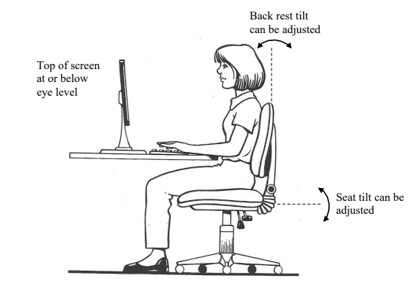

[Original illustration](https://www.worksafe.qld.gov.au/__data/assets/pdf_file/0006/83067/guide-ergo-comp-workstations.pdf) © The State of Queensland 2012 used with permission (see page 2)

1. Research the following from [SafeWork NSW](https://www.safework.nsw.gov.au/legal-obligations/worker-obligations) and make notes explaining:
   * 1. Consultation (scroll down to this heading)
   1. A fair and just workplace
   2. Your safety responsibilities as a worker

Remember, health and safety representatives play an important role in representing the health and safety issues of a work group and can talk to your employer on your behalf.

1. Access [SafeWork Australia](https://www.safeworkaustralia.gov.au/electrical-safety) and answer the following questions:
   1. How many workers died as a result of contact with electricity between 2003 and 2015?
   2. What was the main cause of these deaths?
   3. Which industry appears the riskiest for electrical deaths? Does this mean you only have to take care if you work in this particular industry?
   4. What types of equipment involve greater risk to workers?
   5. Explain ‘inspect, test, tag’.
   6. What is an RCD?
2. [**SmartMove**](https://smartmove.safetyline.wa.gov.au/certificate/) is a Work Health and Safety online educational program for senior high school students and young workers entering the workforce for the first time. Registering to use the resources and quizzes and work towards achieving a SmartMove Certificate is **free** and only takes a few minutes. Access [SmartMove](https://smartmove.safetyline.wa.gov.au/about/) and undertake the ‘general’ and ‘business and information technology’ modules.
3. Find examples of the type of safety signs you would see in an information technology environment. Look for signs which:
   1. indicate you must **not** do something (stop signs: white background, red circle with cross bar)
   2. warn you of a danger (caution signs: yellow background, black symbol)
   3. provide emergency information (green and white)
   4. indicate what you must do (mandatory signs: circle with a blue background and white symbol)
4. Match the two halves of each sentence.   
   Draw a line between each or write (or cut and paste) the correct sentences, in full, below the table.

|  |  |
| --- | --- |
| An employer | is the responsibility of an employer. |
| Hazards | law must provide workers with training and supervision and a safe and healthy workplace. |
| Safety Signs | employers and employees to consult and cooperate (work together) to make their workplace safe. |
| The title of the NSW safety legislation (laws) that protect workers is | should follow safety procedures, work safely and not put the safety and health of others in the workplace at risk. |
| The control of hazards | warn people of danger and provide safety information. |
| NSW safety and health laws encourage | The NSW Work Health and Safety Act 2011 (WHS Act) and the NSW Work Health and Safety Regulation 2017 (WHS Regulation). |
| An employee (worker) | is available from SafeWork NSW. |
| Information on safety and health at work | must be controlled by the employer, manager or supervisor. |

1. Access websites <http://www.whitecardsafety.com/fire-safety.html> and <https://www.fireequipmentonline.com.au/6-fire-extinguisher-classes-in-australia> to complete the following:

|  |
| --- |
| Fire is a chemical reaction requiring what three components? |
|  |
|  |
|  |
| The way to extinguish a fire is to remove any, or all, of the components of the fire triangle. List four: |
|  |
|  |
|  |
|  |
| The type of alarm needed can range from a simple shout of 'fire', to sophisticated automatic systems. Whatever system is chosen, make sure it: |
|  |
|  |
|  |
| There are six classes or types of fires in Australia. List them below providing an example and indicating what extinguishing agent should be used on each. |
| Class A |
| Class B |
| Class C |
| Class D |
| Class E |
| Class F |

1. Locate this ‘[Draft Health and Safety Policy for ‘Department of Information Technology’](https://bvi.gov.vg/sites/default/files/resources/DoIT%20Health%20&%20Safety%20Policy.pdf) and prepare a list of the headings contained within. Include a short summary of the content of each heading.
2. Managing risks in the workplace.

The [Department of Industry, Innovation and Science](https://www.business.gov.au/risk-management/health-and-safety/how-to-make-your-workplace-safer) provides guidance on how to manage risks in the workplace using a systematic process. Provide a definition for each step in the process.

A systematic process for managing risks in the workplace

|  |  |
| --- | --- |
| Identify hazards |  |
| Assess risks |  |
| Control risks |  |
| Review control measures |  |
| Record and report safety issues |  |
| Support return to work |  |
| Make your workplace healthier |  |

1. Consider the following three information technology environments. For each one, develop a list of three safety topics to be discussed at a WHS Safety meeting.



Image licenced under CC0. The original version can be found on [pexels](https://www.pexels.com/photo/group-of-people-watching-on-laptop-1595385/).

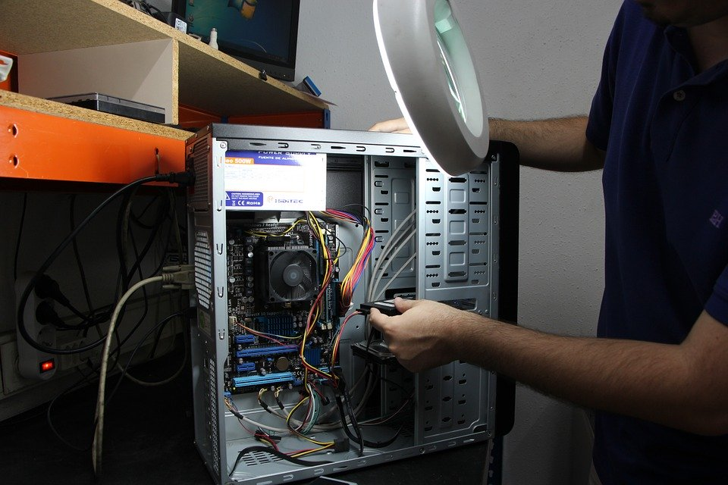

Image licenced under CC0. The original version can be found on [pixabay](https://pixabay.com/photos/workshop-repair-computers-computer-377099/).



Image licenced under CC0. The original version can be found on [pixabay](https://pixabay.com/vectors/movers-moving-carry-lift-walk-24402/).

1. Managing risks in the information technology workplace.
   1. What is the difference between a risk and a hazard?
   2. Consider a range of areas within the IDT workplace which could potentially be considered a risk or hazard.
   3. Develop a list of at least three examples of a risk control measure which could be implemented
   4. Use these examples in your mind map (below).
2. Fill in the blanks, using the words provided.

|  |  |  |  |
| --- | --- | --- | --- |
| effective | communication | implementing | frequency |
| hazardous | earliest | instructions | activity |
| emergency | procedures | storage | workers |

[**What is an emergency plan**](https://www.safeworkaustralia.gov.au/system/files/documents/1702/emergency_plans_fact_sheet.pdf)**?**

An emergency plan is a written set of ( ) that outlines what ( ) and others at the workplace should do in an ( ). An emergency plan must provide for the following:

* emergency procedures, including: an ( ) response to an emergency
* evacuation ( )
* notifying emergency service organisations at the ( ) opportunity
* medical treatment and assistance, and
* effective ( ) between the person authorised to coordinate the emergency response and all people at the workplace
* testing of the emergency procedures—including the ( ) of testing, and
* information, training and instruction to relevant workers in relation to ( ) the emergency procedures.

**What types of emergencies should be covered?**

The types of emergencies to plan for may include fire, explosion, medical emergency, rescues, incidents with ( ) chemicals, bomb threats, armed confrontations and natural disasters.

The emergency plan should be based on a practical assessment of hazards associated with the work ( ) or workplace, and the possible consequences of an emergency occurring as a result of those hazards. External hazards should also be considered in preparing an emergency plan, for example a chemical ( ) facility across the road.

In developing the plan, consideration should be given to the application of all relevant laws, including public health ( ) (for example, workplaces that are also public places) and state or territory disaster plans.

# Putting the theory into practice

The following questions are from [past years’ NSW HSC examination papers](https://educationstandards.nsw.edu.au/wps/portal/nesa/11-12/resources/hsc-exam-papers) for this subject. HSC exams are intended to be rigorous and to challenge students of all abilities. To better understand a question, you should look for key words and identify the aspect of the course to which these relate. You are then in a position to formulate your answer from relevant knowledge, understanding and skills.

All questions in ‘Putting the theory into practice’ are acknowledged © [2019 NSW Education Standards Authority (NESA) for and on behalf of the Crown in right of the State of New South Wales.](https://educationstandards.nsw.edu.au/wps/portal/nesa/mini-footer/copyright)

## Multiple Choice

1. Which of the following is the best strategy to reduce manual handling injuries in the workplace?
   1. Two people sharing a heavy load
   2. Unpacking heavy objects before moving them
   3. Only taking delivery of packages below a safe weight
   4. Reporting heavy packages to the workplace safety officer
2. Which of the following is most likely to be covered in an organisation’s work health and   
   safety policy?
   1. Time in front of a computer
   2. Information about superannuation
   3. Protocols for dealing with suspicious emails
   4. Guidelines surrounding the personal use of the internet
3. Your supervisor has asked you to mop up a spill of water next to a workstation.

What is this an example of in the risk control hierarchy?

* 1. Elimination
  2. Isolation
  3. Modification
  4. Substitution

1. Which of the following is an internal source of work health and safety (WHS) information in an ICT organisation?
   1. Minutes of a compliance meeting
   2. A hardware manufacturer’s manual
   3. A WorkCover information document
   4. An Australian Computer Society publication
2. When should a risk assessment be adjusted?
   1. On a daily basis
   2. As soon as a worker makes a complaint
   3. Where there is evidence that a risk is no longer valid
   4. When no injuries have been recorded recently against a risk
3. What form of risk control is applied when a hazard is isolated?
   1. Administration
   2. Assessing
   3. Elimination
   4. Minimisation
4. What is the purpose of a safety data sheet (SDS)?
   1. It outlines safe methods for moving heavy objects.
   2. It provides critical information about hazardous chemicals.
   3. It states the maximum temperature at which a computer can be safely operated.
   4. It specifies the safe power level that needs to be provided for each electrical device.
5. One example of a human cost of a workplace injury is loss of
   1. staff.
   2. profit.
   3. output.
   4. morale.
6. Which type of work health and safety document provides guidelines that are legally enforceable?
   1. Regulation
   2. Code of practice
   3. Industry standard
   4. Australian standard
7. Which electrical test tag contains all of the information required by SafeWork NSW?

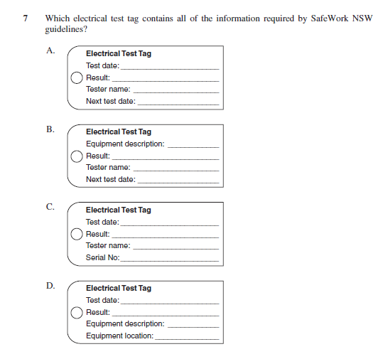

1. An employee has tripped over a computer cable and injured his wrist. After first aid has been provided, who should next be notified of this incident?
   1. Union
   2. Manager
   3. WorkCover
   4. Workplace Assessor
2. A computer company redesigned all of its workstations to reduce the chance of injury to workers. Which type of risk control measure has been used?
   1. Administrative
   2. Engineering
   3. Isolation
   4. Substitution
3. Which of the following is an INCORRECT statement about work health and safety when using a computer?
   1. Chairs should be adjustable, and the user’s feet should be supported.
   2. To improve readability the light source should be directed at the monitor.
   3. Keyboard height should ensure that the forearms are parallel to the floor and the wrists are not bent.
   4. Job rotation and incorporating breaks and exercise into work routines can reduce the risk of repetitive strain injury.
4. Which of the following is responsible for the legal enforcement of Work Health and Safety (WHS) standards?
   1. Unions
   2. Local council
   3. WorkCover NSW
   4. Professional associations
5. The symbol shown normally appears with a yellow background.



What is indicated by this symbol?

* 1. First aid
  2. Keep dry
  3. Hazard or warning
  4. Request for assistance

## Questions from Section II

These questions should be answered in the suggested number of lines (handwritten) as it gives a guide to the length of your response.   
  
Plan out your answer and key points before you commence writing

Question 1  
The image below shows a power board at a worksite.

powerboard at a worksite

Illustration from **HSC Examination** Information Technology 2013

The table below shows how the risk level (low, medium and high) of a hazard is determined based on the type of injury and the likelihood of the injury occurring.

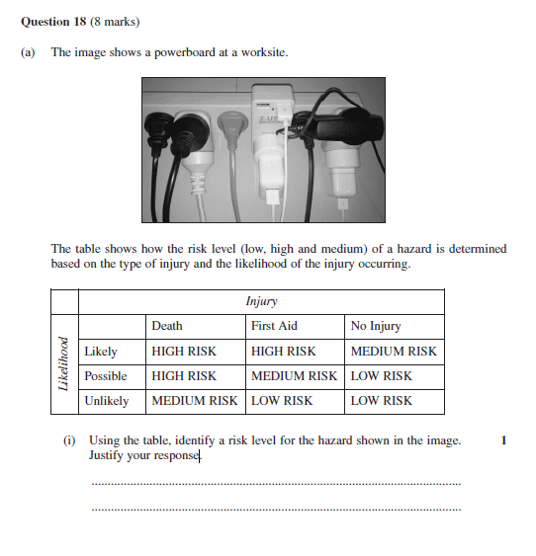

Using the table, identify a risk level for the hazard shown in the image. Justify your response. (3 marks)

Question 2

* 1. Why are power leads tagged? (2 marks)

* 1. Describe how a workstation can be setup to minimise neck, back and wrist pain. (4 marks)

Question 3

* 1. What precautions should be taken when moving a 30 kg printer from a storeroom to an office? (2 marks)

* 1. An organisation has purchased new laptops to replace its existing desktop computers. Identify TWO ergonomic considerations for setting up these new laptops. (2 marks)

* 1. Describe how old computer equipment can be disposed of in a safe and environmentally responsible manner. (4 marks)

Question 4

The image shows a workspace.

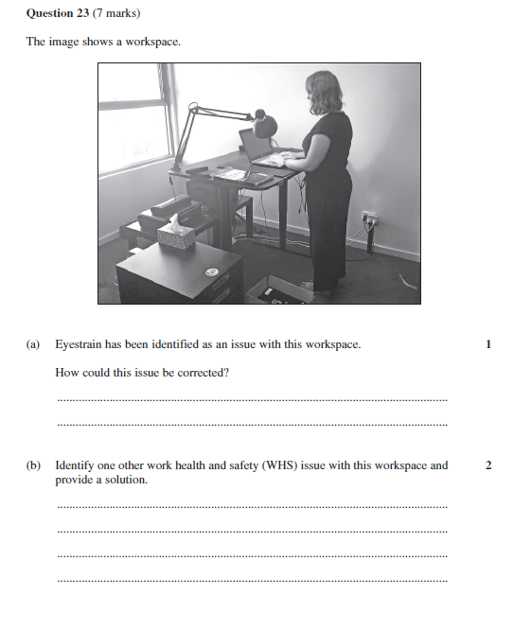

Illustration from **HSC Examination** Information and Digital Technology 2018

* 1. Eyestrain has been identified as an issue with this workspace.   
     How could this issue be corrected? (1 mark)

* 1. Identify one other work health and safety (WHS) issue with this workspace and provide a solution. (2 marks)

Question 5

Explain how a workstation can be set up to minimise workplace injuries. (4 marks)

Question 6

Describe the role of SafeWork NSW (formerly WorkCover NSW). (2 marks)

## Questions from Section III

In the HSC -

* there will be one structured extended response question **based on the stream focus area** and **can also draw from the mandatory focus areas** (15 marks).
* the question will have two or three parts, with one part worth at least 8 marks.
* the question will have an expected length of response of around four pages of an examination writing booklet (approximately 600 words) in total.

## Questions from Section IV

In the HSC -

* there will be one extended response question based on the **mandatory focus areas**
* the expected length of response is around four pages of an examination writing booklet (approximately 600 words).
* your answer will be assessed on how well you:
* demonstrate knowledge and understanding relevant to the question
* communicate ideas and information using relevant workplace examples and industry terminology
* present a logical and cohesive response

You should allow about 25 minutes for a question in Section IV in the exam.

You will note that the questions from Section IV usually require you to bring together knowledge from several areas of study/competencies to do justice to the answer.

In each of the following, map out your answer using post-it notes or a sheet of paper.

Pay particular attention to incorporating a variety of aspects of your IDT curriculum into the plan. Consider why we have included this question within this module and what other areas of study you would need to draw upon.

Question 1 (15 marks)

A business has assigned a crucial nine-month ICT project to a small team of three employees. Due to the tight timeline and limited resources, it is concerned that the project could be affected by illness or injuries of its team members.

Recommend strategies that can be implemented by the business to minimise human, economic and organisational costs to the business if a team member is unable to work due to prolonged illness or injury.

Question 2 (15 marks)

A technology company is reviewing its risk management after several workplace injuries.   
A technician was struck by a box falling from a shelf while repairing a printer. A client slipped and fell on a wet floor when the floor was being cleaned. Most recently, a trainee suffered an electric shock while attempting to repair a computer.

Explain how risk management could be applied in this workplace to identify hazards, and to assess, control, monitor and review risks.

Question 3 (15 marks)

A large manufacturer of ICT components employs people from diverse cultural backgrounds as well as people with disabilities. The company operates 24 hours a day, 6 days a week, requiring staff to undertake shift work.

A recent evacuation drill highlighted a number of serious concerns at this workplace. It was noted that a large number of staff members were unaware of their responsibilities. People, including managers and visitors, were unaccounted for. People with disabilities had difficulty evacuating.

Recommend and justify ways in which this organisation can raise awareness among its entire staff on the importance of consultation and participation in work health and safety processes

# HSC Focus Areas

For the purposes of the HSC, all students undertaking the 240 HSC indicative hours course in Information and Digital Technology must address **all of the mandatory focus area** **content** plus **one** **stream** **focus area.**

IDT **Mandatory** focus areas

* Working in the industry
* Operating system software
* Diagnostic testing
* Safety

IDT **Stream** focus areas (know which **one** of the stream focus areas you are studying)

* Web and software applications
* Networking and hardware
* Digital animation

The unit of competency associated with the focus area ‘Safety’ is [BSBWHS304 Participate effectively in WHS communication and consultation processes](https://training.gov.au/Training/Details/BSBWHS304)

The scope of learning describes the breadth and depth of the HSC Content and has been grouped together into key ideas/areas. The scope of learning describes the minimum content that must be addressed, and the underpinning knowledge drawn from the associated unit(s) of competency.

How to use the scope of learning for ‘Safety’ (which follows over).

1. draw up your own mind map showing the connection between the various concepts listed; examples appear on the last page of this module
2. use the key terms and concepts to add to your mind map
3. add examples or case study prompts to show how the concept is applied in the information technology working environment

The following information is taken directly from page 38 ff of [Information and Digital Technology Curriculum Framework Stage 6 Syllabus (NSW Education Standards Authority) for implementation from 2020.](https://educationstandards.nsw.edu.au/wps/wcm/connect/852daa22-4180-4a58-b57f-c2a09540e5e7/vet-information-digital-technology-11-12-syllabus-based-on-V.5.0-jan-2020.pdf?MOD=AJPERES&CVID=) © [2019 NSW Education Standards Authority (NESA) for and on behalf of the Crown in right of the State of New South Wales.](https://educationstandards.nsw.edu.au/wps/portal/nesa/mini-footer/copyright)

|  |
| --- |
| work health and safety (WHS) |
| * meaning of health, safety and duty of care |
| * implications of the cost of workplace injury: * human * social * economic * organisational |
| * acknowledge that WHS is everyone’s responsibility in the workplace and the implications of this responsibility |
| * concept of ‘participation’ and ‘consultation’ in relation to WHS |
| * primary role/function of key bodies involved in WHS: * SafeWork NSW * Safe Work Australia * local councils * unions * professional associations |
| * importance of acting within the level of authority in relation to WHS in the workplace: * taking initiative * problem-solving * decision-making |
| WHS compliance |
| * difference between an act, regulation, code of practice, guidance material and standard (Australian, industry, workplace) |
| * consequences of failure to observe (non-compliance) WHS workplace policy and procedures and legislative requirements |
| * ICT industry and workplace requirements for monitoring and reporting in relation to WHS |
| * describe how, when and to whom to report WHS issues and incidents: * types: * formal and informal * written * verbal * reporting to appropriate persons |
| * purpose and importance of monitoring and reporting |

|  |
| --- |
| WHS compliance cont/d |
| * apply workplace policy and protocols and regulatory requirements when recording and reporting in relation to WHS |
| * purpose and intent of WHS legislation and codes of practice and their application to the ICT industry and workplace and a specific job role: * WHS legislation: * *Work Health and Safety Act 2011* (NSW)(as amended) * *Work Health and Safety Regulation 2011* (NSW) (as amended)   codes of practice related to:   * using electricity * manual handling * risk management * WHS consultation |
| * WHS rights, duties and responsibilities of the person conducting a business or undertaking (PCBU), officer and worker (as defined in the legislation) |
| risk management |
| * difference between a hazard and a risk |
| * risk management and its application in the workplace: * hazard identification: * potential hazards to self, colleagues, clients and visitors * range of hazards: * electricity and cabling * tools and equipment * manual handling * materials * work processes and practices * work environment * human factors (self and others) * risk assessment * risk control (hierarchy): * eliminate the risk * minimize the risk: * substitution * modification * isolation * engineering control * other controls: * administrative * safe work practices * personal protective equipment (PPE) * monitor and review |
| safe work practices and procedures |
| * importance of safe work practices and procedures |
| * safe work practice and procedures for an ICT workplace and their purposes: * electrical safety: * cabling and leads: * proper placements and securing * maintenance * appropriate storage * tagging * general electrical safety * ergonomics: * use of adjustable furniture * correct placement of equipment * posture and exercise: * adequate rest breaks * task rotation * lighting * ventilation * manual handling techniques: * when working individually, in pairs and in a team * recommended weight limits * tools and equipment: * selection appropriate to the task/work activity * correct use * maintenance * procurement and disposal * clean-up procedures and waste disposal with due consideration of WHS and the environment |
| * propose safe ICT work practices and procedures for a specific workplace within the ICT industry |
| WHS consultation and participation |
| * barriers to successful consultation and participation in WHS processes: * reasons why consultation and participation may be hindered: * lack of, or limited access to, WHS-related information * unsupportive workplace culture * failure to cater for the needs of those with disabilities * language and literacy levels of participants * unsystematic approaches to work * poor communication skills * unrealistic timeframes * cultural differences |
| WHS consultation and participation cont/d |
| * geographic dispersal of employees * remote location work sites * resolutions |
| * importance of, and procedures for, raising awareness about the need for WHS consultation and participation in an ICT workplace |
| * roles and responsibilities of relevant personnel in WHS consultation and participation: * PCBU * manager/supervisor/team leader * other workers * self * union * health and safety representative (HSR) * health and safety committee (including election/formation) * WHS specialist/technical adviser * workplace assessor |
| * opportunities for workers to provide input into WHS consultation and participation processes: * WHS audit * WHS inspection * meetings * formal and informal discussions |
| * importance of recording recommendations and following up the outcomes arising from WHS consultation and participation |
| * methods for communicating WHS information and recommendations |
| WHS information and data |
| * internal and external sources of WHS information and data: * experts/specialists * industry and professional bodies * manufacturer’s manuals and specifications * minutes of meetings * safety data sheets (SDS) and registers * records * regulatory authorities * reports * unions * websites, journals and newsletters |
| * tools and techniques for gathering WHS information and data: * WHS audits * checklists |
| WHS information and data cont/d |
| * formal and informal meetings * inspections * interviews * self-assessment * surveys |

Creating a mind map is a great way to organise your knowledge and understanding of the content of a topic.

You could use software such as a hierarchy chart, download ‘MindNode’ or similar or use a large sheet of paper (or several A4 sheets taped together)!

It is important to try to include all the detail you can, so add definitions, case studies or examples to prompt your memory. Include the information downloaded from the unit of competency and also from the Scope of Learning and Key Terms and Concepts.

