Entertainment Industry
Mandatory Focus Area: Safety

Welcome: this module will assist you to review and revise the content of the mandatory focus area ‘Safety’. Each focus area prescribes the scope of learning for the HSC and is drawn from associated units of competency.
You will have studied these competencies, which address the scope of learning:
CPCCOHS1001A Work safely in the construction industry
CUAWHS302 Apply work health and safety practices

This module is broken up into:
- Important notes
- Key terms and concepts
- Activities
- Putting the theory into practice
- HSC focus areas
How to use the resource
Work through the notes and the suggested activities in any order. Great revision techniques include working through how a problem is solved, explaining the concept, testing yourself and retrieving information from your memory. Spread your revision over a number of sessions rather than sitting at one subject for lengthy periods.
Discuss your responses with your teacher, fellow students or an interested family member.
All images, apart from those acknowledged, are © NSW Department of Education.

Important Notes
You should use the information here as a prompt and guide when revising your study notes or text-book information or other resources provided by your teacher.
You can also access industry specific information at SafeWork NSW, Live Performance Australia and Media Entertainment and Arts Alliance.

The unit CPCCOHS1001A Work safely in the construction industry specifies the mandatory work health and safety training required prior to undertaking construction work. The unit requires the person to demonstrate personal awareness and knowledge of health and safety legislative requirements in order to work safely and prevent injury or harm to self and others. It covers identifying and orally reporting common construction hazards, understanding basic risk control measures, and identifying procedures for responding to potential incidents and emergencies. It also covers correctly selecting and fitting common personal protective equipment (PPE) used for construction work.

The unit CUAWHS302 Apply work health and safety practices describes the skills and knowledge required to follow work health and safety (WHS) requirements in the creative industries. It applies to those who are required to identify their individual WHS responsibilities and implement procedures to work safely in various creative industry work contexts.

The outcomes of the HSC mandatory focus area ‘Safety’ require that the student:
- demonstrates an understanding of work health and safety (WHS) compliance, participation and consultation in the entertainment industry
- explains workplace policy, procedures and practices that ensure the safety of the entertainment industry worker and their colleagues and customers/clients
- applies risk management in an entertainment industry workplace
- proposes appropriate responses to emergency situations.

Key terms and concepts
You can use the following information to revise the key terms and concepts from this unit of competency. Perhaps you could:
- Copy the table into your own file, remove all the key terms, then fill in the blanks (without peeking at the original file) with your own answers.
- Copy the table into your own file and remove the definitions. Write a definition in your own words – it doesn’t have to word perfect but should show you understand the concept.
- You could add an example of this term or concept which is relevant to the entertainment environment. If the key term was ‘safety hazard’ your Entertainment Industry example might be ‘double adaptors, piggy-back plugs, un-switched power boards and the daisy chaining of power boards is prohibited’.
Key term or concept | and Definition
Absenteeism | In Australia, absenteeism is generally considered to be non-attendance at work by employees when they are rostered to work. Absenteeism can include genuine absences (such as illness or caring for an ill child) and questionable absences (for example where an employee is not actually ill or caring for a family member).
Breach | Failure to follow requirements.
Bullying | Workplace bullying is repeated and unreasonable behaviour directed towards a worker or group of workers that creates a risk to health and safety. Examples include abusive or offensive language or comments, aggressive and intimidating behaviour, belittling, or humiliating comments, practical jokes or initiation and/or unjustified criticism or complaints.
Compensation | The cost of workplace injuries is enormous to our society through both compensation monies and lost production time. Compensation monies may be paid to make up for someone's loss, damage, or injury, giving the injured party an appropriate benefit.
Consultation | Consultation is a statutory requirement of most WHS legislations around the world. The aim is to gather information from all stakeholders in the organisation and allow effective participation in the establishment of meaningful health and safety policies and procedures.
Control measures | The steps required to keep a hazard from causing injury, illness and/or damage.
Dangerous goods | Dangerous Goods are substances or articles that are hazardous to people and property. They may be explosives, gases, chemicals, flammable solids or liquids or toxic substances.
Emergency | An emergency is an incident or a situation which endangers, or may endanger, the health, safety and welfare of persons in the workplace, and which requires urgent action to control.
Emergency Plan | An emergency plan is a written set of instructions that outlines what workers and others at the workplace should do in an emergency.
Ergonomics | the process of designing or arranging workplaces, products and systems so that they fit the people who use them.
Evacuation | All organisations and businesses must have an Emergency Evacuation Plan that guides people inside the building, out to an assembly area, as quickly as possible. Procedures for fire and other emergencies should always include provisions for the evacuation of people including those with a disability. It is compulsory by law to have evacuation diagrams at relevant places.
Feedback | Response to a query or reaction to something, used to facilitate future discussions and decisions.
Harassment | Harassment can be against the law when a person is treated less favourably on the basis of certain personal characteristics, such as race, sex, pregnancy, marital status, breastfeeding, age, disability, sexual orientation, gender identity or intersex status. Harassment can include behaviours such as: telling insulting jokes about particular racial groups; sending explicit or sexually suggestive emails or text messages; displaying racially offensive or pornographic posters or screen savers; making derogatory comments or taunts about someone’s race; asking intrusive questions about someone’s personal life, including his or her sex life.
Hazard | Standards Australia defines a hazard as ‘a source or a situation with the potential for harm in terms of human injury or ill-health, damage to property, damage to the environment, or a combination of these.’
Health | Includes both physical and psychological health.
Health and Safety Representative | A worker who has been elected by their work group under the WHS Act to represent them on health and safety matters.
Industry Safety Guidelines | These are developed with a particular industry to provide safety advice relevant to that industry. In arts and entertainment in Australia, for example, safety guidelines have been developed by SafeWork NSW, Live Performance Australia and Media Entertainment and Arts Alliance.
Legislation | The NSW Work Health and Safety Act 2011 (WHS Act) and the NSW Work Health and Safety Regulation 2017 (WHS Regulation) define the obligations both employers and workers have to health and safety in the workplace.  The WHS legislation is supported by a Compliance policy and prosecution guidelines, which supplements the National compliance and enforcement policy.
Managing risk | A process set out in the WHS regulations to eliminate health and safety risks so far as is reasonably practicable, or if this is not reasonably practicable, minimise the risks so far as is reasonably practicable. Includes identifying hazards, assessing and implementing control measures, and reviewing and maintaining the control measures to ensure ongoing effectiveness.
Manual Handling | Manual handling is any activity where the use of force physically, by a person, is exerted to push, pull, lift, lower, extend, restrain, carry, move or hold a stationary or moving, or animate or inanimate object.
Mental health | A person’s mental health affects how they feel, think, behave and relate to others.
MSDS  Material Safety Data Sheet | The Material Safety Data Sheet (MSDS) is a document that describes the chemical and physical properties of a material and provides advice on safe handling and use of the material
Noise | Usually rated in decibels (dB), noise is the phenomena associated with sound pressure on the human ear drum.
Occupational Overuse Syndrome (OOS) | Sometimes referred to as repetitive strain injury (RSI), OOS is a malady affecting bones, muscles, and ligaments, usually arising from repetitive stressing of those body parts, such as repetitive movement. It can be exacerbated by such mental pressures as dislike of the task, or pressure to get the job finished.
Pain and suffering | ‘Pain and suffering’ is the legal term for the physical and emotional stress caused from an injury.
Participation | Participation is the act of sharing in the activities of a group; encouraging involvement and engagement and action. The Work Health and Safety Act aims to provide for fair and effective workplace representation, consultation, co-operation and issue resolution in relation to work health and safety.
PCBU | A PCBU is an umbrella concept which intends to capture all types of working arrangements. A ‘person conducting a business or undertaking’ (PCBU) might be a company, a partnership conducting a business, an unincorporated body or association, a sole trader or self-employed person.
PPE (personal protective equipment) | Used to describe protective equipment that is worn to being protected someone from hazardous situations. PPE includes such things as hats and hair nets, aprons, gloves, overalls, safety shoes and boots, eye and face protection such as goggles, face shields and masks; ear protection such as ear-muffs and ear plugs and breathing equipment.
Productivity | A link has been identified between WHS and productivity. Poor work, health and safety has been linked to lower levels of workplace productivity and performance.
Reporting | WHS reporting, like any other business intelligence, needs to provide management with relevant, robust and timely information that can inform the decisions that influence ongoing business performance. Reporting of incidents and concerns contributes to a safe workplace.
Representation | The Work Health and Safety Act (the WHS Act) aims to provide for fair and effective workplace representation, consultation, co-operation and issue resolution in relation to work health and safety.  Worker representation provides a means for facilitating consultation, involving workers and giving them a voice in health and safety matters.
Risk | The likelihood of a hazard becoming a danger. The possibility that harm (death, injury, illness) might occur when exposed to a hazard.
Risk management | The holistic approach to looking after health, safety and welfare of all people; a systematic process for addressing hazards in the workplace.
Safe Work Practices | These include identifying potential hazards, training and inducting staff, ensuring all staff use the appropriate Personal Protective Equipment and ensuring that all equipment is properly maintained
Significant Injury | Sometimes called ‘serious injury’ or ‘notifiable injury’, generally a significant injury is any injury likely to lead to a person being unable to perform their pre-injury functions for seven days or more.
Visitor | Basically, under the conditions of the WHS Act, a visitor is considered to be anyone who is not doing ‘work’ on behalf of the firm, sometimes described as ‘others’. This will include door-to-door salespeople, relatives, and friends of employees, and so on.
White Card | An industry term for a ‘general construction induction training card’
WHS Policies and Procedures | WHS policies and procedures outline the requirements for complying with both external and internal WHS compliance requirements.
Work Health and Safety Management System | A system that includes all the programmes, policies, procedures, organisational structures, planning activities, responsibilities, processes, practices and resources for developing, implementing, achieving, reviewing and maintaining the Work Health and Safety of all persons in, or affected by, the workplace.
Worker’s responsibilities | All workers are responsible for the WHS impact of their own actions. They also have a duty to make sure their work is carried out in line with WHS procedures and any applicable legislation. More specifically, workers must take reasonable care for their own health and safety.

Activities
- The NSW Work Health and Safety Act 2011 (WHS Act) and the NSW Work Health and Safety Regulation 2017 (WHS Regulation) define the obligations that both employers and workers have to health and safety in the workplace.
List at least five obligations of the employer and at least five obligations of the employee.
- Access SafeWork Australia and answer the following questions:
  - How many workers died as a result of contact with electricity between 2003 and 2015?
  - What was the main cause of these deaths?
  - Which industry appears the riskiest for electrical deaths? Does this mean you only have to take care if you work in this particular industry?
  - What types of equipment involve greater risk to workers?
  - Explain ‘inspect, test, tag’.

- Research the following from SafeWork NSW and make notes explaining:
  - Consultation (scroll down to this heading)
  - A fair and just workplace
  - Your safety responsibilities as a worker

- The Media Entertainment and Arts Alliance has developed an Australian Screen Industry Code of Practice for Discrimination, Harassment, Sexual Harassment and Bullying. Read about ‘employers’ legal obligations’ (page 5) and how ‘reasonable steps’, to prevent the discrimination, harassment, sexual harassment or bullying from occurring, are determined (page 7).
- Have a break by completing this activity – find the words, then sort them into the five categories listed at the bottom. You may need to print this page
- SmartMove is a Work Health and Safety online educational program for senior high school students and young workers entering the workforce for the first time. Registering to use the resources and quizzes and work towards achieving a SmartMove Certificate is free and only takes a few minutes. Access SmartMove and undertake the ‘general’ and ‘building and construction’ modules.
- Find examples of the type of safety signs you would see in an entertainment environment. Look for signs which:
  - indicate you must not do something (stop signs: white background, red circle with cross bar)
  - warn you of a danger (caution signs: yellow background, black symbol)
  - provide emergency information (green and white)
  - indicate what you must do (mandatory signs: circle with a blue background and white symbol)

- For each illustration, identify the missing items of PPE. The dot points indicate how many you need to find.
Illustration | Missing item of PPE
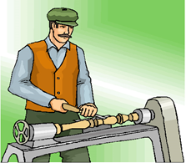
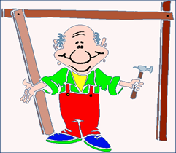
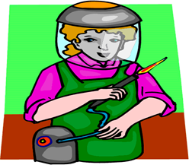
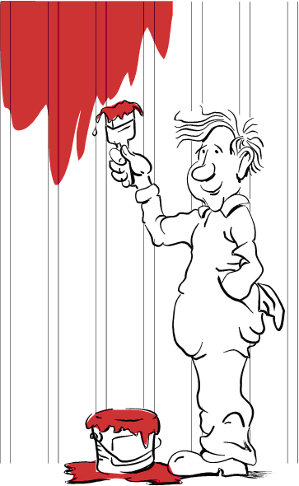
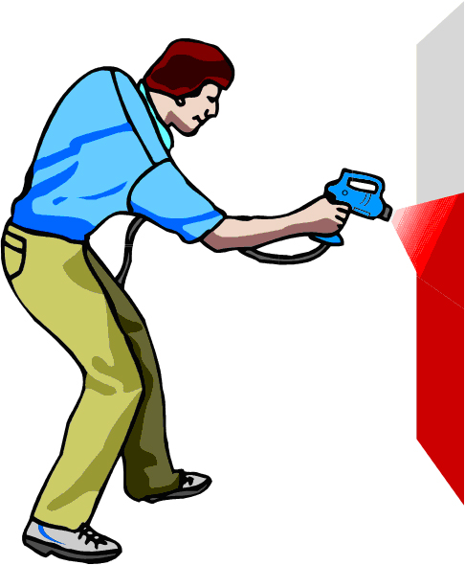
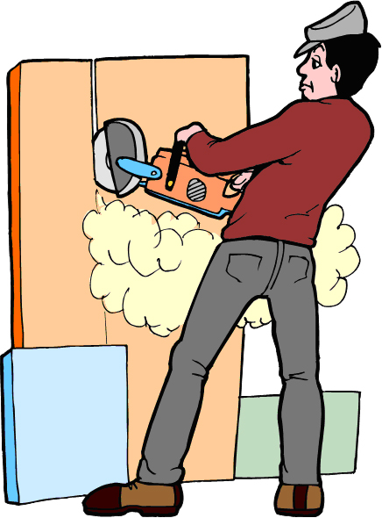

- Construct a chart with the following headings, showing the safe level of exposure for various decibels. Find examples between 0 and 140 dB.
Safe levels of exposure
Sound pressure level | Example of sound source | Safe exposure time | Hearing protection measures
85 dB | Front end loader | 8 hours

- Match the two halves of each sentence. Draw a line between each or write (or cut and paste) the correct sentences, in full, below the table.
An employer | is the responsibility of an employer.
Hazards | law must provide workers with training and supervision and a safe and healthy workplace.
Safety Signs | employers and employees to consult and cooperate (work together) to make their workplace safe.
The title of the NSW safety legislation (laws) that protect workers is | should follow safety procedures, work safely and not put the safety and health of others in the workplace at risk.
The control of hazards | warn people of danger and provide safety information.
NSW safety and health laws encourage | The NSW Work Health and Safety Act 2011 (WHS Act) and the NSW Work Health and Safety Regulation 2017 (WHS Regulation).
An employee (worker) | is available from SafeWork NSW.
Information on safety and health at work | must be controlled by the employer, manager or supervisor.

- Access websites http://www.whitecardsafety.com/fire-safety.html and https://www.fireequipmentonline.com.au/6-fire-extinguisher-classes-in-australia to complete the following:
Fire is a chemical reaction requiring what three components?
The way to extinguish a fire is to remove any, or all, of the components of the fire triangle. List four:
The type of alarm needed can range from a simple shout of 'fire', to sophisticated automatic systems. Whatever system is chosen, make sure it:
There are six classes or types of fires in Australia. List them below providing an example and indicating what extinguishing agent should be used on each.
Class A
Class B
Class C
Class D
Class E
Class F

- Briefly explain the WHS issues in each of the following.
 | 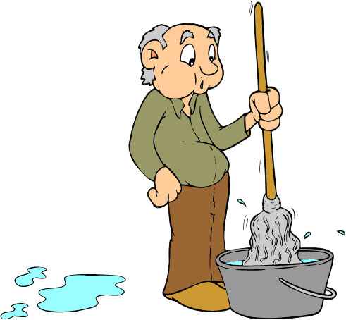 | 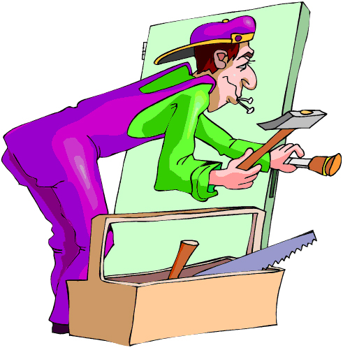

- For each of the following entertainment environments develop a list of three safety topics to be discussed at a WHS Safety meeting. You might like to utilise the Risk Management Plan produced by the National Australia Day Council to give you some ideas.
Image licenced under CC0. The original version can be found on pexels

Image licenced under CC0. The original version can be found on pexels
- Fill in the blanks, using the words provided.
effective | communication | implementing | frequency
hazardous | earliest | instructions | activity
emergency | procedures | storage | workers

An emergency plan is a written set of ( ) that outlines what ( ) and others at the workplace should do in an ( ). An emergency plan must provide for the following:
- emergency procedures, including: an ( ) response to an emergency
- evacuation ( )
- notifying emergency service organisations at the ( ) opportunity
- medical treatment and assistance, and
- effective ( ) between the person authorised to coordinate the emergency response and all people at the workplace
- testing of the emergency procedures—including the ( ) of testing, and
- information, training and instruction to relevant workers in relation to ( ) the emergency procedures.
What types of emergencies should be covered?
The types of emergencies to plan for may include fire, explosion, medical emergency, rescues, incidents with ( ) chemicals, bomb threats, armed confrontations and natural disasters.
The emergency plan should be based on a practical assessment of hazards associated with the work ( ) or workplace, and the possible consequences of an emergency occurring as a result of those hazards. External hazards should also be considered in preparing an emergency plan, for example a chemical ( ) facility across the road.
In developing the plan, consideration should be given to the application of all relevant laws, including public health ( ) (for example, workplaces that are also public places) and state or territory disaster plans.

- The Department of Industry, Innovation and Science provides guidance on how to manage risks in the workplace using a systematic process.
  - Provide a definition for each step in the process.
A systematic process for managing risks in the workplace
Identify hazards
Assess risks
Control risks
Review control measures
Record and report safety issues
Support return to work
Make your workplace healthier
  - The same government department lists a range of WHS considerations for the arts and recreation services industry. Choose two and give an example relevant to your course of study.
  - What is the difference between a risk and a hazard?
  - Develop a list of at least three examples of a risk control measure which could be implemented within the Entertainment Industry workplace.
  - Use these examples in your mind map (below).

Putting the theory into practice
The following questions are from past years’ NSW HSC examination papers for this subject. HSC exams are intended to be rigorous and to challenge students of all abilities. To better understand a question, you should look for key words and identify the aspect of the course to which these relate. You are then in a position to formulate your answer from relevant knowledge, understanding and skills.
All questions in ‘Putting the theory into practice’ are acknowledged © 2019 NSW Education Standards Authority (NESA) for and on behalf of the Crown in right of the State of New South Wales.

Multiple Choice
- Who has the most responsibility for ensuring that patron numbers do not exceed maximums set by Work Health and Safety (WHS) regulations?
  - Stage manager
  - Venue manager
  - Production manager
  - Front of house manager

- Which of the following describes the hierarchy of risk control measures?
  - Eliminate the risk, minimise the risk, adopt controls
  - Assess the risk, substitute equipment, isolate the hazard
  - Modify the equipment, document the risk, evaluate the risk
  - Complete risk assessment, check the hazards, inform supervisor

- Which of the following is true of WHS?
  - It is only important when working at heights
  - It does not apply to working with machinery
  - The responsibility is shared by everybody in the organisation
  - The regulations are determined by the Person Conducting a Business or Undertaking (PCBU)

- Which of the following must an organisation adhere to in order to meet WHS legislative requirements?
  - Regulations
  - Codes of practice
  - Industry guidelines
  - Australian standards
- Which of the following indicates mandatory compliance on a work health and safety (WHS) sign?
  - Red circle with a diagonal line
  - Blue circle with a white symbol
  - Green square with a white symbol
  - Yellow triangle with a black symbol
- A new type of stage paint is delivered to a venue. Which of the following would be used to check the hazard rating for this product?
  - Safety Data Sheet
  - Job Safety Analysis
  - Safe Work Method Statement
  - Work Health and Safety Act 2011 (NSW)
- A live, roving camera vision feed is required to move through the audience. What is the best way to ensure that the camera cable does not cause trip hazards?
  - Use cable trays
  - Employ a cable assistant
  - Tape the entire cable down
- At which level can an audio signal present an electrical hazard?
  - Mic level
  - Line level
  - Preamp level
  - Speaker level

- When a footlight is turned on it catches fire.
What type of firefighting equipment would be most effective in this situation?
  - Fire hose
  - Fire blanket
  - Foam extinguisher
  - Powder extinguisher
- The safety officer has placed a physical barrier around an area where people are working at height. Which level of the hierarchy of control does this action represent?
  - Engineering
  - Isolation
  - Modification
  - Substitution

- An employee understands that their workplace does not comply with the Live Performance Australia industry safety guidelines, but it does meet its obligations under the Work Health and Safety Act 2011 (NSW). In relation to the non-compliance, an employee has
  - no obligation to report this non-compliance.
  - a legal obligation to report this non-compliance.
  - a contractual obligation to report this non-compliance.
  - an obligation to report this non-compliance to the union.

- The sign shown is seen backstage. What type of sign is this?
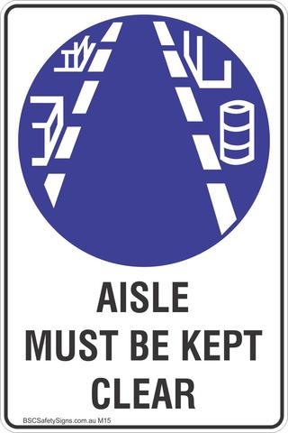 Illustration used with permission of Broadley Signs Newcastle NSW
  - Danger
  - Mandatory
  - Prohibition
  - Warning

Questions from Section II
These questions should be answered in the suggested number of lines (handwritten) as it gives a guide to the length of your response.
Plan out your answer and key points before you commence writing
Question 1
  - Describe the technical requirements a lighting technician must consider when installing moving light fixtures. (3 marks)

  - A lighting technician is seriously injured by a falling light fixture. Describe the reporting procedures required of the PCBU following this injury. (4 marks)

Question 2
- What are the key functions of SafeWork NSW? (2 marks)

- Describe how an usher can participate in maintaining a safe workplace. (3 marks)

Question 3
  - Describe the work health and safety consultation process a Person Conducting a Business or Undertaking (PCBU) is required to follow. (3 marks)

  - A lighting technician has noticed a lighting fixture has tripped a circuit breaker and the insulation on the power cable has melted. Describe the safe work procedures that the lighting technician should follow in this situation. (3 marks)

Question 4
A local production company is planning to use a park for a free outdoor theatrical performance in summer.
  - Outline potential hazards that could affect the employees at this event. (3 marks)

  - Explain how the risk hierarchy should be used to control potential hazards to ensure safety at this event. (5 marks)

Questions from Section III
The Section III question in the HSC is worth 15 marks -
- there will be one structured extended response question.
- the question will have two or three parts, with one part worth at least 8 marks.
- the question will have an expected length of response of around four pages of an examination writing booklet (approximately 600 words) in total.
You may be guided to answer different parts of a question in SEPARATE writing booklets.

Questions from Section IV
There will be one extended response question in Section IV (15 marks) of the HSC. This will provide you with the opportunity to:
- demonstrate knowledge and understanding relevant to the question
- communicate ideas and information using relevant workplace examples and industry terminology
- present a logical and cohesive response
The expected length of response for questions in Section IV is around four pages of an examination writing booklet (approximately 600 words).
You should allow about 25 minutes for a question in Section III and the same for Section IV of the exam.
You will note that these questions usually require you to bring together knowledge from several areas of study/competencies to do justice to the answer.

In each of the following, map out your answer using post-it notes or a sheet of paper. Pay particular attention to incorporating a variety of aspects of your Entertainment Industry curriculum into the plan. Consider why we have included this question within this safety module and what other areas of study you would need to draw upon.

Question 1
A community Carols by Candlelight picnic event is being held in the local sports ground.
  - Describe the information required for the planning and control of possible incident, accident and emergency situations during this event. (7 marks)
  - Complaints were received after a previous similar event regarding overcrowding, a lack of facilities, unruly patrons and late-arriving audience members blocking walkways with picnic rugs. Explain the strategies event volunteers and crew should implement to ensure the efficient running of this year’s event. (8 marks)

Question 2
The performance run sheet for an awards night at a hired venue is shown.
Performance run sheet
Item number | Item name
1 | Introduction/welcome speech
2 | 30-piece band on stage (including music stands and chairs)
3 | Award presentation – recipients enter and exit from backstage
4 | Dance performance using full stage
5 | Thank-you speech

  - Provide a detailed overview of the safety induction a venue manager would conduct with the awards night organising team when they arrive at the venue. (5 marks)

  - Describe how the stage manager of this event would organise personnel and production elements to implement the performance run sheet effectively for this awards night. (10 marks)

Question 3
Use the information shown to answer parts (a) and (b).
An events company has been contracted to provide the staging elements for a community event at the local showground.
Staging elements include a portable stage, a roof structure supported by a truss, stage access stairs and a stage access ramp.
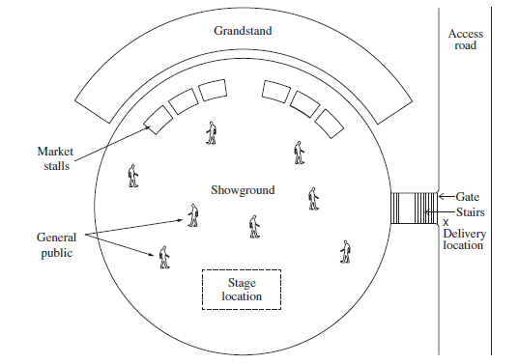
Illustration from NSW Entertainment Industry HSC examination 2016

- Describe the risk management process that needs to be undertaken prior to this event. (7 marks)
- Describe the procedures necessary for the safe bump in and bump out of this event.
(8 marks)

Question 4 (15 marks)
You have been appointed to design the vision system for a rock band that is embarking on a world tour. During this tour, concerts will be held at a variety of venues including outdoor stadiums and indoor theatres.
What creative, safety and technical considerations are required to fulfil the brief across the range of venues?

HSC Focus Areas
For the purposes of the HSC, all students undertaking the 240 HSC indicative hours course in Entertainment Industry must address all of the mandatory focus area content.
The scope of learning describes the breadth and depth of the HSC Content and has been grouped together into key ideas/areas. The scope of learning describes the minimum content that must be addressed, and the underpinning knowledge drawn from the associated unit(s) of competency.
Entertainment Mandatory Focus Areas include:
- Audio
- Customer service
- Lighting
- Safery
- Staging
- Vision
- Working in the entertainment industry
The units of competency associated with the focus area ‘Safety’ are
CPCCOHS1001A Work safely in the construction industry
CUAWHS302 Apply work health and safety practices

How to use the scope of learning for ‘Safety’ (which follows over).
- draw up your own mind map showing the connection between the various concepts listed; examples appear on the last page of this module
- use the key terms and concepts to add to your mind map
- add examples or case study prompts to show how the concept is applied in the entertainment working environment

The following information is taken directly from page 36 ff of Entertainment Industry Curriculum Framework Stage 6 Syllabus (NSW Education Standards Authority) for implementation from 2020. © 2019 NSW Education Standards Authority (NESA) for and on behalf of the Crown in right of the State of New South Wales.

work health and safety (WHS)
- meaning of health, safety, security and duty of care
- implications of the cost of workplace injury:
- human
- social
- economic
- organisational
- acknowledge that WHS is everyone’s responsibility in the workplace and the implications of this responsibility
- concept of ‘participation’ and ‘consultation’ in relation to WHS
- primary role/function of key bodies/authorities involved in WHS:
- SafeWork NSW
- Safe Work Australia
- local councils
- unions
- professional associations
- internal and external sources of workplace WHS information
- importance of acting within scope of responsibility/level of authority in relation to WHS in the workplace:
- taking initiative
- problem-solving
- decision-making
WHS compliance
- difference between an act, regulation, code of practice, guidance note, guideline and standard (Australian, industry and workplace)
- purpose and intent of WHS legislation and codes of practice and their application to the entertainment industry and workplace and a specific job role:
- WHS legislation:
    - Work Health and Safety Act 2011 (NSW) (as amended)
    - Work Health and Safety Regulation 2017 (NSW) (as amended)
- codes of practice related to:
    - amenities and induction for construction work
    - first aid
    - hazardous substances and dangerous goods
    - manual handling
    - risk management
- purpose and intent of industry safety standards and guidelines and their application to the entertainment industry and workplace and a specific job role
WHS compliance cont/d
- work tasks/activities requiring a licence, ticket or certificate of competency
- WHS rights, duties and responsibilities of the person conducting a business or undertaking (PCBU), officer and worker (as defined in the legislation)
- functions and powers of WHS inspectors
- consequences of failure to observe (non-compliance) WHS workplace policy and procedures and legislative requirements
- safety signs, symbols and barricades used in the entertainment industry and their use in the workplace:
- legislative requirements
- meaning of colour and shape
- placement and positioning
- entertainment industry and workplace requirements for monitoring and reporting in relation to workplace safety
- describe how, when and to whom to report:
- types of reports:
    - formal/informal
    - written
    - verbal
- reporting to appropriate person(s)
- purpose and importance of monitoring and reporting
- apply workplace policy and protocols and regulatory requirements when recording and reporting in relation to WHS
WHS consultation and participation
- opportunities for workers to provide input into WHS consultation and participation processes:
- formal and informal discussion
- meeting
- survey
- training
- WHS audit
- WHS inspection
- requirements (including election/formation) of a health and safety committee or health and safety representative (HSR) and their role and responsibilities in the workplace
- role and responsibilities of relevant personnel in WHS consultation and participation:
- PCBU
- manager/supervisor/team leader
- self
- other workers
- union
WHS consultation and participation cont/d
- importance of identifying and reporting:
- WHS issues and concerns
- workplace hazards
- unsafe work practices
- breaches of health, safety and security
and examples of each for the entertainment industry and workplace
risk management
- difference between a hazard and a risk
- risk management and its application in the entertainment industry workplace:
- hazard identification:
    - potential hazards to self, colleagues, customers/clients and others typical to the industry
    - range of hazards:
- hazardous and non-hazardous materials
- human factors (self and others)
- manual handling
- tools, equipment and machinery
- work environment
- work processes and practices
- working at heights; in a confined space; in the dark and/or in reduced/adverse lighting conditions; on special effects, stunts or action sequences; and with electricity and cabling
- risk assessment
- risk control (hierarchy):
    - eliminate the risk
    - minimise the risk:
- substitution
- modification
- isolation
- engineering control
    - other controls:
- administration
- safe work practices
- personal protective equipment (PPE)
- monitor and review
safe work procedures and practices
- safe work procedures and practices and their purposes:
- WHS induction training (general, work activity and site-specific)
- adherence to:
    - safe work method/job safety analysis (JSA)
    - standard operating procedures (SOPs)
    - work documentation and plans
    - work instructions
    - workplace policy
- selection, use and maintenance of PPE
- manual handling techniques:
safe work procedures and practices cont/d
    - when working individually, in pairs and with a team:
- moving, lifting, carrying and placing items down
- bending and twisting
- loading and unloading
- working with tools, machinery and equipment
- undertaking repetitious tasks
- using mechanical aids/lifting equipment
    - recommended weight limits
- ergonomics and posture:
    - correct placement of equipment
    - sitting and standing positions
    - task rotation
    - use of adjustable furniture and equipment
- hazardous substances and dangerous goods:
    - correct handling, application, labelling, transport and storage
    - safety data sheet (SDS)
- tools, equipment and machinery:
    - selection appropriate to task/work activity
    - pre-operational checks and correct use
    - regular maintenance and correct storage
    - safety tags and lockout
- working with electricity:
    - general electrical safety
    - cabling and leads:
- proper placement and securing
- maintenance
- appropriate storage
    - electrical tagging
- working at heights:
    - points of contact
    - harnessing
    - ladders:
- selection
- safety check
- precautions when ascending and working from and around
    - precautions when working on and around scaffold and elevated work platforms
- housekeeping:
    - clean-up procedures
    - storage and disposal of waste
    - consideration of WHS and the environment
- security:
    - potential breaches
    - for:
- cash
- documents
- equipment
- people (staff, customers/clients, others) and their belongings
- workplace/building (secure areas and general access)
    - reporting breaches in security to appropriate personnel
safe work procedures and practices cont/d
- importance of safe work procedures and practices
- propose safe work procedures and practices for a workplace and specific job role within the entertainment industry
incidents, accidents and emergencies
- meaning of incident, accident and emergency
- a range of incidents, accidents and emergencies common to the entertainment industry
- distinguish between a manageable first aid situation and an emergency situation
- range of potential injuries common to an entertainment industry workplace, their cause(s) and basic first aid for these injuries
- strategies to reduce workplace accidents, injury and impairment
- responding to incidents, accidents and emergencies:
- emergency situations
- seeking assistance
- emergency contact numbers
- emergency signals, alarms and exits:
    - location
    - use
- procedures to follow:
    - notification
    - workplace policy and procedures:
- evacuation
- security
    - reporting
- basic process of fighting a fire and use of firefighting equipment:
    - fire blanket
    - fire extinguishers
    - fire hose and reel
- role of personnel in an emergency
- first aid:
    - basic principles
    - personnel responsible
- apply workplace policy and protocols and regulatory requirements when recording and reporting in relation to incidents, accidents and emergencies

Creating a mind map is a great way to organise your knowledge and understanding of the content of a topic.
You could use software such as a hierarchy chart, download ‘MindNode’ or similar or use a large sheet of paper (or several A4 sheets taped together)!
It is important to try to include all the detail you can, so add definitions, case studies or examples to prompt your memory. Include the information downloaded from the unit of competency and also from the Scope of Learning and Key Terms and Concepts.

Example of mind map being developed
