Entertainment Industry
Mandatory Focus Area: Customer Service

Welcome: this module will assist you to review and revise the content of the mandatory focus area ‘Customer Service’. Each focus area prescribes the scope of learning for the HSC and is drawn from associated units of competency.
You will have studied the competency SITXCCS303 Provide service to customers which addresses the scope of learning.

This module is broken up into:
- Important notes
- Key terms and concepts
- Activities
- Putting the theory into practice
- HSC focus areas

How to use the resource
Work through the notes and the suggested activities in any order. Great revision techniques include working through how a problem is solved, explaining the concept, testing yourself and retrieving information from your memory. Spread your revision over a number of sessions rather than sitting at one subject for lengthy periods.
Discuss your responses with your teacher, fellow students or an interested family member.
All images, apart from those acknowledged, are © NSW Department of Education.

Important Notes
You should use the information here as a prompt and guide when revising your study notes or text-book information or other resources provided by your teacher.
You can also access industry specific information at SafeWork NSW, Live Performance Australia and Media Entertainment and Arts Alliance.

The unit SITXCCS303 Provide service to customers describes the performance outcomes, skills and knowledge required to communicate effectively with and provide quality service to both internal and external customers. It requires the ability to establish rapport with customers, determine and address customer needs and expectations and respond to complaints.

The outcomes of the HSC mandatory focus area ‘Customer Service’ require that the student shows the ability to:
- provide quality customer service on multiple occasions and cover a range of diverse customer service situations, including the resolution of complaints
- communicate effectively with a variety of internal and external customers including those with special needs
- demonstrate knowledge of professional service standards expected of service industry personnel
- complete service within commercial time constraints and designated response times so that all customers are served effectively.

Key terms and concepts
You can use the following information to revise the key terms and concepts from this unit of competency. Perhaps you could:
- Copy the table into your own file, remove all the key terms, then fill in the blanks (without peeking at the original file) with your own answers.
- Copy the table into your own file and remove the definitions. Write a definition in your own words – it doesn’t have to word perfect but should show you understand the concept.
- You could add an example of this term or concept which is relevant to the entertainment environment. If the key term was ‘efficient service’ your Entertainment Industry example might be ‘A check-in that efficiently serves customers and avoids long lines.’
Key term or concept | and Definition
Active listening | A structured way of listening and responding to another person to ensure they have understood what was said.
Anti-discrimination | Opposing or preventing discrimination.  According to the Anti-Discrimination Act 1977 (NSW) discrimination can be either 'direct' or 'indirect' and includes discrimination and harassment based on: sex, race, age, marital status, disability, and carers' responsibilities, because of who you are related to or associated with.
Appraisal | An evaluation of someone or something’s worth
Authority | The decision making power of a person within an organisation.
Benefits of good customer service | Include repeat and loyal customers and increased sales and profits.
Bullying | Workplace bullying is repeated and unreasonable behaviour directed towards a worker or group of workers that creates a risk to health and safety. Examples include abusive or offensive language or comments, aggressive and intimidating behaviour, belittling, or humiliating comments, practical jokes or initiation and/or unjustified criticism or complaints.
Closed questions | Require the customer to give specific information. These questions can be answered with a yes/no or one-word answer.
Communication | The gathering, conveying and receiving of information and ideas. There are four parts to the process: sender, message, receiver and feedback.
Complaints | Usually arise when the goods received are not what is expected (damaged/not fit for service) or the expectations of service have not been met.
Consultation | Discussion (often with a more experienced person) to assist with the resolution of an issue
Cultural diversity | Individual differences in culture, race, customs/traditions, language and religious beliefs.
Current industry practice | Industry currency and professional obsolescence are terms that relate to the capacity of an individual to continue to perform their job.
Current issues | Problems or ideas which have an impact on the industry and are being discussed at the present time.
Customer dissatisfaction | Occurs when a customer is unhappy with a product or the level of customer service received.
Customer expectations | Refers to the benefits the customer wants from the product or service.
Customer needs | Are the requirements that a customer has of a product or service.
Customer preferences | Refers to the order of choice a customer places on aspects of the product(s).
Customer satisfaction | The customer’s positive impression from the service they receive.
Customer special needs/requirements | When customers have a special request for a particular purchase.
Deadline | The time by which something must be done or completed
External customers | People who do not belong to your workplace that use your services. They include clients, visitors, tradespeople and contractors.
Feedback | A reply to a message. Feedback is also used to develop and refine new ideas and approaches.
Follow-up action | May take the form of formal documentation or be as simple as a phone call to check the customer is happy.
Handling customer complaints | Process followed to resolve customer complaints effectively and efficiently.
Harassment | Harassment can be against the law when a person is treated less favourably on the basis of certain personal characteristics, such as race, sex, pregnancy, marital status, breastfeeding, age, disability, sexual orientation, gender identity or intersex status.  Harassment can include behaviours such as: telling insulting jokes about particular racial groups; sending explicit or sexually suggestive emails or text messages; displaying racially offensive or pornographic posters or screen savers; making derogatory comments or taunts about someone’s race; asking intrusive questions about someone’s personal life, including his or her sex life.
Internal customers | Internal customers include employees, supervisors and managers.
Negotiation | Discussion aimed at reaching an agreement.
Non-verbal communication | Communicating without speaking. Using body and facial expressions to convey a message.
Open questions | Open questions gather detailed information from the customer. They begin with words such as what, when, where, why and how.
Policies and procedures | A set of rules and methods designed and communicated to structure certain processes within an organisation.
Problem solving | Strategies used to find a solution for difficult situations.
Priorities | Order of importance
Reflective questions | Reflective questions are asked to clarify what has been said and to ensure that the message has been understood.
Responsibilities | The specific tasks or duties that members are expected to complete as a function of their roles.
Roles | The position or particular job a team member assumes or the part they play in a particular operation or process
Task management | The process of managing tasks over days, weeks, months or years including planning, testing, tracking, reporting.
Teamwork | Teamwork involves a set of interdependent activities performed by individuals who collaborate toward a common goal. Teamwork involves shared responsibility and collaboration.
Time management | The ability to use one's time effectively or productively, especially at work.
Verbal communication | Communication that is spoken.
Win-win | A solution to a problem which makes each person feel they have gained something.
Work routines | Sequence of activities to complete a series of tasks.
Workplace policy and procedures | Policies and procedures outline the requirements for complying with both external and internal compliance requirements.

Activities
- The Principles of good customer service are explained in this article from Business Queensland. Fill in the blanks using the words provided.

Use these words
ensure | negative | greet | relationships
know | service | happy | event
positive | understand | improve | time
The key to good customer ( ) is building good ( ) with your customers.
Thanking the customer and promoting a ( ) helpful and friendly environment will ( ) they leave with a great impression. A ( ) customer will return often and is likely to spend more.
To ensure you provide the best customer service:
- ( ) what your customers consider to be good customer service
- take the ( ) to find out customers' expectations
- follow up on both positive and ( ) feedback you receive
- ensure that you consider customer service in all aspects of your business
- continuously look for ways to ( ) the level of customer service you deliver.
The following are some of the main elements of good customer service.
Customer relationships
To build good customer relationships you need to:
- ( ) customers and approach them in a way that is natural and fits the individual situation
- show customers that you ( ) what their needs are
- accept that some people won't want your products and concentrate on building relationships with those who do
- help people - even just letting a customer know about an ( ) that you know they're personally interested in is helpful
- continue to keep customers aware of what's in it for them to do business with you.

- Explain and give an example of each of these techniques for effective communication:
  - Open and closed questioning
  - Paraphrasing
  - Effective listening
  - Voice tonality and volume
  - Body language and its role in customer service

- What is the commercial impact of negative customer service? What about positive customer service?
- Identify and explain five effective communication strategies for interacting with customers from diverse backgrounds.

- Organisational policies and procedures set benchmarks for staff. Research and identify two common organisational standards for each of the following elements of customer service:
  - Service response times
  - Interacting with customers
  - Solving routine problems
  - Providing information to customers

- Develop a poster showing at least 10 basic principles for achieving positive customer service.

- Outline the steps you might use to resolve a routine customer problem at your level of responsibility.

- Why should you endeavour to collect customer feedback? How could you do so in a range of entertainment environments?

- Find tips for managing complaints from customers, Make your own table with examples from the entertainment industry environment.
Managing complaints
General tips for managing complaints | Interpersonal approaches to managing complaints | Organisational approaches to managing complaints

- For each of the following scenarios describe what you would do / how you should respond and how you would you communicate effectively to resolve each situation.
Provide effective communication strategies for each scenario
- You are on the telephone to another patron, and the call is not urgent.
A customer enters the office and starts looking at the brochures for an upcoming production.
- Your venue has a Facebook page, and you are in charge of communicating with the public via this medium. One visitor to an event has posted the following comment on the Facebook wall:
‘Had a terrible experience today. My seat was physically missing due to renovations. Like there was NO seat. Took forever to be reassigned and the show had started.’
- A regular customer, Mr Smith, has booked his usual seat on the mezzanine level for tonight’s performance. This morning, the elevator malfunctioned, and the repairs are estimated to take until tomorrow. Mr Smith arrives on crutches; he broke his ankle yesterday.

- Consider how verbal, non-verbal, paralanguage and signs etc are used effectively in the entertainment industry. Provide examples of how each of the following can be used effectively in providing quality customer service.
Types of communication
 | Verbal communication | Non-verbal communication | Written communication
Example 1
Example 2
Example 3

- Have a break by completing this find-a-word activity.
You may need to print this page.

- Each of these definitions is in the wrong place. Match the ‘barrier’ to communication with the explanation. Draw a line between the key term and the correct definition or rewrite (or cut and paste) each correct pairing in your own table.
Correctly match the ‘barrier’ to the definition.
Barrier to communication | Definition
Language background | Communicating with another person with an attitude of disinterest or unwillingness will be ineffective. Anything in your mind which gets in the way of communication.
Stereotyping | If the means of communication is highly time consuming, then it becomes a barrier to efficient working. If the participants are time poor, they will pay less attention to the process.
Physical barriers | Inclination or prejudice for or against one person or group, especially in a way considered to be unfair.
Inconsistency | A preconceived idea that attributes certain characteristics (in general) to all the members of that group eg ‘old people don’t know how to use technology’.
Psychological barriers or emotions | Providing too much or too little information is equally disruptive to effective communication.
Personal beliefs and culture | Special words and phrases that are used by particular groups of people, especially in their work eg set dressing, backlight.
Semantics and interpretation | Anything in the physical world (ie not in your mind) that stands between you and effective communication eg temperature, natural noise or work environment noise.
Time pressure | Conﬂict can arise from differences in core beliefs and can result in poor communication.
Bias | Subtext is content hidden beneath the actual dialogue or text; you may ‘read between the lines’ and hear something negative which hasn’t actually been spoken.
Too much information | The environment or your own thoughts can prevent you from comprehending and properly understanding what is being said.
Jargon or workplace specific terminology or abbreviations | A culturally diverse population will include people from different ethnic groups and nationalities whose first language may not be English.
Negative subtext | While modern technology has dramatically changed the way we communicate through writing, most employment situations will involve at least some handwriting, and many require the communication of critical information.
Distractions or inattention | Being told one thing at one time and then a different message at another time.
Unclear handwriting | Difficulties in communication arise when the sender and the receiver of the message use words or symbols which carry different meanings to each.

- Research ‘tips for assisting customers with disability’ and make your own checklist.

- These two cartoons both make a comment about customer service.
Consider how you might use each one as part of staff training in your entertainment workplace.

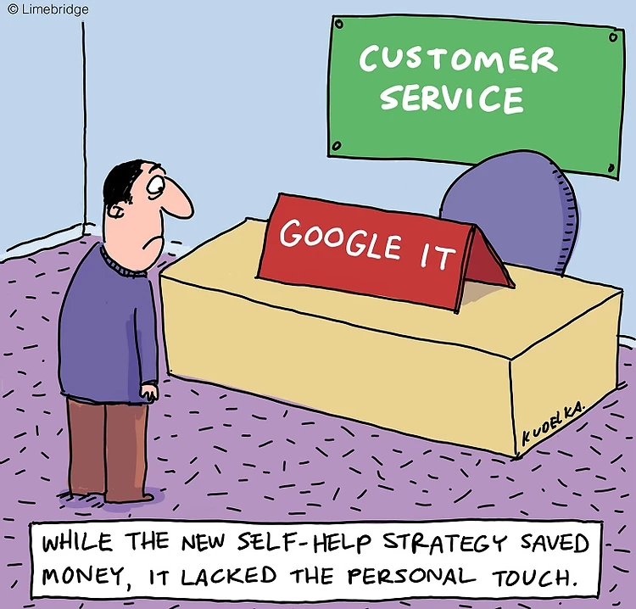
Images licenced under CC0. Original version can be found at LimeBridge Australia Pty Ltd

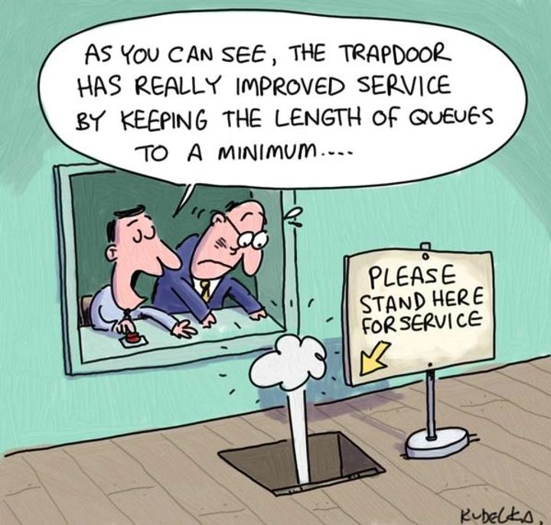
Images licenced under CC0. Original version can be found at LimeBridge Australia Pty Ltd
- Use the following words to complete the passage.
Use these words
people | opinions | social | negative
mass | positive | potential | blogs
Amazon | internet | reviews | work

Managing online customer reviews
Customer opinions have always had the _____________ to influence other people's attitudes towards a business. In the past, these _____________ were communicated mostly by word of mouth.
But the _____________ has given customer opinions _________ exposure. Millions of customers now post reviews of goods and services on websites, blogs and other _____________ media. And millions of ____________ read them. Research shows that ____________ online reviews increase the likelihood of customers using your business, while ___________ reviews reduce it.
Customer reviews are posted on:
- general review sites (e.g. Yelp, Product Review)
- specialised review sites (e.g. Zomato, TripAdvisor)
- retailers' websites (e.g._____________)
- personal ___________
- other social media (e.g. Twitter, Facebook).
This guide explains who reads and writes online____________, their potential impact on your business, and how reviews can __________ for you - even when they're negative.

Putting the theory into practice
The following questions are from past years’ NSW HSC examination papers for this subject. HSC exams are intended to be rigorous and to challenge students of all abilities. To better understand a question, you should look for key words and identify the aspect of the course to which these relate. You are then in a position to formulate your answer from relevant knowledge, understanding and skills.
All questions in ‘Putting the theory into practice’ are acknowledged © 2019 NSW Education Standards Authority (NESA) for and on behalf of the Crown in right of the State of New South Wales.

Multiple Choice
- A customer makes a complaint to an usher regarding the temperature inside a large
entertainment venue.
What is the most appropriate action for the usher to take?
  - Offer a refund
  - Record the customer’s details
  - Refer the matter to a supervisor
  - Adjust the air-conditioning temperature
- A box-office staff member receives a phone call from an angry patron who claims he has not received a response to his email about poor customer service at the venue. What is the most appropriate response?
  - Admit fault and offer a refund
  - Show concern about the problem and request contact details
  - Say that the email has not been received and ask for a new copy
  - Inform the patron that they are busy and that the problem will be investigated later
- In which of the following are all categories in current anti-discrimination legislation in NSW?
  - Marital status, education, race
  - Political preference, dress, age
  - Social status, pregnancy, gender
  - Sexual orientation, religion, disability
- Which of the following is most important for box office staff when greeting customers?
  - Listen actively
  - Rephrase questions
  - Use an appropriate tone
  - Maintain a consistent volume
- Which of the following shows the correct order of procedures for handling customer complaints?
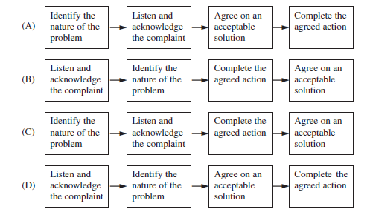

- Two members of a band are having an ongoing disagreement which is affecting their work.
What approach should be implemented by the band’s manager to resolve this conflict
  - Ignore the problem
  - Document the problem in a work diary
  - Discuss the problem with the whole band
  - Arrange for mediation for the two band members
- Which of the following is most effective to help identify a customer’s needs?
  - Asking open questions
  - Maintaining eye contact
  - Asking closed questions
  - Observing body language
- A customer telephones a venue with an inquiry about access to public transport. What is the most effective response to deal with the customer’s enquiry?
  - Refer the customer to a supervisor
  - Direct the customer to the venue website
  - Look up the information and provide it during the call
  - Instruct the customer to send an email to the box office
- What is the purpose of workplace policies and procedures for dealing with customers?
  - To provide staff with information about their rights
  - To provide customers with information about the organisation
  - To provide customers with information on how to make a complaint
  - To provide staff with information about the organisation’s expectations
- Who would access a hearing induction loop during a performance?
  - Stage manager
  - Audio operator
  - Front of house manager
  - Audience members with special needs
- A week before a scheduled performance, a box office staff member receives a call from a patron whose tickets have not yet arrived.
Which of the following is the appropriate course of action?
  - Transfer the call to the manager
  - Listen to, respond and follow up the call
  - Refer the patron to the condition of sale policy
  - Ask the caller to phone back later in the week
- Customers have different needs, preferences and expectations. Which of the following represents a customer’s preference?
  - Seating in the third row
  - Wheelchair accessibility
  - Access to the bathrooms
  - Hearing aid loop accessibility

Questions from Section II
These questions should be answered in the suggested number of lines (handwritten) as it gives a guide to the length of your response. Plan out your answer and key points before you commence writing
Question 1
A production team has been contracted to provide event management for a charity concert.

Describe effective strategies that can be used by the production team to provide quality customer service to the different types of customers involved in this event. (5 marks)

Question 2
  - How should the front of house manager deal with people who arrive late for a performance? (2 marks)

  - What are the possible implications for customer satisfaction and patron safety if patrons are allowed late entry? (5 marks)

Question 3
An entertainment industry trade show is being held at a convention and exhibition centre. The event involves presentations by industry professionals as well as exhibitors demonstrating their latest products and services.
  - Outline strategies that event organisers could use to effectively communicate with the exhibitors to ensure the exhibitors’ requirements are met for the trade show.
(2 marks)

  - Describe how a vision system could be set up to show promotional videos and slides displaying venue information in multiple locations at the trade show.
(3 marks)

Question 4

‘A customer focused workplace is orientated towards serving its clients’ needs and prioritising customer satisfaction.’
Explain how the needs and expectations of the diverse range of customers within the entertainment industry can be met. (5 marks)

Questions from Section III
The Section III question in the HSC is worth 15 marks -
- there will be one structured extended response question.
- the question will have two or three parts, with one part worth at least 8 marks.
- the question will have an expected length of response of around four pages of an examination writing booklet (approximately 600 words) in total.
You may be guided to answer different parts of a question in SEPARATE writing booklets.

Questions from Section IV
There will be one extended response question in Section IV (15 marks) of the HSC. This will provide you with the opportunity to:
- demonstrate knowledge and understanding relevant to the question
- communicate ideas and information using relevant workplace examples and industry terminology
- present a logical and cohesive response
The expected length of response for questions in Section IV is around four pages of an examination writing booklet (approximately 600 words).
You should allow about 25 minutes for a question in Section III and the same for Section IV of the exam.
You will note that these questions usually require you to bring together knowledge from several areas of study/competencies to do justice to the answer.

In each of the following, map out your answer using post-it notes or a sheet of paper. Pay particular attention to incorporating a variety of aspects of your Entertainment Industry curriculum into the plan. Consider why we have included this question within this Customer Service module and what other areas of study you would need to draw upon.

Question 1
Students were asked to answer this question in two separate writing booklets – one for part a) and one for part b).
You are employed to coordinate an outdoor ANZAC Day Dawn Service which will be attended by a large crowd including numbers of elderly and less mobile people. The event includes a live vision feed from Gallipoli, production lighting and a speaker from the Australian Defence Force.
  - How will you ensure equitable access to this service for all attendees? (5 marks)
  - Describe the technical production requirements for this service. (10 marks)

Question 2

An outdoor New Year’s Eve event that showcases a variety of performances could be compromised by predicted severe weather.
  - Describe how the organiser can effectively manage the potential changes prior to this event. (7 marks)
  - Explain how the organiser would communicate with both internal and external customers to relay these changes. (8 marks)

Question 3
A community Carols by Candlelight picnic event is being held in the local sports ground.
  - Describe the information required for the planning and control of possible incident, accident and emergency situations during this event. (7 marks)
  - Complaints were received after a previous similar event regarding overcrowding, a lack of facilities, unruly patrons and late-arriving audience members blocking walkways with picnic rugs. Explain the strategies event volunteers and crew should implement to ensure the efficient running of this year’s event. (8 marks)

HSC focus areas
For the purposes of the HSC, all students undertaking the 240 HSC indicative hours course in Entertainment Industry must address all of the mandatory focus area content.
The scope of learning describes the breadth and depth of the HSC Content and has been grouped together into key ideas/areas. The scope of learning describes the minimum content that must be addressed, and the underpinning knowledge drawn from the associated unit(s) of competency.
Entertainment Mandatory Focus Areas include:
- Audio
- Customer service
- Lighting
- Safety
- Staging
- Vision
- Working in the entertainment industry
The unit of competency associated with the focus area ‘Customer Service’ is SITXCCS303 Provide service to customers

How to use the scope of learning (which follows over):
- draw up your own mind map showing the connection between the various concepts listed; examples appear on the last page of this module
- use the key terms and concepts to add to your mind map
- add examples or case study prompts to show how the concept is applied in the entertainment working environment

The following information is taken directly from page 27 ff of Entertainment Industry Curriculum Framework Stage 6 Syllabus (NSW Education Standards Authority) for implementation from 2020. © 2019 NSW Education Standards Authority (NESA) for and on behalf of the Crown in right of the State of New South Wales.

customers
- types of customers:
- internal
- external
- new
- repeat
- customers with special needs and implications for customer service
- a range of customers with different service requirements
- difference between customer needs, preferences and expectations
- establishing customer needs, preferences and expectations through:
- active listening
- open, closed and reflective questions
- observation and recognition of non-verbal cues
- communicating effectively with customers:
- verbal, written and non-verbal communication
- face-to-face, over the telephone and electronically
- importance of being accurate, clear, concise and courteous
quality customer service
- industry approaches to service delivery:
- underpinning principles
- standards of customer service for industry personnel
- how work is organised and undertaken
- timing and designated response times for service to workplace and industry standard
- the relationship between customer service and business success
- concept of a ‘customer focused’ workplace
- characteristics and benefits of quality customer service
- role of communication in the provision of quality customer service
- establishing quality customer service:
- detailed knowledge of a range of products and services offered within an entertainment industry workplace
- matching customer needs, preferences and expectations to appropriate product(s) and/or service(s):
    - meet the customer need, preference and/or expectation
    - seek assistance from others as necessary in order to meet the customer need, preference and/or expectation
    - refer to appropriate person where unable to meet the customer need, preference and/or expectation

quality customer service cont/d
- seeking opportunities to deliver additional level of service beyond customer’s immediate request or expectation
- developing collegial working relationships with others involved in the provision of customer service
- using/adopting a teamwork approach
- seeking assistance to improve customer service
- dealing with problems and/or delays in the delivery of products and/or services
- seeking feedback on customer service practices:
    - the value of feedback from staff and customers
    - its use in improving and enhancing service delivery
workplace policy and procedures for customer interaction
- workplace policy and procedures for establishing contact with customers:
- techniques for approaching a customer
- developing rapport
- workplace policy and procedures for dealing with:
- customers from diverse backgrounds
- customers with special needs
- difficult and abusive customers
- workplace policy and procedures for directing customers to relevant personnel and/or more experienced staff
customer inquiries
- a range of customer inquiries common to the entertainment industry workplace
- establishing the details of the inquiry by questioning, summarising and clarifying
- paper-based and electronic methods for recording customer inquiries
- sources of information that can be used when handling customer inquiries
- effective responses to a range of customer inquiries common to the entertainment industry within appropriate timeframes
communication technology
- features, purpose and limitations of a range of communication technologies common to the entertainment industry including:
- telephone
- electronic devices
- social media
- other
- selection of communication technologies appropriate to work tasks
- working knowledge of a range of communication technologies
customer dissatisfaction, problems and complaints
- causes of/reasons for customer dissatisfaction, problems and complaints
- examples of dissatisfaction, problems and complaints common to the entertainment industry
- problems and complaints-handling policy and procedures
- skills required for handling complaints, including:
- problem-solving
- decision-making
- negotiating
- conflict-resolution
- using conflict-resolution techniques when handling customer dissatisfaction, problems and complaints
- effective responses to a range of instances of customer dissatisfaction, problems and complaints
- the importance of:
- entertainment industry staff offering a range of viable solutions in accordance with workplace policy and procedures
- entertainment industry staff and the customer agreeing on what is to be done in regard to the problem or complaint
- implementing solution(s) within acceptable timeframes
- acting within level of authority and scope of responsibility when handling customer dissatisfaction, problems and complaints
- identify when it is appropriate to seek assistance and/or refer customer to other appropriate personnel for issues that cannot be resolved effectively
- an awareness of the importance of recording and/or reporting instances of customer complaints and feedback
- workplace practices for recording and reporting:
- formal and informal
- verbal and written
- recognition of the value of customer complaints and feedback

Creating a mind map is a great way to organise your knowledge and understanding of the content of a topic.
You could use software such as a hierarchy chart, download ‘MindNode’ or similar or use a large sheet of paper (or several A4 sheets taped together)!
It is important to try to include all the detail you can, so add definitions, case studies or examples to prompt your memory. Include the information downloaded from the unit of competency and also from the Scope of Learning and Key Terms and Concepts.

Example of mind map being developed
