Construction
Work effectively and sustainably in the construction industry
Welcome.
This module will assist you to review and revise content in the area of ‘Work effectively and sustainably in the construction industry’ in the NSW HSC Construction syllabus.
You will have studied the competency CPCCCM1012A Work effectively and sustainably in the construction industry, which addresses the scope of learning.

This module is broken up into:
- Important notes regarding HSC focus areas
- Key terms and concepts; constructing a mind map
- Activities
- Putting the theory into practice

How to use the resource
Work through the notes and the suggested activities in any order.
Spread your revision over a number of sessions rather than sitting at one subject for lengthy periods.
Discuss your responses with your teacher, fellow students or an interested family member.
All images, apart from those acknowledged, are © NSW Department of Education.

Important Notes: HSC focus areas
You should use the information in this module as a prompt and guide when revising your study notes or text-book information or other resources provided by your teacher. You can also access industry specific information at SafeWork NSW, Department of Industry, Innovation and Science, Anti-Discrimination Board of NSW, Industrial Relations NSW, and Australian Council of Trade Unions
The HSC examination in Construction is based on a set of examinable units of competency (see table below) from the Construction (240 indicative hours) course.
Examinable Units
Code | Title
CPCCCM1012A | Work effectively and sustainably in the construction industry
CPCCCM1013A | Plan and organise work
CPCCCM1014A | Conduct workplace communication
CPCCCM1015A | Carry out measurements and calculations
CPCCCM2001A | Read and interpret plans and specifications
CPCCCM2005B | Use construction tools and equipment
CPCCWHS1001 | Prepare to work safely in the construction industry
CPCCOHS2001A | Apply OHS requirements, policies and procedures in the construction industry

This module helps revise the focus area ‘Work effectively and sustainably in the construction industry’ (based on CPCCCM1012A Work effectively and sustainably in the construction industry).
This unit of competency specifies the outcomes required to prepare for and sustain effective work within the construction industry, the identification and clarification of the construction industry work context, scope and employment conditions, responsibility required to be accepted by the individual, working in a team, individual career path improvement activities and sustainable work practices and techniques.

The scope of learning describes the breadth and depth of the HSC Content, the minimum content that must be addressed, and the underpinning knowledge drawn from the associated unit(s) of competency.
The full scope of learning is available from Construction Curriculum Framework 2020 HSC exam and beyond, Syllabus Part B, Mandatory units of competency ‘Work effectively and sustainably in the construction industry
The following extract is taken from the above document. © 2019 NSW Education Standards Authority (NESA) for and on behalf of the Crown in right of the State of New South Wales.
Required knowledge for Work effectively and sustainably in the construction industry:
- basic understanding of sustainability on a construction work site
- common construction industry terminology and interpersonal communication requirements
- construction industry quality requirements
- construction industry size, scope of work and national economic importance
- environmental and resource hazards/risks, including compliance with relevant legislation associated with the environment, job specifications and procedures
- federal, state and territory environmental or sustainability legislation, regulations and codes of practice relevant to this sector and applicable to own work role, eg Building Code of Australia (BCA)
- job safety analysis (JSA) and safe work method statements
- relevant environmental and resource efficiency systems and practices
- relevant industrial awards and enterprise agreements
- relevant legislation, regulations and workplace requirements relating to provisions covering discrimination and equal employment opportunity
- site meeting procedures
- typical site/teamwork structure, methods and communication processes

Key terms and concepts
You can use the following information to revise the key terms and concepts from this unit of competency. Perhaps you could:
- Copy the table into your own file, remove all the key terms, then fill in the blanks (without peeking at the original file) with your own answers.
- Copy the table into your own file and remove the definitions. Write a definition in your own words – it doesn’t have to word perfect but should show you understand the concept.
- You could add an example of this term or concept relevant to the construction environment. If the key term was ‘environmental hazard’ your construction example might be ‘Fumes, emissions and spills from chemicals applied during construction (eg finishers, sealants, adhesives, solvents, curing compounds) must be managed so as to avoid an environmental hazard.

Constructing a mind map
Creating a mind map is a great way to organise your knowledge and understanding of the content of a topic.
- draw up your own mind map showing the connection between the various concepts listed; examples appear on the last page of this module
- use the key terms and concepts to add to your mind map
- add examples or case study prompts to show how the concept is applied in the construction working environment
You could use software such as a hierarchy chart, download ‘MindNode’ or similar or use a large sheet of paper (or several A4 sheets taped together)!
It is important to try to include all the detail you can, so add definitions, case studies or examples to prompt your memory. Include the information downloaded from the unit of competency and also from the Scope of Learning and Key Terms and Concepts.

Key term or concept | and Definition
Breach | Failure to follow requirements.
Clear and concise language | Giving a lot of information clearly and in a few words; brief but comprehensive.
Code of practice | A code of practice provides detailed information on how you can achieve the standards required under relevant workplace laws.
Conflict resolution | The process by which two or more parties reach a peaceful resolution to a dispute
Construction industry | Building construction, the techniques and industry involved in the assembly and erection of structures, primarily those used to provide shelter.
Consultation | Consultation is a statutory requirement of most WHS legislations around the world. The aim is to gather information from all stakeholders in the organisation and allow effective participation in the establishment of meaningful WHS policies and procedures.
Contract | An employment contract is an agreement between an employer and employee that sets out terms and conditions of employment. A contract can be in writing or verbal.
Current industry practice | Work procedures which, at present, are considered to be the most effective for performing a specific task or process. May also refer to the terms ‘industry currency’ and ‘professional obsolescence’ which relate to the capacity of an individual to continue to perform their job.
Deadline | The latest time or date by which something should be completed
Duty Statement | A personnel management tool which describes the overall intent or purpose of a position, the tasks being performed by that position, the purpose for those tasks and the manner in which they are performed.
Emerging technologies | New technologies that are currently developing or will be developed over the next five to ten years, and which will substantially alter the business and social environment.
Employment conditions | A condition of employment refers to something that both the employee and employer agree to at the beginning of a worker’s employment eg duties, hours of work, salary etc.
Employer rights | In Australia, employers have the right to hire and dismiss workers providing they are following proper procedures and the right to expect reasonable work performance from their staff.
Employee rights | The various rights that have arisen over time which employees are legally entitled to in the workplace
Environmental issues | Environmental issues are harmful effects of human activity on the biophysical environment
Environmental sustainability | The ability to maintain things or qualities that are valued in the physical environment; the study of how natural systems function, remain diverse and produce everything it needs for the ecology to remain in balance.
Fair Work Act 2009 | The Fair Work Act 2009 is legislation which covers the rights and responsibilities of employees, employers and employees’ organisations in relation to employment.
Flexible work arrangements | Flexible work arrangements can include changing hours of work, changing patterns of work, changing the place of work etc to allow employees to manage family responsibilities.
Grievance | Conflict between an employee and employer or an employee and another employee.
Harassment | When a person is treated less favourably on the basis of certain personal characteristics, such as race, sex, pregnancy, marital status, breastfeeding, age, disability, sexual orientation, gender identity or intersex status
Indirect Discrimination | Indirect discrimination occurs when there is a rule or requirement that is the same for everyone but unfairly affects people who have one of the characteristics protected by New South Wales law
Leave form | A form completed for any absence from work
Listening effectively | Hearing the message being sent, making meaning of it and responding in a way that lets the sender know you truly understand
Multi-culturalism | The presence of, or support for the presence of, several distinct cultural or ethnic groups within a society.
Occupational licensing | A licence or certificate allows you to do and/or supervise the work described on your licence card, subject to any specified conditions eg building contractor licence, carpentry, general concreting etc.
Open questions | Open questions do not have a perfect answer and require a person to come up with additional details and information.
Organisation chart | A diagram or ‘map’ that shows how responsibilities are organised in a business, lines of reporting etc.
Outsourcing | Obtain (goods or a service) by contract from a supplier outside the organisation.
Paraphrasing | Expressing the meaning of (something written or spoken) using different words, especially to achieve greater clarity.
Policies and procedures | Workplace policies and procedures articulate an organisation’s mission and values and set standards for employee behaviour and performance.
Personal development | Personal development covers activities that improve awareness and identity, develop talents and potential, build human capital and facilitate employability, enhance the quality of life and contribute to the realisation of dreams and aspiration.
Positive Discrimination | ‘positive measures’ or ‘special measures’ aimed at fostering greater equality, by supporting groups of people who face/have faced entrenched discrimination, allowing them similar access to opportunities as others in the community.
Productivity | A link has been identified between WHS and productivity. Poor work, health and safety has been linked to lower levels of workplace productivity and performance.
Quality requirements | Specifications of the quality of products, services, processes or environments.
Resource use and efficiency | Maximising of the supply of money, materials, staff, and other assets that can be drawn on by a person or organisation in order to function effectively, with minimum wasted (natural) resource expenses.
Responsibility for work | A person is responsible for completion of workplace tasks and the successful outcome of the work. Some supervisory positions have responsibility for the work of the team.
Task management | The process of managing a task through its life cycle allowing collaboration and achievement of goals.
Teamwork | Teamwork involves a set of interdependent activities performed by individuals who collaborate toward a common goal. Teamwork involves shared responsibility and collaboration
WHS Policies and Procedures | WHS policies and procedures outline the requirements for complying with both external and internal WHS compliance requirements.
Work Health and Safety Management System | A system that includes all the programmes, policies, procedures, organisational structures, planning activities, responsibilities, processes, practices and resources for developing, implementing, achieving, reviewing and maintaining the Work Health and Safety of all persons in, or affected by, the workplace.
Worker’s responsibilities | All workers are responsible for the WHS impact of their own actions. They also have a duty to make sure their work is carried out in line with WHS procedures and any applicable legislation and must take reasonable care for their own health and safety.
Work schedules | A plan for performing work or achieving an objective by specifying the order and allotted time for each part.

Activities
- SafeWork Australia has developed a Construction Work Code of Practice as a practical guide to achieving required standards of health, safety and welfare. Access this document and answer the following:
  - Define ‘construction work’ and provide examples
  - What is ‘high risk construction work’?
  - What is a ‘construction project’?
  - Explain ‘toolbox talks’ and typical site/work team structures.
  - Identify the good housekeeping practices essential to a safe workplace (p 32).
- In New South Wales, certain types of discrimination are against the law
(Anti-Discrimination Act 1977) in specific areas of public life. What is the difference between discrimination, harassment and bullying? Use the link and construct a table to remind yourself of definitions, key points and examples. Add as many rows as you need.
Discrimination, harassment and bullying
Discrimination | Harassment | Bullying

- You need to be clear about the difference between a JSA and SWMS. Write up summary notes describing each, using information from SafetyAction. Make sure you include examples of when each would be used.

- Fill in the blanks, using the words provided.
Use these words
conflicts | official | alcohol | ethical
confidential | document | treatment | work
workplace | disciplinary | email | dress
According to Workplacelaw.com.au a Code of Conduct is essentially
a ( ) that establishes behavioural and ( ) standards for employees in a particular ( ) and confirms the business’ ( ) position on a range of issues.
For example, a Code of Conduct might have policies on:
- Employee (including management) ( ) of other employees and the business’ clients
- Business ethics and ( ) of interest
- Drug and ( ) use
- Internet and ( ) use
- ( ) information
- Quality of ( )
- ( ) codes; and
- Health and safety.
A Code of Conduct should also outline that breaches of the Code may result in
( ) action.
- The Australian Industry and Skills Committee has produced an overview of the Construction industry. Answer the following:
  - How does this website define ‘the construction industry’?
  - What is the value generated by the Construction industry?
  - Scroll down to ‘Industry cluster snapshot’ and click on VET related occupations. List the occupations mentioned. Which occupations appear to be showing employment growth?
- Work processes review
- Describe a job you’ve undertaken, perhaps as a class activity or perhaps on work placement. The job must involve a team of workers.
- List the trade teams you observed on site and describe at least two tasks they completed.
- List your own work activities and deadlines.
- Describe how you prioritised your tasks.
- Describe any guidelines or specifications your supervisor gave you about safety, quality and/or environmental standards expected on the site.
- List the PPE you were required to wear or use.
- Describe a task you undertook helping a team member.
- Describe at least three ways the team communicated with each other.
- Describe at least one difficulty you experienced in completing your task and how you overcame the difficulty.
- Describe a meeting you attended. Who else attended and what topics were discussed?
- Provide two suggestions on how to improve the way the team worked to complete the task.
- Consider another project or work placement.
- What are the main construction materials that were used in this project?
- What was done with any left-over materials?
- What suggestions could you make for more sustainable work practices and resource use at this worksite?
- What policies and procedures were in place for the following?
    - Waste management
    - Stormwater protection or other environmental issues
    - Safe clean-up
    - Tool and equipment maintenance

- The Department of Industry, Innovation and Science lists the laws that apply to the building and construction industry.
- List the ‘Legislation, standards and initiatives’ that apply to building and construction and provide a short explanation of each.
- List the ‘licences and permits’ applicable to building and construction.

- Summarise the three ways that the construction industry can help the environment.

- The Green Building Council Australia believes that everyone should have access to healthy buildings that are also good for our environment. The Green Star for Homes strategy describes homes which are ‘healthy’, ‘resilient’ and ‘net zero energy’.

How would using this strategy contribute to environmental and resource efficiency systems and practices in the construction industry?

- Watch this three minute clip describing renewable alternatives to using concrete. List the advantages of each as a renewable or sustainable resource.

- Research: Are awards legally binding? Why or why not? What about industrial or enterprise agreements? What role do unions play in award agreements?

- Protection at work can be more than just providing adequate PPE. Explore FairWork and describe your (7) protected rights at work.

- The National Employment Standards (NES) detail the ten minimum employment entitlements that have to be provided to all employees in Australia.
  - Who is covered by the NES?
  - Make up your own table listing the 10 minimum entitlements and give a quick explanation of each.
National Employment Standards
NES | Explanation
Maximum weekly hours of work | For full-time workers, 38 hours per week plus reasonable additional hours
  - What would be considered as reasonable grounds for requesting or refusing to work on a public holiday?
  - Define the word ‘redundancy’. What does the NES say about redundancy pay?
- The Building and Construction General On-Site Award 2010 covers employers throughout Australia in the on-site building, engineering and civil construction industries. Check out the following:
- What does the award say about the NES (Section 6)?
- List some of the allowances mentioned in Section 21. Why are these allowances paid?
- Summarise characteristics of a good team and a good team member.
The information here is useful.
Image licenced under CC0. The original version can be found on Pixabay

- There are many common causes of miscommunication on a construction site. Provide suggestions and examples of how to improve effective communication on the worksite.
Sample flowchart showing communication chain
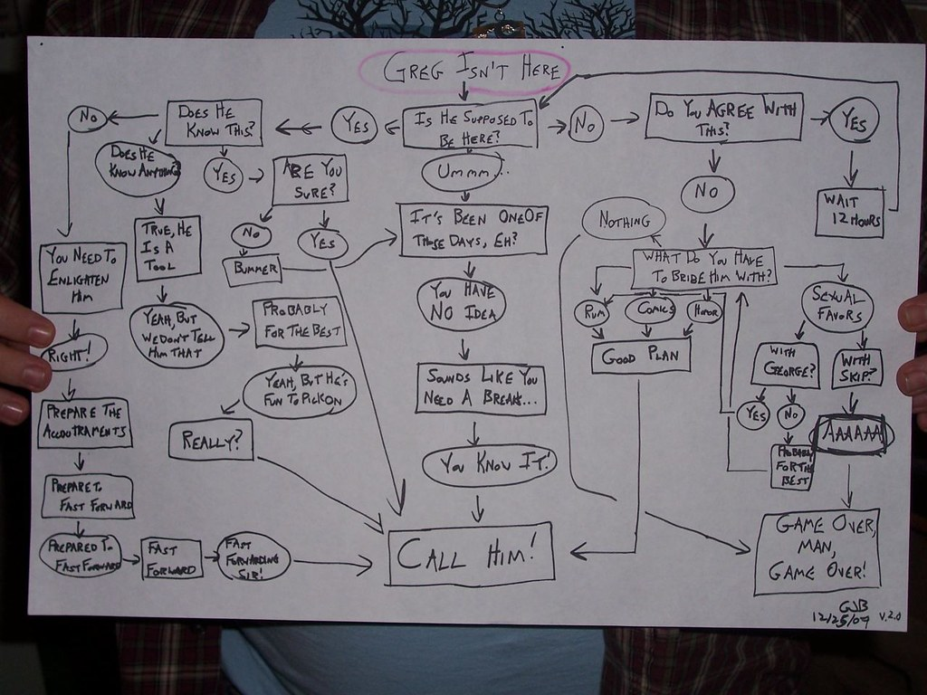
‘flowchart for the rizen mitchells’ by Reclamation Revolution is licensed under CC BY-NC-SA 2.0

- List TWO examples of each of the following methods of communication used when working in construction.
Communication in construction industry
 | Verbal communication | Non-verbal communication | Written communication
Example 1
Example 2

- Provide a workplace scenario which shows how the following can be used well or poorly.
Using communication at work
 | Verbal communication | Non-verbal communication | Written communication
Used well in the workplace
Used poorly in the workplace

- Draw up your own diagram to summarise effective communication in a construction working environment.
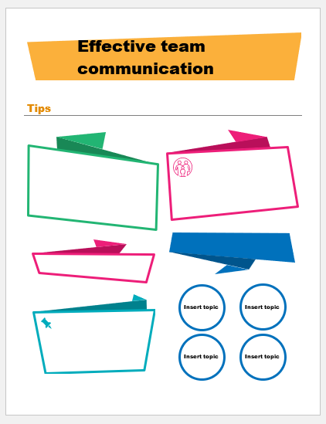

- Correctly match the two halves of each sentence.
Draw a line between each or write (or cut and paste) the correct sentences, in full, below the table.
Match the sentence parts
Your employer can require you to work reasonable additional hours | in a manner that is ‘harsh, unjust or unreasonable’.
Your employer must consider a request for flexible working arrangements | is secured by new federal laws
Employees are entitled to 12 months unpaid parental (or adoption) leave | to work a public holiday.
You are entitled to Notice of termination | and can only refuse on reasonable business grounds.
Existing long service leave | and must leave employees better off overall than they would be if the award applied.
You have the right to reasonably refuse | but you have the right to refuse unreasonable hours
An enterprise agreement must be genuinely agreed to by the majority of employees at the workplace, | and redundancy pay
Your employer should not dismiss you | for each parent after the birth (or adoption) of a child

Putting the theory into practice
The following questions are from past years’ NSW HSC examination papers for this subject. HSC exams are intended to be rigorous and to challenge students of all abilities. To better understand a question, you should look for key words and identify the aspect of the course to which these relate. You are then in a position to formulate your answer from relevant knowledge, understanding and skills.
All questions in ‘Putting the theory into practice’ are acknowledged © 2019 NSW Education Standards Authority (NESA) for and on behalf of the Crown in right of the State of New South Wales.

Multiple Choice

- Why is it important for an apprentice to have an understanding of recognition of prior
learning (RPL)?
  - To ensure site safety
  - To gain a white card
  - To qualify for a first aid certificate
  - To provide evidence of qualifications

- What procedures would minimise the impact on the environment of a construction site?
  - Monitoring the number of employees working onsite
  - Monitoring the total volume of emissions from plant and equipment
  - Safe storage of reusable materials in accordance with workplace/company policy
  - Inservicing employees on the roles and responsibilities of the Environmental Protection Authority (EPA)
- What is the first safety control measure for a risk?
  - Work safely
  - Eliminate the risk
  - Substitute the equipment
  - Use Personal Protection Equipment (PPE)

- What is the first action that management should take after the identification of asbestos
containing materials (ACM) on a construction site?
  - Notify unions and emergency services
  - Secure the area and place signs to stop entry
  - Distribute appropriate personal protection equipment (PPE) to employees
  - Have trained employees remove materials containing asbestos to designated
storage bins

- Which of the following documents would be used by a construction worker to help calculate their weekly wage?
  - Industry code of practice
  - Workplace award agreement
  - Anti-Discrimination Act 1977 (NSW)
  - Work Health and Safety Act 2011 (NSW)
- An employer has the right to dismiss a construction worker for
  - being untidy in appearance.
  - negligence, resulting in an accident.
  - consuming alcohol on a construction site.
  - an incident of unexplained lateness to work
- What is the main job role of a rigger?
  - To direct crane drivers
  - To erect site boundaries
  - To drive earth-moving equipment
  - To secure loads for mechanical lifting
- What do enterprise agreements involve?
  - Verbal agreement
  - Union membership
  - Individual contracts
  - Minimum employment conditions
- What information is contained in an enterprise agreement?
  - Employment terms and conditions
  - Membership of relevant trade unions
  - Employee pay rates and code of practice
  - Workplace Health and Safety regulations
- What is the purpose of a construction work Code of Practice?
  - To meet union regulations
  - To meet industry standards
  - To reduce workplace hazards and risks
  - To comply with material safety data sheets (MSDS)

- What best contributes to successful teamwork?
  - Open communication skills
  - Sound qualifications and work history
  - An understanding of the role of each individual
  - An ability of workers to speak several languages
- Why is a site meeting most commonly held?
  - To order materials
  - To plan the work schedule
  - To discuss future wage rates
  - To communicate changes to work practices

Questions from Section II
These questions should be answered in the suggested number of lines (handwritten) as it gives a guide to the length of your response.
Plan out your answer and key points before you commence writing.
You may need to bring together knowledge from several areas of study/competencies to do justice to the answer.

Question 1
  - What is the purpose of the Anti-Discrimination Act 1977 (NSW)? (2 marks)

  - Outline ways a construction company could promote effective teamwork. (3 marks)

Question 2
  - Outline TWO types of work a carpenter would do on a residential construction site.

2 marks

  - Describe the purpose of ONE checklist that could be used by a carpenter wanting to produce high-quality work. (2 marks)

  - Explain factors that could affect the planned progress of a carpenter on a construction site. (6 marks)

Question 3
Describe the benefits of a mandatory site induction for an employee. (4 marks)

Question 4
Describe the benefits of effective teamwork for both the individual and the workplace.
(4 marks)

Question 5
  - Why is clear and concise communication important when working on a construction site? (2 marks)

  - Identify ONE form of written communication and explain its use when working on a construction site. (3 marks)

Questions from Section III
In the HSC –
- there will be one structured extended response question (15 marks)
- the question will have an expected length of response of around four pages of an examination writing booklet (approximately 600 words)

Questions from Section IV
In the HSC –
- there will be one structured extended response question in Section IV (15 marks).
- the question will have two or three parts, with one part worth at least 8 marks
- the question will have an expected length of response of around four pages of an examination writing booklet (approximately 600 words) in total.

This will provide you with the opportunity to:
- demonstrate knowledge and understanding relevant to the question
- communicate ideas and information using relevant workplace examples and industry terminology
- present a logical and cohesive response

You will note that these questions usually require you to bring together knowledge from several areas of study/competencies to do justice to the answer. You should allow about 25-30 minutes for a question in Section III and the same for Section IV of the exam.

In each of the following, map out your answer using post-it notes or a sheet of paper. Pay particular attention to incorporating a variety of aspects of your Construction curriculum into the plan. Consider why we have included this question within this ‘work effectively’ module and what other areas of study you would need to draw upon.

Question 1
This illustration shows a worker carrying a plan of wood on a construction site.

  - Identify ONE hazard and its potential risk to workers on this construction site. (2 marks)
  - Outline how the builder on this site can reduce the impact on the environment, neighbouring residents and roads. (5 marks)
  - Justify the housekeeping/clean-up processes the builder should undertake at the completion of work each day on this construction site. (8 marks)

Question 2 (15 marks)
Government legislation requires both the employer and the employee to have responsibilities under duty of care.
Explain how both employers and employees meet their responsibilities of duty of care on construction sites.

Question 3 (15 marks)
Describe actions that can be taken to control waste management and reduce hazardous threats to waterways, neighbouring properties and roads and site amenities when working on a building site.

Question 4 (15 marks)
Describe the possible effects of conflict in the construction industry.
In your answer, consider
- causes of conflict
- consequences of conflict
- solutions to conflict.

Question 5 (15 marks)
Explain the environmentally sustainable work practices a builder should use on a construction site.
In your answer, consider the following:
- materials
- equipment
- legislation and regulations.

Question 6 (15 marks)
Site supervisors have many tasks and responsibilities throughout the day.
Explain how these tasks and responsibilities allow for the smooth and safe operation of the job site.

Question 7 (15 marks)
Explain the importance of using environmentally sustainable and recycled construction materials.
In your response refer to TWO of the following:
- composite decking timber
- plantation timbers
- manufactured timber products such as particle board and plywood
- steel as a timber substitute.

