Construction
Safety
Welcome.
This module will assist you to review and revise content in the area of ‘Safety’ in the NSW HSC Construction syllabus.

You will have studied CPCCWHS1001 Prepare to work safely in the construction industry
and CPCCOHS2001A Apply OHS requirements, policies and procedures in the construction industry which (together) address the scope of learning.

This module is broken up into:
- Important notes
- Key terms and concepts, constructing a mind map
- Activities
- Putting the theory into practice
- HSC Focus Area

How to use the resource
Work through the notes and the suggested activities in any order.
Spread your revision over a number of sessions rather than sitting at one subject for lengthy periods.
Discuss your responses with your teacher, fellow students or an interested family member.
All images, apart from those acknowledged, are © NSW Department of Education.

Important Notes
You should use the information in this module as a prompt and guide when revising your study notes or text-book information or other resources provided by your teacher. You can also access industry specific information at SafeWork NSW, Department of Industry, Innovation and Science and Department of Industry, Science, Energy and Resources.
The HSC examination in Construction is based on a set of examinable units of competency from (page 17) of the Construction (240 indicative hours) course.
Examinable Units - Codes and Titles
CPCCCM1012A | Work effectively and sustainably in the construction industry
CPCCCM1013A | Plan and organise work
CPCCCM1014A | Conduct workplace communication
CPCCCM1015A | Carry out measurements and calculations
CPCCCM2001A | Read and interpret plans and specifications
CPCCCM2005B | Use construction tools and equipment
CPCCWHS1001 | Prepare to work safely in the construction industry
CPCCOHS2001A | Apply OHS requirements, policies and procedures in the construction industry
This module helps revise the competency units associated with ‘safety’ – ‘Prepare to work safely in the construction industry’ and ‘Apply OHS requirements, policies and procedures in the construction industry’.
The full scope of learning for ‘Safety’ (from Construction Curriculum Framework 2020 HSC exam and beyond, Syllabus Part B) can be found under ‘HSC Focus Area’.

Key terms and concepts
You can use the following information to revise the key terms and concepts from this unit of competency. Perhaps you could:
- Copy the table into your own file, remove all the key terms, then fill in the blanks (without peeking at the original file) with your own answers.
- Copy the table into your own file and remove the definitions. Write a definition in your own words – it doesn’t have to word perfect but should show you understand the concept.
- You could add an example of this term or concept relevant to the construction environment. If the key term was ‘safety hazard’ your construction example might be ‘poor manual handling when laying concrete can lead to back strain’.

Key term or concept | and the Definition
Absenteeism | In Australia, absenteeism is generally considered to be non-attendance at work by employees when they are rostered to work. Absenteeism can include genuine absences (such as illness or caring for an ill child) and questionable absences (for example where an employee is not actually ill or caring for a family member).
Breach | Failure to follow requirements.
Bullying | Workplace bullying is repeated and unreasonable behaviour directed towards a worker or group of workers creating a risk to health and safety. Examples include abusive or offensive language or comments, aggressive and intimidating behaviour, belittling, or humiliating comments, practical jokes or initiation and/or unjustified criticism or complaints.
Compensation | The cost of workplace injuries is enormous to our society through both compensation monies and lost production time. Compensation monies may be paid to make up for someone's loss, damage, or injury, giving the injured party an appropriate benefit.
Consultation | Consultation is a statutory requirement of most WHS legislations around the world. The aim is to gather information from all stakeholders in the organisation and allow effective participation in the establishment of meaningful health and safety policies and procedures.
Control measures | The steps required to keep a hazard from causing injury, illness and/or damage.
Dangerous goods | Dangerous Goods are substances or articles that are hazardous to people and property. They may be explosives, gases, chemicals, flammable solids or liquids or toxic substances.
Emergency | An emergency is an incident or a situation which endangers, or may endanger, the health, safety and welfare of persons in the workplace, and which requires urgent action to control.
Emergency Plan | An emergency plan is a written set of instructions that outlines what workers and others at the workplace should do in an emergency.
Ergonomics | the process of designing or arranging workplaces, products and systems so that they fit the people who use them.
Evacuation | All organisations and businesses must have an Emergency Evacuation Plan that guides people inside the building, out to an assembly area, as quickly as possible. Procedures for fire and other emergencies should always include provisions for the evacuation of people including those with a disability. It is compulsory by law to have evacuation diagrams at relevant places.
Feedback | Response to a query or reaction to something, used to facilitate future discussions and decisions.
Harassment | Harassment can be against the law when a person is treated less favourably on the basis of certain personal characteristics, such as race, sex, pregnancy, marital status, breastfeeding, age, disability, sexual orientation, gender identity or intersex status. Harassment can include behaviours such as: telling insulting jokes about particular racial groups; sending explicit or sexually suggestive emails or text messages; displaying racially offensive or pornographic posters or screen savers; making derogatory comments or taunts about someone’s race; asking intrusive questions about someone’s personal life, including his or her sex life.
Hazard | Standards Australia defines a hazard as ‘a source or a situation with the potential for harm in terms of human injury or ill-health, damage to property, damage to the environment, or a combination of these.’
Health | Includes both physical and psychological health.
Health and Safety Representative | A worker who has been elected by their work group under the WHS Act to represent them on health and safety matters.
Industry Safety Guidelines | These are developed with a particular industry to provide safety advice relevant to that industry. In construction in Australia, for example, safety guidelines have been developed by SafeWork NSW, Department of Industry, Innovation and Science and Department of Industry, Science, Energy and Resources.
Legislation | The NSW Work Health and Safety Act 2011 (WHS Act) and the NSW Work Health and Safety Regulation 2017 (WHS Regulation) define the obligations both employers and workers have to health and safety in the workplace.  The WHS legislation is supported by a Compliance policy and prosecution guidelines, which supplements the National compliance and enforcement policy.
Managing risk | A process set out in the WHS regulations to eliminate health and safety risks so far as is reasonably practicable, or if this is not reasonably practicable, minimise the risks so far as is reasonably practicable. Includes identifying hazards, assessing and implementing control measures, and reviewing and maintaining the control measures to ensure ongoing effectiveness.
Manual Handling | Manual handling is any activity where the use of force physically, by a person, is exerted to push, pull, lift, lower, extend, restrain, carry, move or hold a stationary or moving, or animate or inanimate object.
Mental health | A person’s mental health affects how they feel, think, behave and relate to others.
MSDS  Material Safety Data Sheet | The Material Safety Data Sheet (MSDS) is a document that describes the chemical and physical properties of a material and provides advice on safe handling and use of the material
Noise | Usually rated in decibels (dB), noise is the phenomena associated with sound pressure on the human ear drum.
Occupational Overuse Syndrome (OOS) | Sometimes referred to as repetitive strain injury (RSI), OOS is a malady affecting bones, muscles, and ligaments, usually arising from repetitive stressing of those body parts, such as repetitive movement. It can be exacerbated by such mental pressures as dislike of the task, or pressure to get the job finished.
Pain and suffering | ‘Pain and suffering’ is the legal term for the physical and emotional stress caused from an injury.
Participation | Participation is the act of sharing in the activities of a group; encouraging involvement and engagement and action. The Work Health and Safety Act aims to provide for fair and effective workplace representation, consultation, co-operation and issue resolution in relation to work health and safety.
PCBU | A PCBU is an umbrella concept which intends to capture all types of working arrangements. A ‘person conducting a business or undertaking’ (PCBU) might be a company, a partnership conducting a business, an unincorporated body or association, a sole trader or self-employed person.
PPE (personal protective equipment) | Used to describe protective equipment that is worn to being protected someone from hazardous situations. PPE includes such things as hats and hair nets, aprons, gloves, overalls, safety shoes and boots, eye and face protection such as goggles, face shields and masks; ear protection such as ear-muffs and ear plugs and breathing equipment.
Productivity | A link has been identified between WHS and productivity. Poor work, health and safety has been linked to lower levels of workplace productivity and performance.
Reporting | WHS reporting, like any other business intelligence, needs to provide management with relevant, robust and timely information that can inform the decisions that influence ongoing business performance. Reporting of incidents and concerns contributes to a safe workplace.
Representation | The Work Health and Safety Act (the WHS Act) aims to provide for fair and effective workplace representation, consultation, co-operation and issue resolution in relation to work health and safety.  Worker representation provides a means for facilitating consultation, involving workers and giving them a voice in health and safety matters.
Risk | The likelihood of a hazard becoming a danger. The possibility that harm (death, injury, illness) might occur when exposed to a hazard.
Risk management | The holistic approach to looking after health, safety and welfare of all people; a systematic process for addressing hazards in the workplace.
Safe Work Practices | These include identifying potential hazards, training and inducting staff, ensuring all staff use the appropriate Personal Protective Equipment and ensuring that all equipment is properly maintained
Significant Injury | Sometimes called ‘serious injury’ or ‘notifiable injury’, generally a significant injury is any injury likely to lead to a person being unable to perform their pre-injury functions for seven days or more.
Visitor | Basically, under the conditions of the WHS Act, a visitor is considered to be anyone who is not doing ‘work’ on behalf of the firm, sometimes described as ‘others’. This will include door-to-door salespeople, relatives, and friends of employees, and so on.
White Card | An industry term for a ‘general construction induction training card’
WHS Policies and Procedures | WHS policies and procedures outline the requirements for complying with both external and internal WHS compliance requirements.
Work Health and Safety Management System | A system that includes all the programmes, policies, procedures, organisational structures, planning activities, responsibilities, processes, practices and resources for developing, implementing, achieving, reviewing and maintaining the Work Health and Safety of all persons in, or affected by, the workplace.
Worker’s responsibilities | All workers are responsible for the WHS impact of their own actions. They also have a duty to make sure their work is carried out in line with WHS procedures and any applicable legislation. More specifically, workers must take reasonable care for their own health and safety.

Activities
- The NSW Work Health and Safety Act 2011 (WHS Act) and the NSW Work Health and Safety Regulation 2017 (WHS Regulation) define the obligations that both employers and workers have to health and safety in the workplace.
List at least five obligations of the employer and at least five obligations of the employee.
- Access SafeWork Australia and answer the following questions:
  - How many workers died as a result of contact with electricity between 2003 and 2015?
  - What was the main cause of these deaths?
  - Which industry appears the at risk of electrical deaths? Does this mean you only have to take care if you work in this particular industry? Why would you need to take greater care?
  - What types of equipment involve greater risk to workers?
  - Explain ‘inspect, test, tag’.

- Research the following from SafeWork NSW and make notes explaining:
  - Consultation (scroll down to this heading)
  - A fair and just workplace
  - Your five safety responsibilities as a worker

- SmartMove is a Work Health and Safety online educational program for senior high school students and young workers entering the workforce for the first time. Registering to use the resources and quizzes and work towards achieving a SmartMove Certificate is free and only takes a few minutes. Access SmartMove and undertake the ‘general’ and ‘building and construction’ modules.

- Click on the link to SafeWork Australia and answer the following.
  - Complete the table.
Most common workplace injuries in 2015
Cuts and open wounds
21%
Chronic joint or muscle conditions

  - Complete the table
Between 2003 and 2013, 401 workers died on construction sites in Australia.
Fatalities were made up of:
Falls from height | 28%
Vehicle collisions
 | 15%
Being hit by a moving object
Being hit by a falling object
 | 8%
Other | 9%

- Find examples of the type of safety signs you would see in a construction environment. Try to find at least three in each category. Look for signs which:
  - indicate you must not do something (prohibition/stop signs: white background, red circle with cross bar)
  - warn you of a danger (caution signs: yellow background, black symbol)
  - provide emergency information (green and white)
  - indicate what you must do (mandatory signs: circle with a blue background and white symbol)
- The SafeWork Australia Construction Work Code of Practice provides practical guidance on how to achieve the standards of work health and safety required under the WHS Act and the Work Health and Safety Regulations (the WHS Regulations) and effective ways to identify and manage risks. Access the document and answer the following:
  - List the hierarchy of control measures from highest level of protection and reliability, to lowest (page 12)
  - What is the difference between a risk and a hazard?
  - List the six obligations that workers have in relation to construction work (page 20)
  - Find examples of risk control measures (page 22) to add to your mind map (Part E at the end of this module). Make sure you understand ‘substitution’, ‘isolation’, ‘engineering controls’, ‘administrative controls’ and ‘PPE’. Remember to add these to Part E below.
  - Write an explanation of ‘safe work method statement (SWMS) using ‘who, ‘what’, ‘where’, ‘when’ and ‘why’. Include the information about SWMS compliance on page 51.
  - Why is ‘workplace specific induction training’ required on a construction workplace? List the topics which need to be included in this induction training (page 34).
  - Read through the examples of high risk construction work (page 44). Consider why these carry more risk than, for example, making wall frames or roof trusses at the construction site.

- Construct a chart with the following headings, showing the safe level of exposure for various decibels. Find examples between 0 and 140 dB.
Safe levels of exposure
Sound pressure level | Example of sound source | Safe exposure time | Hearing protection measures
85 dB | Front end loader | 8 hours

- For each illustration, identify the missing items of PPE. The dot points indicate how many you need to find.
Illustration | Missing item of PPE
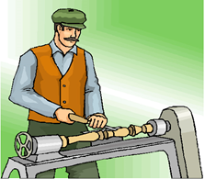
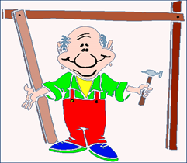
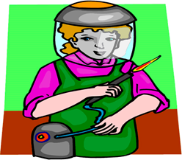
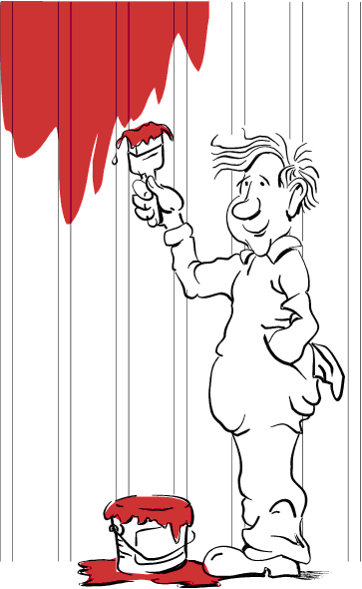
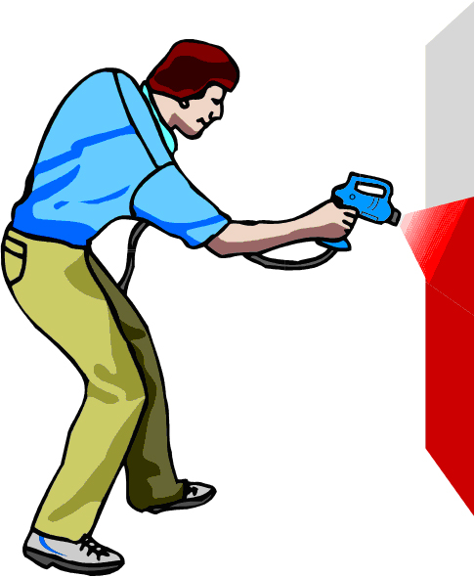
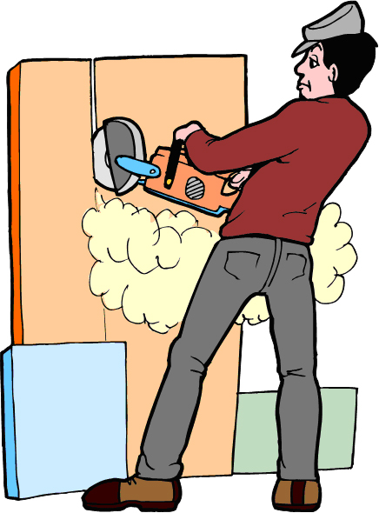

- Match the two halves of each sentence.
Draw a line between each or write (or cut and paste) the correct sentences, in full, below the table.
An employer | is the responsibility of an employer.
Hazards | law must provide workers with training and supervision and a safe and healthy workplace.
Safety Signs | employers and employees to consult and cooperate (work together) to make their workplace safe.
The title of the NSW safety legislation (laws) that protect workers is | should follow safety procedures, work safely and not put the safety and health of others in the workplace at risk.
The control of hazards | warn people of danger and provide safety information.
NSW safety and health laws encourage | The NSW Work Health and Safety Act 2011 (WHS Act) and the NSW Work Health and Safety Regulation 2017 (WHS Regulation).
An employee (worker) | is available from SafeWork NSW.
Information on safety and health at work | must be controlled by the employer, manager or supervisor.

- Briefly explain the WHS issues in each of the following.
 | 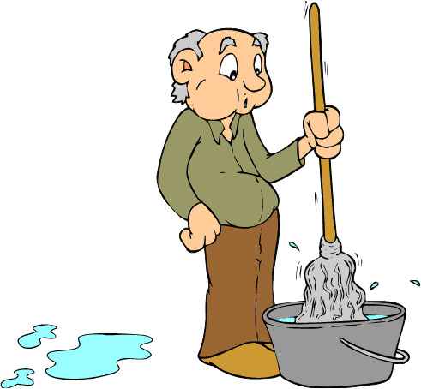 | 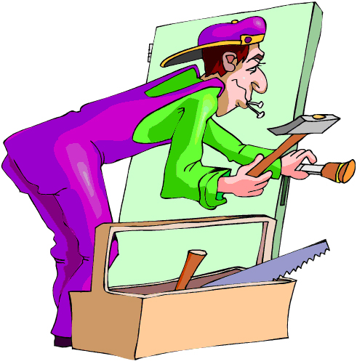

- Consider the following two construction environments. For each one, develop a list of three safety topics to be discussed at a WHS Safety meeting.
Image licenced under CC0. The original version can be found on pexels

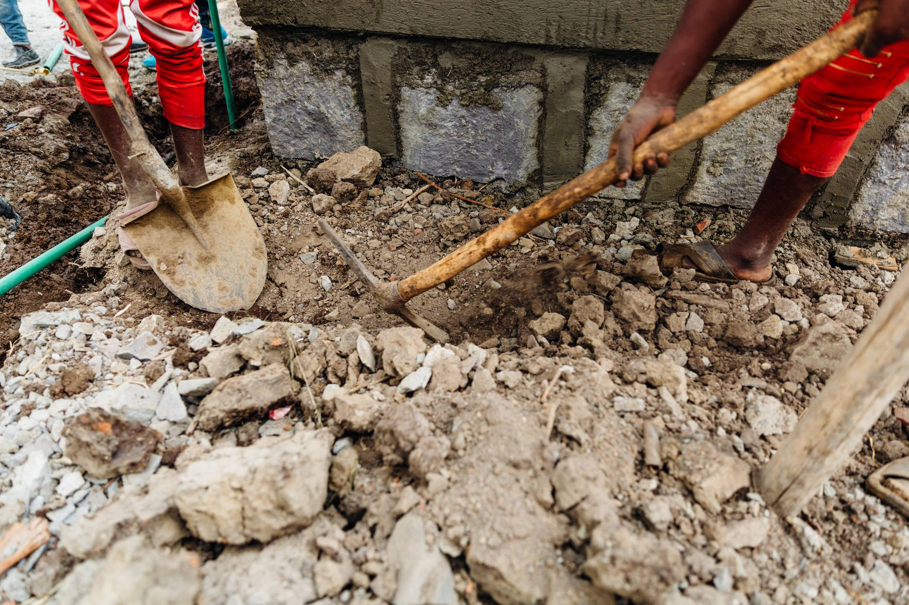
Image licenced under CC0. The original version can be found on pexels
- Access websites http://www.whitecardsafety.com/fire-safety.html and https://www.fireequipmentonline.com.au/6-fire-extinguisher-classes-in-australia to complete the following:
Fire is a chemical reaction requiring what three components?
The way to extinguish a fire is to remove any, or all, of the components of the fire triangle. List four:
The type of alarm needed can range from a simple shout of 'fire', to sophisticated automatic systems. Whatever system is chosen, make sure it:
There are six classes or types of fires in Australia. List them below providing an example and indicating what extinguishing agent should be used on each.
Class A
Class B
Class C
Class D
Class E
Class F

- Fill in the blanks, using the words provided.
effective | communication | implementing | frequency
hazardous | earliest | instructions | activity
emergency | procedures | storage | workers
What is an emergency plan?
An emergency plan is a written set of ( ) that outlines what ( ) and others at the workplace should do in an ( ). An emergency plan must provide for the following:
- emergency procedures, including: an ( ) response to an emergency
- evacuation ( )
- notifying emergency service organisations at the ( ) opportunity
- medical treatment and assistance, and
- effective ( ) between the person authorised to coordinate the emergency response and all people at the workplace
- testing of the emergency procedures—including the ( ) of testing, and
- information, training and instruction to relevant workers in relation to ( ) the emergency procedures.
What types of emergencies should be covered?
The types of emergencies to plan for may include fire, explosion, medical emergency, rescues, incidents with ( ) chemicals, bomb threats, armed confrontations and natural disasters.
The emergency plan should be based on a practical assessment of hazards associated with the work ( ) or workplace, and the possible consequences of an emergency occurring as a result of those hazards. External hazards should also be considered in preparing an emergency plan, for example a chemical ( ) facility across the road.
In developing the plan, consideration should be given to the application of all relevant laws, including public health ( ) (for example, workplaces that are also public places) and state or territory disaster plans.

- The Department of Industry, Innovation and Science provides guidance on how to manage risks in the workplace using a systematic process.
  - Provide a definition for each step in the process in the table below.
A systematic process for managing risks in the workplace
Identify hazards
Assess risks
Control risks
Review control measures
Record and report safety issues
Support return to work
Make your workplace healthier

  - The same government department lists examples of WHS in the construction industry. Scroll down to ‘workplace health and safety’. Choose two and give an example relevant to your course of study.
  - Develop a list of at least three examples of a risk control measure which could be implemented within the Construction workplace.
  - Use these examples in your mind map (below).

Putting the theory into practice
The following questions are from past years’ NSW HSC examination papers for this subject. HSC exams are intended to be rigorous and to challenge students of all abilities. To better understand a question, you should look for key words and identify the aspect of the course to which these relate. You are then in a position to formulate your answer from relevant knowledge, understanding and skills.
Questions in ‘Putting the theory into practice’ are acknowledged as © 2019 NSW Education Standards Authority (NESA) for and on behalf of the Crown in right of the State of New South Wales.

Multiple Choice
- What is the first safety control measure for a risk?
  - Work safely
  - Eliminate the risk
  - Substitute the equipment
  - Use Personal Protection Equipment (PPE)
- What is the first action that management should take after the identification of asbestos
containing materials (ACM) on a construction site?
  - Notify unions and emergency services
  - Secure the area and place signs to stop entry
  - Distribute appropriate personal protection equipment (PPE) to employees
  - Have trained employees remove materials containing asbestos to designated
storage bins
- Which of the following is a role of a workplace safety committee?
  - To undertake site inspections
  - To resolve workplace conflicts
  - To maintain tools and equipment
  - To issue penalties for non-compliance under Work Health and Safety legislation
- Which of the following signs is a hazard warning?
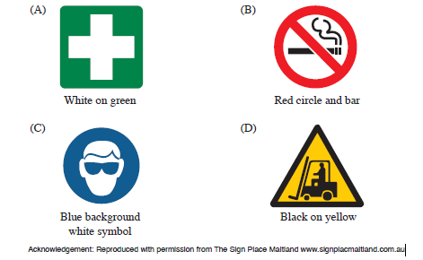
Illustration from NSW Construction HSC Exam 2014
- Which of the following includes two essential pieces of information required when contacting emergency services to attend an accident at a construction site?
  - Nature of injuries, location
  - Nature of incident, name of local doctor
  - Contact name, family emergency contact number
  - Nearest cross-street, injured person’s years of employment
- Which of the following tools cannot be used when removing identified asbestos-containing materials on a construction site?
  - Pinch bar
  - Claw hammer
  - Impact hammer
  - Sledge hammer
- Which of the following incidents must be reported to WorkCover/Safe Work Australia?
  - a structural wall collapse
  - a cut finger requiring stitches
  - an emergency evacuation site drill
  - an electrical fault with a power saw

- A supplier has substituted a different brand of adhesive on a builder’s order of material. Which of the following is used to check the hazard rating for the adhesive?
  - Job Safety Analysis
  - Material Safety Data Sheet
  - Safe Work Method Statement
  - Work Health and Safety Act 2011 (NSW)

- When in use, a 240-volt power drill catches fire. Which fire extinguisher would be suitable to use?
  - Foam
  - Water
  - Dry chemical
  - Wet chemical
- What does a mandatory safety sign indicate?
  - A hazard
  - Required PPE
  - A potential danger
  - An electrical hazard

- A fire has broken out on a construction site. What should be the first response to this emergency situation?
  - Notify emergency services
  - Evacuate the construction site
  - Obtain help for any injured workers
  - Raise the alarm to alert everyone on site

- Which set of responsibilities is part of an employer’s duty of care?
  - Providing toilet facilities, clean drinking water and PPE
  - Providing lunch, toilet facilities and clean drinking water
  - Providing a safe working environment, toilet facilities and regular overtime
  - Providing clean drinking water, safe working environment and on-site parking

- Who should a construction worker contact first to resolve a safety concern?
  - The supervisor
  - SafeWork NSW
  - The property owner
  - The union representative

- What is the highest level of safety control in the hierarchy of control?
  - Work safely
  - Eliminate the risk
  - Substitute the equipment
  - Use personal protective equipment (PPE)

- Which combination of information is legally required on electrical testing tags?
  - Date and testing company
  - Voltage and next test date
  - Weight and serial number
  - Voltage and phone number

Questions from Section II
These questions should be answered in the suggested number of lines (handwritten) as it gives a guide to the length of your response. Plan out your answer and key points before you commence writing.
You may need to bring together knowledge from several areas of study/competencies to do justice to the answer.

Question 1
  - What written information should be recorded at a construction site meeting? (2 marks)

  - Recommend an appropriate method for an employer to communicate information about dangerous goods to employees. (2 marks)

Question 2
  - A construction worker is operating an excessively noisy power tool. Describe communication techniques which could be used to attract the worker’s attention to stop operating that power tool. (2 marks)

  - Outline reasons why a power tool would make excessive noise. (2 marks)

  - Complete the table by identifying the potential hazards and safety controls when cutting timber with a power saw. (4 marks)

Hazards | Safety Controls
1

2

Question 3
  - Name the colour for each sign listed in the table.
Signs | Colours
Regulatory mandatory
Regulatory prohibition

  - Outline the factors to be considered when carrying out maintenance on a wheelbarrow. (2 marks)

  - Other than cost, what features should be considered when purchasing a wheelbarrow? (2 marks)

Question 4
A delivery of 50 sheets of 3 m × 1.2 m 19 mm plywood needs to be unloaded from a truck parked on a busy street outside a construction site.
Explain how to manually unload the sheet material safely on to the site. (5 marks)

Question 5

A worker is injured after falling four metres from a scaffold. Describe the procedures that should be followed immediately, and then as a result of this incident. (6 marks)

Question 6
The following diagram shows a typical skip bin for a construction site. The cross-section of the skip bin is a trapezium.
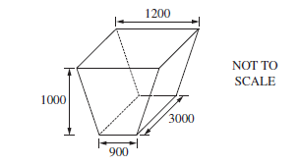
Illustration from NSW Construction HSC exam 2018

  - Outline TWO safety considerations when placing waste materials into the skip bin.
(2 marks)

  - Calculate the volume of the skip bin in cubic metres. (3 marks)

  - Outline what should be considered when placing the skip bin on a construction site.
(2 marks)

  - Explain why construction waste is sorted on building sites before being removed. (3 marks)

Questions from Section III
In the HSC –
- there will be one structured extended response question (15 marks)
- the question will have an expected length of response of around four pages of an examination writing booklet (approximately 600 words)

Questions from Section IV
In the HSC –
- there will be one structured extended response question in Section IV (15 marks).
- the question will have two or three parts, with one part worth at least 8 marks
- the question will have an expected length of response of around four pages of an examination writing booklet (approximately 600 words) in total.

This will provide you with the opportunity to:
- demonstrate knowledge and understanding relevant to the question
- communicate ideas and information using relevant workplace examples and industry terminology
- present a logical and cohesive response

You will note that these questions usually require you to bring together knowledge from several areas of study/competencies to do justice to the answer. You should allow about 25-30 minutes for a question in Section III and the same for Section IV of the exam.

In each of the following, map out your answer using post-it notes or a sheet of paper. Pay particular attention to incorporating a variety of aspects of your Construction curriculum into the plan. Consider why we have included this question within this safety module and what other areas of study you would need to draw upon.

Question 1
Click on the link to see the photograph referred to in the questions below.

  - Identify ONE hazard and its potential risk to workers on this construction site. (2 marks)
  - Outline how the builder on this site can reduce the impact on the environment, neighbouring residents and roads. (5 marks)
  - Justify the housekeeping/clean-up processes the builder should undertake at the completion of work each day on this construction site. (8 marks)
Question 2
The photograph shows a pedestrian pathway on a construction site. 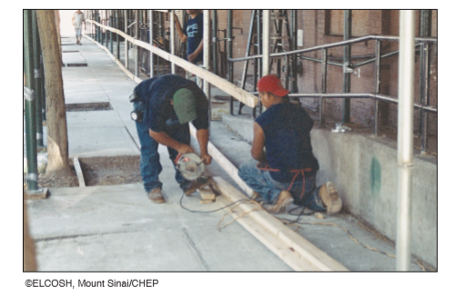
Illustration from NSW Construction HSC Exam 2015

  - Identify ONE hazard and its potential risk to workers on this construction site. (2 marks)
  - How would you communicate work-site information to workers and visitors on this work site? (5 marks)
  - Explain a method for assessing the risks and hazards on this work site by:
    - Assessing potential risks
    - Prioritising the most dangerous hazards. (8 marks)

Question 3
During an excavation on a construction site, a gas line explodes resulting in a number of workers being injured.
  - Describe the emergency procedures to be followed in response to this critical incident (3 marks)
  - What documentation and communication will be required by management after the immediate response to this critical incident? (4 marks)
  - Explain the risk management assessment process that should have been implemented to prevent the accident. (8 marks)

Question 4 (15 marks)
An evacuation alarm on a large construction site has been sounded, due to an electrical fire.
Discuss the procedures that must be followed by management and workers during the emergency, the investigation, and the short-term impact on the work site.

HSC Focus Area: Safety
For the purposes of the HSC exam, all students undertaking the 240 HSC indicative hours course in Construction must address all of the focus area content for Safety (see following pages).
The scope of learning describes the breadth and depth of the HSC Content, the minimum content that must be addressed, and the underpinning knowledge drawn from the associated unit(s) of competency.

The units of competency associated with the focus area ‘Safety’ in Construction are:
CPCCWHS1001 Prepare to work safely in the construction industry
CPCCOHS2001A Apply OHS requirements, policies and procedures in the construction industry

How to use the scope of learning for ‘Safety’
- draw up your own mind map showing the connection between the various concepts listed; examples appear on the last page of this module
- use the key terms and concepts to add to your mind map
- add examples or case study prompts to show how the concept is applied in the construction working environment

The following information is taken directly from ‘Safety – HSC requirements and advice’ Construction Curriculum Framework (NSW Education Standards Authority) for 2018 HSC examination and beyond .
© 2019 NSW Education Standards Authority (NESA) for and on behalf of the Crown in right of the State of New South Wales.

work health and safety (WHS)
- meaning of health, safety and duty of care
- cost of workplace injury:
  - human
  - social
  - economic
  - organisational
- acknowledge that WHS is everyone’s responsibility in the workplace and the implications of this responsibility
- concept of ‘participation’ and ‘consultation’ in relation to WHS
- primary role/function of key bodies/authorities involved in WHS:
  - SafeWork NSW
  - Safe Work Australia
  - local councils
  - unions
  - professional associations
- internal and external sources of workplace WHS information
- importance of acting within scope of responsibility/level of authority in relation to WHS in the workplace:
  - taking initiative
  - problem-solving
  - decision-making

WHS compliance
- difference between an act, regulation, code of practice and standard (Australian, industry and workplace)
- purpose and intent of WHS legislation and codes of practice and their application to the construction industry and workplace and a specific job role:
  - WHS legislation:
- Work Health and Safety Act 2011 (NSW) (as amended)

WHS compliance cont/d
- Work Health and Safety Regulation 2017 (NSW) (as amended)
- Workers Compensation Act 1987 (NSW) (as amended)
- Workplace Injury Management and Workers Compensation Act 1998 (NSW) (as amended)
  - codes of practice related to:
- amenities and induction for construction work
- first aid
- manual handling
- risk management
- WHS consultation
- purpose and intent of industry safety standards and guidelines and their application to the construction industry and workplace and a specific job role
- work tasks/activities requiring a licence, permit, ticket or certificate of competency
- WHS rights, duties and responsibilities of the person conducting a business or undertaking (PCBU), officer and worker (as defined in the legislation)
- functions and powers of WHS inspectors
- consequences of failure to observe (non-compliance) WHS workplace policy and procedures and legislative requirements
- safety signs, symbols and barricades used in the construction industry and their use in the workplace:
  - legislative requirements
  - meaning of colour and shape
  - placement and positioning
- construction industry and workplace requirements for monitoring and reporting in relation to workplace safety
- describe how, when and to whom to report:
  - types:
- formal and informal
- written
- verbal
  - reporting to appropriate persons
- purpose and importance of monitoring and reporting
- application of workplace policy and protocols and regulatory requirements when recording and reporting in relation to WHS

WHS consultation and participation
- opportunities for workers to provide input into WHS consultation and participation processes:
  - formal and informal discussion
  - meeting
  - survey
  - training
  - WHS audit
  - WHS inspection
- requirements (including election/formation) of a health and safety committee or health and safety representative (HSR) and their role and responsibilities in the workplace
- role and responsibilities of relevant personnel in WHS consultation and participation:
  - PCBU
  - manager/supervisor/team leader
  - self
  - other workers
  - union
- importance of identifying and reporting:
  - WHS issues and concerns
  - workplace hazards
  - unsafe work practices
  - breaches of health and safety
and examples of each for the construction industry and workplace

risk management
- the difference between a hazard and a risk
- risk management and its application in the construction workplace:
  - hazard identification:
- potential hazards to self, colleagues, general public and others typical to the industry
- range of hazards:
- hazardous and non-hazardous materials
- human factors (self and others)
- manual handling
- tools, equipment, machinery and plant
- work environment
- work processes and practices
- working alone; at heights; in confined spaces; in and around excavations; near traffic and water; and with compressed air, electricity and liquids under pressure
  - risk assessment
  - risk control (hierarchy):

risk management cont/d
- eliminate the risk
- minimise the risk
- substitution
- modification
- isolation
- engineering control
- other controls:
- administrative
- safe work practices
- personal protective equipment (PPE)
  - monitor and review

safe work procedures and practices
- safe work procedures and practices and their purposes, including:
  - WHS induction training (general, work activity and site-specific)
  - adherence to:
- job safety analysis (JSA)
- safe work method statement (SWMS)
- safety data sheet (SDS)
- standard operating procedures (SOPs)
- site/project safety plan
- work documentation and plans
- work instructions
- workplace policy
  - PPE:
- importance of correct fit
- types, purpose, selection and use
- maintenance and storage
  - access to appropriate site amenities and communication devices
  - correct handling, application, labelling, transport and storage of hazardous substances and dangerous goods
  - asbestos containing materials (ACM):
- types, use in common building materials and possible location
- associated risks
- workplace/company policy for prevention of exposure, including asbestos management code
  - tools, equipment and machinery:
- restrictions placed on use
- selection appropriate to task/work activity
- safety equipment and devices and their use, limitations and maintenance
- pre-operational checks and correct use
- regular maintenance and correct storage

safe work procedures and practices cont/d
- reporting faults:
- verbal notification to appropriate personnel
- recording on job card/maintenance log
- safety tags and lockout
  - manual handling techniques:
- when working individually, in pairs and with a team:
- moving, lifting, carrying and placing items down
- bending and twisting
- loading and unloading into general storage, in/out of transport and to/from raised work area
- working with tools, equipment and machinery
- undertaking repetitious tasks
- using mechanical aids/lifting equipment
- recommended weight limits
  - ergonomics and posture:
- correct placement of equipment
- sitting and standing positions
- task rotation
- use of adjustable equipment
  - working with electricity:
- general electrical safety
- electrical tagging
  - housekeeping:
- clean-up procedures for the immediate work area and the work site
- storage and disposal of waste
- consideration of WHS and the environment
- importance of safe work procedures and practices
- propose safe work procedures and practices for a workplace and specific job role within the construction industry

incidents, accidents and emergencies
- meaning of incident, accident and emergency
- a range of incidents, accidents and emergencies common to the construction industry
- distinguish between a manageable first aid situation and an emergency situation
- a range of potential workplace injuries common to a construction workplace, their cause(s) and basic first aid
- strategies to reduce workplace accidents and injury and impairment

incidents, accidents and emergencies cont/d
- responding to incidents, accidents and emergencies:
  - emergency situations
  - seeking assistance
  - emergency contact numbers
  - emergency signals, alarms and exits:
- location
- use
  - procedures to follow:
- notification
- workplace policy and procedures:
- evacuation
- security
- reporting
  - basic process of fighting a fire and use of firefighting equipment:
- fire blanket
- fire extinguishers
- class and type of fire
- type of extinguisher and identifying colour
- fire hose and reel
  - role of personnel in an emergency
  - first aid:
- basic principles
- personnel responsible
- application of workplace policy and protocols and regulatory requirements when recording and reporting in relation to incidents, accidents and emergencies

Creating a mind map is a great way to organise your knowledge and understanding of the content of a topic.
You could use software such as a hierarchy chart, download ‘MindNode’ or similar or use a large sheet of paper (or several A4 sheets taped together)!
It is important to try to include all the detail you can, so add definitions, case studies or examples to prompt your memory. Include the information downloaded from the unit of competency and also from the Scope of Learning and Key Terms and Concepts.
Example of mind map being developed
