Construction
Carry out measurements and calculations
Welcome.
This module will assist you to review and revise content in the area of ‘Carry out measurements and calculations’ in the NSW HSC Construction syllabus.
You will have studied the competency CPCCCM1015A Carry out measurements and calculations, which addresses the scope of learning.

This module is broken up into:
- Important notes regarding the HSC focus area
- Key terms and concepts; constructing a mind map
- Activities
- Putting the theory into practice

How to use the resource
Work through the notes and the suggested activities in any order.
Spread your revision over a number of sessions rather than sitting at one subject for lengthy periods.
Discuss your responses with your teacher, fellow students or an interested family member.
All images, apart from those acknowledged, are © NSW Department of Education.

Important Notes: HSC Focus Area
You should use the information in this module as a prompt and guide when revising your study notes or text-book information or other resources provided by your teacher. You can also access industry specific information at SafeWork NSW, Department of Industry, Innovation and Science, Anti-Discrimination Board of NSW, Industrial Relations NSW, and Australian Council of Trade Unions
The HSC examination in Construction is based on a set of examinable units of competency (see table below) from the Construction (240 indicative hours) course.
Examinable Units
Code | Title
CPCCCM1012A | Work effectively and sustainably in the construction industry
CPCCCM1013A | Plan and organise work
CPCCCM1014A | Conduct workplace communication
CPCCCM1015A | Carry out measurements and calculations
CPCCCM2001A | Read and interpret plans and specifications
CPCCCM2005B | Use construction tools and equipment
CPCCWHS1001 | Prepare to work safely in the construction industry
CPCCOHS2001A | Apply OHS requirements, policies and procedures in the construction industry

This module helps revise the focus area ‘Carry out measurements and calculations’ (based on CPCCCM1015A Carry out measurements and calculations).
This unit of competency specifies the outcomes required to carry out measurements and perform simple calculations to determine task and material requirements for a job in a construction work environment.
The scope of learning describes the breadth and depth of the HSC Content, the minimum content that must be addressed, and the underpinning knowledge drawn from the associated unit(s) of competency.
The full scope of learning is available from Construction Curriculum Framework 2020 HSC exam and beyond, Syllabus Part B, Mandatory units of competency ‘Carry out measurements and calculations

The following extract is taken from Syllabus Part B, Mandatory units of competency ‘Carry out measurements and calculations.
Required knowledge for this unit is:
- basic calculators
- communication devices
- company procedures
- construction terminology
- job safety analysis (JSA) and safe work method statements
- measuring, calculating, geometry and determination of quantities
- processes for care of measuring equipment
- project quality requirements
- site and equipment safety (WHS) requirements
- tolerances.

Key terms and concepts
You can use the following information to revise the key terms and concepts from this unit of competency. Perhaps you could:
- Copy the table into your own file, remove all the key terms, then fill in the blanks (without peeking at the original file) with your own answers.
- Copy the table into your own file and remove the definitions. Write a definition in your own words – it doesn’t have to word perfect but should show you understand the concept.
- You could add an example of this term or concept relevant to the construction environment. If the key term was ‘perimeter’ your construction example might be ‘the total length of fencing required for the job will be the perimeter of the entire site’.

Constructing a mind map
Creating a mind map is a great way to organise your knowledge and understanding of the content of a topic.
- draw up your own mind map showing the connection between the various concepts listed
- use the key terms and concepts to add to your mind map
- add examples or case study prompts to show how the concept is applied in the construction working environment
You could use software such as a hierarchy chart, download ‘MindNode’ or similar or use a large sheet of paper (or several A4 sheets taped together)!
It is important to try to include all the detail you can, so add definitions, case studies or examples to prompt your memory. Include the information downloaded from the unit of competency and also from the Scope of Learning and Key Terms and Concepts.

Key term or concept | and Definition
Accuracy | Being correct or precise
Addition | The process of adding something to something else
Areas | The extent or measurement of a surface
Basic Calculations | Simple 1 to 2 step calculations using addition, subtraction, multiplication or division
Calculating Tools and Equipment | Tools and equipment used in calculating mathematical questions
Calculation factors | The factors involved in the calculation
Circles | A round plane figure whose boundary consists of points equidistant from a fixed point (the centre)
Cones | An enclosed object that tapers from a circular base to a point
Cubes | A symmetrical three-dimensional shape, either solid or hollow, contained by six equal squares
Cylinders | A solid geometrical figure with straight parallel sides and a circular or oval cross section
Depth | The distance from the top or surface to the bottom of something
Diagram / Sketch | A simplified drawing showing the appearance, structure, or workings of something
Division | The process of dividing one number by another
Estimate | To roughly calculate or judge the value, number quantity or extent of
Formulas | A mathematical relationship or rue expressed in symbols
Geometry | The properties and relations of points, lines, surfaces, solids and higher dimensional analogues
Grade | A gradient or slope
Height | The measurement of something from the base to the top; a high place or position
Length | The measurement of something from end to end; the greater dimension of a two- or three-sided object
Mass | The amount of material; weight
Material Quantities | The number or amount of a measured material
Measurements | The size, length, width, breadth, thickness of part of an object; a unit or system of measuring
Measuring Tools and Equipment | Tools and equipment used in the measurement of an object – rule, measuring tape, laser level
Metric | Relating to or based on the metre as a unit of measure
Multiplication | The process or skill of multiplying
Numbers | A figure that represents a quantity or amount; used in counting and making calculations
Percentages | A rate, number, or amount in each hundred; any portion or share in relation to a whole
Perimeters | The continuous line forming the boundary of a closed geometrical figure
Plans | A detailed map, diagram, sketch made by projection on a horizontal plane showing the layout of a building
Project Quality Requirements | The quality / standard required for a certain project or part of a project
Pyramids | An object or shape, with a square base and sloping sides that meet in a point at the top
Ratios | The quantitative relationship between two amounts showing the number of times one value contains or is contained within the other
Recording Information | Documenting information in relation to the measurement, calculation, task or project
Rectangles | A plane figure with four straight sides and four right angles, but only 2 sides are equal, not all four, like a square
Scales | A graduated range of values forming a standard system for measuring or grading something; the relative size or something
Specifications | A detailed description of the design and materials used to construct something
Squares | A plane figure with four equal straight sides and four right angles
Subtraction | The process of taking one number or amount away from another
Tolerances | An allowable amount of variation of a specified quantity or dimension
Trapeziums | A quadrilateral shape with one pair of sides parallel
Triangles | A plane figure with three straight sides and three angles
Volume | The amount of space that a substance or object occupies, or that is enclosed within a container
Waste Minimisation | Limiting and/or minimising the amount of waste produced; Limiting and/or minimising the amount of extra material you calculate when calculating material quantity
Weight | The mass of an object
Width | The measurement or extent of something from side to side; the lesser of a two- or three-sided object
Workplace documentation | Documents specific to the workplace or project

Activities
- List the various types of measuring tools and equipment used within the Construction Industry.

- What tools and equipment are required when undertaking the following measuring and calculating tasks?
  - A concrete slab for a garden shed.
  - The grass required to cover 2 football ovals.
  - The length of roof sheets for a factory building.
  - The required timber edge boards for a concrete footpath 150m long.
- What safety precautions must you take when you are measuring in preparation for calculating?

- Convert the following measurements:
From | To |  | From | to
500mm | m |  | 4Kg | g
7800mm | m |  | 33Kg | g
13450mm | m |  | 0.38Kg | g
1.2m | mm |  | 1500g | Kg
0.75m | mm |  | 88g | Kg
10.55m | mm |  | 670g | Kg
10000m | Km |  | 2500ml | L
600m | Km |  | 250ml | L
6510m | Km |  | 25ml | L
0.8KM | m |  | 25L | ml
15.75KM | m |  | 100L | ml
9.35KM | m |  | 0.9L | ml

- In this question, you are required to apply the correct unit or units of measure to each distance or item. The various units of measure have been provided below.
(Some of these can use more than one unit of measure. Some need a unit of measure for the calculation and are then purchased in a different unit of measure)
Units of measure include:

Millimetres (mm)
Metres (m)
Metres Squared (m²)
Metres Cubed (m³)
Millilitres (ml)
Litres (L)
Kilograms (KG)
Tonnes (t)
Quantity (Qty)

Distance or Item | Unit/s of Measure
Length, Width, Depth, Breadth
Perimeter, Circumference
Area
Volume
Tin of paint
Container of nails
Bag of cement
Truckload of soil

- How many metres of timber are required for the edgeboard formwork for a concrete slab 4.8m x 3.8m?

- Calculate the total metres of 70x45 timber if I have 55 lengths at 2.4m, 67 lengths at 3.6m, 43 lengths at 4.8m and 28 lengths at 5.4m.
- You are required to order the temporary fencing for the new construction site. The site boundary is shown in the image below.
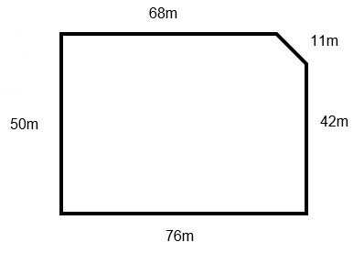
  - How many metres are required to enclose the site?
  - Each fence panel is 2.4m wide. How many panels are required?
- You’re constructing a new paved area 5400mm x 3600mm. Calculate the square metres of pavers required for the job. Allow 7% for cutting of pavers.

- The school liked your paving so much they have asked you to construct two more paved areas, this time they are circular. Each circle has a radius of 2.3m. How many square metres are required for the 2 paved areas? Allow 10% for cutting.

- The pavers cost $48.50 / m². What is the total cost of all 3 paved areas in Q9 and Q10?

- How many sheets of 3600mm x 1200mm x 10mm plasterboard would be required to sheet the walls of an office building, with a total wall size of 670m²?

- You are ordering yellow tongue particle board sheet flooring for a house extension. Each sheet is 3600mm x 900mm. How many sheets of flooring would be required for a first floor 18.8m x 14.7m?
- How many nails in the following sizes?
- 1kg of 75mm bullet head nails. Each nail weights 44 grams.
- 7.5kg of 15mm panel pins. Each pin weighs 6 grams.
- 5kg of 30mm clouts. Each nail weighs 8 grams.

- You are required to board up the side of a building 19m long and 4.7m high. Your supervisor order 30 sheets of plywood 2400mm x 1200mm in size, to complete the job.
- Do you have enough sheets to complete the job?
- How many extra sheets do you have or how many more sheets do you require to finish the job?

- The client wants the plywood wall from the previous question painted. 1 litre of paint covers approximately 14m².
- How much paint do I need to paint the wall twice? (answer to be in litres)
- I can only buy paint in 4L, 10L or 15L drums. How much do I need to buy?

- You need to apply a sealer to a new concrete driveway. The sealer is a 2 Part polyurethane product with a base and a hardener. How much hardener needs to be added to 5 litres of base at a ratio of 1 part hardener 4 parts base?

- What is the volume the following size water tanks?
- Round water tank with a radius of 1.5m and a height of 2.7m
- Round water tank with a circumference of 3.6m and a height of 1.2m
- Round water tank with a radius of 1200mm and a height of 1850mm

- A retaining wall is being constructed between 2 houses.
- How much soil needs to be excavated from the trench that is 27m long, 450mm wide and 700mm deep?
- The concrete footing is the length and wide of the trench but is only 550mm deep. How much concrete needs to be ordered for the footing?
- You are excavating for concrete footings for a double car garage. The concrete slab is 10m x 7m. The footings are 500mm wide and 450mm deep. The footings run around the perimeter of the slab and one through the middle of the slab (as shown in the diagram) How many cubic metres of material will be excavated from the footings?

- You are installing a new tongue and groove floor. You are using Blue Gum flooring which has a sectional size of 85 x 19mm.
- Calculate the rows of boards required to cover the floor space if the room is 5.4m long.
- How many metres of floorboard do you require if the room is 3.35m wide?
- Which supplier is the cheapest? (show your calculations)
    - Bunnings - $70 per square metre
    - Mitre 10 - $6.25 per lineal metre

- Calculate the number of bricks required to construct the following 2 walls if there are 50 bricks per m²
- A single skin brick wall, 10.6m long by 3m high. Allow for 1 door opening 2100mm x 950mm.
- A double skin brick wall 15.5m long by 2.7m high. Allow for 2 window openings of 1200 x 1350mm.
- You need to clad the walls of a new granny flat with fibre cement boards. Two sides of the house are 4.75m long and the other two sides are 3.8m long. The height of the wall is 2.7m. The boards are 325mm high and 2400mm long.
- How many square metres of cladding are required to complete the job?
- How many lineal metres of cladding are required to complete the job?

- Your school is installing a new concrete footpath. You are to calculate the materials required to construct the footpath. The length of the path is 33.5m, the width of the path is 1800mm and the depth of the path is 100mm. The edgeboard timber is 90x35 structural pine.
- How many metres of timber do I require for the formwork?
- Calculate the total amount of formwork required including 15% waste.
- If I ordered the 90x35 timber in 2.4m lengths, how many lengths do I require?
- If I ordered the 90x35 timber in 3.6m lengths, how many lengths do I require?
- You need to install a moisture barrier under the concrete slab. How much plastic do you need to order for this concrete slab? (Answer in m²)
- You need to install F62 sheet mesh reinforcement. Each sheet is 6m x 2.4m in size. It covers 13.4m² (including the overlap of sheets). How many mesh sheets do you need to order for this slab?
- You need to install 30mm of sand for your subgrade. How much sand do you need to order?
- How much concrete do you need to order for this concrete slab? Include 10% waste in your calculations.
- Calculate the following costs: complete the missing information on each line then calculate the sub-total, GST and total costs.
Item | Quantity | Cost per Item | Total Cost
90x35x2400 Structural Pine | 45 | $7.27 each | $
Tas Oak Dowel 8mm x 1.8m | 12 | $ each | $39.60
Bracket Angle – 75x75x20 |  | $1.38 each | $6.90
Quickset Concrete 20kg Bag |  | $6.88 bag | $206.40
90x90 Radiata Pine Posts | 28m | $9.77/m | $
Screws SelfTap 6x15 PKT 100 | 2 | $ pkt | $10.46
Screws Timber Type 17 7-16x12 | 4 | $12.64 | $
Mending Plate – 75mm |  | $2.98 | $26.82
Mending Plate – 150mm | 3 | $ | $12.54
Drawer Runners – 450mm Standard | 18 | $ | $196.38
Decking Stain – Merbau 1L | 2 | $48 | $
Drill Bit – 3mm |  | $6.20 | $49.60
 |  | Sub Total | $
 |  | GST (10%) | $
 |  | Total (inc GST) | $

Putting the theory into practice
The following questions are from past years’ NSW HSC examination papers for this subject. HSC exams are intended to be rigorous and to challenge students of all abilities. To better understand a question, you should look for key words and identify the aspect of the course to which these relate. You are then in a position to formulate your answer from relevant knowledge, understanding and skills.
All questions in ‘Putting the theory into practice’ are acknowledged © 2019 NSW Education Standards Authority (NESA) for and on behalf of the Crown in right of the State of New South Wales.

Multiple Choice

- A trench 26.0 m long by 300 mm deep and 450 mm wide is excavated.
What is the approximate volume of soil excavated allowing for 15% bulking?
  - 3.51 m³
  - 4.04 m³
  - 35.10 m³
  - 40.40 m³
- How many flooring sheets should be ordered to cover an area measuring
14.6 m × 9.0 m?
The size of flooring sheets is 3.6 m × 0.9 m.
  - 40.0
  - 40.5
  - 41.0
  - 41.5
- How would a measurement of 36 metres be dimensioned on a site plan, where the
drawing scale is 1:100?
  - 3.6
  - 36
  - 360
  - 36000
- A timber platform is to be built. The materials required and their cost are shown in the
table.
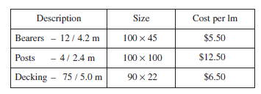
What is the total cost of the materials?
  - $283.46
  - $603.50
  - $2834.70
  - $6035.00
- What is the area of a triangle with a base of 12.2 m and a perpendicular height of 3200 mm?
  - 19.52 m²
  - 39.044 m²
  - 195 m²
  - 3904 m²
- What is the height difference from Peg A to Peg B, taken from the staff reading?

  - 0.15
  - 1.50
  - 1.970
  - 150

- The top view of a concrete slab is shown.
What is the area of the concrete slab?
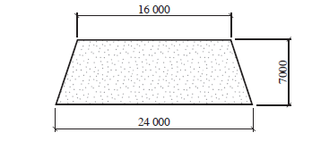
  - 1.344m²
  - 140m²
  - 154m²
  - 168m²
- Electricity is required for a power tool and is to be taken from an on-site power pole. Portable electrical lead posts will be required to support the lead over a distance of 28 metres and will be set out 4 metres apart.
What is the cost to purchase the electrical lead posts if each post costs $12.50?
  - $87.50
  - $100.00
  - $112.50
  - $187.50
- How many linear metres of 90×45 timber lengths are needed to prepare formwork for a 4m×3m concrete slab?
  - 7m
  - 9m
  - 12m
  - 14m

- A transfer level is to be measured over a distance of 10 metres by a tradesman who is working alone. Which of the following levelling devices would be most suitable to complete this task?
  - Laser level
  - Spirit level
  - Water level
  - String line level
- The graph displays the number of injuries that occurred on a work site for each month. What is the average number of injuries per month that occurred during the main construction period?
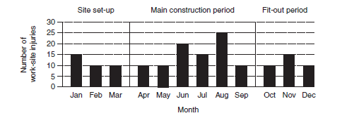

  - 10
  - 12
  - 15
  - 18
- How many cubic metres of concrete are required to fill a column with a radius of 500 mm and a height of 5 m?
The formula for finding the volume of a cylinder is V = pr2h.
  - 0.785 m³
  - 1.57 m³
  - 3.93 m³
  - 7.85 m³

- The following specifications are given:
• Section: 90 × 90 mm pine
• Length: 2.4 m
• Amount: 125 lengths

Based on these specifications, which of the following is the minimum number of cubic metres of timber required?
  - 2.0
  - 2.3
  - 2.5
  - 2.9
- The top view of a concrete path is shown. The path is 2 m wide.
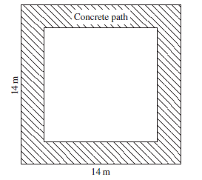
What is the area of the concrete path?
  - 96 m²
  - 100 m²
  - 112 m²
  - 196 m²

- Which is the best tool for checking the length of a curved site boundary?
  - Trundle wheel
  - 8 m tape measure
  - 30 m tape measure
  - Builder’s folding rule
- Which rule can be applied to check the squareness of the formwork for a small concrete slab?
  - 1-2-3 rule
  - 3-4-5 rule
  - 5-6-7 rule
  - 7-8-9 rule
- A temporary fence is needed to enclose a rectangular area of 41 metres by 30 metres. Each fence panel is 2.1 m long and 1.8 m high.
How many panels are needed to fence the area?
  - 20
  - 34
  - 70
  - 79
- What is the standard unit of measurement used on construction drawings?
  - Centimetre
  - Decimetre
  - Kilometre
  - Millimetre

Questions from Section II
These questions should be answered in the suggested number of lines (handwritten in the exam) as it gives a guide to the length of your response.
Plan out your answer and key points before you commence writing.
You may need to bring together knowledge from several areas of study/competencies to do justice to the answer.
Question 1
The diagram shows a concrete slab.
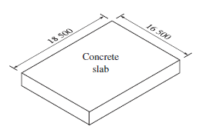

  - If the slab is 120 mm thick, what is the volume in cubic metres? (2 marks)

  - How many 4.2 m lengths of 140x35 mm timber were needed to prepare formwork for the slab? (3 marks)

Question 2
A gable end of a house is to be lined with 140 mm × 19 mm cypress pine boards.
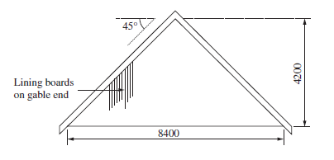

- Calculate the amount of paint required to apply two coats of exterior paint to the gable end. One litre of exterior paint covers 5 m2. (2 marks)

- Calculate the linear metres of lining boards required to cover the gable end. (3 marks)

Question 3
The diagram shows a sketch of a proposed backyard garden.
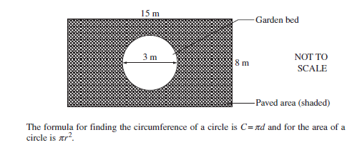

- Calculate how many lengths of 1.8 × 90 × 19 treated pine timber are needed to form and bend an edge for the garden bed. (2 marks)

- Calculate the volume of sand needed to form a 50 mm sand bed for the paving. (2 marks)

Continued over

- How many 400 x 400 pavers are required for the paved area? (3 marks)

Question 4
The diagram shows a proposed plan drawing of a concrete walkway and a paved area.
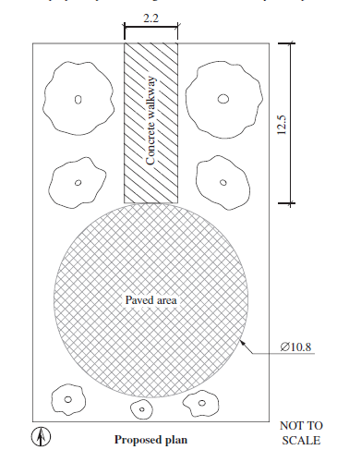

- Calculate the amount of concrete to be ordered to form a 75mm thick walkway, allowing for 10% waste. Show all working. (2 marks)

Continued over

- Using the formula
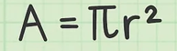 calculate the number of square metres of pavers required for the circular paved area, allowing for 15% waste. Show all working. (3 marks)

- Calculate the total cost of labour to construct the walkway and paved area and for site clean-up if the labour cost is $48.00 per hour. The work log is reproduced below. Show all working. (3 marks)
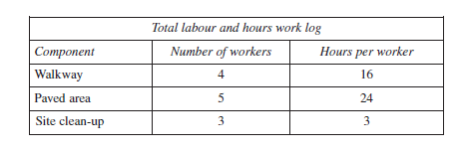

Question 5
The diagram shows two views of a child’s cubby house.
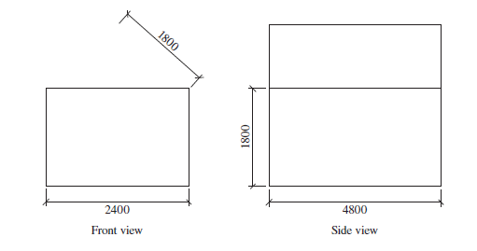
- Calculate the number of 2.4 m ×1.2 m plywood sheets required for the walls of the cubby house with minimal wastage. Show all working. Note: The roof gable is not included in this calculation. (2 marks)

- Calculate the number of roof tiles required and the cost to cover the roof. Each roof tile costs $2.20 and covers an area of 200 ×180 mm. Show all working. (3 marks)

Continued over

- Why is it important for a construction company building a cubby house to comply with Australian Standards? (2 marks)

Questions from Section III
In the HSC –
- there will be one structured extended response question (15 marks)
- the question will have an expected length of response of around four pages of an examination writing booklet (approximately 600 words)

Questions from Section IV
In the HSC –
- there will be one structured extended response question in Section IV (15 marks).
- the question will have two or three parts, with one part worth at least 8 marks
- the question will have an expected length of response of around four pages of an examination writing booklet (approximately 600 words) in total.

This will provide you with the opportunity to:
- demonstrate knowledge and understanding relevant to the question
- communicate ideas and information using relevant workplace examples and industry terminology
- present a logical and cohesive response

These questions usually require you to bring together knowledge from several areas of study/competencies to do justice to the answer. You should allow about 25-30 minutes for a question in Section III and the same for Section IV of the exam.
Consider how ‘Carry out measurements and calculations’ would contribute to an extended response question in the HSC.

