Pedigrees – autosomal inheritance
Masterclass details
Key learning area: science
Course: biology
Module: Module 5 – heredity
Topic: Pedigrees – autosomal inheritance
Resource type: YouTube videos, website, activities
Description: This lesson will explain autosomal inheritance patterns, including how to construct and interpret Punnett squares and pedigrees.

Lesson content

Inquiry questions:
- How are autosomal traits inherited?
- How are pedigrees constructed?
- How can autosomal inheritance patterns be determined from pedigrees?

Part 1: Punnett squares and autosomal inheritance
Autosomal traits refer to those traits that are coded for on autosomes. Autosomes are chromosomes that are not sex chromosomes. Use the following resources to learn about how autosomal traits are inherited:
- How Mendel’s peas plants helped us understand genetics (duration 3:06)
- BBC Bitesize - Genetic Inheritance pages 1 to 6

Activity
- Define the following terms:
- Gene

- Allele

- Genotype

- Phenotype

- Homozygous

- Heterozygous

- Distinguish between a dominant trait and a recessive trait.

- For each of the following traits, determine the genotype (homozygous recessive, homozygous dominant or heterozygous) and phenotype.

- Purple flowers (P) are dominant over yellow flowers (p)
 | PP | Pp | pp
Genotype:
Phenotype:

- Tall pea plants (T) are dominant over short pea plants (t)
 | TT | tt | Tt
Genotype:
Phenotype:

- Draw Punnett squares for each cross below and determine the genotype and phenotype ratios of the offspring. Include a key to show how each allele will be represented.
- Brown eye colour is dominant over blue eye colour. A man who is homozygous for brown eyes has a child with a woman who is homozygous for blue eyes.
- Curly hair is dominant over straight. A man and woman who are both heterozygous have a child.

Part 2: Constructing pedigrees
Pedigrees are charts that depict the inheritance of a specific trait throughout multiple generations of a family. Watch the Khan Academy video on Pedigrees classical genetics (duration 6:07) to learn about how to construct and interpret pedigrees.

Activity
- Draw diagrams, labelled where necessary, to summarise the features of a pedigree.
Features of pedigree trees
Affected male:

Unaffected male:

Affected female:

Unaffected female:

Parents / mating couple:

Offspring (in order of age):

Remember:
All individuals in the same generation should be drawn on the same horizontal line.
Generations are written in Roman numerals on the left of the pedigree.
Individuals should be identified using regular Arabic numerals.

- Draw a pedigree to depict the inheritance of the given trait in each family. Include a key and label the generations and individuals.

- Madeline has albinism, a condition characterised by complete or partial absence of pigment in the skin, hair and eyes. Neither of Madeline’s parents, have the disorder. Madeline married Steve, who does not have albinism. They have three children, one son who does have albinism, and one son and one daughter who do not have albinism.
- James and his father both have widow’s peaks, but his mother does not. He married Sarah who does not have a widow’s peak, and neither do her parents. Together they have one son with a widow’s peak, one son with widow’s peak and one daughter without a widow’s peak.

Part 3: Determining autosomal inheritance patterns
Pedigrees can be used to determine the inheritance pattern of a trait. Autosomal traits are carried on autosomes and are unaffected by gender. Autosomal traits can be autosomal dominant or autosomal recessive.
Watch Pedigree Analysis - Part 1: Autosomal Inheritance Patterns (duration 9:20) to learn how to determine autosomal inheritance patterns.
Remember:

AUTOSOMAL DOMINANT
- An affected child must always have at least one affected parent
- An unaffected child can have two affected parents

AUTOSOMAL RECESSIVE
- An affected child can have wo unaffected parents
- Two affected parents can have only affected children

Activity
- The pedigree shows the inheritance of Huntington’s disease. Identify the inheritance pattern of Huntington’s disease. Justify your answer using evidence from the pedigree and a Punnett square.

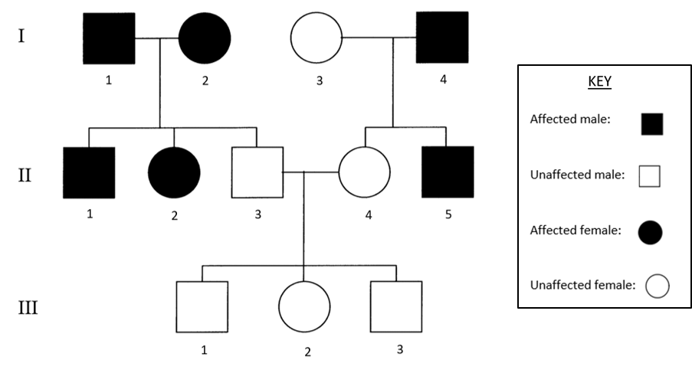
- The pedigree shows the inheritance of Tay-Sachs disease.
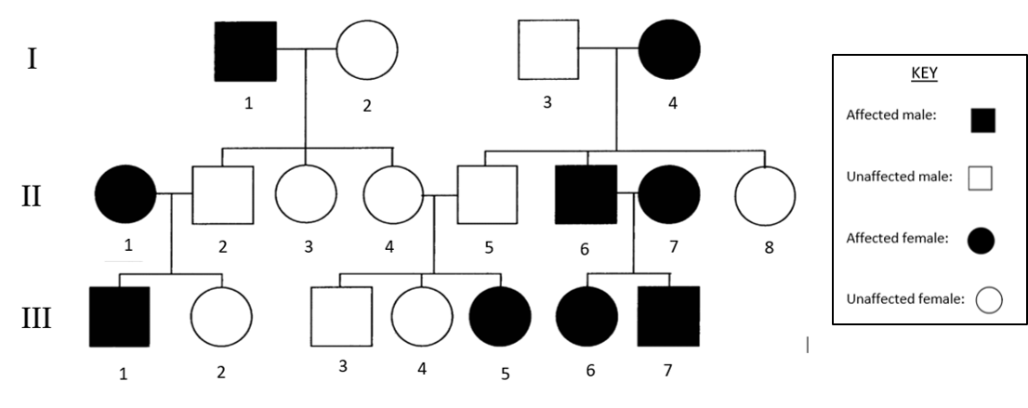
- Identify the inheritance pattern of Tay-Sachs disease. Justify your answer using evidence from the pedigree and a Punnett square. Draw your answer in the space below.
- Identify the genotypes of the following individuals from the pedigree.
  - Individual II-2

  - Individual III-5

- Is it possible to determine the exact genotype of individuals III-3 and III-4? If not, what are the genotype possibilities for both individuals?

- What is the probability of individuals II-4 and II-5 having another child with Tay-Sachs disease? Use a Punnett square to support your answer. Draw your answer in the space below.

Suggested answers – part 1 activities

  - A sequence of DNA that codes for a trait
  - Variations of a gene
  - The combination of genes that an organism has
  - The physical appearance of an organism
  - A genotype consisting of identical alleles for a gene
  - A genotype consisting of different alleles for a gene

- A dominant trait is expressed in a heterozygous individual because the dominant allele masks the effects of a recessive allele. A recessive trait is only expressed in homozygous recessive genotype.

- a
 | PP | Pp | pp
Genotype: | Homozygous dominant | Heterozygous | Homozygous recessive
Phenotype: | Purple flowers | Purple flowers | Yellow flowers

 | TT | tt | Tt
Genotype: | Homozygous dominant | Homozygous recessive | Heterozygous
Phenotype: | Tall pea plant | Short pea plant | Tall pea plant

- a. Brown eye colour is dominant over blue eye colour. A man who is homozygous for brown eyes marries a woman who is homozygous for blue eyes.

 | A | A
a | Aa | Aa
a | Aa | Aa
Key
A = brown eye colour
a = blue eye colour

- Curly hair is dominant over straight. A man and woman who are both heterozygous marry.

 | A | a
A | AA | Aa
a | Aa | aa
Key
A = curly hair
a = straight hair

Suggested answers – part 2 activities

2. a.
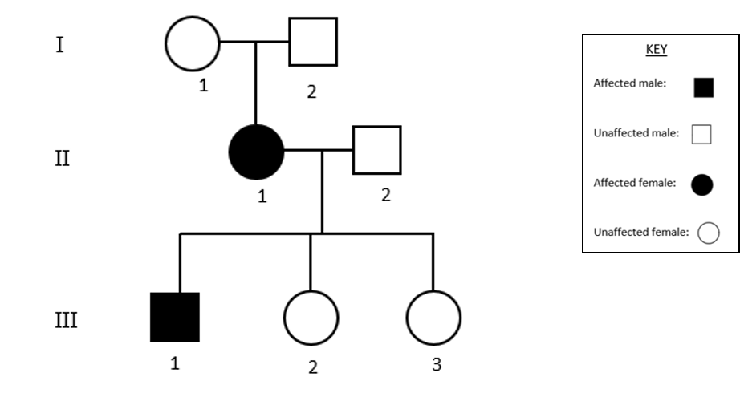
b.
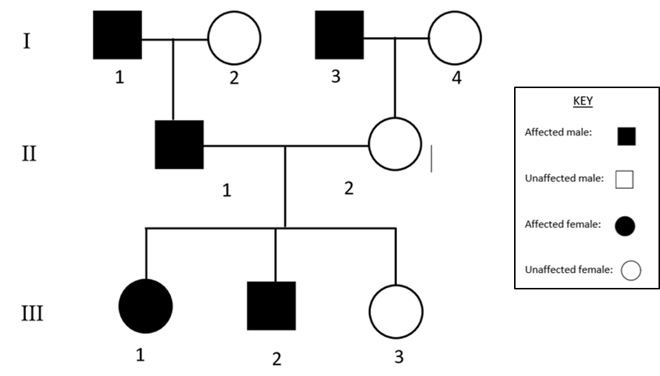

Suggested answers – part 3 activities
1. The inheritance pattern for Huntington’s disease is autosomal dominant. Every affected child has at least one affected parent, e.g. II-5 is affected and their father I-4 is also affected. Punnett square for family I-3 (aa), I-4 (Aa), II-4 (aa) and II-5 (Aa):
 | A | a
a | Aa | aa
a | Aa | Aa
Key
A = Huntington’s disease
a = normal
Furthermore, parents II-3 an II-4 are both unaffected and so must have a homozygous recessive genotype. Thus, they are only able to pass on recessive alleles to their children III-1, III-2 and III-3, who are also all homozygous recessive, proving the recessive allele to be ‘normal’.

2a. Tay-Sachs disease is an autosomal recessive trait. Parents II-4 and II-5 are unaffected, but they have a child III-5 who is affected. As shown in the pedigree, the parents must have a heterozygous genotype such that they do not express the trait but are still able to pass on a recessive allele each to child III-5.
 | A | a
A | AA | Aa
a | Aa | aa
Key
A = normal
a = Tay-Sachs disease
2b i. II-2 has a heterozygous genotype (Aa).
2b ii. III-5 has a homozygous recessive genotype (aa).
2c. It is not possible to determine the genotypes of III-3 and III-4. They must each have one dominant allele from one parent as they do not express the recessive trait. However, considering both of their parents are heterozygous, the second allele cold be either recessive or dominant. The genotypes of III-3 and III-4 could be heterozygous (Aa) or homozygous dominant (AA).
2d. From part a, II-4 and II-5 are both heterozygous. As shown in the Punnett square, there is a 25% chance that a child of theirs would have the homozygous recessive genotype and therefore have Tay-Sachs disease.

 | A | a
A | AA | Aa
a | Aa | aa
Key
A = normal
a = Tay-Sachs disease

Mapping grid
Outcome | Content
BIO12-12 | Explains the structures of DNA and analyses the mechanisms of inheritance and how processes of reproduction ensure continuity of species

Outcomes referred to above are from the Biology Stage 6 Syllabus © 2017 NSW Education Standards Authority (NESA) for and on behalf of the Crown in right of the State of New South Wales.

